

Jan-Luca Vettel

Philipp Karcher

Philipp Pelcz

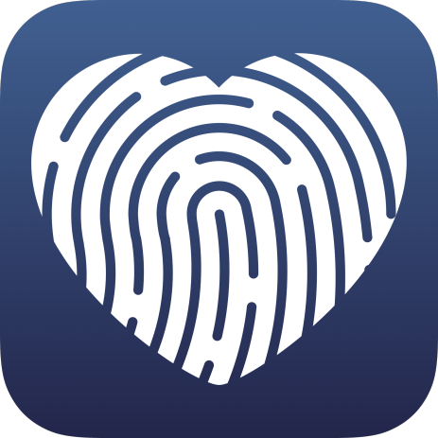

Medox

**Erklärung zur Benutzung der Medox-Anwendungen**

In folgendem Dokument wird die Benutzung der Medox-Anwendungen beschrieben und erklärt, wie die Nutzung der entsprechenden Funktionen gedacht ist. Dafür wird jede Seite gezeigt und zu jedem Element auf einer Seite wird kurz ihre Funktion und die benutzbaren Elemente aufgelistet. Dabei sind alle Seiten der Medox-App in ihre übergeordneten Tabs untergliedert. Die einzige Ausnahme dabei ist die Lexikonseite, da sie keinem festen Tab zugeordnet ist. Da die Medox-Desktop-Anwendung keine Tabs besitzt, werden hier alle Seiten in der vorgesehen Nutzungsreihenfolge aufgelistet.

*Table of Contents*

*Page:*

*Medox-App 3*

*Overview 3*

*Medications 4*

*Receive 7*

*Profile 9*

*Dictionary 9*

*Medox-Desktop-Application 10*

**Medox-App:**

Overview: Main page:

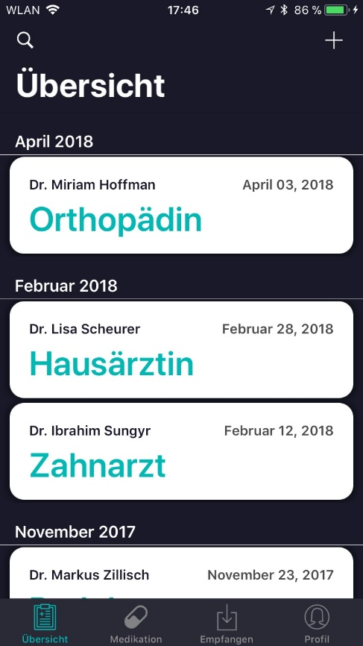With the "+" button you can add new medical reports. Clicking on this button opens the page "Adding medical reports".

Here the name of the doctor is shown.

Here the specialty of a doctor is presented.

Here the date of a doctor's letter is shown.

Each tile represents a doctor's letter. Tapping a doctor's letter opens the detailed presentation.

In this bar all tabs are displayed. Tapping on a tab opens it.

Overview: Add a doctor's letter

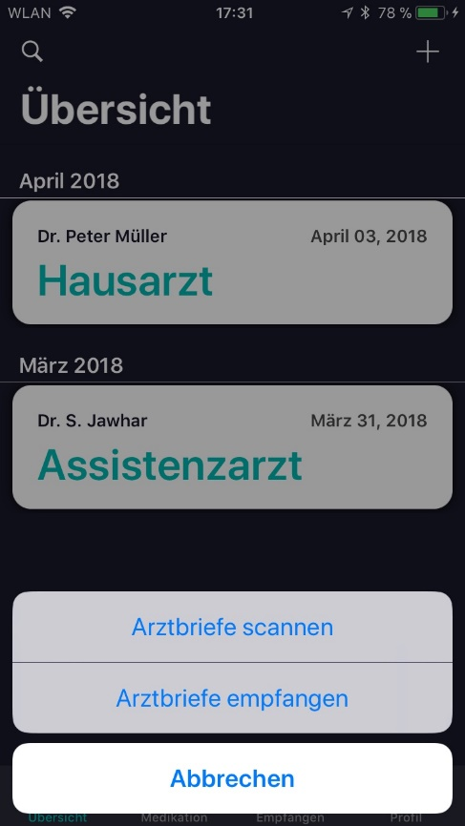Tapping on the magnifying glass opens the dictionary page. Here you can look up the explanation of medical terms.

With this button, the scanning function is called.

This button switches to the Receive tab.

With this button the adding is aborted, and one changes back to the overview main page.

Overview: scan a doctor's letter

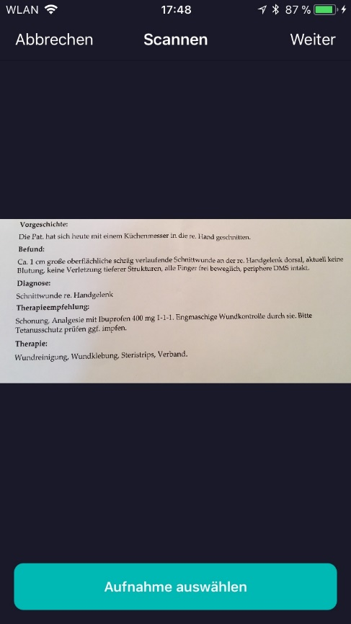The next button confirms the recording. And you will be forwarded to complete the doctor's letter.

The Cancel button navigates back to the overview main page.

Here the current recording is shown.

With this button one is forwarded to the selection of a recording. Here you can either select an existing photo from the gallery or take a new photo.

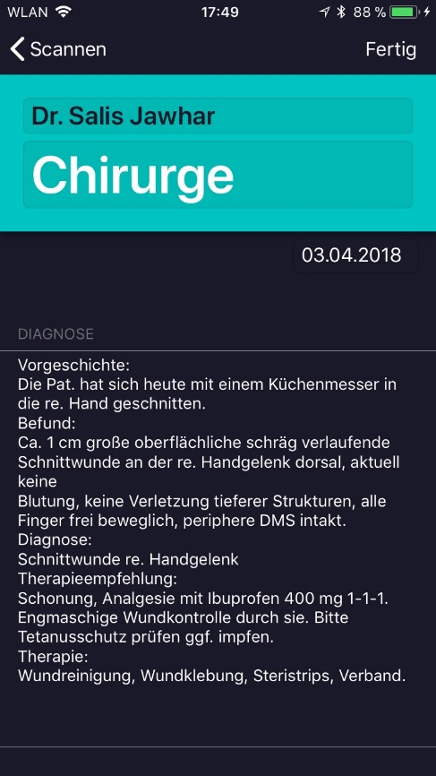Overview: edit scanned doctor's letter

With the Done button, the new doctor's letter is created and added to the overview.

With this button you get back to the scan page.

Here you must enter the name of the doctor.

Here you must specify the specialty of the doctor.

Here the scanned diagnosis is displayed.

Medication: main page

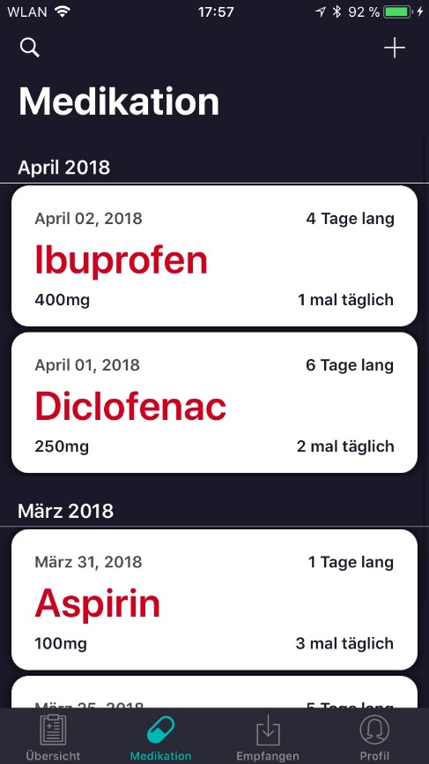

The "+" button adds a new medication.

This is the name of the drug. Each "tile" can be tapped. This allows the editing of the respective medication.

Here the intake duration is shown.

Here, the frequency of intake is displayed.

Here, the start date of the medication intake is displayed.

Here the medication dose is displayed.

Medication: add new medication

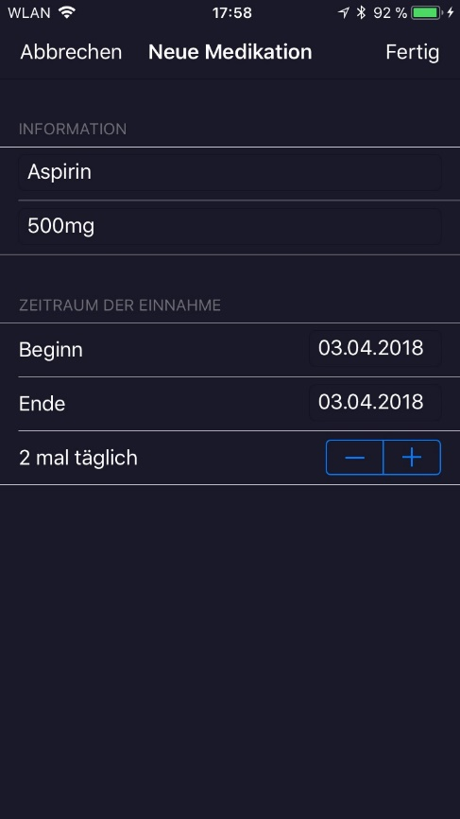This button saves the medication.

With this button, the medication is discarded.

Here the information about the drug must be given.

Medication: Interaction warning

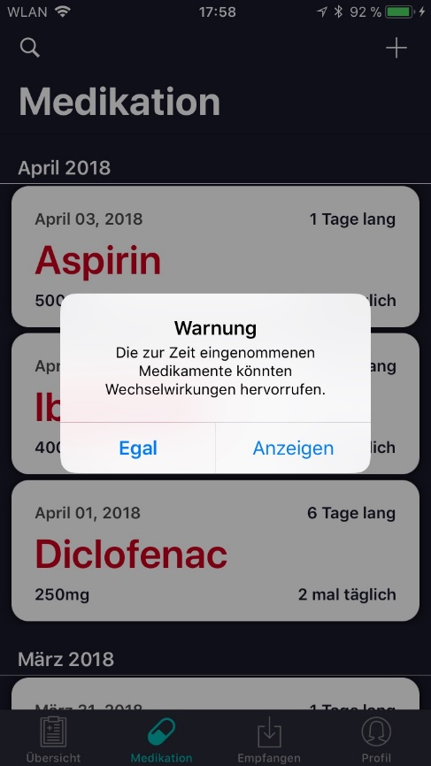

This button redirects you to the medication interaction page.

With this button you stay on the medication main page.

Medication: interaction

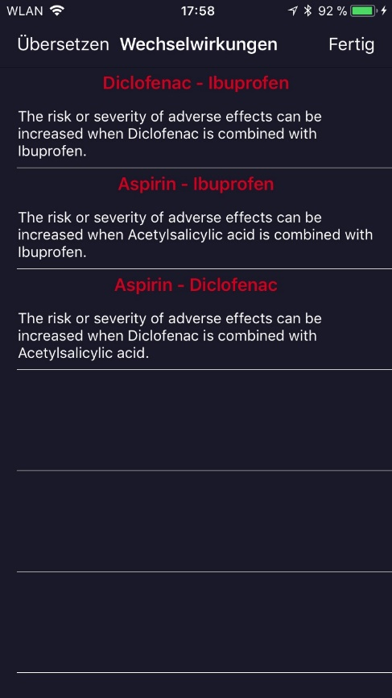

This button translates the warnings into German.

This button closes the medication interaction page.

Here are all existing interactions between the currently taking medication.

Medication: delete medication

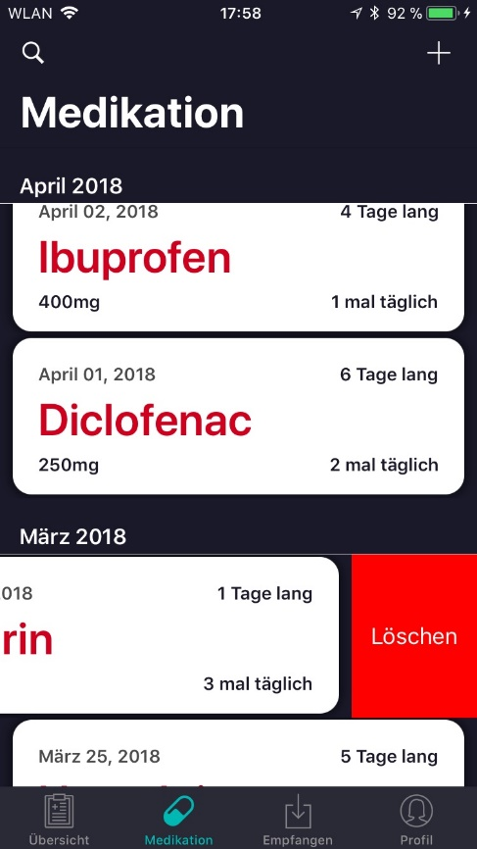

Use Swipe-To-Delete (iOS) / Hold-To-Select (Android) to delete a medication.

Receive: main page

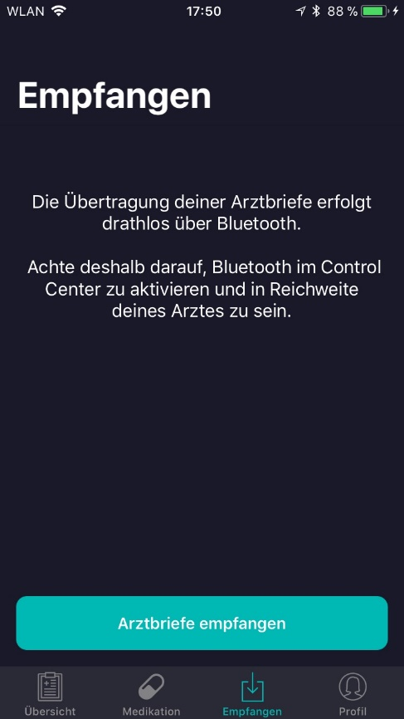

Here is a brief note about data transfer.

By tapping on this button, you will be redirected to the receiving side.

Receive: Receive side

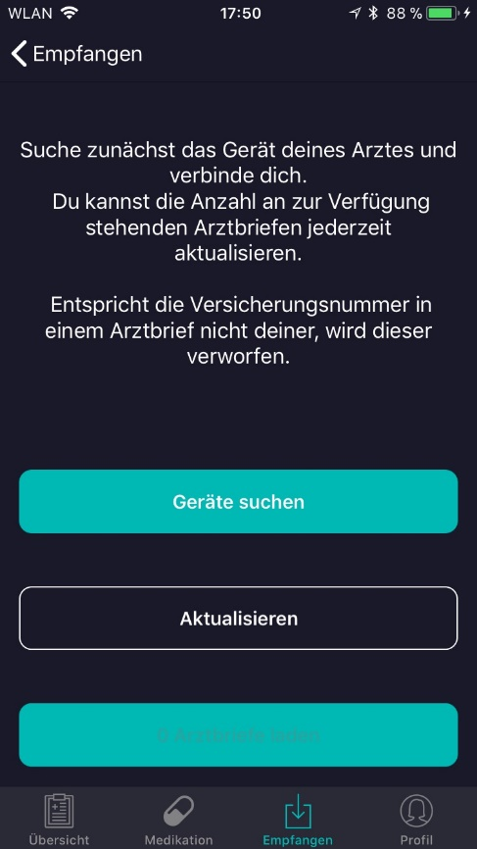

Here is another note on the progress of the data transfer is shown.

This button starts the search for nearby devices.

With this button you can update the number of medical reports you want to receive.

This button is activated only when a device has been found nearby.

Receive: View devices nearby

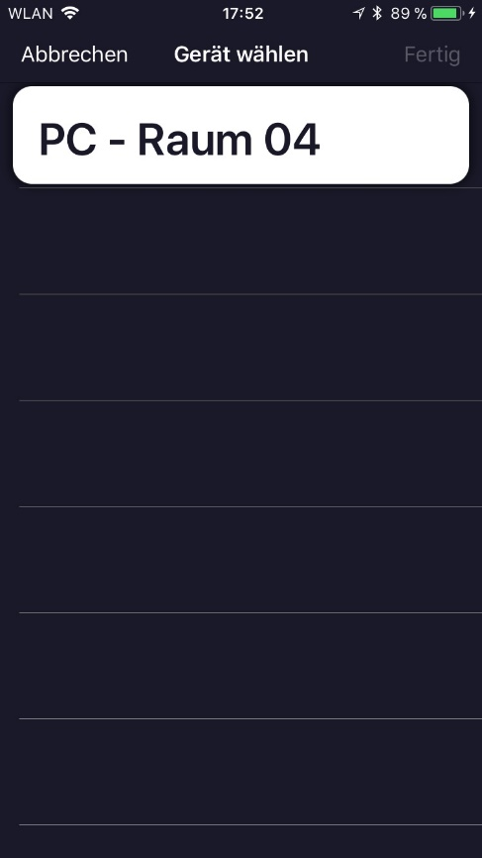

Here you can select a device nearby.

Cancel returns you to the Receive main page.

Receive: receive doctors letters

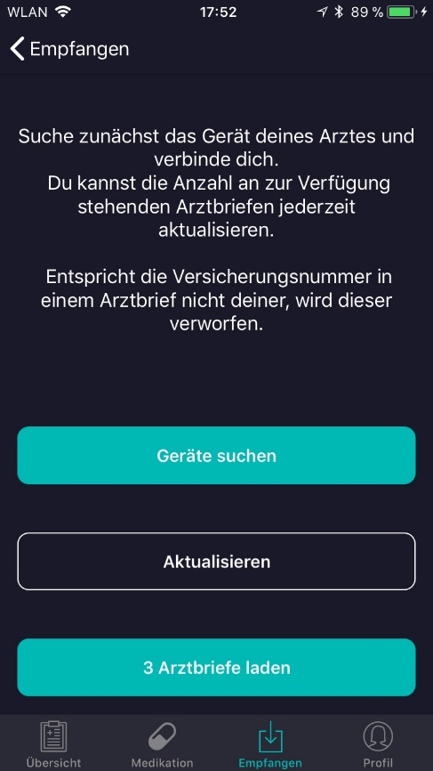

The button is now activated, and the medical reports can be received.

Receive: Transfer completed

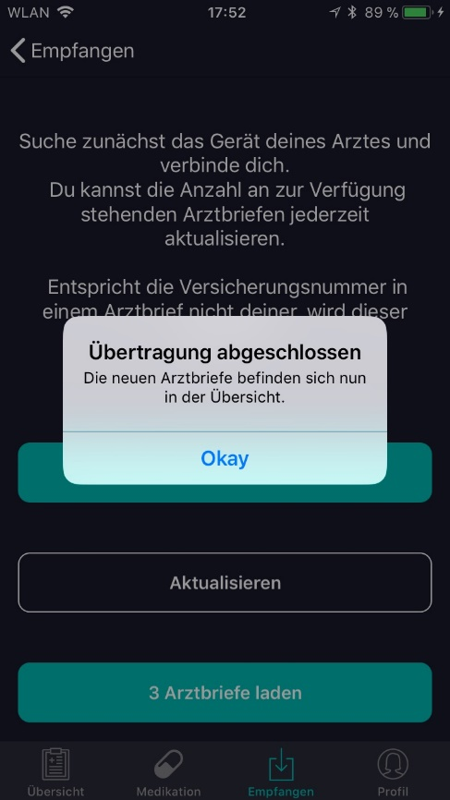

Here a pop-up is displayed, which signals that the transfer has been successfully completed.

Profile: main page

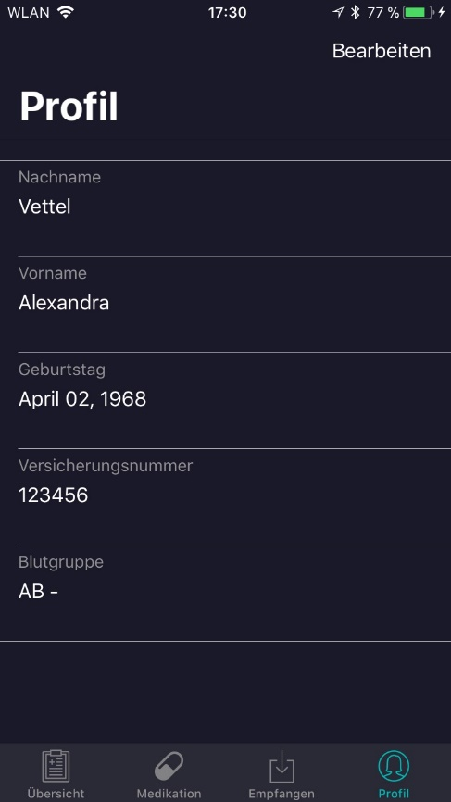

To edit a profile, you must tap “Bearbeiten” first.

Here you should enter data about the user.

Particularly important is the insurance number, as without them no doctor's letter can be received by a doctor.

Lexicon: Search for technical terms

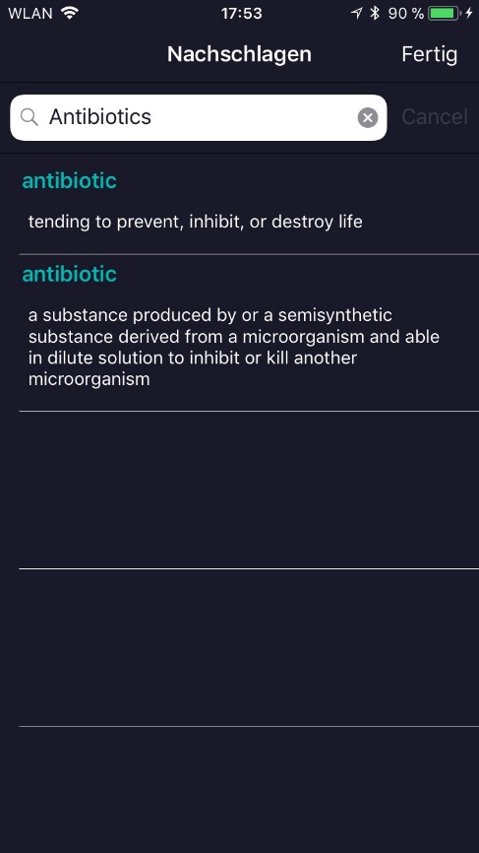

The Done button closes the Dictionary page and returns you to the original page.

Here the search term is entered.

Here the search results are presented.

**Medox desktop application:**

Desktop: 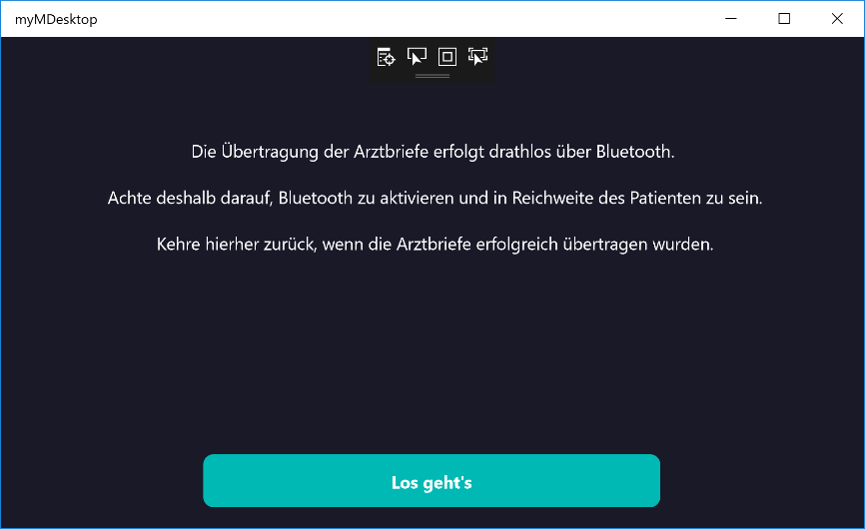start page

This is a brief note text on how the transmission works.

This button starts the Bluetooth server and switches to the main page.

Desktop: main page

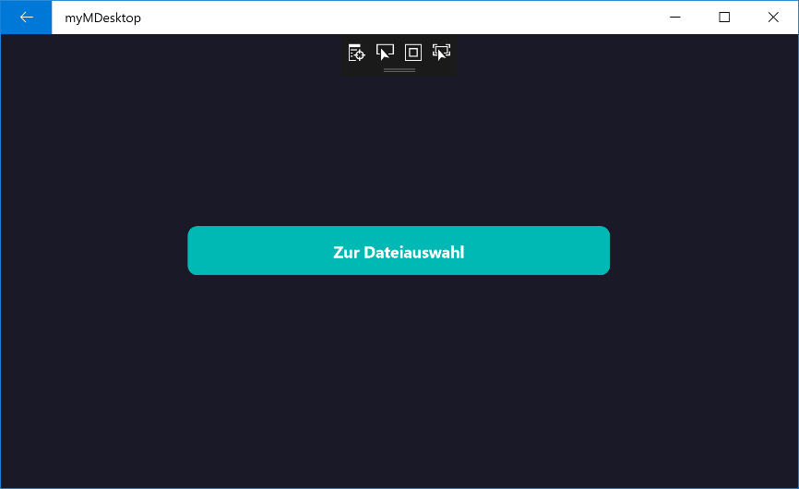

In the main page, the Bluetooth server is active and offers the currently selected files.

With this button one is forwarded to the file selection.

Desktop: files selected

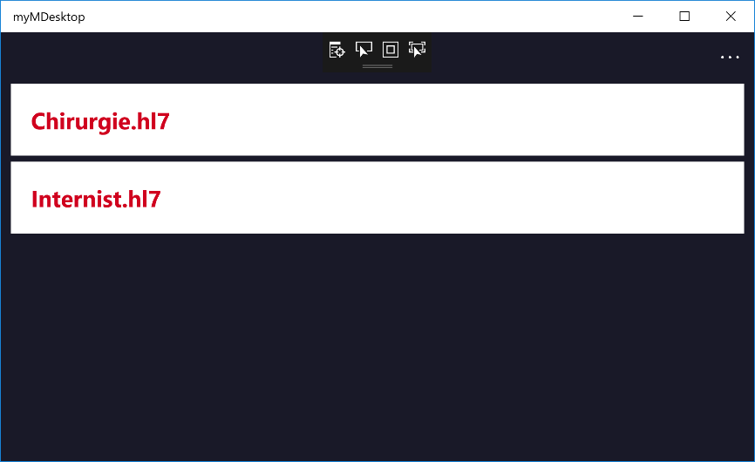

Tapping on "..." opens the buttons described above.

Here the selected files are listed with their file name. Only .hl7 files may be selected. In addition, no duplicates may be selected.