Network research project by peleg odi

Input:

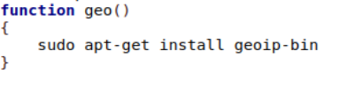

Output:



Function "geo" creted to check if "geoiplookup" is installed and if not then installing it.

input:

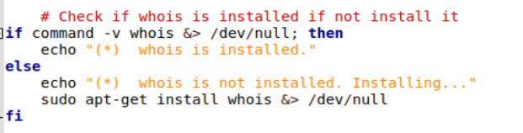

Output:



Function "whois"creted to Check if whois is installed if not install it.

Input:

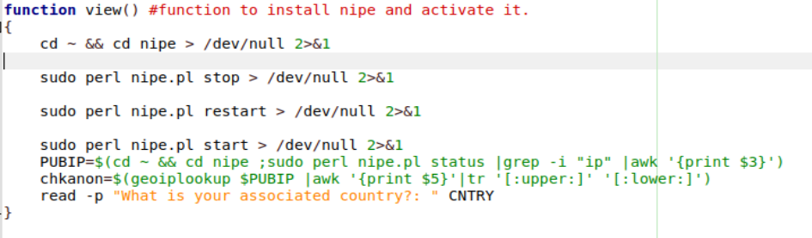

Output:



Function "view" creted to install nipe and activate it.

Input:

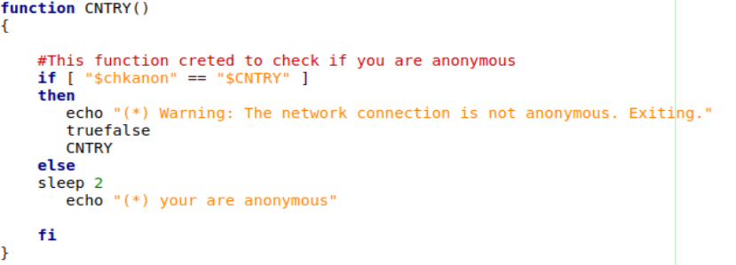

Output:



Function "cntry" creted to check if you are anonymous.

Input:

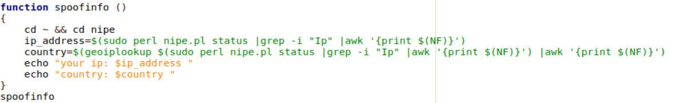

Output:



Function "spoofinfo" cretrd to show the uptime and country.

Input:

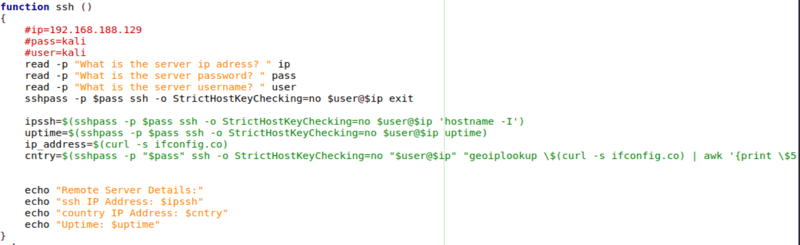

Output:

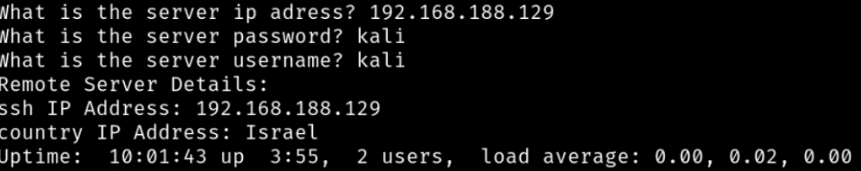

Function "ssh" creted to showed to spoofinfo abut the server ip

Country,uptime.

Input:

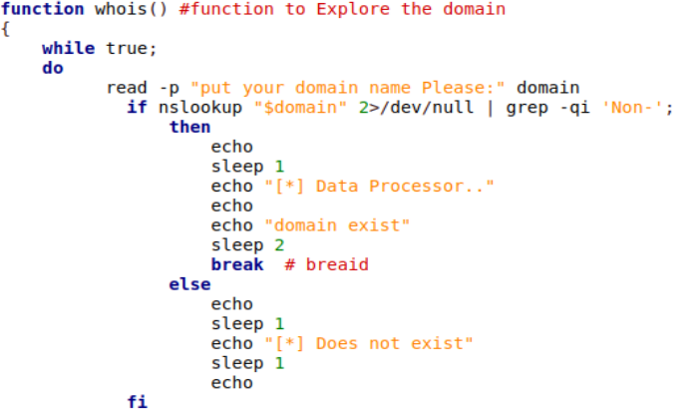

Output:

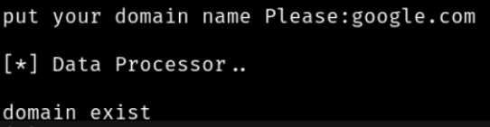

Function "domain" creted to Explore the domain.

Input:

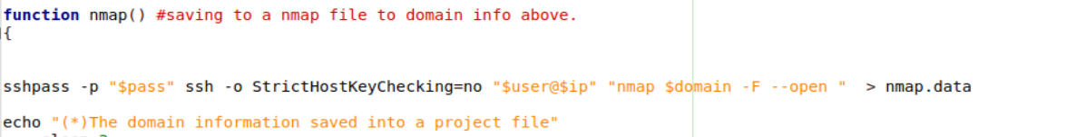

Output:



Function "nmap" creted to save the domain info into a file.

Geoiplookup- is the process of finding information about a specific Internet Protocol (IP) address. Every device connected to the internet is assigned a unique numerical label known as an IP address.

Whois -is a widely used internet protocol and a query/response system that provides information about registered domain names and their registrants.