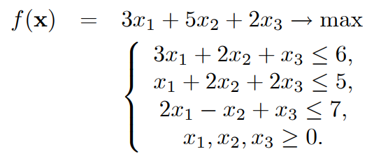

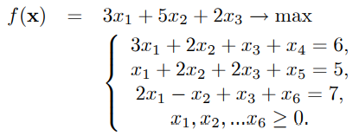

|  |  |  |  |  |  |  |  |  |
| --- | --- | --- | --- | --- | --- | --- | --- | --- |
|  |  | 3 | 5 | 2 | 0 | 0 | 0 | C |
| cB | Baza | p1 | p2 | p3 | p4 | p5 | p6 | B |
| 0 | p4 | 3 | 2 | 1 | 1 | 0 | 0 | 6 |
| 0 | p5 | 1 | **2** | 2 | 0 | 1 | 0 | 5 |
| 0 | p6 | 2 | -1 | 1 | 0 | 0 | 1 | 7 |
|  | f | 0 | 0 | 0 | 0 | 0 | 0 | 0 |
|  | c-f | 3 | 5 | 2 | 0 | 0 | 0 | - |
| 0 | p4 | **2** | 0 | -1 | 1 | -1 | 0 | 1 |
| 5 | p2 | 1/2 | 1 | 1 | 0 | 1/2 | 0 | 5/2 |
| 0 | p6 | 5/2 | 0 | 2 | 0 | 1/2 | 1 | 19/2 |
|  | f | 5/2 | 5 | 5 | 0 | 5/2 | 0 | 25/2 |
|  | c-f | 1/2 | 0 | -3 | 0 | -5/2 | 0 | - |
| 3 | p1 | 1 | 0 | -1/2 | 1/2 | -1/2 | 0 | 1/2 |
| 5 | p2 | 0 | 1 | 5/4 | -1/4 | 3/4 | 0 | 19/4 |
| 0 | p6 | 0 | 0 | 13/4 | -5/4 | 7/4 | 1 | 33/4 |
|  | f | 3 | 5 | 19/4 | 1/4 | 9/4 | 0 | 51/4 |
|  | c-f | 0 | 0 | -11/4 | -1/4 | -9/4 | 0 | - |

Xmax = (1/2, 19/4, 0); fmax = 51/4;