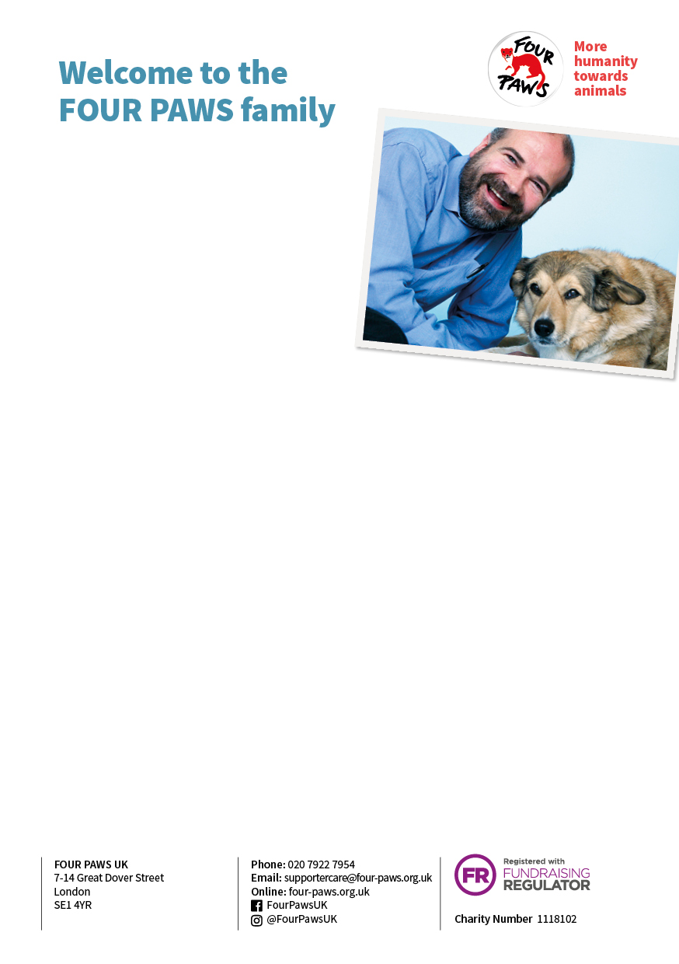

Dear Mr Yeates,

Thank you so much for arranging to make a monthly gift of £5.00 and welcome to the   
FOUR PAWS family.

Like you, I have a deep love for animals. Back in 1988, that love inspired me to found FOUR PAWS with the aim of creating a world in which people treat animals with respect, compassion and understanding. Since then, our charity has grown to encompass a world-wide network of animal lovers, and I’m very grateful to be able to count you as one of them.

At FOUR PAWS we are passionate about speaking up for the rights of those who cannot speak for themselves.

Our teams work tirelessly on the frontline of animal welfare – rescuing, aiding and treating animals who are in desperate need of our help. Thanks to the support of caring people like you, there are many bears, dogs, lions – as well as foxes and elephants – that are now safe and living as nature intended.

***Please turn over…***

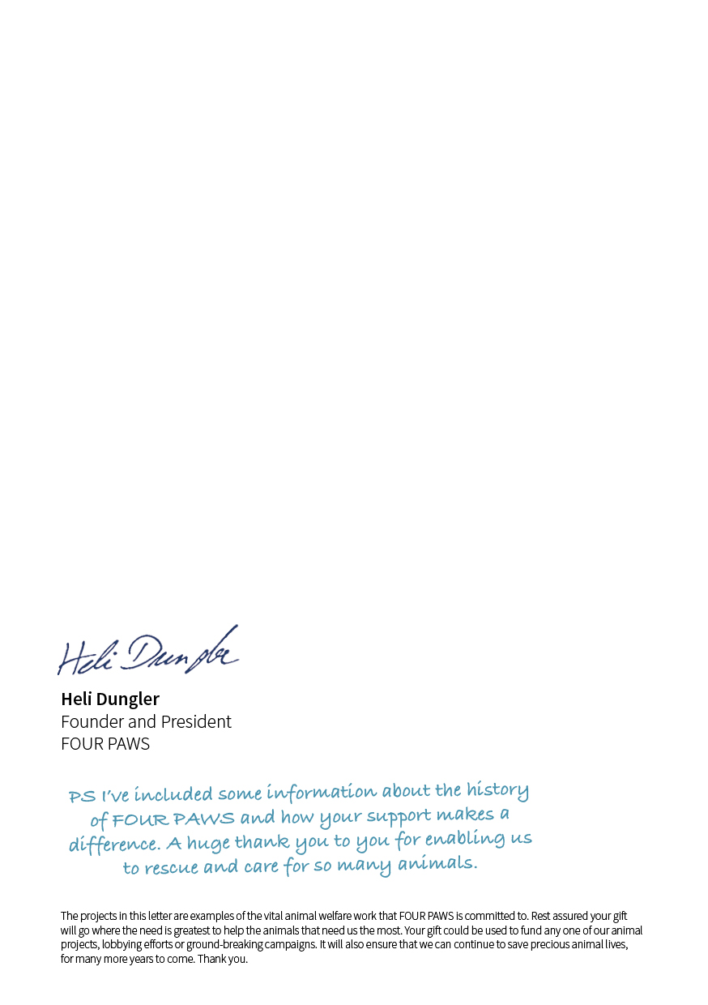Along with rescuing animals, we also campaign for them to be treated with respect. By putting pressure on policy makers we have scored major victories over the years. In Poland, for example, our persistent lobbying of the government has resulted in a complete ban on cruel bear-keeping, meaning that bears are no longer abused or kept in cages in Poland.

But there are still many battles yet to fight.

With the help of our supporters we can keep moving forward, setting up new projects and saving vulnerable animals from suffering. We can bring love and kindness into the lives of animals all over the world who have never known compassion. And it’s people like you, Kenneth Yeates, who make all of this possible.

If you haven’t already, you will soon receive official confirmation that your direct debit has been set up. In the meantime, if you have any questions at all, please do not hesitate to get in touch either by phone 0300 770 1841 or email [supportercare@four-paws.org.uk](mailto:supportercare@four-paws.org.uk)

Thank you so much for joining the FOUR PAWS family. Your generosity is priceless to the animals we help.