javac -d bin -classpath '.\lib\*' src/analysis/*.java src/time_analysis/*.java src/preprocessing/*.java src/main/*.java



jar -cvf TransactionDriver.jar -C bin .

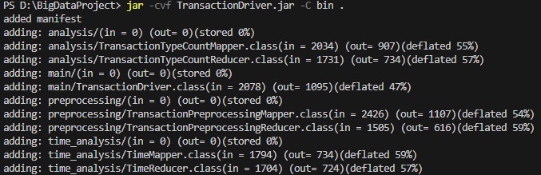

docker cp TransactionDriver.jar sparkproject-namenode-1:/tmp/TransactionDriver.jar



docker compose build

docker compose up -d

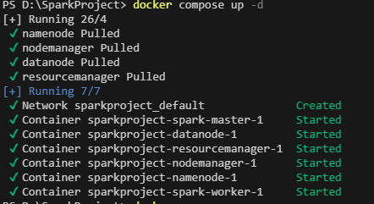

docker ps

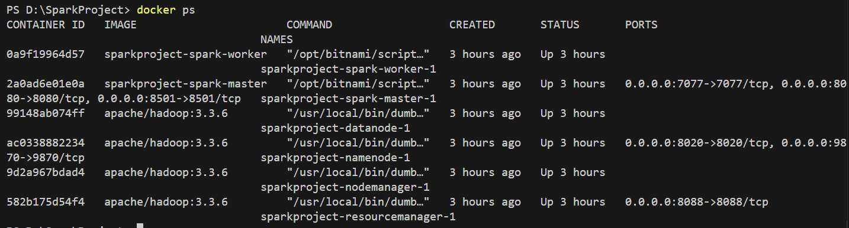

docker cp .\transaction_logs.csv sparkproject-namenode-1:tmp

docker exec -it sparkproject-namenode-1 bash

hdfs dfs -mkdir /input

hdfs dfs -mkdir /input/transaction

hdfs dfs -ls /

hdfs dfs -chmod 777 /

hdfs dfs -put /tmp/transaction_logs.csv /input/transaction

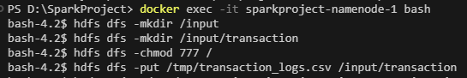

hadoop jar /tmp/TransactionDriver.jar main.TransactionDriver /input/transaction /intermediate /output /finaloutput

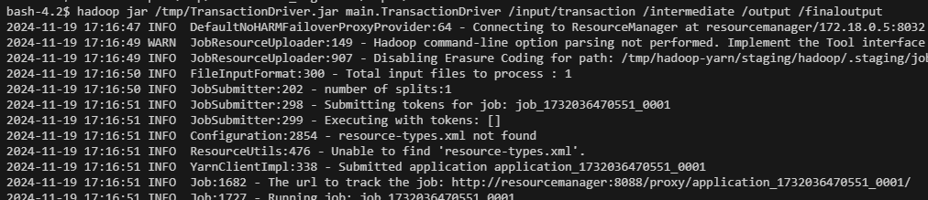

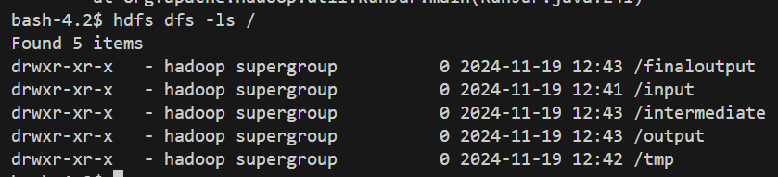

docker cp .\train_model.py sparkproject-spark-master-1:/opt/bitnami/spark

docker exec -it sparkproject-spark-master-1 bash

./bin/spark-submit train_model.py>> submit and train the train_model

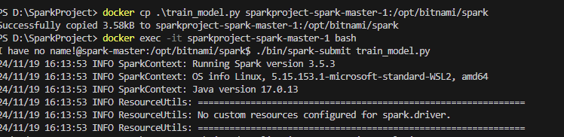



MAE: 271.0959136555383, MSE: 104259.43080545151, RMSE: 322.8922897894149

to verify go to hdfs and list the directory >> hdfs dfs -ls /

docker cp .\dashboard.py sparkproject-spark-master-1:/opt/bitnami/spark

docker exec -it sparkproject-spark-master-1 bash

pip install py4j

python -c "import py4j; print('Py4J is installed')"

streamlit run dashboard.py

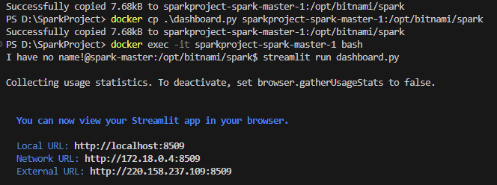

Dashboard  
