**An analysis of peatland projects in Ireland using specific aspects of web applications in order to create a database and website of Irish peatland projects.**

**A Dissertation for the degree of Bachelor of Arts**

**In the University of Galway**

**2023**

Name: Peter McGuinness

ID: 20364193

Course: Bachelor of Arts

Module Code: TI3123

Module Title: Research Seminar in Biogeography

Advisor: Prof. Terry Morley

Head of Geography: Dr. Marie Mahon

Year of Presentation: 2023

**Statement of Originality**

“I hereby certify that this dissertation is entirely my own work. Neither the work nor parts thereof have been published elsewhere in either paper or electronic form unless indicated otherwise through referencing.”

Student Signature………………………… Date…………………………………

Contents

Table of Figures 4

Abstract 5

1. Introduction 6

1.1 Overview 6

1.2 Aims and Objectives 6

1.3 Structure of paper 7

2. Literature Review 8

2.1.1 Peatland Projects in Ireland 8

2.1.2 The importance of peatlands 9

2.1.3 The current state of Irish peatlands 10

2.1.4 Peatland Formation and Classification 11

2.1.5 Change in Irish Peatland 12

2.1.6 Peatland restoration 13

2.1.6 EU Peatland Activities 13

2.2.1 The geomorphology of Peatlands 14

2.2.2 Soil profiles in Ireland 14

Soil Mapping in Ireland 15

2.2.3 Peatlands and Forestry 16

2.2.4 Mapping of Ireland Peatlands 17

2.2.5 The Future of Peatlands 17

2.2.6 Ecosystem benefit to humans 18

2.2.7 Geohive 19

2.2.8 MapBox 19

3. Methodology 20

4. Results 24

5. Discussion 28

5.1 Overview and Analysis 28

5.2 Limitations 28

6.Conclusion 29

7. Bibliography 31

# Table of Figures

**Figure 2**

**2.0 - Soil Mapping of Ireland**

**Figure 3**

**3.0, 3.1 Data Analysis of Excel sheets**

**3.2 Unorganized Data Excel**

**Figure 4**

**4.0 Websites Home page**

**4.1 The Map page**

**4.2 Addition of a project page**

**4.3 Washington Example**

**4.4 Washington demonstration**

# Abstract

“Degradation of ecosystems is a great concern on the maintenance of biodiversity and ecosystem services”[1](Kareksela et al., 2015). A peatland project database a large undertaking that requires planning and implementation. This paper will examine the importance of peatlands and the need for the creation of the website. The website was created shows the database through an interactive map hosted using MapBox software. This paper details the state of Irish peatland, how they were formed and what will happen into the future of these areas. Peatland restoration projects are vitally important now more than ever.

The paper continues to review more about the peatlands, looking into EU policies, the Kyoto protocol, websites like Geohive, Teagacs, Bord Na Mona and Argiland.

# Introduction

## Overview

This paper will detail the creation of a database of peatlands projects in Ireland. The reasoning for the creation of this database is to justify the questioning why there is no single website to display the peatlands projects of Ireland in an interactive format. This paper will encompass the questioning of the hypothesis for the formation of the database and the creation of the website, the research and findings which had to be carried out in order to create the database of peatland projects in Ireland and the website which it is hosted on. Research into Irish peatlands continues to seek the solution for the restoration of peatlands. The research into peatlands will need to be continually studied. Peatlands are a natural carbon storage and regulate the climate by doing so. “Peatlands offer a series of ecosystem services including carbon storage, biomass production, and climate regulation” [1](Budiman Minasny a et al., 2019).

## Aims and Objectives

The main intention of this paper is to understand the creation of the website using the database of the peatland projects in Ireland. The database is connected with the MapBox API, which then displays it to the website using a section of JavaScript code which will be detailed in the methodology . The website holds three pages: The Home page which is for general information and will display a small amount of information on the properties of the database, such as the different types of peatlands in the database, some information surrounding the companies that promote these peatlands projects to the public.

The Map page which will display the interactive map to the user and allow them to interact, select points and have the ability to learn more about the database.

This page will also contain a key to the map. The key will display that different colours will mean different types of peatlands in the area. The Map will also in include past, present, and future peatland projects. These projects will be stored in the database so that at any point they can be recalled, and all of the information is present and available.

## Structure of paper

The paper will be broken into the following sections. The literature review will review literature and currently on-going peatland projects to contextualise the need for this research. The literature review section will read peatland projects, research on the interactive map, research into the formation, maintenance and destruction of peatlands as well as a glance at European Union projects and policies. It includes a background surrounding the state of the mapping of Irish soil and peatlands, this is a necessary addition to the rest of the paper and the overall project. The methodology will encompass the creation of the website and how the database supporting functions. The figures of the website in the methodology section will explain in more detail. In the results section the website and how it functions will be detailed. This will include screengrabs of the website and the HTML code that goes with it. In the discussion section will help to understand the meaning of the results and will detail the relevance of the results of this research.

# Literature Review

## Peatland Projects in Ireland

Peatlands are a vitally important ecosystem which provides ecosystem services, these include carbon storage, water filtration and biodiversity conservation. Ireland is covered by approximately 16.2% peatland, human activities in these regions include agriculture, forestry and peat extraction. Their activities have significantly impacted these ecosystems [2](Anderson et al., 2016; Fennessy and Cronin , 2019). They cover three percent of the earth’s surface even containing up to a third of the organic carbons found in the earth’s soils” [2](Dunn C ., et al., 2011).

In order to address these issues, a number of restoration and conservation projects have been commenced in the previous few years. The Irish Peatland Conservation Council has a program named Peatland Conservation and Restoration Project, the aim of this project is to restore degraded peatlands by reducing grazing pressure , blocking drainage channels, and re-introducing native plant species [2](IPCC, 2019).

The National Parks and Wildlife Services(NPWS) is another Irish government initiative. One of the projects currently underway is a raised bog restoration project. This project will focus on restoring raised bogs, these bogs are especially important for carbon storage, which makes projects like this vital for the continuation of peatland maintenance in Ireland. The NPWS are working with local communities to restore damaged bogs. This work has aided in the restoration of these ecosystems. These series of projects have also allowed for an improvement in habitat quality for a range of species[2] (Fennessy and Cronin,2019).

There are also efforts underway to develop sustainable peatland management practices in Ireland. The Irish Peatland Conservation Council has been working to promote the uses of some alternative fuel sources for energy production, everyday household usage and the sustainable agricultural practices in Peatland areas[2] (IPCC, 2019). These efforts are being proven effective and will be vital for the long-term sustainability of peatland ecosystems.

Some other studies have investigated new methods of remote sensing in order to monitor and manage peatland ecosystems[2](Doyle et al., 2010), the role of peatlands in regulating water quality and quantity[2] (Krause et al., 2020), and the impact of climate change on peatland ecosystems and associated biodiversity [2](Wright et al., 2020).

## The importance of peatlands

Peatlands have been reduced by more than half in the last seventy-five years [2](Spiers 1999; Joosten 2012);(Andersen et al., 2016). It is undoubtable that peatlands are necessary resource in the fight against climate change. Climate change is a highly sensitive topic in the modern world. Peatlands are a highly valuable asset this is due to the mitigation factors found in peatlands. During flooding or soil erosion they can trap large amount of carbon. Peatlands are under constant pressure; this is brought on by human activity mostly. Turf cutting plays a large role in the destruction of peatlands[2]( Harenda et al, 2018). The mapping of these peatlands will be a value resource. “Peatland protection and restoration can both mitigate climate change and water balance disturbances”[2]( Harenda et al, 2018).

The Kyoto Protocol is an extension of the 1992 United Nations Framework Convention on Climate Change. This protocol introduced that the countries who it fell over would have to abide by the greenhouse gas emissions targets. The mapping of peatlands has always been a difficult endeavour [2](Vitt, D.H., 2000) [2](Connolly., et al , 2007).

## The current state of Irish peatlands

134 million hectares of Irish land are covered by peatlands, this equates to roughly 16.2% of the country (Hammond, 1981). Peatlands are the most efficient terrestrial carbon store on Earth and deliver multiple other ecosystem services.” [2](Andersen et al., 2016). Included in this excellent carbon storage are the ecosystem services of climatic regulation, water purification and the preservation of physical records both ecological and archaeological. After human interaction with peatlands such as the use of peatlands for agriculture or harvesting on pe at for the uses of energy production. In recent times it was deemed that only “10% of raised bog and 28% of blanket bog in Ireland are still able for conservation”[2] (Renou-Wilson, 2011).

Peat farming in Ireland has a strong cultural history. It was and still is an essential part to the rural lifestyle in Ireland. Farming peat in Ireland has seen a reduction in the last 100 years due to government directives such as European Green Deal in 2019, Biodiversity Strategy for 2030. The peat farming culture will be dead in the next 100 years killing a way of life with it. This would be an interesting aspect to research with the sustainability of peatlands in an Irish setting. Bord Na Mona would be useful due to the face they hold valuable and extensive information on peatlands and peatland development in Ireland.

Hammond(1981) supposed 44% of Ireland peatlands had been disturbed. Using the term man modified to describe this interruption of the natural land.

## Peatland Formation and Classification

“The classification of Irish peatlands (blanket bog, raised bog and fen) is derived from their surface vegetation and genesis” [2](Tansley, 1939; Osvald, 1949; Moore, 1962)(Hammond et al,1979). Peat production is heavily influenced by the local hydrology. Bellamy mentions those conditions as peat formation templates (1972). In order to demonstrate the elements crucial to development, he uses this equation:

**Inflow + precipitation = Outflow + evaporation + retention**

The equation displays the formation of peatlands and allows us to understand the formation of these areas in a straighter forward format. In order for an area of land to be classified as a peatland the organic material needs to be at least 45cm on an undrained surface or 30cm on drained land. This excludes the thickness of any plant mater[2] (Hammond,1981). Hammond (1981) is the single most important piece of literature produced on the classification of peatlands in Ireland. As the systems, methods and ideologies brought to light in the paper are being used today.

Peat type or mires return two categories in Ireland; ombrogenous mires meaning raised or blanket bog these would mostly be found in the western side of the country, topogenous mires transpire as Fen types these are determined by the surface topography and the ground water table.

## Change in Irish Peatland

“The lack of globally consistent, temporally frequent peatland maps results in uncertainty when assessing the role of peatlands in the global carbon and water cycles”[2](Kranina et al., 2018). Remote censoring had quickly grasped the attention of these organizations. The equipment is a gateway to identifying differences in the state of an object or phenomenon by observing it during different intervals.

Remote sensing techniques such as LiDAR and satellite imagery can be used in the detection of change in peatlands in Ireland. This can allow for a more comprehensive understanding of ecosystem change.

There are currently two methods to read the depth of a peatland area. This monitoring is useful as it can alert the end user if there is any change in the peatland area. Manual probing requires little effort and is cost-efficient as it is performed with a thin metal pole, which is pushing into the peat at spatial intervals until the bedrock below can be felt by the end of the pole. The Agronomy Purdue extension describes two methods of sampling; zone based, and grid based. The second method uses ground penetrating radar (GPR), this is a non-invasive proximal sensing technique[2] (Budiman Minasny a *et al.* 2019). The use of this delivers spatial resolution measurements of peat thickness every 0.5 to 1 m along a transect. This can then be produced to a map format[2] (Budiman Minasny a *et al.* 2019). The GPR technique uses more of financially than the manual probing technique. But the GPS is more time and data efficient as the data is saved automatically, while with the probing it must be saved by hand initially.

## 2.1.6Peatland restoration

Clara bog in Offaly is a 665ha bog with 460 of these hectares in an area of conservation. Raised bog in this area has declined by 46ha every year. “Ireland has a clear international responsibility for the conservation of such exceptional landscape biodiversity.” (Renou-Wilson, 2011). This is a clear indication of the value of research in peatlands in Ireland and shows the immense importance of this research, supports the given research question. Raised bog has been deemed as a Special Area of Conservation by the EHD.

Bord Na Mona have been re-enabling peat landscapes in Ireland to return them to a state in which the further release of carbon dioxide is slowed or halted. In 2020, the harvesting of peat was stopped. Since then, Bord Na Mona have been using their rehabilitated bogs as areas for use of renewable energy sources like wind or solar energy farms.

Coillte is an Irish Peatland Habitat Restoration organization. Coillte literally means “Forest” in English. It is a state-owned organization which manages approximately 7% of Ireland’s natural ground. This organization has been committed to playing an important role in the restoration of natural habitats. Raised and blanket bogs are a high priority not only for Coillte but also under EU law (Coillte, 2021).

## EU Peatland Activities

Thus far, the majority of peatland restoration projects in Western European have been funded via the LIFE projects or private companies. The EU policies introduced make the idea of peatland restoration more appealing as there are financial incentives (Andersen et al., 2016). This is similar to the afforestation scheme introduced in Ireland to promote the grow of forests in Ireland. The afforestation scheme also in turn aids the support of peatland restoration. In the 1980’s research was carried out by Irish and Dutch scientists to understand the hydrological processes which support the peat formation in raised bogs. This research led to an advancement in management strategies. The work has been used with remote sensing to highlight the most important areas for restoration(Andersen et al., 2016).

Bord Na Mona is an Irish state-owned peat extraction organisation. Using techniques such as drain blocking and damming they have restored over 117,5 ha of damaged raised bog since 2009 (Andersen et al., 2016). Natura 2000 is a network of ecological sites. The network is made up of special Protection Areas (SPA). Ireland is littered with these areas. “The terrestrial areas of the SPA network include inland wetland sites important for wintering waterbirds and extensive areas of blanket bog”[2](NPWS, 2009).

## 2.2.1 The geomorphology of Peatlands

Ireland’s peatlands are predetermined by the bedrock geology. It is the combination of bedrock and the period of glaciation which has formed the peatlands which currently exist in Ireland. When the contributions of climate change on the stability of land surface are understood the responses can also take shape [2](Harrison S., et al, 2019).

## 2.2.2Soil profiles in Ireland

“The combination of bedrock geology and glaciation has determined peatland distribution patterns. “(Hammond 1981). In the paper “Peatlands of Ireland” written by R.F Hammond, it details how difficult it is to gain the necessary data to produce a new peat map of Ireland. It is complicated due to the fact that there are so many different sources. The data was coming from “published and unpublished material”(Hammond 1981). Data types such as map, written aerial photograph and personal communication coming into play. This would understandably make it difficult to create a single map of all the peatlands in Ireland.

### Diagram Description automatically generatedSoil Mapping in Ireland

figure 1.0

The map seen in figure is the map produced from the paper of R.F Hammond, as can be seen, it details the soil profiles in Ireland. From the interpretation of myself, it can be clearly seen that the data gathered for this comes from many different sources. The data here seems all over the place. These only seems like general estimates of the actual land area taken up by these features.

## 2.2.3Peatlands and Forestry

In Ireland, there are two main types of peatlands: Fens and bogs. Fens are formed in wetlands, which will rely on the groundwater and require thousands of years to form. A wetland is an area of surface in which the water table is close to or on the ground level.

Ireland only has four types of native tree species. Afforestation schemes introduced financial incentivization to the public and farm owners. Who allowed an increase in this. The afforestation up until the 1990s was less than twenty percent, then in 1995 it rose to twenty percent only to decease down to thirteen percent in 2000(ITGA,2002): (Florence Renou et al., 2004).

The LIFE Celtic Rainforest project, which aims to restore Atlantic oak woodland and related ecosystems in the west of Ireland, is another successful endeavour. In order to restore the native oak woodland habitat, which is crucial for maintaining ecosystem services like carbon storage and biodiversity, non-native conifers must be removed.

The idea of developing peatlands to become afforested areas was initialized in the government in the early 1950s. It saw to the possibility to blanket bogs, offering large scale plantations. This would be an inexpensive method of creating a fertilizer for these plantations. The afforestation grew from 255ha to 3,750ha in the ten-year period between the 1950s and the 1960s. An estimated 200,000 ha of land was in usage as forested peatland in the 1990s. (Farrell, 2004)

## 2.2.4Mapping of Ireland Peatlands

Peatlands worldwide have been slowly degrading for some time. Action is required to prevent this from continuing at its current rate. It is a necessity to better understand peatland extent and status. This research into peatlands has to be improved in many aspects in order to provide maps and tools this would in turn support investors in these fields[2](Budiman Minasny a et al., 2019). As part of a study a map was created using ArcGis to analysis the extent of the soil and land-cover maps produced between the 1970s and 1990s . The map shows 1px to 100m. 0.95 Mha (13.8%) is the peatland resource in Ireland on the map. Which is compared to the estimated 13.2% by the CORINE data from the 1990s[2](Connolly, 2007). Classification of peatlands in any country will be difficult, these systems are merely based on concept(Hammond, et al, 1979). The meaning of this system would be to create a single method of identifying, maintaining, and protecting peatlands. A single unified system which ascertains to all peatlands.

## 2.2.5 The Future of Peatlands

“Anthropogenic degradation of peatlands through draining, fires and exploitation can increase the production of GHGs”[2](Dunn C ., et al, 2011). Peatlands will consistently play a major role in the maintenance of carbon storage. GHG’s are greenhouse gas emissions carbon dioxide will make up the majority of these emissions. The gases produced are released during burning fossil fuels.

The research on the future of Irish peatlands is minimal. Although there has been research done on peatland restoration in western Europe. “ Peatland science is a critical research area and that we still have a long way to go to fully understand the peatland–carbon–climate nexus”(Loise, J., et al, 2020)

AI2PEAT is a new major project which is intended to discover how artificial intelligence can be used in the monitoring and protection of Irish peatlands. Agriland is an Irish organisation who’s goal it is to produce and display news stories which ascertain to domestic agricultural and energy stories. The AI2PEAT project will cost an estimated 200,000 euros the main intention of this project is to influence policy surrounding government policy of protection, biodiversity and climate change(McDonnell, 2023).

## 2.2.6Ecosystem benefit to humans

“Peatlands are active sinks, absorbing carbon dioxide from the atmosphere” [2](NPWS, 2009). Irish peatlands contain roughly 64% of the total organic carbon stock present. It will become clear during my research just how important this topic is to humanity. Bog and peatlands hold an immense amount of wildlife and are home to micro ecosystems. “The European Union is expected to see only limited growth of 1.6 per cent in 2020 and 1.7 per cent in 2021.” [2](UN,2020)

Blanket bog in Ireland is recognized internationally as a valuable habitat for nature conservation. These areas are extremely diverse and contain flushed fens, lakes and hummocks, which give the area a wide range of eco-diversity(Coillte, 2016).

## 2.2.7 Geohive

Geohive was initially developed by Ordnance Survey Ireland in 2015. The web app intends to make all of Ireland’s geospatial data accessible, all in one place(Geohive, 2016). This may contrast the meaning of this project although, this proposal just proves the need for this research. Geohive is a geospatial datahub which is created to provide easy viewing of map with layers of geospatial data which has been created by the Public Sector bodies(PSB) which is outlines in the Public Services Data strategy. Geohive will be the foundation of this project. It is a model from which the website will be based.

## 2.2.8MapBox

MapBox, the API software which will be used for this project. It is a powerful geocoding platform, which can be implemented and hosted on to a website. The main differences between MapBox and Google Maps are that MapBox allows for far more customization. In a beta of the website an embedded Google map was used as a placeholder so the website could be visualised. MapBox allows the developer to add features, such as a zoom function a key function and place datapoints on the map which an embedded Google map cannot do. This is an essential part of this project. The management of data in a secure, quick, and easy to understand fashion for the benefit of the public(*Public Service Data strategy 2019-2023* 2018). The data included in the website is a database of the projects in Ireland.

# Methodology

The reasoning for this research is to create a database of Irish peatlands and produce such a map to a website which is easily accessible to the general public and future researchers. To first collect the necessary data for this research, I collected the data from a previous student’s study. This student was linked to the project by the project supervisor.

One of the methods used in order to gain the necessary data was by researching the current peatland projects in Ireland online to find the ongoing projects. Websites such as Bord Na Mona, Coillte, The IPPC and CANN were all discovered to have a large amount of information surrounding peatland projects. This researched opened new possibilities for the database, instead of only using the data provided by the student Alex.

The zip folder enclosed a file named “Ireland projects” , which held five excel documents. The first of these documents named “Completed_projects” showed three columns when opened. These were the projects which had been completed at categorized in Ireland. This data was quite small. It would only show the type of bog and the coordinates(longitude/ latitude) of the locations. This data would have to be altered in order to be used in the database. The data needed to be correlated.

The issue with the data having one more or one less column is that some points were unable to place the coordinates on the map within the MapBox software. Therefore, the data had to be corrected into a single excel document to be uploaded to the MapBox software. The other data found in these excel sheets was similar to the first document. Where some documents would have a short paragraph to detail the project and others would not. All of the data found in these excel sheets had to be unified and streamlines to make it readable by the MapBox software.

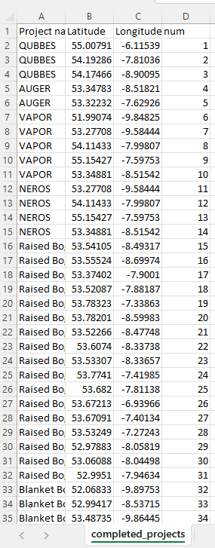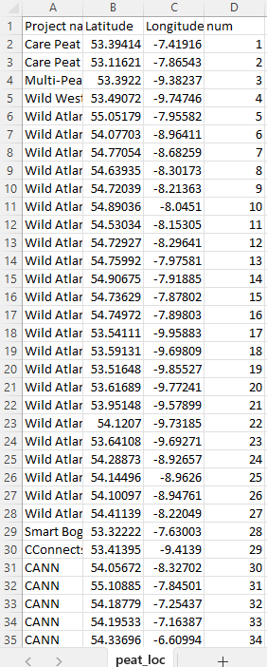

**Data Analysis Images**

**(Figure 3.0) (Figure 3.1)**

The above figures display the data found in the folder given by the former student as can be seen the section titled numbers don’t match up with each other and therefore they must be altered in order to fix them. It is also apparent that the only thing which will match these two sets of data is the coordinates they have.

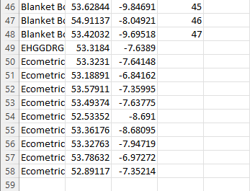Some of these data points did not have numbers. This gave more reason for the data to need to be reorganized.

**Unorganized data Image (figure 3.2)**

This process was started by writing out the most important columns from all the data sources. This included numbers, names, descriptions, coordinates in an X and Y format. This process started in a new excel document. Where there would be a small amount of excel code used in order to arrange the data into a better format for the MapBox software.

For the research collection, a previous student at University of Galway, studied the peatlands of Ireland. This student created a static map of the peatlands of Ireland. The data was given to me through my supervisor. The data on these excel spreadsheets will be used in the research for the Irish Peatlands Project map website.

This study designed a map of the peatlands of Ireland. Similar to my study, this data could be used in the research I will be preforming. I would research into this previous database using my research methodology as my framework. A quantitative method of evidence collection in physical geography is lab-based experiments. I think this could be a useful method of categorising my spatial database. In the area of surveying, I would be able to survey many data sources. For example, bogland-usage, peatland destruction, carbon dioxide release from peatlands, etc. This would be a good start to the project.

The website allows the user to create an additional peatland in the database in the section of the website titled “Add a Project”. After the user has sent their peatland project into the website, first the user sent data will be checked to identify if it is an existent project in Ireland, secondly it will be checked to ensure that it does not already exist in the database and finally, it will be matched to the variables currently existing in the database to allow it to be displayed on the interactive map. This will allow new data to sit into the database without an issue or any redundancy. The data will be stored through the MapBox cloud.

As was mentioned before developing analysis from lab-based experiments would be a good method of gaining statistic data. The SEEA-EA or System of Environmental Economic Accounting is a framework directive which could be used to build an ecosystem account. “Applying relevant available datasets identified during the data inventory, we followed the process steps as outlined in the SEEA-EA (UNSD 2021), to develop extent and condition accounts for the Dargle.”(Farrell et al., 2021). Ecosystem accounting works on a four-term step process.

# 4. Results

This section will underscore the meaning, importance, and relevance of the results of the website. The reasoning for the creation of this website was to illustrate the data in a viewable and interactive format. This was activated on the website. This will be an ongoing project as the database will need to be continually updated and maintained due to the fact, there will always be projects developing and finishing in Ireland.

**The Websites “Home” page**

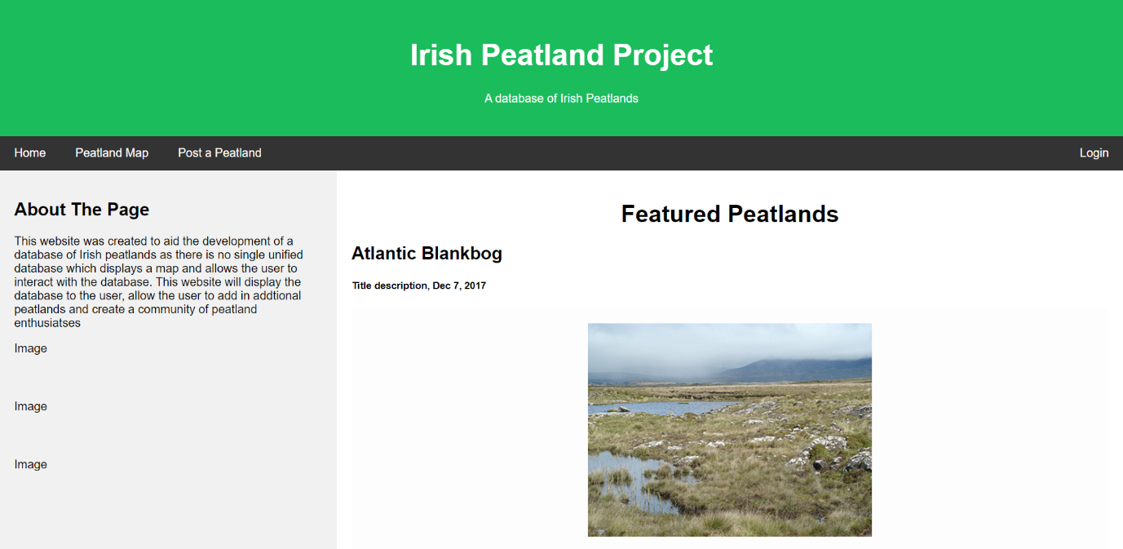

**(Figure 4.0)**

The above is a development of the home page for this project. It is merely a beta of the website; therefore, it is subject to change. The idea behind this page was to simply display some of the types of peatlands on the Map in the “Peatland Map” page. The website uses HTML and CSS to display the website in the format it is in.

**Irish Peatland Project Map page**

**(Figure 4.1)**

The above figure is the page of the website titled “The Peat Map”. It uses the MapBox software linked with the database from the Excel spreadsheet which was uploaded to the MapBox API and displays it was the white points on the map. These white points currently are inactive. What needs to be done is a small amount of JavaScript. The user will be able to click on a point in the finished version. This is merely a demo of the webpage. The interactive aspect is unfinished, but it will be shown how it will work.

**Adding To the Database Page**

**Figure(4.2)**

This webpage has been careful engineered to in turn create new points for the database. The website will work on a refreshed system basis. This means a user can introduce a new peatland project to the database through filling out the form and clicking submit. After the submission button is clicked, the data input by the user will be sent through JavaScript to the website manager. The login button will only be accessible to the developers of the site this is where the data will be interpreted from the user This data will be searched to ensure it is not redundant and to ensure the data is coherent. This is essential in order for this website to have a lifecycle and be sustainable. After the checks have been completed the data will be added to an excel document, which will be uploaded to the MapBox API. This will not be done for a single project rather more than three or four as the uploading and alteration of the database will be costly and time consuming.

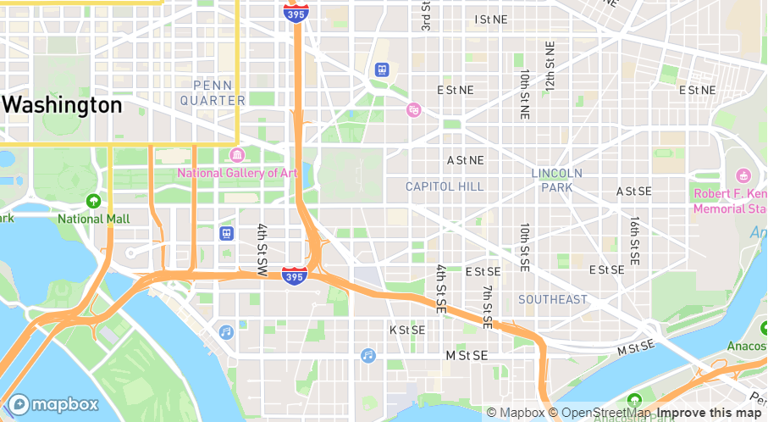

**Example Map : Washington**

**Figure (4.3)**

In the above, a map of Washington City is shown. While this shows to much detail it will be used as an example for this project. This map is displayed using the map box software. The software can show many different layers. The streets aren’t necessarily linked to surface which they lie.

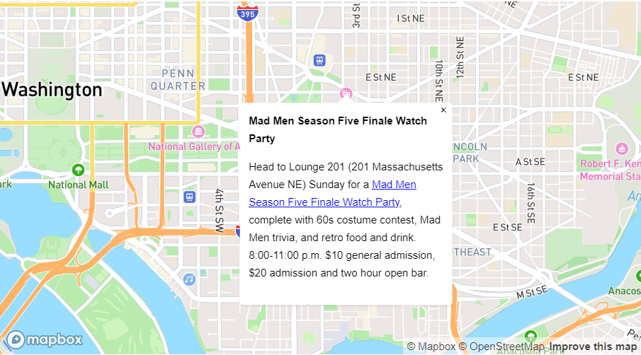

**Washington Displaying Data**

**(Figure 4.4)**

This is useful feature of map box. On the website, the map will only show the necessary layers for the project. Although it could be a feature to add later “Route to location” could be a beneficial feature but is not necessary in the current format.

The reasoning for using these images is to display the code surrounding the above image figure 4.4 “OnClick” in JavaScript lets the user click an area of the map. Depending on the code within the OnClick function it will dictate what happens when the click condition is met. This is a fundamental feature of this website and this project.

# 5. Discussion

## 5.1 Overview and Analysis

This paper presents a review of recent peatland projects in Ireland, with a focus on the maintenance of these areas. It is designed to display the database of the peatlands in a format which can be understood in the simplest form. Peatlands are so vitally important ecosystems not only in Ireland but as part of a global fight against the altering climate. These regions provide carbon storage most essentially, but also regulate water contamination and promote biodiversity.

The website has achieved what it set out to create. The maintenance of this website is now the priority. The aim was to create a database and website along with it.

## 5.2 Limitations

The limitations of this project were the knowledge of website development. This is the amount and quality of code that I am able to produce. The website is well structured and developed. Although, it merely scratches the surface of web development. Frameworks such as Bootstrap, Flask and Ruby would be used in a professional capacity and given the correct funding this could be achieved.

The Mapbox software is also a bottleneck of this project. There are financially free methods of using the software. Which is what the website is built on currently. But to further expand this project, opting for a paid version of the software would be a necessity.

# 6.Conclusion

In conclusion, peatland restoration initiatives have further developed an importance in Ireland in recent years. These are designed to counteract the detrimentally negative effects of human activity on Irish peatlands. These effects include drainage, overharvesting, and poor land usage, which result in larger carbon emissions and the loss of biodiversity. The advantages of maintenance of peatlands would include carbon storage, better quality of water and quality of life for the local wildlife. This can be achieved through the blockage of drains, revegetation (such as afforestation) and other conservation methods. This is why continued research in this section on study is absolute essential.

The creation of the database of spatial peatlands has taken place. Through my supervisor Terry Morley, I have been given the opportunity to converse with previous students. One of whom has some data on peatlands. I believe the short answer to my research question may be no, there is no one single unified spatial database of Irish peatland and Irish peatland projects. This is the reasoning for my research in this field.

Increased efforts are required to build on achievements previously made and address the issues invasive species, climate change, and changing land use pose to Ireland's peatland ecosystems. To create efficient conservation and restoration programmes for peatlands in Ireland, the main investors into Irish peatlands must continue their great work with these areas, stakeholders, including government organizations such as Bord Na Mona, conservation groups such as the IPPC, and local people, will be needed to increase their attention into these regions.

# 7. Bibliography

[1]

Kareksela, S. *et al.* (2015) “Fighting carbon loss of degraded peatlands by jump-starting ecosystem functioning with ecological restoration,” *Science of The Total Environment*, 537, pp. 268–276. Available at: https://doi.org/10.1016/j.scitotenv.2015.07.094.

Author links open overlay panel Budiman Minasny a *et al.* (2019) *Digital mapping of peatlands – A critical review*, *Earth-Science Reviews*. Elsevier. Available at: <https://www.sciencedirect.com/science/article/pii/S001282521830360X>

[2]

Special protection areas (SPA) (2009) Special Protection Areas (SPA) | National Parks & Wildlife Service. NPWS. Available at: https://www.npws.ie/protected-sites/spa

Reclaiming peatlands for forestry: The Irish experience - researchgate (no date). Available at: https://www.researchgate.net/profile/Florence-Renou-Wilson/publication/237502119_Reclaiming_peatlands_for_forestry_the_Irish_experience/links/02e7e52983a1f2b5bb000000/Reclaiming-peatlands-for-forestry-the-Irish-experience.pdf

Hammond, R.F. (1979) *Peatlands of Ireland - Teagasc*. Available at: https://www.teagasc.ie/media/website/environment/soil/Peatlands-of-Ireland.pdf

Andersen, R. *et al.* (2016) “An overview of the progress and challenges of Peatland Restoration in Western Europe,” *Restoration Ecology*, 25(2), pp. 271–282. Available at: https://doi.org/10.1111/rec.12415.

Anderson, P., Byrne, K.A., Kiely, G. and Leahy, P., 2016. Agricultural land use effects on Irish peatland carbon storage: Evaluating ecosystem service provision within different management systems. Science of the Total Environment, 553, pp.147-155

Irish Peatland Conservation Council(IPCC). (2019). IPCC Peatland Conservation and Restoration Project. Available at: https://www.ipcc.ie/peatland-conservation-restoration-project/Krause, S., Hannah, D.M., Fleckenstein, J.H., Heppell, K., Kaes

Fennessy, J. and Cronin, G., 2019. Peatland restoration in Ireland. Restoration Ecology, 27(S2), pp.S84-S91.

McDonnell, F. (2023) *Project to explore how artificial intelligence can protect peatlands*, *Agriland.ie*. Available at: https://www.agriland.ie/farming-news/project-to-explore-how-ai-can-protect-peatlands/ (Accessed: April 19, 2023).

Connolly, John, Nicholas M Holden, and Shane M Ward. "Mapping Peatlands in Ireland Using a Rule-Based Methodology and Digital Data." Soil Science Society of America Journal 71.2 (2007): 492-99. Web.

UN (2020) *EU economic developments and projections - european parliament*, *EU economic development*. Available at: https://www.europarl.europa.eu/RegData/etudes/BRIE/2020/645716/IPOL_BRI(2020)645716_EN.pdf).

Krankina, O.N., Pflugmacher, D., Friedl, M., Cohen, W.B., Nelson, P., Baccini, A., 2008. Meeting the challenge of mapping peatlands with remotely sensed data. Biogeosciences 5, 1809–1820.

Dunn, Christian, and Chris Freeman. ‘Peatlands: Our Greatest Source of Carbon Credits?’ *Carbon Management* 2, no. 3 (1 June 2011): 289–301. <https://doi.org/10.4155/cmt.11.23>.

Harrison, S., Mighall, T., Stainforth, D.A. *et al.* Uncertainty in geomorphological responses to climate change. *Climatic Change* **156**, 69–86 (2019). https://doi.org/10.1007/s10584-019-02520-8

Loisel, J., Gallego-Sala, A.V., Amesbury, M.J. *et al.* Expert assessment of future vulnerability of the global peatland carbon sink. *Nat. Clim. Chang.* **11**, 70–77 (2021). https://doi.org/10.1038/s41558-020-00944-0

Andersen, R. *et al.* (2016) “An overview of the progress and challenges of Peatland Restoration in Western Europe,” *Restoration Ecology*, 25(2), pp. 271–282. Available at: https://doi.org/10.1111/rec.12415.

*Public Service Data strategy 2019-2023* (2018) *Search for services or information*. Department of Public Expenditure, NDP Delivery and Reform . Available at: https://www.gov.ie/en/publication/1d6bc7-public-service-data-strategy-2019-2023/ (Accessed: April 7, 2023).

*Peatland Habitat Restoration* (2021) *Coillte*. Available at: https://www.coillte.ie/our-business/our-projects/nature-conservation/ (Accessed: April 10, 2023).

“Addendum to world economic situation and prospects 2020 (online only)” (2020) *World Economic Situation and Prospects 2020* [Preprint]. Available at: https://doi.org/10.18356/8b2cc231-en.

Andersen, R. *et al.* (2016) “An overview of the progress and challenges of Peatland Restoration in Western Europe,” *Restoration Ecology*, 25(2), pp. 271–282. Available at: https://doi.org/10.1111/rec.12415.

Farrell, C. *et al.* (2021) “Applying the system of Environmental Economic Accounting-ecosystem accounting (SEEA-EA) framework at catchment scale to develop ecosystem extent and condition accounts,” *One Ecosystem*, 6. Available at: https://doi.org/10.3897/oneeco.6.e65582.

Renou-Wilson, F. (2011) *Bogland: Sustainable Management of Peatlands in Ireland*. Johnstown Castle, Co. Wexford: Environmental Protection Agency.