## 2004A-D

**August 2004**

http://www.transportscotland.gov.uk/road/landslides/a83-other-known-landslide-areas

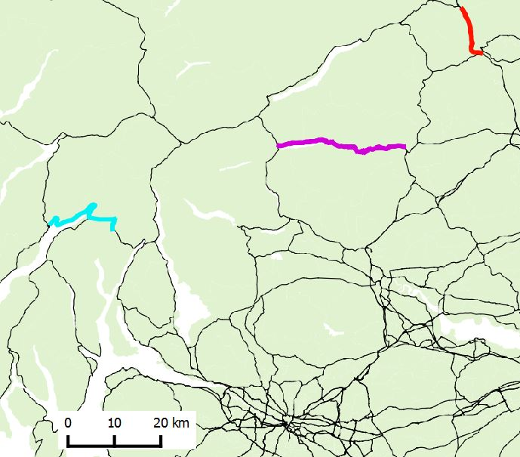

A83

A9

A85

|  |  |  |  |  |  |  |  |  |  |  |  |  |  |
| --- | --- | --- | --- | --- | --- | --- | --- | --- | --- | --- | --- | --- | --- |
| **A** |  | **B** | **C** | |  |  |  |  | **D** | | | | |
|  |  | **A9** |  |  |  |  |  |  |  |  |  |  |  |
| **A83** | **A83** | **A83** | **A9** | **A9** |  |  |  |  | **A85** | **A85** | **A85** | **A85** | **A85** |
| **09** | **10** | **11** | **12** | **13** | **14** | **15** | **16** | **17** | **18** | **19** | **20** | **21** | **22** |
|  | | | | | | | | | | | | | |

http://www.transportscotland.gov.uk/report/j10107-05.htm

http://www.gov.scot/Publications/2005/06/13103229/32360

http://www.geoffice.it/files/Download/0015327.pdf

# 17

Sunday 28 October 2007 Rest And Be Thankful

“However, perhaps the most serious single event to affect the trunk road network since August 2004 is that which occurred at approximately 0330 hours on Sunday 28 October 2007 on the eastern approach to the Rest and be Thankful. The event intersected the trunk road at approximate National Grid Reference (NGR) NN 23600 07000.

Figure 2.14 illustrates the event and the surrounding hillside; the photograph is taken from the opposite side of Glen Croe and evidence of numerous past events can be clearly seen. Figure 2.15 illustrates the event in more detail and it is clear that the system of mass movement comprises two discrete but related events.”

<http://www.transport.gov.scot/report/j10107-05.htm#22>