Tech Support

*2015 El Segundo High School Roller Coaster Project*

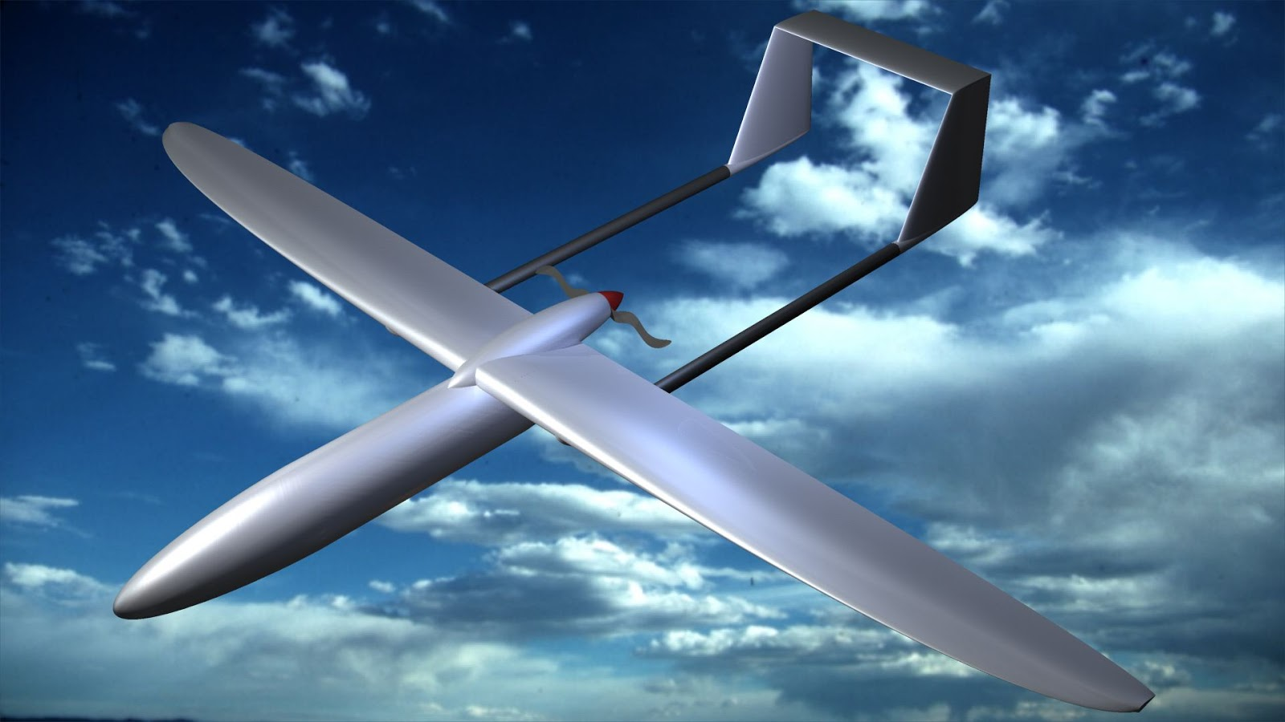

**Submitted By: PenIsland Squad**

|  |  |  |  |  |
| --- | --- | --- | --- | --- |
|  | Age | Grade | Phone Number | Email |
| Bradley Gallon (Technical) | 17 | 12 | (310) 906-6659 | bradleymoore007@gmail.com |
| Nick Mazuk (Systems) | 17 | 12 | N/A | trainridernick@gmail.com |
| Andrew Miyaguchi (Mechanical) | 17 | 12 | (424) 205-4718 | xdleader555@gmail.com |
| Elie Nehme (Manager/Business) | 17 | 12 | (310) 801-8097 | enehme46@gmail.com |

El Segundo High School

640 Main Street, El Segundo, CA 90245

(310) 615-2662

November 3, 2014

# Executive Summary

Hello World.

Table of Contents

Executive Summary ii

1. Team Engagement 1

1.1 Team Formation and Project Operation 1

1.2 Project Planning 1

1.3 Tool Set-up / Learning / Validation 1

1.4 Impact on STEM 1

2. Project Goal 2

2.1 Purpose 2

2.2 Design Constraints 2

2.2.1 Provided Constraints 2

2.2.2 IAAPA Constraints 2

2.2.3 Ecological Constraints 2

2.2.4 Governmental Constraints 2

3. Design 3

3.1 Design Process 3

3.2 Preliminary Designing 3

3.1.1 Preliminary Sketches 3

3.1.2 Selecting the Design 3

3.3 Detailed Design 3

3.3.1 Refining the Design 3

3.3.2 Detailed Dimensions 3

3.3.3 Bill of Materials 3

3.3.4 Physics Analysis 3

3.3.5 Failure Analysis 3

3.4 Design Validation 3

3.4.1 Provided Constraints 3

3.4.2 IAAPA Constraints 3

3.4.3 Ecological Constraints 3

3.4.4 Governmental Constraints 3

3.4.5 Testing and Validation 3

4. Business Case 4

Elie, put your headings here 4

5. Ecological Impact 5

5.1 Elie 5

6. List of Abbreviations, Acronyms, and Symbols 6

6.1 List of Abbreviations 6

6.2 List of Acronyms 6

6.3 List of Symbols 6

7. Resources 7

Appendix A: Meeting Logs 8

Appendix B: Incident Report Logs 9

List of Figures

**No table of figures entries found.**  
In your document, select the words to include in the table of contents, and then on the Home tab, under Styles, click a heading style. Repeat for each heading that you want to include, and then insert the table of contents in your document. To manually create a table of contents, on the Document Elements tab, under Table of Contents, point to a style and then click the down arrow button. Click one of the styles under Manual Table of Contents, and then type the entries manually.

List of Tables

No table of figures entries found.  
In your document, select the words to include in the table of contents, and then on the Home tab, under Styles, click a heading style. Repeat for each heading that you want to include, and then insert the table of contents in your document. To manually create a table of contents, on the Document Elements tab, under Table of Contents, point to a style and then click the down arrow button. Click one of the styles under Manual Table of Contents, and then type the entries manually.

# 1. Team Engagement

## 1.1 Team Formation and Project Operation

### 1.1.1 Team Biographies

### 1.1.2 Project Operation

To keep the project running smoothly, we created an initial contract which we and all our parents signed. This included meeting formation, cancellation, misconduct, as well as other potential issues so we can all agree how to carry forth in the project. The current form of the contract is in Appendix C: Team Terms and Conditions.

In addition, we created a Gantt chart to plan out the entire project timeline. Up to this point, we have successfully stayed with the Gantt chart with a couple exceptions due to unforeseen delays. We have, however, always been able to catch up after each of these delays.

Table 1: Gantt Chart

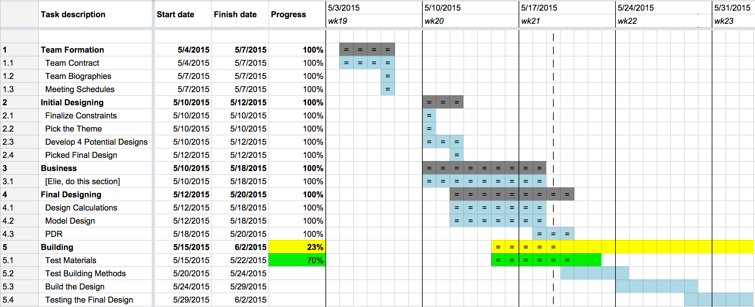

## 1.2 Tool Set-up / Learning / Validation

Our engineering teacher, Mr. Eno, provided the required tools for this project. The main program used for design, simulations, and test was Nolimits 2 (NL2). Andrew Miyaguchi was chosen to learn NL2 as quickly as possible to create an accurate model of thee rollercoaster. Installing the software was simple, using the key provided by our engineering teacher. The more difficult part of the process was to actually learn how to use it. The learning curve for NL2 was not too steep, as the controls worked much like those of a normal video game. On the other hand getting started required that a user read the tutorial and help manuals (thankfully which was short) to fully understand and use NL2.

Autodesk Inventor is a 3D CAD modeling software which was used to create 3D parts to help with the build side of the project. Much of the CAD modeling skill required were already learned due to engineering courses at the local high school.

At first our first selection of tools to model the rollercoaster was going to be mainly Autodesk inventor, but realizing the difficulty and time required to use a CAD modeling software over a rollercoaster software which was meant to create roller coasters quickly had the team reconsider the choice of toolsets.

# 2. Project Goal

## 2.1 Problem Statement

## 2.2 Design Constraints

### 2.2.1 Provided Constraints

### 2.2.2 IAAPA Constraints

### 2.2.3 Ecological Constraints

### 2.2.4 Governmental Constraints

# 3. Design

## 3.1 Design Process

## 3.2 Preliminary Designing

### 3.2.1 Selecting the Theme

To create the maximum opportunity to select an optimum theme, 12 potential theme ideas were brainstormed with the only restriction being that every idea recorded (not necessarily discussed) had to relate to STEM in some way. This way could, for the purposes of brainstorming, be as convoluted or blatant as possible. Below is the list of the 12 ideas:

1. Biodiversity
2. Ecology
3. Law of conservation of energy / momentum
4. Internet data transfer
5. Evolution of technology
6. Use evolution of life as a metaphor of technology
7. History of roller coaster design
8. Molecular structures of chocolate
9. History of design of amusement parks
10. Insulting Spain
11. Social curve
12. History of the indigenous engineering

After brainstorming, we put all of these ideas into a decision matrix and selected the top three to elaborate on further than what we discussed. Below is the decision matrix (sorted by total points, each receiving a rank 1-12 relative to the other ideas):

Table 2: Theme Decision Matrix Part 1

|  |  |  |  |  |  |
| --- | --- | --- | --- | --- | --- |
| Themes | General Opinion | Enthusiasm | Execution | Application to Coaster | STEM Relation |
| Internet | 12 | 12 | 8 | 11 | 11 |
| Evolution of Tech | 11 | 9 | 11 | 8 | 12 |
| Conservation (E/p) | 10 | 11 | 12 | 12 | 10 |
| Ecology | 4 | 6 | 10 | 4 | 9 |
| Social Curve | 9 | 8 | 4 | 9 | 7 |
| Life/Tech Metaphor | 8 | 7 | 7 | 7 | 6 |
| Biodiversity | 5 | 5 | 9 | 3 | 8 |
| Chocolate | 7 | 10 | 3 | 2 | 4 |
| Roller Coaster Design | 2 | 2 | 6 | 10 | 3 |
| Insulting Spain | 6 | 4 | 1 | 1 | 1 |
| Amusement Parks | 1 | 1 | 5 | 6 | 2 |
| History of Engineering | 3 | 3 | 2 | 5 | 5 |

Table 3: Theme Decision Matrix Part 2

|  |  |  |  |  |
| --- | --- | --- | --- | --- |
| Practicality | Reaction to Judges | Entertaining Value | Relevance to Costa Rica | Total |
| 11 | 12 | 12 | 8 | 97 |
| 10 | 10 | 7 | 7 | 85 |
| 12 | 11 | 1 | 1 | 80 |
| 8 | 6 | 8 | 10 | 65 |
| 6 | 8 | 11 | 3 | 65 |
| 5 | 5 | 6 | 9 | 60 |
| 7 | 7 | 3 | 11 | 58 |
| 3 | 9 | 10 | 6 | 54 |
| 9 | 3 | 5 | 5 | 45 |
| 1 | 1 | 9 | 12 | 36 |
| 4 | 2 | 4 | 4 | 29 |
| 2 | 4 | 2 | 2 | 28 |

The detailed ideas are as follows:

* Internet
  + The internet is a broad subject, and explaining it could be done with our new ride: “THE PACKET”, a ride simulating the travel of a lone internet packet through the vast space known as the interwebs. Fly through our new age tech coaster, experiencing the challenges that face each packet, from firewalls, to routers, modems, ethernet and fiber cables, all the way to the final destination: The Client. Enjoy our interactiveness through inclusion of participation from ESHS Gaming International, and please come try our thrilling and suspenseful experience, “THE PACKET”.
  + In terms of actual execution, this will be built on a techy model, with as many computer and internet references as we can include, alongside ideally and end goal some interactivity with our local website [ESHS Gaming](http://www.eshsgaming.com).
  + The design will be built on a standard plywood board, with triggers at both the beginning and end. Built possibly out of computer towers and old modems, securely fastened down, this idea is the one that we can be the most creative with by far, along with have a high level of enthusiasm for.
* Conservation of Energy and Momentum
  + In terms of execution, this idea is the most related to physics, reasonably easy to explain, and by far easiest to demonstrate as a project. We would probably include as many physics references as we can, from Einstein to F=ma, to everything that Eno so amazingly inspired us to learn about.
  + For design, lots of physics references, possibly having 2 charts side by side at various points that show the kinetic and potential energy of the marble at any point. Overall, connecting the theme to the actual coaster would not be too tough.
* Evolution of Tech
  + The general evolution of technology, from the primitive tools of the Stone Age to the complex digital infrastructure of the modern world, and a glimpse at what the future may hold (nanotechnology, nuclear fusion, human colonies on Mars, etc).
  + Divided into four phases, branching from the hunter-gatherer gadgets of our ancestors, to the Industrial Revolution of the 18th and 19th century (complete with steam engines, locomotives, and telegraphs), to the modern age, with references to the leaps in digital technology, the rise of cell phones and smartphones, and a look at the Web.
  + Finally, a glimpse at the future: optimized nanotechnology, spacecraft that fly across the galaxy, and mobile robots that look like and talk like humans. A “Tomorrowland” for the 21st century.

After submission of these ideas to Mr. Eno, we were given the internet as our theme. When Ms. Clemmer returned, however, she suggested a more focused theme than the internet, possibly software related instead of hardware. After some discussions, the theme became focused on internet data transfer and how the data can possibly be manipulated maliciously by a third party.

Later, with the added challenge of adding innovation into the theme, we decided to add the art of wiretapping to show the insecurities of current data transfer. The wiretapping will occur towards the end where, after all the security features, someone is able to steal the data without the user being noticed. This stolen data will then interact with the final trigger mechanism.

### 3.2.2 Preliminary Sketches

After refining the constraints in the problem statement, several possible coasters were sketched. The following are the sketches:

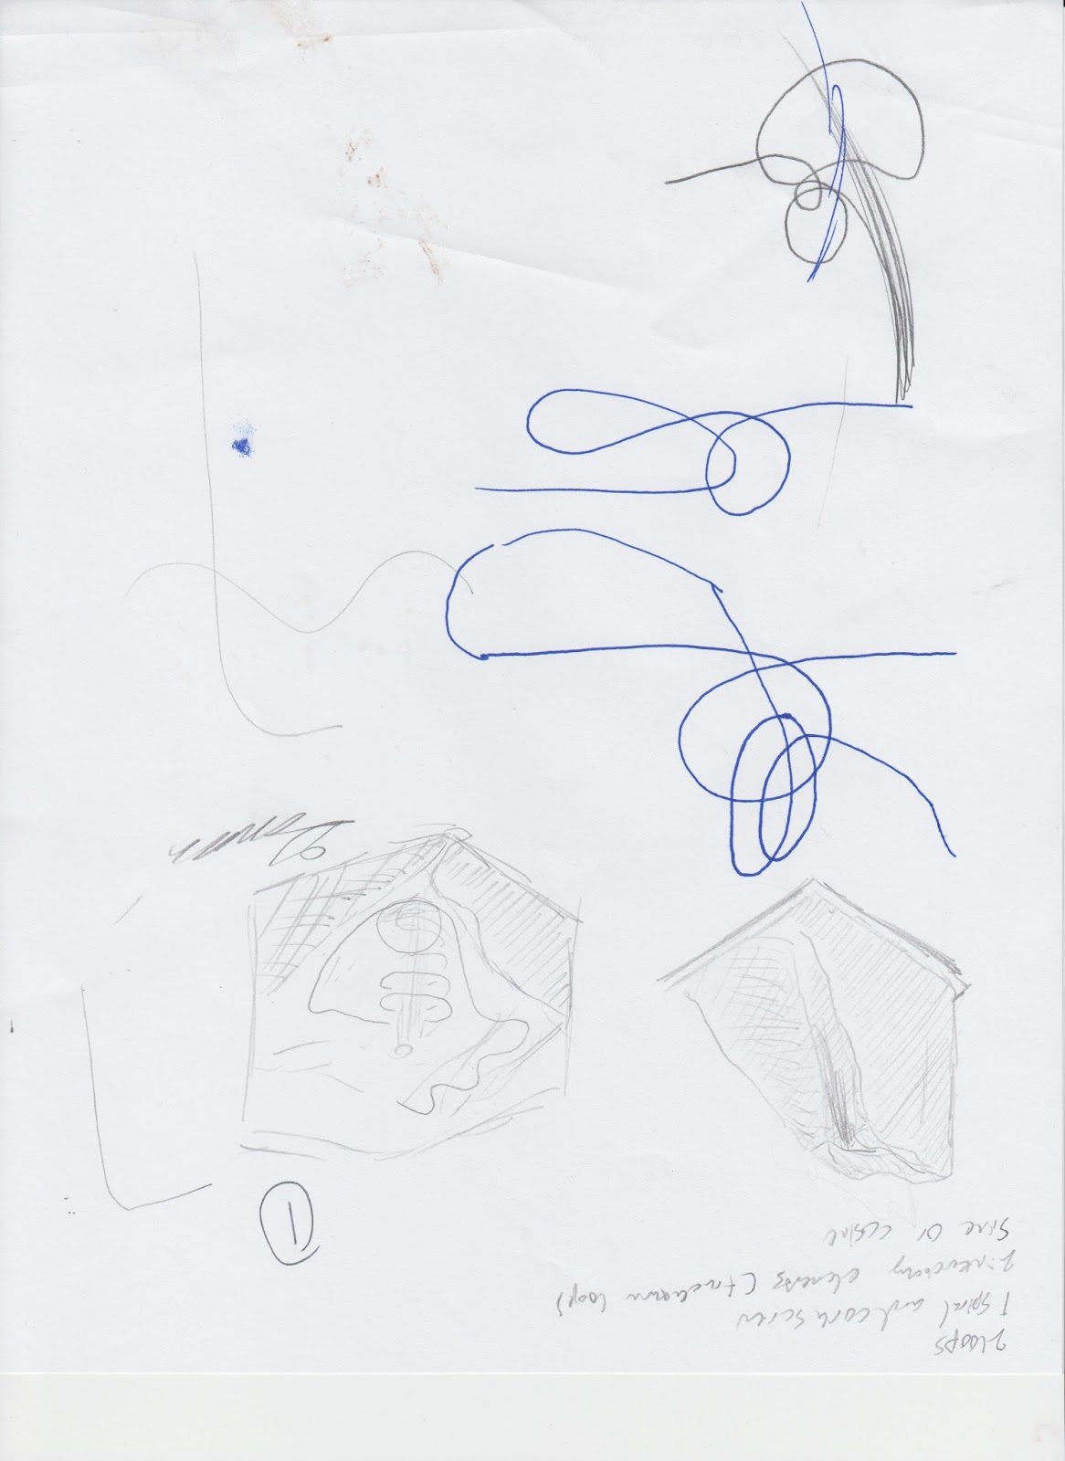

Figure 1: Potential Design 1

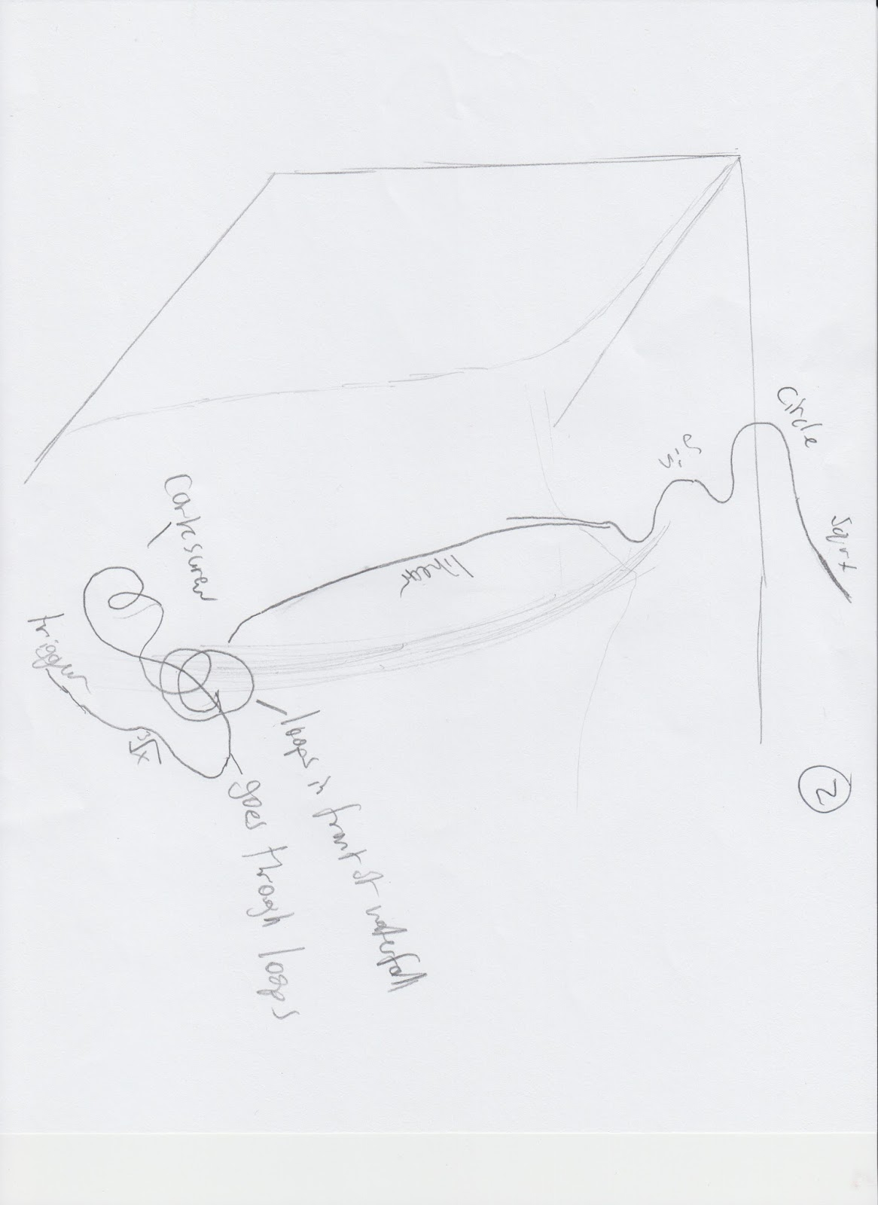

Figure 2: Potential Design 2

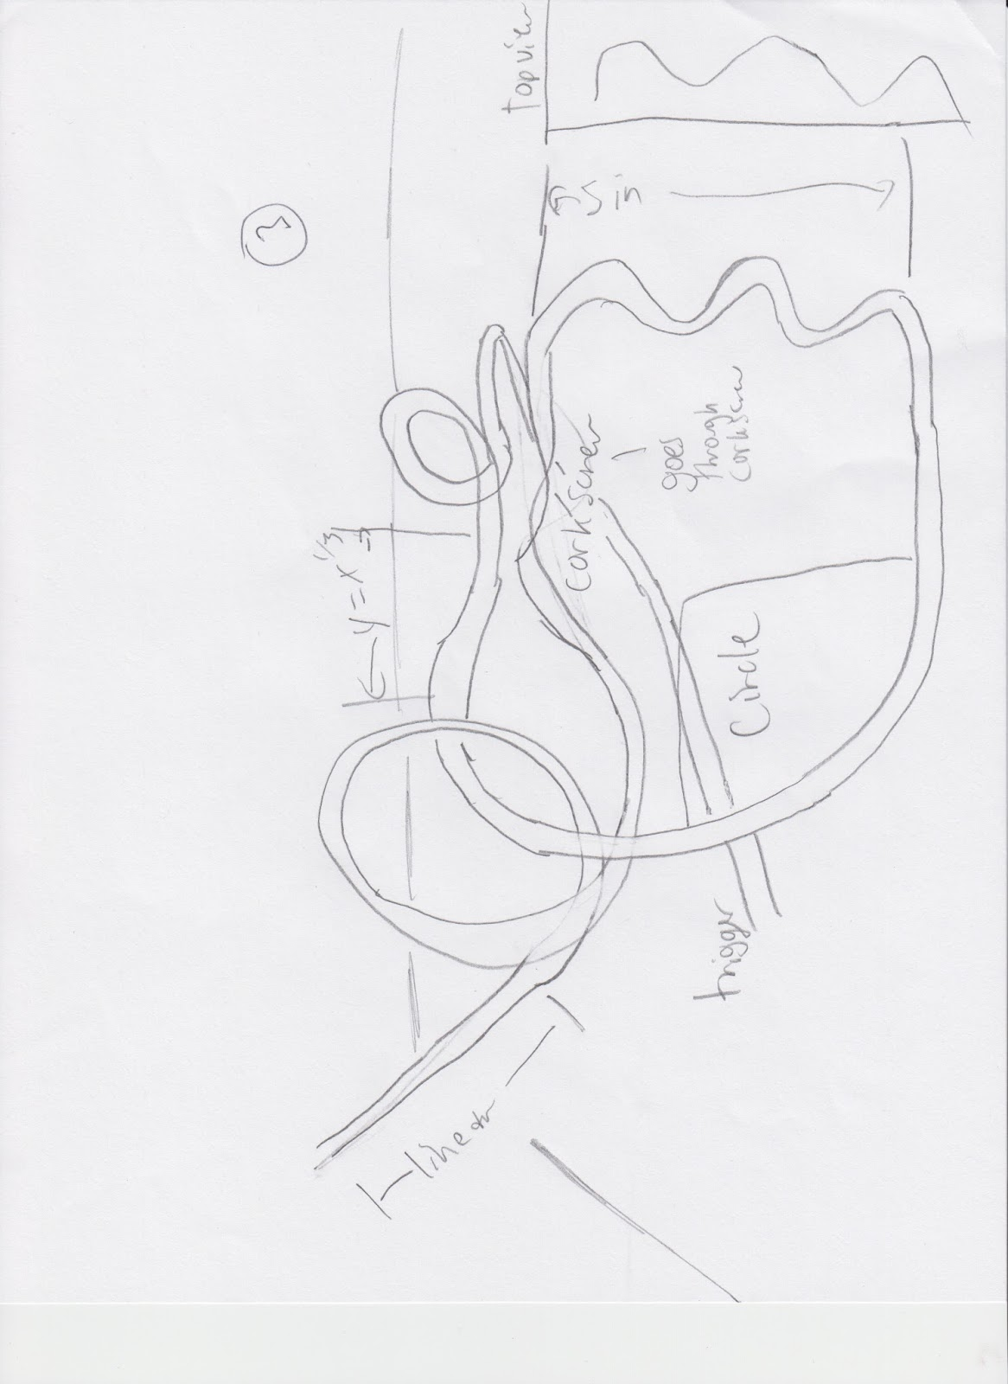

Figure 3: Potential Design 3

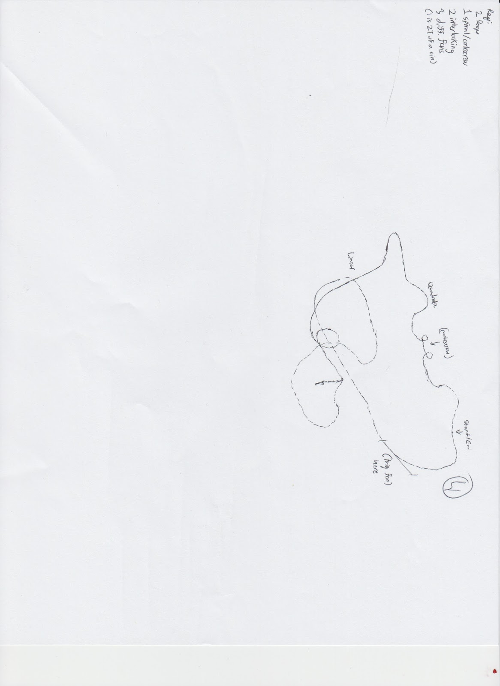

Figure 4: Potential Design 4

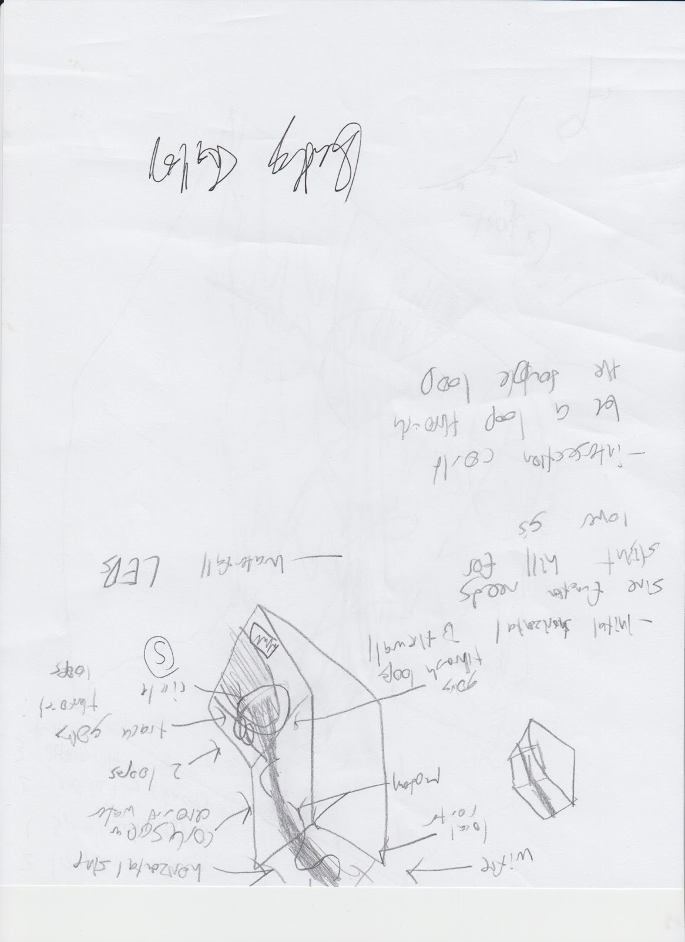

Figure 5: Potential Design 5

### 3.2.3 Selecting the Design

## 3.3 Detailed Design

### 3.3.1 Refining the Design

### 3.3.2 Detailed Dimensions

### 3.3.3 Bill of Materials

### 3.3.4 Physics Analysis

### 3.3.5 Failure Analysis

## 3.4 Design Validation

### 3.4.1 Provided Constraints

### 3.4.2 IAAPA Constraints

### 3.4.3 Ecological Constraints

### 3.4.4 Governmental Constraints

### 3.4.5 Testing and Validation

# 4. Business Case

## 4.1 Case for Change

Given the rapid growth in the Costa Rican tourism industry (aided in no small part by the opening of Jurassic Park on the Isla del Nublar), the PenIsland Squad believes that there is an unprecedented opportunity for economic development on the nearby Isla del Nublar. Currently, the Isla del Coco is designated as both a national park by the Costa Rican government and a World Heritage Site by the United Nations Educational, Scientific and Cultural Organization (UNESCO). However, the current government has expressed a desire to develop an educational theme park on the Isla del Coco in order to tap into the burgeoning tourism industry and to promote the development of STEM (Science, Technology, Engineering, and Mathematics) skills among the general populace and potential tourists.

Yet a major concern of the Costa Rican government (as well as UNESCO) is the risk of massive environmental alteration and/or devastation as a byproduct of development. It must be stated that all large economic projects have the potential for environmental and ecological hazards, given the rather extensive processes used in construction and the often unknown or unpredicted effects of development on natural processes in the affected areas. Nevertheless, the PenIsland Squad is confident in its ability to safely minimize the risk of contamination or other potentially-damaging hazards while fulfilling the educational and economic goals of the Costa Rican government and guaranteeing a sufficiently-profitable rate of return for any potential shareholders.

## 4.2 Scope

## 4.3 Project Implementation

### 4.3.1 External Communications and Stakeholders

### 4.3.2 Advertising Campaign

## 4.4 Funding Arrangements

## 4.5 Assessment of Options

### 4.5.1 Options Considered

### 4.5.2 Conformity to Legislation and Standards

### 4.5.3 Cost-Benefit Analysis

### 4.5.4 Risk Analysis and Management

## 4.6 Financial Appraisal

## 4.7 Economic Appraisal

# 5. Ecological Impact

## 5.1 Summary

Overall, there will not be a high ecological impact in the construction, nor in the operation, of the coaster. No land outside of the immediate radius of the project shall be touched, the river running through the dig site will be unaffected and no chemicals or wastes shall be dumped. The goal is to have as little impact as possible on the terrain and vegetation, minus a minimal amount of trees that will be removed.

## 5.2 Potential Ecological Impact

# 6. Resources

# Appendix A: Meeting Logs

**May 10**

**Time: 5 - 9PM**

**Location: Bradley’s House**

**Members:**

* Bradley
* Nick
* Elie
* Andrew

**Items Completed:**

* Decided on theme
* Created gantt chart
* Created a question document for questions
* Condensed the constraints for the project
* Researched the IAAPA (Could not find their guidelines)

**Status:**

* Still need to find the IAAPA guidelines (practically impossible to find)
* Each member will bring in a roller coaster idea for the next meeting
* Slightly behind, but will be easy to catch up
* Still need to figure out schedule for the business side

**May 12**

**Time: 5:30 - 9PM**

**Location: Bradley’s House**

**Members:**

* Bradley
* Nick
* Elie
* Andrew

**Items Completed:**

* Developed 5 ideas for the roller coaster
* Selected a design
* Started on some business case

**Status:**

* Still need IAAPA (for next meeting)
* Need to start on model and calculations

**May 15**

**Time: 5 - 9PM**

**Location: Bradley’s House**

**Members:**

* Bradley
* Nick
* Andrew
* Elie (6:30 - 9PM)

**Items Completed:**

* Tested efficiency
* Finalized design
* Almost finished model
* Started calculations
* Started business case (cost, purpose, etc.)
* Found some code document related to the IAAPA
* Started PDR
* Created a github repository

**Status:**

* Need to finish the model
* Need to finish calculations
* Need to finish the business case
* Finish PDR

**May 16**

**Time: 5 - 9 PM**

**Location: Bradley’s House**

**Members:**

* Bradley
* Andrew
* Elie
* Nick (7 - 9PM)

**Items Completed:**

* Found greatest resource on standards
* Finished model
* Documented the ASTM F2291-2006: Standard Practice for Design of Amusement Rides and Devices as required by: State of Indiana, 685 IAC 1-2-9 constraints
* Made progress on the business case
* Finished outlining the PDR
* Advertising campaign
* Added a budget document

**Status:**

* Added meeting on Monday, May 18 from 5 - 9PM
* Will start working on the PDR at the next meeting

**May 18**

**Time: 5:45 - 9PM**

**Location: Bradley’s House**

**Members:**

* Bradley
* Nick
* Andrew
* Elie

**Items Completed:**

* Tested the size of 50 marbles
* Ecological Impact
* Finished 3.1 and 3.2
* Started several other sections
* Funding arrangements
* External communications with stakeholders

**Status:**

* Need to finish PDR by tomorrow
* Monday morning: Finish testing

**May 19**

**Time: 5:45 - 9PM**

**Location: Bradley’s House**

**Members:**

* Bradley
* Nick
* Andrew
* Elie

**Items Completed:**

* Completed many portions of the PDR
* Found all the points of the coaster
* Found the acceleration of the coaster at all points

**Status:**

* Need to finish PDR by tomorrow

# Appendix B: Incident Report Logs

# Appendix C: Team Terms and Conditions

Preamble

This contact is between the members of Pen Island Squad (Bradley Gallon, Nick Mazuk, Andrew Miyaguchi, Elie Nehme) for the duration of the Roller Coaster Project assigned for AP Calculus at El Segundo High School in El Segundo, CA. This will be used to set the standards and the guidelines of operations for the team. These terms and conditions will be put into effect once every member submits a version of these conditions to either Steven Eno or Kathy Clemmer signed by both themselves and their parent.

1. Meetings

1.1 Scheduling

All meeting start and end times will be on PDT (UTC-7). The following are the guidelines when creating a meeting:

1. All meetings must be scheduled at least one week (to the day) in advanced. For instance, a meeting for any Saturday must be scheduled at latest the Saturday before that. Scheduling includes start time, end time, location, and the goals for the meeting.
2. If a member cannot attend a meeting, they must inform the rest of the team at least two days in advance. For instance, if a meeting is scheduled for any Saturday, the latest a member can inform the team is the previous Thursday.
3. If a member cannot attend the entire meeting, but can attend a portion of it, the same two-day rule applies as in the clause above.

Exceptions:

1. Before May 15, 2015, meetings can be scheduled within one day.
2. After May 26, 2015, members can inform the rest of the team within one day if they cannot attend part or all of the meeting.
3. After May 26, 2015, meetings can be scheduled within one day.
4. After May 26, 2015, members can inform the rest of the team within one day if they cannot attend part or all of the meeting.

If the meeting is a normal meeting as defined in section 1.5 Normal Meetings, then the signing of this conditions constitutes enough advanced notice and those meetings are compulsory. If a meeting is planned outside of these guidelines, then the meeting is not mandatory.

1.2 Meeting Cancellation

Meetings will only be cancelled under the following conditions:

1. Two members cannot meet and the other two decide to cancel. The meeting is not automatically cancelled if two members cannot meet.
2. The location is unavailable for use.

1.3 Tardiness

As a rule of thumb, tardiness is not allowed. A member is tardy if they arrive after the start time (even one minute), but within 15 after the start time. The clock used to determine the start time is (in this priority):

1. The school bell (if on campus)
2. Any device that regularly syncs with UTC.
3. Any other clock at the location of meeting.

1.4 Consequences for Not Attending

At each meeting, attendance and progress will be recorded for official record and the Project Manager will keep this record. If a member does not attend the meeting:

1. And they informed the rest of the group as described in Section 1.1 Scheduling, the only consequence is that they will not be noted for attending the meeting.
2. And they *did not* inform the rest of the group as described in Section 1.1 Scheduling, then their name will not be noted for attending the meeting *and* another member will fill out the Incident Report as described in Section 2 Incident Report.

If a member attends part but not all of the meeting:

1. And they informed the rest of the group as described in Section 1.1, then their name will be noted as attending the meeting along with the portion of the meeting they attended.
2. And they did not inform the rest of the group as described in Section 1.1, then their name will be noted as attending the meeting along with the portion of the meeting they attended *and* another member will fill out the Incident Report as described in Section 2 Incident Report.

If a member is tardy:

1. They will be noted as attending the entire meeting, but another member will fill out the Incident Report as described in Section 2 Incident Report.

1.5 Normal Meetings

While many meetings will be scheduled later, below is a list of all the currently scheduled meeting times:

* All Tuesdays from 5-9PM
* All Fridays from 5-9PM
* All Sundays from 5-9PM

All meetings, unless specified when the meeting is planned will occur at Bradley Gallon’s house: 526 Sierra Pl. #15, El Segundo, CA 90245 Garage.

2. Incident Report

The incident report is a place where team members can document potentially negative actions from other members. It should *not* be viewed as a place where misconduct is documented, only a place for events out of the norm. Some events, such as showing up at a meeting 1 minute late, is minor and will not affect the project as a whole; the fourth and fifth times start to become a problem. It is, however, impossible to document the fourth or fifth times as problematic if the first was not documented. Therefore, a member of the group is required to fill out the Incident Report every time an incident occurs. For the purpose of this project, an incident is defined by any of the following:

* Violating any of these terms (a new incident is created for each term that is broken)
* Incomplete work
* Unsatisfactory work (as determined by the rest of the group)
* In appropriate conduct
* Any other act that a member feels that it requires documentation

It should be noted that one and only one member should fill out the Incident Report for every incident to eliminate redundancy. In addition, it is compulsory that when a report is filled out, all the required information is provided completely and that all provided information is accurate. All recorded incidents will be provided to any judges/teachers for the project as defined by Kathy Clemmer upon their request as well as in the PDR as an appendix.

To eliminate confusion, the incident report can be found here: h[ttp://goo.gl/forms/yPd3zCKWrh](http://goo.gl/forms/yPd3zCKWrh)

3. Modification of These Terms

These terms can be modified at any time, by any member, without prior notice. However, any modifications will not become active until 48 hours after the modifications were made. Any changes made within that 48 hour time period that counteract any of the modifications will render the modifications void. The new version will have 48 hours from that point on to become effective.

Fortunately, Google keeps track of all the modifications to documents, so the official timestamp will be whatever Google provides. The most recent version of the terms can be found here: <https://goo.gl/NjPSLr>

4. Cancellation

This conditions will terminate upon the following conditions:

1. When the roller coaster project ends on June 3, 2015 at 11:30 AM PST.
2. One or more members quit the group for the roller coaster as determined by Kathy Clemmer.

Upon cancellation, all obligations and responsibilities towards the group cease with the conditions.

5. Signature

1.1 Student

By signing this form, I affirm that I have read and agree to be bound by all terms outlined in this report. I also agree to any modifications that may be made in the future as noted in 3. Modification of These Terms.

________________________________________        ___________________

*Student Signature                                          Date Signed*

________________________________________

*Student Name (Print)*

1.1 Parent

By signing this form, I affirm that I have read these terms, and agree to let my student attend all meetings as outlined in these terms and to not act in such a way as to prevent my student from complying to these terms.

________________________________________        ___________________

*Parent Signature                                          Date Signed*

________________________________________

*Parent Name (Print)*