

UNIVERSITY OF BUCHAREST

FACULTY OF MATHEMATICS AND COMPUTER SCIENCE

SPECIALIZATION: COMPUTERS AND INFORMATION TECHNOLOGY

PROJECT
COMPUTER-AIDED
GRAPHICS

SCIENTIFIC COORDINATOR STUDENT
LECT. DR. DRĂGAN MIHĂIȚĂ PENCEA FLAVIUS ANDREI

BUCHAREST
2025

UNIVERSITY OF BUCHAREST

FACULTY OF MATHEMATICS AND COMPUTER SCIENCE

SPECIALIZATION: COMPUTERS AND INFORMATION TECHNOLOGY

DESIGNING THE SHELL OF AN S.N.E.S CONTROLLER

SCIENTIFIC COORDINATOR STUDENT
LECT. DR. DRĂGAN MIHĂIȚĂ PENCEA FLAVIUS ANDREI

BUCHAREST
2025

Contents
INTRODUCTION 5
1.1 Motivation 6
1.2 History 9
1.3 How It Works 9
2D SKETCHES 14
2.1 Setting Up the Workspace and Layers 15
2.2 Upper Shell 16
2.3 Lower Shell 19
2.4 X, Y, A, B Buttons 22
2.5 Directional Pad 24
2.6 Shoulder Button 25
2.7 Shoulder Button Membrane 26
2.8 X, Y, A, B Button Membrane 26
2.9 Start/Select Membrane 28
2.10 Directional Pad Membrane 29
3D MODELS 30
3.1 Upper Shell 31
3.2 Lower Shell 33
3.3 X, Y, A, B Buttons 34
3.4 Directional Pad 36
3.5 Shoulder Button 36
3.6 Shoulder Button Membrane 37
3.7 X, Y, A, B Button Membrane 38
3.8 Directional Pad Membrane 39
3.9 Start/Select Membrane 41
FINAL PRODUCT 42
4.1 EXPLODED VIEW 43
4.2 ASSEMBLED SHELL 44
4.3 TITLE BLOCK 45
CONCLUSIONS 46
BIBLIOGRAPHY 47

CHAPTER 1

INTRODUCTION

1.1 Motivation

This project presents the design stages of the physical components of an SNES (Super Nintendo Entertainment System) controller, focusing on the outer shell, the buttons and the membranes, using computer-aided design tools (AutoCAD).
I chose this topic because I have been drawn to retro consoles and their accessories since childhood. The SNES controller had a huge impact on the history of video games and is considered an iconic design of the '90s. Even as a kid I liked to figure out how these devices work, and I used to wonder how they were built on the inside.
When I started learning 3D modeling, I realized I could bring this passion into my projects. The idea of rebuilding the shape and the physical components of the SNES controller motivated me right away, especially because it combines a classic design with a very well thought-out construction.
So choosing the topic was not hard at all. I already had a clear direction and a well-defined idea of what I wanted to build, and for me this project is the perfect combination of passion and technical growth.

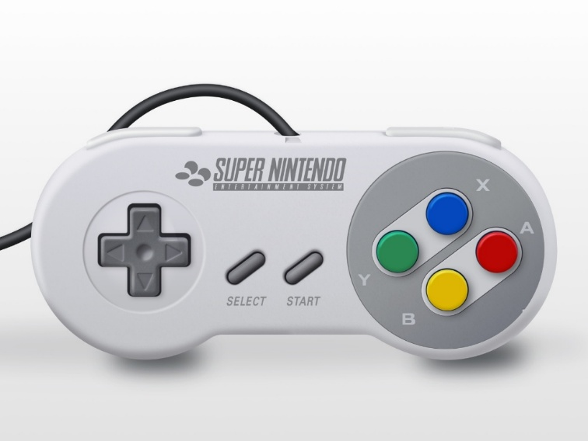
Fig. [1.0] – (Top-down overview of the SNES controller https://www.sketchappsources.com/resources/source-image/snes-controller-tiago-filipe.jpg)
First of all, the design of this controller is classic and iconic. It is the image many people have in mind when they think of retro consoles. Its ergonomic yet simple shape, together with the intuitive placement of the buttons, made it extremely popular and influenced many generations of controllers. The SNES controller is a childhood symbol for many video game fans, including me.
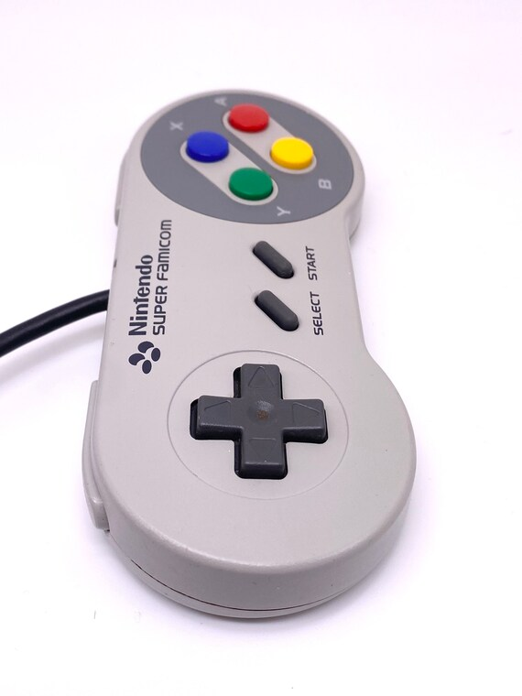
Fig. [1.1] – (Side view of the controller
https://i.etsystatic.com/22609217/r/il/2d6335/3870919412/il_570xN.3870919412_hrvn.jpg)

Second, I was very drawn to its internal construction. Every component has a well-defined role in how the controller works, and they all have to fit together perfectly.

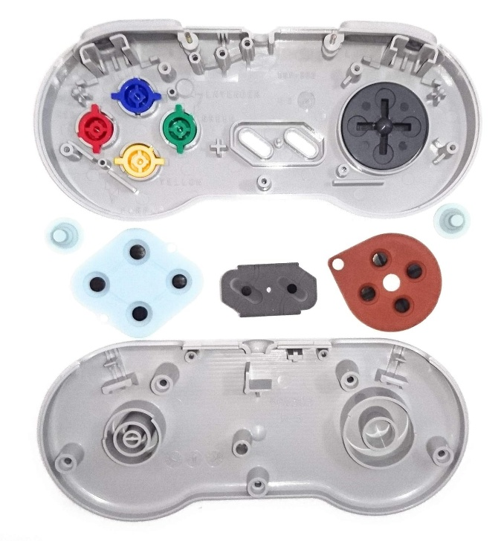
Fig. [1.2] – (Exploded view with the buttons, shell and membranes separated
https://i.etsystatic.com/22609217/r/il/2d6335/3870919412/il_570xN.3870919412_hrvn.jpg)

My first real encounter with this controller was a few years ago, when I saw it in a retro collection. Since then, I have been fascinated by the idea of recreating it digitally. So this topic was a natural choice for me, because it combines a personal passion with the wish to learn and refine 3D modeling techniques in AutoCAD.

1.2 History
Originally launched in Japan in 1990 under the name “Super Famicom”, the Super Nintendo Entertainment System (SNES) was Nintendo's answer to the increasingly fierce competition in the video game industry, especially from Sega. With its international release in North America in 1991 and in Europe in 1992, the SNES quickly became one of the most popular and influential game consoles of the '90s.
One of the most important components behind its success was the controller. The SNES controller was revolutionary for its time, a clear step forward from the square, simplistic design of its predecessor, the NES (Nintendo Entertainment System) controller. Instead of just two action buttons, the SNES controller introduced four main buttons (A, B, X and Y), two shoulder buttons (L and R) and the well-known Start and Select, all placed ergonomically.
At the same time, the cross-shaped button layout became a standard followed by many later manufacturers. This layout gave players better control and a smoother gameplay experience, especially in genres that required fast reflexes and multiple button combinations, such as platformers or action games.
The look of the SNES controller was also innovative for its time. The rounded corners, more compact dimensions and comfortable matte plastic made it easier to use for long periods. In addition, the D-pad (directional pad) introduced by Nintendo and refined on the SNES controller became an essential component of the controllers of the following generations.
The influence of this controller is still visible today. Many modern controllers – including those from Sony, Microsoft and Nintendo – have taken and adapted key elements of the SNES design. Thanks to this influence and its lasting popularity, the SNES controller remains a reference point in gaming history and a symbol of the golden age of video games.

1.3 How It Works
The SNES controller is a classic input device that works through a simple and efficient system of mechanically activated electrical contacts, with no complex circuitry as far as the physical button interface is concerned. In this project, the focus is on the physical components of the controller: the shell, the buttons and the rubber membranes.

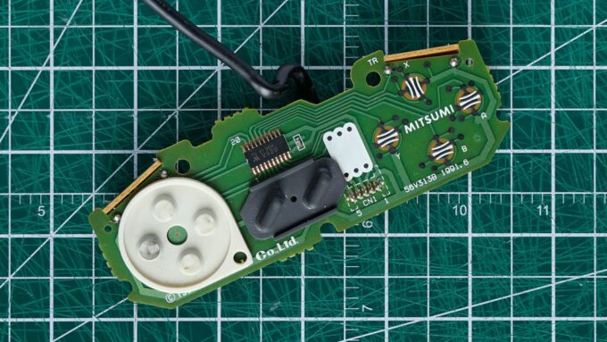
Fig.[1.3]–(https://gizmodo.com/app/uploads/2018/09/qwwehxipexhwhp1jesw1-680x383.jpg)
Each button on the controller (X, Y, A, B, D-Pad, Start, Select, L, R) sits on top of a rubber membrane that has a conductive disc on its underside. When the user presses a button, it pushes the membrane's conductive disc down, which in turn touches the contact board, closing an electrical circuit. This is how the signal is sent to the console.

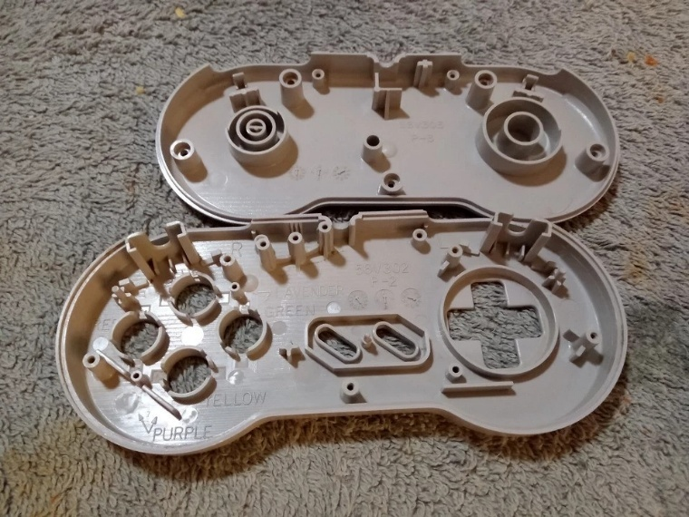
Fig.[1.4]–(https://i.ebayimg.com/images/g/bZIAAOSwwg1lAMKT/s-l960.webp)
The controller shell holds all the components in place. It consists of two main parts: the upper shell and the lower shell. They fit together perfectly, and inside there are spaces and guides designed specifically for each type of button or membrane, so that the movement is precise and does not jam.
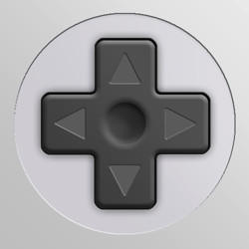
Fig.[1.5]–(https://www.deviantart.com/supernes/art/SNES-Style-D-Pad-61997931)
The D-pad (directional pad) is a single plastic piece that presses on four separate contacts depending on the direction pressed (up, down, left, right). It is supported by a special membrane that quickly returns the pad to its neutral position after it is released.

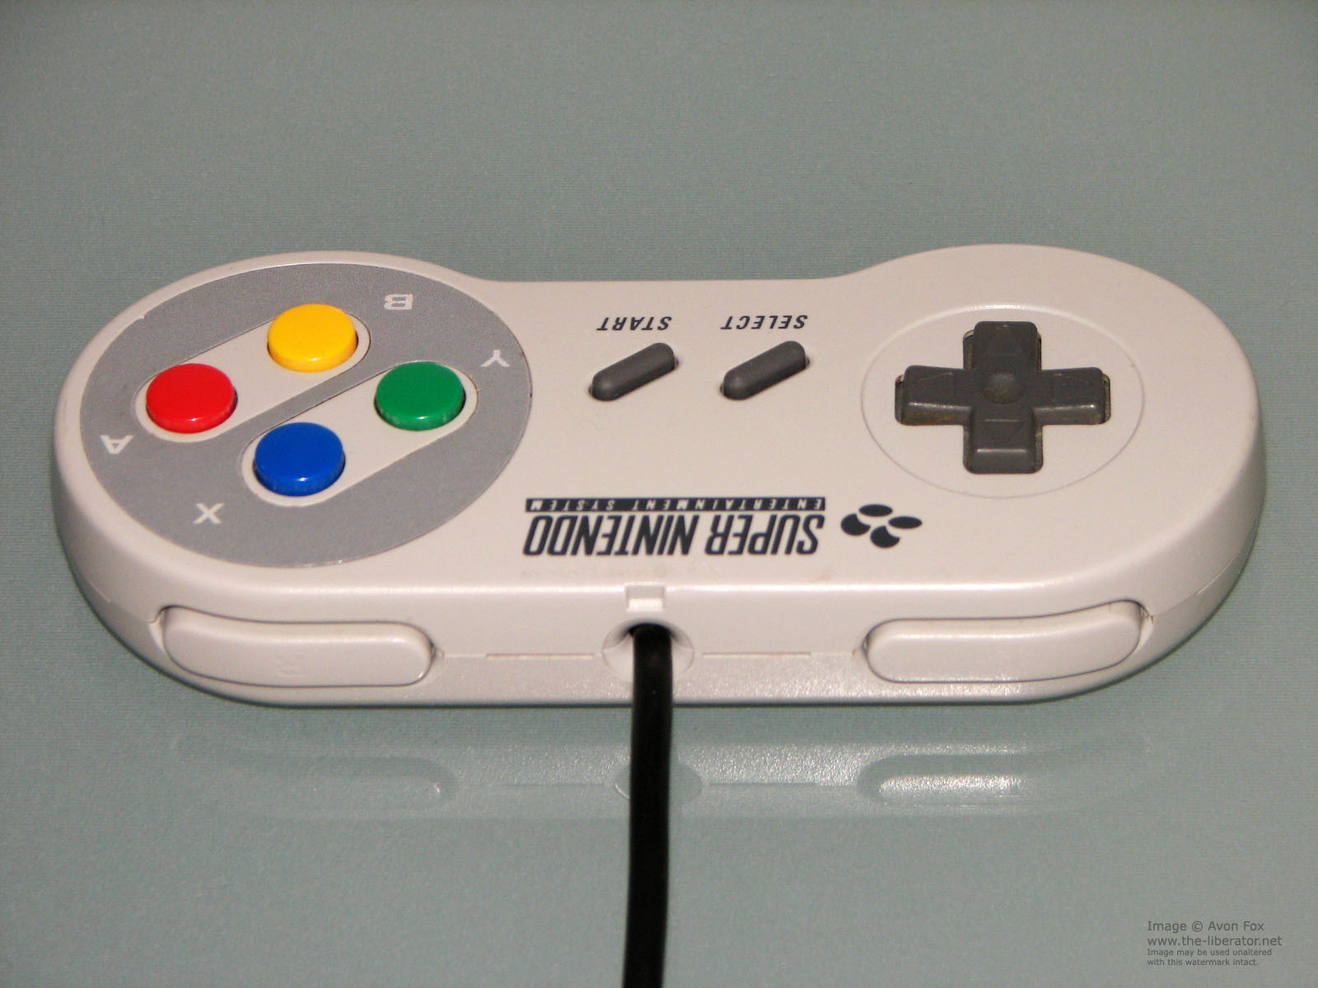

Fig.[1.6]-(https://www.the-liberator.net/site-files/retro-games/hardware/Nintendo-Super-NES-Controller/snes-nintendo-controller.htm)

For the shoulder buttons (L and R), the system is similar but oriented differently: the buttons are mounted on the sides of the upper shell and press the membranes diagonally or vertically, depending on the internal design.
The membranes are key elements in how the controller works. They are made of flexible rubber that provides both elasticity and wear resistance. They also contribute significantly to the “feedback” the user feels when pressing a button.

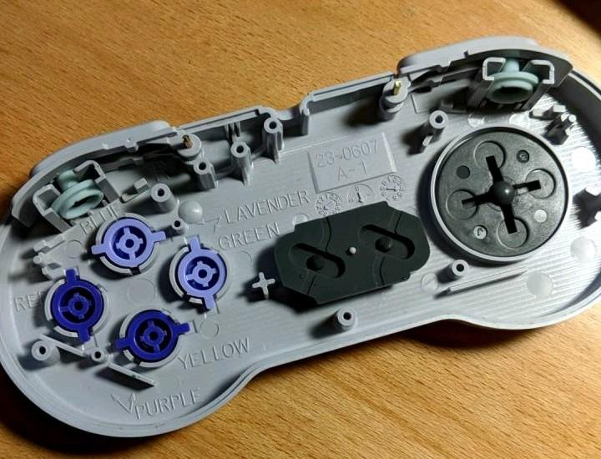
Fig.[1.7]-(https://www.reddit.com/r/snes/comments/8t6dqe/til_inside_a_snes_controller_it_has_the_color/)

Overall, the way the SNES controller works is an example of simple mechanical efficiency, where the design of the physical parts is enough to allow precise control without the need for complicated mechanisms. This principle made the SNES controller not only reliable, but also easy to manufacture and maintain.

CHAPTER 2

2D SKETCHES

2.1 Setting Up the Workspace and Layers

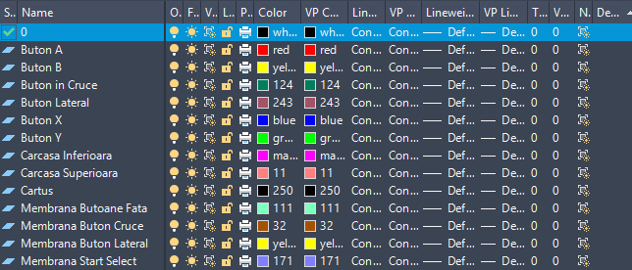
Fig. [2.0]

The project was made using AutoCAD’s default “acad.dwt” template, without changing the size of the workspace. The metric system was used for units, replacing the default inch scale with millimeters.
For better organization, each component of the SNES controller was drawn on a separate layer.
A custom dimension style was also used to ensure a clear and consistent presentation of the dimensions across all sketches.

2.2 Upper Shell

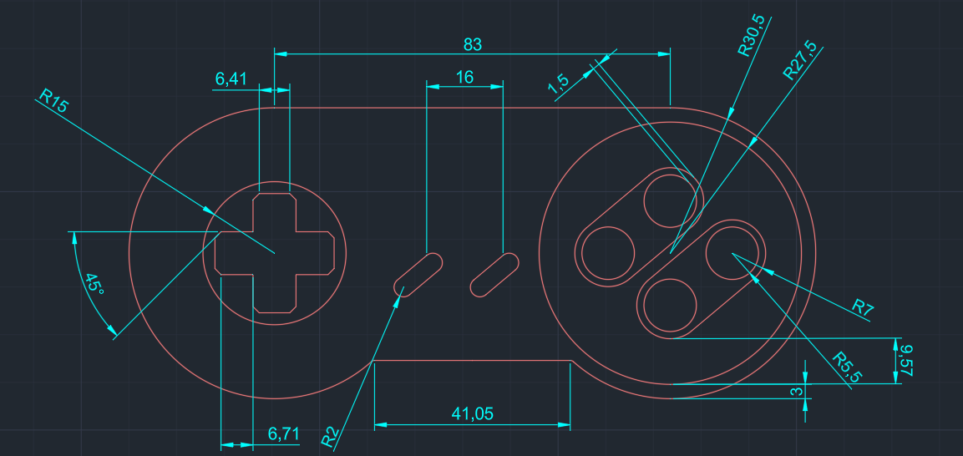
Fig. [2.1] - Outside view of the upper shell
To create the outline of the upper shell, two circles were placed with the “Circle – Radius” tool from the “Draw” panel, defining the two rounded ends of the controller. The top side was closed with “Line”, using the “Quadrant” snap points, and the bottom side was completed with a line and rounded with “Fillet” from the “Modify” panel. The final shape of the shell was adjusted and cleaned up with the “Trim” tool.
The A, B, X and Y button groups were created with the “Circle” tool and placed according to the layout specific to the SNES controller.
For the D-pad area, the “Rectangle” tool was used, and the final shape was obtained by adjusting it with “Trim” and finishing the corners with “Chamfer”.
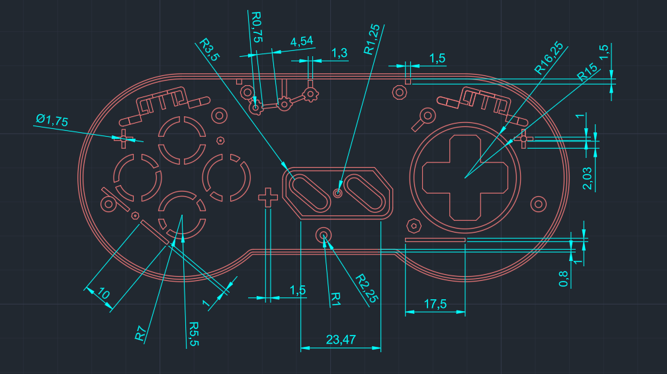
Fig. [2.2] – Inside view of the upper shell
For the inside view, the “Offset” tool from the “Modify” panel was used to create the mating edges with the lower shell, ensuring that the two components line up correctly.
The screw holes were created with the “Circle” tool, and in the upper part the support for the cable coming out of the controller was drawn. It was built from several small circles placed with “Circle” and distributed with the “Array – Polar” command; support lines were added between them with “Line”, then separated with “Explode” and adjusted with “Trim” to keep only the needed portions.
For the A, B, X and Y button area, a guide outline for the membrane was defined using the “Line”, “Circle”, “Trim” and “Polygon” tools. In the Start and Select area, a support outline for the membrane was built using “Line”, “Chamfer” and “Fillet”, to get a functional and well-defined shape.

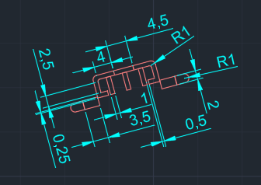
Fig. [2.3] – Support for the shoulder button membrane
The support for the shoulder button membrane was made with the “Circle” and “Rectangle” tools, to define the outline and the mounting elements. The “Fillet” command was applied to round the corners, and the final shape was adjusted with “Trim”.
To create the wall thickness and inner edges, the “Offset” tool was used, adapting the shape to the structure of the shell.
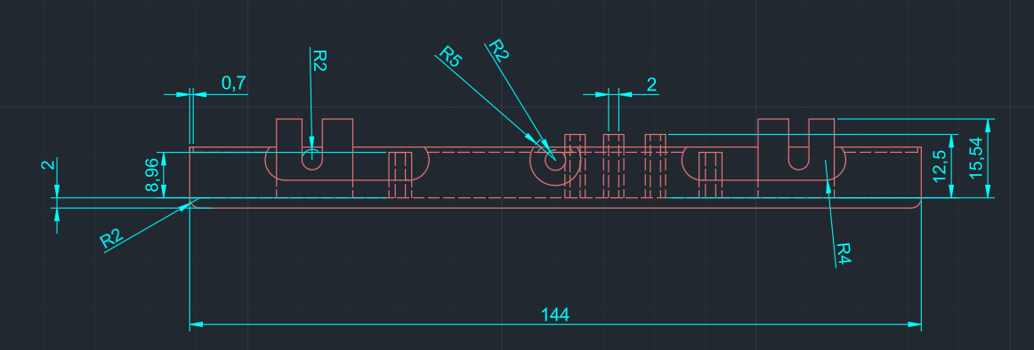
Fig. [2.4] – Side section of the upper shell
The outline of the shell was drawn with “Line”, and the bottom corners were rounded with “Fillet”. The holes for the cable and the shoulder buttons were built with “Circle” and “Line”, then adjusted with “Trim”.
The raised part in the shoulder button area was drawn with “Line” to show the height. For hidden internal elements, such as the screw holes, the ACAD_ISO02_W100 linetype was used.

2.3 Lower Shell

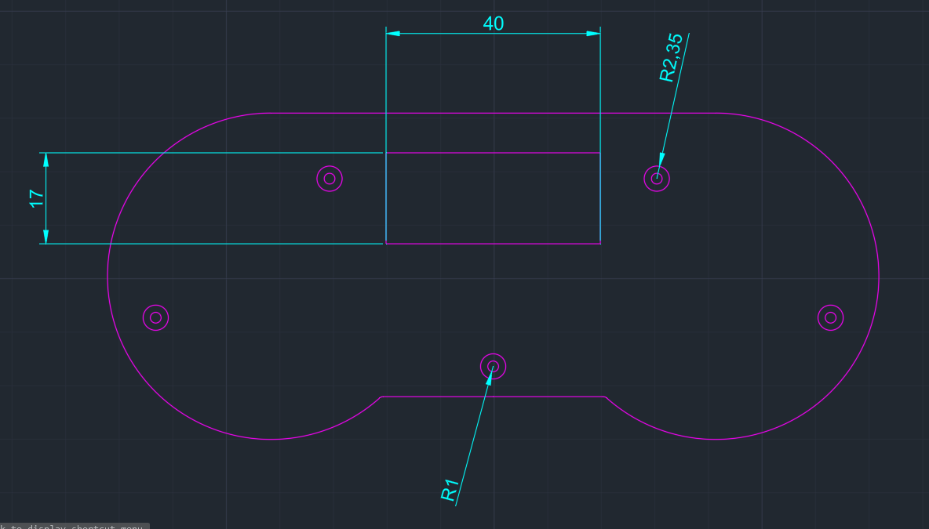
Fig. [2.5] – Outside view of the lower shell

The outline was kept identical to the upper shell for a precise fit. The screw holes were drawn in the same positions with “Circle”, but with different radii.
For the label area on the back, the “Rectangle” command was used, forming a simple frame centered on the surface of the shell.

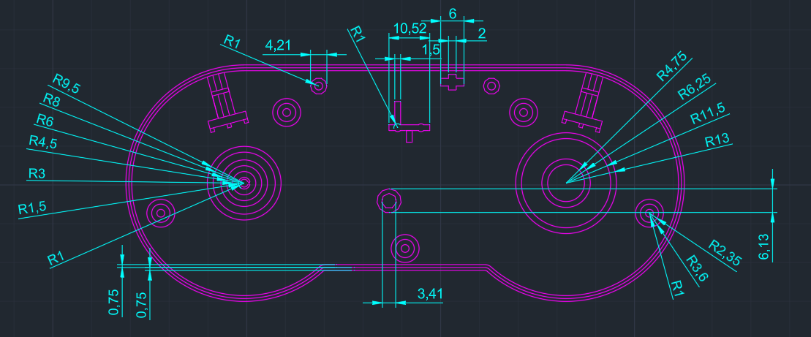

Fig. [2.6] – Inside view of the lower shell

The inner outline was made similarly to the upper part, using the “Offset” tool to create the mating edge with the upper shell.
To create a support base for the board the buttons are mounted on, the “Circle” command was used. In the center, a support made with “Rectangle” and “Circle” was added for extra stability.
To hold the shoulder buttons in place, the “Polygon” command was used, defining a simple and effective shape for support.

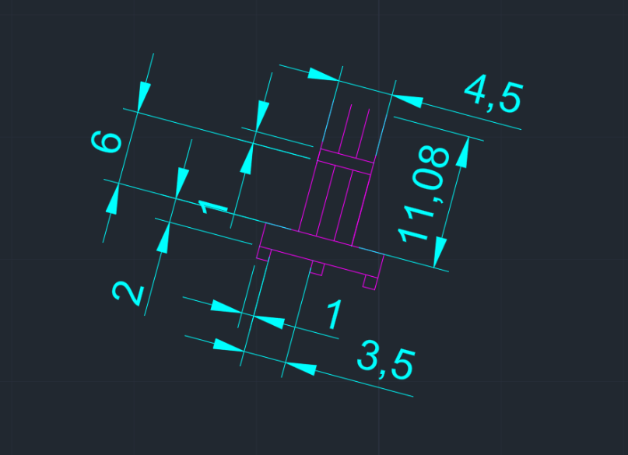
Fig. [2.7] – Support for the shoulder button membrane
The base shape was made with “Rectangle”, completed with “Line” to define the specific outline. Finally, the “Trim” command was used to adjust the drawing.
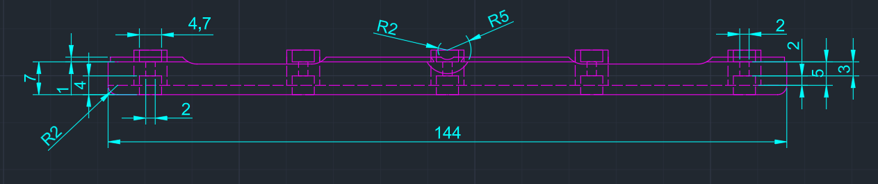
Fig. [2.8] – Side section of the lower shell
The outline of the section was drawn with “Line”, and the bottom corners were rounded with “Fillet”. The screw holes were drawn with “Rectangle”, and the “ACAD_ISO02_W100” linetype was used for their hidden internal elements.
For the openings for the cable and the shoulder button, the “Circle” command was used.

2.4 X, Y, A, B Buttons

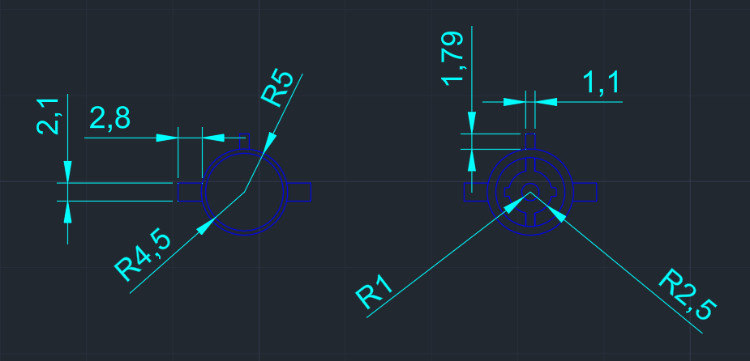
Fig. [2.9] – Button X

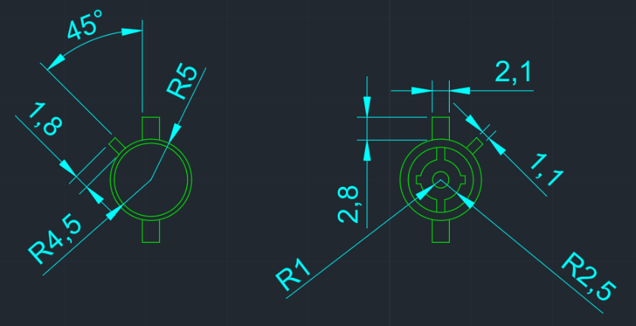
Fig. [2.10] – Button Y
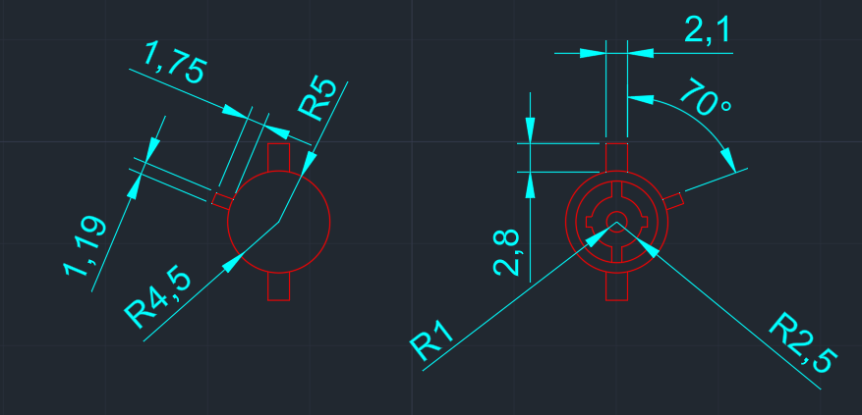
Fig. [2.11] – Button A

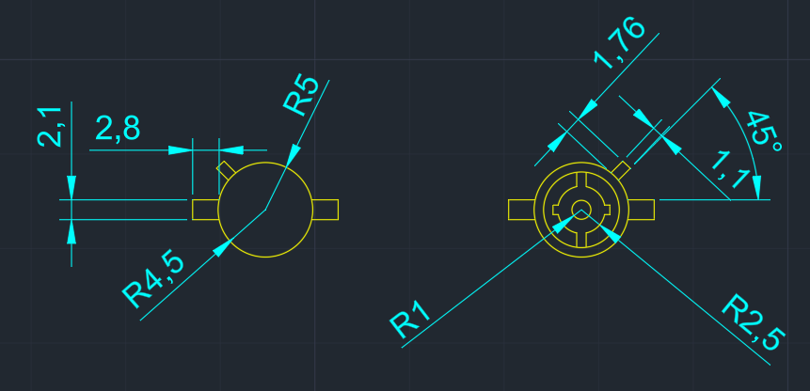
Fig. [2.12] – Button B
The X, Y, A and B buttons were outlined using the “Circle” and “Line” commands to draw the outer shape, including the retaining tabs on the edges that hold the button in the shell.
The inner part, which presses on the membrane, was built using the “Rectangle”, “Circle” and “Trim” commands to define the flat surfaces and precisely adjust the edges, ensuring that the button works correctly.
The only difference between these buttons is the orientation angle of the retaining tabs, adapted to the position of each button in the assembly.

2.5 Directional Pad

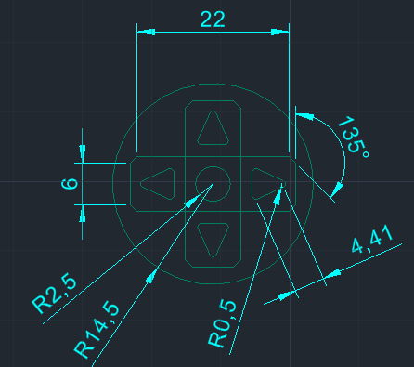
Fig. [2.13] – Front view of the directional pad
To create the directional pad (D-pad), the “Circle” command was used for the outer disc surrounding the button. The cross shape of the button was built using “Rectangle”, and the corners were finished with “Chamfer” to get beveled edges, ensuring a functional design.
The arrows on the button were drawn as triangles with the “Line” command, and their edges were rounded with “Fillet” for an ergonomic and clean look.
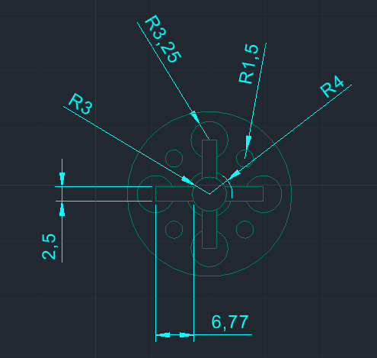
Fig. [2.14] – Bottom view of the directional pad
In the bottom view, the outline of the button was made using the “Rectangle” and “Circle” commands to define the shape and edges. The “Trim” command was used to adjust and finish the inner details, ensuring an accurate layout of the surfaces that press on the membrane.

2.6 Shoulder Button

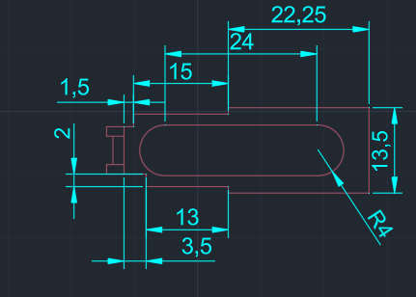
Fig. [2.15] – Front view of the shoulder button
For the front view of the shoulder button, the “Arc” and “Line” commands were used to define the curved outline and the straight edges of the button. The resulting shape blends smoothly with the controller shell.
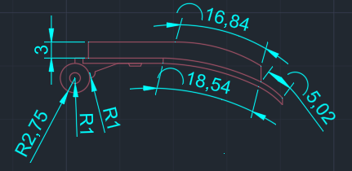
Fig. [2.16] – Side view of the shoulder button
The “Circle” command was used to build the area where the button attaches to the shell, as well as the pivot point that allows it to be pressed effectively. The overall shape of the button was made using the “Line” and “Arc” commands to get a curved outline.
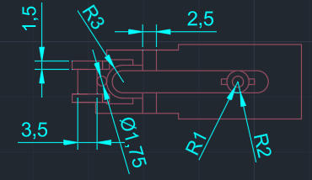
Fig. [2.17] – Bottom view of the shoulder button
In the bottom view, the outline of the button was taken from the top shape, and the lower part that comes into contact with the membrane was made using the “Line”, “Arc” and “Circle” commands. The resulting shape ensures the pressing mechanism works correctly.

2.7 Shoulder Button Membrane

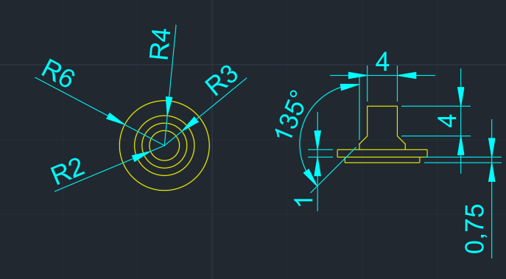

Fig. [2.18] – Front and side view of the shoulder button membrane

The top of the membrane was made using the “Circle” tool from the “Draw” panel, with a series of concentric circles that show the elastic shape and the central contact point of the membrane.
The side section was built with the “Line” tool, to show the vertical profile of the membrane, including the thickness and height of the support element. This view shows the overall shape and the spring-back structure typical of a rubber membrane.

2.8 X, Y, A, B Button Membrane

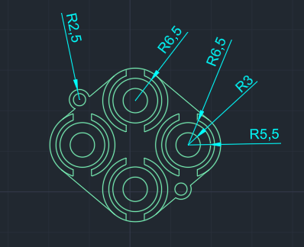
Fig. [2.19] – Front view of the membrane
The central pressing part of the membrane was made using the “Circle”, “Line” and “Trim” tools from the “Draw” and “Modify” panels. These allowed an accurate outline of the contact area that transmits the press to the main board.
The outer outline was built using the “Circle” and “Line” tools, combined with the “Tangent” snap, accessed with the Shift + right-click shortcut, to ensure a clean connection between the curved elements and the straight segments of the membrane.
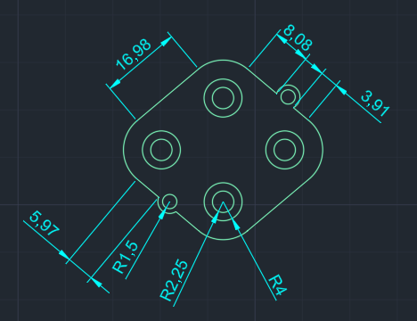
Fig. [2.20] – Bottom view of the membrane
For the bottom of the membrane, the outline from the top drawing was kept and adapted for this view. Using the “Circle” tool from the “Draw” panel, the area that represents the contact point with the circuit board was added.

2.9 Start/Select Membrane
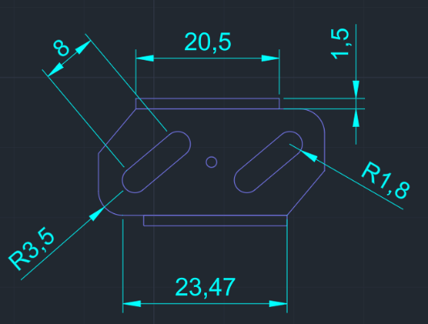
Fig. [2.21] – Front view of the Start/Select membrane
The shape of the buttons was made with the “Circle” and “Line” tools from the “Draw” panel, keeping the specific proportions and the spacing between the two elements.
The support area, which holds the membrane in place inside the shell, was built with “Rectangle” and completed with “Line” and “Fillet” from the “Modify” panel, to get a clear outline with rounded corners. This part keeps the membrane stable and the buttons correctly positioned in the assembly.
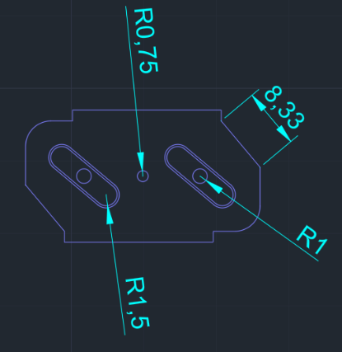
Fig. [2.22] – Bottom view of the Start/Select membrane
For this view, a circle was added with the “Circle” tool from the “Draw” panel, representing the area that comes into contact with the button and transmits the press to the support point on the shell. It is centered so that the press is even.

2.10 Directional Pad Membrane

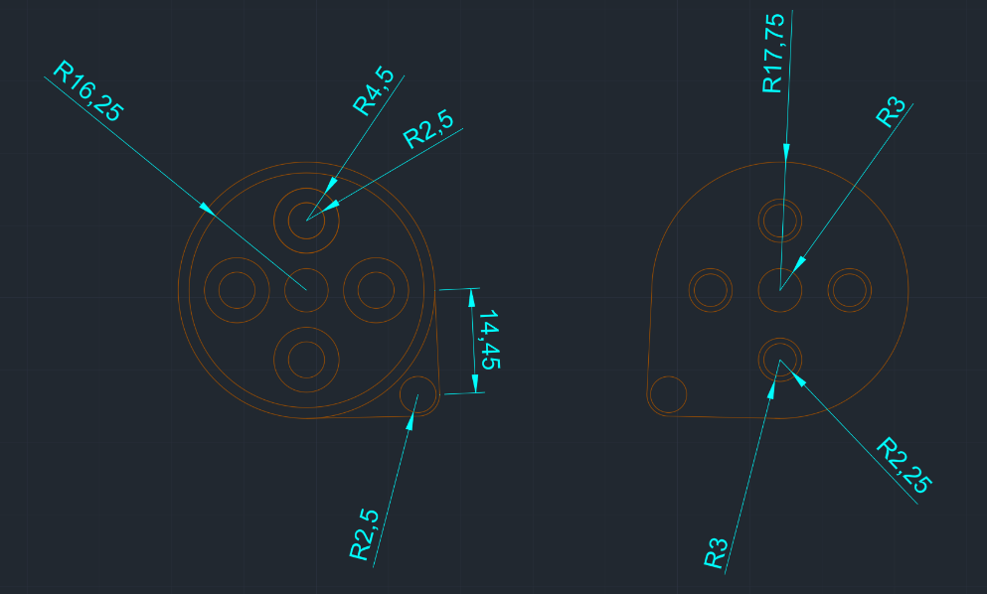
Fig. [2.23] – Directional pad membrane

The shape of the membrane was built using the “Circle” tool from the “Draw” panel, with several circles placed to represent the pressing areas of the D-pad. They are distributed radially around the center, matching the directions the user can press.
An extra circle was added in the corner of the part, representing the element that attaches the membrane to the controller shell.

CHAPTER 3

3D MODELS

3.1 Upper Shell

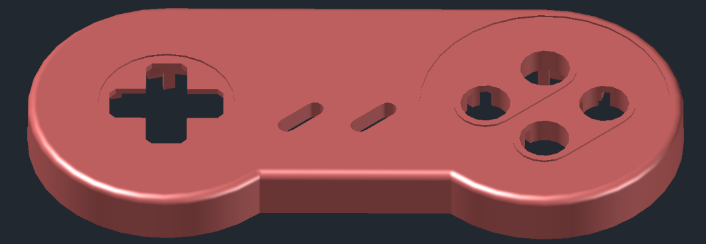
Fig. [3.0] - Front view of the upper shell
Modeling the upper shell started by applying the “Presspull” command on the top face sketch, extruding the volume to the height specified in the side sketch. This raised the edges of the shell according to the project dimensions, and it was finished with the “Filletedge” command to round the edges, improving both looks and ergonomics.
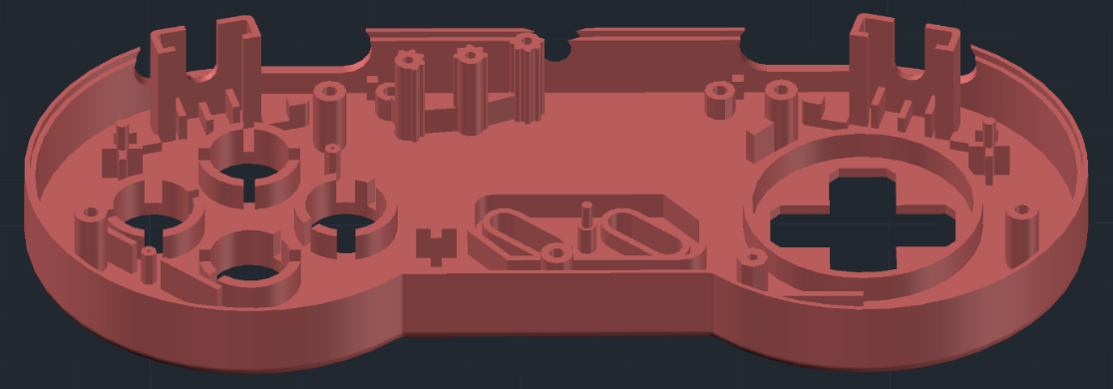
Fig. [3.1] - Outside view of the upper shell
Inside, I created the membrane supports by applying the “Presspull” command on their outlines; they hold the membranes in place. I also made the elements that guide and secure the cable using the same method.

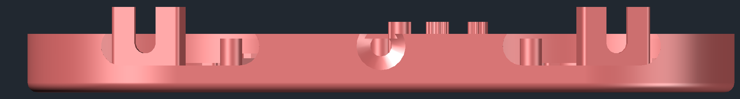
Fig. [3.2] – Side view of the upper shell

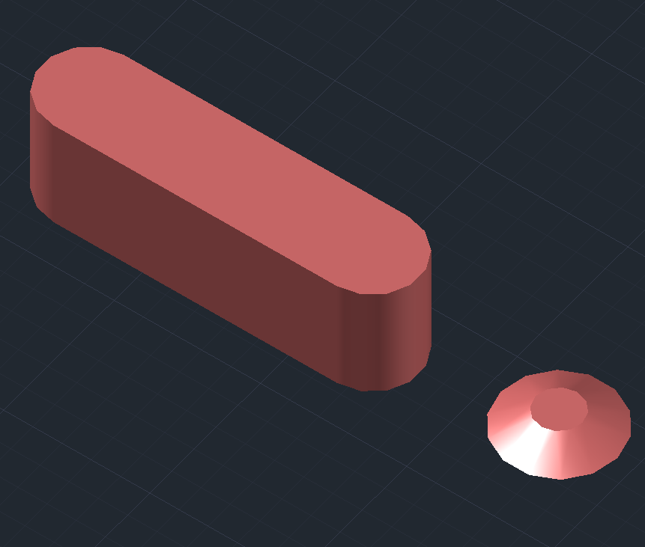
Fig. [3.3] – Parts used for “Subtract”

For the side of the shell, I subtracted the parts from Fig. [3.2] using the “Subtract” command. One of the parts was created with “Presspull”, and the other with a “Loft” between two circles.

3.2 Lower Shell

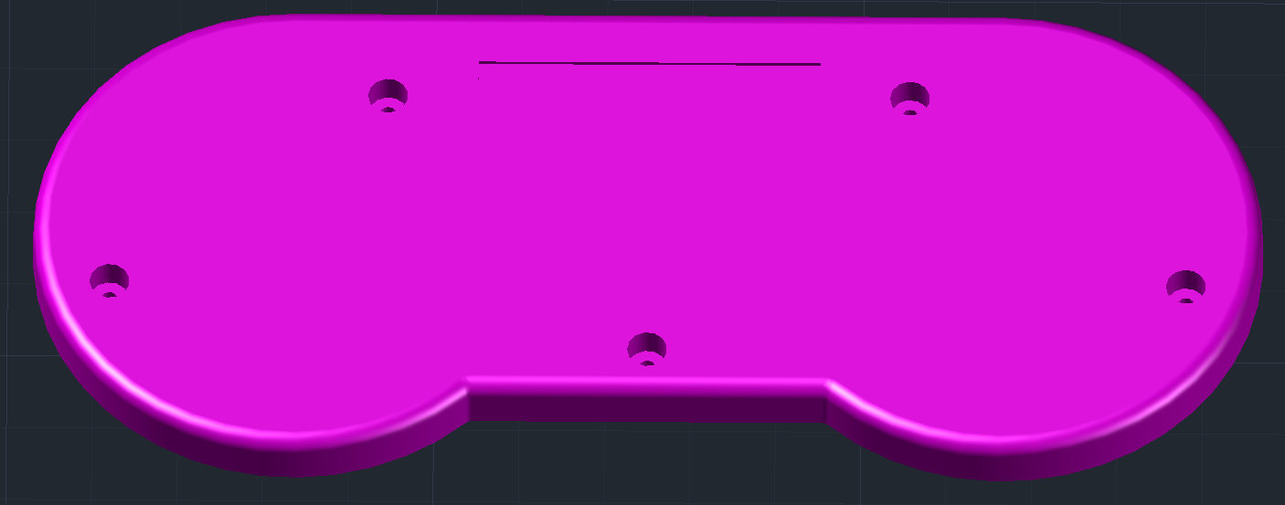
Fig. [3.4] – Outside view of the lower shell
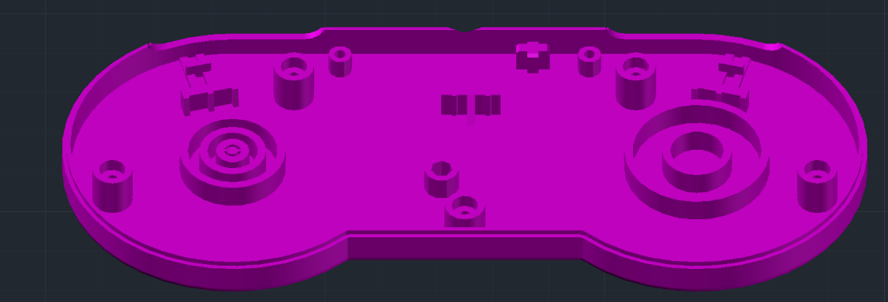
Fig. [3.5] – Inside view of the lower shell
Fig. [3.6] – Side view of the lower shell

For the lower shell I used the same method as for the upper shell, using “Presspull” for extrusion. In addition, I used “Wedge” and “Chamfer edge” on some of the support points to increase stability and improve the finish of the part.

3.3 X, Y, A, B Buttons

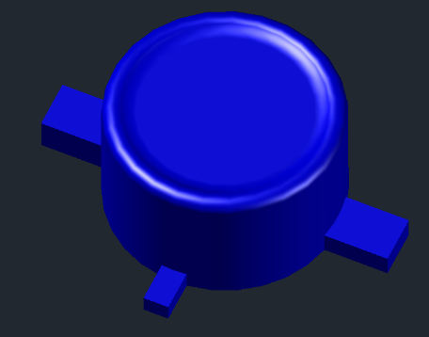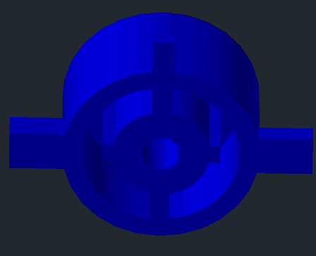
Fig. [3.7] – Button X front Fig. [3.8] – Button X back

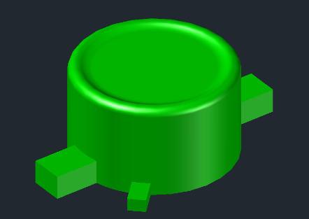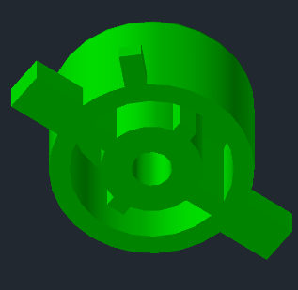
Fig. [3.9] – Button Y front Fig. [3.10] – Button Y back

Modeling the X and Y buttons started by applying the “Presspull” command on the circular outlines of the 2D sketches. To get the concave shape on top, “Presspull” was applied in reverse. On the bottom, reverse “Presspull” was used again to create the bumps that press on the membrane. Finally, the “Filletedge” command was applied on each top edge of the button, rounding the edges for a nicer and more ergonomic look.

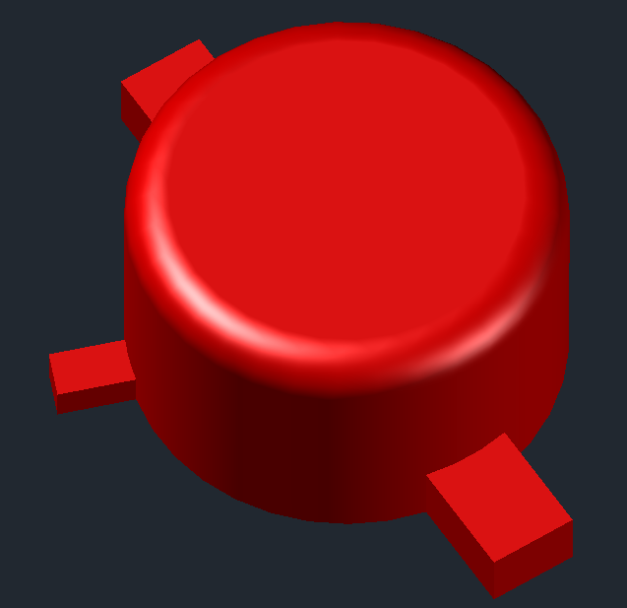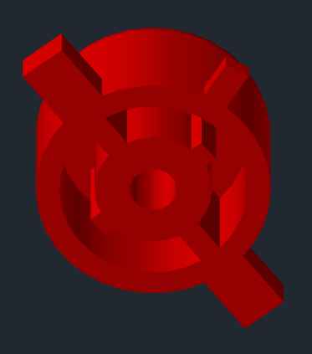
Fig. [3.11] – Button A front Fig. [3.12] – Button A back

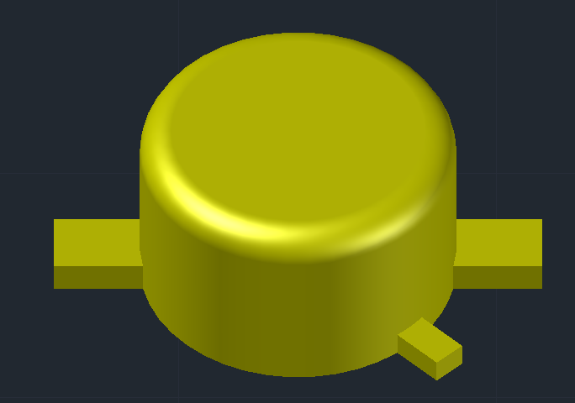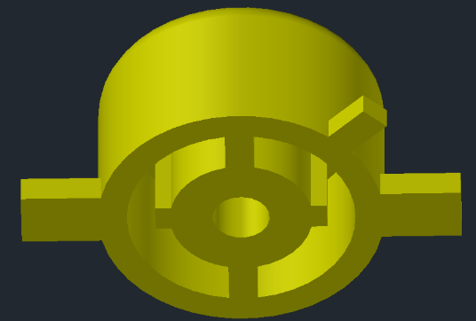
Fig. [3.13] – Button B front Fig. [3.14] – Button B back

For the A and B buttons, the same modeling procedure was used, applying the “Presspull” command on the outlines from the 2D sketch. On top, the convex shape was obtained by applying the “Filletedge” command on the top edge of the button.

3.4 Directional Pad

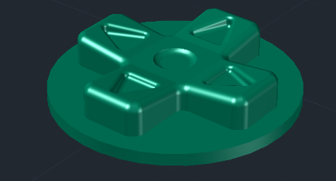
Fig. [3.15] – Front view of the directional pad
The top of the directional pad was first made with the “Presspull” command, applied on the base outline. Then the edges at the ends – left, right, up and down – were raised to get a slight slope towards the center and suggest the pressing directions.
To bring out the arrow shapes, the “Presspull” command was used again to sink the direction symbols and the center circle into the volume. Finally, the “Fillet” command was applied on the edges to round the corners and give the part a uniform, ergonomic look.
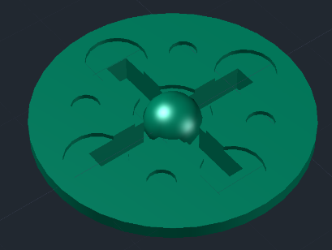
Fig. [3.16] – Bottom view of the directional pad
For the bottom of the directional pad, the “Presspull” command was applied in reverse on the flat base, to define the cut-out outline of the inner arms. These cut-outs are the areas that let the button flex when it is pressed.
A sphere was added in the center of this assembly using the “Sphere” command; it acts as the contact point with the elastic membrane underneath, transmitting the movement through a single central point.

3.5 Shoulder Button

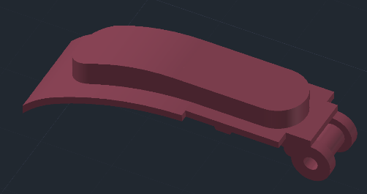
Fig. [3.17] – Front view of the shoulder button
To create the shoulder button, the “Presspull” command was used on the side sketch to get the base shape. Then, with “FilletEdge”, the ends of the pressing area were rounded for a nicer, more ergonomic look.
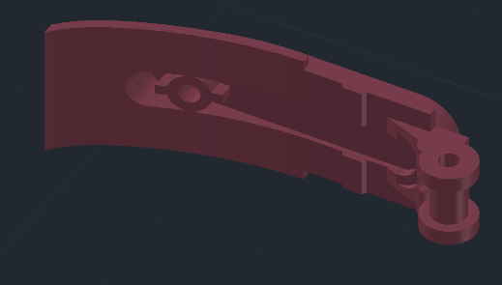
Fig. [3.18] – Inside view of the shoulder button
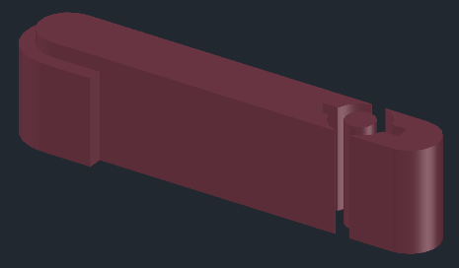
Fig. [3.19] – Part used for “Subtract”
The bottom of the shoulder button was made with the “Subtract” command, using as the cutting element the part from Fig. [3.19], previously created with “Presspull”. This produced an optimal shape for pressing the membrane inside the shell.

3.6 Shoulder Button Membrane

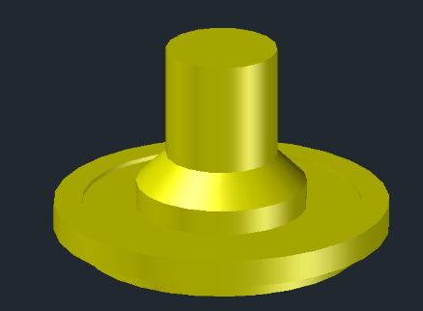
Fig. [3.20] – Front view of the shoulder button membrane
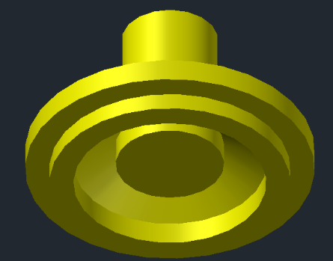
Fig. [3.21] – Bottom view of the shoulder button membrane
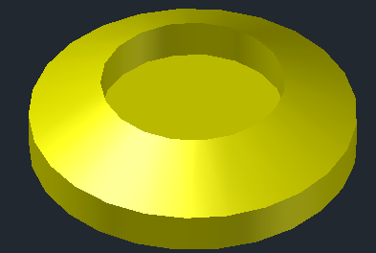
Fig. [3.22] – Part used for “Subtract”
The membrane was created with the "Revolve" command applied to the 2D sketch, rotating it 360 degrees to get the full round shape. To create the required cut-out and the correct shape, I used a part made with "Loft" and “Presspull”, Fig. [3.22], which was subtracted from the volume obtained with "Revolve" using the "Subtract" command.

3.7 X, Y, A, B Button Membrane

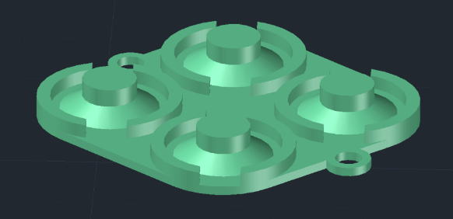
Fig. [3.23] – Side view of the button membrane
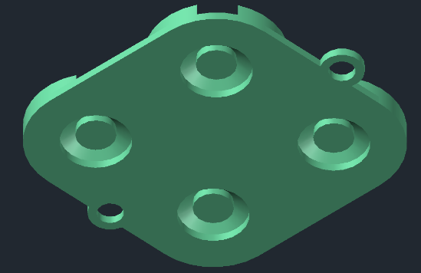
Fig. [3.24] – Bottom view of the button membrane
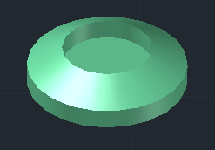
Fig. [3.25] – Part used for “Subtract”
The button membrane was created with the “Presspull” command for the base shape. The part that presses on the board was modeled with “Loft”. Then I subtracted a shape matching Fig. [3.25] using “Subtract”, to get the correct contact area with the board.

3.8 Directional Pad Membrane

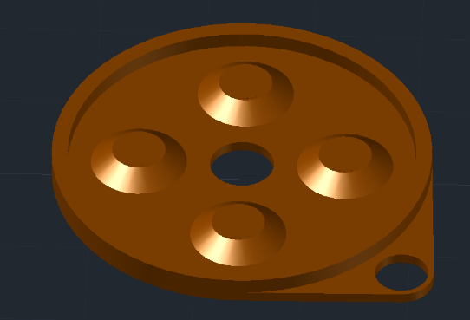
Fig. [3.26] – Front view of the directional pad membrane
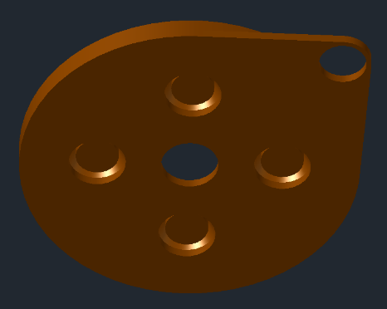
Fig. [3.27] – Bottom view of the directional pad membrane
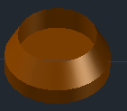
Fig. [3.28] – Part used for “Subtract”
The directional pad membrane was made similarly to the previous button membrane, using the “Presspull” command for the base shape and “Loft” for the active part that presses on the board. Here too, “Subtract” was applied to define the contact area.

3.9 Start/Select Membrane

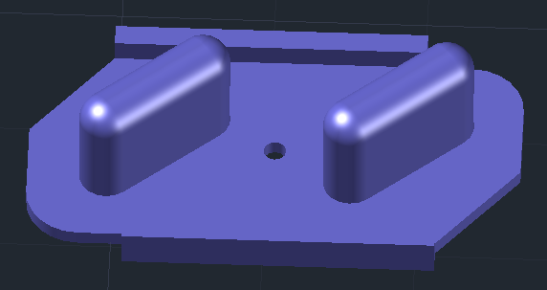
Fig. [3.29] – Front view of the Start/Select membrane

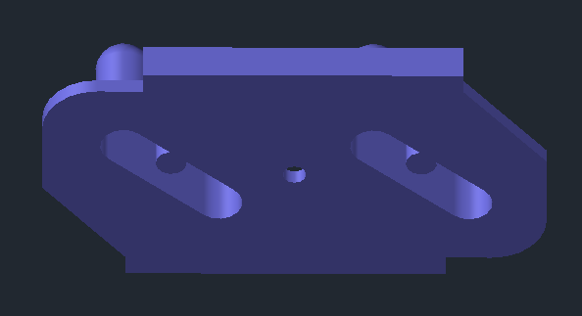
Fig. [3.30] – Bottom view of the Start/Select membrane

The membrane for the Start and Select buttons was created with the “Press Pull” command to define the base shape. The tops of the buttons were rounded using “Fillet Edge”, for an ergonomic and comfortable pressing surface. The bottom part, which makes contact with the board, was modeled by applying “Press Pull” in reverse.

CHAPTER 4

FINAL PRODUCT

For the final product, I applied specific materials to bring out the realistic look of the components. All the buttons, as well as the controller shell, were finished with the “High Gloss” material, giving them a shiny, clean look.
The membranes were given the “Rubber” material, to suggest the rubbery texture and flexibility needed for the buttons to work correctly.

4.1 EXPLODED VIEW

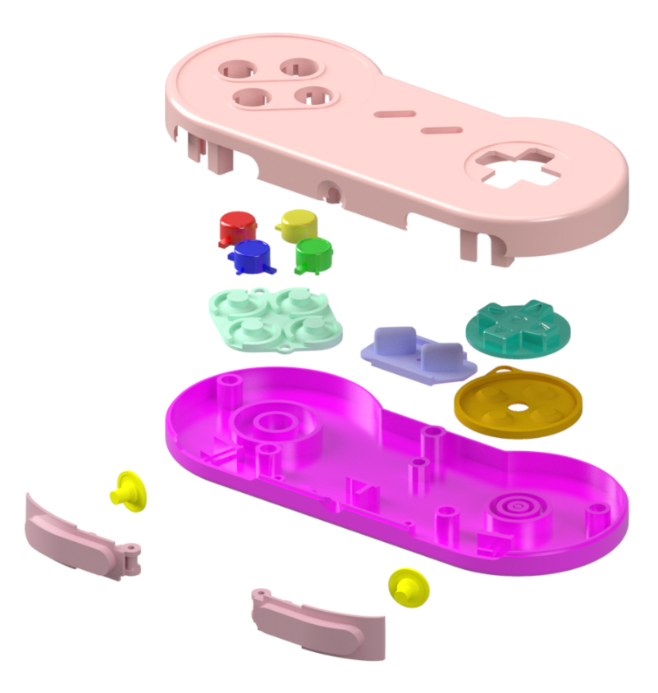
Fig. [4.0] – Render of the final model

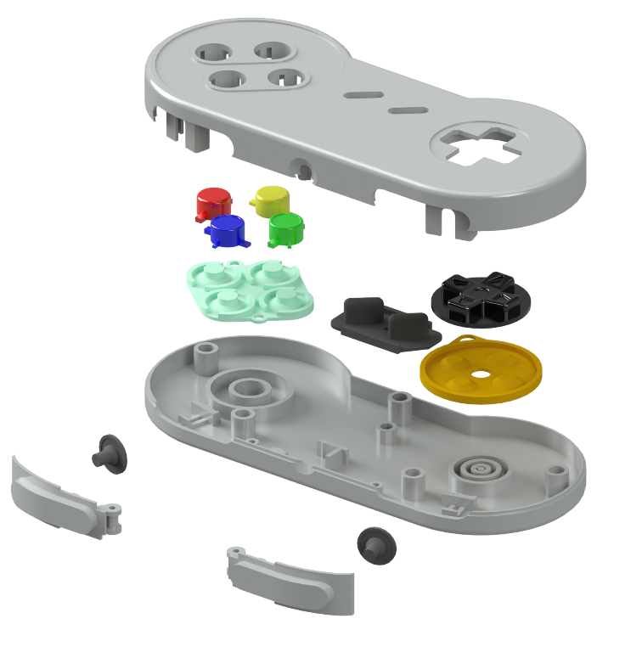
Fig. [4.1] – Render of the final model with the real colors applied

4.2 ASSEMBLED SHELL
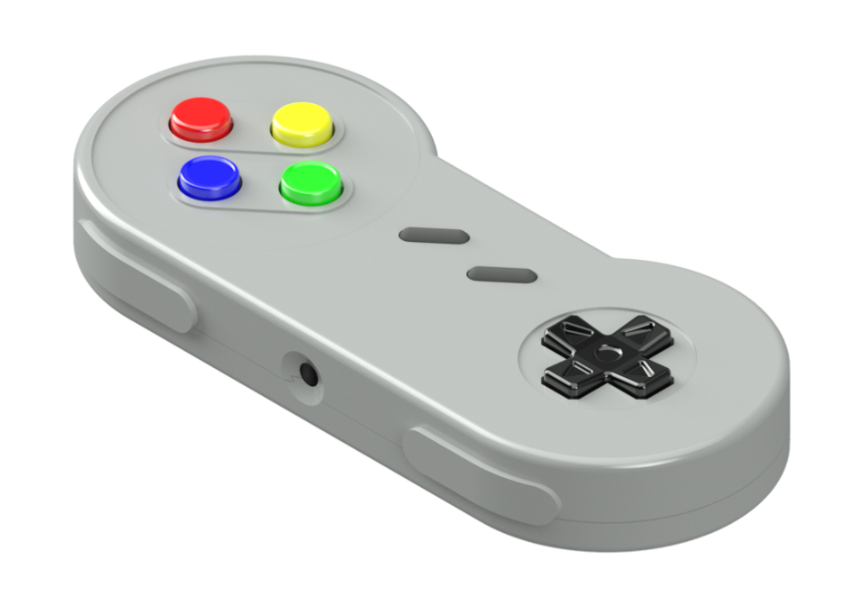
Fig. [4.2] – Render of the assembled final model

4.3 TITLE BLOCK

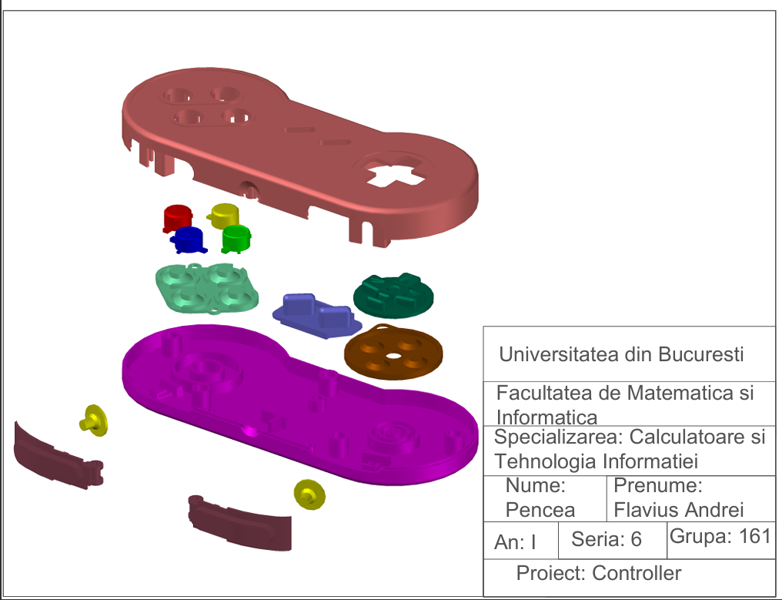Fig. [4.2]

CONCLUSIONS

By finishing this project, I gained and deepened essential knowledge of creating 2D and 3D graphic models, growing both technically and personally.
First of all, this project was one of the most complex modeling works I have done so far, requiring not only a good understanding of AutoCAD commands, but also careful organization of the work stages and logical thinking in building each component.
The work also highlighted the importance of research and of understanding the real object in detail, as well as applying the right materials and textures, so that the final model is as faithful to reality as possible.
The most important lesson I learned is that perseverance, attention to detail and the ability to go back over previous steps to improve them are essential skills in any creative or technical process.
Therefore, this project was not just an exercise in applying AutoCAD knowledge, but also a valuable personal and professional learning experience.

BIBLIOGRAPHY

- https://www.pcgamingwiki.com/wiki/Controller:Super_Nintendo_Entertainment_System_Controller
- https://www.digitalgamemuseum.org/consolecontrollerevolution/d-pad/snes/
- https://en-americas-support.nintendo.com/app/answers/detail/a_id/47357/~/super-nintendo-entertainment-system-controller-overview-%26-faq
- https://en-americas-support.nintendo.com/app/answers/detail/a_id/47358/~/super-nintendo-entertainment-system-controller-diagram
- https://forums.nesdev.org/viewtopic.php?t=24434

