Alex Pendell

CIS 421 – Artificial Intelligence

Assignment 3 – A Star Search

October 24th, 2019

When executing the A\* program, you will be asked which version of the search you wish to run. There are three searches, and each of them provide different f-values to the cities in Middle Earth.

The first search (search 0 in the program) is the simple heuristic search derived directly from the example given to us in our lecture slides. To explain, a cities f value is based only on how far it would be to get there from where we are now, and how far away from our goal it is.

The idea is that if we’re not going TOO far in one jump and we’re continuously decreasing the distance to our goal; we should reach our destination eventually. The program’s output is as follows:

Not-Winter: Winter:

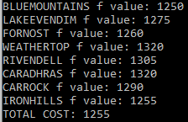 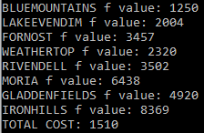

As you can see, winter plays a large role in deciding which paths our dwarves take when travelling. In the algorithm, the role of the winter parameter is reversed. That is, in the write up, the danger of winter descends as the value increases (0 is more dangerous than 25). However, in the algorithm, this is reversed, so 25 is the most dangerous, while 0 means that the road is basically in-doors. That value is then cubed and added to the f value.

The Winter heuristic is applied to any of the searches if the winter flag is set (it’s the first thing being asked.)

The following searches use road risk and road quality to help determine which path to take. The second search (search 1 in the program) will favor higher quality roads when travelling. The road quality is multiplied by three. Here are the results:

Not Winter: Winter:

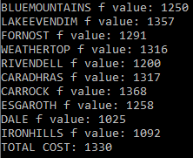 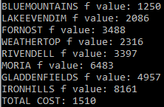

The third search (search 2 in the program) will square the value of the risk of travelling on that road when deciding which road to take, so our dwarves will heavily favor safer roads:

Not Winter: Winter:

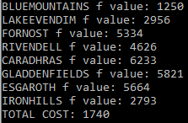 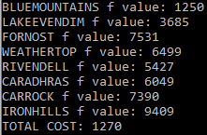

The total cost is only proportional to distance travelled and does not reflect risk or quality or winter threats.