Checklist: Publish a Quarto Dashboard to GitHub

Complete these Tasks First
 What students need before starting
This section ensures everyone has the correct software and accounts before beginning to publish a dashboard.

Download and Install Software
- Download and install R from https://cran.r-project.org.
- Download and install RStudio from https://posit.co/download/rstudio-desktop/.
- Download and install the Quarto CLI from https://quarto.org/docs/get-started/.
- Download and install GitHub Desktop from https://desktop.github.com/download/.

Create a GitHub Account
 I recommend Gmail
I have done this multiple times using different gmail accounts to create multiple GitHub accounts and the process has been straightforward.

- Go to https://github.com and click Sign Up.
- Choose a username, email, and password.
- Verify your email and complete setup.

Generate a Personal Access Token (PAT)
 Important
- According to AI: GitHub no longer accepts passwords for Git operations; a Personal Access Token (PAT) is required instead.
- Despite the statement above, I have been able to sign-in with a password.
- I recommend saving the PAT as a precaution and keeping it handy.
- I did not need my PAT when I added a new GitHub account to my GitHub Desktop but you might.

- Log into GitHub and go to Settings → Developer settings → Personal access tokens → Tokens (classic)
- Click Generate new token (classic)
- Name it (e.g., “GitHub Desktop Token”), set expiration, and check repo scope.
- Click Generate and copy and save the token immediately.

Add GitHub account/PAT to GitHub Desktop
- Open GitHub Desktop → File → Options → Accounts.
- Click Sign in to GitHub.com.
- When prompted for your password, paste your PAT instead.

Create and Render a Quarto Website
 Dashboard Website will be Incomplete until Lecture 27
- This checklist will help you create and publish your stock dashboard.
- Before Lecture 27 you will simply create the framework.
- In Lecture 27, I will provide the code and text to everyone in class to complete dashboard.

Create a New Quarto Website Project in RStudio
- In RStudio: File → New Project → New Directory → Quarto Website.
- Enter a directory name (e.g., Stock_Dashboard).
- Choose a location on your computer (e.g., Desktop).
- Ensure these boxes are checked:
  - Create a git repository
  - Use renv with this project
  - Use visual markdown editor (not required)
- Click Create Project.

Modify Project as Follows:
- In the folder for this project, delete about.qmd.
- Download this zipped folder, dashboard_files.zip, and unzip it.
- Place all the files in the project folder you created above.
  - Replace files in your destination folder.

Update renv
- In the Console, type renv::snapshot().
- Click Enter or Return, and then select Option 2.
  - This process will take time.
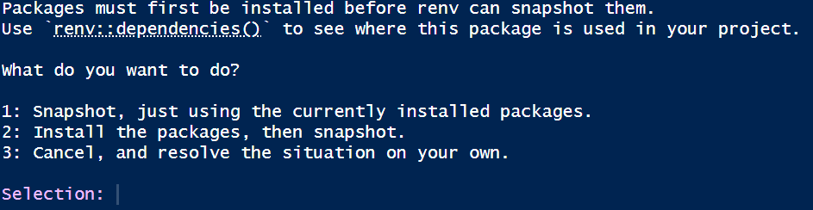
- When you see the question Do you want to proceed?, type Y.
- In the Console, type renv::status(), and confirm that you receive this message: No issues found -- the project is in a consistent state..
 The renv update needs to be repeated periodically.
- renv is a software ‘bubble’ within your software.
- As you expand your project or the packages are updated, the above Update renv steps will need to be repeated.
- If you see the message The project is out-of-sync -- use renv::status() for details., repeat the Update renv process.

Render Incomplete Dashboard
- If you see a message like the one in this screenshot, at the top for any packages, click install.
- Run Setup chunk.
- Render (incomplete) dashboard.
- Verify that that the rendering has created an .html file.
  - The .html file is located in the _site folder.
  - This file will only have the last page.
  - All code and instructions will be provided in Lecture 27.
 Why render before publishing
- GitHub Pages needs the rendered HTML files to exist before deployment.

Publish Your Dashboard with GitHub Pages

Make an Initial Commit Using GitHub Desktop
- Open GitHub Desktop.
- Click File → Add local repository…
- Navigate to project folder and click Add repository.
- Write a short comment (required) such as init commit in the summary box.
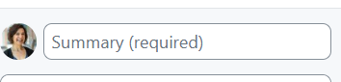
- Click Commit to main
- Click Publish repository
- Name the repo without spaces and ensure it is public.
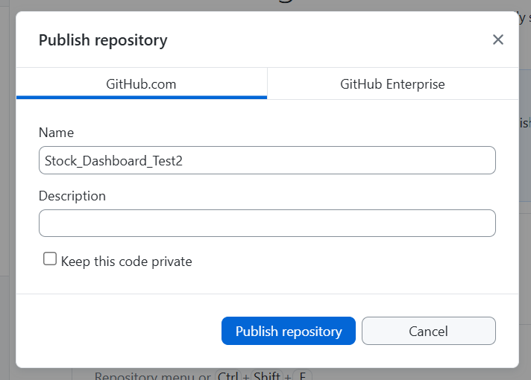

Enable GitHub Pages
- Go to your repository on GitHub.com.
- Click Code → Main → View all branches → New branch.
- Name the new branch gh-pages and click Create new branch.
- Click Settings → Pages
- Under Source confirm that it says Deploy from a branch.
- Under branch it should say gh-pages.
 Initial publication is very very slow
- The first time you do this it will take about 20-30 minutes.
- You can watch the progress in action by clicking Actions → ‘init commit’ → build-deploy.
- When build-deploy is done, ’pages build and deployment will rerun automatically.

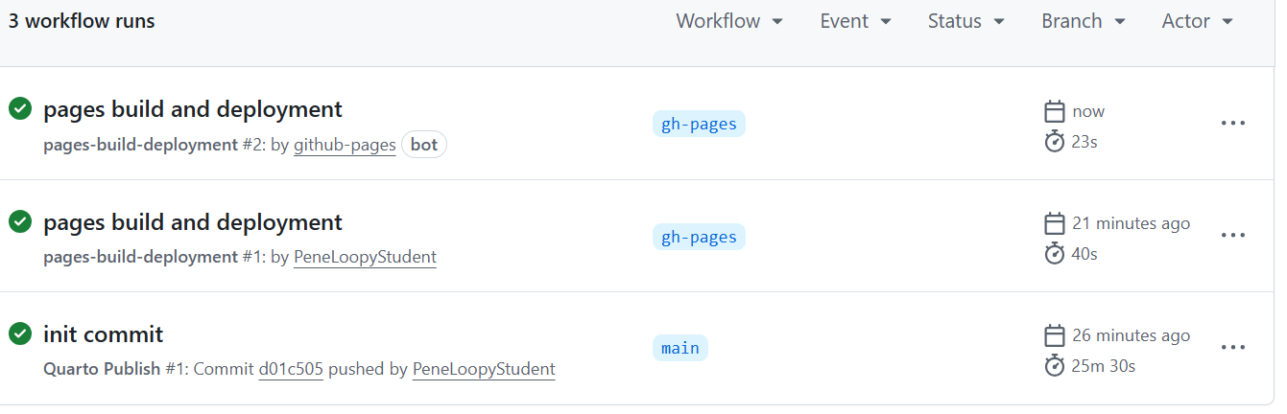 ::: callout ### SUCCESS! Your Quarto website is now live on GitHub Pages. :::

Finding Your Website
- On GitHub, Click Actions → pages build and deployment.
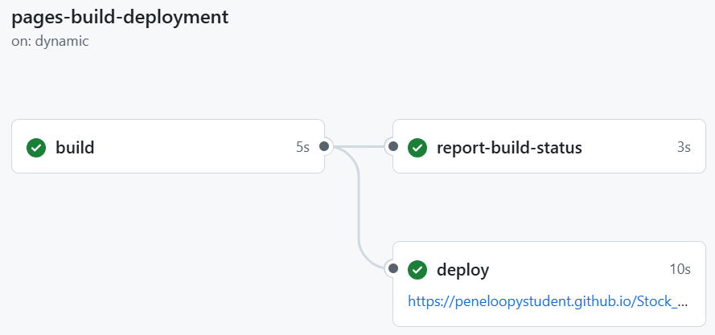

Updating Your Website
 Repeat some steps from initial commit to update website.
- Project is setup to automatically update on GitHub one you push it.

- Make desired changes to index.qmd and render it.
- Open GitHub Desktop and navigate to correct repo.
  - Eventually you will have multiple repos.
- Add new comment to summary box (required).
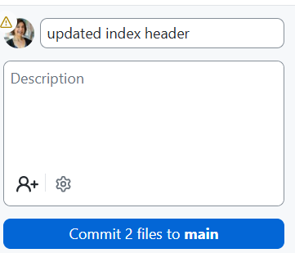
- Click Commit to main.
- Click Push origin.

