1. Subscribe to voice features in the Azure cloud
2. Apply for resources on the Azure cloud, this subscription voice service, “free trial” can

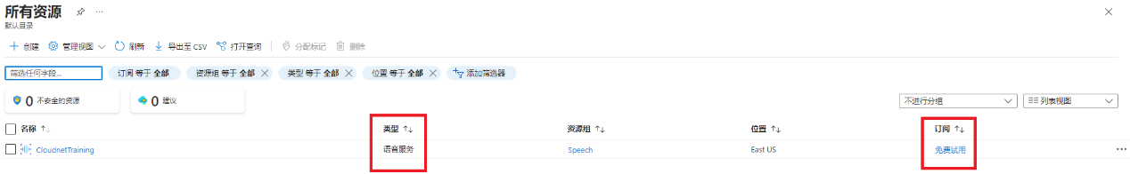

1. Copy the “key” in this resource, set it in the system variable, and give it a name, for example: AZURE_API_KEY

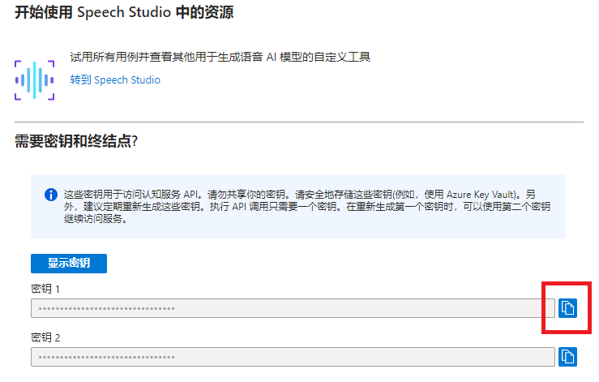

1. In the sample code speech.py, use this key, it will be fine

speech_key = os.environ.get('AZURE_API_KEY')

1. Python code to read paragraphs from docx manuscript

docxpara.py: read the script2.docx file, skip the P+ number field, and read the paragraph content

1. Python code to convert a piece of text into .wav voice

speechssml.py: Convert a piece of text to .wav speech through ssml

1. Python code to batch generate .wav speech from paragraphs in an original manuscript

speechssmlbatch.py: Read the content of script2.docx and generate a .wav voice file for each paragraph

Ways to Modify the Voice and Speech Rate

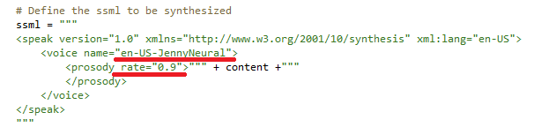

1. Notice

In the content read by ssml, there cannot be characters like & and /, such as O&M, AI/BigData, etc., which will cause the audio to not be generated, and need to be modified as appropriate