Configure Conda
Usually, the computers in the lab already have Anaconda installed. If the lab computers do not have Conda installed, or if you are using your own Windows computer, please refer to the following tutorial to configure Conda.

Install Miniconda
Download the Miniconda installer from the following link, and then follow the steps below to complete the installation.
MiniConda: https://repo.anaconda.com/miniconda/Miniconda3-py311_25.9.1-1-Windows-x86_64.exe
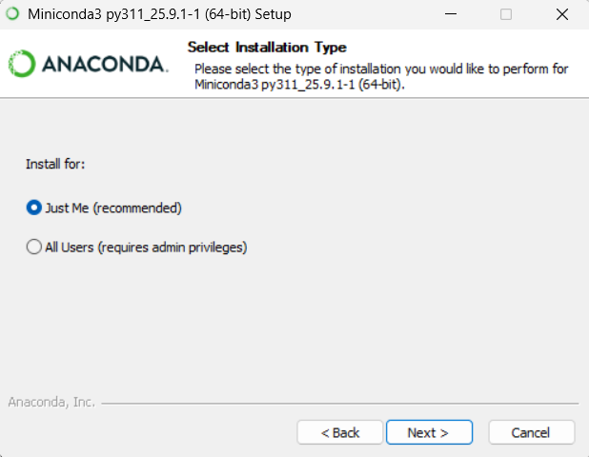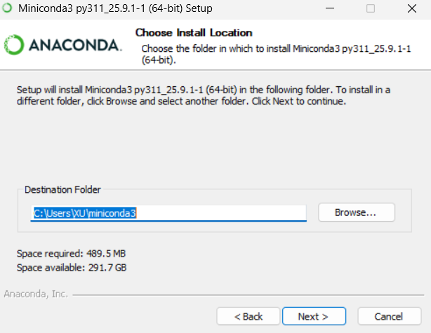
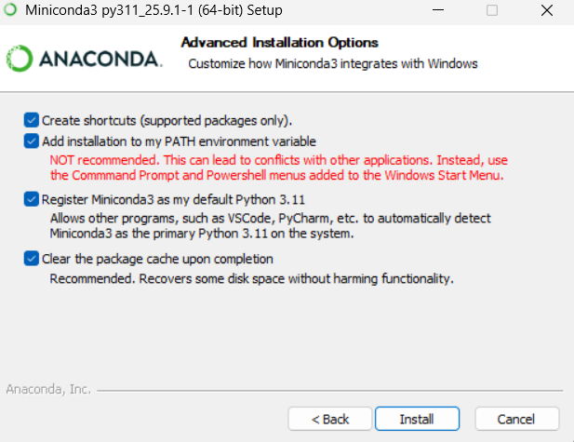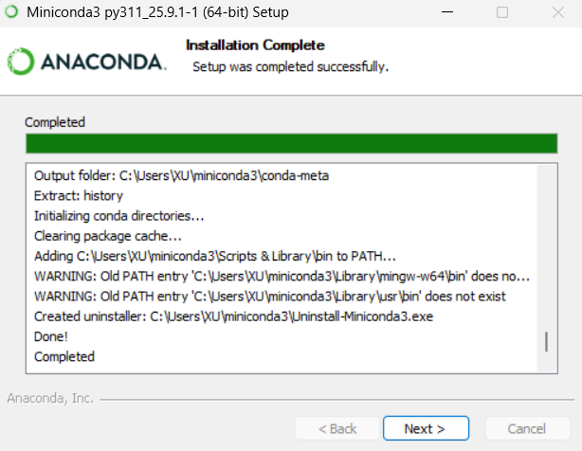
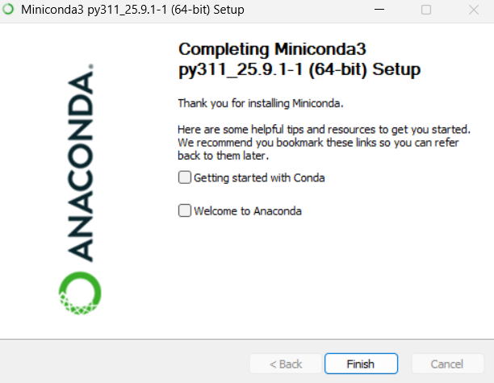
Search for ‘Anaconda Prompt’ in the Start menu and open it.
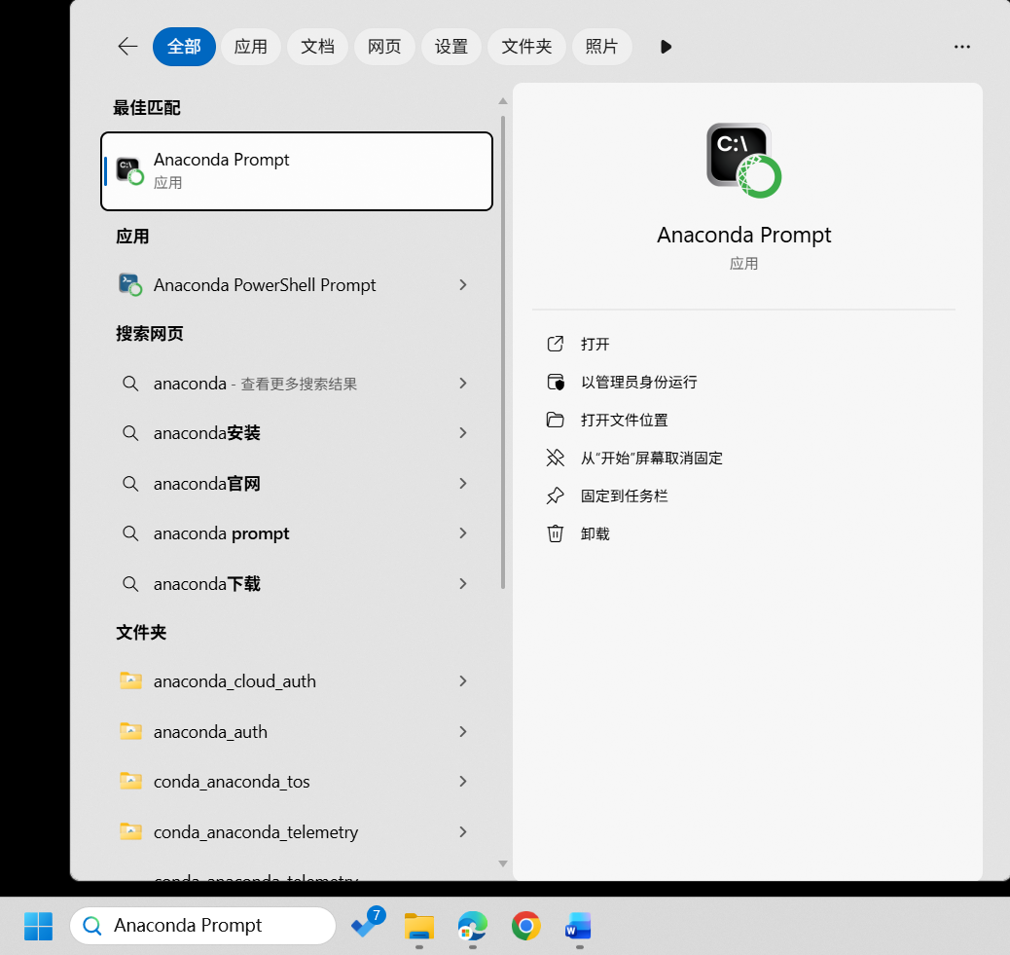
Check the installed environments in the terminal that appears.
conda info -e
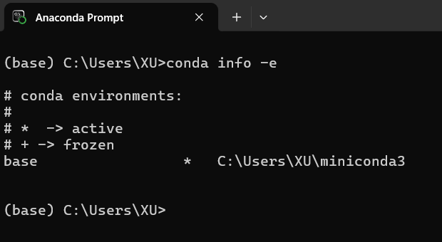

Change pip Source
Usually, we use pip to install the required packages. However, the official pip source is often unstable or inaccessible. Therefore, we need to switch to a domestic mirror source, such as AliYun.
Open Anaconda Prompt and enter the following command
pip config set global.index-url https://mirrors.aliyun.com/pypi/simple/
pip config list -v
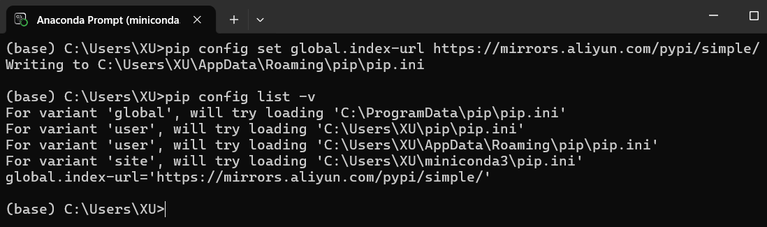

Configure Python Environment

Create a New Python Environment
To avoid interference between different Python environments, we use Conda to create a completely new Python environment and install the required packages.
# create a new python environment
conda create -n peft python=3.11.11
# press a/y when asking for proceed

# activate this new python environment
conda activate peft
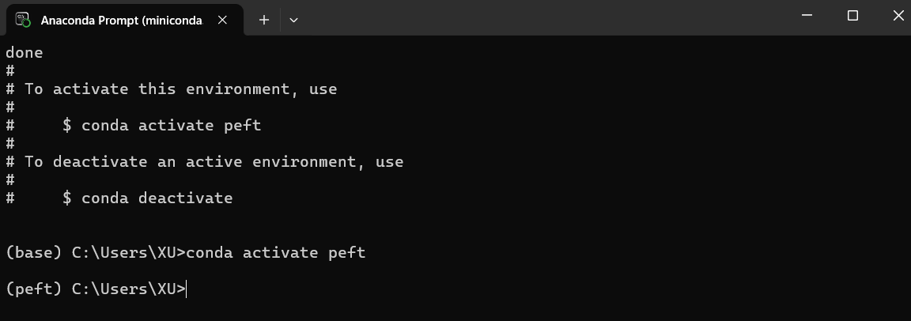

Install Packages

Online Installation packages
Usually, we can directly install the required packages online.
# Install PyTorch and other dependencies
pip install torch==2.6.0 torchvision==0.21.0 torchaudio==2.6.0 --index-url https://download.pytorch.org/whl/cu124
pip install pytz==2025.2
pip install pandas==2.2.3
pip install matplotlib==3.10.1
pip install transformers==4.51.2
pip install sentencepiece==0.2.0
pip install gputil==1.4.0
pip install datasets==4.0.0
pip install peft==0.15.2
conda install mpi4py==3.1.4
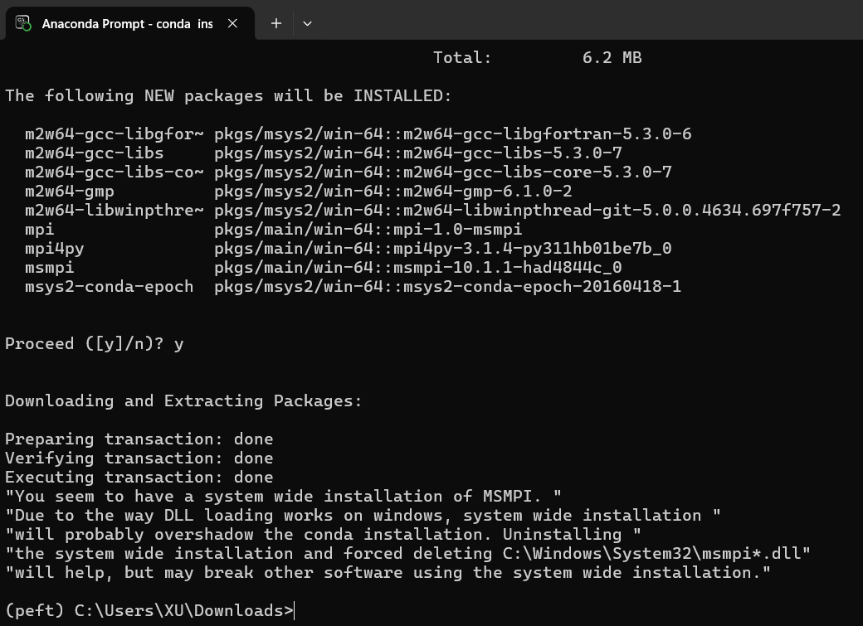

Online + Local Hybrid Installation
If your internet speed is very slow, for example, the lab is limited to 500 KB/s, you can use the following method to install packages:
- Download the .whl files under a different network and then copy it to your local machine.
For example, for PyTorch, its installation package is ‘torch-2.6.0+cu124-cp311-cp311-win_amd64.whl’, which is 2.35 GB in size. You can download it from the following link:
https://download.pytorch.org/whl/torch/
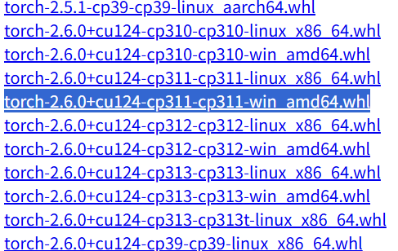
- Use pip to directly install this package; pip will automatically detect its dependencies.
pip install "torch-2.6.0+cu124-cp311-cp311-win_amd64.whl"
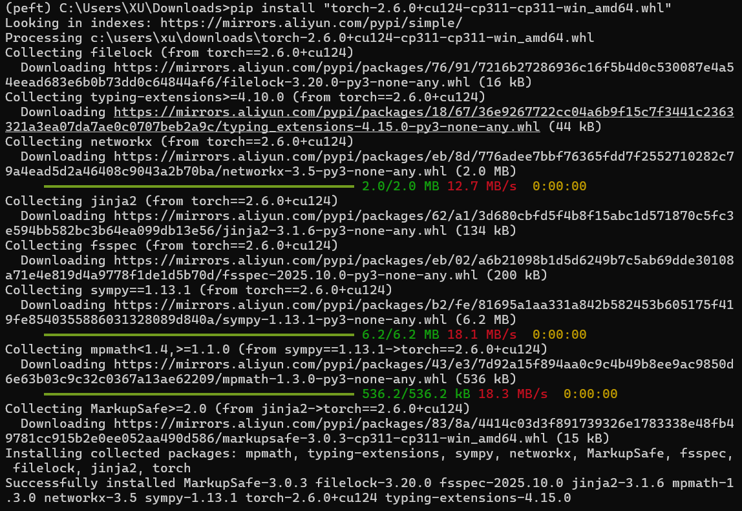
3、For other smaller packages, please install them directly online using pip.
pip install pytz==2025.2
pip install pandas==2.2.3
pip install matplotlib==3.10.1
pip install transformers==4.51.2
pip install sentencepiece==0.2.0
pip install gputil==1.4.0
pip install datasets==4.0.0
pip install peft==0.15.2
conda install mpi4py==3.1.4

Set Up HuggingFace
HuggingFace provides many open-source LLM weight files that can be used for fine-tuning.

Switch to Official Mirror Source
However, we cannot access its official website. Therefore, you need to switch to a mirror site in your code.
# Switch the HuggingFace download site at the beginning of the Python script
import os
os.environ['HF_ENDPOINT'] = 'https://hf-mirror.com'

Copy Cache Files
If your internet speed is very slow, for example, the lab is limited to 500 KB/s, you can configure the pre-trained LLM weights using the following method:
- Download the LLM weight files under a different network and then compress them into a ZIP file.
HuggingFace cache dir: C:\Users\username\.cache\huggingface\hub
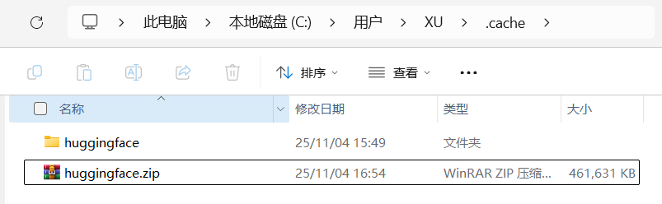
- Extract the files to the local cache directory, ensuring the folder structure remains exactly the same.
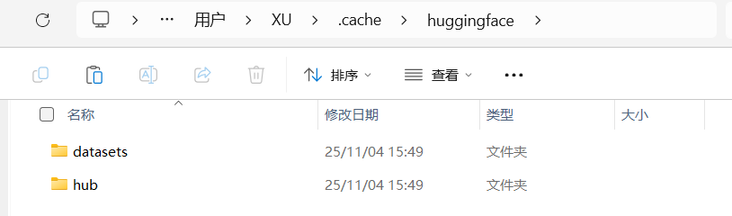

Configure VSCode
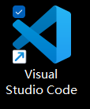
VSCode is a very powerful Integrated Development Environment (IDE) that allows you to write, debug, and run Python scripts. You can download it from the following link:
https://code.visualstudio.com/download
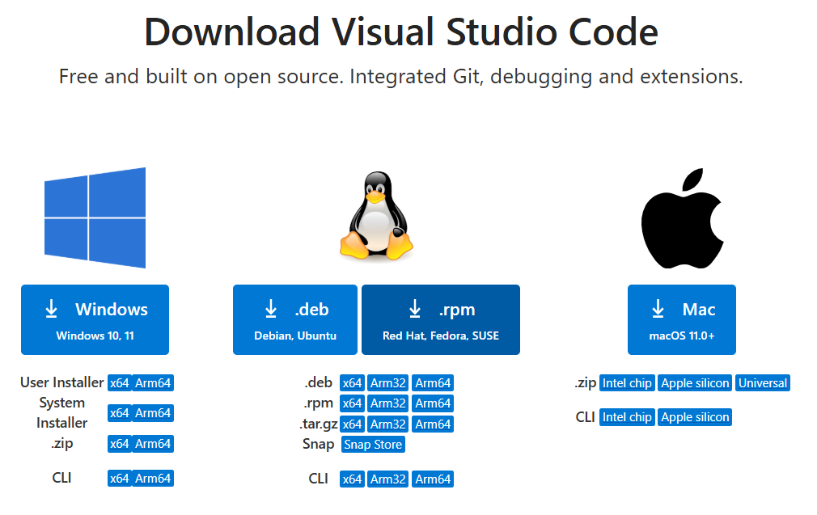

Install Python Extensions
Open VSCode Extensions Search for ‘Python’ and ‘Jupyter’ Install the following extensions: Python、MagicPython、Python Debugger、Jupyter
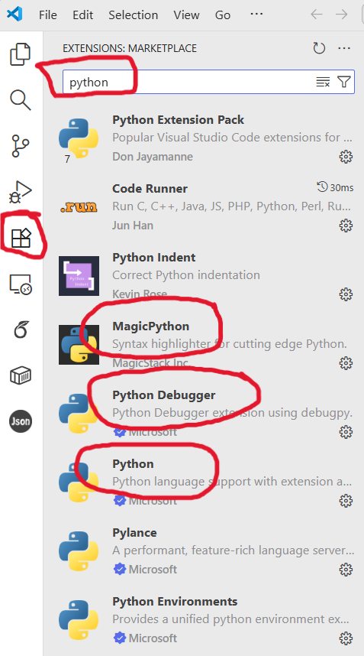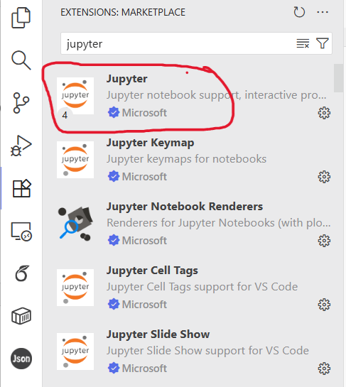

Set Command Prompt as the Default Terminal
Press Ctrl+Shift+P Search for ‘setting.json’ Select ‘Preference: Open user Settings (JSON)’ Add the following content at the end of the file:
"terminal.integrated.defaultProfile.windows": "Command Prompt"
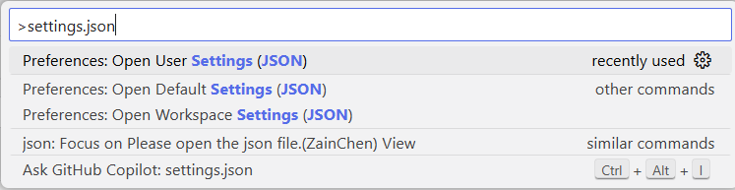
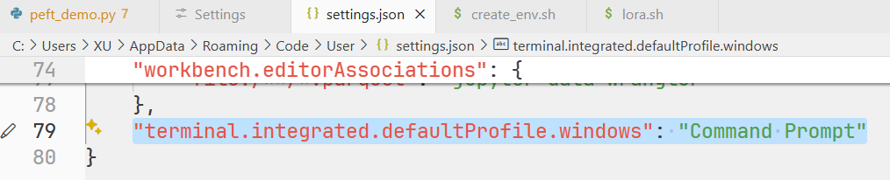
Terminal New Termianl
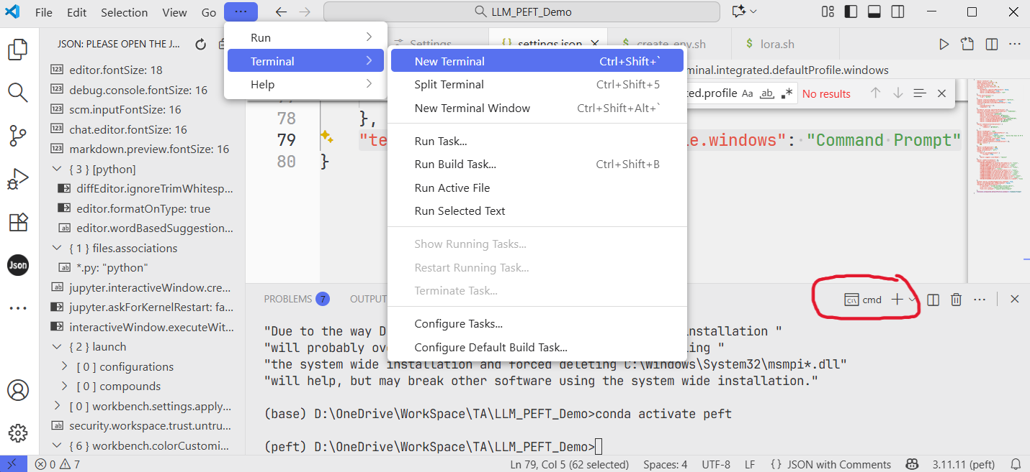

Switch to the Specified Python Environment
File Open Folder … Open a python script Switch to peft
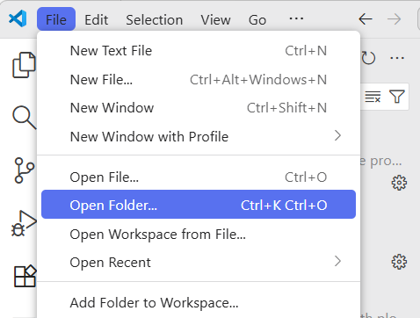
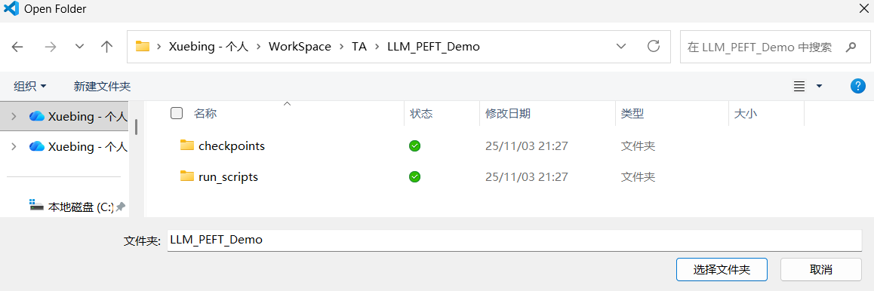
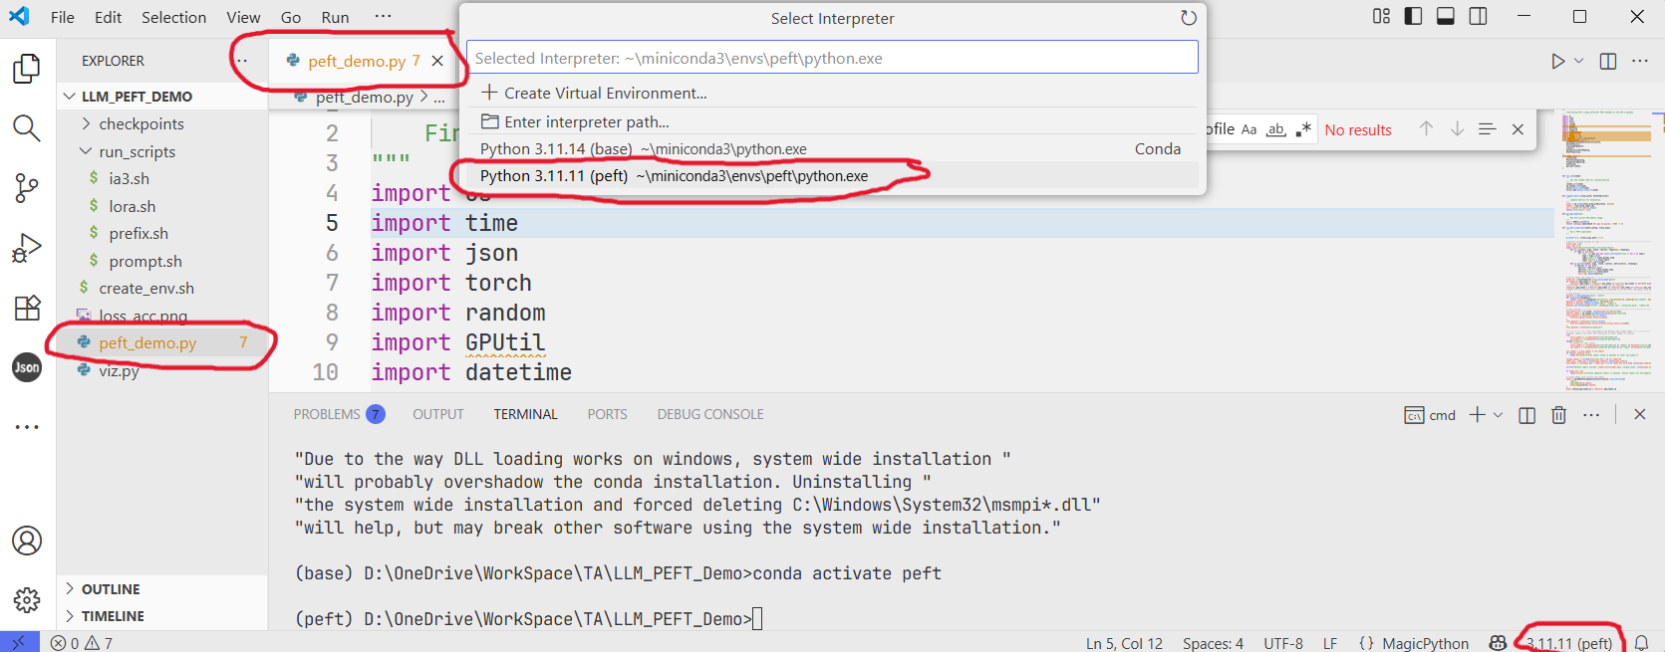

Run the Project
Execute the Python script containing the main program in the terminal
python peft_demo.py --seed 124458240 --peft LoRA --lr 1e-3 --epoch 10 --batch_size 16 --logging_steps 1
Run the Python script using the Python extension.
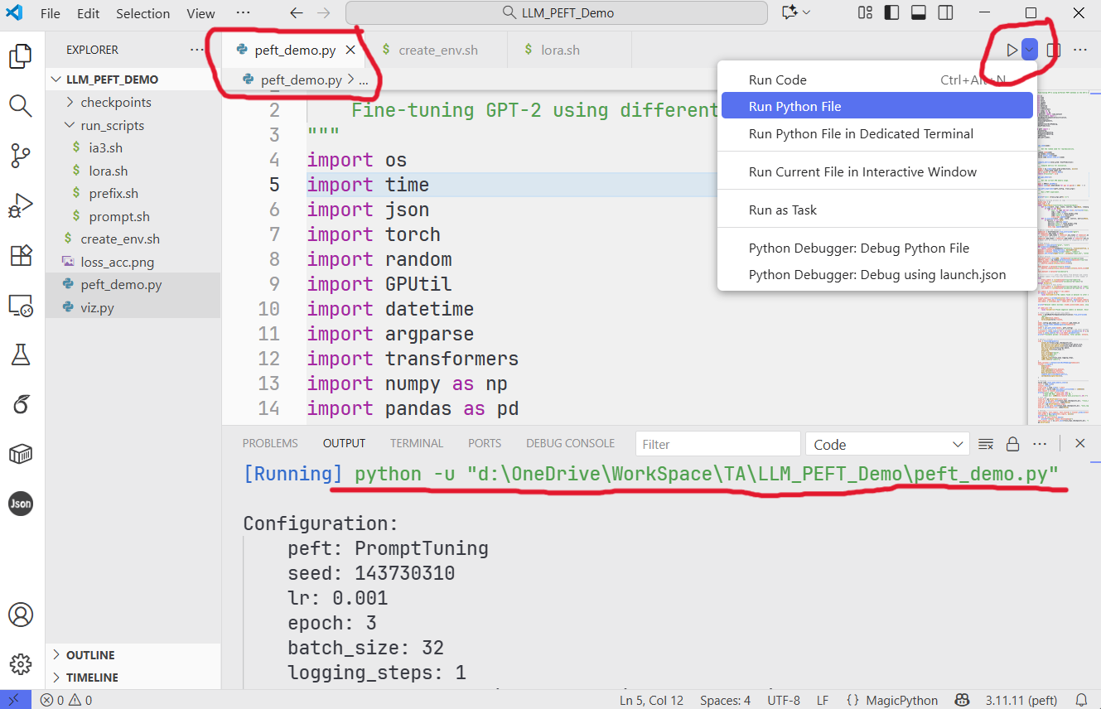

Debug
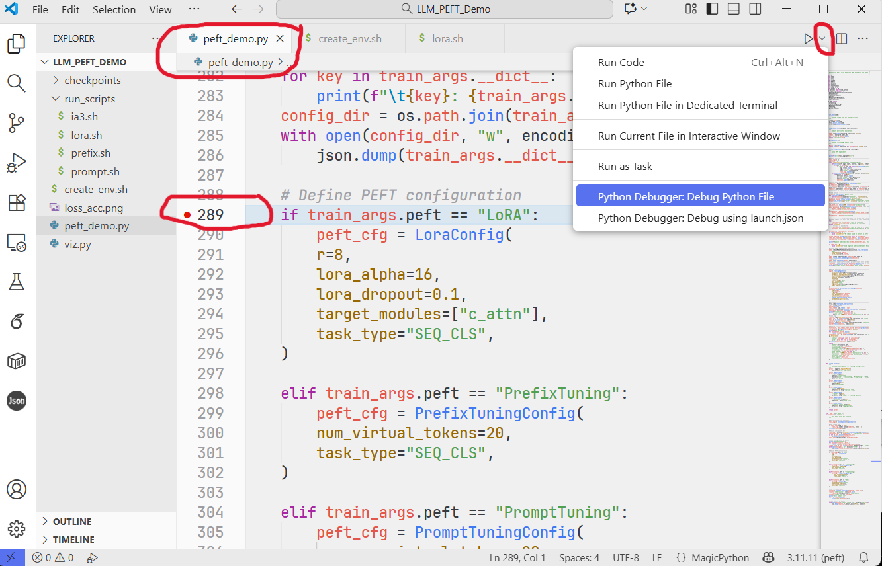
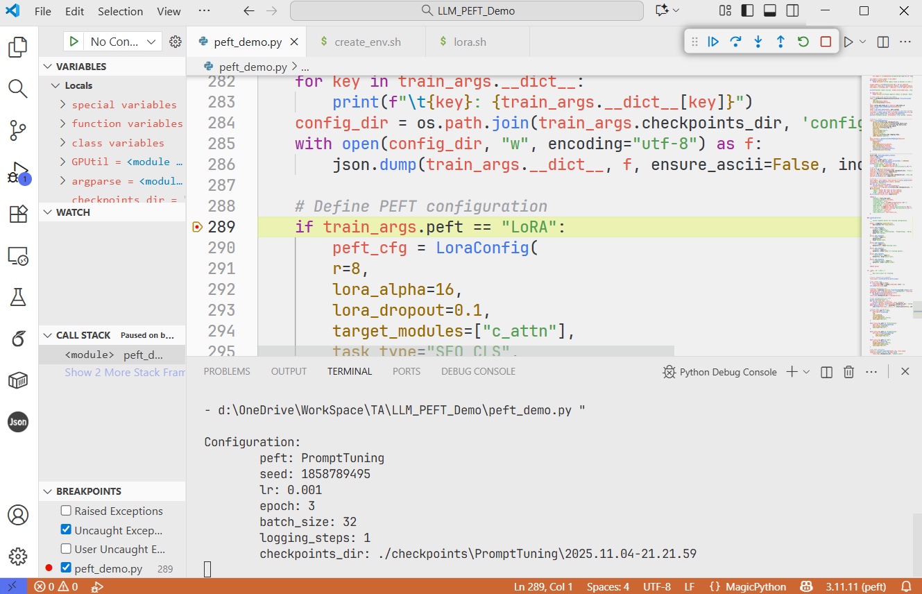

JupyterNotebook
Press Ctrl+Shift+P Search for ‘Jupyte: Create Interactive Window’ Launch Jupyter
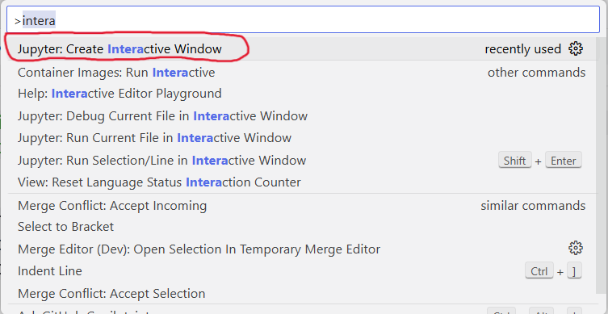
When launching for the first time, you need to install the required packages.
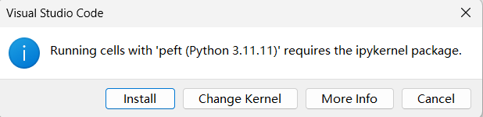
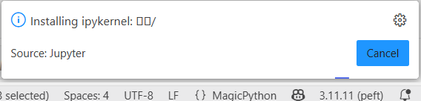
You can directly enter the commands you want to run in the window, just like in a Jupyter Notebook.
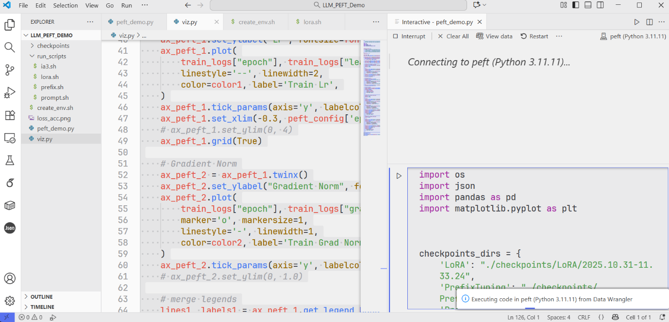
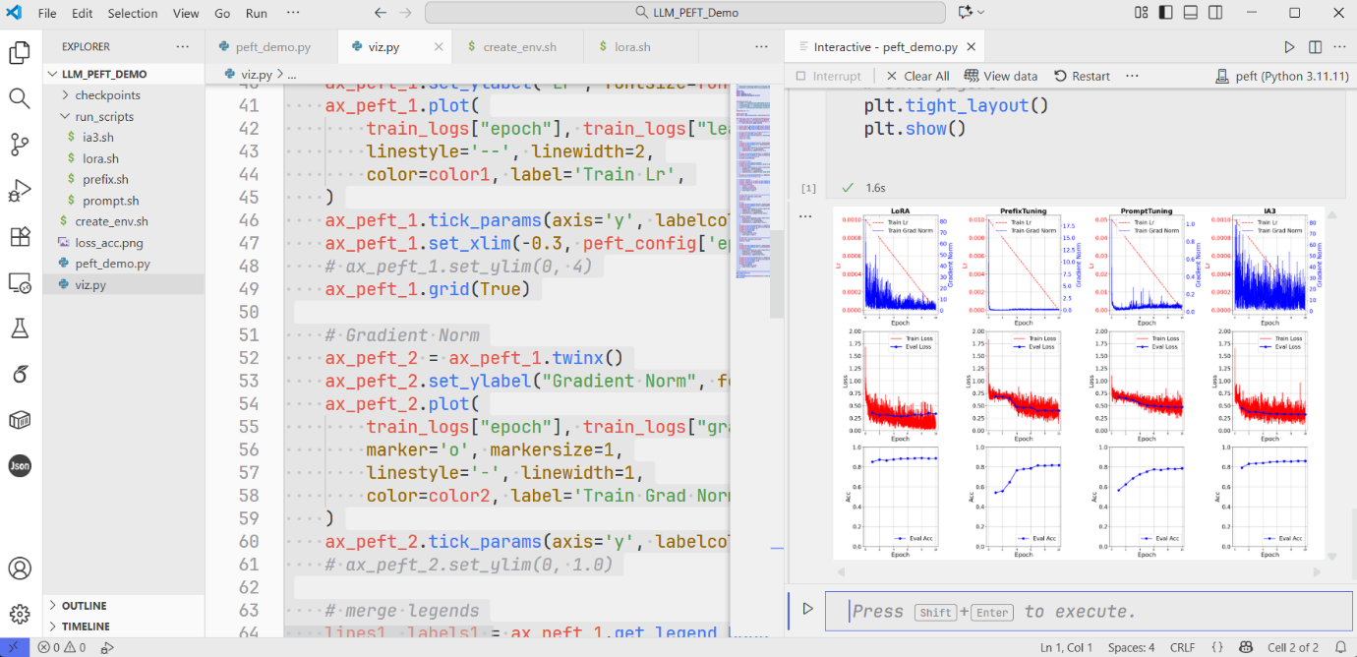
This interactive window is temporary; if you close or restart it, all history will be cleared.

