一、考虑的粒子

H2(v=0)~ H2(v=14)

H

H+

H2+

H3+

变量：上述参数的密度、电子密度、电子温度、

输入参数：进气流量、气压、气体温度、腔体尺寸

二、反应过程

|  |  |  |  |  |  |
| --- | --- | --- | --- | --- | --- |
|  |  | 过程 | 阈值 | 文献 | 备注 |
| 1 | 1.1 |  |  | CCC |  |
|  | 1.2.1  1.2.2  1.2.3 |  | 10.2  12.09  12.75 | CCC |  |
| 5 | 1.3 |  | 13.6 | Janev2003 |  |
|  |  |  |  |  |  |
| 6 | 2.1 |  |  | CCC |  |
| 7 | 2.2.1  2.2.2 | e+H2->e+H2(v=1,2) | 0.516  1.003 | Janev2003 |  |
|  |  |  |  |  |  |
| 9 | 2.3.1  2.3.2  2.3.3  2.3.4  2.3.5  2.3.6  2.3.7  2.3.8  2.3.9  2.3.10  2.3.11  2.3.12 | e+H2->e+H2* | EF1/12.42  B’’1/14.62  B’1/13.84  B1/11.37  C1/12.41  D’1/14.74  D1/14.13  c3/11.89  d3/13.98  e3/13.36  h3/13.98  a3/11.90 | CCC/阈值取自Fantz2006 |  |
| 21 | 2.4 | e+H2->e+2H | 10 | Yoon2008/阈值Janev1989 |  |
|  | 2.5 |  | 15.4 | Dirk |  |
|  | 2.6.1  2.6.2 |  | g/18.15  u/30.6 | Dirk |  |
| 25 | 2.7 |  | 3.72 | Janev2003 |  |
|  |  |  |  |  |  |
|  |  |  |  |  |  |
|  |  |  |  |  |  |
| 26 | 3.1 | e+H+->H+hv | 0 | Janev2003 |  |
| 27 | 4.1 |  | 2.4 | Janev1989 |  |
| 28 | 4.2 |  |  | Janev2003 |  |
|  | 4.3 | e+H2+->2e+2H+ |  | Janev2003 | 很小不考虑 |
|  |  |  |  |  |  |
|  | 5.1 |  | 2.5 |  | Janev2003可忽略 |
| 29 | 5.2 |  | 14 | Janev1989 |  |
|  | 5.3 |  | 0 | Janev2003 |  |
|  | 5.4 |  | 0 | Janev2003 |  |
|  | 5.5 |  |  |  | Janev2003中未提及，故不考虑 |
|  | 5.6 |  |  |  | Janev2003中未提及，故不考虑 |
|  |  |  |  |  |  |
|  |  |  |  |  |  |
| 32 | 6.1 |  | 0.754 |  |  |
|  | 6.2 |  |  |  | Janev2003不重要 |
|  |  |  |  |  |  |
| 33 | 7.1 |  |  | 1.3E-9*1E-6 | Matveyev1995 |
|  | 7.2 |  |  | 未找到截面 |  |
|  | 7.3 | H-+H2->H+H2+e |  |  | 暂不考虑 |
|  |  |  |  |  |  |
|  |  |  |  |  |  |
| 34 | 7.4.1  7.4.2 |  |  | n=2; 9.1E-11*(300./Tg)^(0.83)*1E-6  n=3; 1.77E-7*(300./Tg)^(0.5)*1E-6 | 只能生成n=2、3 (Janev2003).速率取自Matveyev1995 |
|  | 7.5 |  |  | 8.29E-13*(300/Tg)^0.5 | 5 |
|  | 7.6 |  |  | 2E-7*(300./Tg)^(0.5)*1E-6 | Matveyev1995 |
|  |  |  |  |  |  |
|  | 7.7 |  |  |  | Janev2003无此反应 |
|  | 7.8 |  |  |  | Janev2003无此反应 |
| 38 | 7.9 |  |  | 2E-7*(300/Tg)*1E-6 | 文献3 |
|  |  |  |  |  |  |
|  | 7.10 |  |  | 6.4E-16 | 5 |
|  |  |  |  |  |  |
|  | 7.11 |  |  | 2.1E-15 | 2,3 |
|  |  |  |  |  |  |
|  |  |  |  |  |  |
|  |  |  |  |  |  |
|  |  |  |  |  |  |
|  |  |  |  |  |  |
|  |  |  |  |  |  |
| 41 | 8.1 |  |  |  |  |
|  | 8.2 |  |  |  |  |
| 43 | 8.3 |  |  |  |  |
|  |  |  |  |  |  |
| 44 | 8.4 |  |  |  |  |

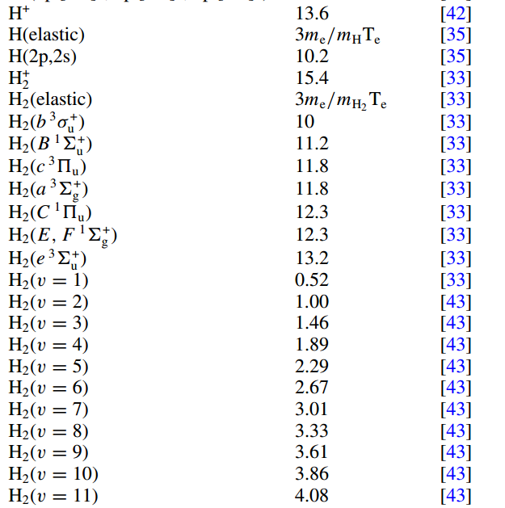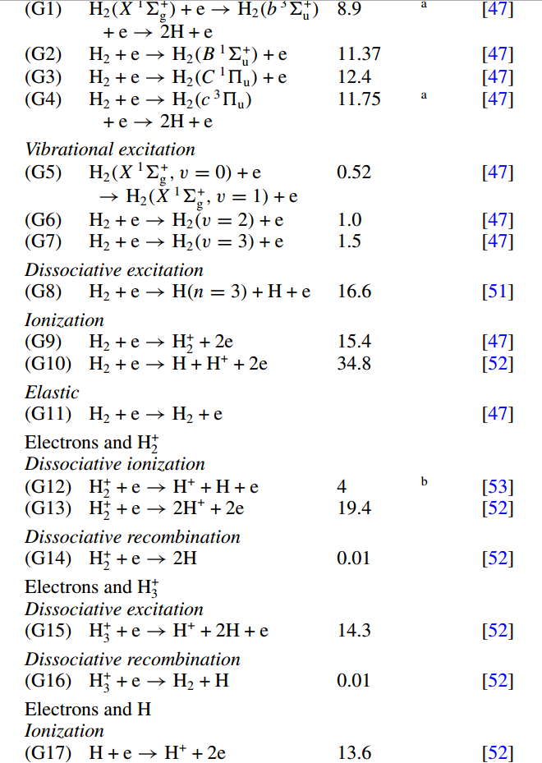

|  |  |  |  |  |
| --- | --- | --- | --- | --- |
|  | 反应过程 | 阈值 | 速率 | 文献 |
| 1.1 |  |  | 1.8E-7*Te^(-0.2)*exp(-0.2/Te)*1E-6 | 1 |
| 1.2 |  | 13.6 | 8.1E-9*Te^(0.5)*exp(-13.6/Te)*1E-6 | 1 |
|  |  |  | 1.75 E−14*exp(−15.4/Te) | 2 |
|  |  |  | 7.89E-15*Te^(0.41)*exp(-14.23/Te) | 5 该速率和Janev的最接近 |
| 1.3 |  | 10.2 | n=2 |  |
|  |  | 12.09 | n=3 |  |
| 1.4 |  | 1.89 |  |  |
| 1.5 |  | 3.4 | n=2 |  |
|  |  | 1.51 | n=3 |  |
| 2.1 |  |  | 1.6E-7*exp(-0.2/Te)*1E-6 | 1 |
| 2.2 |  |  | 1.8E-9*Te^(0.5)*exp(-18.1/Te)*1E-6 | 1 |
|  |  |  | 3.07E-16*exp(-17.5/Te) | 2 和Dirk的数据较接近，建议用Dirk的.其实这个要分成两个过程 |
|  |  | 18.15 | g | 用了Dirk的截面数据 |
|  |  | 30.6 | u |  |
| 2.3 |  | 15.4 | 9.1E-9*Te^(0.5)*exp(-15.4/Te)*1E-6 | 1 |
|  |  |  | 3.11E-14*exp(-18.9/Te) | 2 |
|  |  |  | 1.1E-14*Te^0.42*exp(-16.05/Te) | 5 和CCC最接近，Dirk和CCC的几乎完全重合 |
| 2.4 |  | 10 | 1.6E-8*Te^(0.5)*exp(-8.7/Te)*1E-6 | 1 |
|  |  |  | 1.2E-14*exp(-10./Te) | 2 |
|  |  |  | 1.2E-14*exp(-15.4/Te) | 4 |
|  |  |  | 4.73 E−14*Te^(−0.23)*exp(−10.09/Te) | 5 和Yoon2008很接近 |
| 2.5 |  | 3.72 | 2.05E-17*Te^(-1.04)*exp(-9.04/Te) | 5 |
|  |  |  | Janev2003表达式，使用其截面的表达式而非速率表达式 |  |
| 2.6 |  | 14.68 |  | 建议使用Swada |
|  |  | 17.22 | n=3 3.74E-16*exp(-18/Te) | 2 |
| 3.1 |  | 2.4 | 1.45E-13*exp(-1.97/Te) | 2 和Janev1989很接近，建议使用 |
|  |  |  | 1.88E-13*Te^(-0.39)*exp(-28.82/Te) | 5 比Janev1989小2个数量级 |
| 3.2 |  | 14.4 |  | 建议使用Janev2003 |
|  |  |  |  | 建议加上解离复合过程 |
|  |  |  |  |  |
| 3.3 |  | 0.01 | 5.3E-8*Te^(0.5)*exp(0/Te)*1E-6 | 1 |
|  |  |  | 2.35E-14*Te^(0.4) | 5 用 |
|  |  |  | 3E-8*(300/Te)^0.5*1E-6 | 3 |
|  |  |  | n=2 Janev1989 |  |
|  |  |  | n=3 Janev1989 |  |
| 4.1 |  | 2.5 | 1.93E-16*Te(-1.07)*exp(-2.7/Te)+2.59E-15*Te^(-1.27)*exp(-6.45/(Te+0.1)) | 5 阈值从文献7估读 |
| 4.2 |  | 14 | 1E-13*Te^(0.37)*exp(-14.46/Te) | 5 和Janev1989很接近 |
| 4.3 |  | 0 | 2.19E-15*Te^(0.8) | 5 |
| 4.4 |  | 0 | 3.7E-8*Te^(0.5)*exp(0/Te)*1E-6 | 1 不同文献的阈值略有差别，取自Janev1989 |
|  |  |  | 7.3E-16*Te^(0.8) | 5 |
|  |  |  | 1.55E-13*(300/Tg)^0.97 | 2,3 |
| 5.1 |  | 0.754 | 1.24E-12*Te^(0.03)*exp(-10.44/Te) | 5 比Janev2003小，Janev2003和1989很像 |
| 6.1 |  |  | 1.28E-13*(300/Tg)^0.5 | 5 |
| 6.2 |  |  | n=2; 9.1E-11*(300./Tg)^(0.83)*1E-6 | 6 |
|  |  |  | n=3; 1.77E-7*(300./Tg)^(0.5)*1E-6 | 6 |
| 7.1 |  |  | 2E-11*1E-6 | 1 |
|  |  |  | 6.4E-16 | 5 |
| 7.2 |  |  | 1.2E-9*1E-6 | 1 |
|  |  |  | 2.1E-15 | 2,3 |
|  |  |  | 2E-15 | 5 |
|  |  |  | Janev1989有图 |  |
| 7.3 |  |  | 2E-7*(300/Tg)*1E-6 | 3 |
|  |  |  | 8.29E-13*(300/Tg)^0.5 | 5 |
| 7.4 |  |  | 2E-7*(300./Tg)^(0.5)*1E-6 | 6 |
| 8.1 |  |  | 8.29E-13*(300/Tg)^0.5 | 5 |
| 8.2 |  |  | 2E-7*(300./Tg)^(0.5)*1E-6 | 6 |
| 8.3 |  |  | 2E-7*(300/Tg)*1E-6 | 3 Yang2018无此过程 |
| 9.1 |  |  | 1.3E-9*1E-6 | 6 |
|  |  |  | Janev2003有截面拟合公式 |  |
| 10.1 |  |  |  |  |
| 10.2 |  |  |  |  |
| 10.3 |  |  |  |  |
| 10.4 |  |  |  |  |
| 10.5 |  |  |  |  |

1] Model of a two-stage rf plasma reactor for SiC deposition

J. Appl. Phys., Vol. 90, No. 2, 15 July 2001 G. M. Petrov and J. L. Giuliani

2] Properties of inductively coupled rf Ar/H2 plasmas: Experiment and global

Model J. Appl. Phys. **107**, 083308 2010 T. Kimura and H. Kasugai

3] A travelling wave sustained hydrogen discharge: modelling and experiment Plasma Sources Sci. Technol. **9** (2000) 295–303. Printed in the UK

4] Takashi Kimura and Hiroki Kasugai 2012 *Jpn. J. Appl. Phys.* **51** 046202

5] A T Hjartarson *et al* 2010 *Plasma Sources Sci. Technol.* **19** 065008

6] A A Matveyev and V P Silakov 1995 *Plasma Sources Sci. Technol.* **4** 606

7] Journal of Physical and Chemical Reference Data **19**, 617 (1990) Cross Sections and Related Data for Electron Collisions with Hydrogen Molecules and Molecular Ions H. Tawara, Y. Itikawa, H. Nishimura, and M. Yoshino