Homework4 Programing Assignment report

Part 1.

Part 2.

In this part, I chose the #28 image in the training set of neutral expression images. As the plot of the MSE vs. the number of the PCs used in image reconstruction, the MSE drops rapidly from 2 to 10, and it continuously drops as the number of PCs reached about 87 and then raises rapidly then quickly falls. Based on the tendency of the MSE, the performance of image reconstruction when PCs = 50 is better than the performance when PCs = 10.

As for the set of smiling expression, I chose the image #44. The tendency of its MSE vs. the number of PCs has a quick drop when number of PCs equals to 20, and a rapid raise when number of PCs reaches to 90. Based on that, the reconstruction image using 50 PCs has more details than the one of 10 PCs. However, we can also observe some overlapping shadows around the area of mouth. It should be minimized or even removed as the PCs we used increase to about 90.

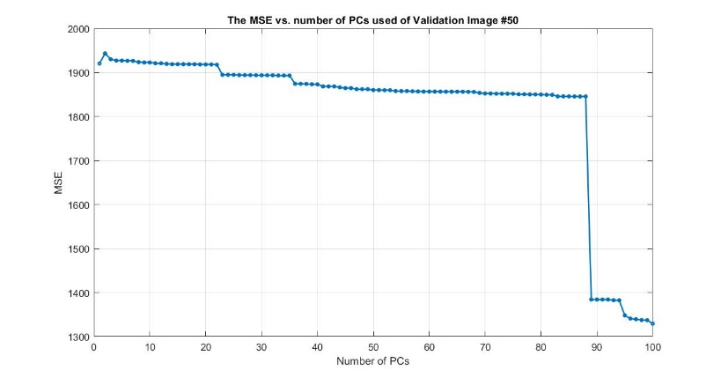Part 3.

In part 3, the tendency of the MSE of the validation neutral expression image # 50 is gradually decreases as PCs becomes larger and has a quick fall when PCs hits 90. Therefore, I use 90 PCs to reconstruct the image which has a fine performance.

As for the validation of smiling, I chose image 28. The tendency of its MSE has a rapid drop when PCs = 30 and a quick raise when PCs = 92. Therefore, I used 91 PCs to reconstruct the image. However, the overlapping shadows around the mouth are still exists.

Part 5.

The accuracy of neutral expression prediction = 0.13333

The accuracy of smiling expression prediction = 0.46667

From the missed prediction, we can see that the MSE of both smiling and neutral prediction are really closed.