Redis操作5种数据类型
传统的关系型数据库支持的数据类型:字符串,数字,时间日期,其他
Redis支持的5种数据类型: 字符串,哈希,字符串列表,字符串集合,有序字符串集合

Redis操作字符串
set name tom
get name
set name mary
get name
getset name smith
get name
del name
get name
incr num01
decr num01
incrby num01 33
decrby num01 33
append num01 abc

Redis操作哈希类型数据
hset myhash01 name tom
hset myhash01 age 18
hget myhash01 name
hget myhash01 age
hmset myhash02 name lucy age 18 m:multiple:多个的
hmget myhash02 name age
hgetall myhash02
hdel myhash02 name age
del myhash02
hincrby myhash02 age
hexists myhash02 username
hlen myhash02
hkeys myhash02
hvals myhash02

Redis操作列表类型数据
*_ArrayList和LinkedList特点回顾:
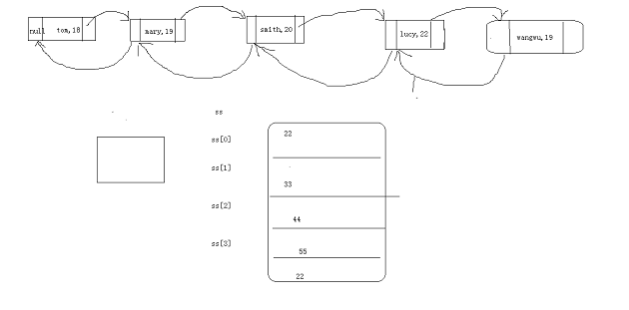
*_双线链表中添加数据
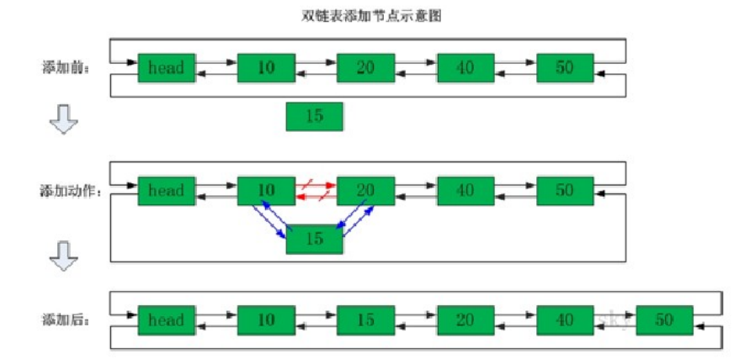

*_双线链表中移除数据
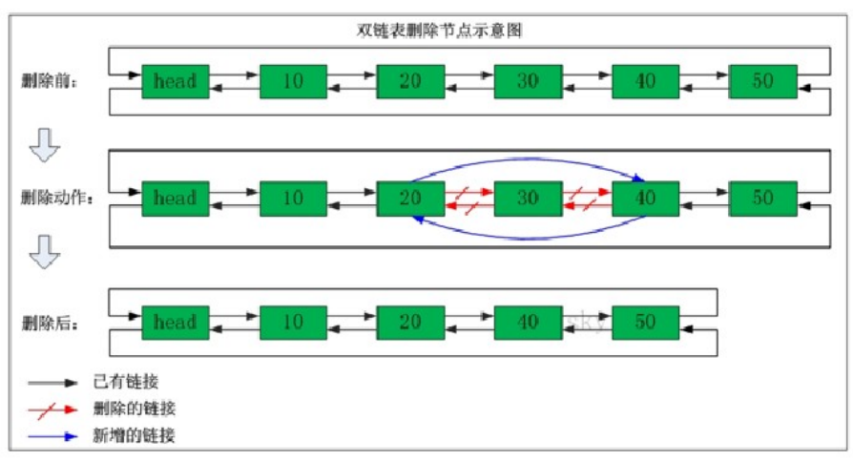
*_核心命令
PS:redis中的列表有头尾,约定:左头右尾
lpush mylist01 1 2 3
lpush mylist01 1 2 3
rpush mylist02 a b c d
rpush mylist02 1 2 3
lrange mylist01 0 -3
lrange mylist01 0 -1
lpop mylist01
rpop mylist01
llen mylist01
lpushx mylist01 33
lpushx mylist03 ff
rpushx mylist01 44
rpushx mylist03 44
lpush mylist03 1 2 3 1 2 3 1 2 3
lrem mylist03 2 3
lrem mylist03 -2 1
lrem mylist03 0 2
lset mylist03 3 444
linsert mylist03 before b 11
linsert mylist03 after b 22
lpush mylist05 1 2 3
lpush mylist06 a b c
rpoplpush mylist05 mylist06
rpoplpush mylist06 mylist06
PS:rpoplpush的使用场景

Redis操作set类型数据
sadd myset01 a b c
sadd myset01 a
srem myset01 a b
smembers myset01
sismember myset01 a
sadd mya1 a b c
sadd myb1 a c 1 2
sdiff mya1 myb1
sadd mya2 a b c
sadd myb2 a c 1 2
sinter mya2 myb2
sadd mya3 a b c
sadd myb3 a c 1 2
sunion mya3 myb3
scard myset01
sranmember myset01
sdiffstore my1 mya1 myb1
sinterstore my1 mya2 myb2
sunionstore my1 mya3 myb3

Redis操作sortedset类型数据
zadd mysort01 70 zhangsan 80 lisi 90 wangwu
zadd mysort01 100 zhangsan
zadd mysort01 50 jack
zscore mysort01 zhangsan
zcard mysort01
zrem mysort01 zhangsan lisi
zrange mysort01 0 -1
zrange mysort01 0 -1 withscores
zrevrange mysort01 0 -1 withscores
zremrangebyrank mysort01 0 4
zremrangebyscore mysort01 50 80
zrangebyscores mysort01 0 100 withscores
zrangebyscores mysort01 0 100 withscores limit 0 2

Redis干什么的?
llen mylist01
zcard mysort01

Keys的通用操作
keys *
keys my?
del myname
exists myname
rename myname name
expire myname 1000
ttl myname
type mystring string
type mylist list
type myset zset
type mysort sort
type myhash hash
type myzzz none

5种数据类型操作: 知道做了哪些事情?内存分布情况,命令依次敲一遍
Keys通用操作
Java操作Redis

