14.

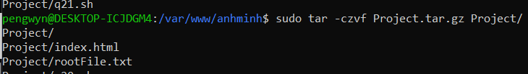



15.

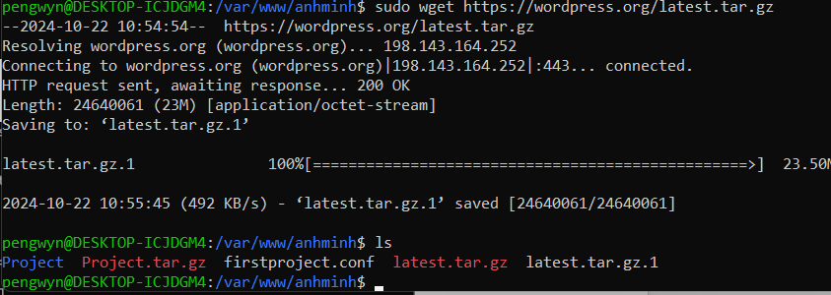

16.

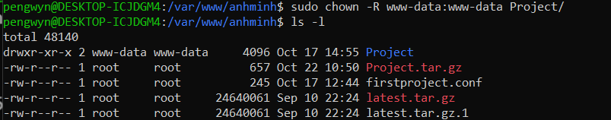

17.

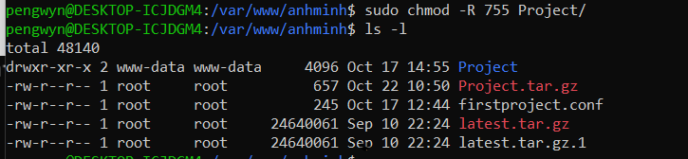

18.



19.

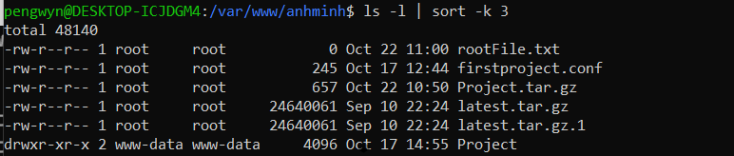

20.



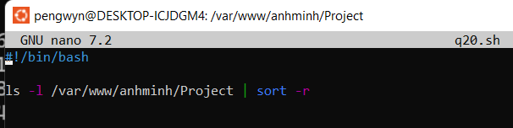

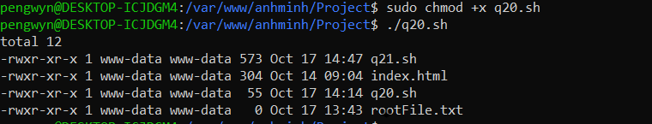

21.

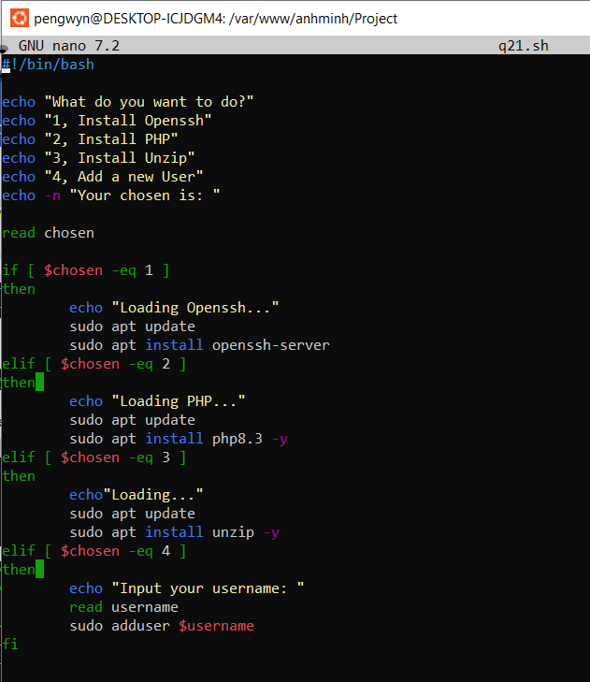

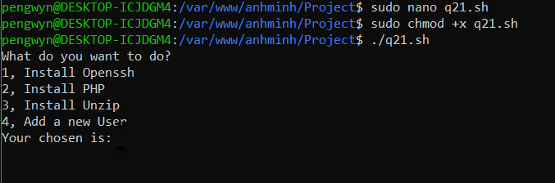

1. Create Account

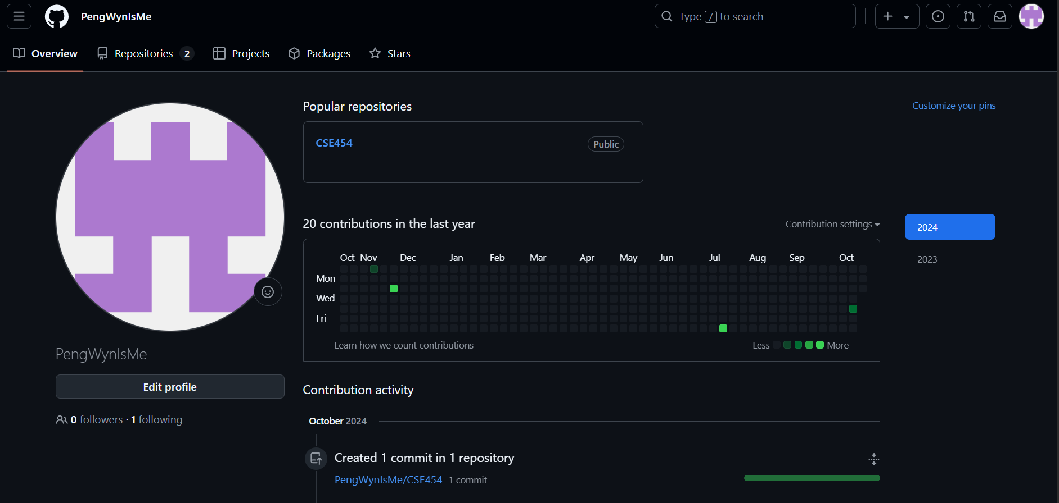

1. Create a new repository



1. Exploring repository settings

* Rename **Repository name**

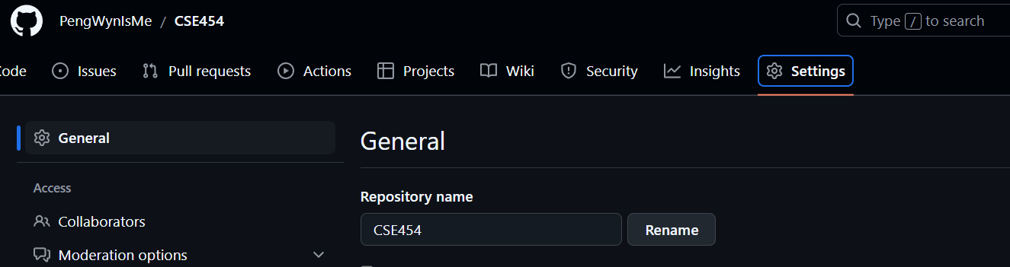

* Turn on/off features: Wiki, Issues

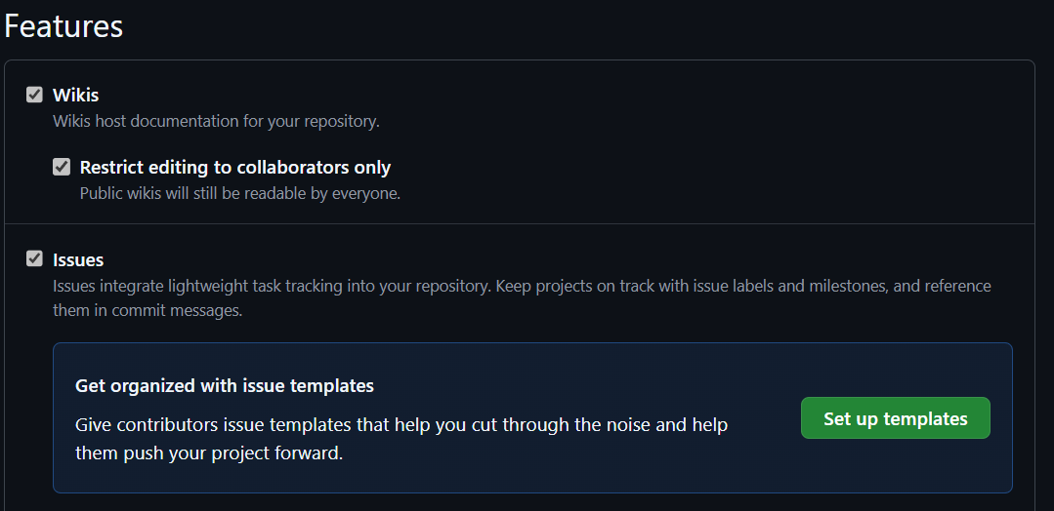

* Change repository visibility

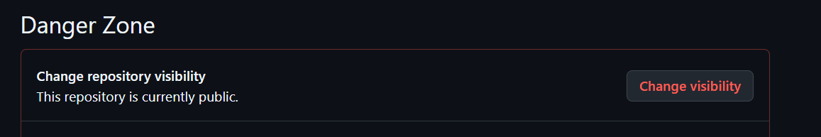

* Transfer ownership

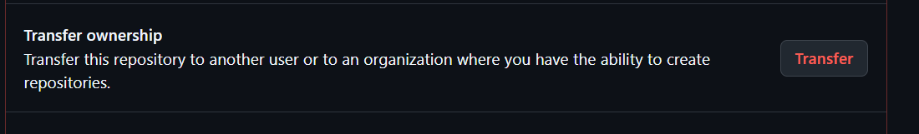

-Delete a repository

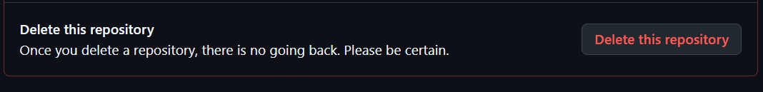

* Add/Delete collaborators

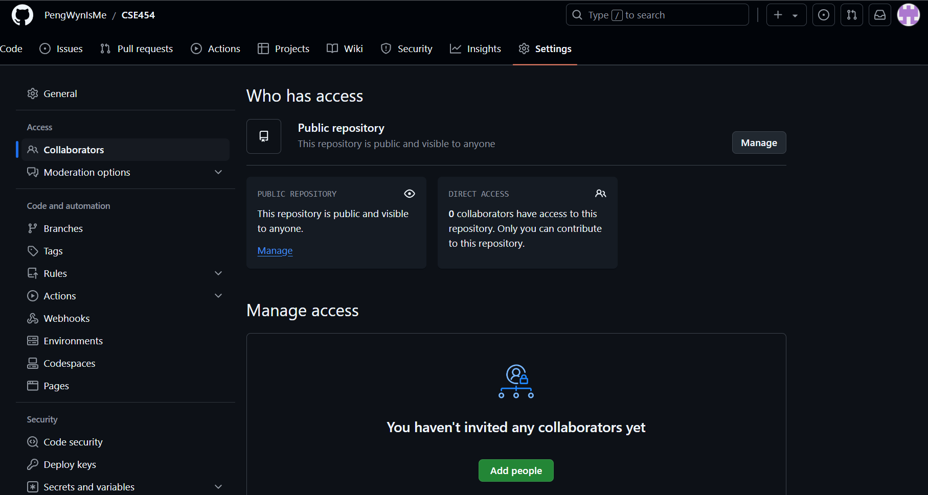

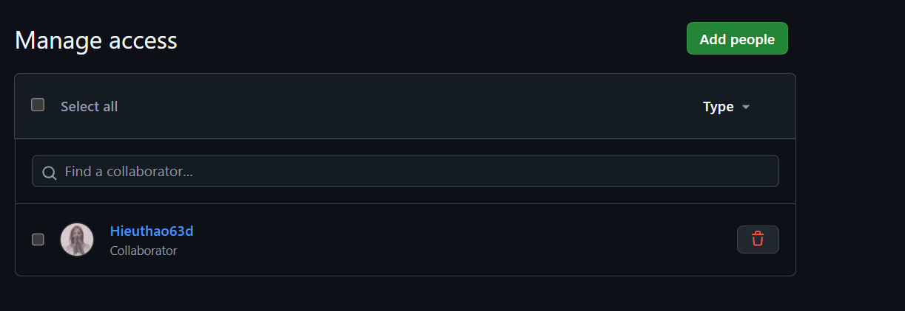

1. Exploring account settings

* Change username

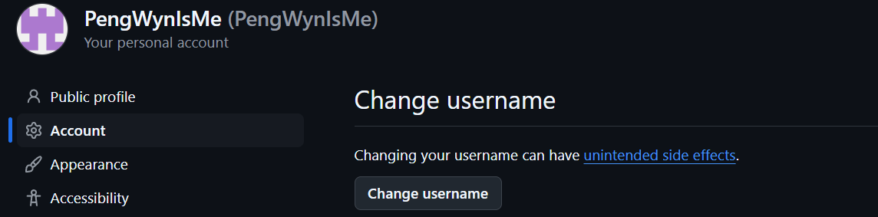

* SSH keys

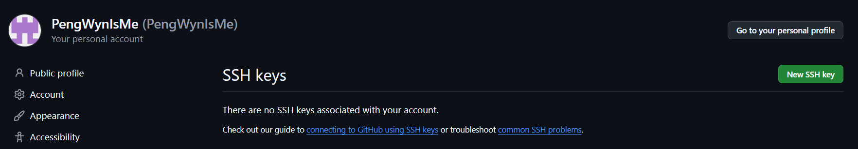

* Accept colloaborator invitation

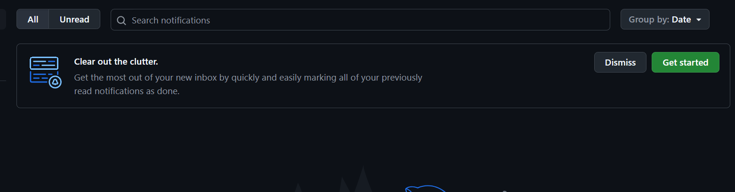- Get Personal access tokens

