- Introduction
- Data Preparation

  - Number counts for datasets
Two datasets were used for model training:
- Walls: retaining wall images divided into cracked and non-cracked classes.
- Decks: bridge deck images divided into cracked and non-cracked classes.
The first step was to determine the total number of images in each dataset and the class distribution, as shown below
Table - The number of images on the wall and deck datasets
Wall |  | Deck
Cracked | Non-Cracked | Cracked | Non-Cracked
3751 | 14188 | 1926 | 11496
The results indicate that the wall dataset contains a greater number of images than the deck dataset. Specifically, the wall dataset contains 17,939 images, whereas the deck dataset contains 13,422 images. The greater number of wall images could lead to better performance on the wall dataset than on the deck dataset.
In both datasets, the number of non-cracked images is substantially higher than the number of cracked images, indicating a clear class imbalance, as shown below
Figure – Class distribution of the wall and deck datasets
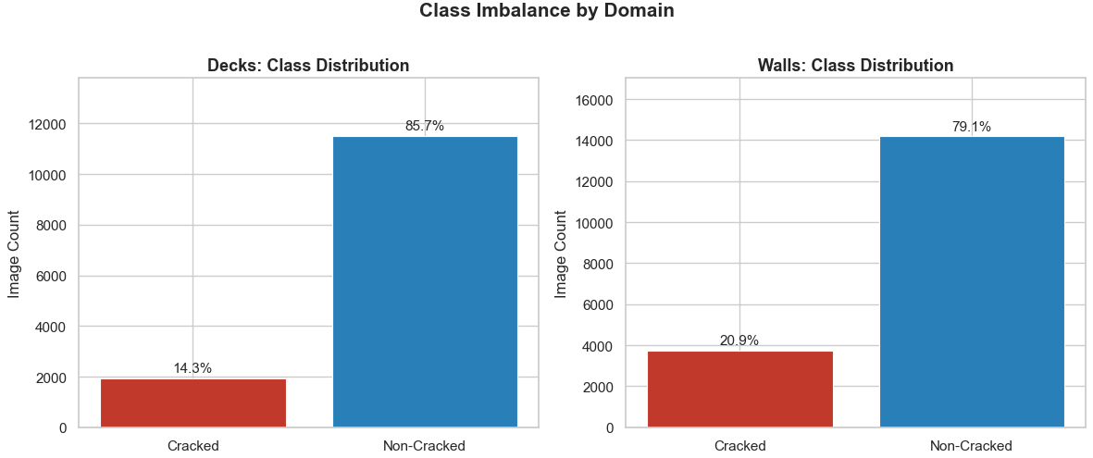
This class imbalance is significant because it can bias the model towards predicting the majority class(non-cracked) more frequently. As a result, the model may achieve an acceptable overall accuracy while still performing poorly in detecting the minority class(cracked). In a structural inspection task, this is particularly important because failing to identify a cracked image (False Negative) is more serious than incorrectly classifying a non-cracked image as cracked (False Positive).
Recall
Weights
$$weight cracked=\frac{Total number of images}{2*number of cracked images}$$
Table – Weights for Cracked and Non Cracked images
 | Number of images | Weight
Cracked | 3,974 | 2.762
Non-Cracked | 17,978 | 0.611

  - Standardize image format
Format check was performed on both training datasets, it shows that all images were already provided in a standardized format, with a resolution of 256 × 256 pixels.
Figure – Format check of all images
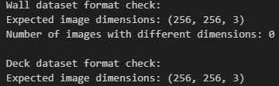
This is consistent with the project brief, which states that basic preprocessing had already been carried out before the data were supplied. Therefore, no additional resizing was required. The original image format was retained for model development to preserve the visual details needed for crack detection.

  - Grey Scale

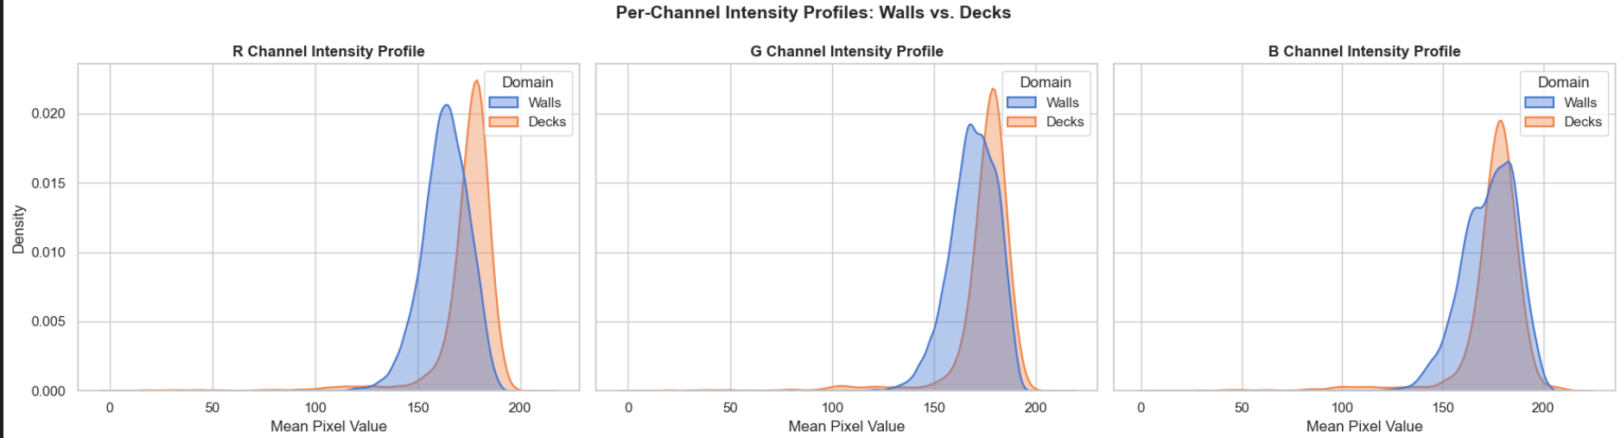
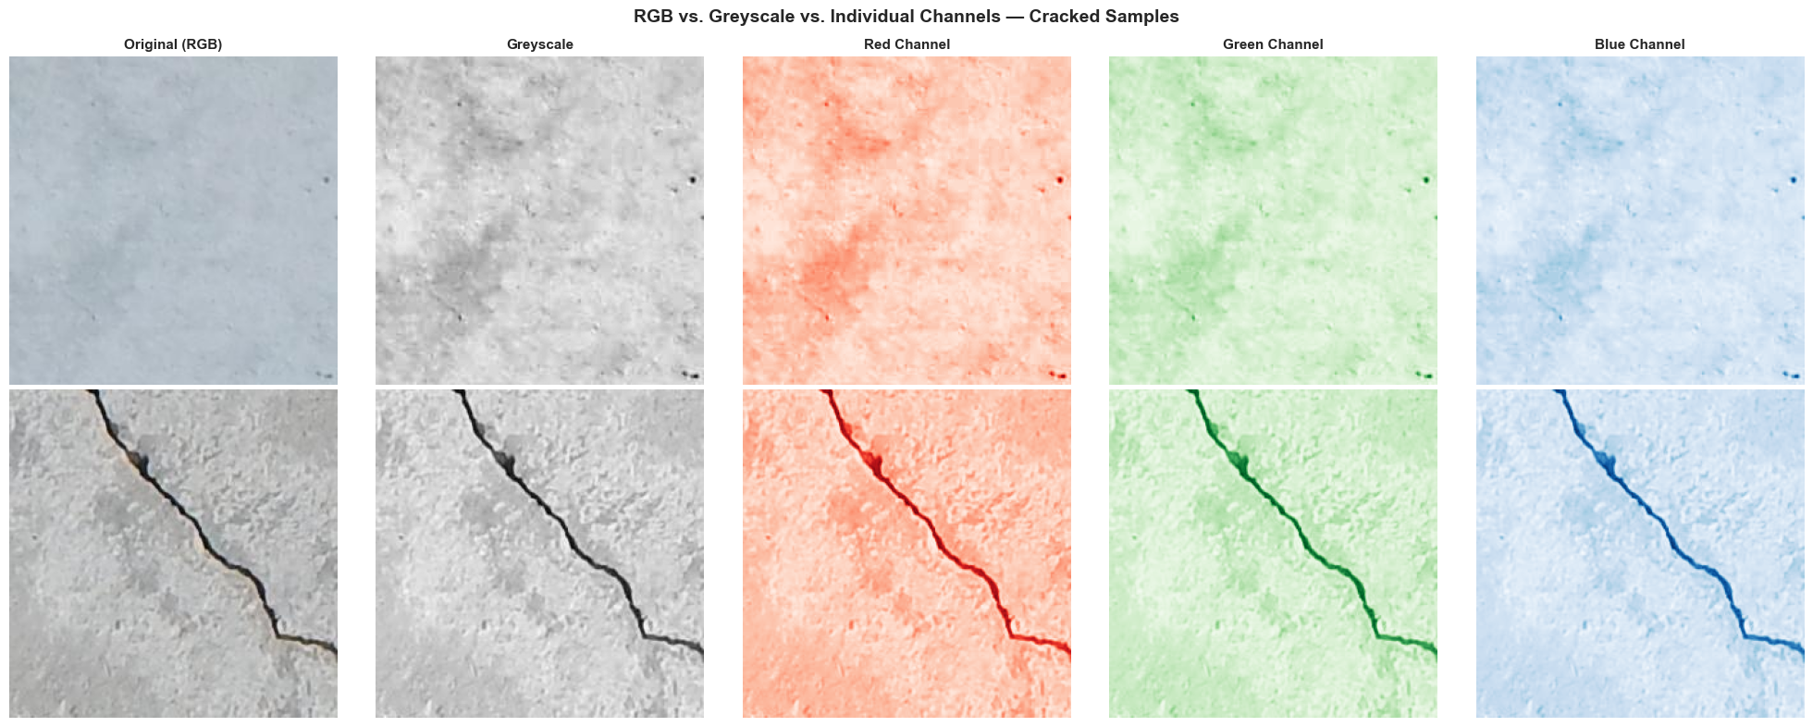

  - Flag Outliers
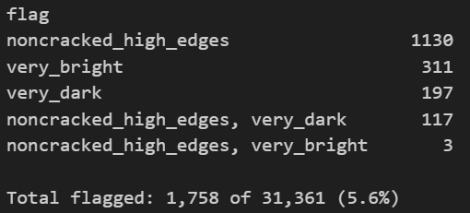

  - Mystery Test Set Audit

