

The Web Content Accessibility Guidelines are designed to aid in the development of web content considerate of a wider range of users with varying disabilities to empower all manner of users to feel confident navigating web content. By adhering to the guidelines, content becomes more accessible and is delivered to a higher standard which benefits hosts from increased usability and thus, more web traffic.

Throughout the production of the FMA, designs were considerate of the layers of guidance. Designs were evaluated against the four core principles of accessibility, assessed through their compliance with established guidelines.

The four principles evaluated against design were:

1. **Perceivability** – achieved by ensuring information was perceivable through various ‘senses’ to ensure web content could be communicated to users through a range of methods.
2. **Operability** - achieved by ensuring user interface components were navigable through various input mediums to empower users to interact and navigate through various input devices.
3. **Understandability** – achieved by ensuring user interface components adhered to design norms and were intuitive to interact with, not requiring further explanation beyond fundamentals to interpret web content
4. **Robust** – achieved by ensuring content can be interpreted reliably by varying user agents and any assistive technologies employed

Below entails an evaluation of the FMA’s degree of accessibility attained against established guidelines of the four principles.

**Perceivability**

*Text Alternatives:*

For non-text content, text descriptions have been included which can be used by screen-readers to communicate content through an auditory medium, affording consideration to users with visual impairments.

*Time-based Media:*

Time-based media concerns audio and video media. Within the FMA video content was implemented to satisfy robustness concerns by sourcing media in several filetypes for compatibility with user-agents. However, video content could be criticised regarding perceivability. With no captions or audio descriptions, users with visual impairments were unable to interpret video content.

*Adaptability:*

The decision to create individual pages to encapsulate purpose-specific content allowed relationship between content and structure to be refined. This allowed to maintain a meaningful sequence of presented content which would have been difficult to achieve through a single-page approach.

Additionally, consideration has been afforded across user-agents to ensure content is not restricted or absent across orientations and screen-sizes.

*Distinguishable:*

An important factor as part of making web content distinguishable is the use of colour. Throughout the design of the FMA, the colours were considered for users with varying types of colour deficiencies in mind. Below are screenshots depicting the FMA with different colour-blind filters, notice that content still remains legible.

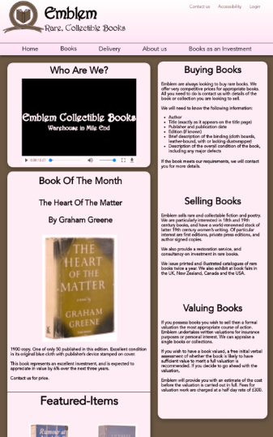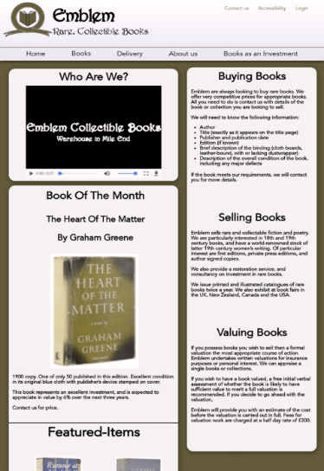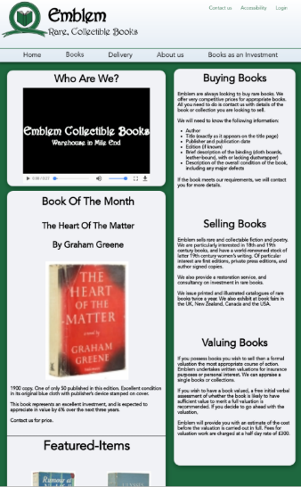

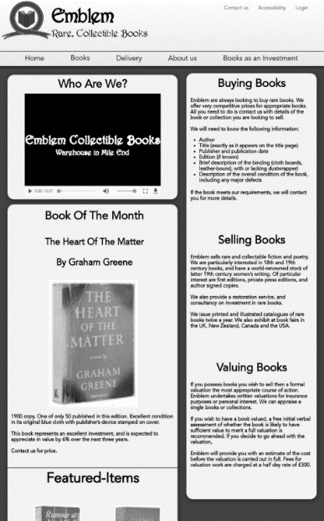

Figure 3- Deuteranopia Website

Figure 2- Protanopia Website

Figure - Original website

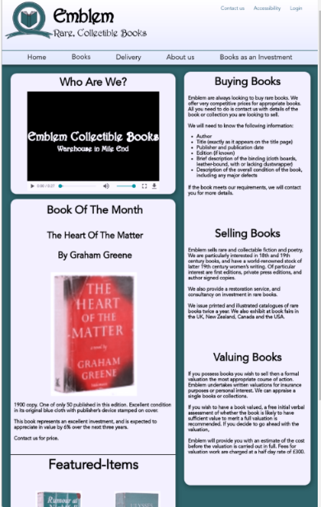

Figure 5- Greyscale Website

Figure 4- Tritanopia Website

Audio controls were implemented as a mechanism separate from the user’s system volume level, controllable through keyboard or mouse.

Furthermore, hoverable content – such as the desktop books sub-navigation was designed to remain persistent while the pointer is moved over said content.

Operability

All content has been designed to operate through a keyboard interface without requiring specific timings for input. Steps have been taken to avoid the ‘keyboard trap’ and focus can be navigated using the keyboard. Furthermore, CSS has been engineered to show focus on UI elements through visual indication, such examples include when “book” is focused in the navigation bar and when either the email or phone number is focused in the footer.

In addition, location is presented to the user when navigating within embedded webpages. One such example is shown in the 19th century webpage which is an embedded page belonging to the books page. This allows users to be aware of their location within the webpage at all times. Also, embedded webpages (i.e. 19th century page) may be located in multiple ways – however this feature is only provided on desktop displays (through sub navigation)

One criticism of operability would arguably be a lack of native pointer gesture support. The FMA has not been designed for non-keyboard/mouse input methods and without an OS specific feature (such as VoiceOver on iOS devices), users may find it difficult to navigate the FMA through pointer interaction.

Understandability

Language employed by the site is clear and compliant to a lower secondary education level. Furthermore, web pages behave in a predictable and consistent manner including a consistent form of webpage navigation and a consistent approach to information presentation. UI elements which remain present throughout the FMA are stylised consistently to be easily identified by users.

Steps have been taken to for users to avoid and correct mistakes when user input is required. This includes error identification, whereby HTML and JavaScript validation were leveraged to identify errors in user input with feedback on addressing errors. Labels have also been implemented in association with input fields to explicitly indicate the expected input to users and error prevention steps ensured input errors were caught and users were afforded opportunities to resolve them.

However, one area for development focuses on the user-interface’s lack of icons to signify content. An example would be the absence of email or phone icons for footer contact details. It is important to recognise users may have limited understanding of a language or may struggle with impairments, such as illiterate users. The use of language-independent icons provides an intuitive form of conveying information to the user to better communicate the purpose of web content.

Robustness

CSS3 has been engineered to ensure robustness across all current versions of popular HTML Layout Engines including:

1. WebKit (Apple Safari + iOS Browsers)
2. Blink (Chromium Group)
3. Gecko (Firefox Group)

*(Opera Group has migrated from Presto to Chromium & Blink)*

**Discontinued Browser Support**

1. EdgeHTML (UWP Apps + Discontinued Edge Browser)
2. Trident 6.0+ (IE10+) [Trident and IE has been Discontinued]

To conclude, the FMA takes a considerate approach to content accessibility based on the core principles and their respective guidelines. However, it is important to recognise the scope for further developing the perceivability and operability of the FMA. Overall, the FMA meets accessibility expectations to a satisfactory degree.

References

<https://www.toptal.com/designers/colorfilter/>

<https://en.wikipedia.org/wiki/Comparison_of_browser_engines_(HTML_support)>

<https://en.wikipedia.org/wiki/Internet_Explorer#:~:text=On%20March%2017%2C%202015%2C%20Microsoft,2019%20primarily%20for%20enterprise%20purposes.>