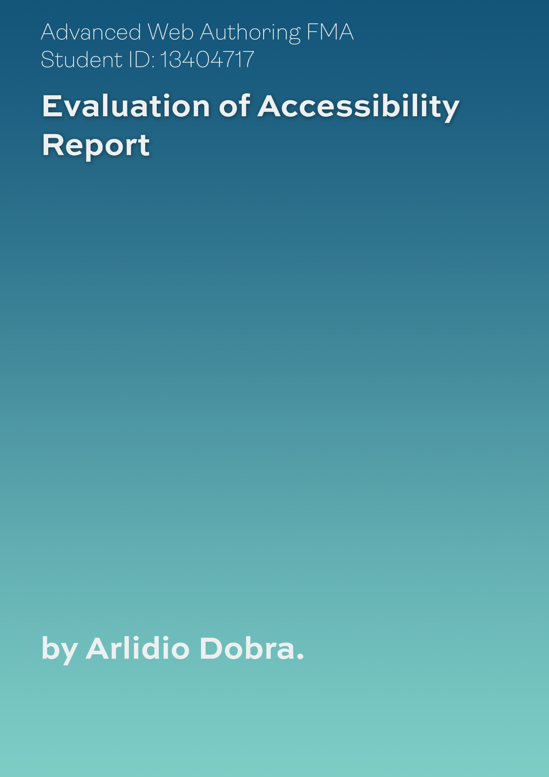
The Web Content Accessibility Guidelines are designed to aid in the development of web content considerate of a wider range of users with varying disabilities to empower all manner of users to feel confident navigating web content. By adhering to the guidelines, content becomes more accessible and is delivered to a higher standard which benefits hosts from increased usability and thus, more web traffic.
Throughout the production of the FMA, designs were evaluated against the four core principles of accessibility, assessed through their compliance with established guidelines.
The four principles evaluated against design were:
- Perceivability – achieved by ensuring information was perceivable through various ‘senses’ to ensure web content could be communicated to users through a range of methods.
- Operability - achieved by ensuring user interface components were navigable through various input mediums to empower users to interact and navigate through various input devices.
- Understandability – achieved by ensuring user interface components adhered to design norms and were intuitive to interact with, not requiring further explanation beyond fundamentals to interpret web content
- Robust – achieved by ensuring content can be interpreted reliably by varying user agents and any assistive technologies employed
Below entails an evaluation of the FMA’s degree of accessibility attained against established guidelines of the four principles.
Perceivability
Text Alternatives:
For non-text content, text descriptions have been included which can be used by screen-readers to communicate content through an auditory medium, affording consideration to users with visual impairments.
Time-based Media:
Time-based media concerns audio and video media. Within the FMA video content was implemented to satisfy robustness concerns by sourcing media in several filetypes for compatibility with user-agents. However, video content could be criticised regarding perceivability. With no captions or audio descriptions, users with visual impairments were unable to interpret video content.
Adaptability:
The decision to create individual pages to encapsulate purpose-specific content allowed content to be presented through tailored structure, unique to the nature of the information being conveyed, which would have been difficult to achieve through a generic single-page approach.
Additionally, consideration has been afforded across user-agents to ensure content is not restricted or absent across orientations, screen-sizes or assistive-technologies employed.

Distinguishable:
An important factor as part of making web content distinguishable is the use of colour. Throughout the design of the FMA, the colours were considered for users with varying types of colour deficiencies in mind. Below are screenshots depicting the FMA with different colour-blind filters, notice that content still remains legible and distinguishable, making it easier for users to see content.
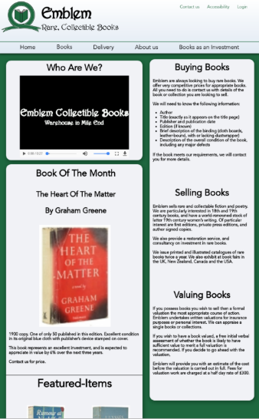
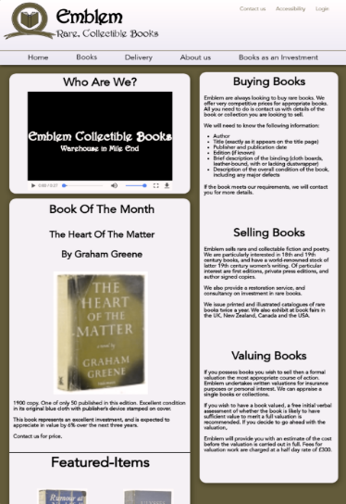
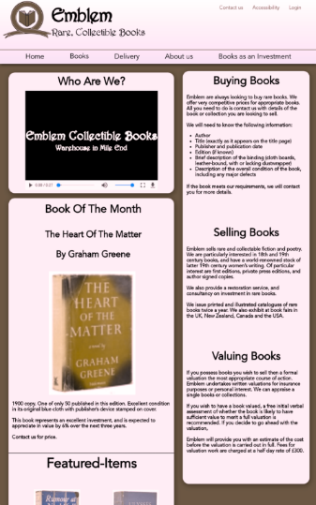

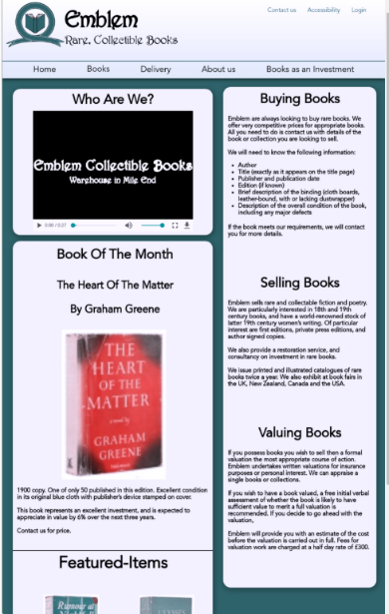
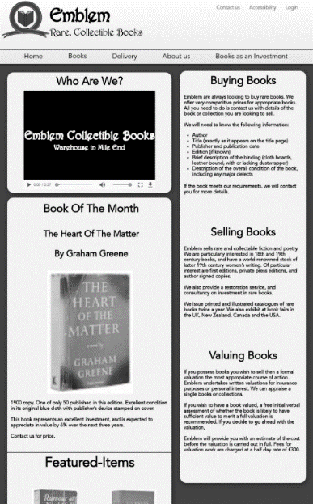
Figure 1 - Original website
Figure 2- Protanopia Website
Figure 3- Deuteranopia Website

Figure 4- Tritanopia Website
Figure 5- Greyscale Website
Audio controls were implemented as a mechanism separate from the user’s system volume level, controllable through keyboard or mouse, making it easier for users to hear content.

Operability
All content has been designed to operate through a keyboard/mouse interface with appropriate tab-order and without requiring specific timings for input, affording time to read and interact with content. Steps have been taken to avoid the ‘keyboard trap’ as focus can be navigated using the keyboard at all times. Furthermore, CSS has been engineered to show focus on UI elements through visual indication, considerate of visual-keyboard users. Skip-links are employed on all webpages for keyboard users to navigate content efficiently.
In addition, location is presented to the user when navigating within embedded webpages, as shown in the 19th century webpage which is an embedded page belonging to the books page. This allows users to be aware of their location when navigating ‘sub-content’ at all times.
Moreover, content within the FMA contains minimal animations, all of which are engineered not to cause seizures of physical reactions when interacting with content.
Another consideration remained Forms and Tables which were engineered to adhere to principles of accessible design as elaborated in Session 6 Slides 15-23.
One criticism of operability would arguably be a lack of native pointer gesture support. The FMA has not been designed for non-keyboard/mouse input methods and without an OS specific feature (such as VoiceOver on iOS devices), users may find it difficult to navigate the FMA through pointer interaction.
Understandability
Language employed by the site is clear and compliant to a lower secondary education level. Furthermore, web pages behave in a predictable and consistent manner including a consistent form of webpage navigation and a consistent theme when presenting content. UI elements which remain present throughout the FMA are stylised consistently to be easily identified by users.
Steps have been taken to for users to avoid and correct mistakes when user input is required. This includes error identification, whereby HTML validation was leveraged to identify errors in user input with feedback on addressing errors communicated through CSS. Error prevention steps were also taken to ensured errors are caught immediately by highlighting input fields red for invalid input allowing users to address errors.
However, one future improvement would be the user-interface’s use of icons to signify content. An example follows the implementation of email/phone icons for footer contact details. It is important to recognise users may have limited understanding of a language or may struggle with impairments, such as illiterate users. The use of language-independent icons provides an intuitive approach to conveying information which better communicates the purpose of web content.

Robustness
CSS3 has been engineered to ensure robustness across all current versions of popular HTML Layout Engines including:
- WebKit (Apple Safari + iOS Browsers)
- Blink (Chromium Group)
- Gecko (Firefox Group)
(Opera Group has migrated from Presto to Blink)

Discontinued Browser Support
- EdgeHTML (UWP Apps + Discontinued Edge Browser)
- Trident 6.0+ (IE10+) [Trident and IE has been Discontinued]

To conclude, the FMA takes a considerate approach to content accessibility based on the core principles and their respective guidelines. However, importance remains in recognising the scope for further developing the perceivability and operability of the FMA, more specifically integrating audio-captions for media, further content visual cues and supporting non-native inputs. Overall, the FMA meets accessibility expectations to a satisfactory degree.

Bibliography
En.wikipedia.org. n.d. Comparison Of Browser Engines (HTML Support). [online] Available at: <https://en.wikipedia.org/wiki/Comparison_of_browser_engines_(HTML_support)> [Accessed 09 August 2020].
En.wikipedia.org. n.d. Internet Explorer. [online] Available at: <https://en.wikipedia.org/wiki/Internet_Explorer#:~:text=On%20March%2017%2C%202015%2C%20Microsoft,2019%20primarily%20for%20enterprise%20purposes.> [Accessed 09 August 2020].
Toptal.com. 2020. Toptal Color Blind Filter. [online] Available at: <https://www.toptal.com/designers/colorfilter/> [Accessed 09 August 2020].

Word Count does not reflect Bibliography. Final word count is 1000 Words.

