# There are three ways to add CSS to HTML:

1. **Inline** - by using the style attribute inside HTML elements
2. **Internal -** by using <style> element in the <head> section
3. **External** – by using a <link> element to link to an external CSS file (the most common way)

Example:

**Inline**:

<h1 style="color:blue;">A Blue Heading</h1>

**Internal:**

**<head>**

**body{background-color: white}**

**</head>**

**External:**

**<link rel =” stylesheet” href =” style.css”>**

# HTML id Attribute

Class and Id (https://www.w3schools.com/html/tryit.asp?filename=tryhtml_id_class)

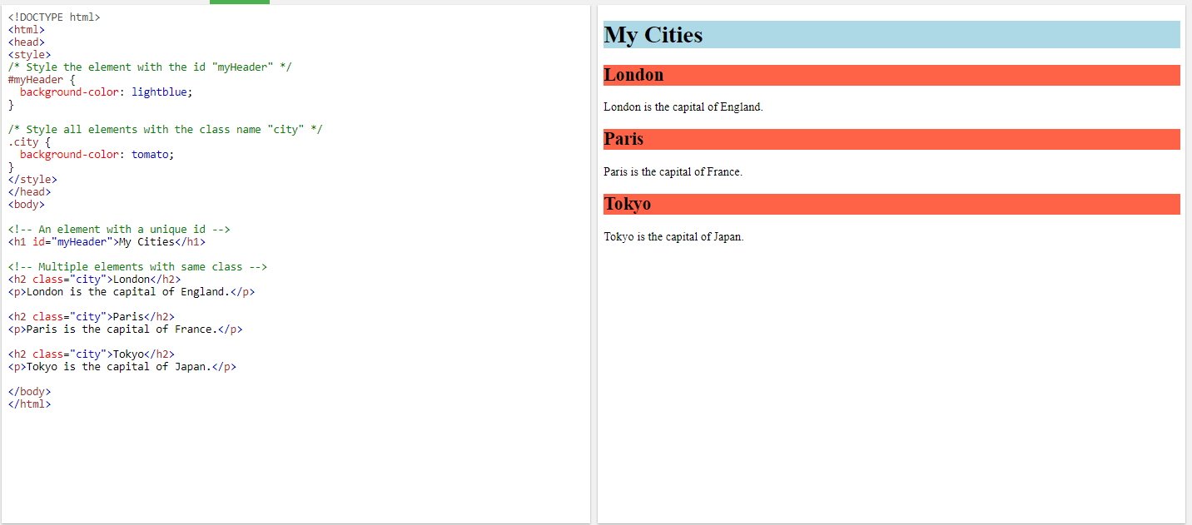

@charset "UTF-8"; // In css file, define the character encoding used in the document as utf-8

The four links states are:

* a:link - a normal, unvisited link
* a:visited - a link the user has visited
* a:hover - a link when the user mouses over it
* a:active - a link the moment it is clicked

# Background-image

Background-image: url (url);

Tilling: background-repeat: type;

Type: repeat(default), repeat-x, repeat-y, no-repeat, round, space.

Attaching: background-attachment:type; (could be used for watermarks)

Type: scroll(default), fixed, or local.

Position: background-position: horizontal vertical; //use for no-tiled images.

Defining the extent of the background:

Background-clip:type;

To define how position coordinates are measured:

Background-origin:type;

Sizing: background-size: width height;

All of these different background options can be organized in the following background property:

background: color url(url) position / size repeat origin clip;

Eg: background:ivory url(draft.png) center center / 10% 10% no-repeat fixed content-box content-box;

Adding multiple background images:

Background: background1, background2;

# Border (border.html)

* Setting Border Width and Color
  + border-width: top right bottom left;
    - Eg: border-width: 10px 20px; /*setting with top and bottom border 10px, right and left border 20px. */
  + border-side-width: width; // side: top right bottom left
    - eg: border-bottom-width: 10px;
  + border-color: top right bottom left;
    - Eg: border-color: gray black black gray;
  + Border-side-color: color;
    - Eg: border-top-color: blue;
* Setting the Border Design
  + border-style: top right bottom left;
    - Eg: border-style: double solid; /*setting top and bottom border style double and right and left border style solid. */
  + border-side-style: style;
    - Eg: border-top-style: dashed;
  + border: width style color;
    - Eg: border: 2px solid blue;
  + border-side: width style color;
    - Eg border-top: 2px solid blue;
* Creating Rounded Corners
  + border-radius: top-left top-right bottom-right bottom-left
    - Eg: border-radius: 10px 20px; /*top-left and bottom-right with 10px, and top-right and bottom-left with 20px */
  + border-corner-radius: radius; /*Setting the curvature for only one corner. Corner can be replaced with either top-left, top-right, bottom-right, or bottom-left.
    - Eg: border-top-left:10px;
  + Creating an elongated corner:
    - Eg: border-radius: 50px/20px;
    - Eg: border-radius: 15%;
    - border-corner-radius: horizontal vertical;
      * eg:border-top-left-radius: 20px 15px;
* Applying a border image:
  + Border-image: url(url) slice stretch;

stretch: The slices are stretched to fill each side.

repeat: The slices are tiled to fill each side.

round: The slices are tiled to fill each side; if they don’t fill the sides with an integer number of tiles, the slices are rescaled until they do.

space: The slices are tiled to fill each side; if they don’t fill the sides with an integer number of tiles, extra space is distributed around the tiles.

* + - Eg: border-image: url(frame.png) 5% 10% stretch; /*
    - Eg: border-image:rul(frame.png) 5 stretch;

# Shadow

* Text Shadow:
  + texst-shadow: color offsetX offsetY blur; /*offsetX and offsetY are the distances of the shadow from the text in the horizontal and vertical directions. */
    - Eg: text-shadow: red 10px 5px 8px;
  + Text-shadow: shadow1, shadow2, shadow3, …;
* Box Shadow:
  + box-shadow: color offsetX offsetY blur;
    - Eg: box-shadow: red 10px 20px 10px; /*shadow exists 10px on the right and 20px on the bottom */
  + Box-shadow: shadow1, shadow2, …
    - Eg: box-shadow: red 10px 20px 10px , green -10px 20px 10px;
  + Box-shadow: inset color offsetX offsetY blur;
    - Eg: box-shadow: inset red 10px 10px 20px;
* Reflection:
  + -webkit-box-reflect: direction offset mask-box-image;
    - Eg: -webkit-box-reflect: below 10px; /* reflection is 10 pixels below the inline image */

4-8a