# On Firebase Website, click on Authentication

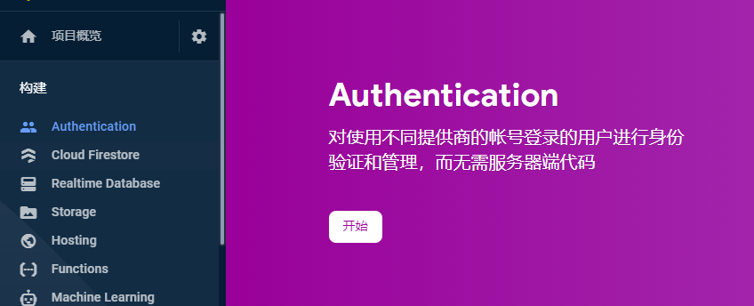

# Enable Google Authentication

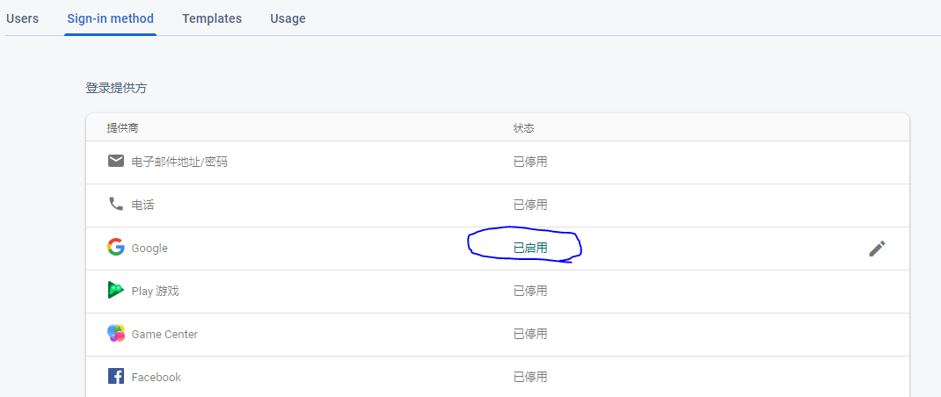

# Get configuring information

Click on the firebase project and look for configuring information and copy and paste to environment files 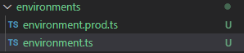

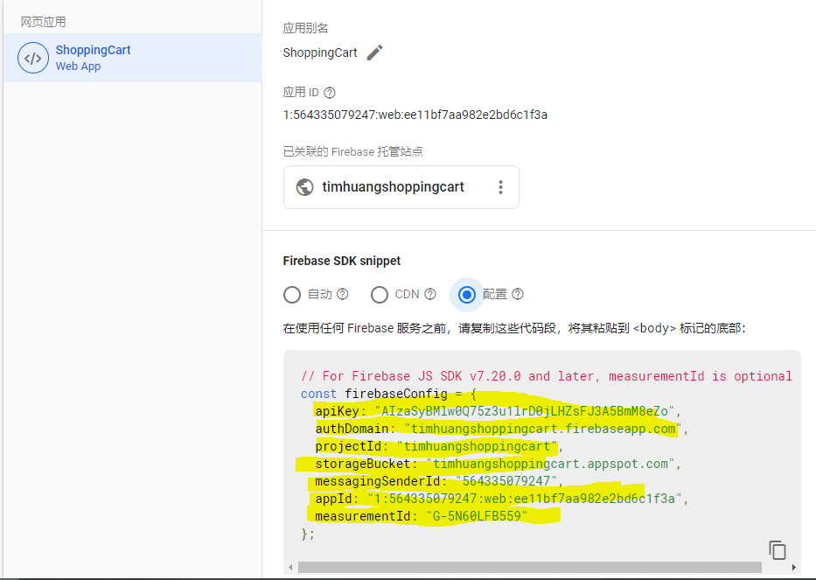

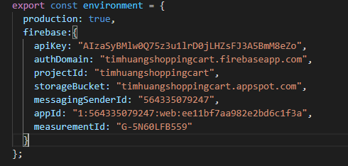

# Import firebase modules

import { AngularFireModule } from '@angular/fire';

import { AngularFireAuthModule } from '@angular/fire/auth';

//Firebase

    AngularFireModule.initializeApp(environment.firebase),

    AngularFireAuthModule

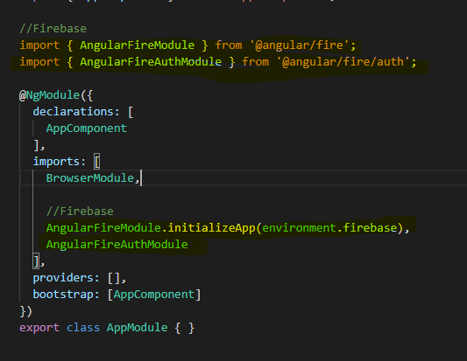

# Created a button and call login function

<button (click)=”login()”>Login with Google</button>

# Login with GoogleAuthProvider

import { AngularFireAuth } from '@angular/fire/auth';

import firebase from 'firebase/app';

 constructor(private afAuth: AngularFireAuth){}

  login(){

    this.afAuth.signInWithPopup(new firebase.auth.GoogleAuthProvider());

  }

## Logout

Calling signout method and redirecting to home page after sign out

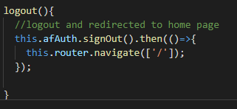

# Done

