# Routing

## Import Routering from @angular/router on app.module.ts

import { RouterModule } from '@angular/router';

## Declare Routing paths and components

RouterModule.forRoot([

{path:””,component: HomeComponent}

])

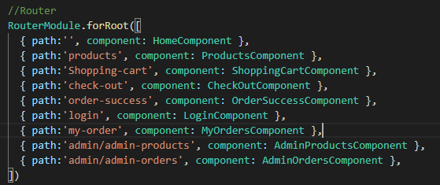

## Add RouterLink

