43008: Reinforcement Learning
Assignent-3, Part-E Project Report

Project Title: [Add title here]

Team Name and Project Number: [Add team name, Project #]
Team Members: [Add team member names and student ID]
Date: [Add date]

Table of Contents
Abstract 3
1. Introduction and Background 4
2 Overview of the architecture/system 5
3 Results and Evaluation 5
4 Discussion and Conclusions 6
5 References 6
Appendices 7

Abstract
<Add a short abstract...no more than 10 lines!>

1. Introduction and Background
[A short general text about the project idea, motivation and the application.]

1.1 The problem you tried to solve
[Here you describe the problem in your own words!]

1.2 Motivation
[Describe briefly the motivation behind the project and why you are try to solve the problem]

1.3 Application
[Describe briefly the application of the project outcome.]

1.4 Dataset/Environment (as applicable)
Our project uses Pikafish, an open-source UCI Chinese chess engine that a team member found through the Pikafish website (Pikafish, n.d.-a, n.d.-b). We integrated the engine as a reference opponent in Xiangqi Lab. Our team built the local browser interface, Python game environment and model interfaces around this research task. The official engine and our local training environment are separate software components.
Our reinforcement learning data consist of starting positions stored in FEN format and experience generated by playing in the environment. The initial Double DQN experiment used a fixed rook and pawn preset. Later experiments used 20 additional rook training positions and 6 separate validation positions, generated through seeded legal moves and checked by our rules. A separate set of 10 test positions contains 4 rook, 3 cannon and 3 horse endgames. These starts were excluded from training but have been evaluated repeatedly. This position bank is not a dataset downloaded from Pikafish. During training, interactions produce state, action, reward and next-state records.
At the environment level, we model the task as a fully observable, turn-based, two-player zero-sum Markov game (Littman, 1994). Red and Black take turns choosing one legal move. The complete state contains the board, side to move, repetition counts, non-capture counter and progress towards the move limit. These records are necessary because the same board can have a different draw status depending on its history. Given this complete state and a legal action, the next state and reward are determined by the game rules. A terminal win gives the winner +1 and the loser -1; non-terminal moves and draws give both players 0. Move-limit truncations are recorded separately.
For DQN and Double DQN training, a separate wrapper controls the opponent with a fixed policy. One learner step includes the learner's move and, if the game continues, the opponent's reply. This gives the learner an induced single-agent decision process while the underlying game remains a Markov game. It does not mean that both players were learning at the same time.

2 Overview of the architecture/system
We built Xiangqi Lab to connect endgame research with an interactive game interface. The platform uses one Python rules module for browser play and training. It accepts model adapters from team members, checks their moves and records complete games. Training runs separately; the website loads trained policies for play and evaluation.

2.1 Workflow
The research workflow starts with choosing FEN positions and separating training, validation and test starts. In Colab, a training script resets the environment, requests an action, applies the move and receives the next state and reward. It repeats this interaction until the game ends or reaches its limit, then starts another episode. Our DQN and Double DQN experiments added periodic validation, early stopping and named best-model checkpoints.
For website integration, a teammate supplies a model folder containing settings, inference code and any weights, together with a compatible Python environment. The user refreshes the model list, runs the interface check, selects a starting board and assigns players to Red and Black. Each turn requests a move, checks that it is legal and updates the board. Play continues until a game ending or move limit, after which the user can save the complete replay.
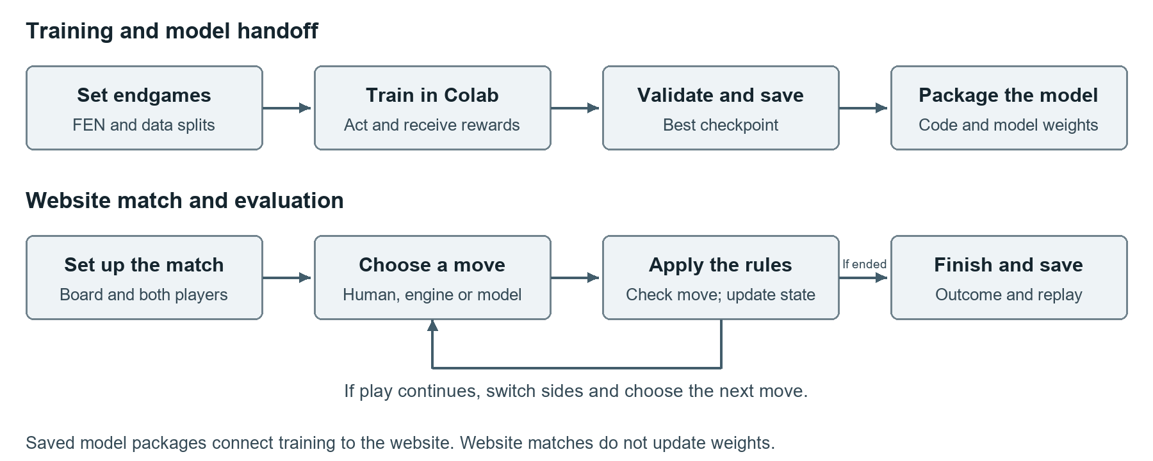
Workflow from endgame preparation to model handoff and website evaluation. The loop represents successive player turns, not further training during a match.
The selected Double DQN and teammate PPO policies have completed website integration and direct matches. The teammate MCTS v4 has also completed batch matches using the shared rules; website model integration remains pending. Batch evaluation saves complete games for analysis.

2.2 System Architecture Design
The browser interface uses plain HTML, CSS and JavaScript, with an SVG chessboard. It sends local HTTP requests and receives JSON state updates from a Python server. The server uses Python's standard-library http.server module, listens on the local computer and keeps each game session in memory. Game exports provide persistent records; there is no database in the current platform.
The shared rules module generates legal moves, applies actions and detects checkmate, stalemate, repetition draws and move-limit truncation. The training interface exposes reset and step functions around the same game state. Colab uses this Python environment directly, so training does not require the browser or a connection to the local web server.
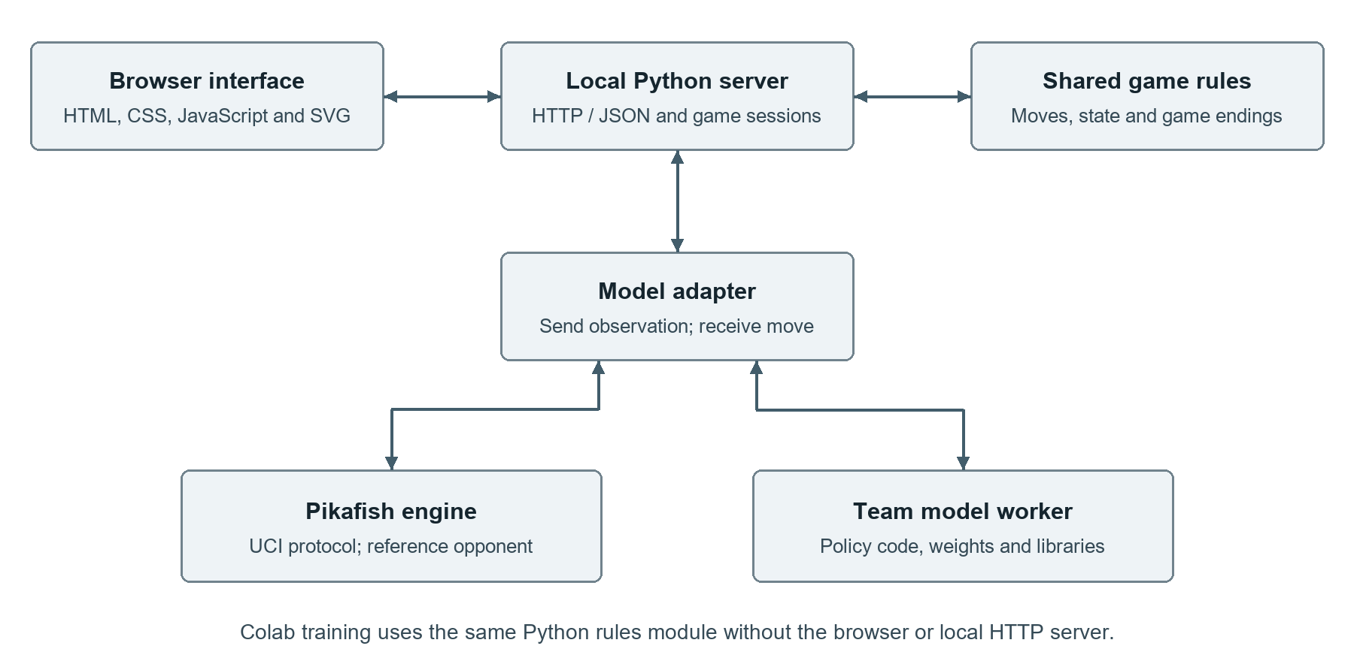
System architecture. The server connects the interface, game rules and model adapters; training reuses the rules independently.
The model layer connects Pikafish through UCI and custom models through a Python policy interface. A model folder contains model.json, policy code and any checkpoint files. The policy receives an observation and returns a move or action ID. Python policies run in reusable worker processes with their configured interpreter, allowing model libraries to remain separate from the basic web application. The server checks every returned move before changing the board.
We prepared launchers and platform-specific packages for Windows and macOS. Neural models still need their required libraries in the configured inference environment. This structure supports shared interfaces across algorithms without requiring every teammate to use the same model architecture.

2.3 GUI/Environment Design
The interface groups board setup, player selection, the chessboard and saved games. Users can choose a preset, edit pieces or load a FEN position, then select human or model players. The board shows whose turn it is and highlights legal destinations. Undo, Flip and Reset support inspection; Play runs turns and AI move requests one model action.
More options contains the requested thinking time, move limit and FEN controls. Save game exports the initial position and complete move history; Load game restores a recorded game. The Models panel refreshes and checks adapters. English is the default menu language, with optional Chinese; both use traditional piece symbols. Controls stack on narrow screens, while wider screens place controls beside the board.
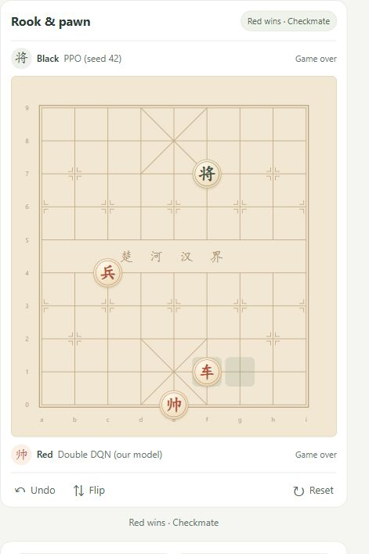
Actual board view from the separate 27-ply website demonstration, showing player labels, the game outcome and board controls. This demonstration is separate from the 20-game test.

3 Results and Evaluation
We evaluated the selected Double DQN against teammate PPO and MCTS agents with learning turned off. Against PPO, Double DQN had 0 wins, 2 losses and 18 draws on the ten-position test set. Against MCTS v4 on the same starts, it had 1 win, 13 losses, 4 draws and 2 move-limit games. Six additional MCTS games on familiar presets are reported separately. These small comparisons describe the delivered agents under the stated settings.

3.1 PPO Match Settings
We used the earlier Double DQN checkpoint saved at episode 200 and the teammate's PPO seed 42 checkpoint saved at episode 700. The test used 10 existing starting positions: 4 rook and pawn, 3 cannon and pawn, and 3 horse and pawn positions. Each position was played twice, with the same FEN and the model assignments swapped between Red and Black, giving 20 games.
Both agents chose their highest-scoring legal action on the CPU. Exploration, gradient updates and further training were disabled. The test was deterministic, so changing a random seed would not create another distinct game. Checkpoint hashes and loaded weights were checked for changes, and all saved moves were replayed successfully under the same rules.
Each game allowed at most 160 plies, where one ply is one move by one player. The environment declares a draw when the same board and side to move occur three times, or after 120 plies without a capture. Games reaching the ply limit are recorded separately. No game in this test reached that limit.

3.2 Neural Model Input Preparation
The shared environment provides board planes, the side to move, legal actions and draw-history information. Each model adapter converts this state into the input used during its own training. Illegal actions are masked before a move is selected.
Both models were trained to play Red. To let either model play Black, the adapter rotates the board by 180 degrees, swaps piece colours and transforms the repetition history. It then maps the chosen move back to the original board. This enables side-swapped play, but does not give either model additional defensive training.

3.3 Double DQN and PPO Results
Table 1 reports the same 20 games from each model's perspective. PPO's win rate was 10%; Double DQN's was 0%. The draw rate was 90%. Both PPO wins occurred when PPO played Red, in rook-01 and rook-03, after 13 and 11 plies respectively.
Table 1 Overall match results
Model | Wins | Losses | Draws | Ply limits | Win rate
Double DQN | 0 | 2 | 18 | 0 | 0%
PPO seed 42 | 2 | 0 | 18 | 0 | 10%

Table 2 Results by endgame type
Endgame | Games | Double DQN wins | PPO wins | Draws
Rook and pawn | 8 | 0 | 2 | 6
Cannon and pawn | 6 | 0 | 0 | 6
Horse and pawn | 6 | 0 | 0 | 6
Total | 20 | 0 | 2 | 18

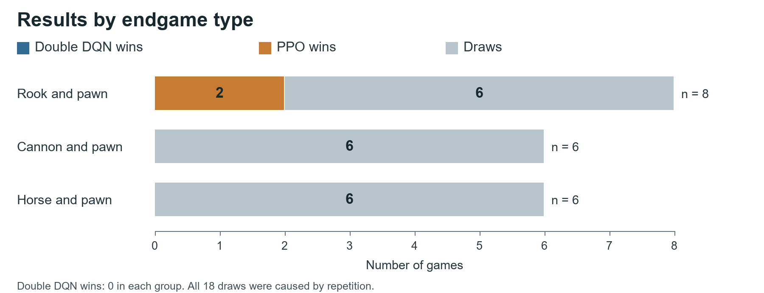
Outcome counts from the 20 saved games. Each starting position appears twice with the model assignments swapped. The cannon and horse games all ended in repetition draws.
Across all games, the agents made 666 legal moves. The 18 repetition draws show that these policies often failed to turn legal play into a decisive result. This test alone does not show whether changing the reward or training method would solve that problem.
Example game and website demonstration
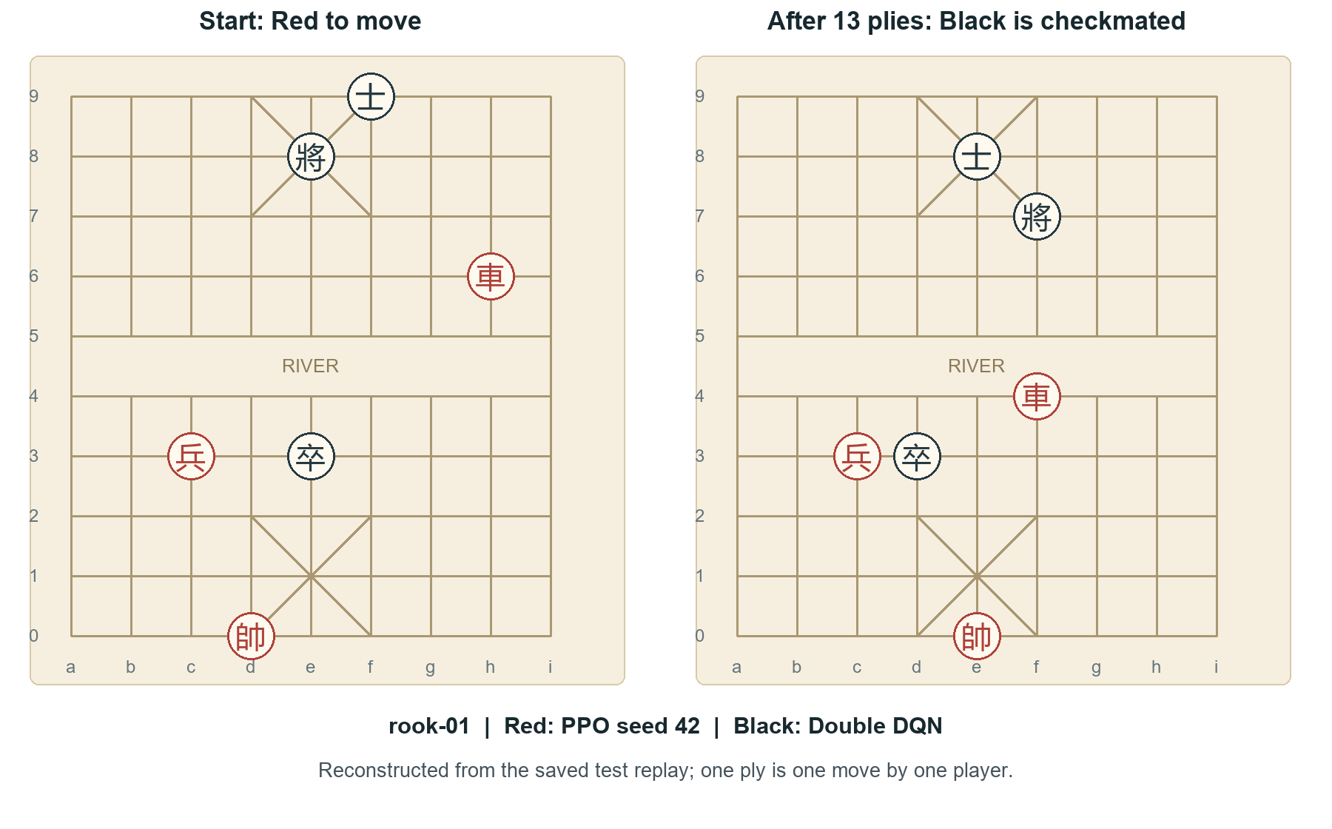
Initial and final positions of rook-01 with PPO as Red and Double DQN as Black. PPO delivered checkmate after 13 plies. The diagrams were reconstructed from the saved replay; they are not a new match.
In a separate website demonstration, Double DQN played Red against PPO as Black on the familiar Rook & pawn preset and won by checkmate after 27 plies. Its saved moves were reproduced with the same adapters. This demonstration checks that the models can play through the website; it is not included in Tables 1 and 2 and is not evidence of broad generalisation.
3.4 Double DQN and MCTS Results
We compared the original Double DQN checkpoint with the received MCTS v4. The supplied v2, v3 and v4 folders are successive experience snapshots; each contains separate memories for the endgame types. We selected v4 before the match. Each of the ten existing test starts was played with both player assignments, followed by six games on the three familiar presets.
MCTS used search alone on the custom test starts and the matching stored experience on familiar presets. Its inference settings allowed up to 96 simulations, rollout depth 10 and a requested 800 ms per move. The code reserves 20% of this budget. Games used the same 160-ply cap and draw rules. Each board used a fixed seed for both assignments, although time-based stopping can change reruns. We created a fresh MCTS instance for every game and kept all weights and stored experience unchanged.
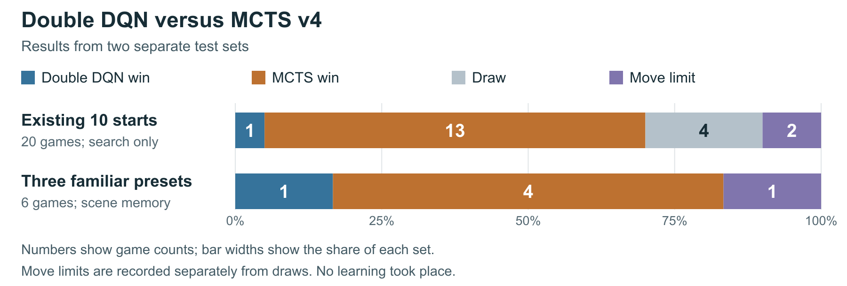
Outcomes for the existing test starts and familiar presets, shown separately. Counts are printed inside each bar; bar widths show percentages within that test set. Both player assignments were used.
MCTS won 13 of the 20 test games (65%), while Double DQN won 1 (5%). Four games were drawn and two reached the move limit. On the familiar presets, MCTS won 4 of 6 games and Double DQN won 1; one reached the limit. The familiar preset results do not measure performance on unseen positions.
Results by endgame type
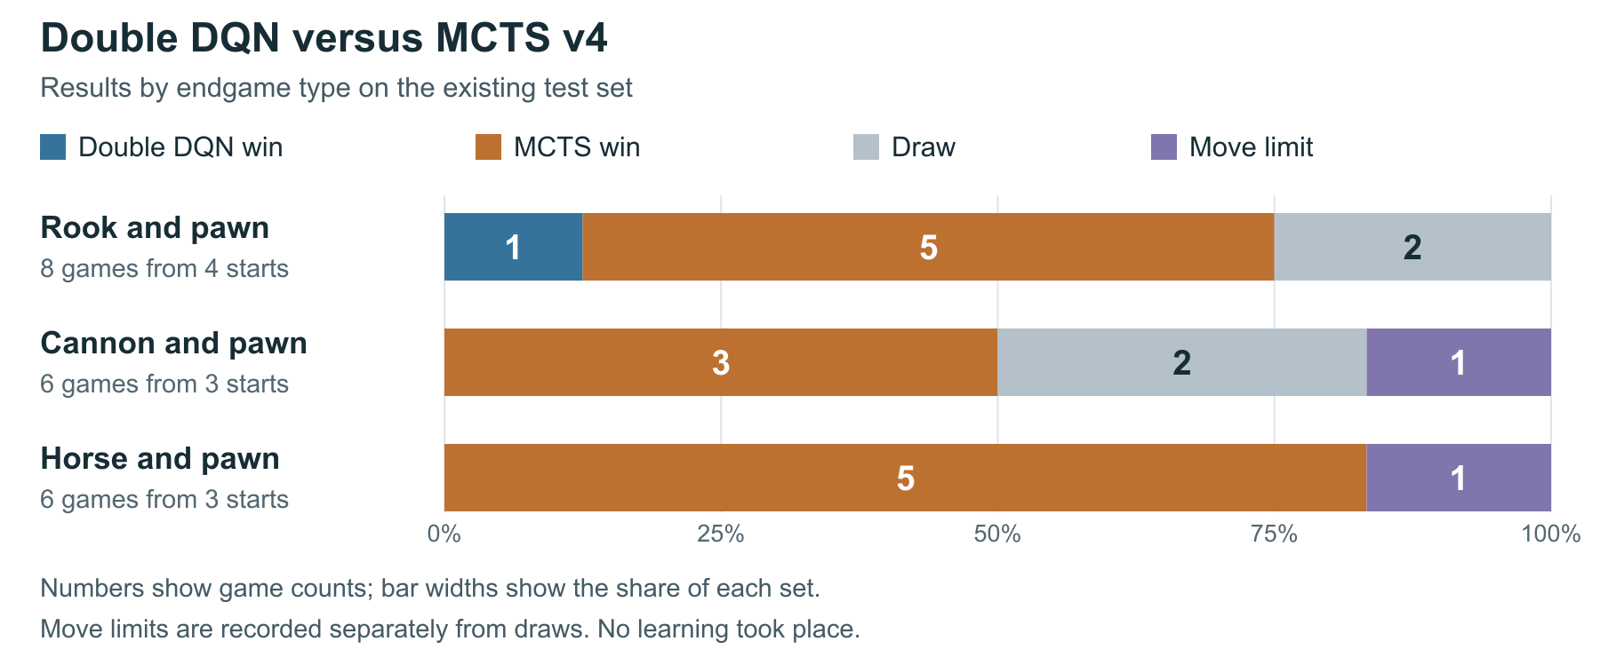
Results by endgame type for the 20 test games only. The groups have different numbers of starting positions. The six familiar-preset games are excluded.
The only Double DQN win in this test set was a rook and pawn game. MCTS won 5 of 8 rook games, 3 of 6 cannon games and 5 of 6 horse games. These outcomes show weaker play by the selected Double DQN against this opponent across all three groups. They do not establish how either algorithm would perform after different training or with different search budgets.
Across all 26 MCTS games, 14 ended in stalemate, 5 in checkmate, 3 in repetition draws, 1 in a no-capture draw and 3 at the move limit. Stalemate is a loss under the implemented Xiangqi rules. All 26 complete move records were replayed successfully, and checkpoint, source and experience hashes were unchanged.

3.5 Limitations
The main comparisons use only 10 paired starting positions and one selected version per agent. These positions had been examined in earlier tests, so this is an exploratory comparison, not a fresh blind evaluation. PPO seed 42 was selected using its earlier random-opponent results; MCTS v4 was selected before this match as the latest received snapshot. The agents have different training histories and computation budgets.
The neural policies were trained as Red, and MCTS stored experience also contains Red actions only. The neural adapters use a perspective transform for Black; MCTS searches natively for either side. Neither approach adds defensive training. The simplified repetition rule differs from full competition rules for perpetual check and chase. These differences limit conclusions about generalisation and defensive strength.
We also reproduced a sign error in the received MCTS rollout code: a forced one-move win returned -1 rather than +1 from the starting player's perspective. We kept the supplied code unchanged for this comparison. The error can affect search scores, but its effect on these win counts has not been measured. A repaired version needs a separate test.
A standardised comparison against Pikafish is still pending for this report. The PPO and MCTS match results should remain separate, and they do not establish a direct ranking between PPO and MCTS. A future comparison should agree on starting positions, both player assignments and search budgets before testing.
Evidence: output/matches/DoubleDQN_vs_PPO42_20261026/ contains plan.json, summary.json, games.csv, all 20 episode replays and the separate website-demo.json. The plan records the starting FENs and checkpoint hashes; tools/match_double_dqn_ppo.py defines the match procedure.
MCTS evidence: output/matches/DoubleDQN_vs_MCTS_v4_20261026/ contains the saved plan, summary, per-game results, all 26 replays and received-code inspection. tools/match_double_dqn_mcts.py defines the test. A checker correction and one discarded partial game are recorded in resume_audit.json; the first 20 completed games were retained. No further training was performed.

4 Discussion and Conclusions
[Summarize your project, results, etc. Suggest future extensions and improvements.]

5 References
Pikafish (n.d.-a). Pikafish official website. https://www.pikafish.com/zh-cn/ (Accessed 26 October 2026).
Pikafish (n.d.-b). Pikafish: A free and strong UCI xiangqi engine. Official source repository. https://github.com/official-pikafish/Pikafish (Accessed 26 October 2026).
Littman, M. L. (1994). Markov games as a framework for multi-agent reinforcement learning. Proceedings of the Eleventh International Conference on Machine Learning, pp. 157-163. https://doi.org/10.1016/B978-1-55860-335-6.50027-1

Appendices (Mandatory Section)

A. Individual Contribution
Each group member should write half-page (max) about his or her contribution in the project development activities.

B. Individual Contribution Split
Team Member Name | Percentage
[Full Name] | %
[Full Name] | %
[Full Name] | %

All the team members have discussed and agreed on the above individual contribution to the project.

[Name] : [Signature]

[Name] : [Signature]

[Name] : [Signature]

