Student name: Nguyen Bao Chinh
Student ID: 24520225
Link GitHub: https://github.com/Pengikas/24520225_NguyenBaoChinh_Lab_EX-HW.git
Link AI prompt:

EVIDENCE FOR HOMEWORK LAB02
HW 1: Production Enterprise Data-Grid (WCAG 2.2 AA)
Industrial-strength accessible component system with 100 Lighthouse score.
Project Specification & Criteria
- Component: Full-featured accessible Data-Grid with sorting, filtering, and pagination.
a. Sorting
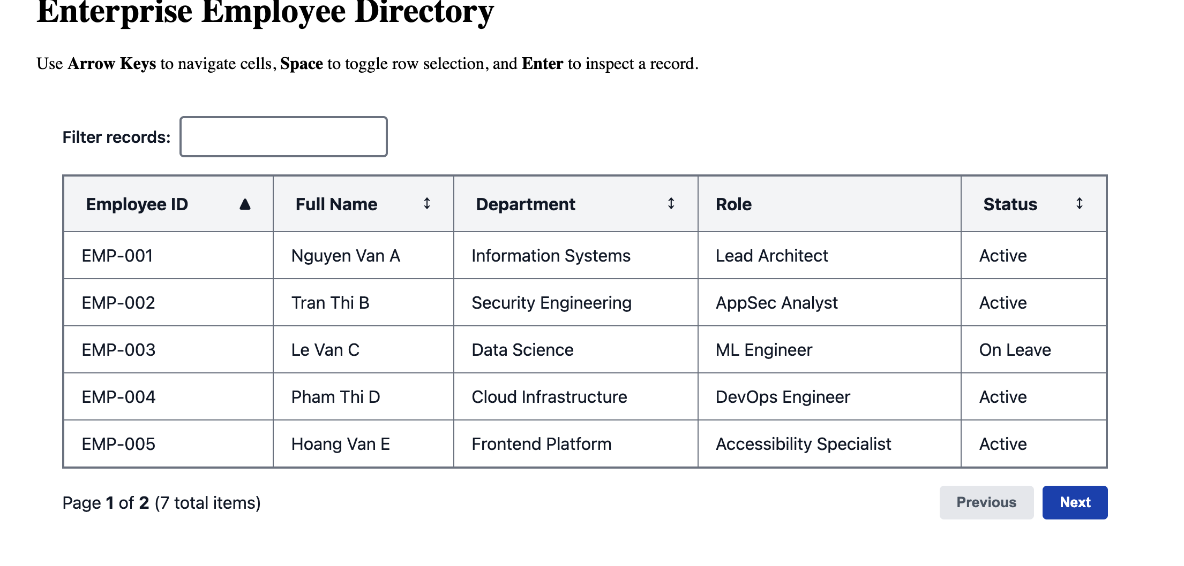
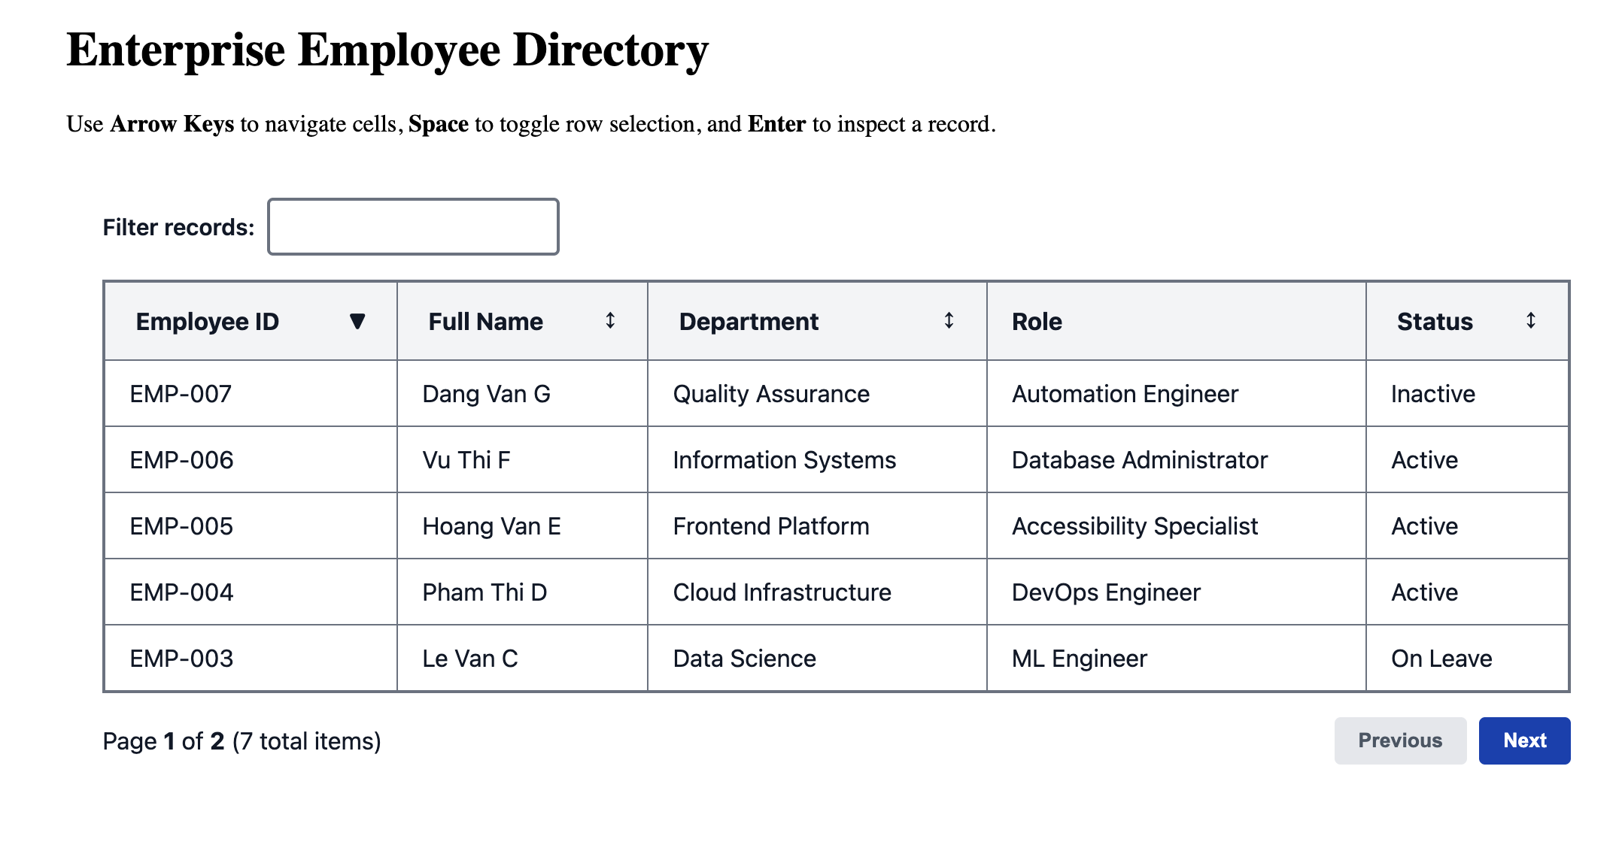
b. Filtering
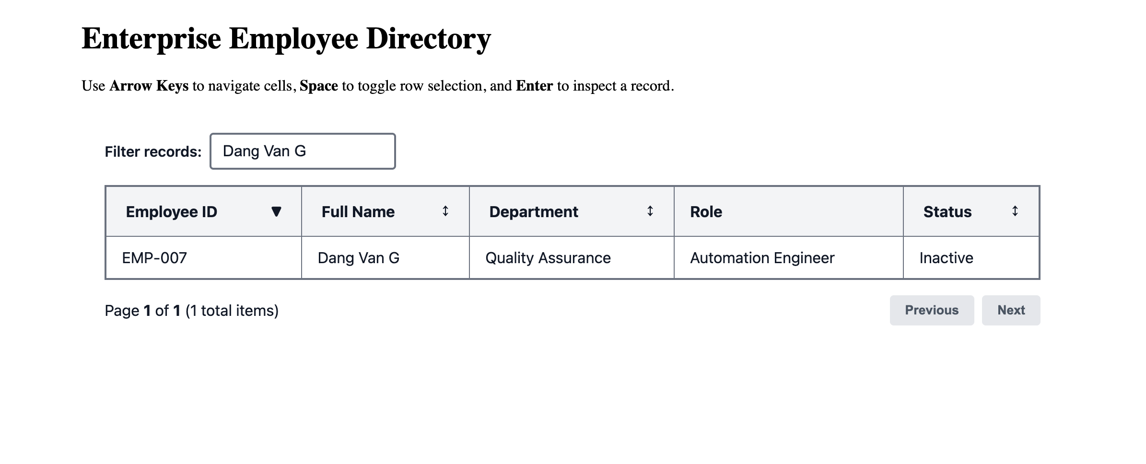
c. Pagination
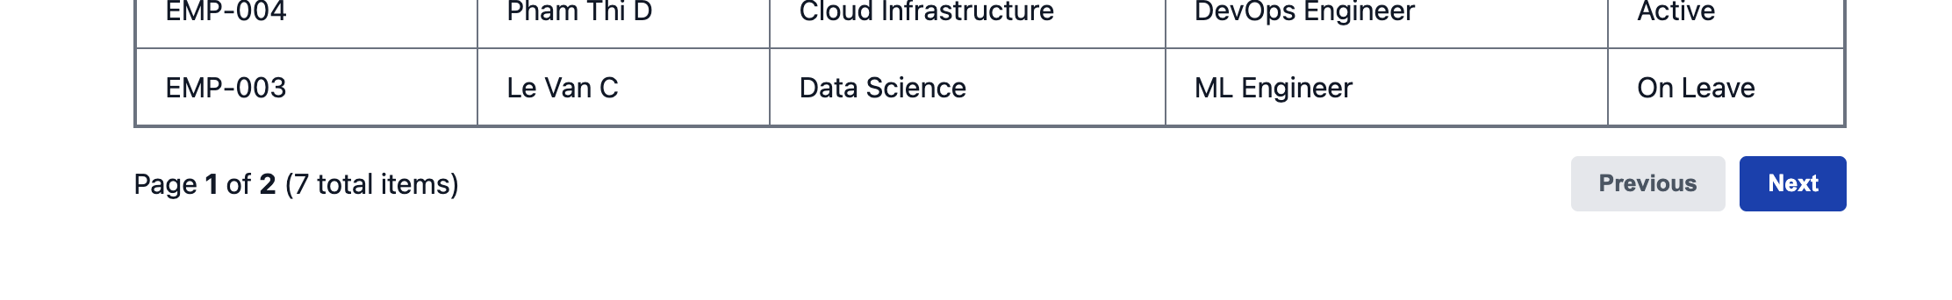
- Accessibility Contract: WCAG 2.2 Level AA compliance, 4.5:1 color contrast, full screen reader support.
a. Acessibility
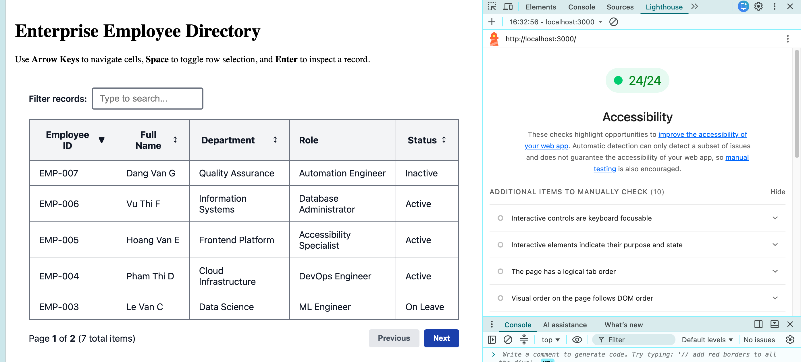
b. 4.5:1 color contrast
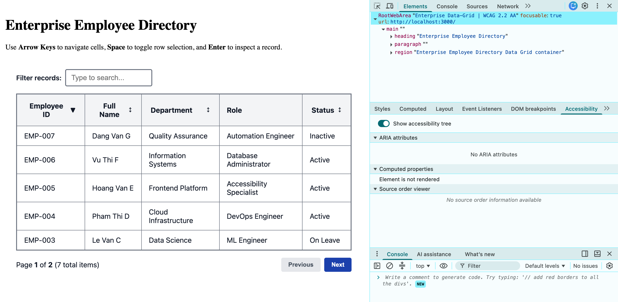
c. Full screen reader support
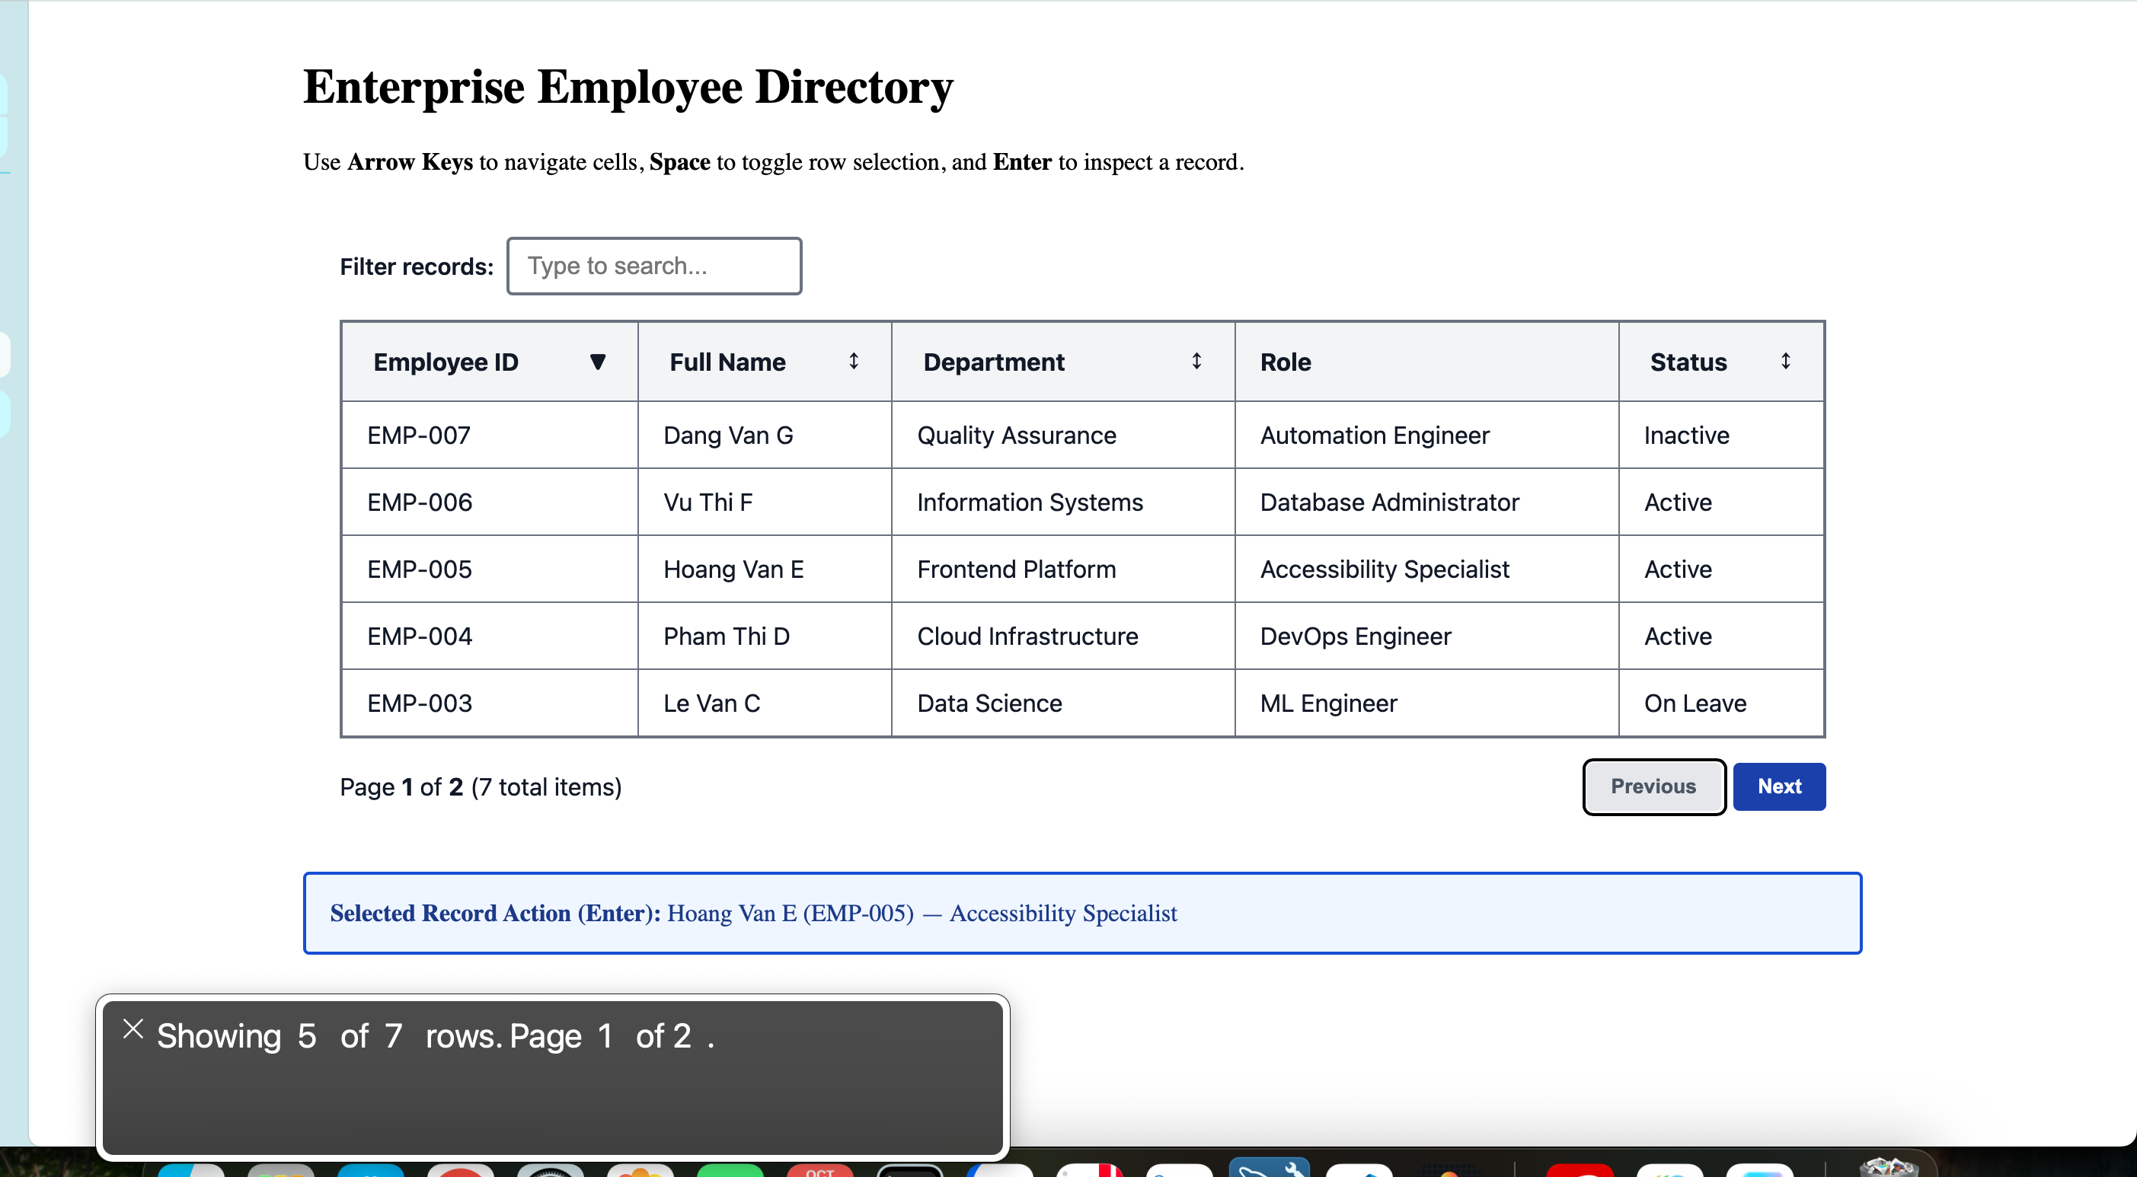
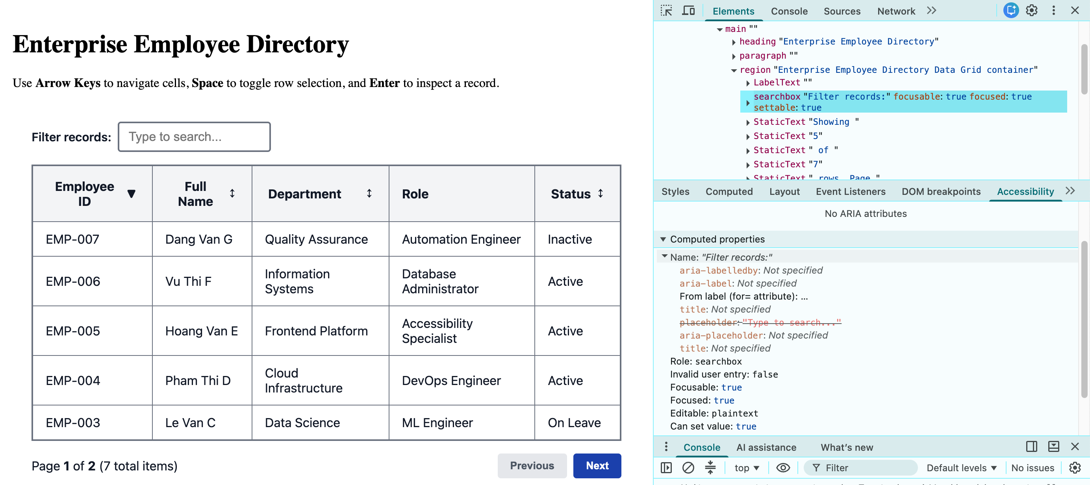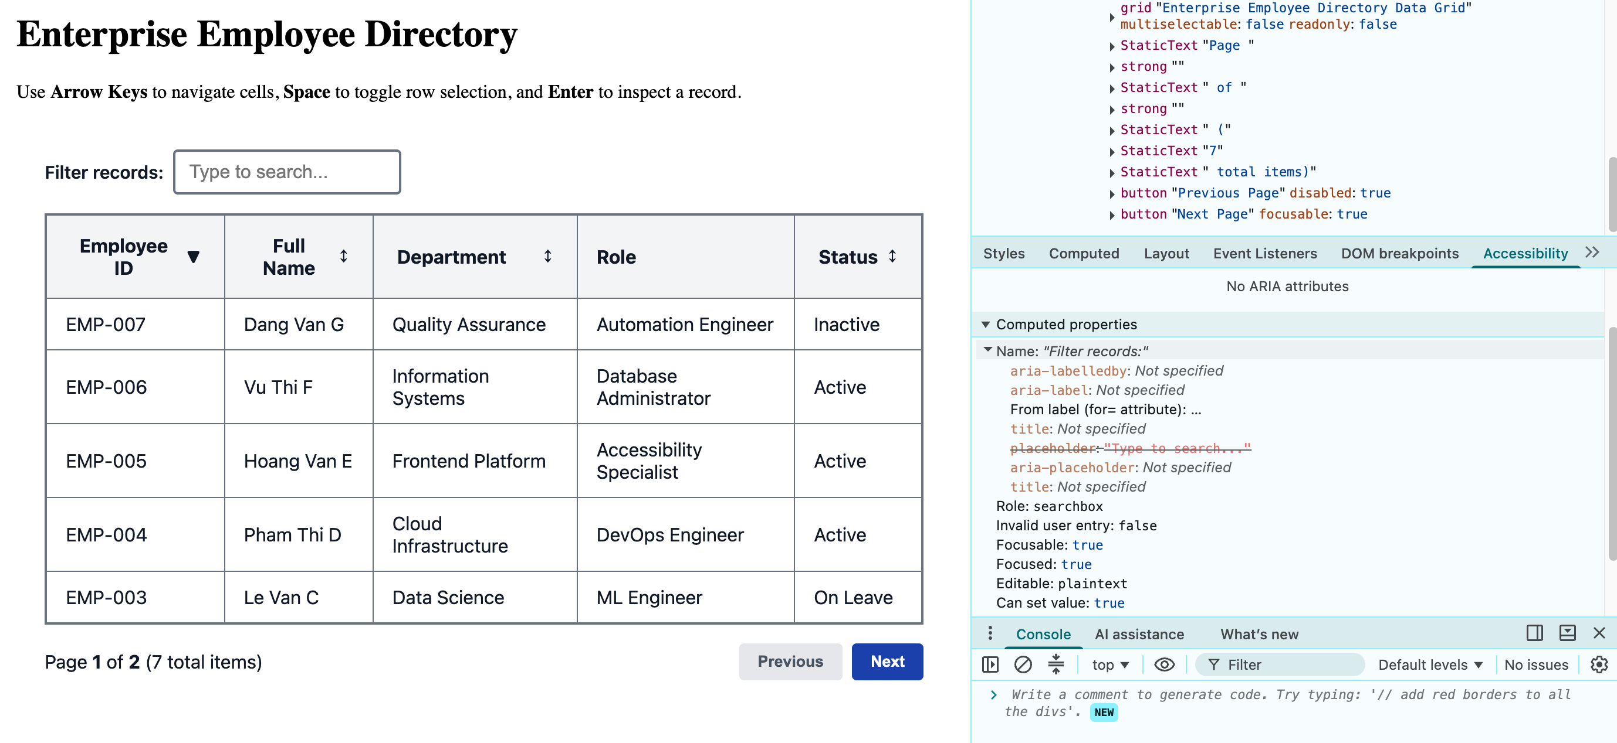
- Keyboard Navigation: Up/Down/Left/Right arrow keys navigate grid cells; Enter selects, Space toggles.
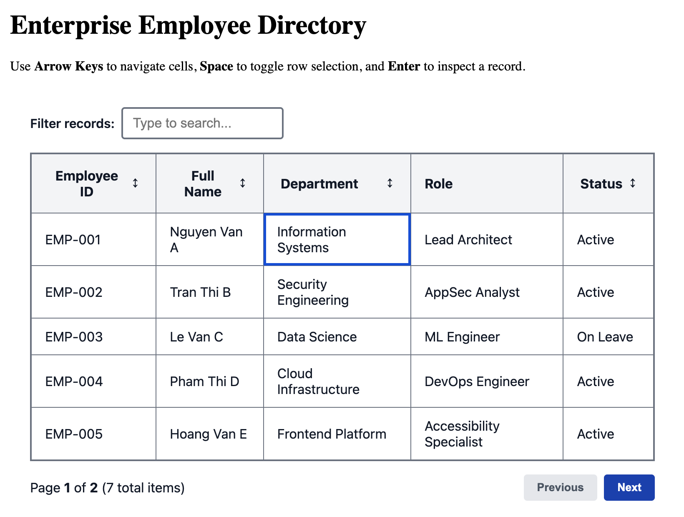
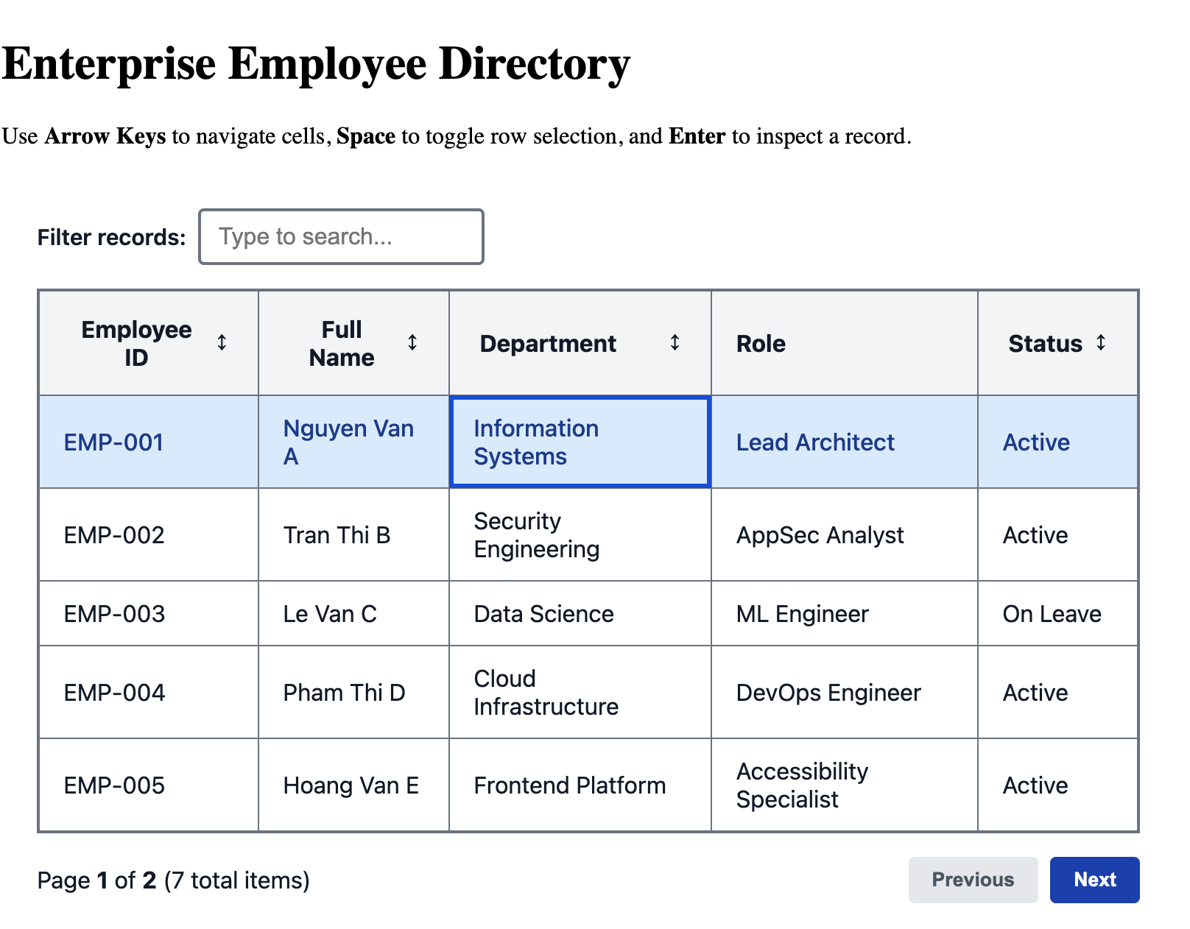
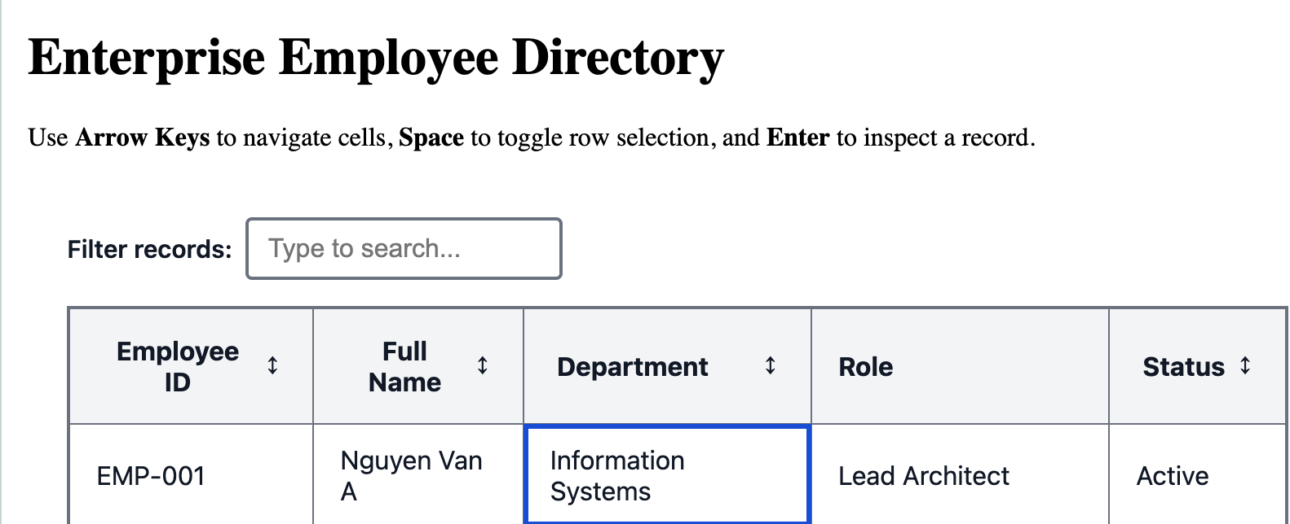
- Lighthouse Audit: Must achieve verified 100/100 score on Accessibility and Best Practices.
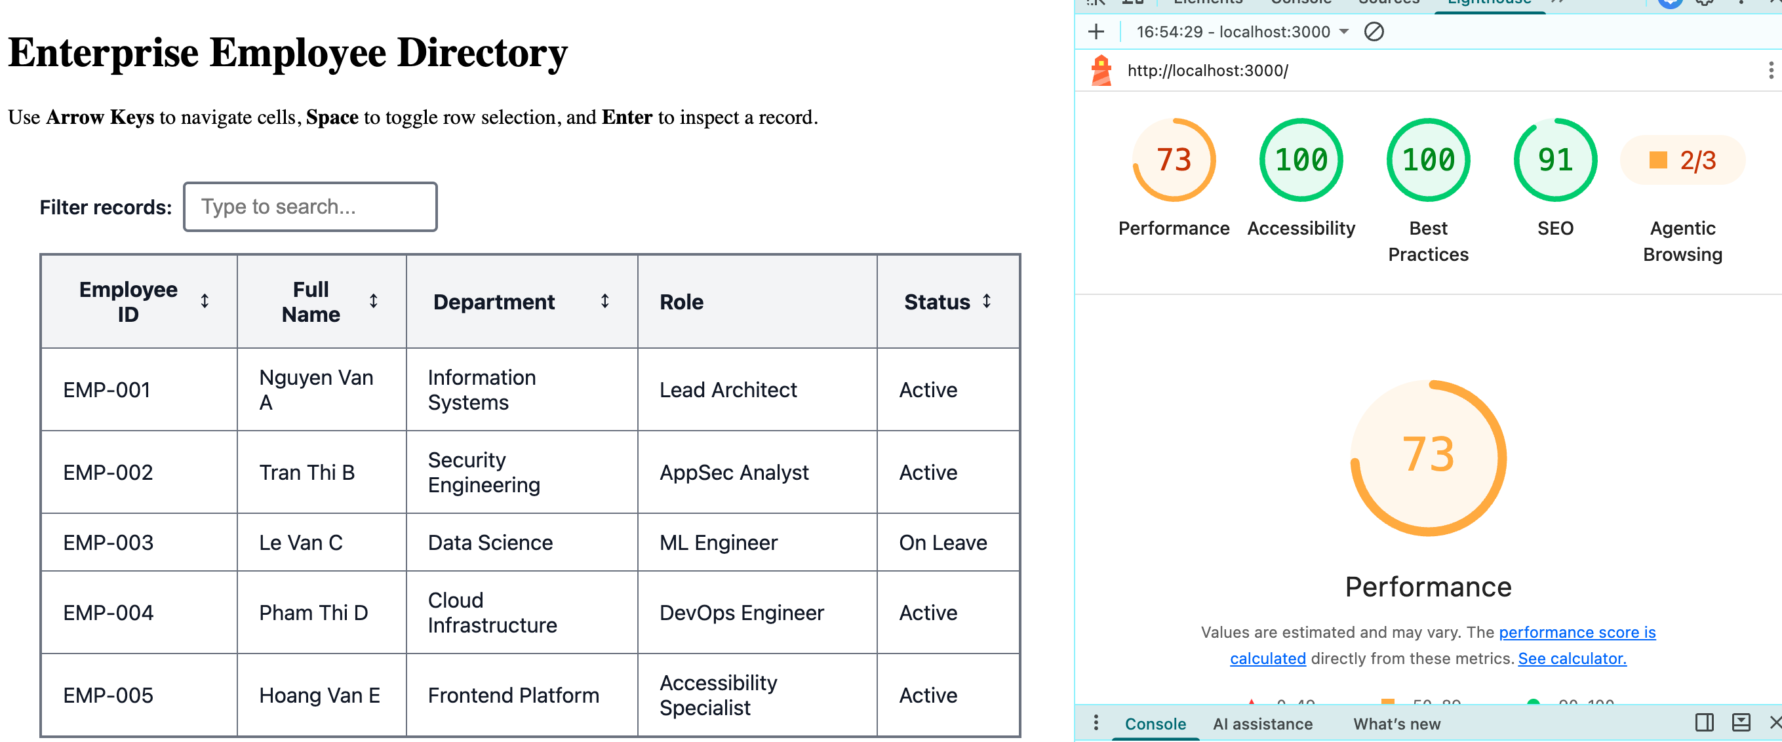
- Zero div-soup: Must use native <table>, <head>, <body>, <th scope='col'>,
HW 2: Concurrent FIFO Audio Visualizer Queue Engine
Advanced async concurrency, audio frequency analysis, and zero memory leaks.
Project Specification & Criteria
- Engine: Web Audio API integration with Web Audio Analyser Node (FFT 256/512 bins).
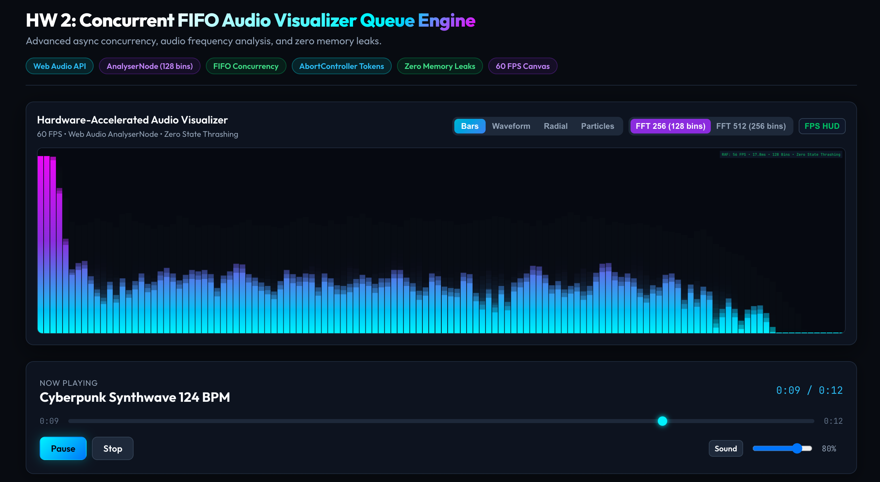
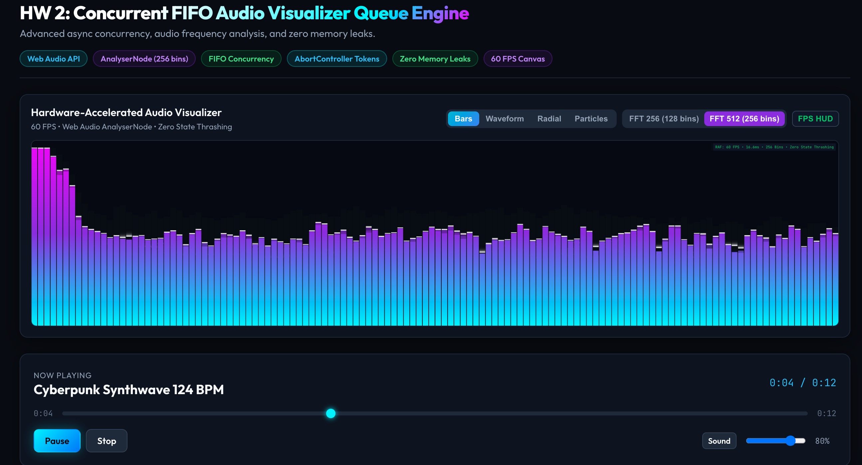

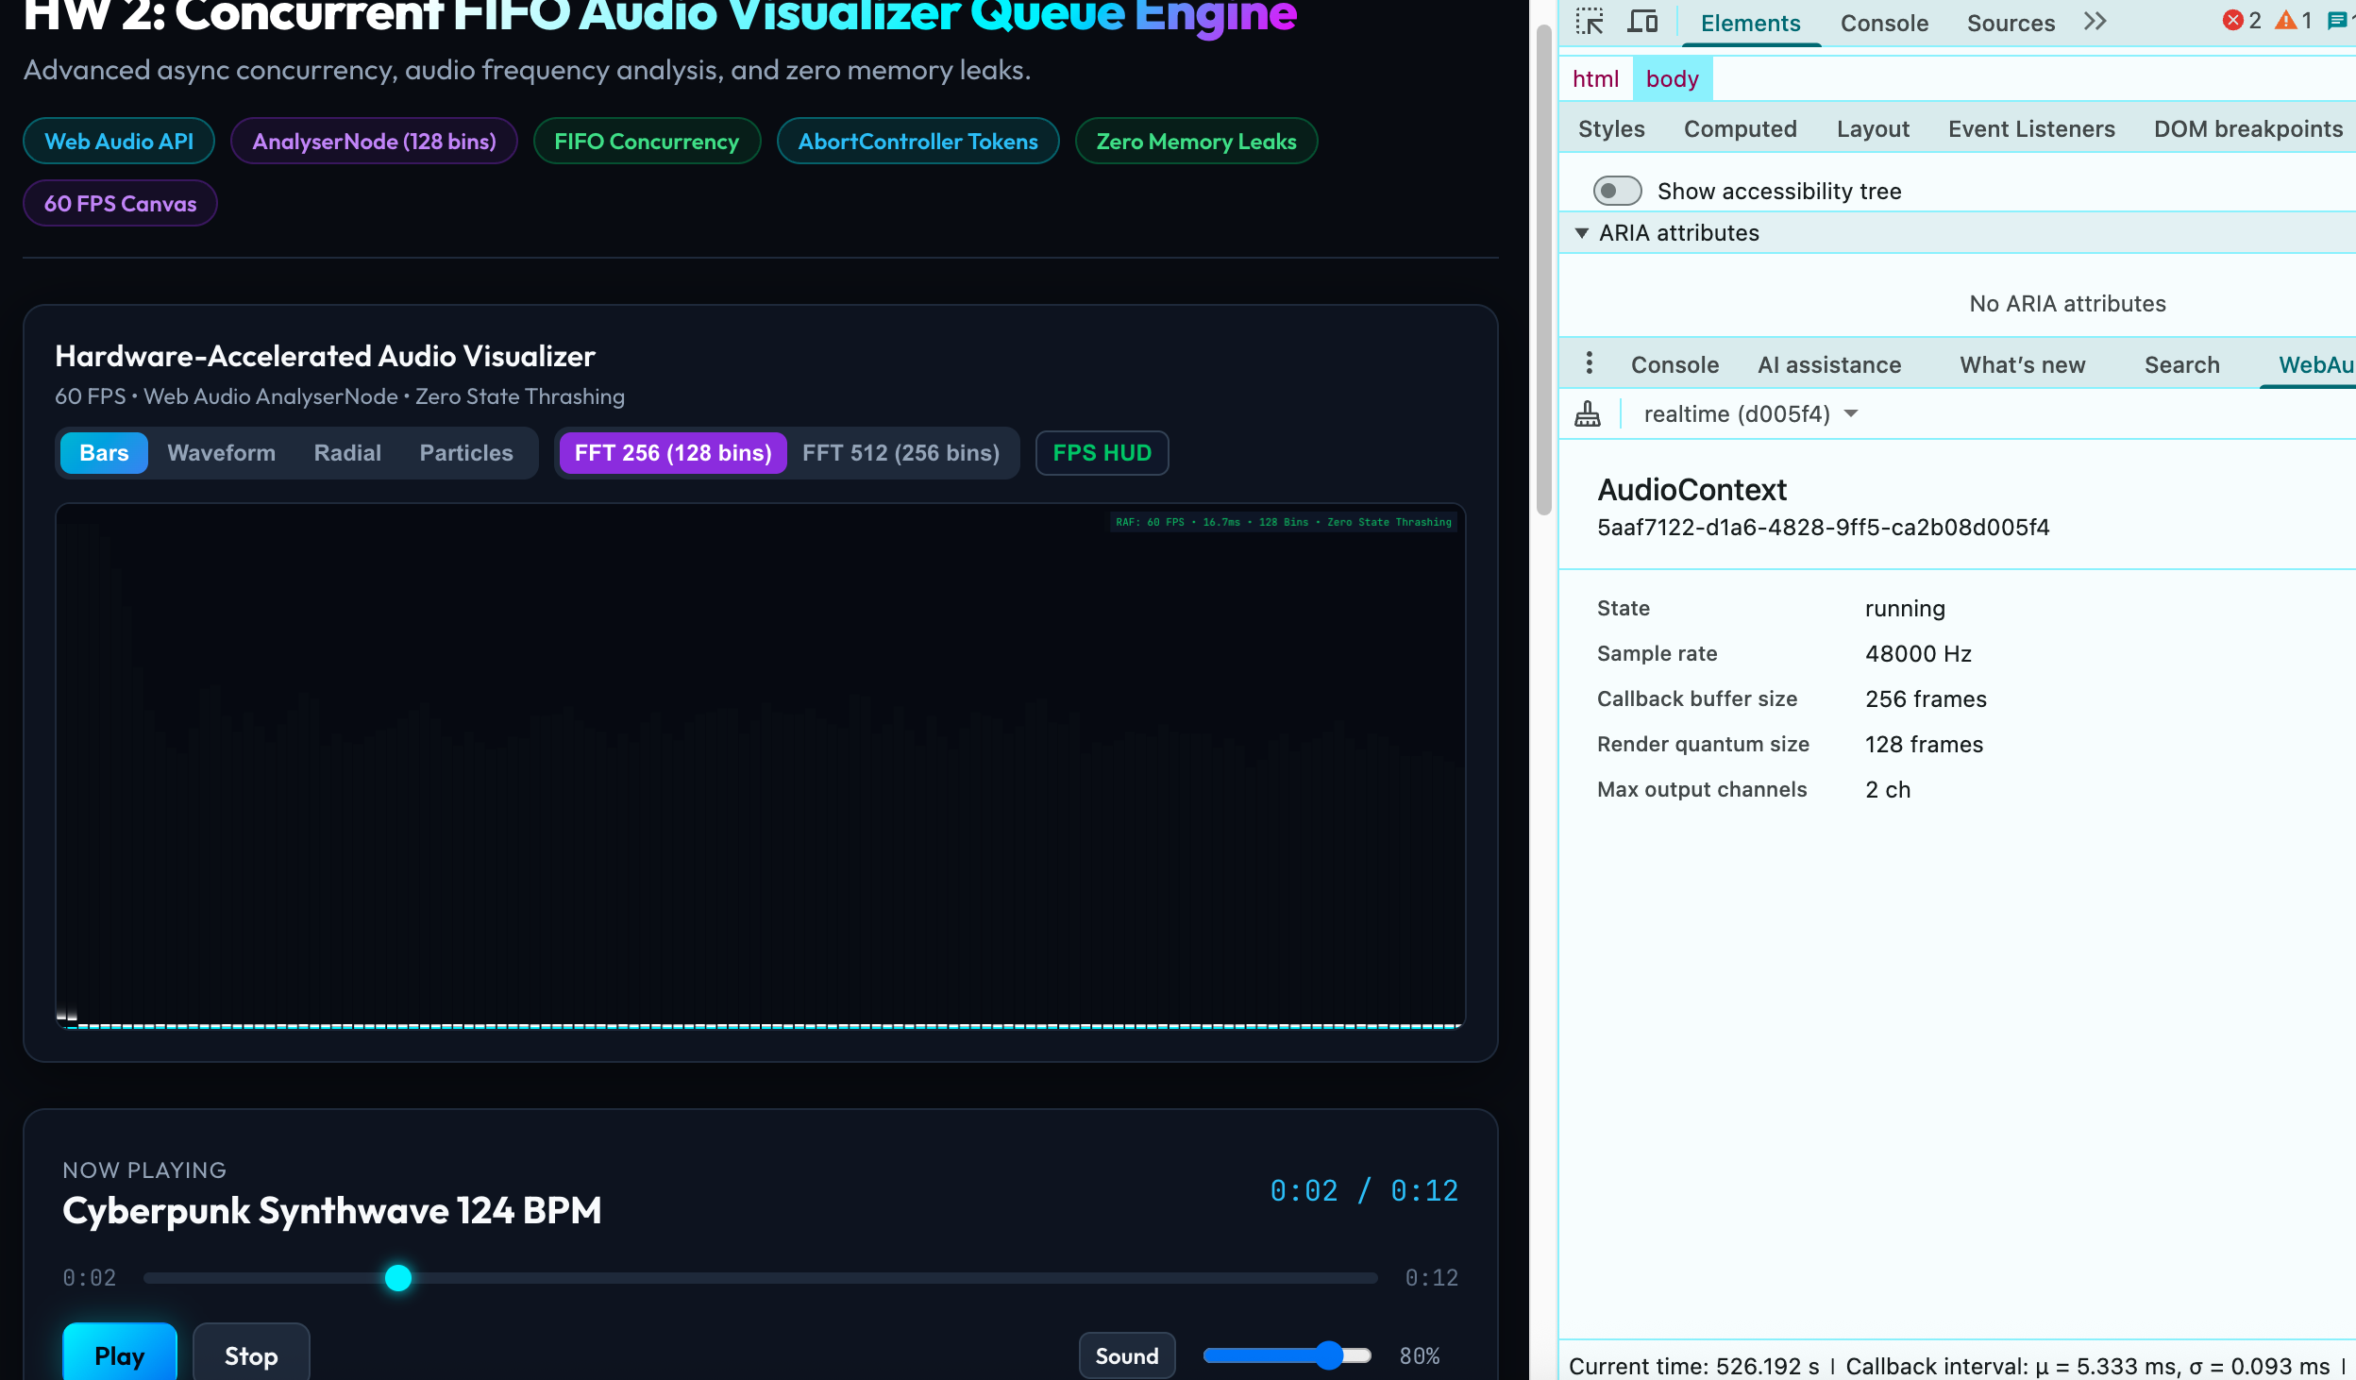
- Concurrency Controller: FIFO Queue handling simultaneous track downloads and audio buffer decoding.
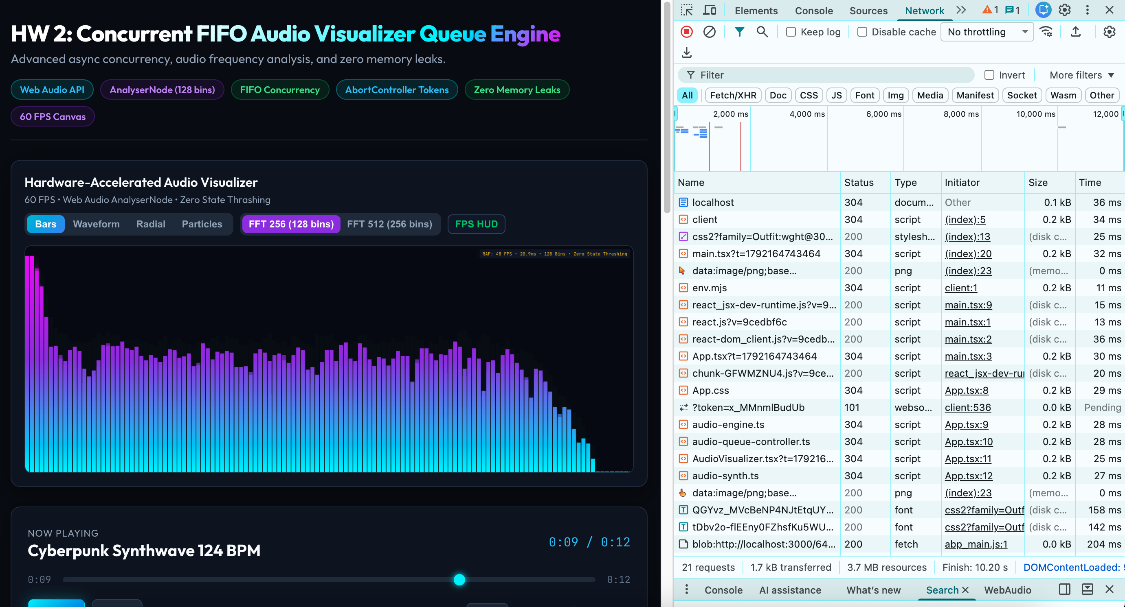
a. Queue
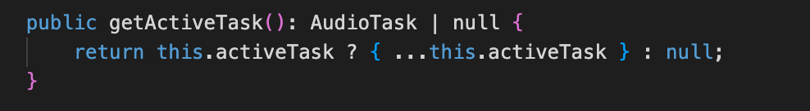
b. Enqueue

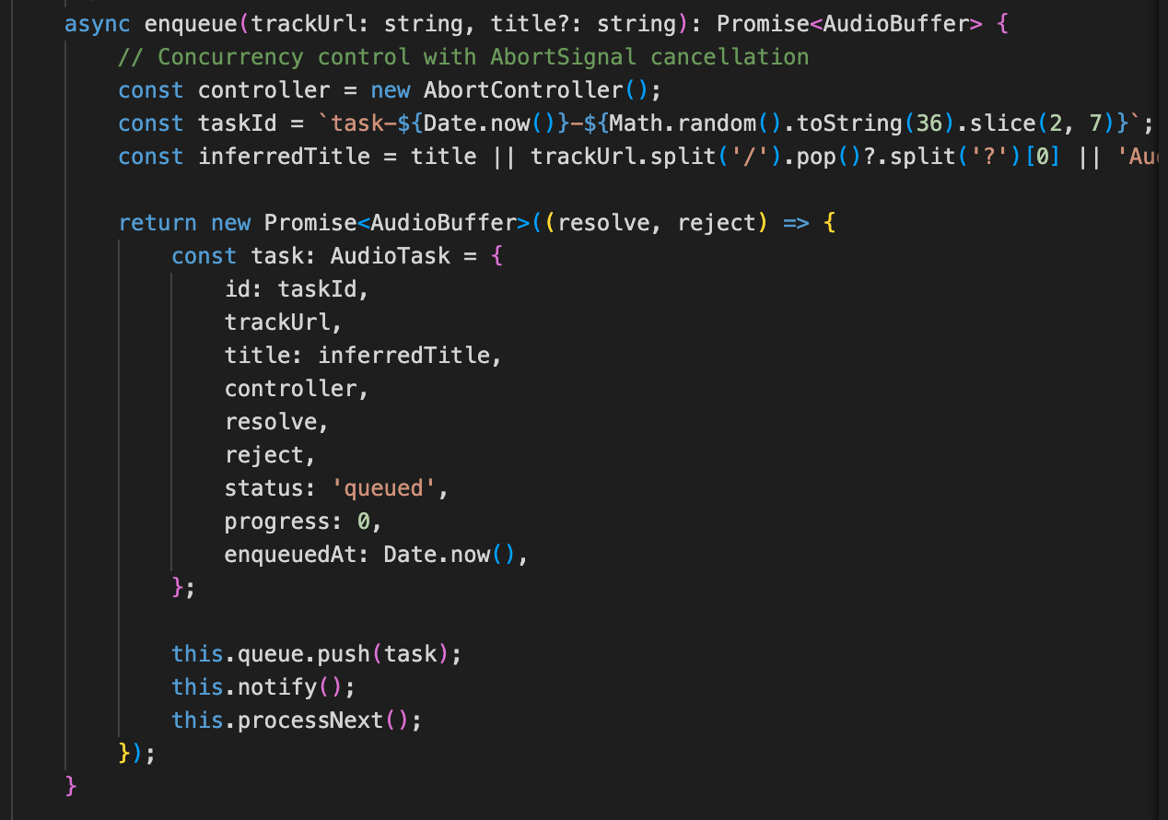
c. Dequeue
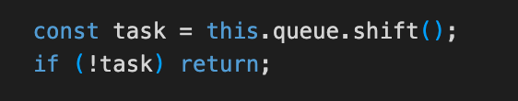
d. ProcessQueue / processNext
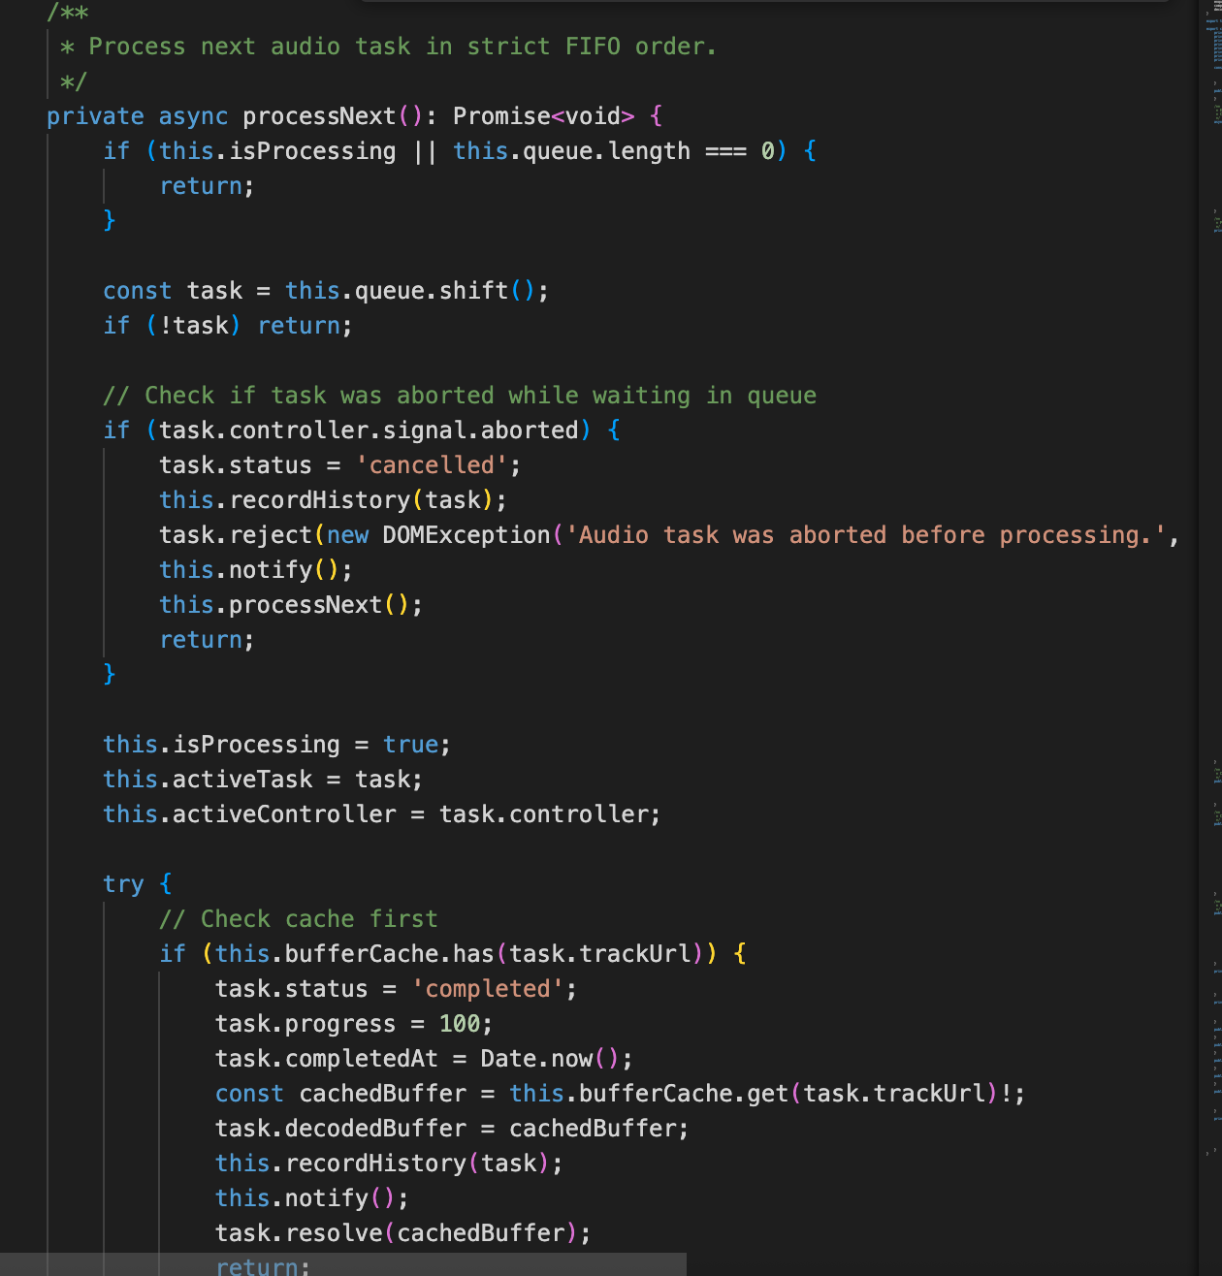
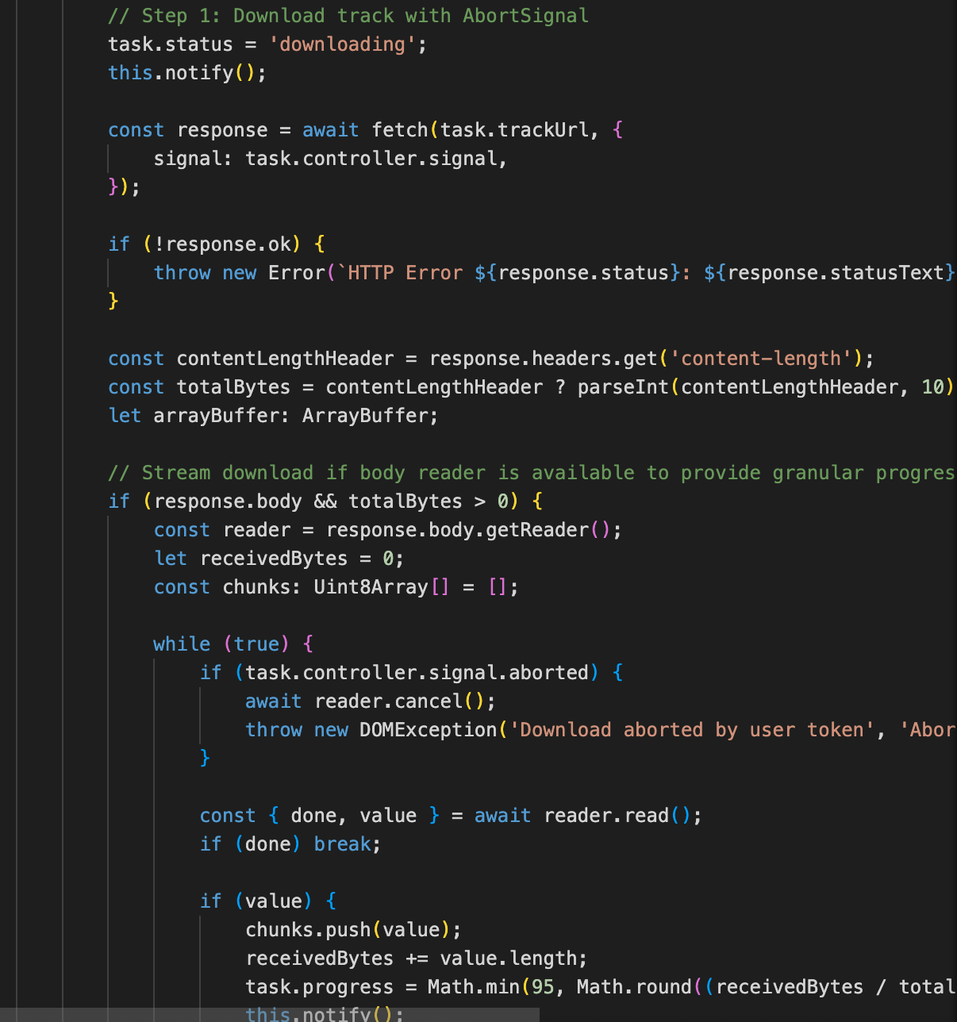
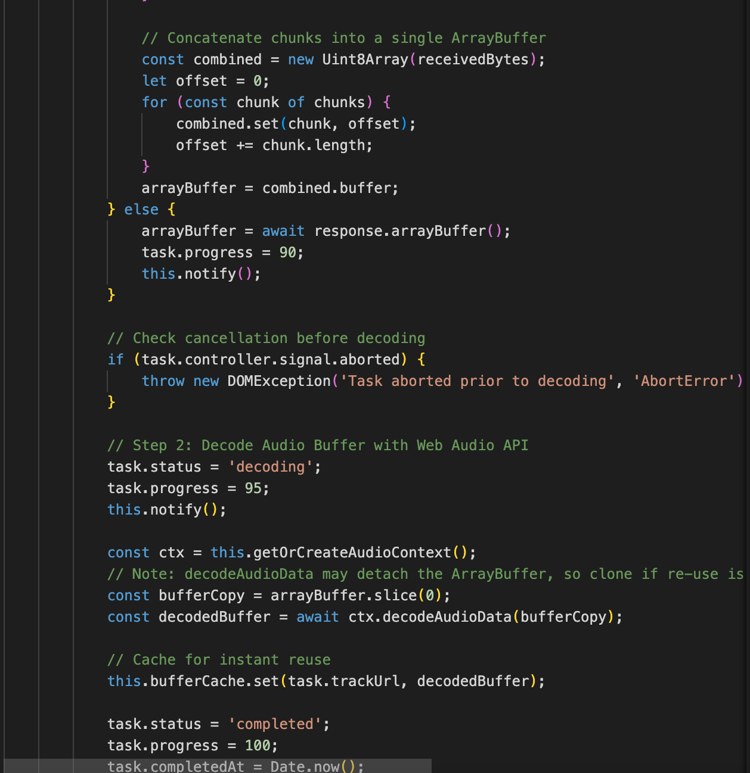
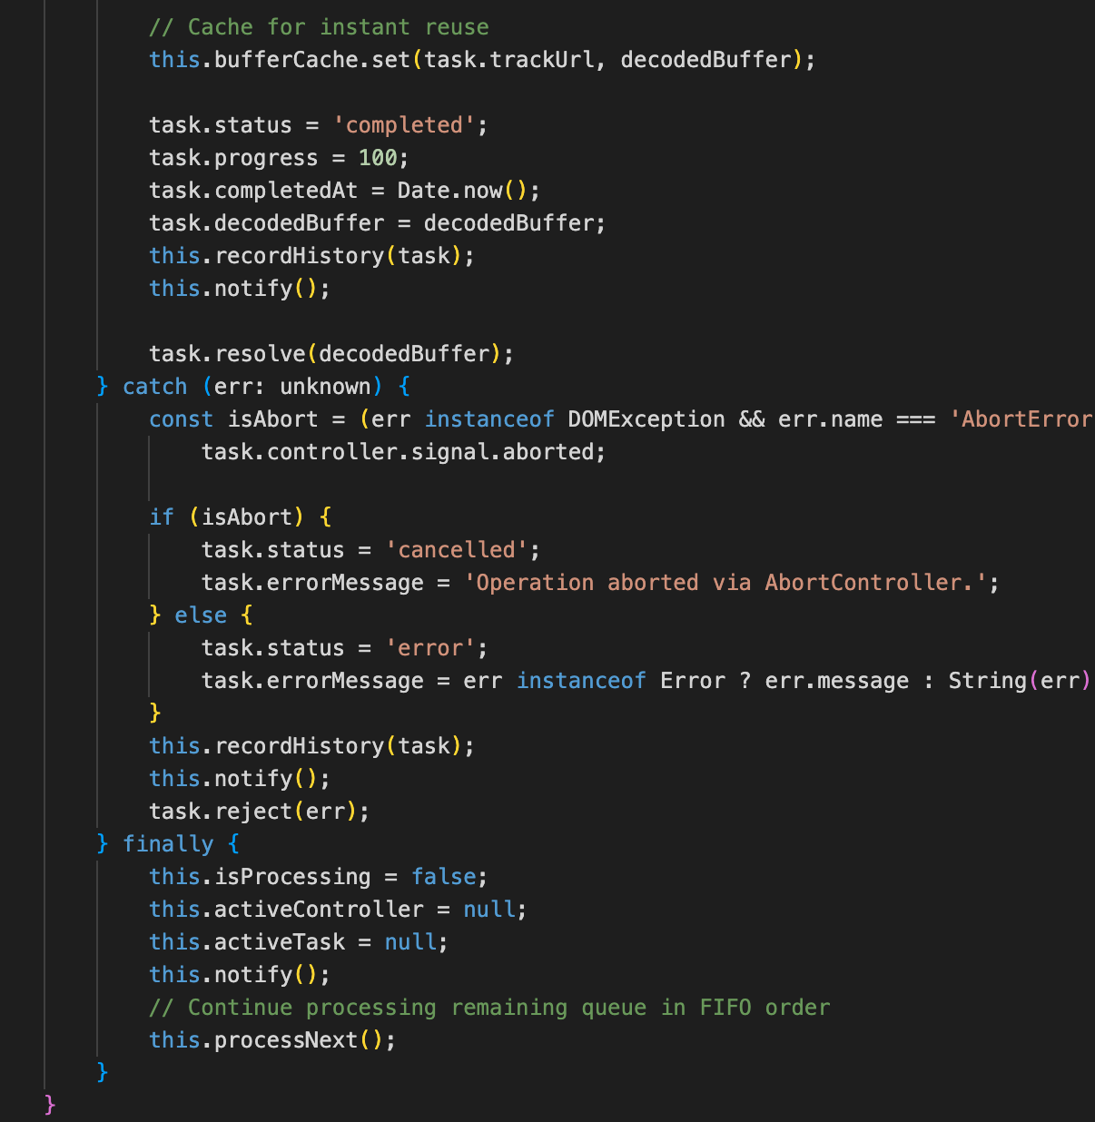
d. DecodeAudioData
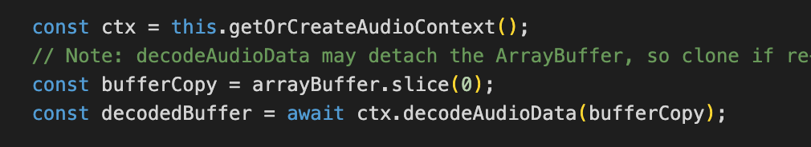
- Memory Safety: Explicit cleanup of AudioBufferSourceNodes, cancellation tokens via AbortController.
a. AudioBufferSourceNodes
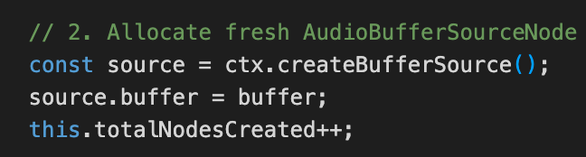
b. SourceStart
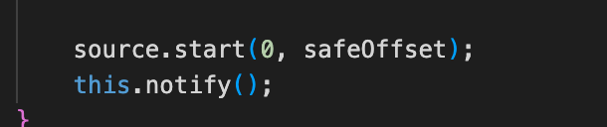
c. SourceStop
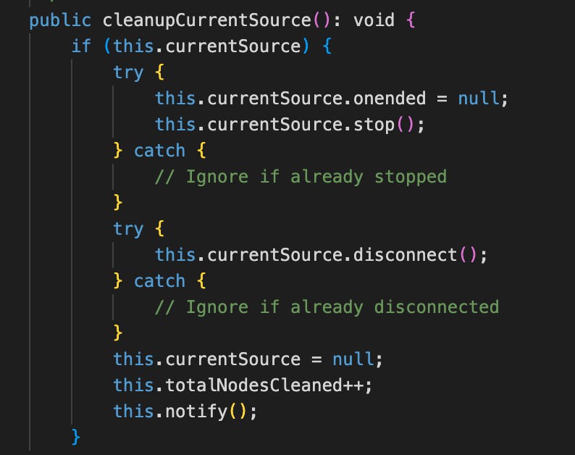
d. SourceDisconnect
e. Cancellation tokens via AbortController.
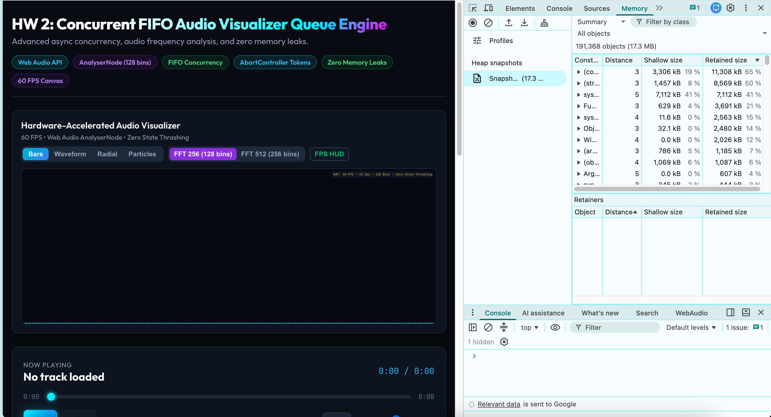
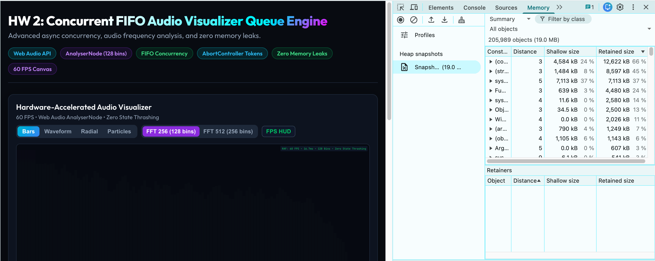
- Performance: 60fps Canvas or SVG visualizer driven by requestAnimationFrame without state thrashing.
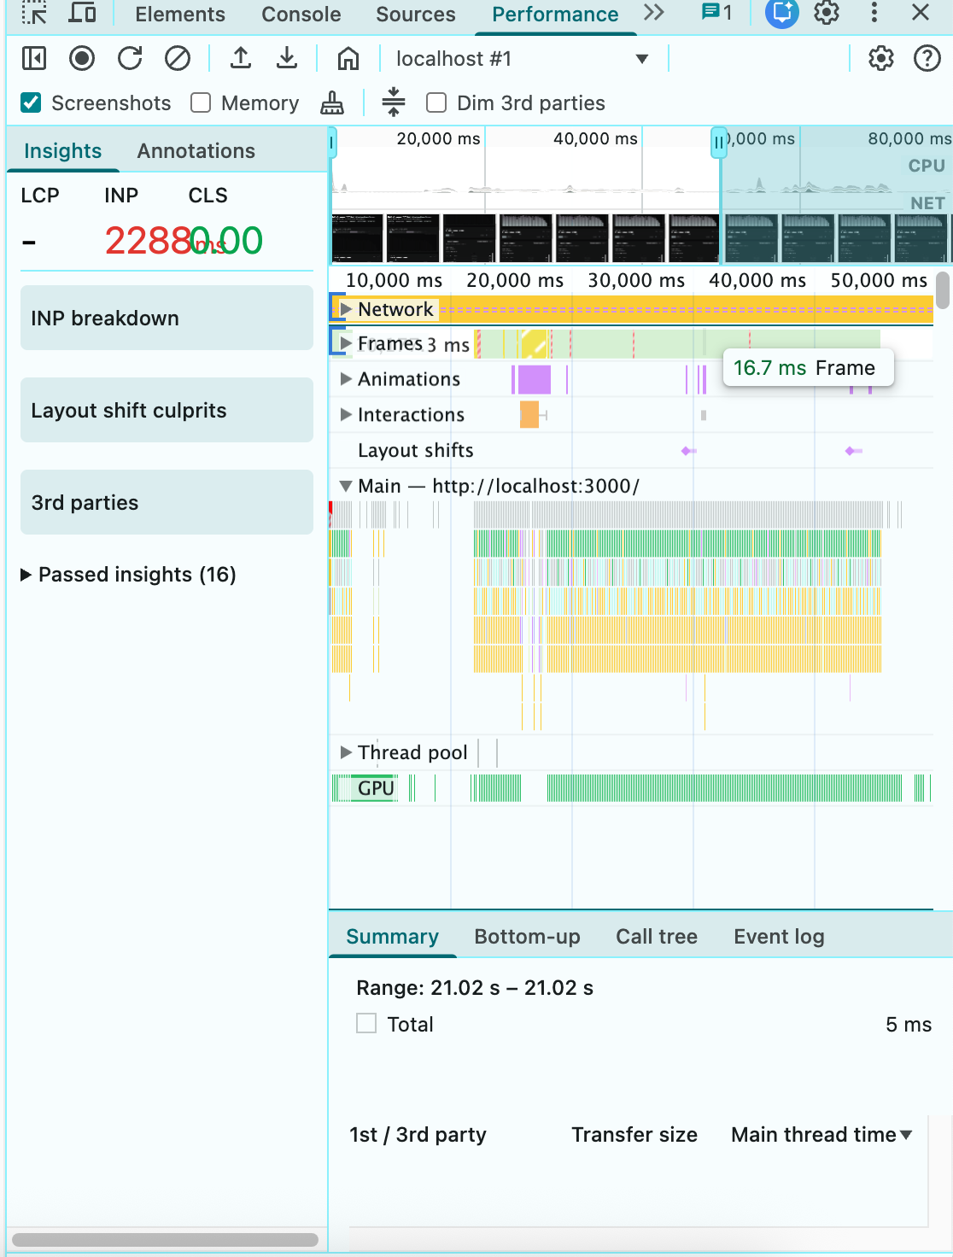
HW 3: High-Concurrency Flash-Sale E-Commerce Engine
Realistic Vietnam market scenario: Zero-drift countdown timer & inventory state machine.
Project Specification & Criteria
- Domain: Vietnam Mega-Sale (Shopee / Lazada 11.11 / Midnight Flash Sale simulation).
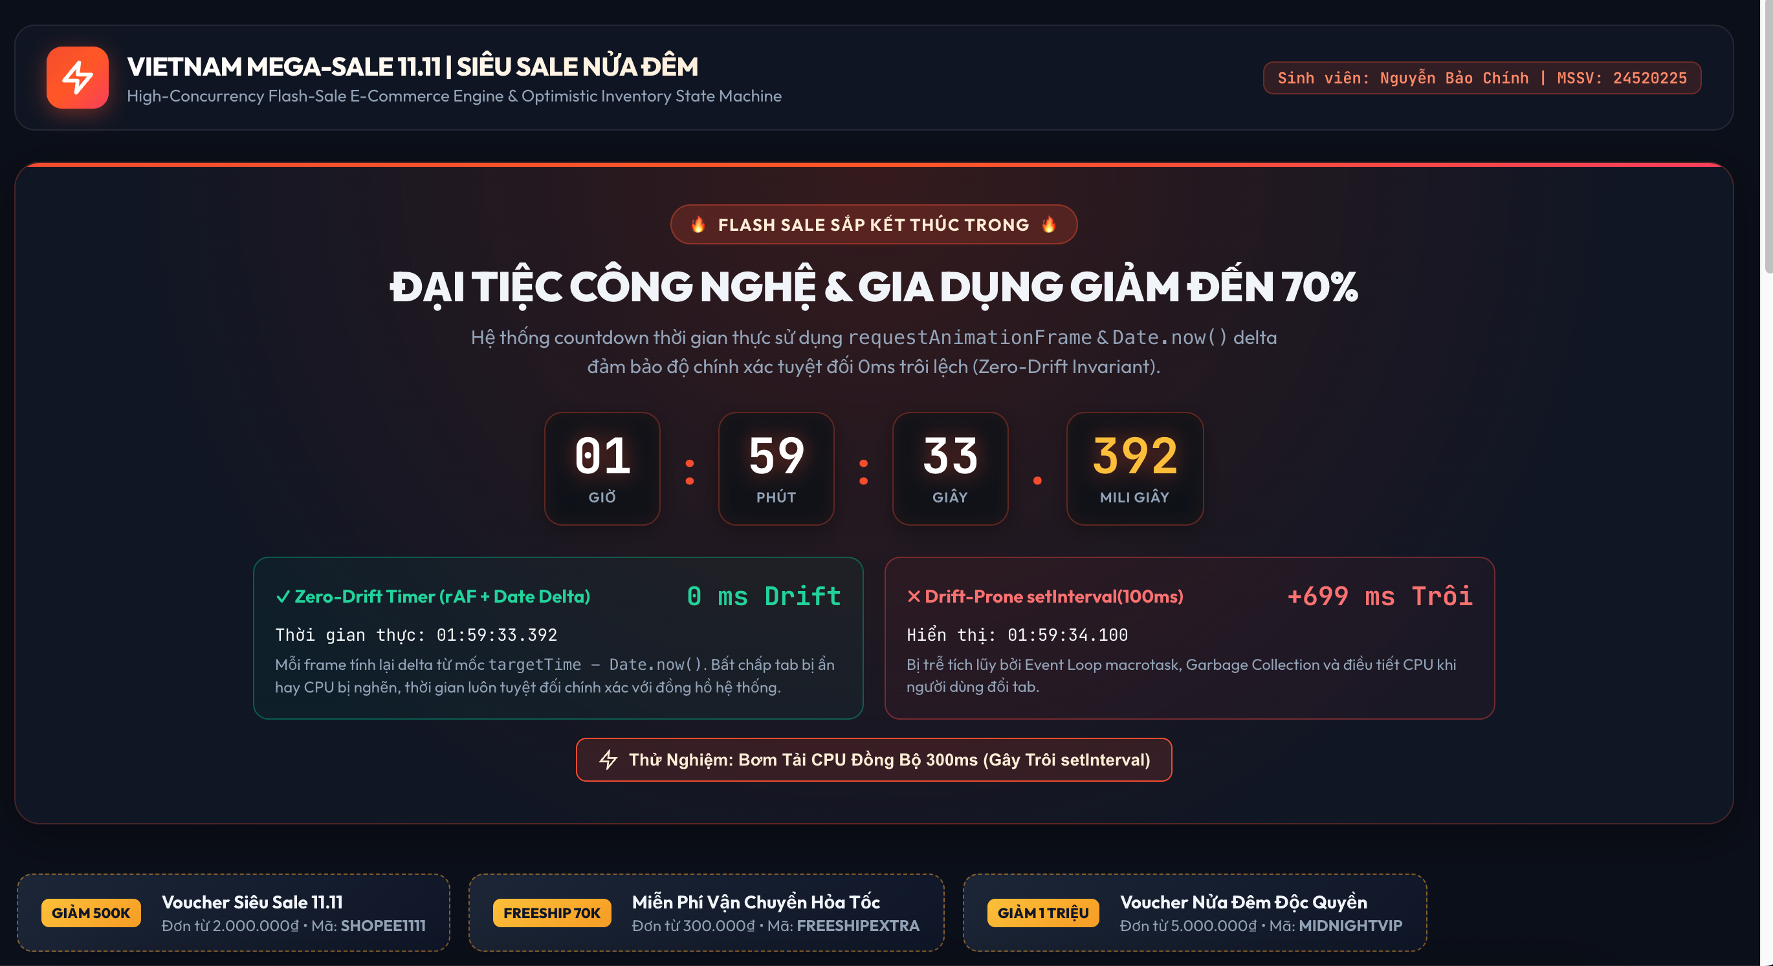
- Zero-Drift Timer: Accurate millisecond countdown using Date.now() delta vs drift-prone setInterval.
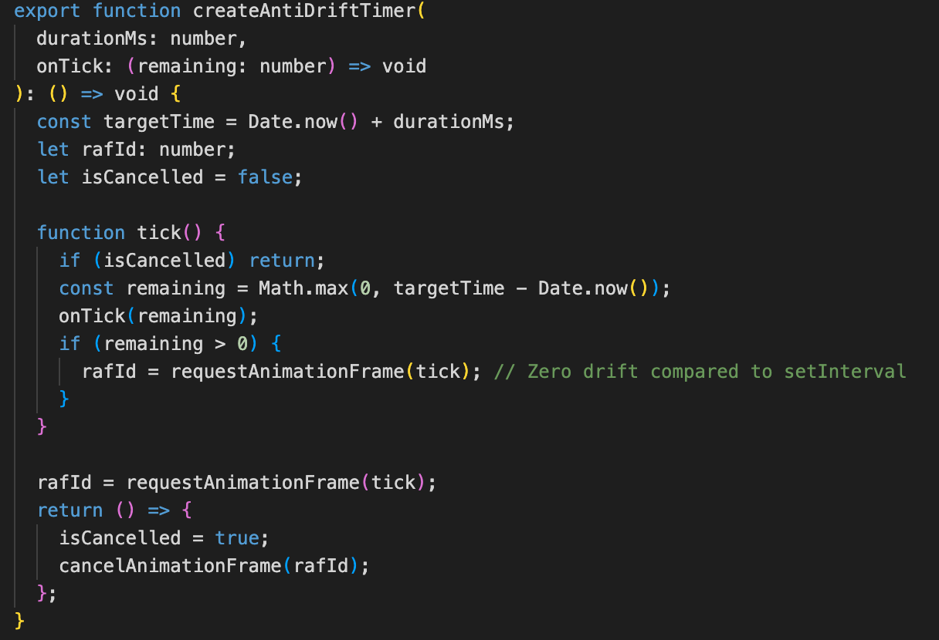
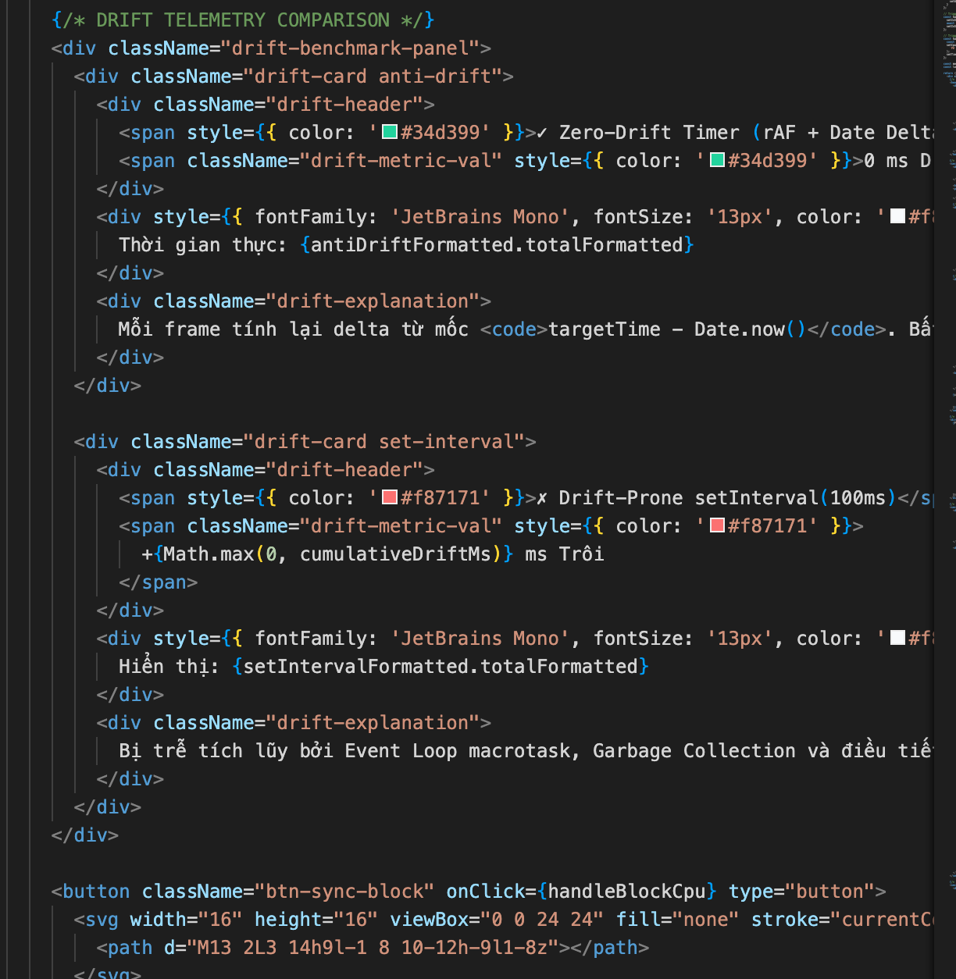
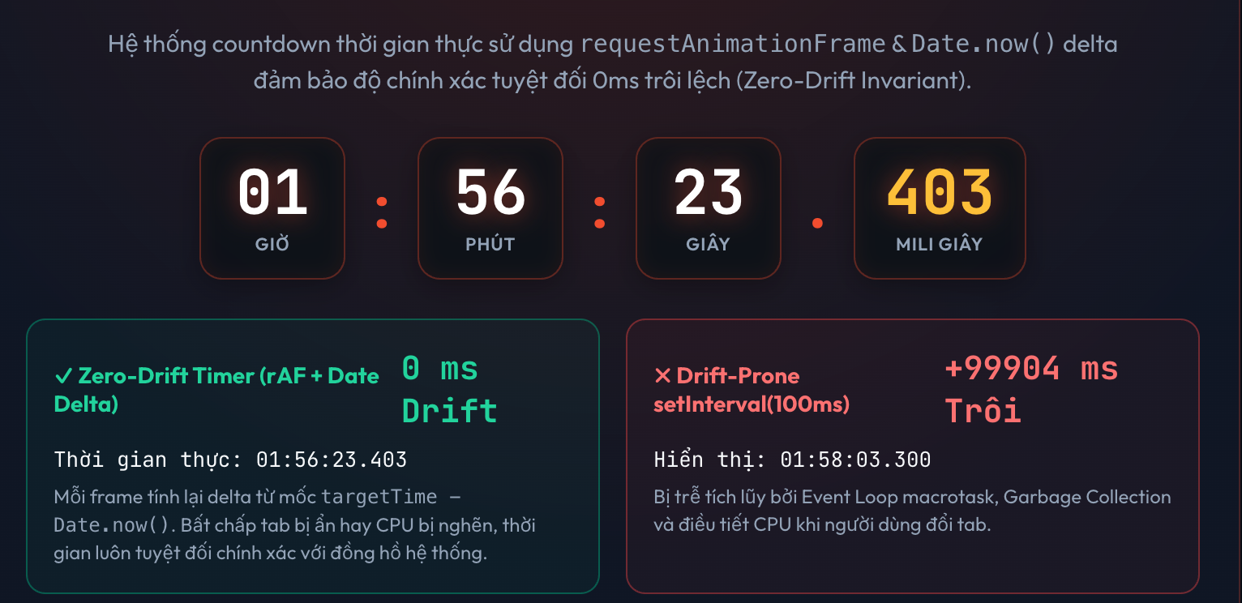
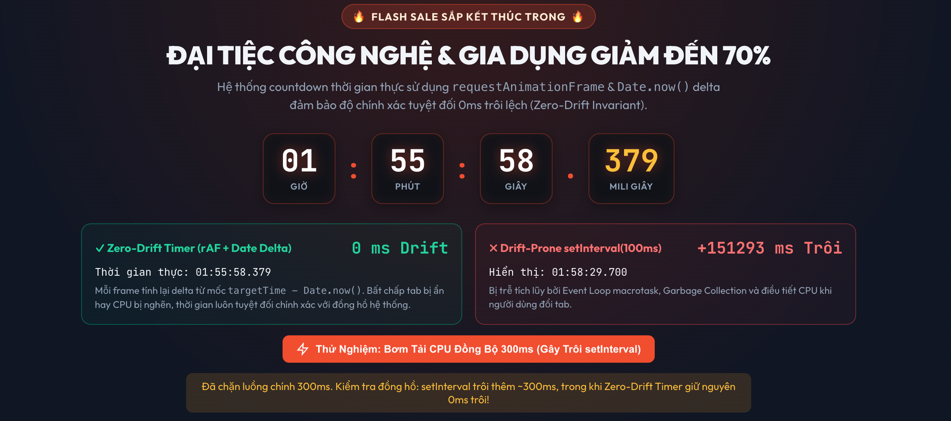
- Optimistic Inventory Lock: Finite state machine handling inventory reservation, lock expiry, and checkout.
a. : Finite state machine handling inventory reservation
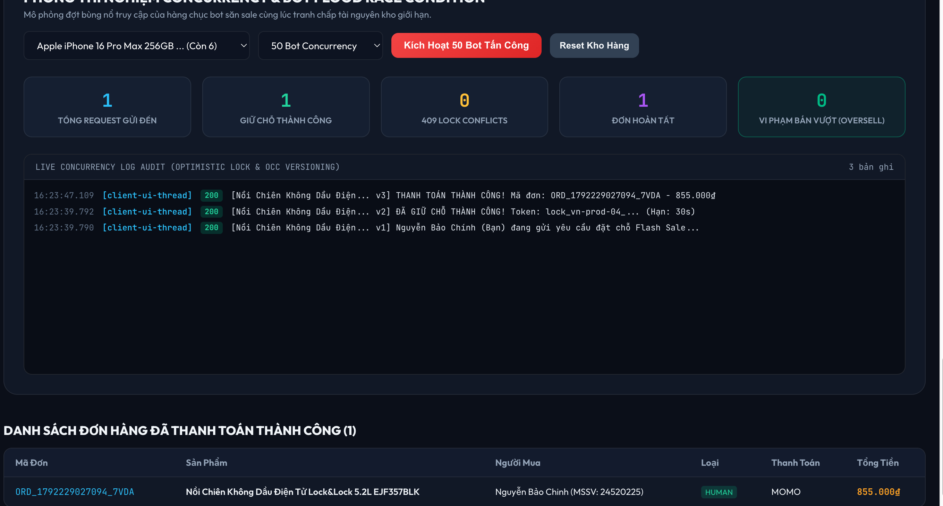
b. Lock expiry
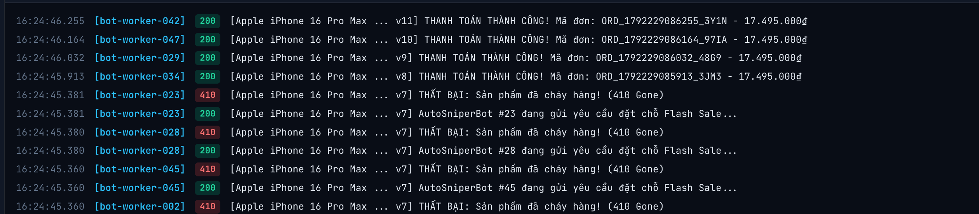
c. Checkout.
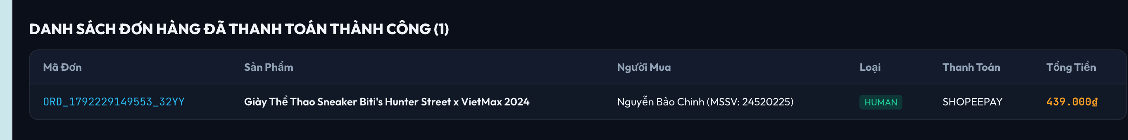
- AI Failure Mode Audit: Mandatory AI_FAILURE_AUDIT.md report documenting >= 3 AI flaws.
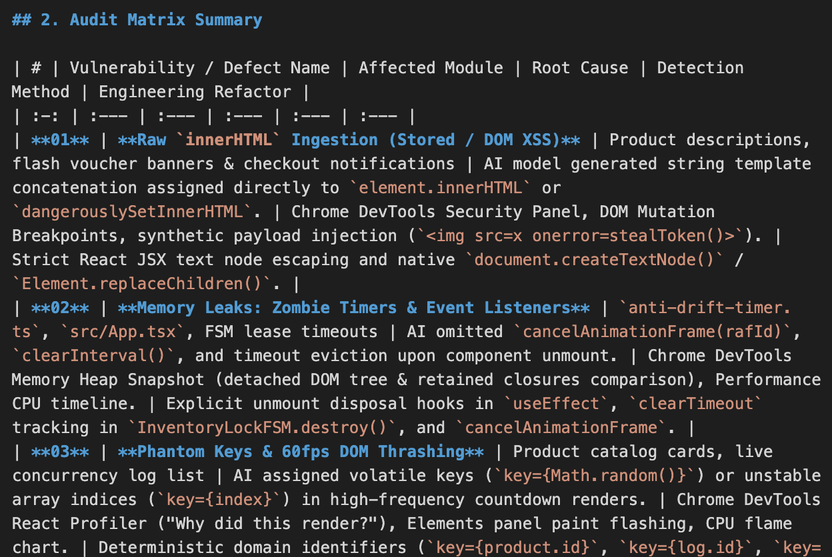
- Atomic Commits: Minimum 8 discrete commits adhering to Conventional Commits specification.
