Student name: Nguyen Bao Chinh
Student ID: 24520225
Link Github: https://github.com/Pengikas/24520225_NguyenBaoChinh_Lab_EX-HW.git

EXERCISE 1
Link AI Agent: https://claude.ai/share/f16d5926-93a6-46bd-b3bd-9ceaf7d9896d
Screenshot for the results
Step 1: WBS Task T-01 in TASK_DECOMPOSITION.md.
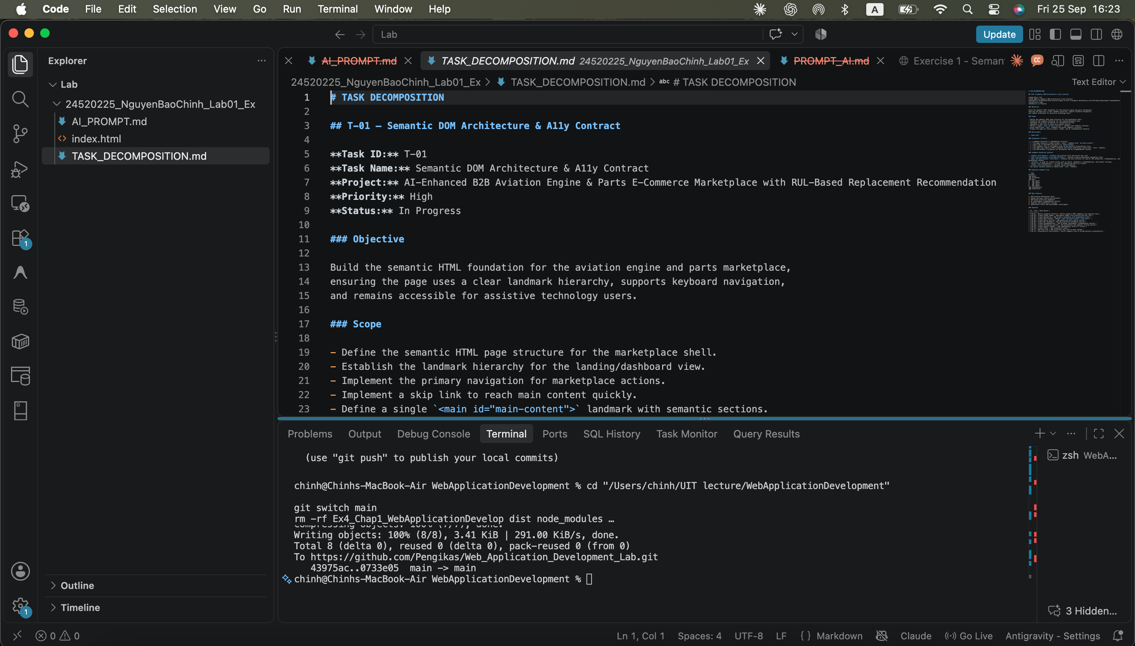
Step 2: Define landmark hierarchy contract (0 <div> elements).
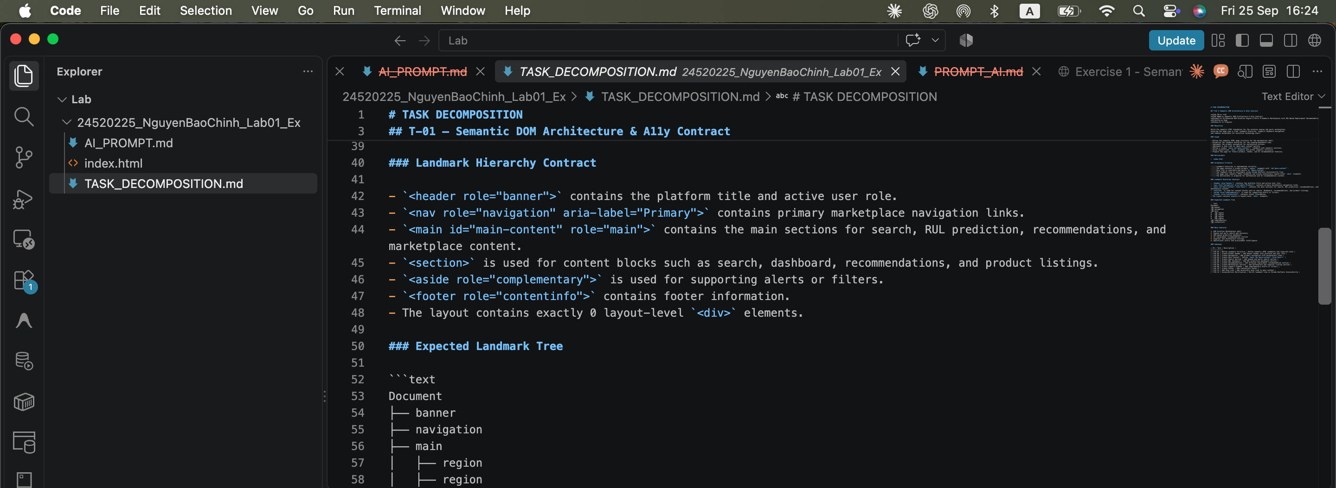
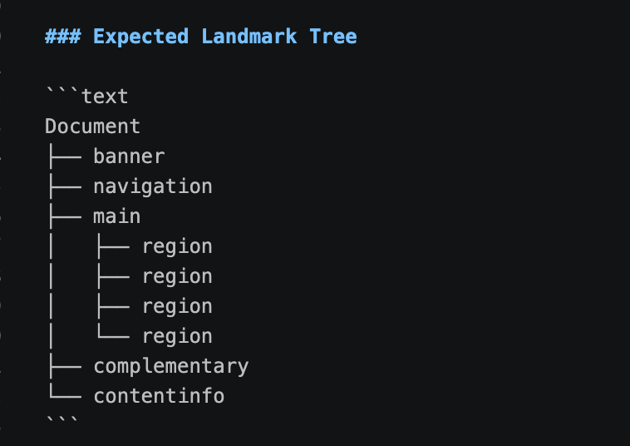
Step 3: Implement accessible skip-link (<a href="#main">Skip to Content</a>).
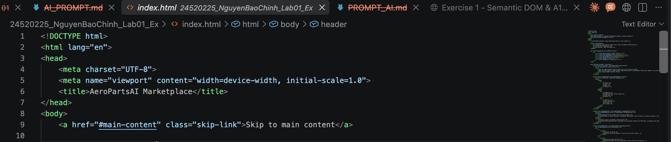
Step 4: Atomic Commit: git commit -m 'feat(html): semantic landmark tree’
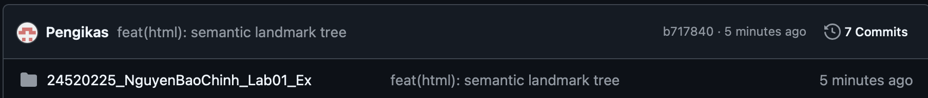
• Open Chrome DevTools -> Accessibility -> Verify Landmark Tree.

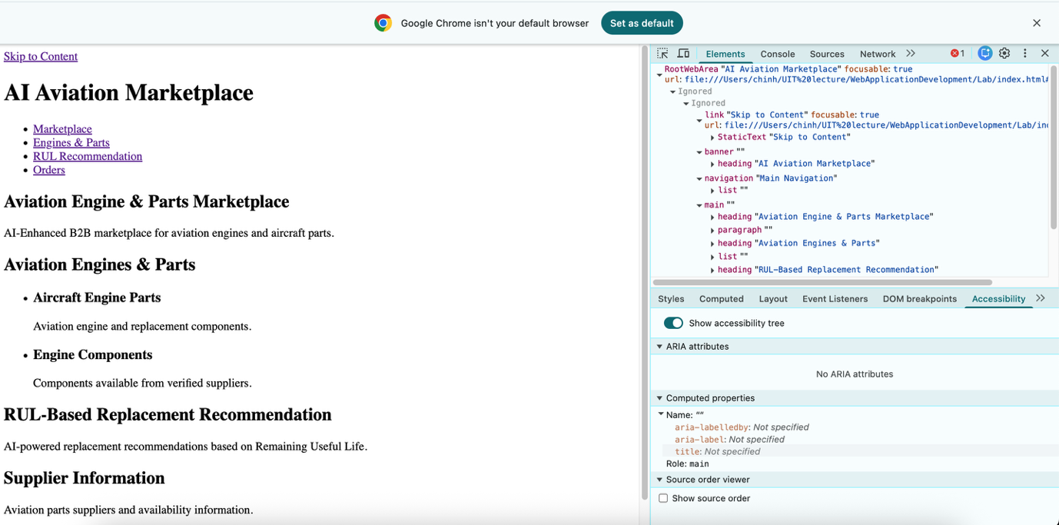
One-shot prompt penalty: Commits combining CSS with HTML get 0 pts.
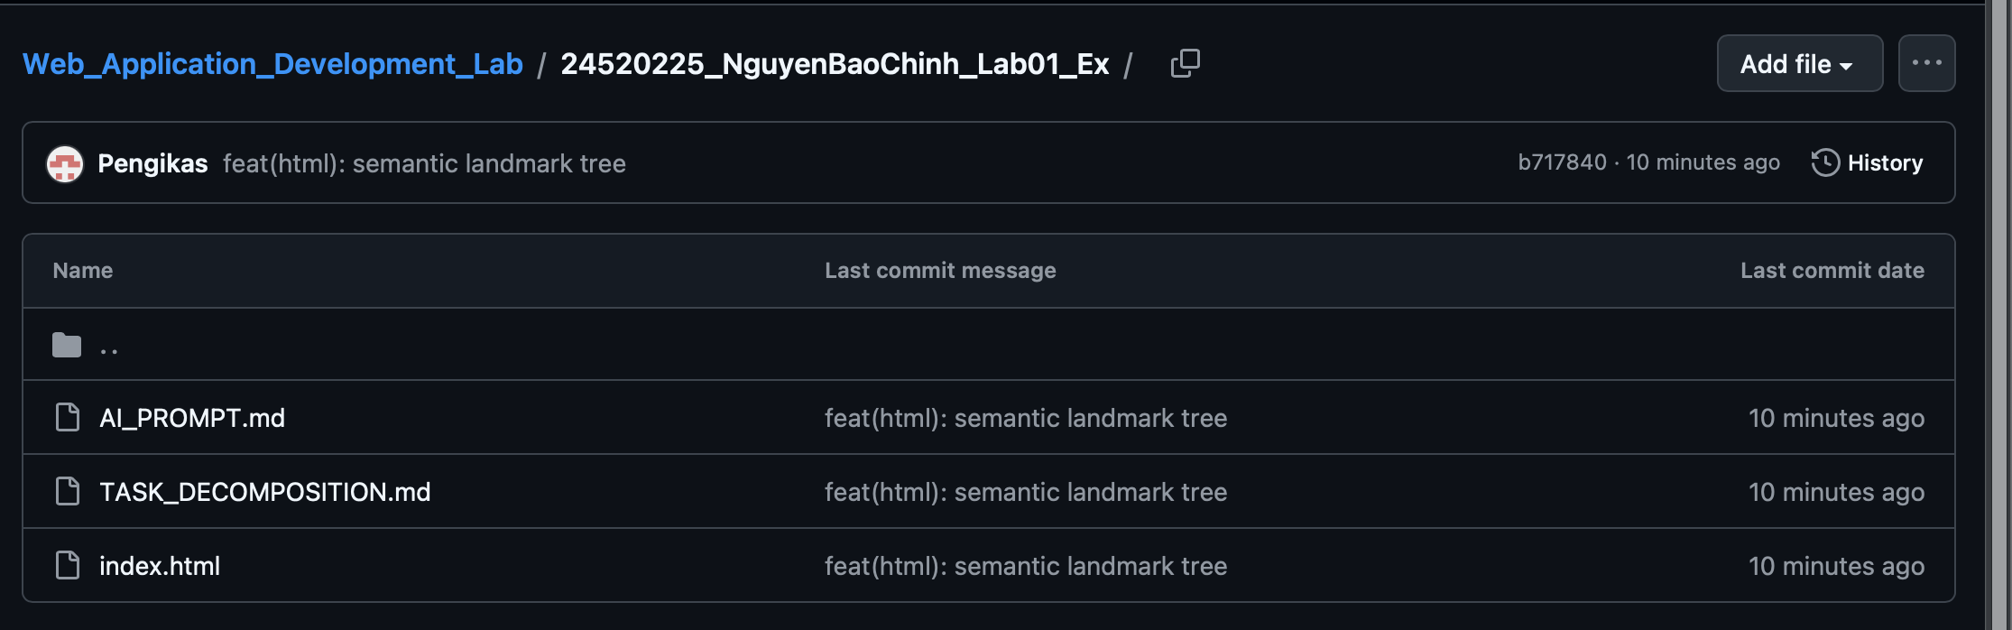

EXERCISE 2
Link AI prompt: https://chatgpt.com/share/6ab6a30b-9340-83ec-af80-1db60ee8609d?ogimg=plain
Screenshot for results
• SUB-TASK T-02A: Tokens & Reset -> git commit -m 'feat(css): tokens & reset'
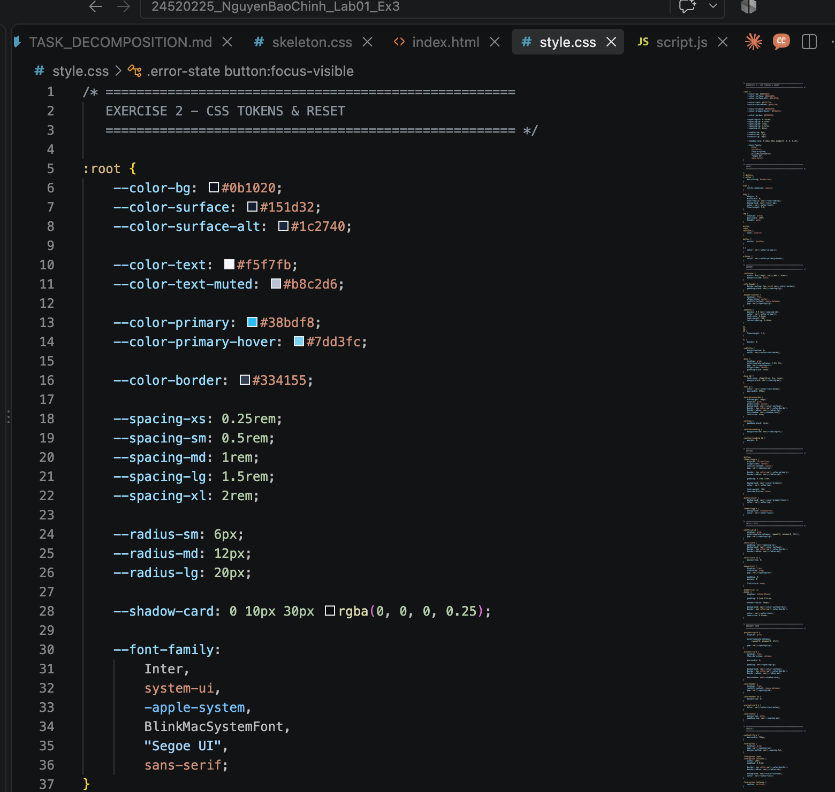
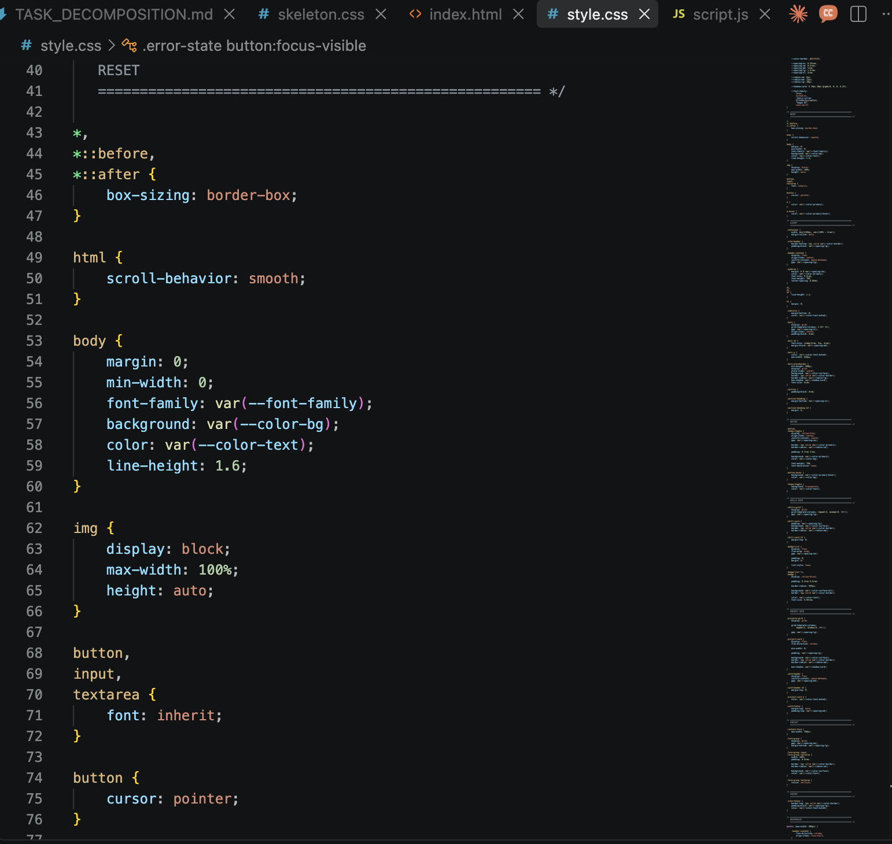
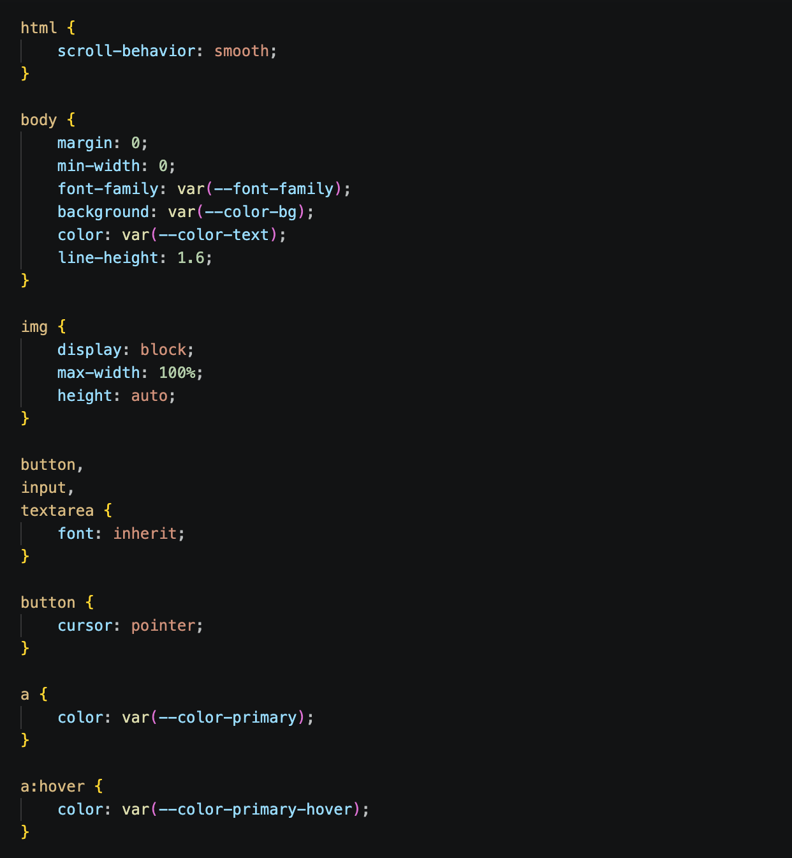
• SUB-TASK T-02B: 2D Grid Layout -> git commit -m 'feat(css): responsive grid'
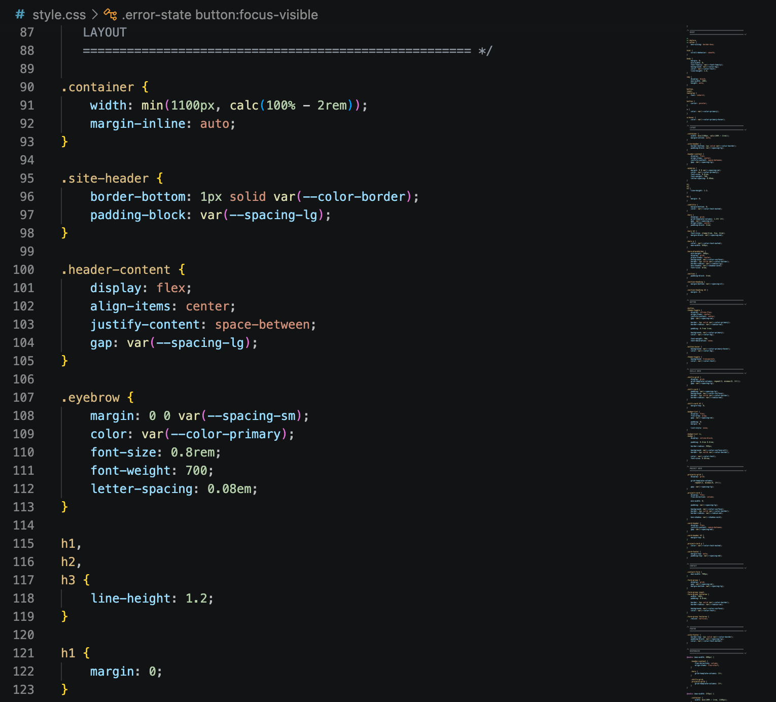
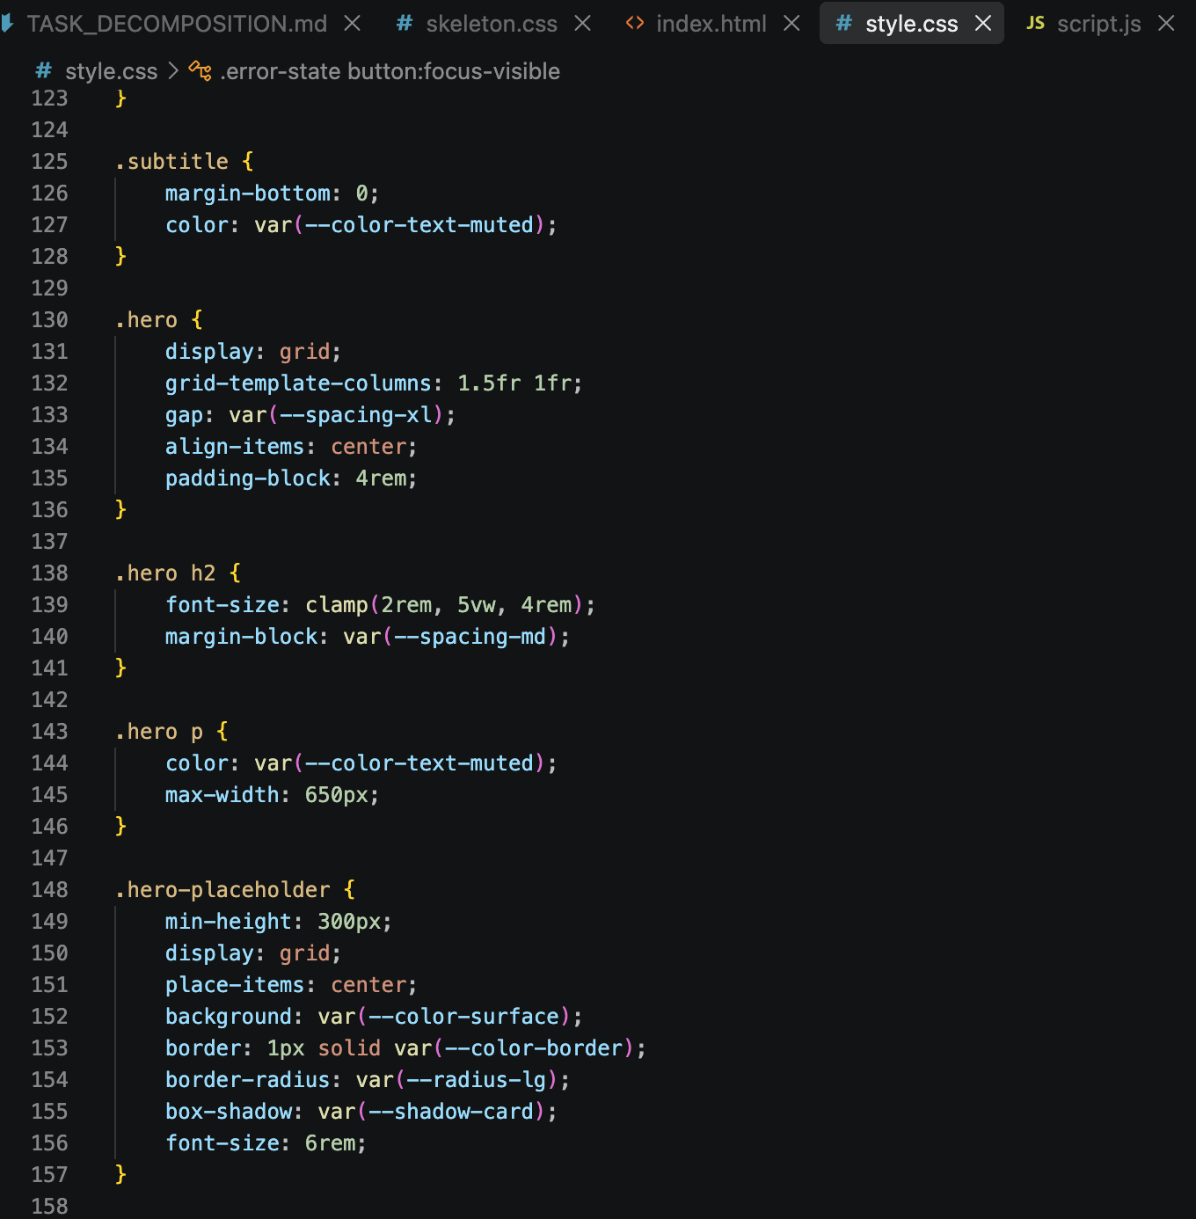
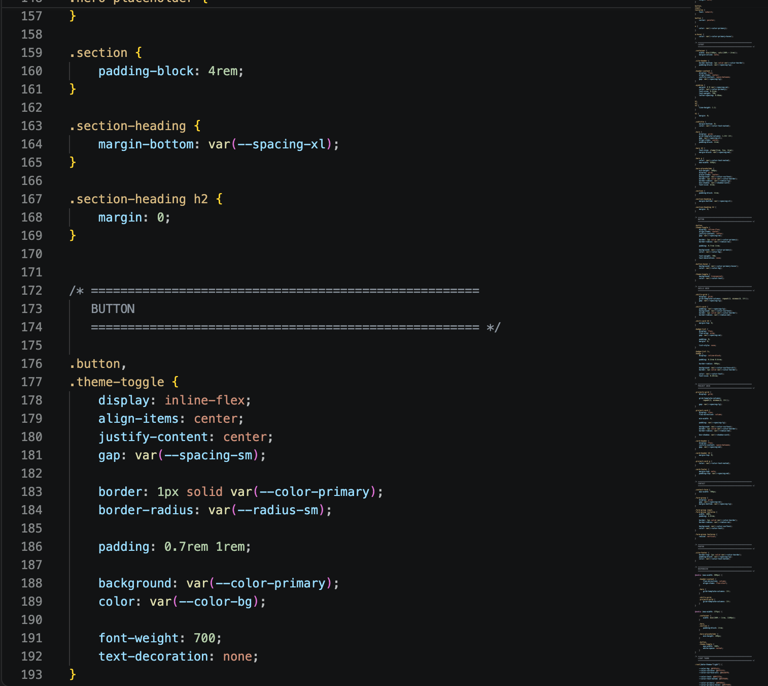
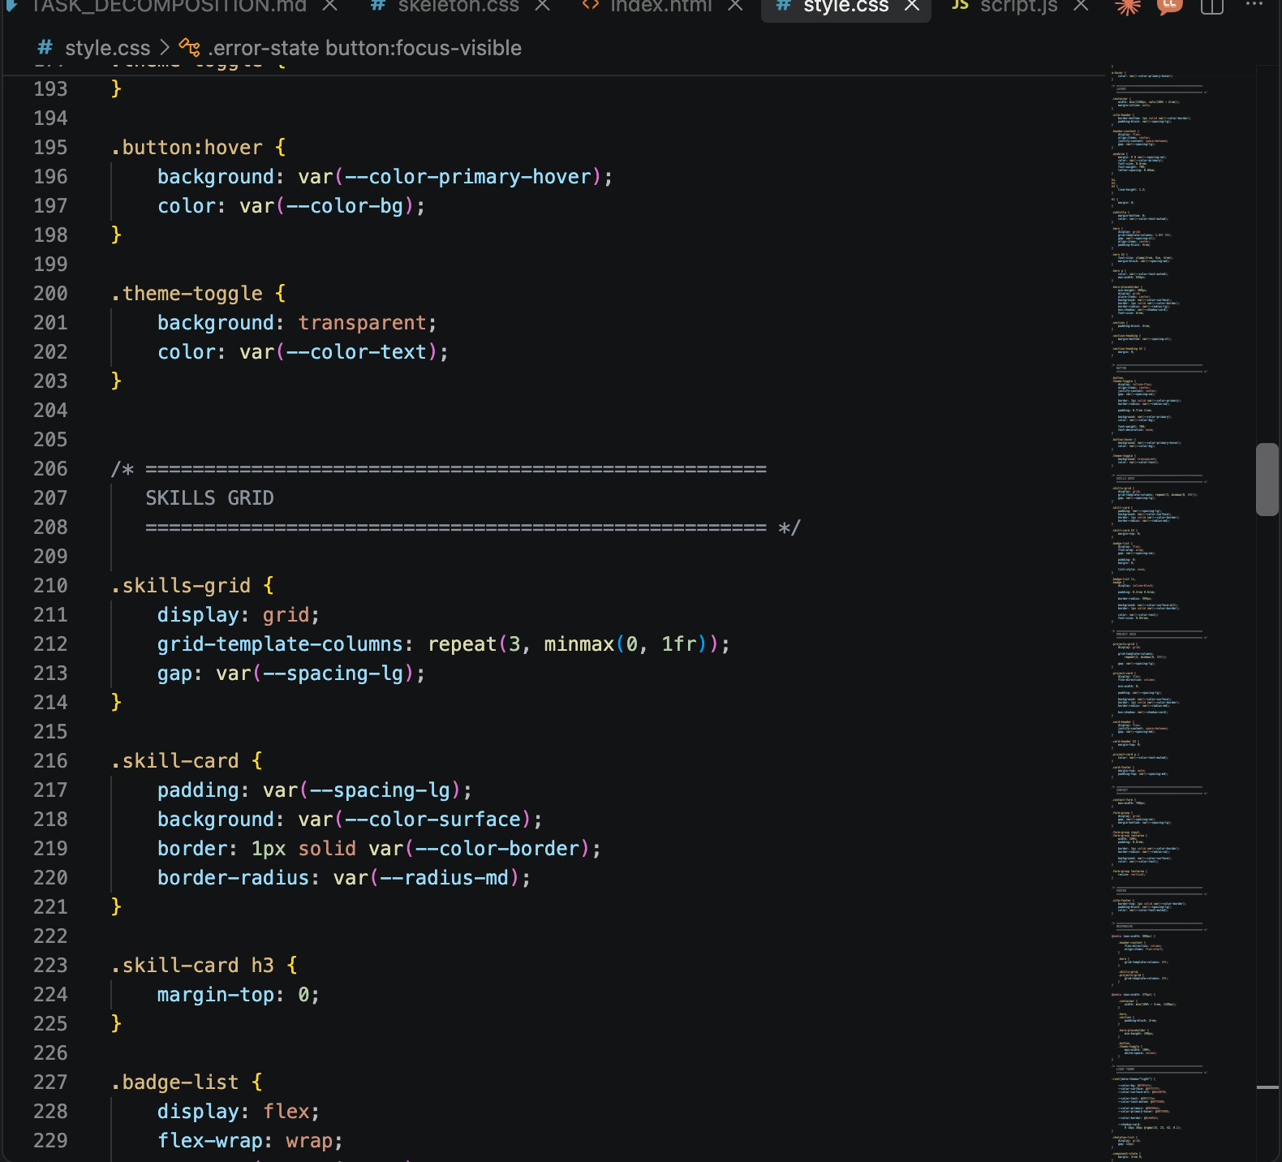
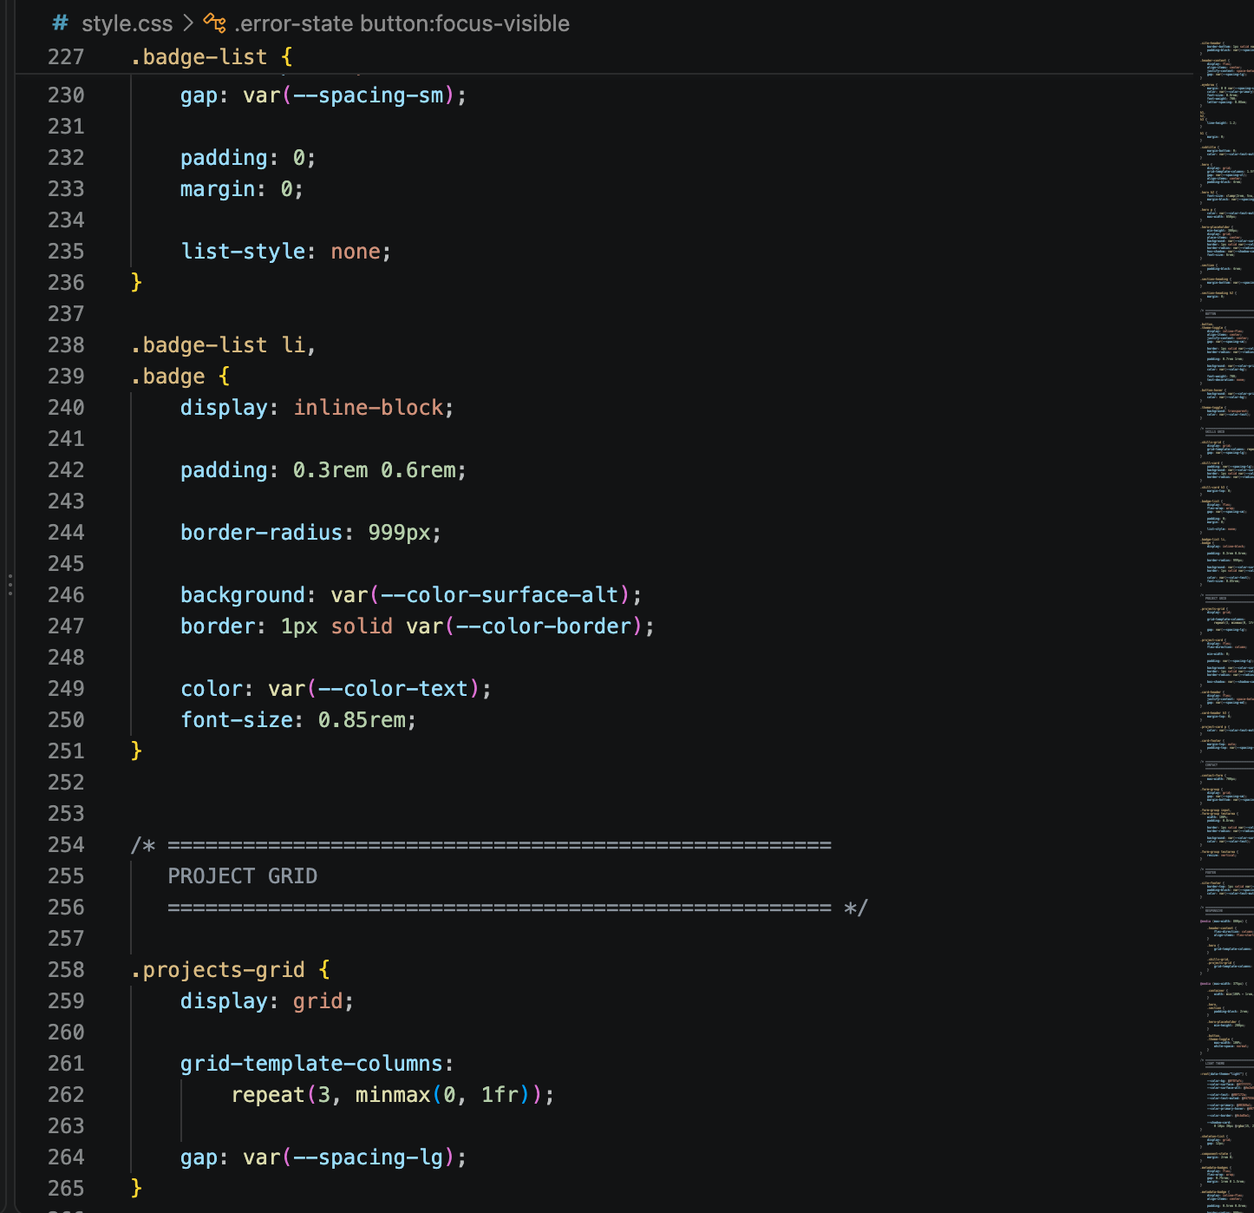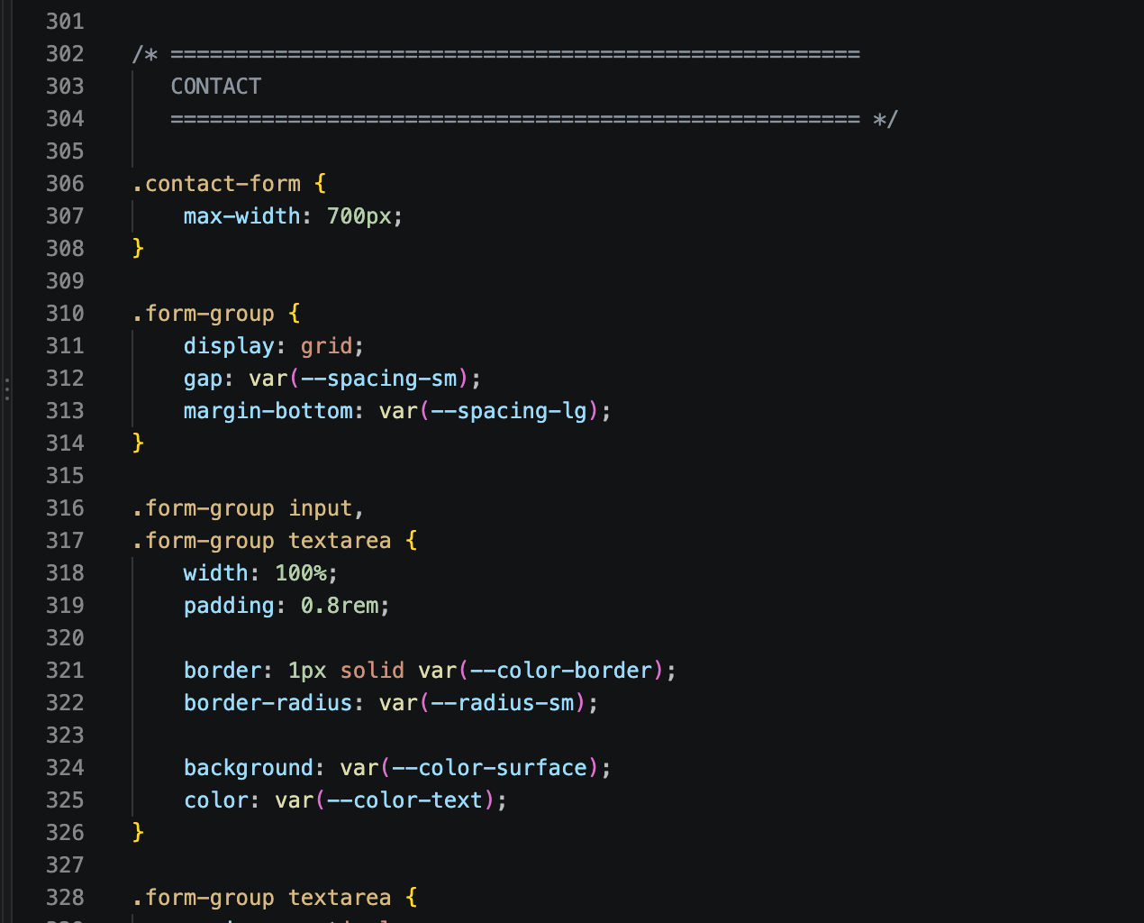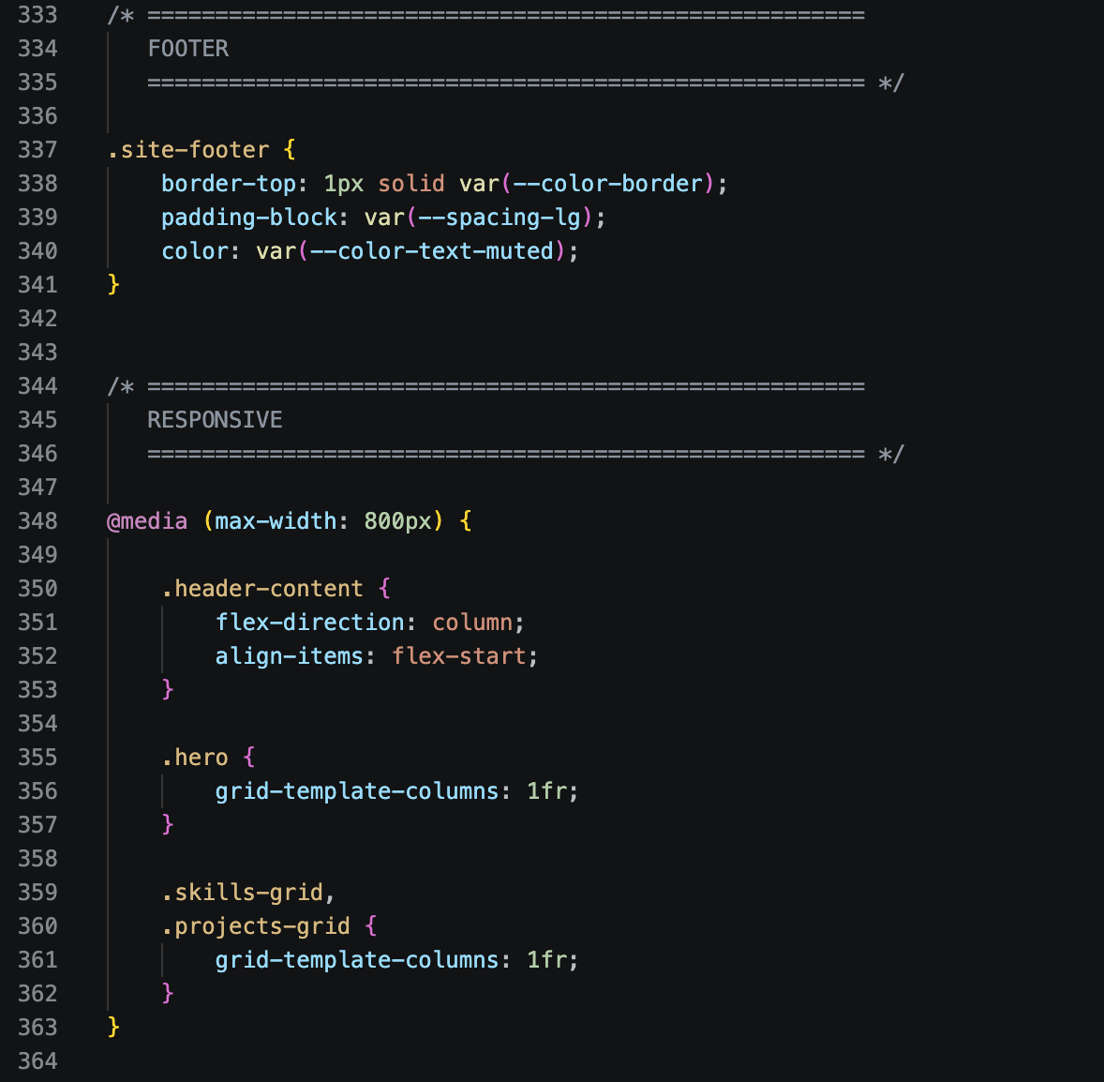
• SUB-TASK T-02C: Theme Engine -> git commit -m 'feat(js): dark mode engine'
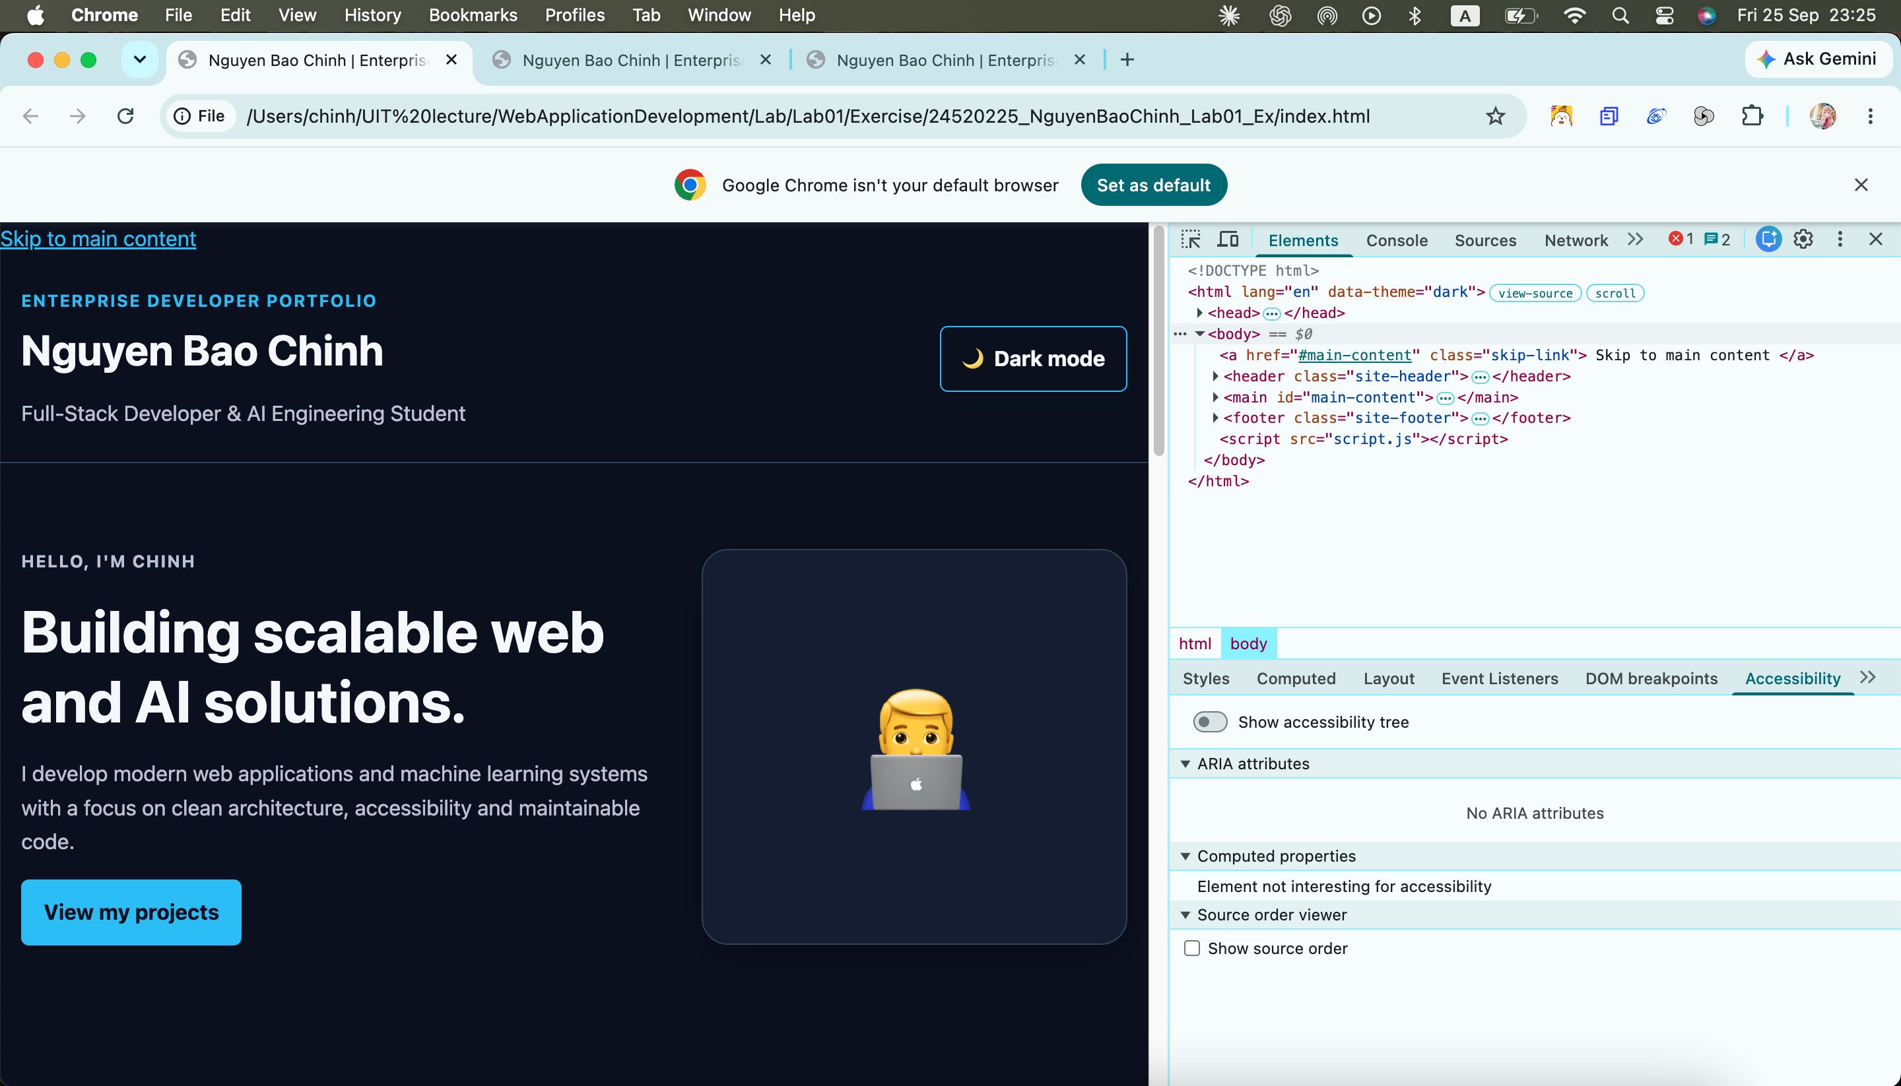
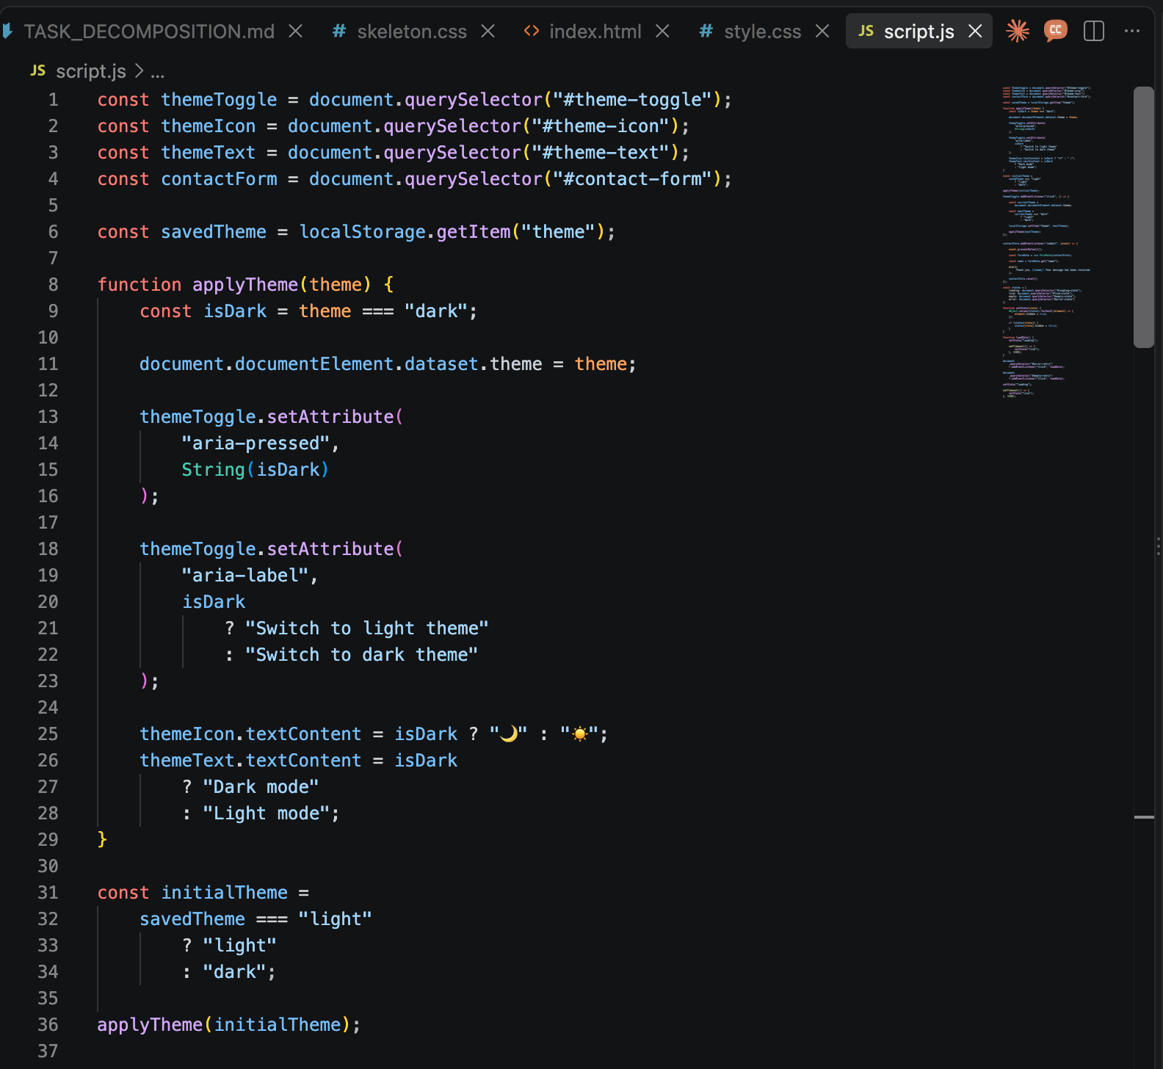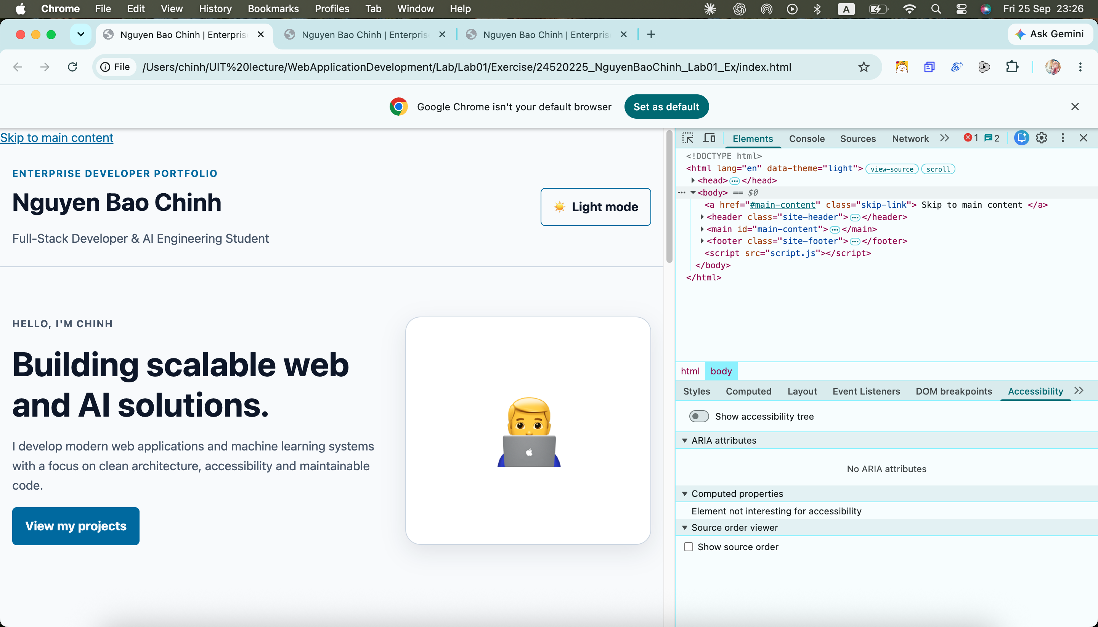
• CONTRACT-FIRST CONSTRAINTS:
• • State persistence strictly via localStorage key 'theme'.
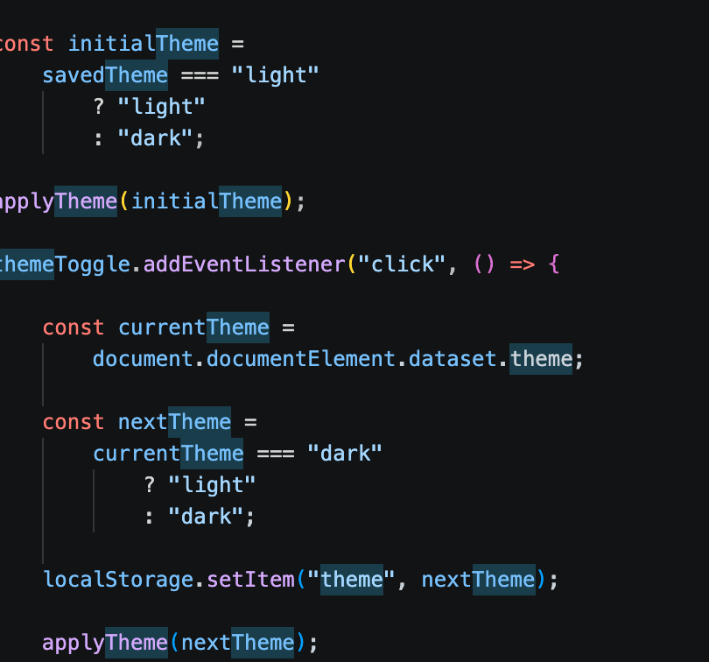
• • Colors paired via CSS variables; zero hardcoded hex codes in rules.
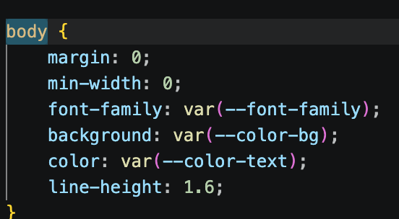
• • Performance Budget: Zero CLS, LCP < 2.0s on DevTools Fast 3G.
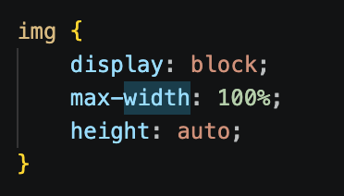

• Hero Section: High-res portrait with explicit dimensions, headline, pitch.
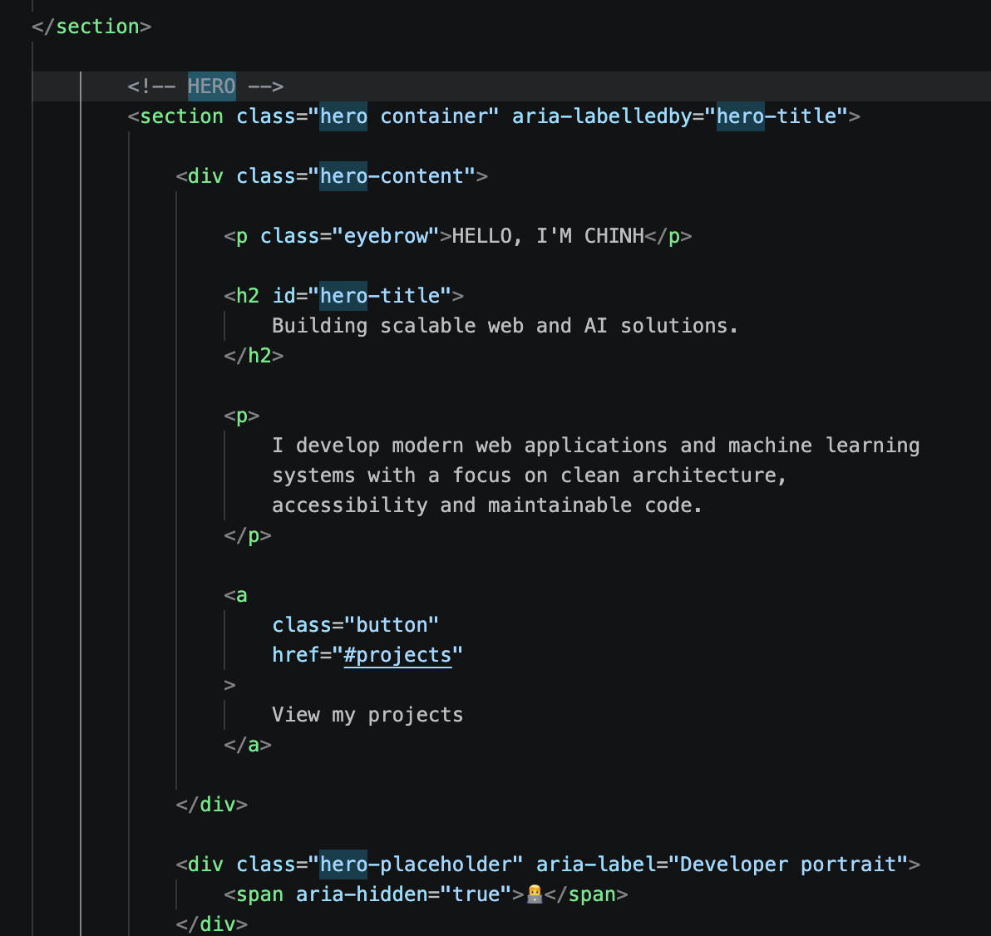
• Theme Switcher: Accessible button with aria-pressed and dynamic icon.

• Skills Matrix: Categorized badges arranged in clean CSS Grid.
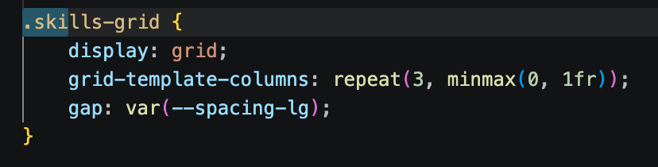
• Project Cards: Self-contained <article> blocks with tags, links, and descriptions.
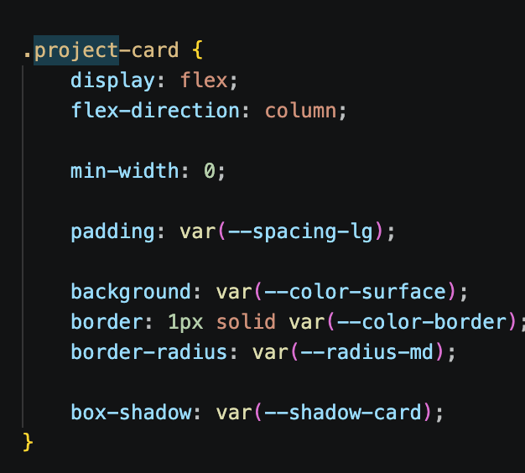
• Contact Form: Validated native form with client-side state handling.
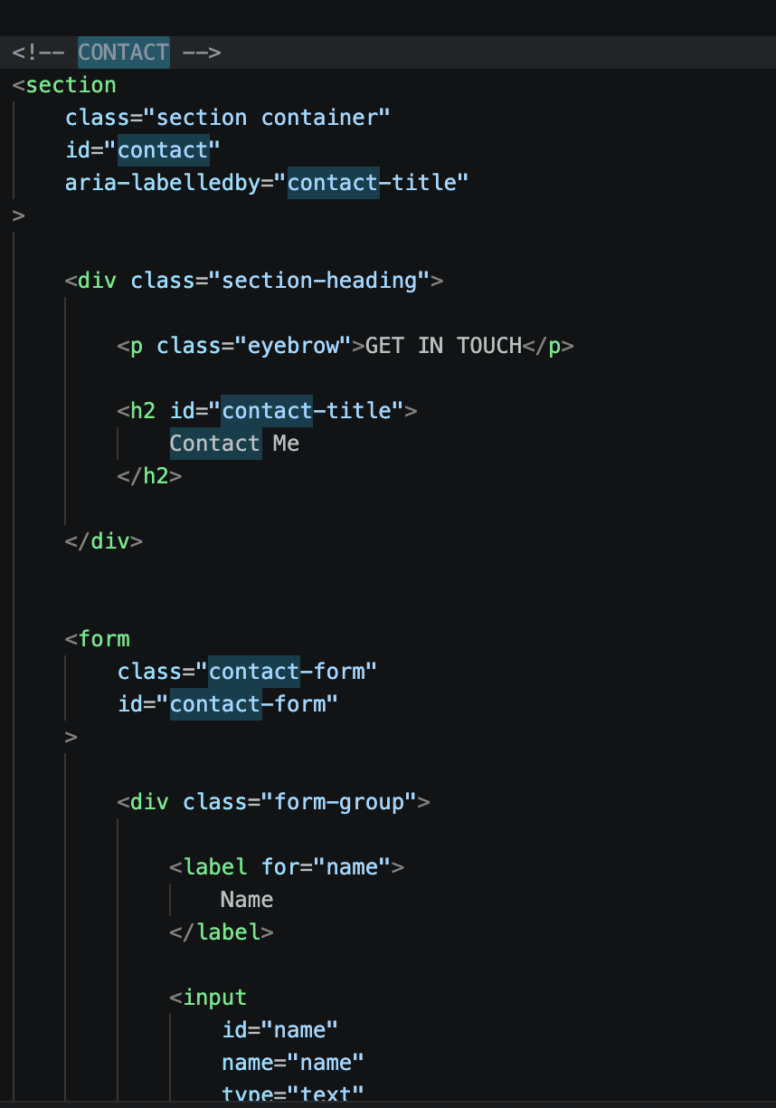

EXERCISE 3
Link AI prompt: https://chatgpt.com/share/6ab6a365-054c-83ec-8d53-4b20153ccef3?ogimg=plain
Screenshot for results
• SUB-TASK T-03A: Loading Skeleton (Pure CSS Shimmer gradient).
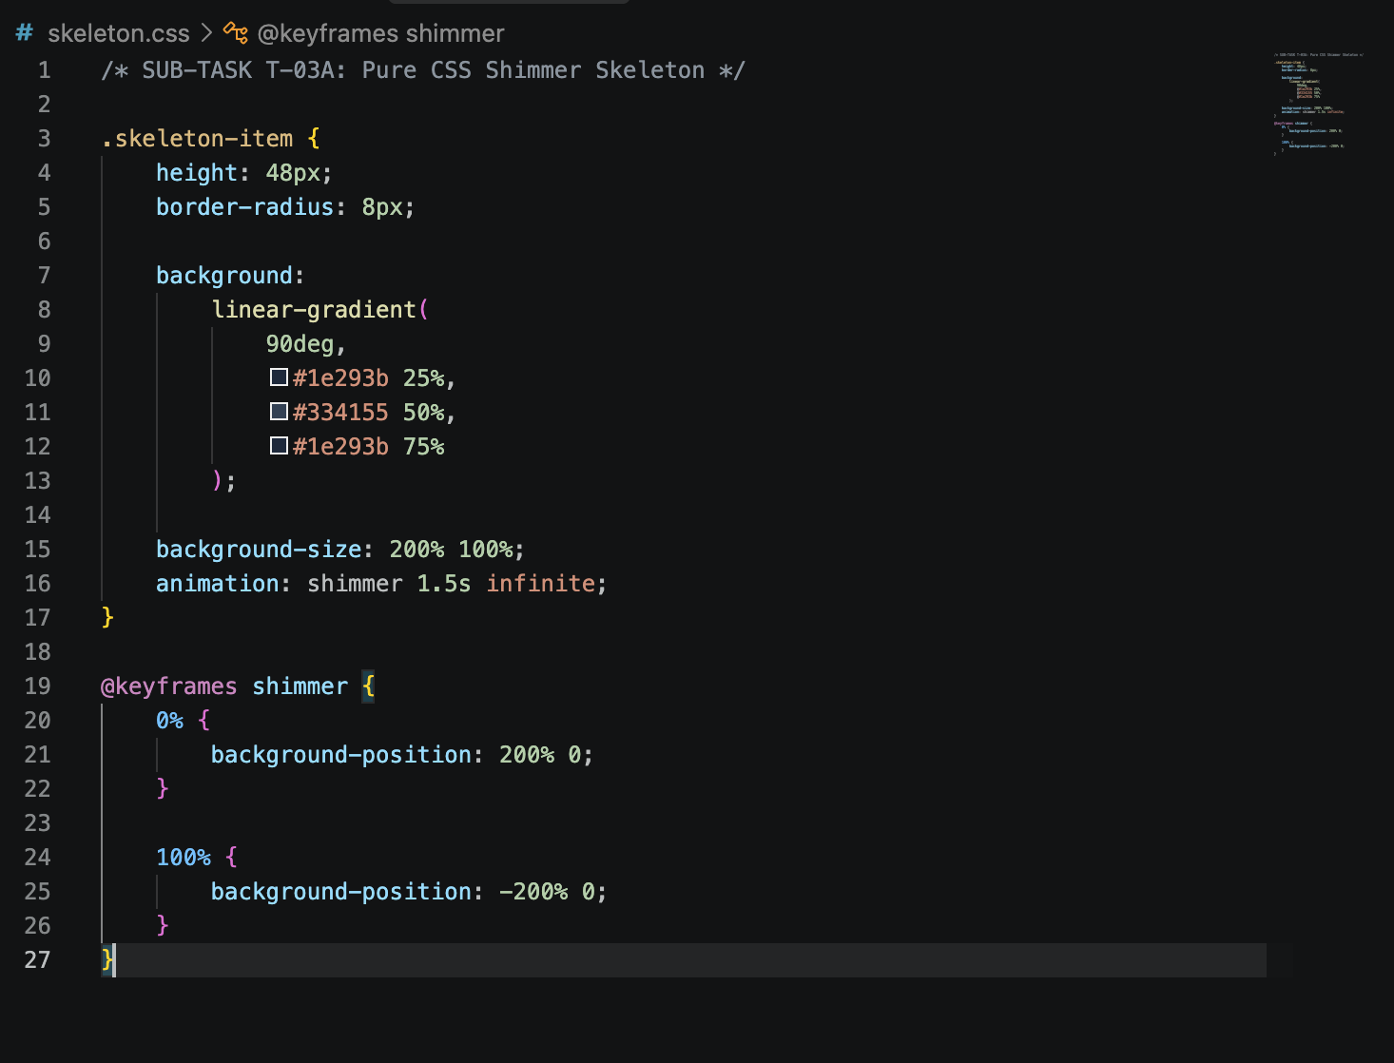
• SUB-TASK T-03B: Live Data State (Flexbox metadata badges & Grid list).
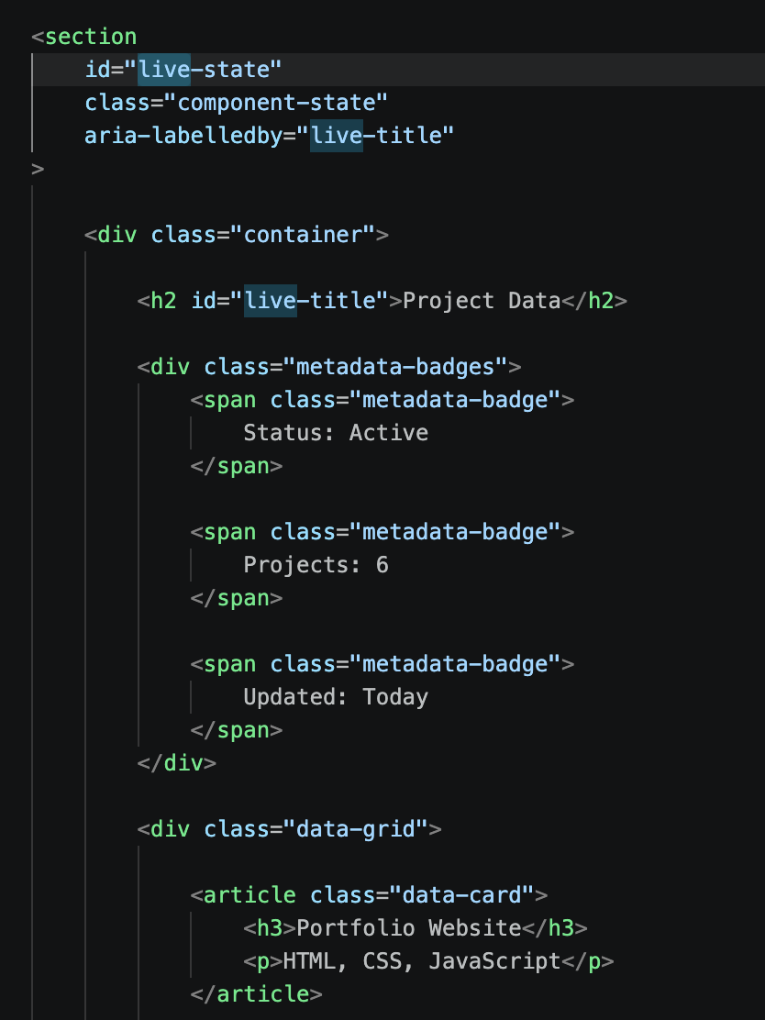
• SUB-TASK T-03C: Empty & Error States with accessible retry trigger.
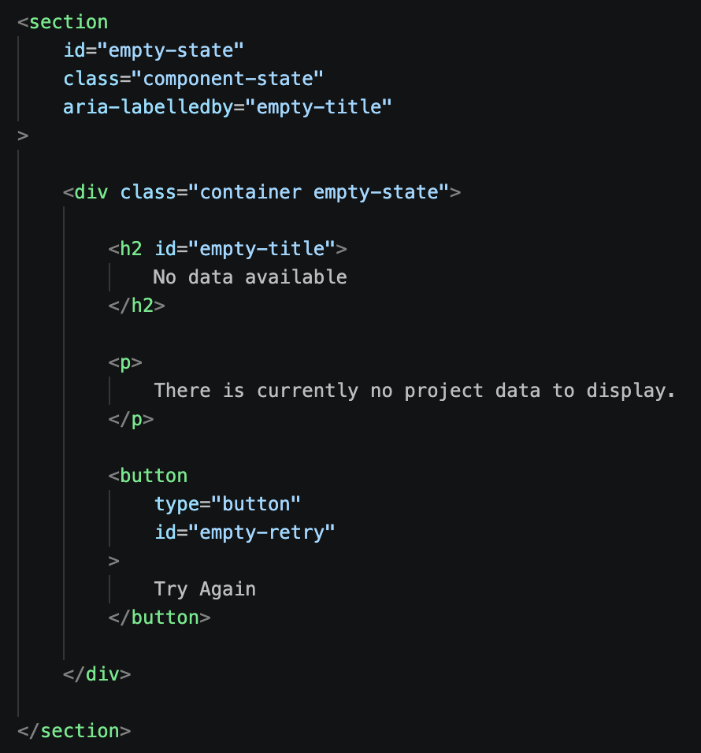
• DECOMPOSITION SUBMISSION PIPELINE:
• • Define state machine in TASK_DECOMPOSITION.md before prompting AI.
