Student Name: Nguyen Bao Chinh
Student ID: 24520225
Link GitHub: https://github.com/Pengikas/24520225_NguyenBaoChinh_Lab_EX-HW.git
Link AI: https://chatgpt.com/c/6ac5073a-2618-83ec-811d-8f11ce530052, https://chatgpt.com/share/6ac523fd-6e48-83ec-9462-20553e42d566

EVIDENCE FOR LAB01 – HOMEWORK
- Exercise 1: MANDATORY ATOMIC MILESTONES (TASK_DECOMPOSITION.md):
- M1: WCAG 2.2 AA audit -> Commit 'fix(a11y): contrast & landmarks'
- Initialize production portfolio
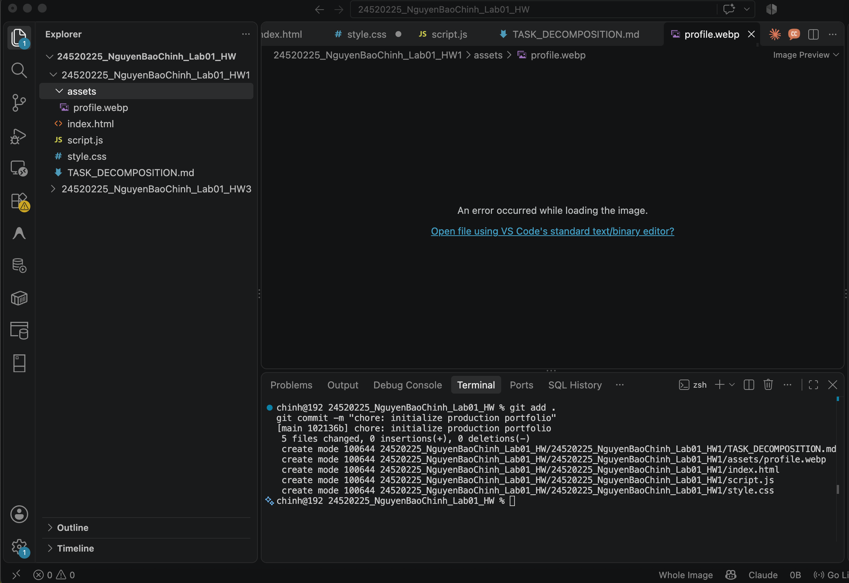
- Add homework task decomposition
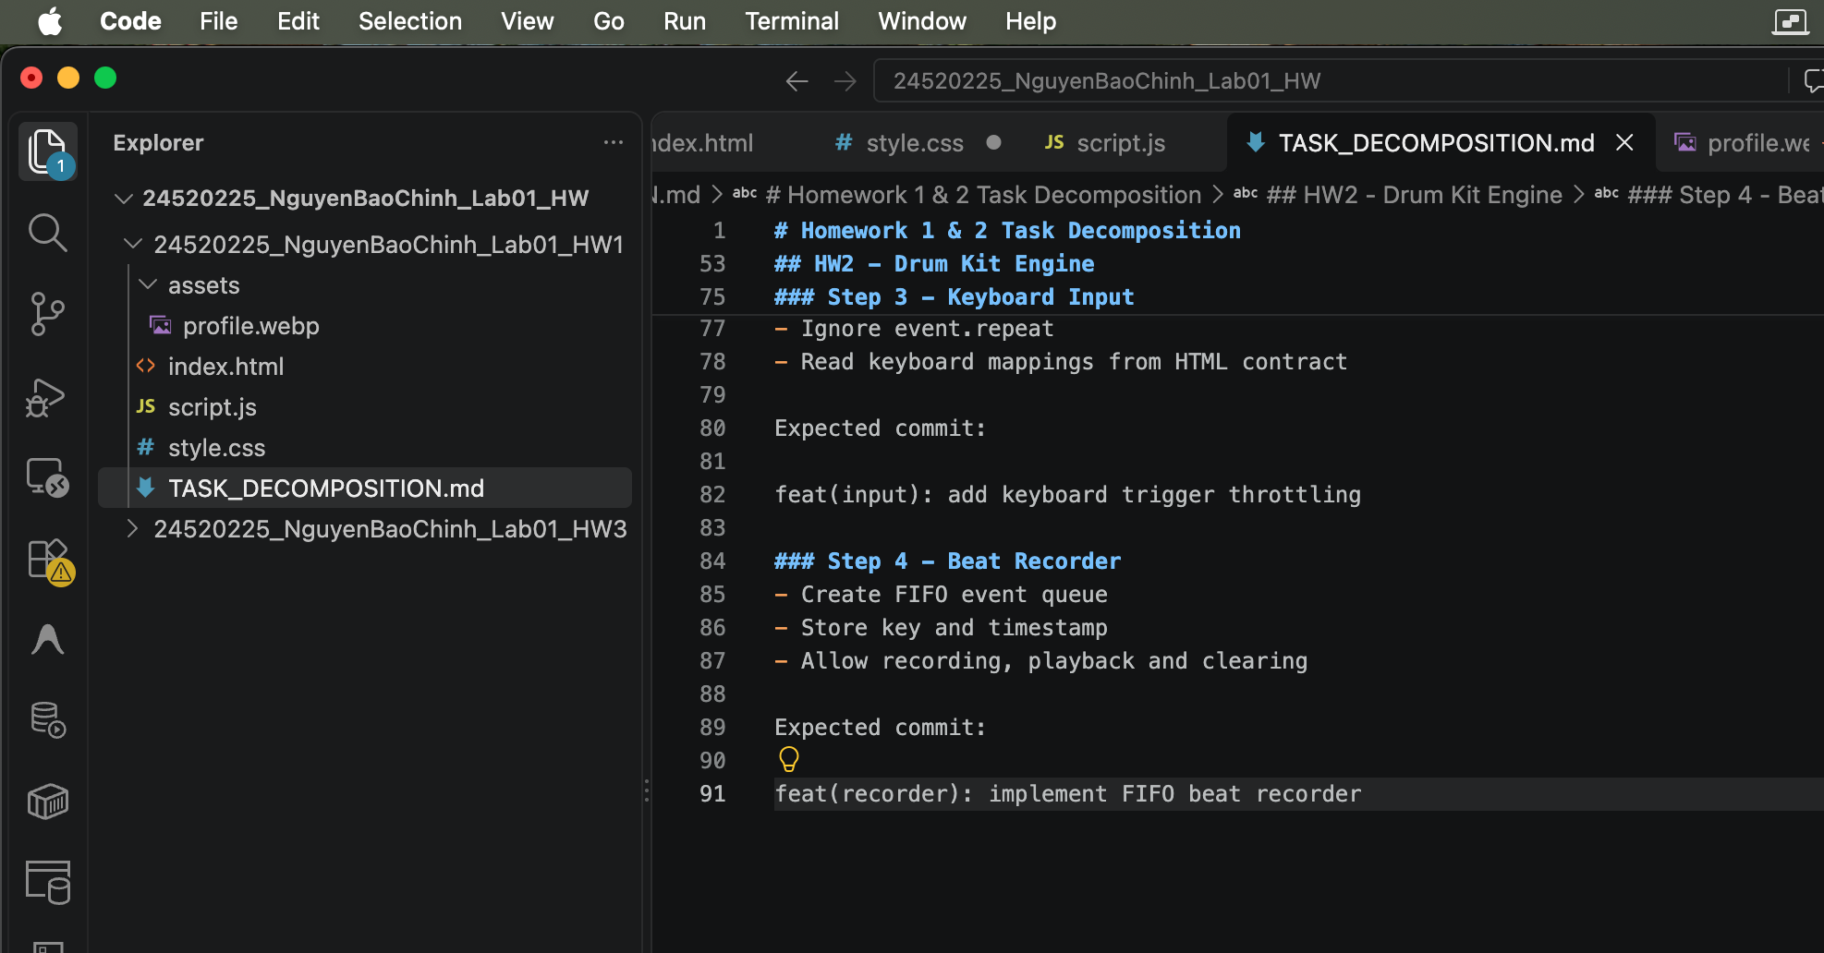
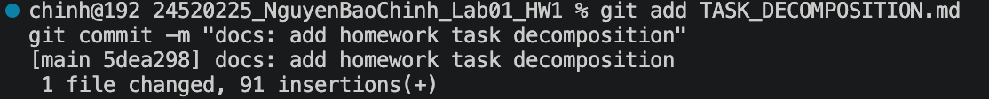
- Commit M1
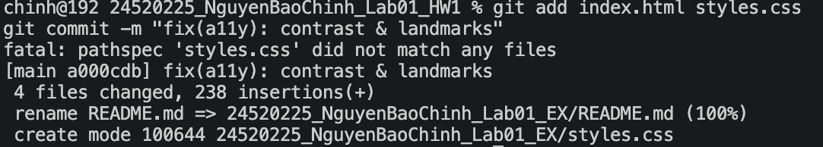
- M2: Focus trap audit -> Commit 'fix(nav): keyboard trap prevention'
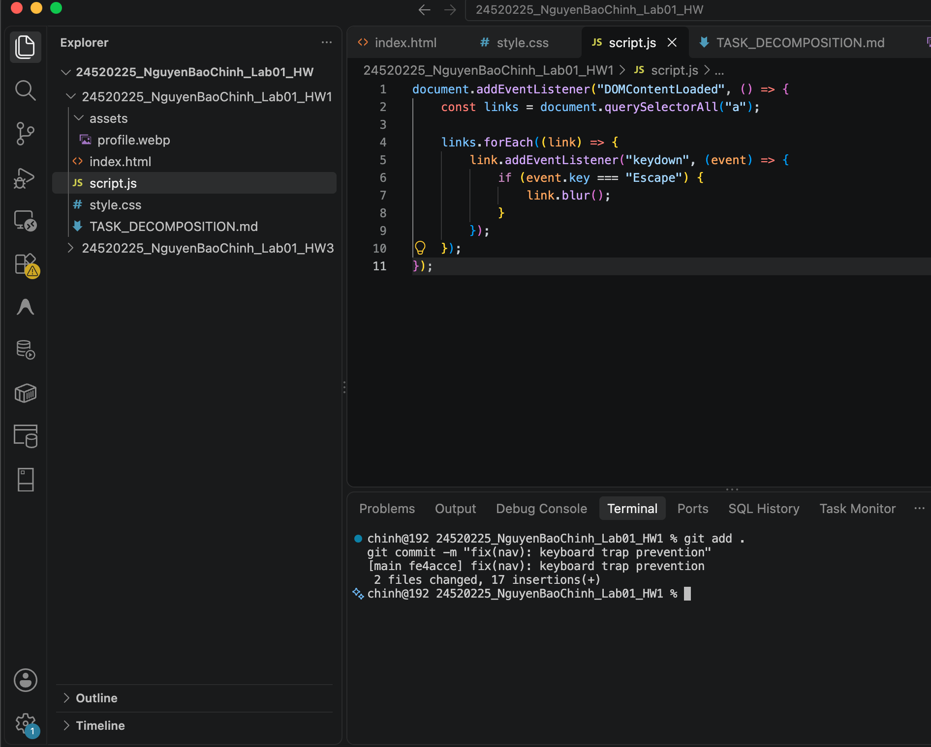

- M3: Strict CSP & zero inline handlers (onclick=... is strictly banned)
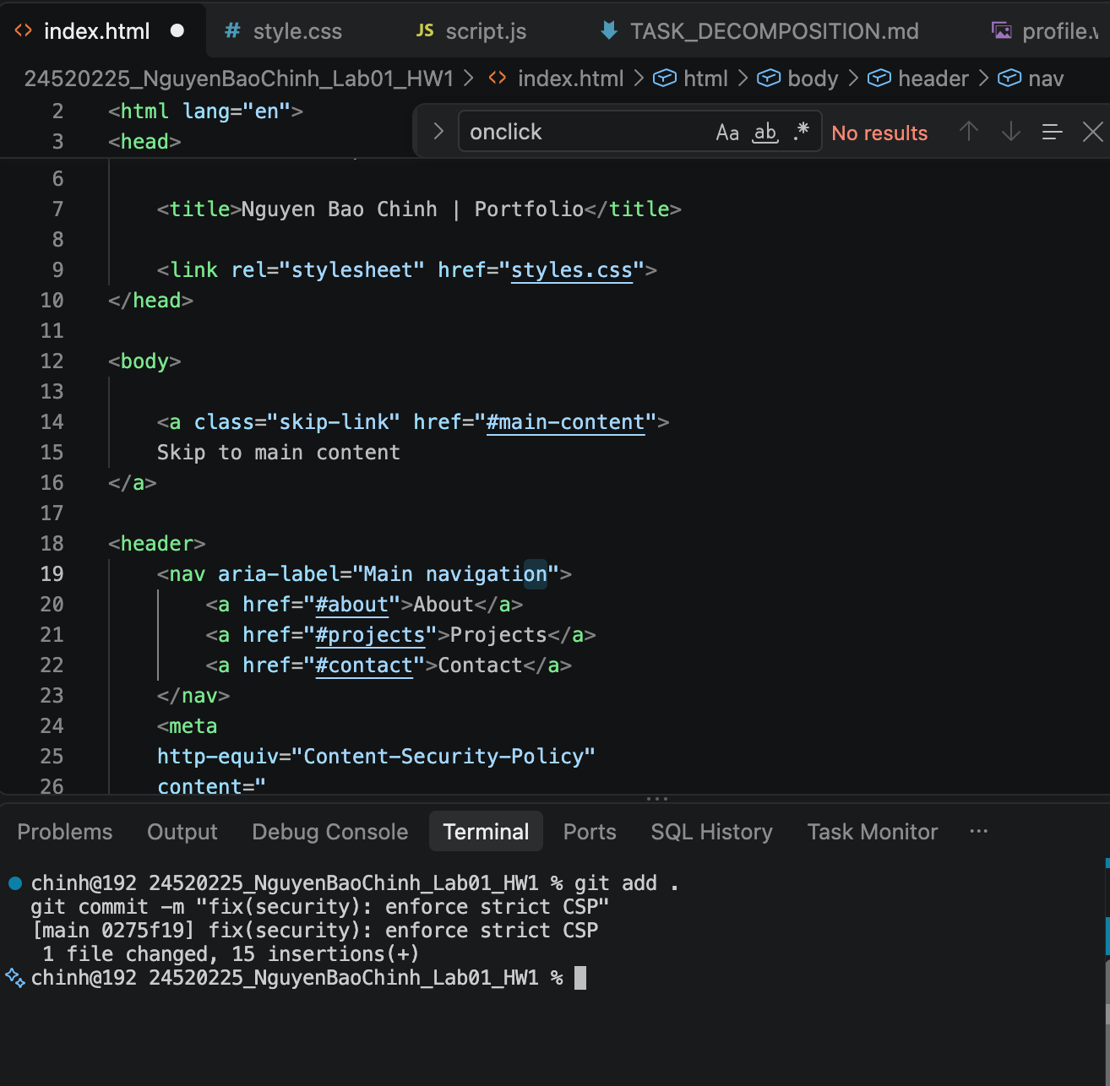
- M4: Lighthouse 100 audit score -> Commit 'perf: optimize assets'
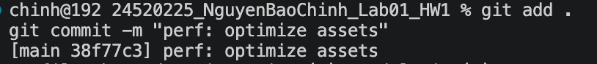
- Result of M1
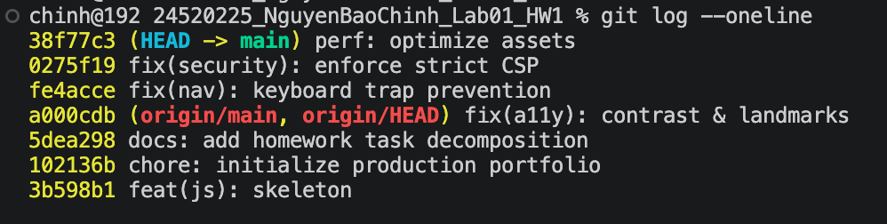
- Exercise 2: Drum Kit Engine (Contract-First)
- Step 1: Commit HTML data-sound contract before touching JavaScript.
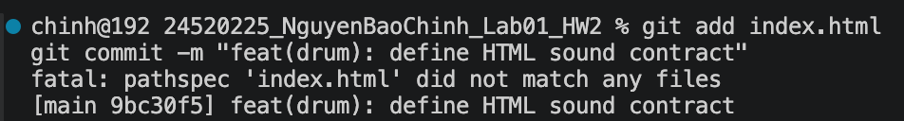
- Step 2: Implement polyphonic Audio playback engine independently.
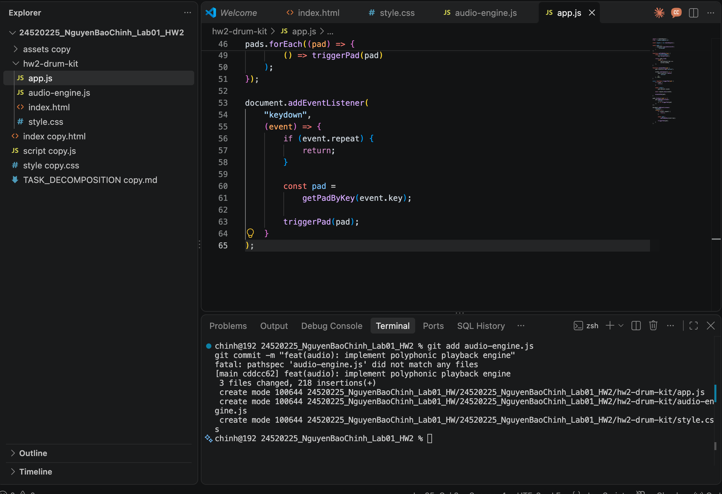
- Step 3: Implement keydown listener with event.repeat throttling.
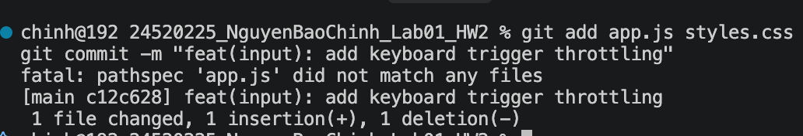
- Step 4: Implement FIFO Beat Recorder (timestamped event queue).

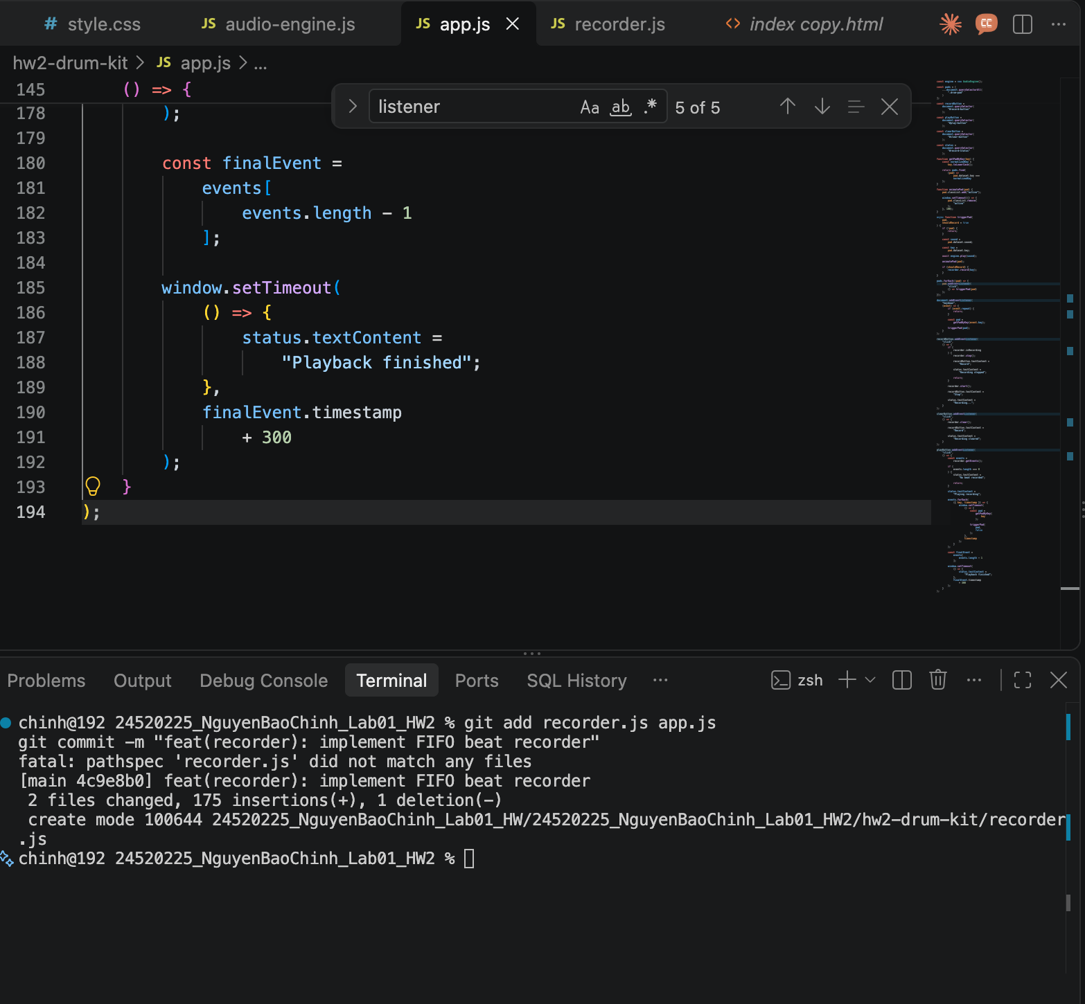
- Result

- Exercise 3: Resilient Landing Page (3 Slices
- SLICE 1: Drift-Free Countdown Engine (UTC ISO 8601 timestamps).
- Add HW3 task decomposition
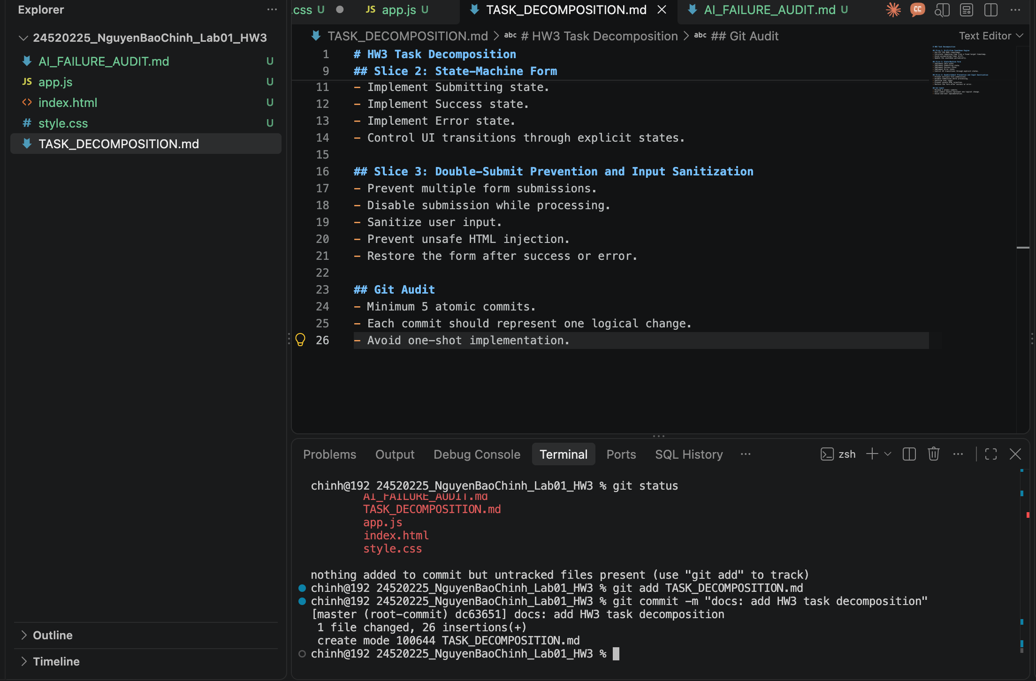
- Implement drift-free countdown
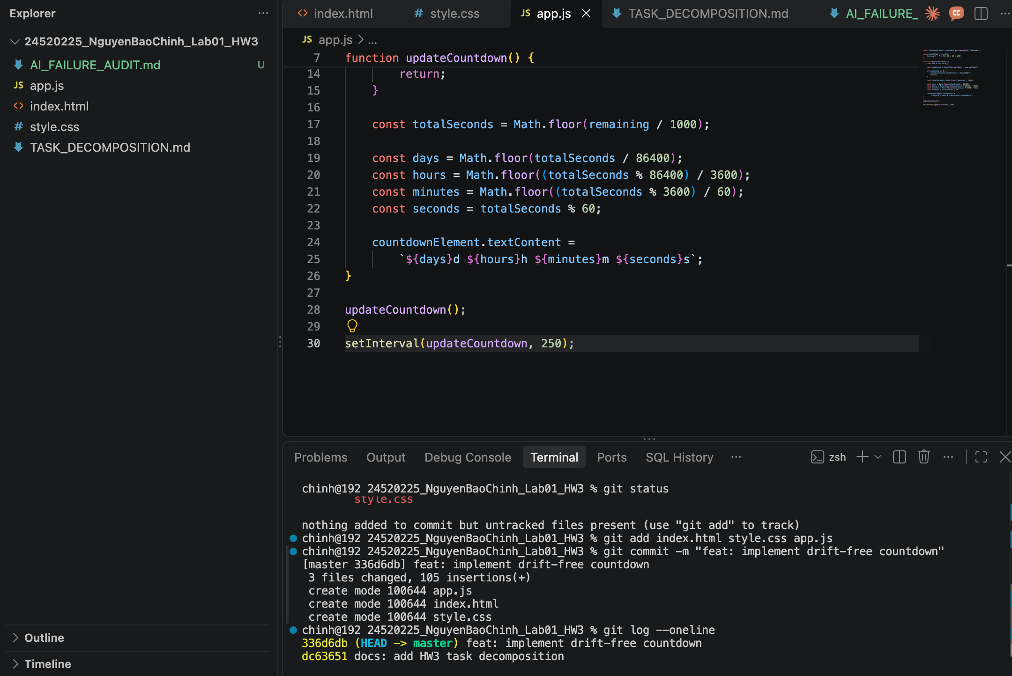
- SLICE 2: State-Machine Form (Idle -> Submitting -> Success/Error).Sadasd
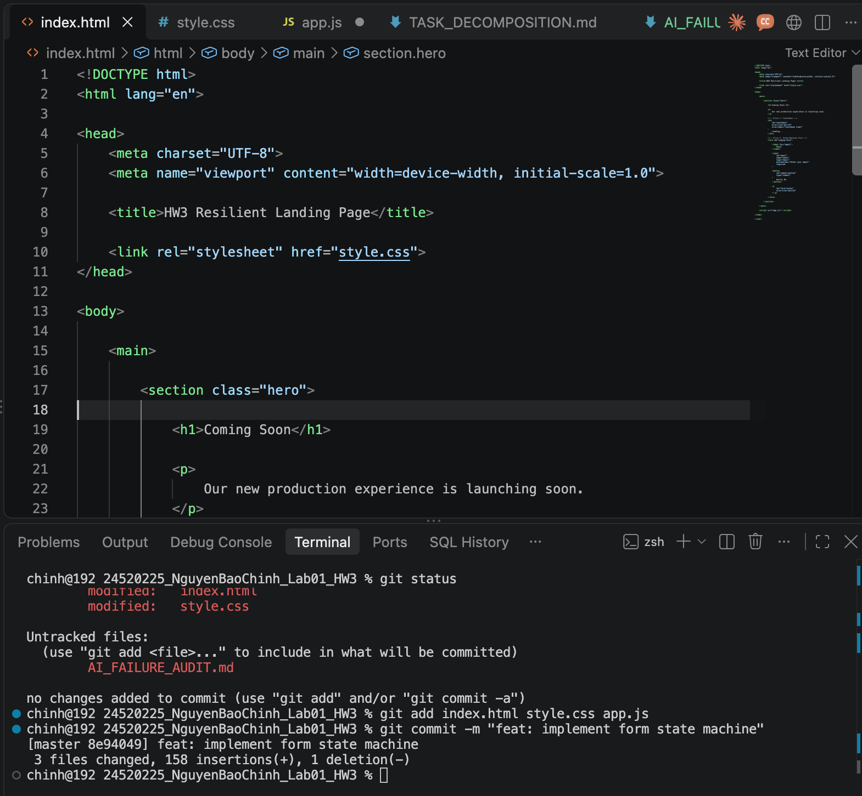
- Sucess
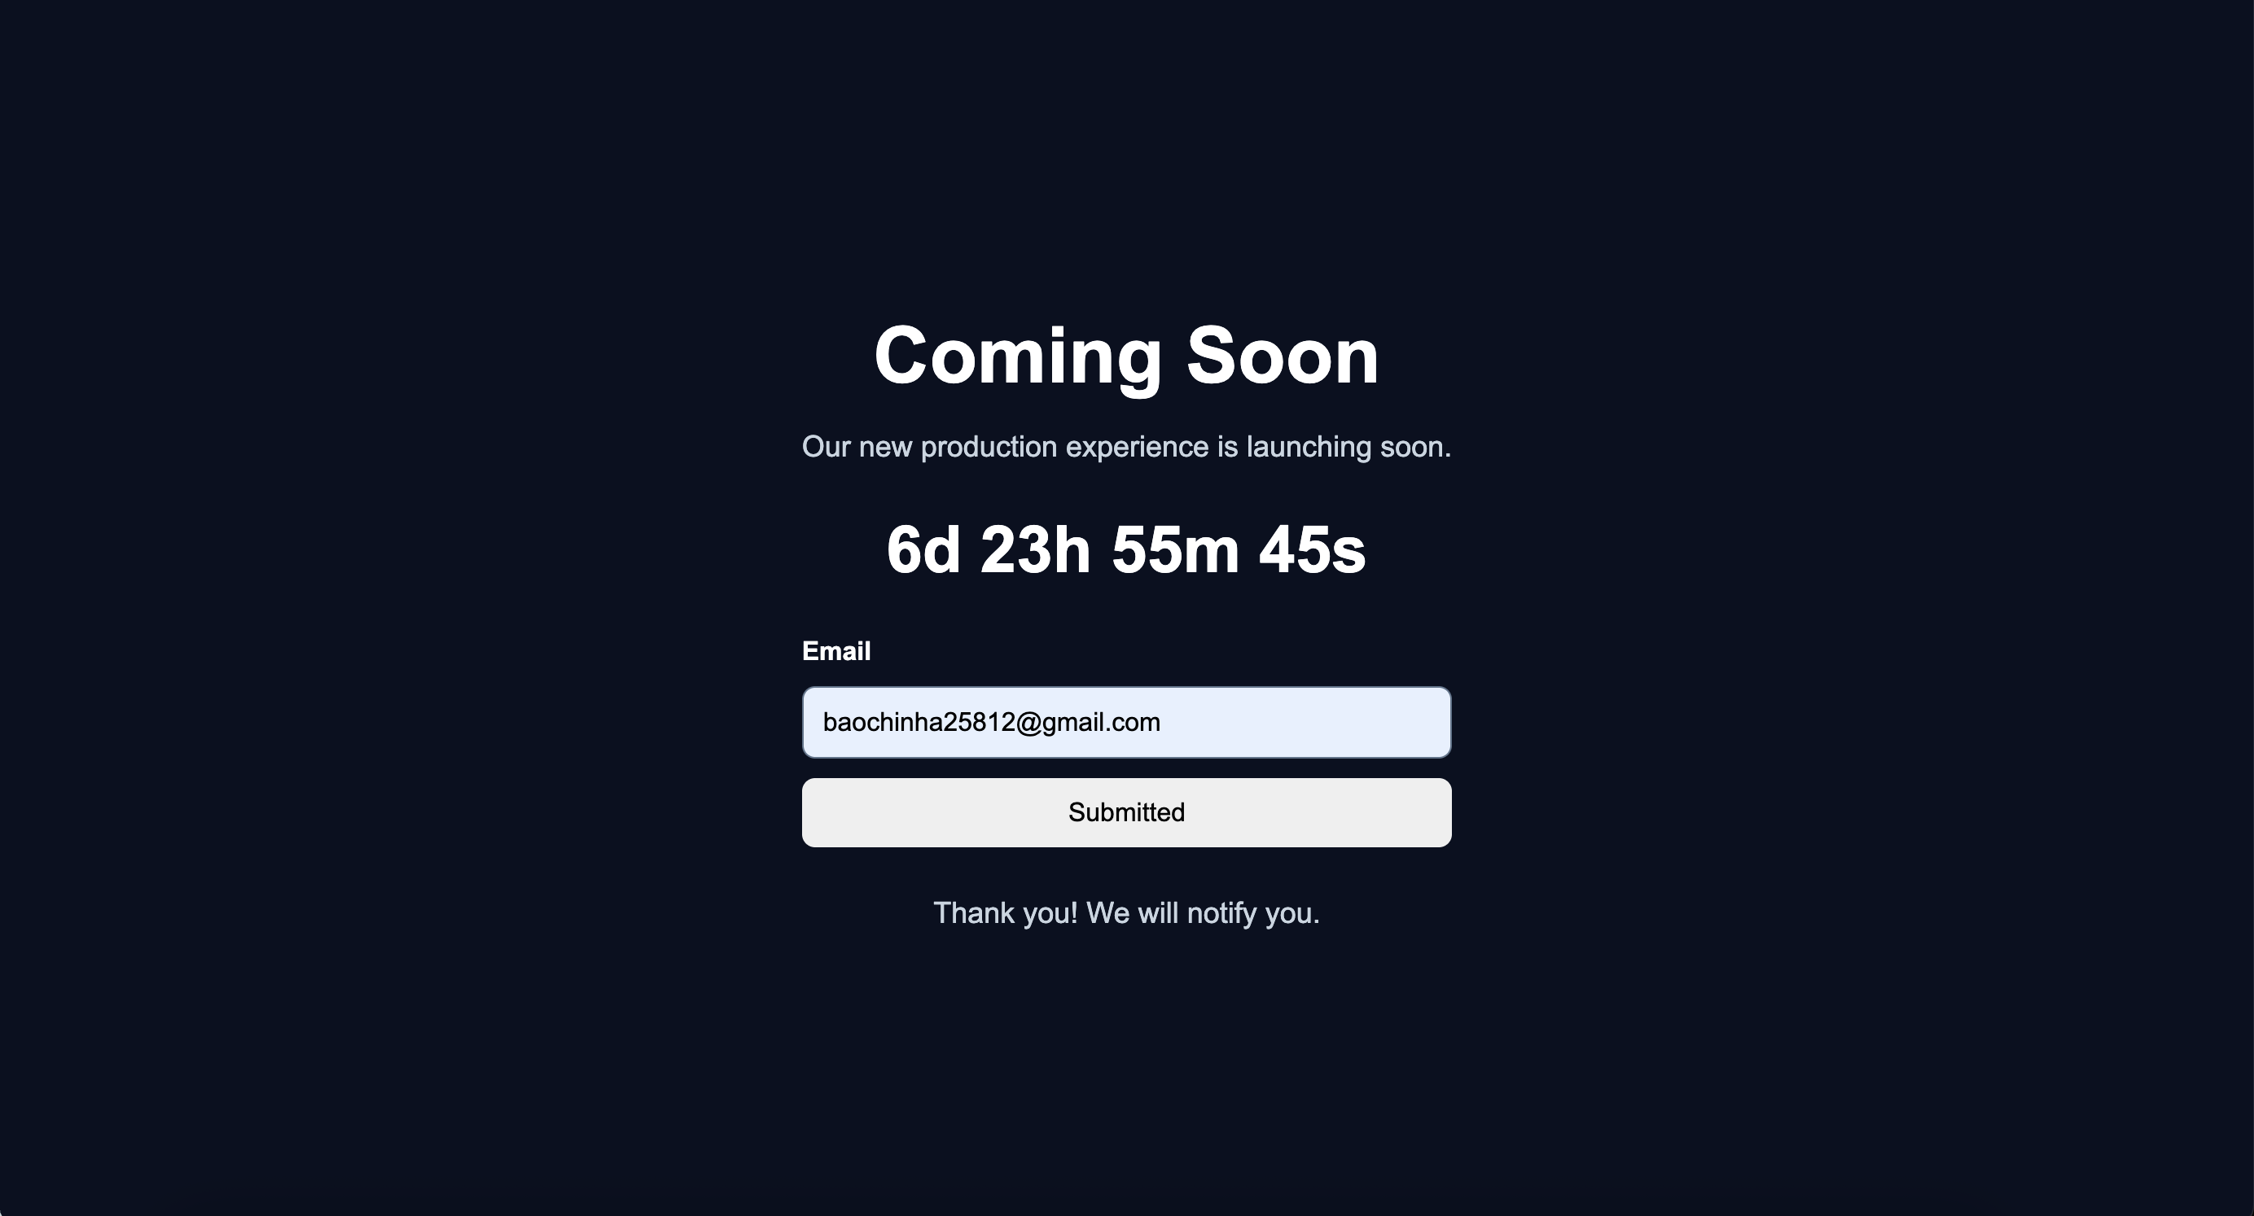
- False
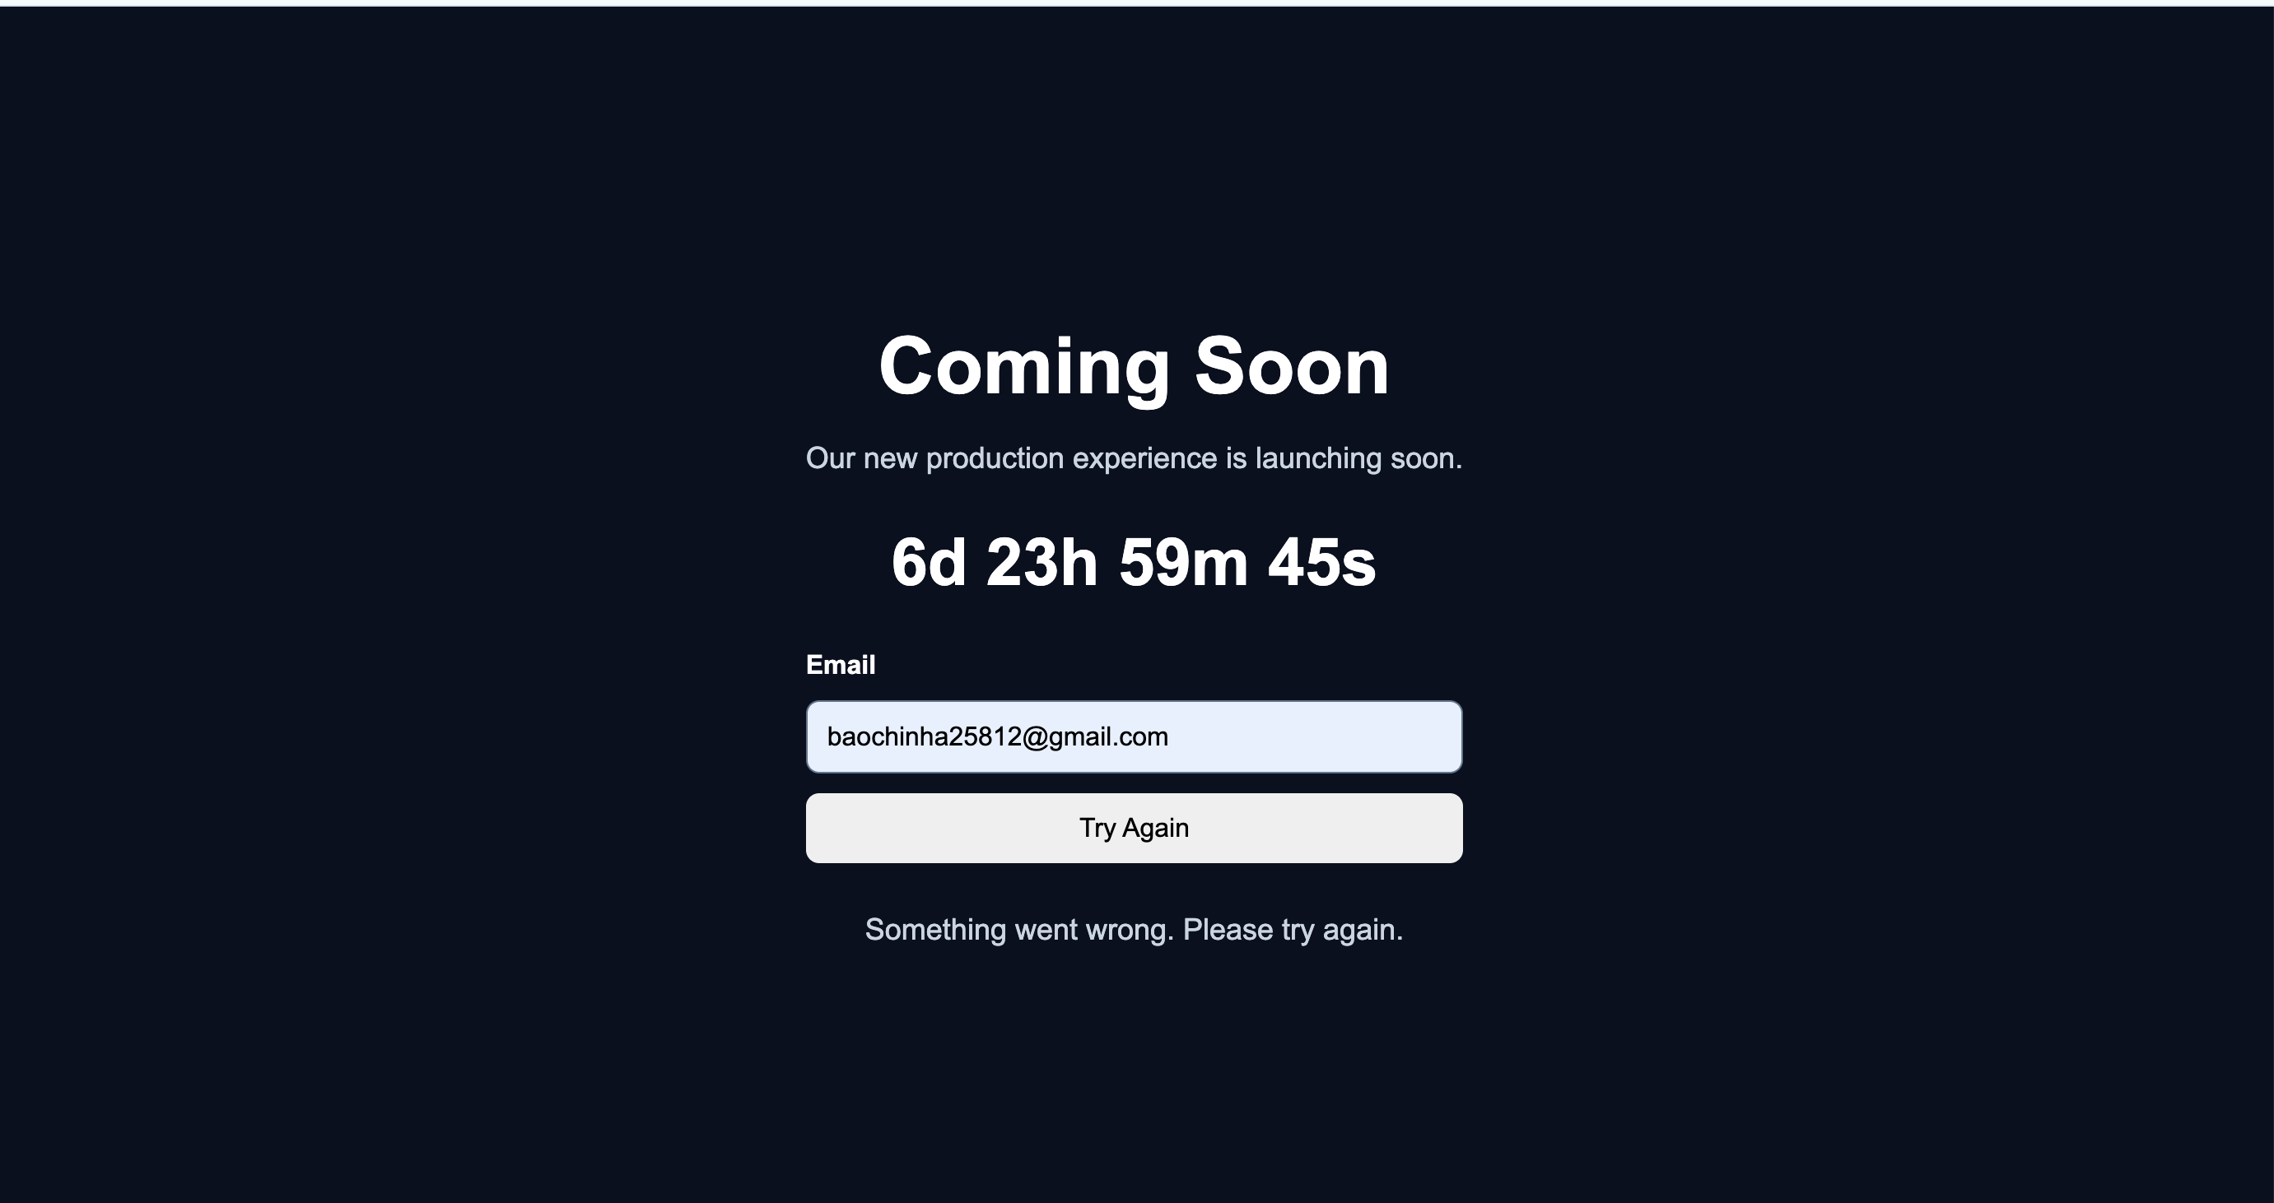
- SLICE 3: Double-submit prevention & input sanitization (zero XSS).Adsasd
