Student name: Nguyen Bao Chinh
Student ID: 24520225
Link github: https://github.com/Pengikas/24520225_NguyenBaoChinh_Lab_EX-HW.git
Link AI Prompt: https://chatgpt.com/share/6ac8b725-5cac-83ec-aa82-a7d89d0ed5a4?ogimg=plain

EVIDENCE FOR EXERCISE LAB02

Exercise 1: Building Mini-React VNode & Mounting Engine
Deliverable: Zero div-soup, strict typeguard verification, and live DevTools audit.
Task Specifications & Constraints
- Objective: Implement createElement, createTextElement, and renderToDOM from scratch.
  - CreateElement
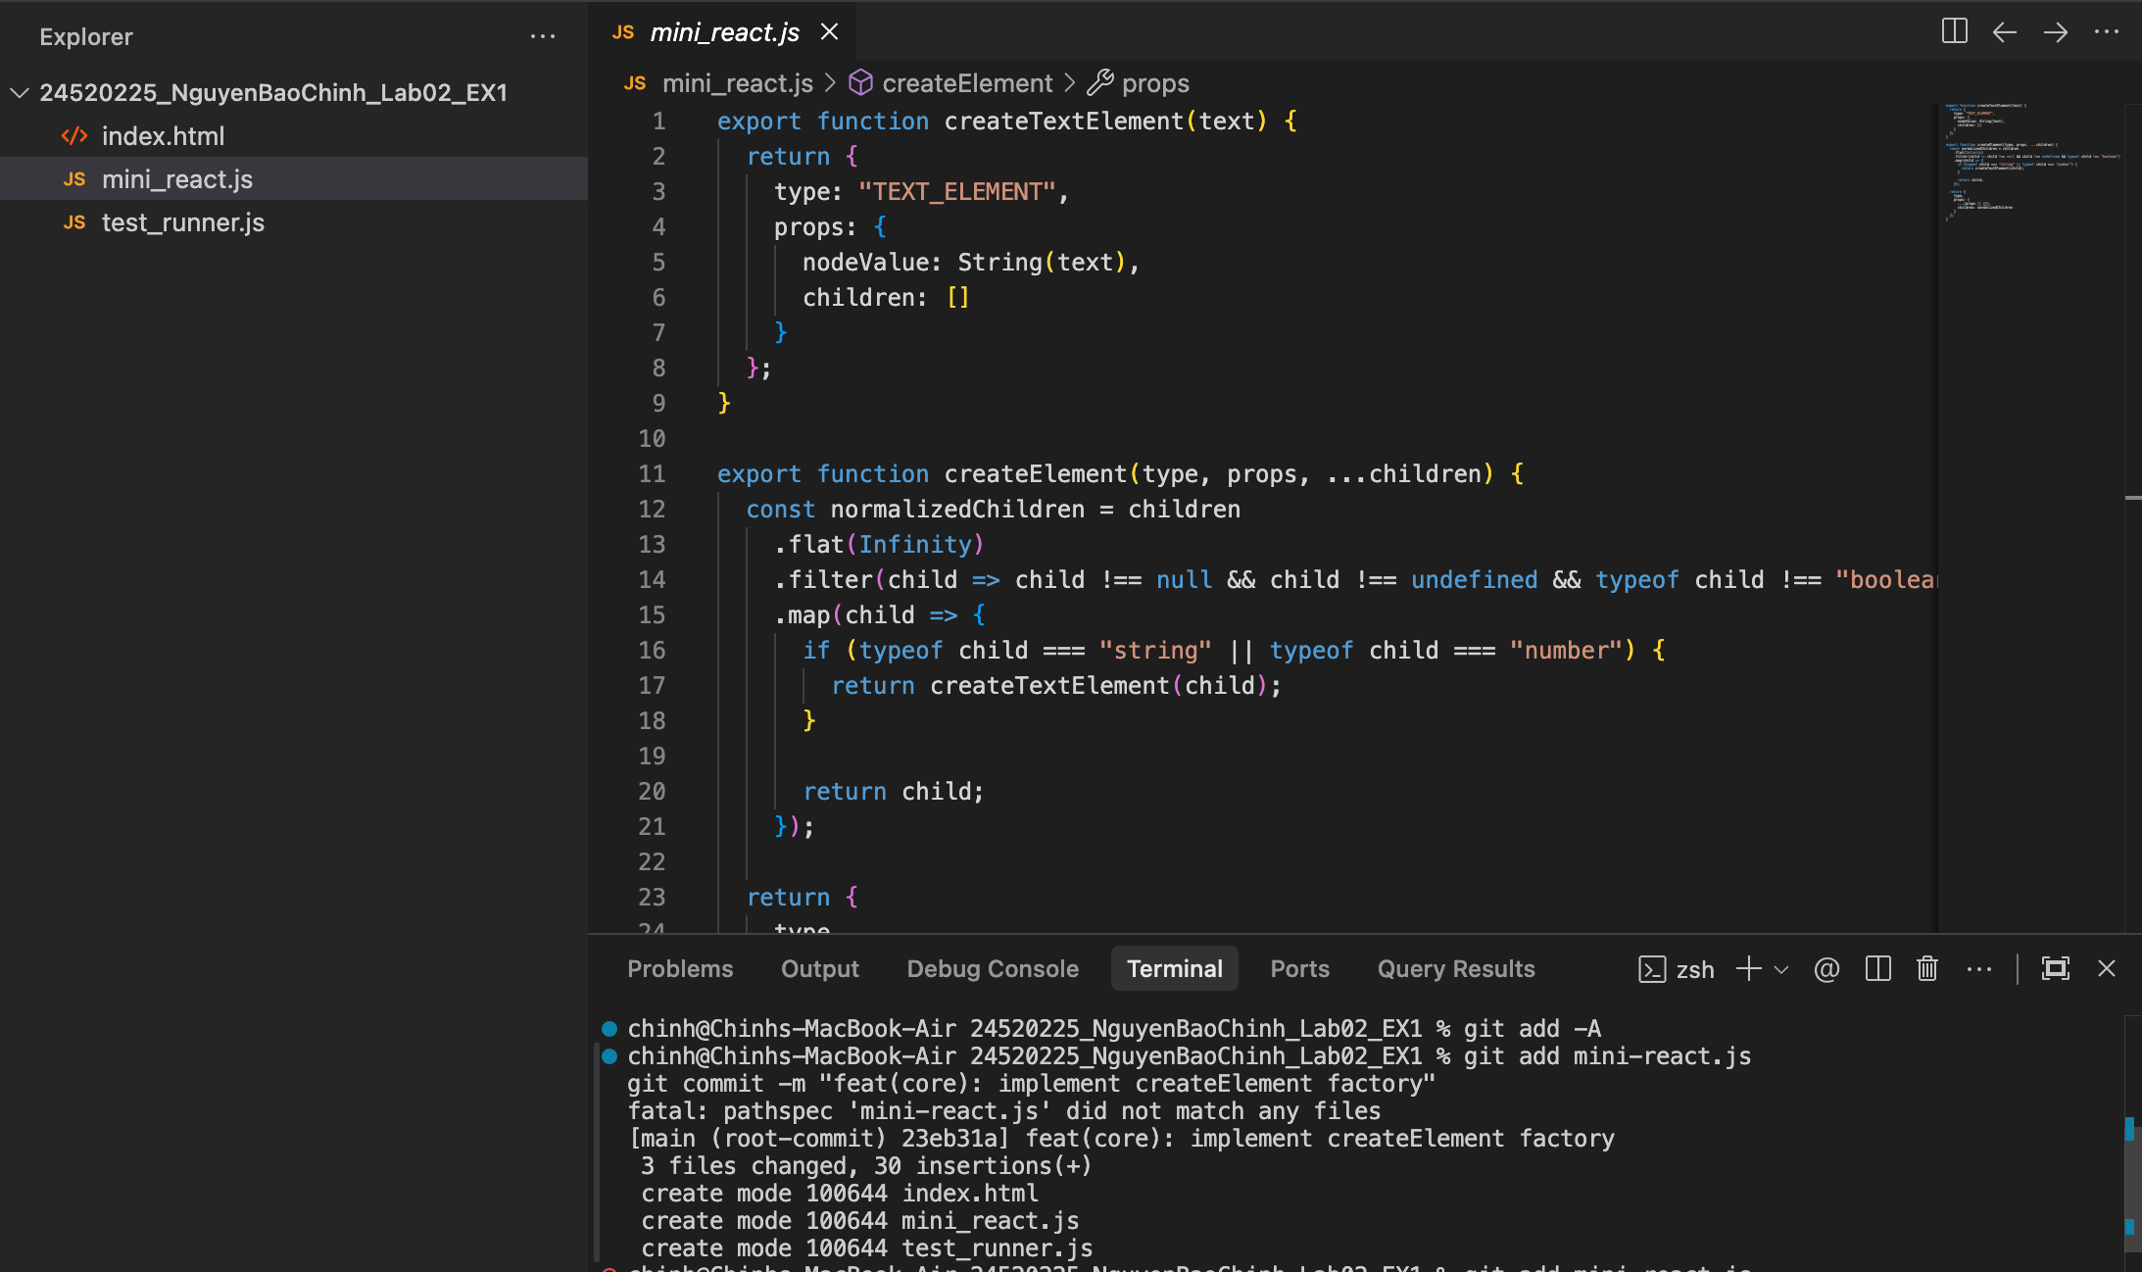
  - createTestElement
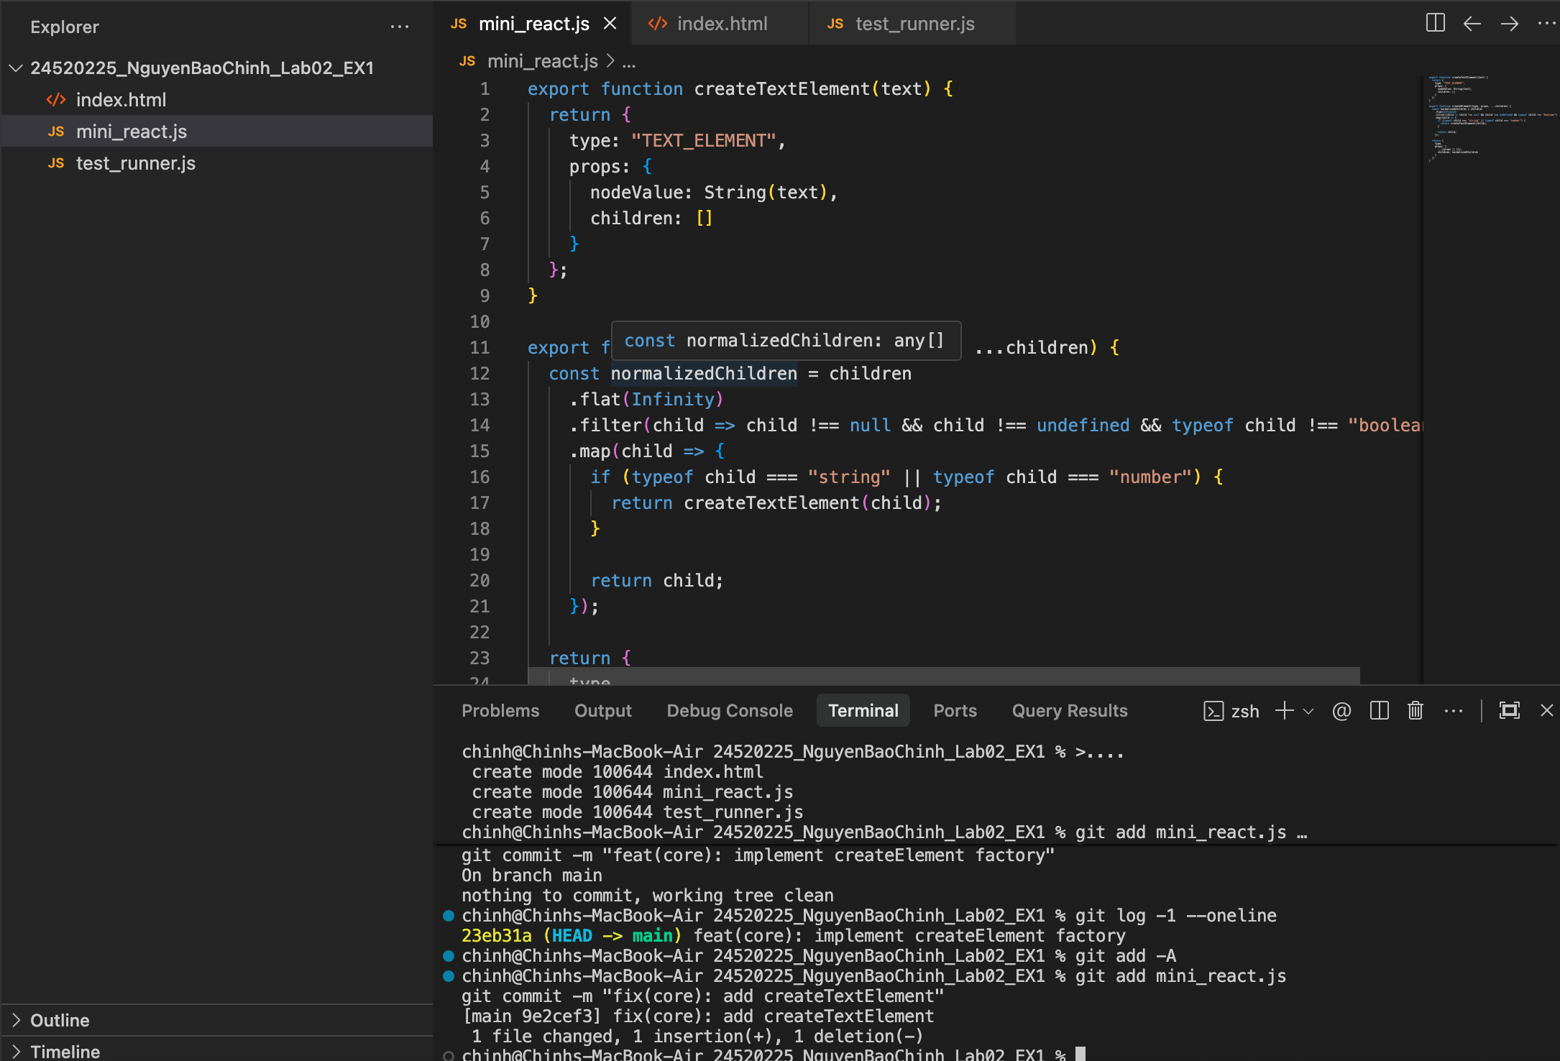
  - renderToDOM
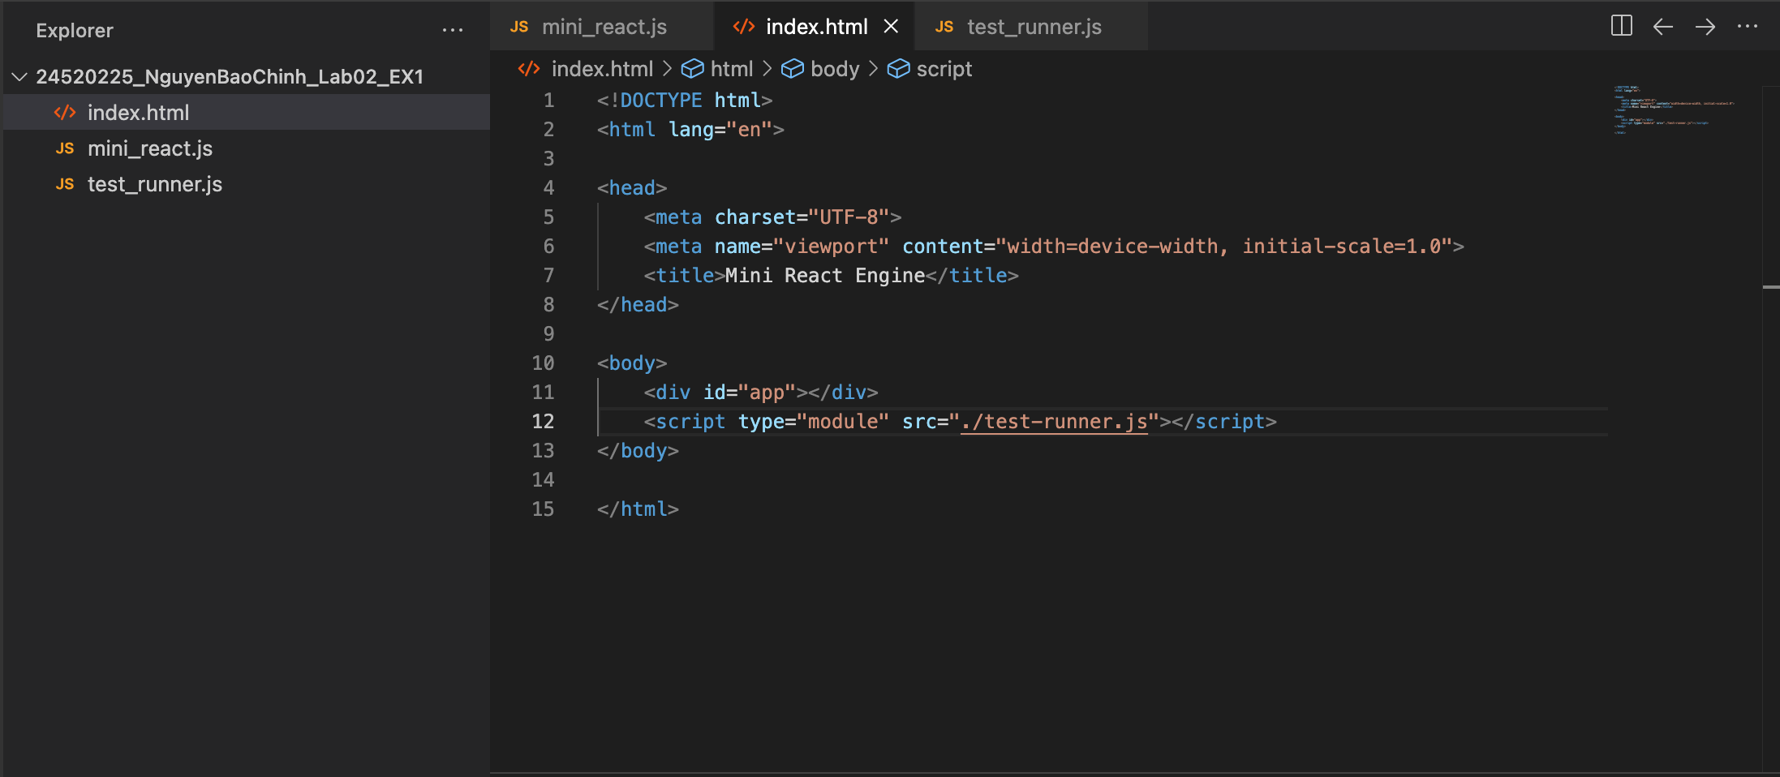
- Semantic Constraint: Output must produce semantic tags (<main>, <section>, <button>) — div-soup banned.
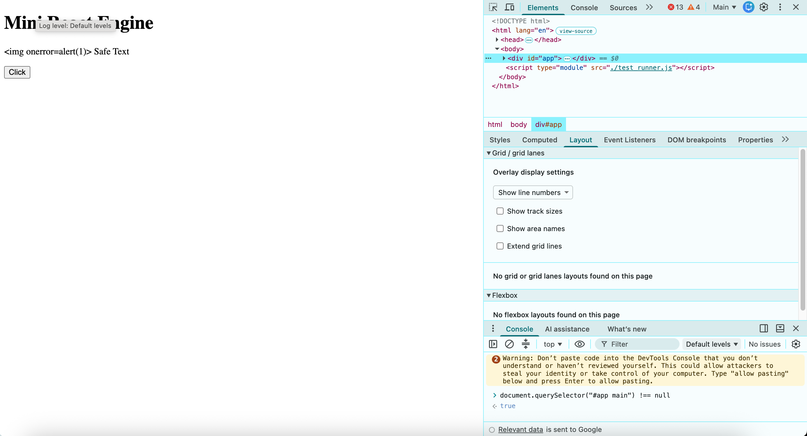
- Security Checkpoint: Verify XSS resistance when passing '<script>alert(1)</script>' string as child.
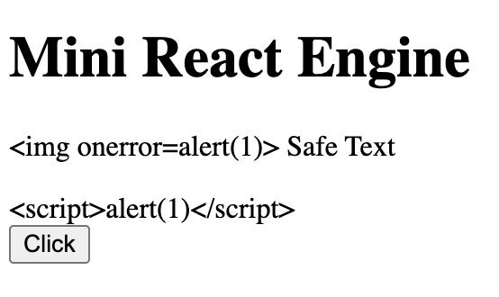
- DevTools Audit: Inspect Elements panel to ensure DOM nodes match VNode tree without orphan nodes.
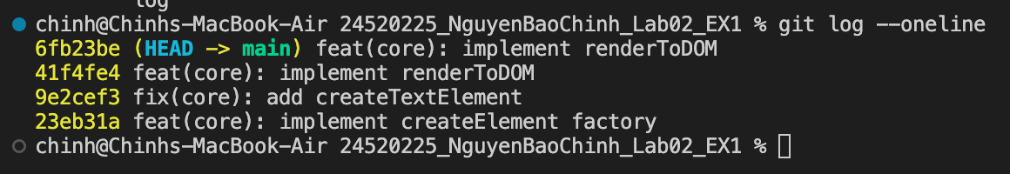
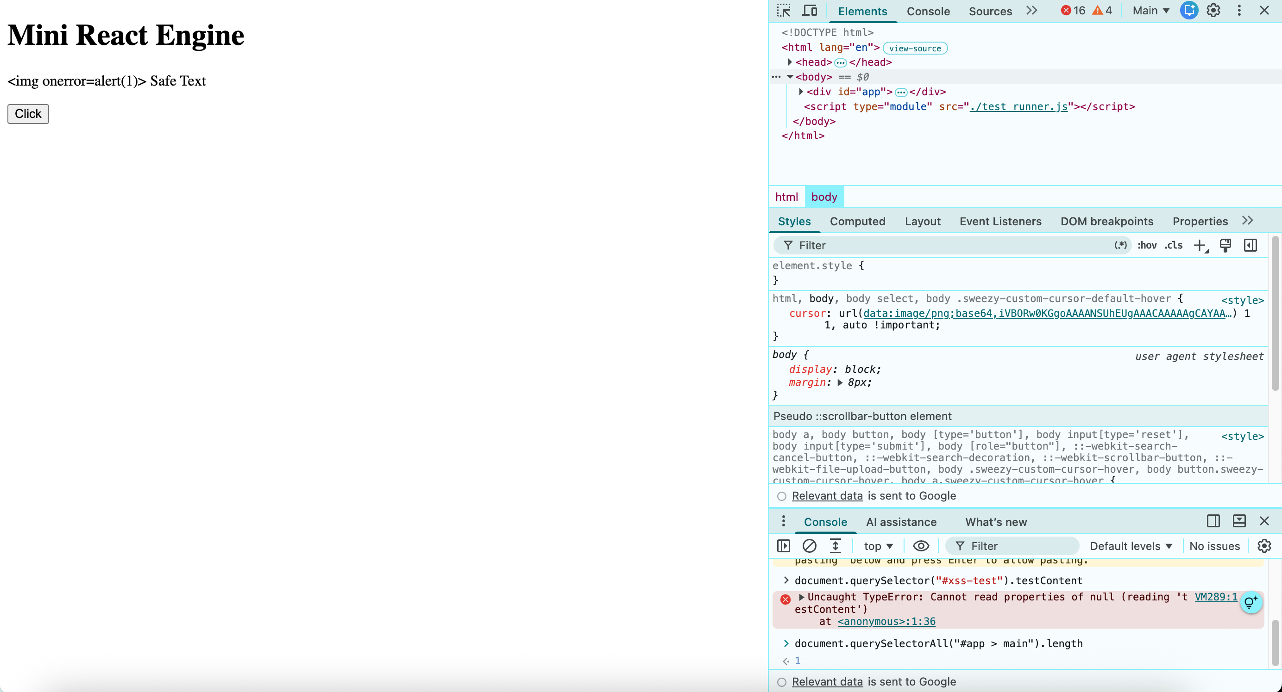
- Git Requirement: Commit 1: 'feat(core): implement createElement factory' | Commit 2: 'feat(core): implement renderToDOM
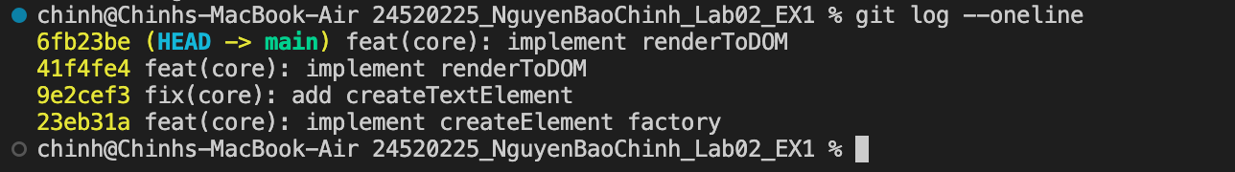
Exercise 2: Reactive State Machine & Delegation Hub
- Objective: Build custom useState closure engine and integrate root Event Delegation hub.
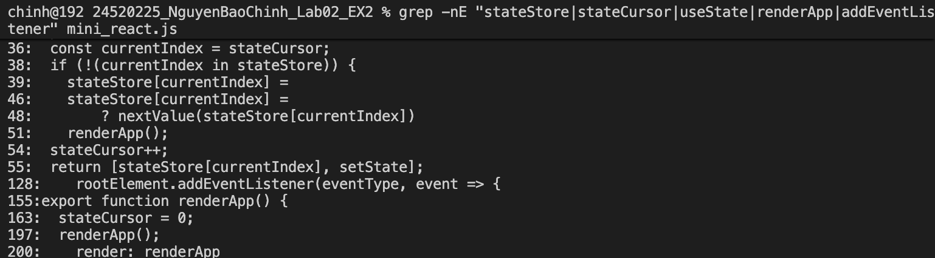

- Application: Implement a real-time reactive Task Manager with dynamic filter toggles.
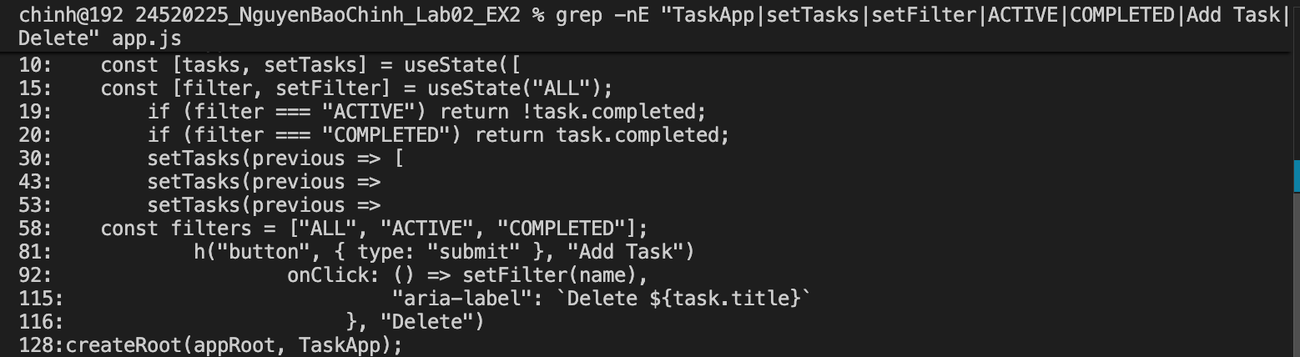
- Git Milestone Commits (Mandatory Atomic Commits):
- 'feat(state): implement stateStore and resetCursor engine'
- 'feat(state): implement reactive useState dispatcher'
- 'feat(events): attach root event delegation listener'
- 'feat(ui): assemble reactive todo application'
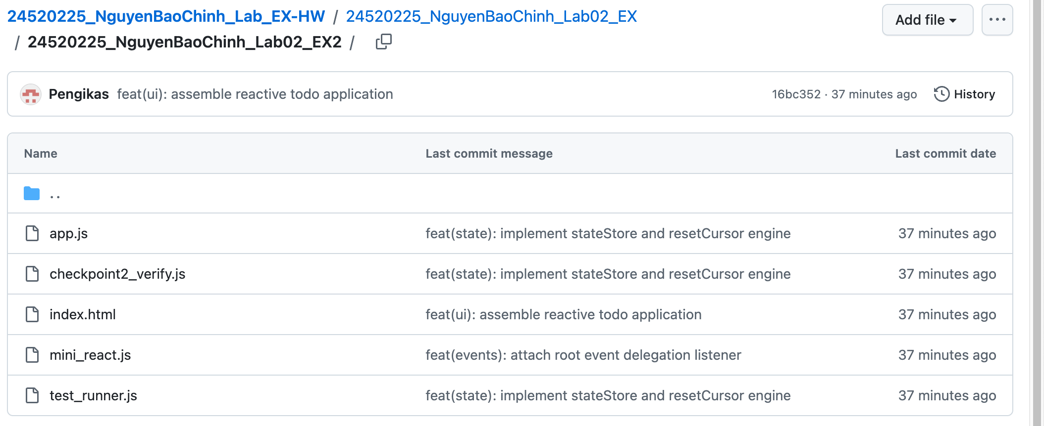
- Checkpoint: Mutate state via UI; verify zero orphan event listeners attached to button children.
  - Mutate state via UI
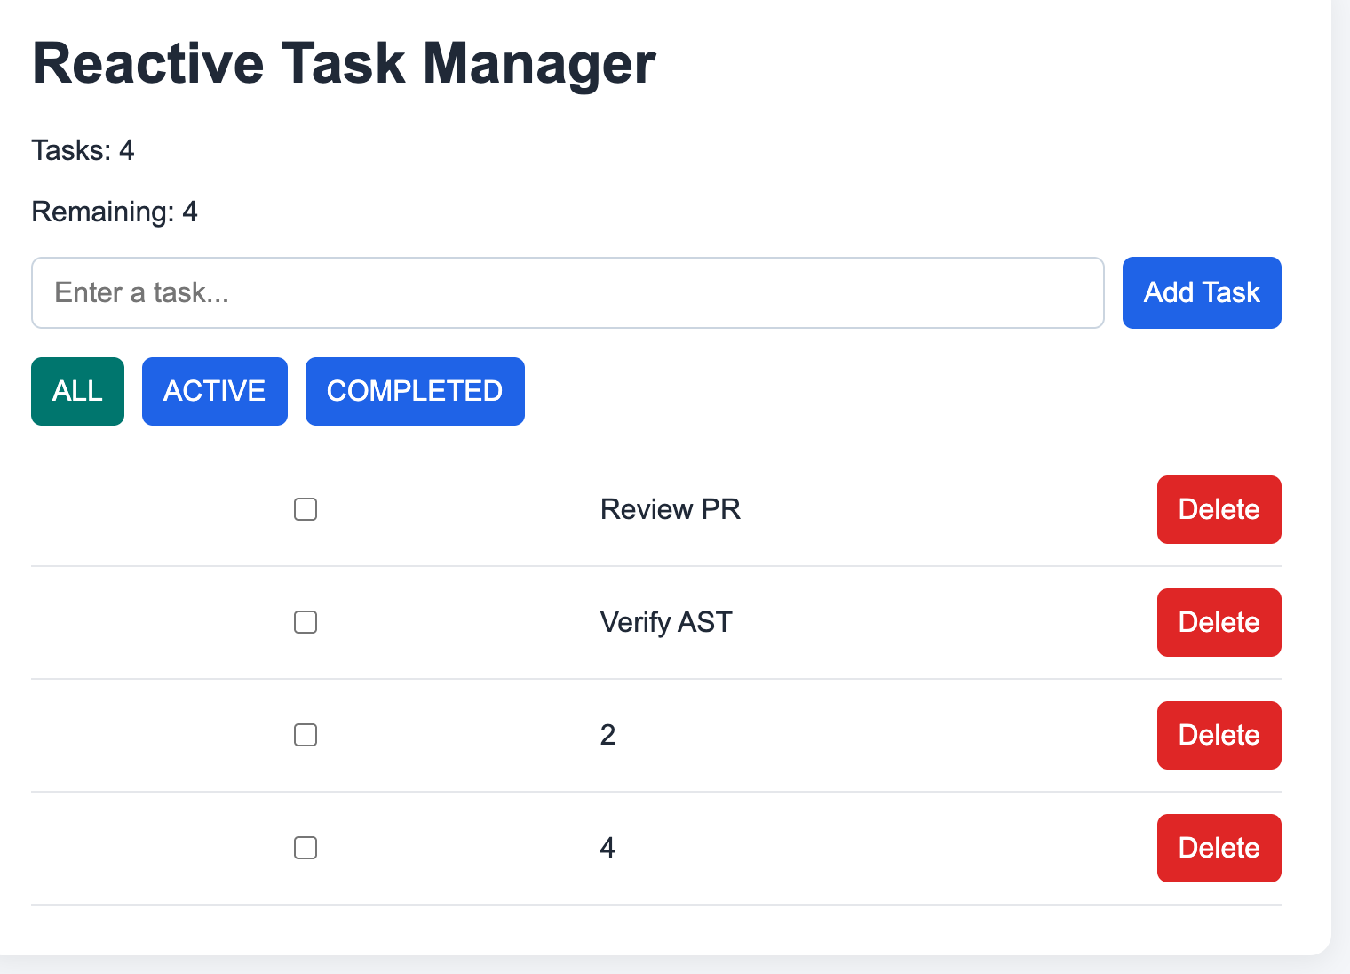
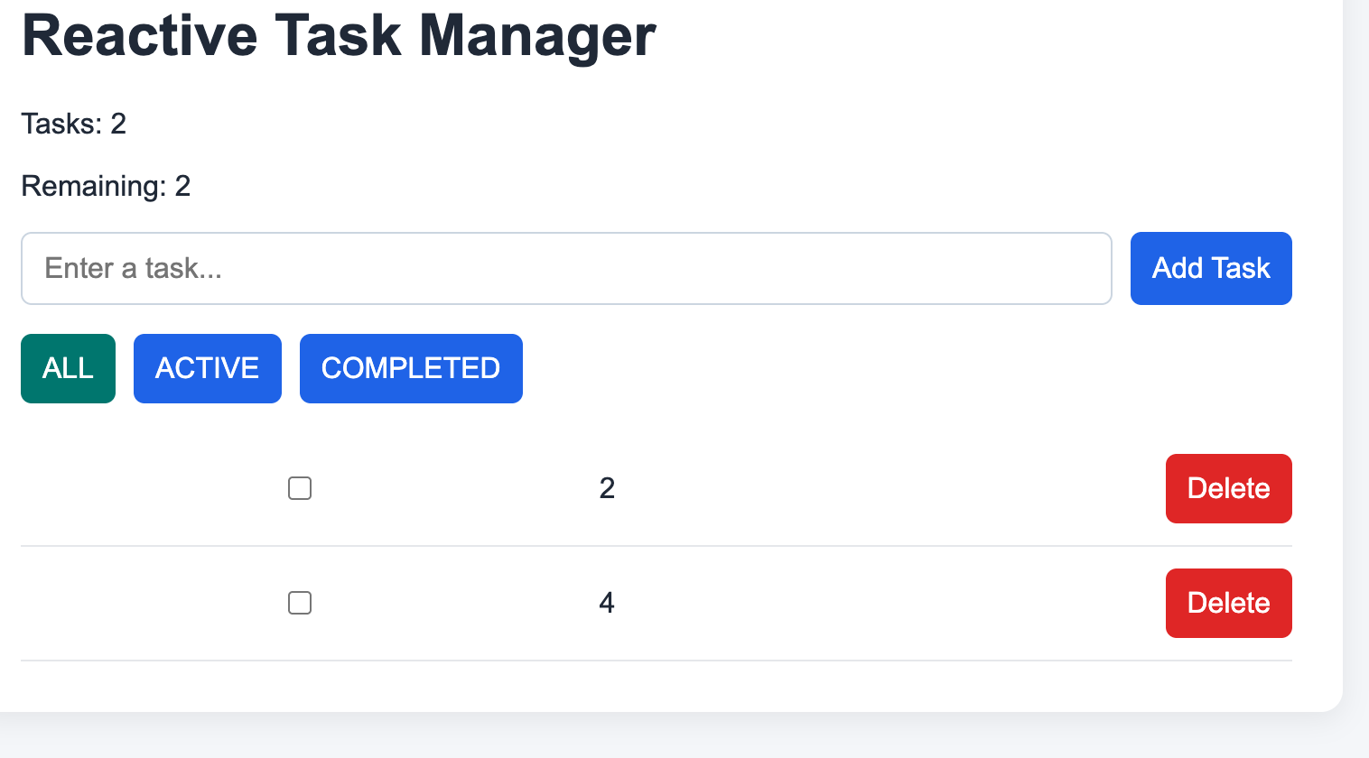
  - Verify zero orphan event listeners attached to button children.
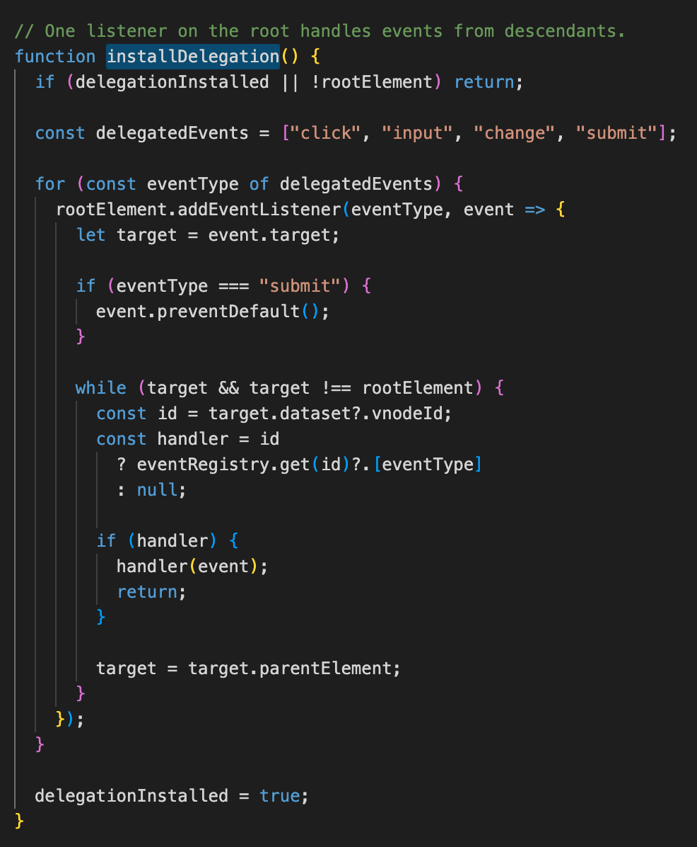
  - Listener is not repeated in may render cycles
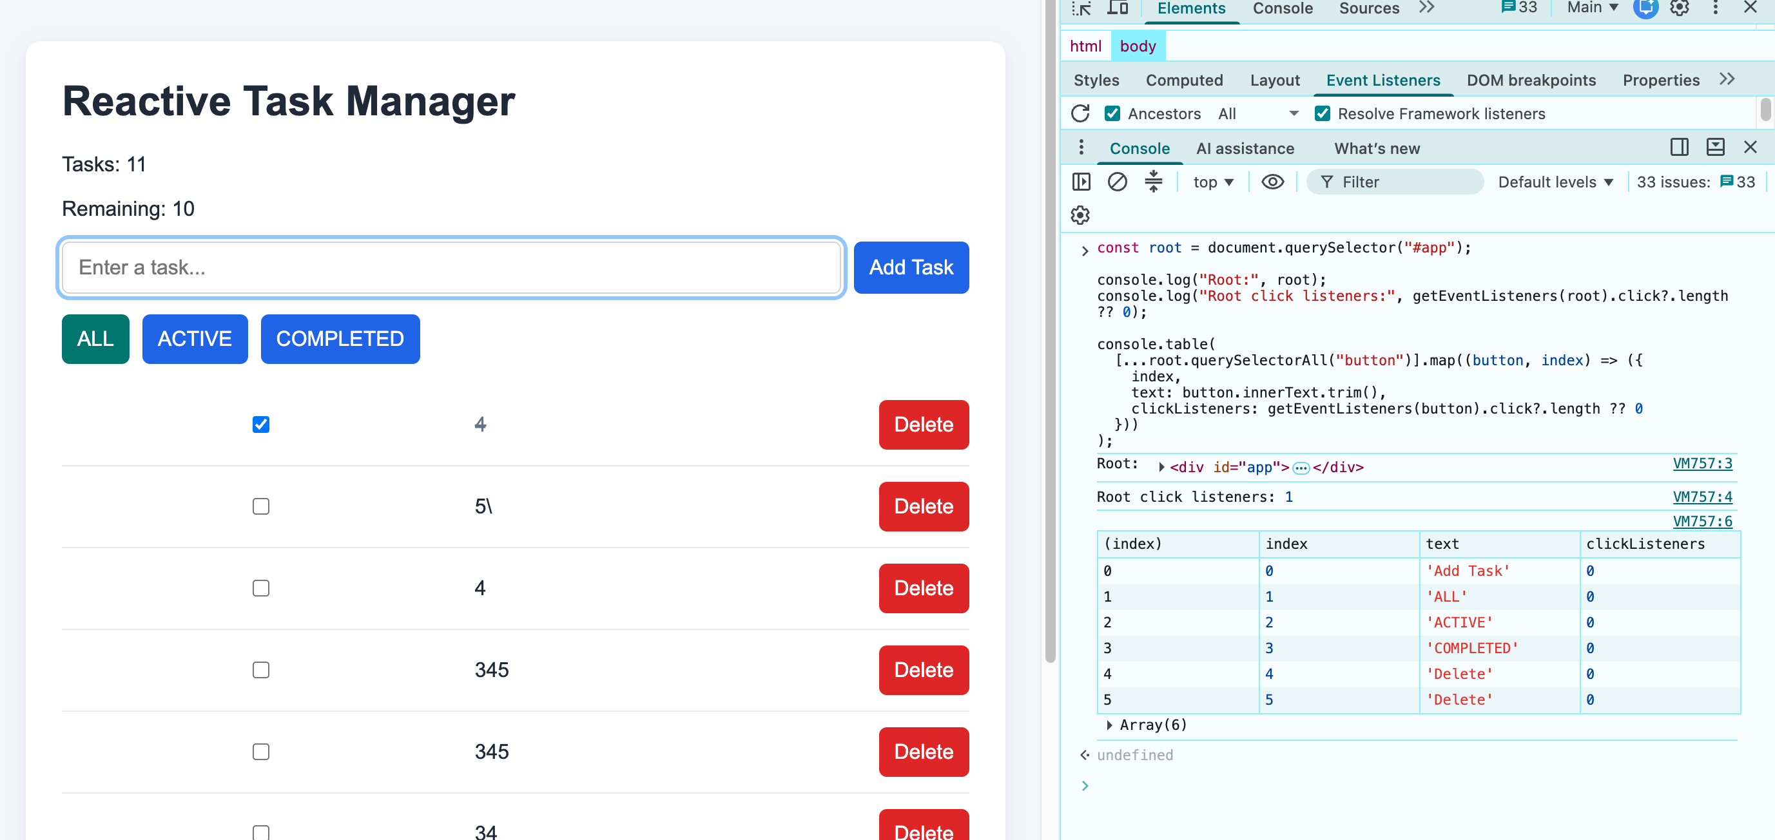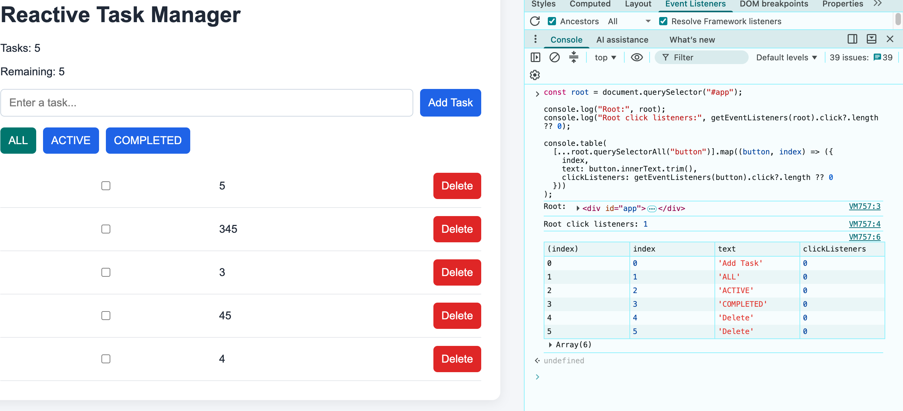

Exercise 3: Resilient State Machine & Skeleton Loader
Task Specifications & Constraints
- Objective: Eliminate race conditions and inconsistent UI states during async data operations.
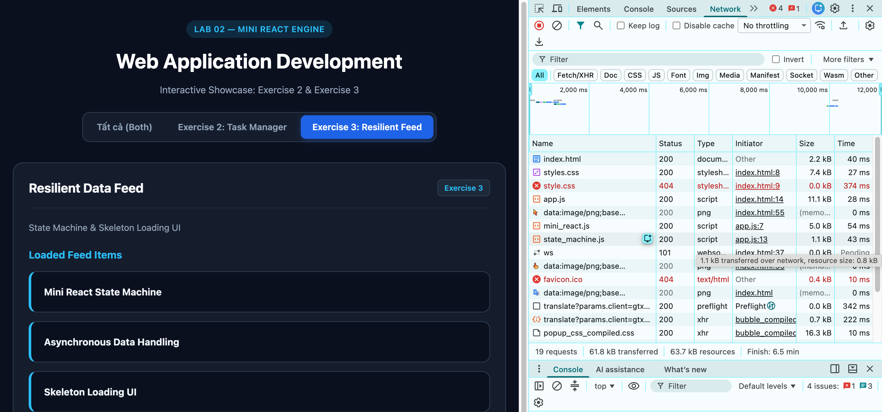
- Finite State Machine: Component state strictly restricted to: 'IDLE' | 'LOADING' | 'SUCCESS' | 'ERROR'.
  - IDLE
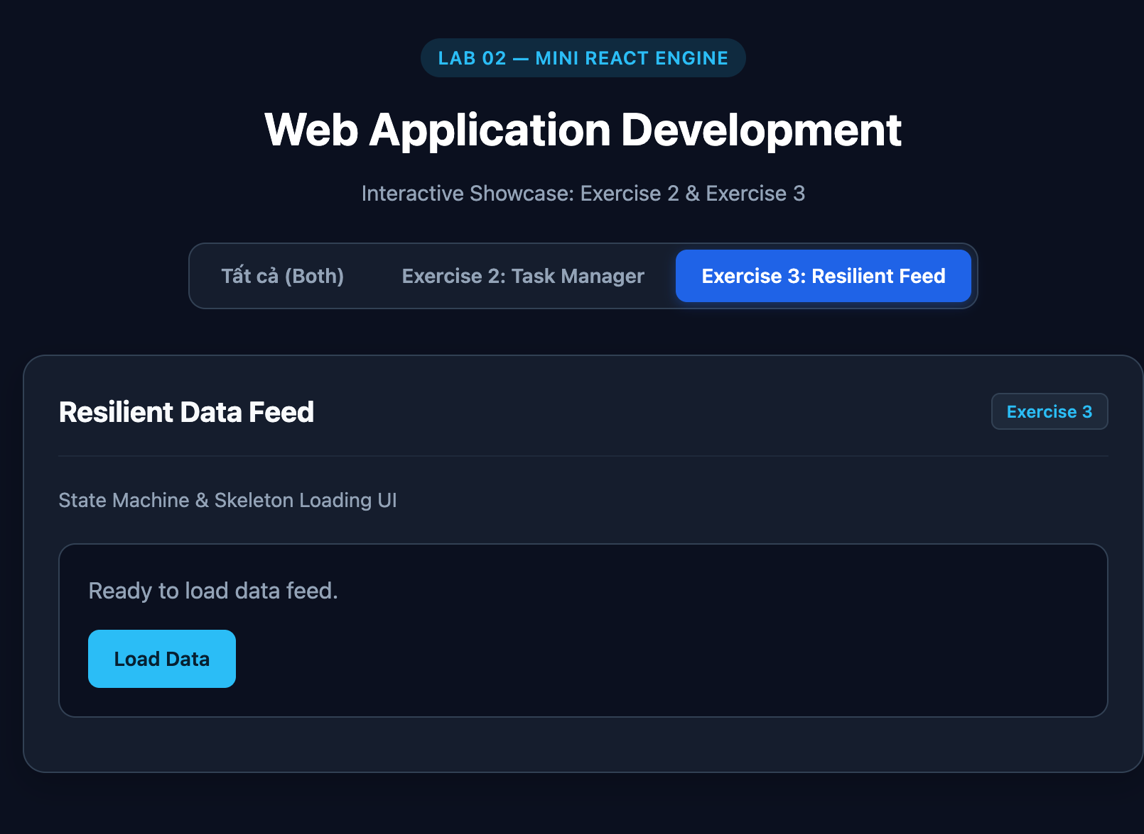
  - Load data
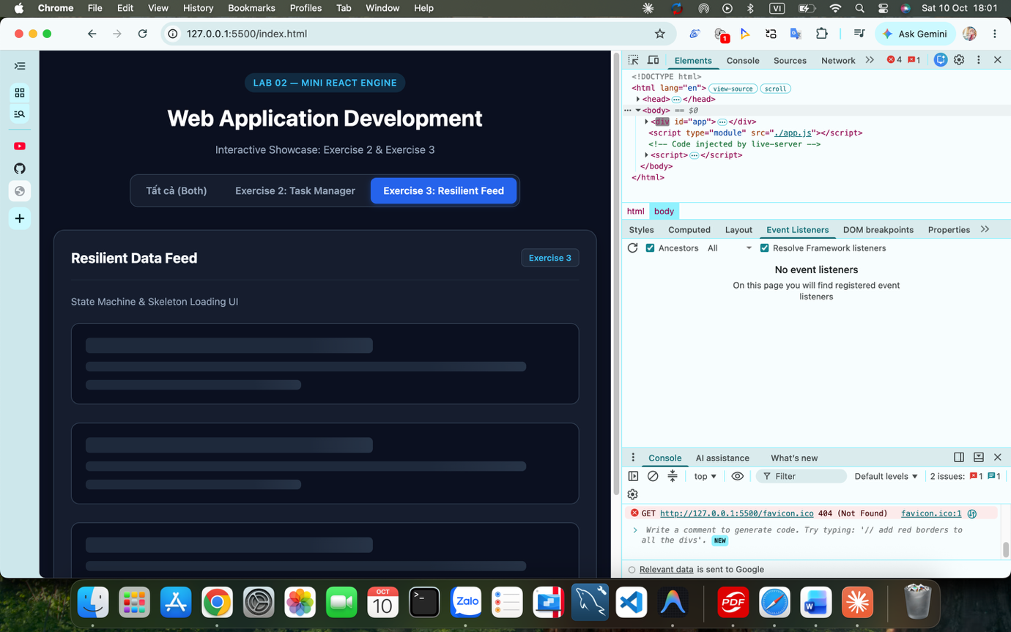
  - Success
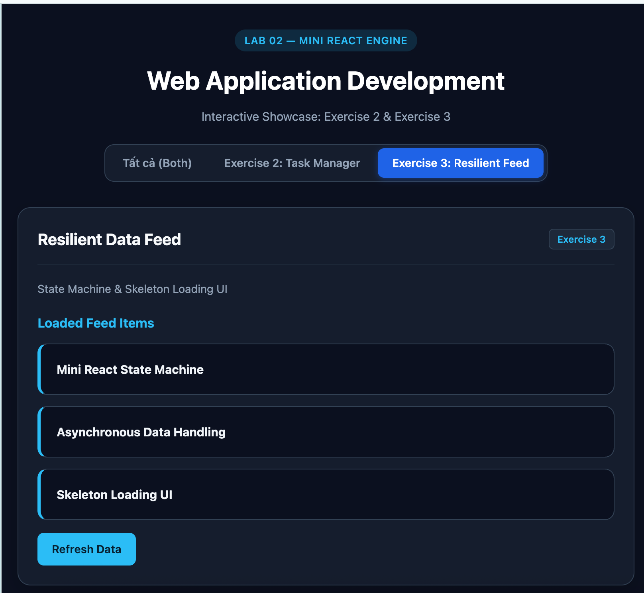
  - Error
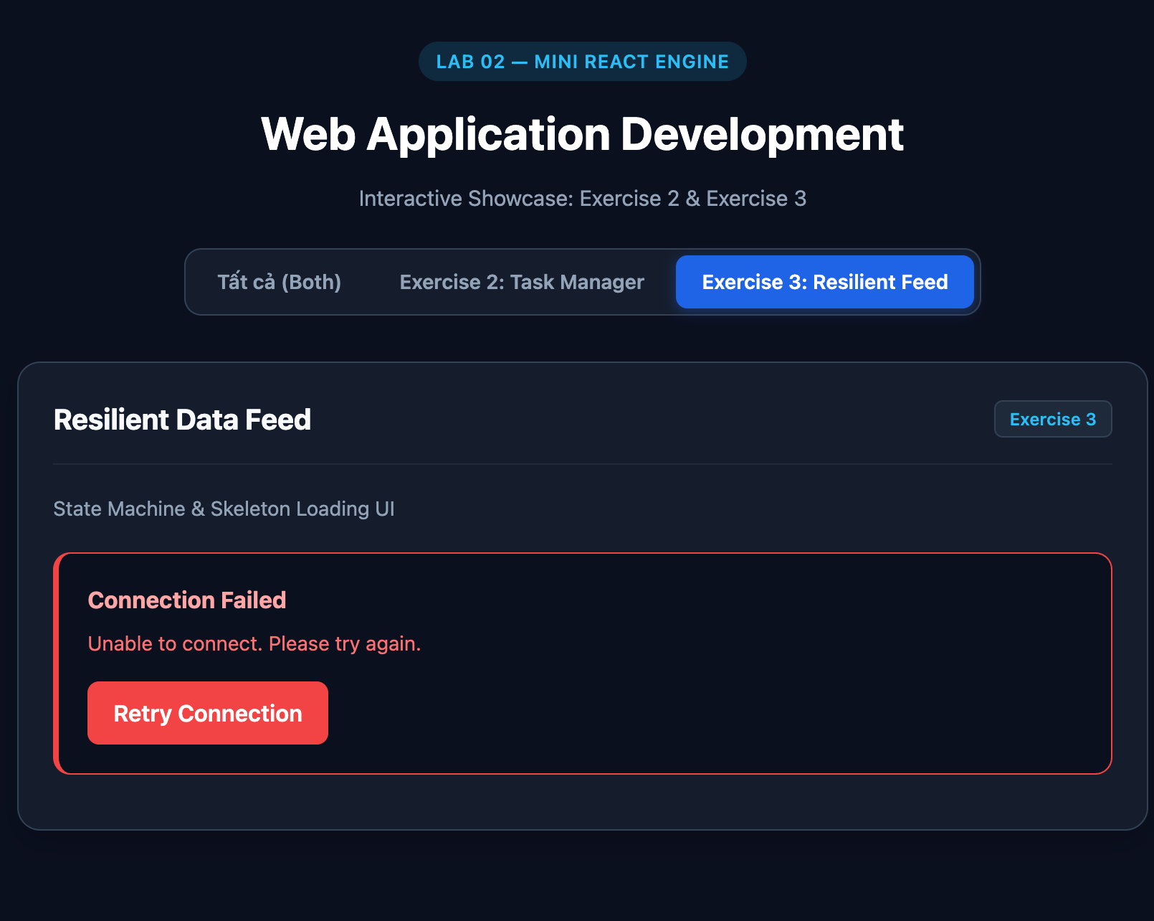
- Skeleton Screen: Render animated pulsing CSS placeholder skeleton during 'LOADING' state.
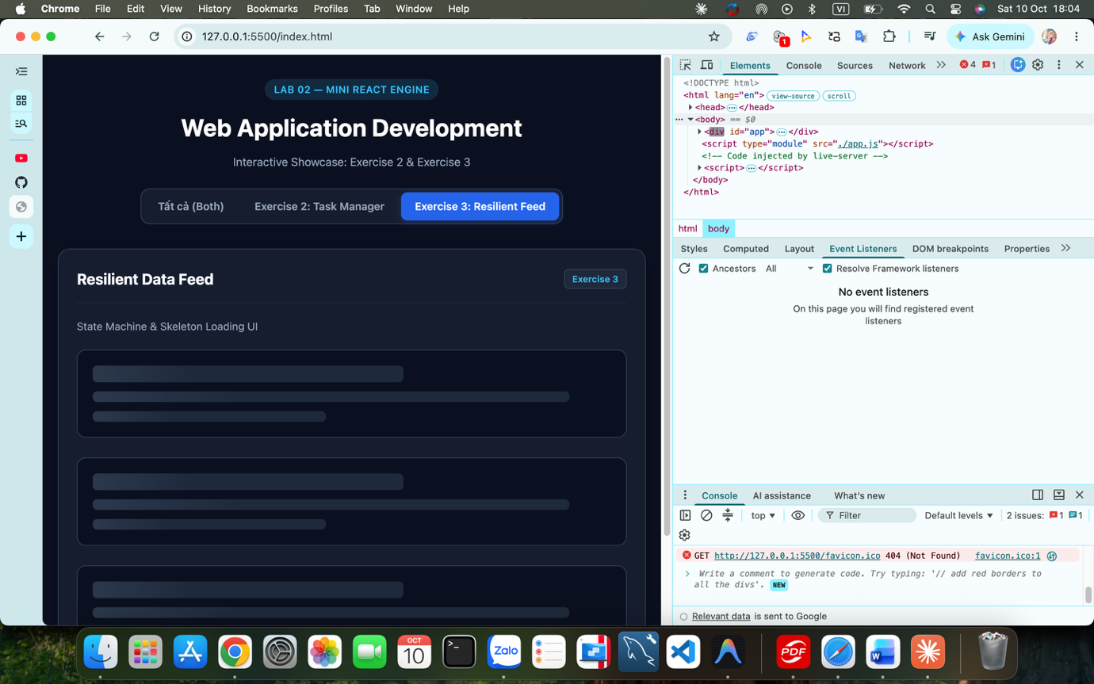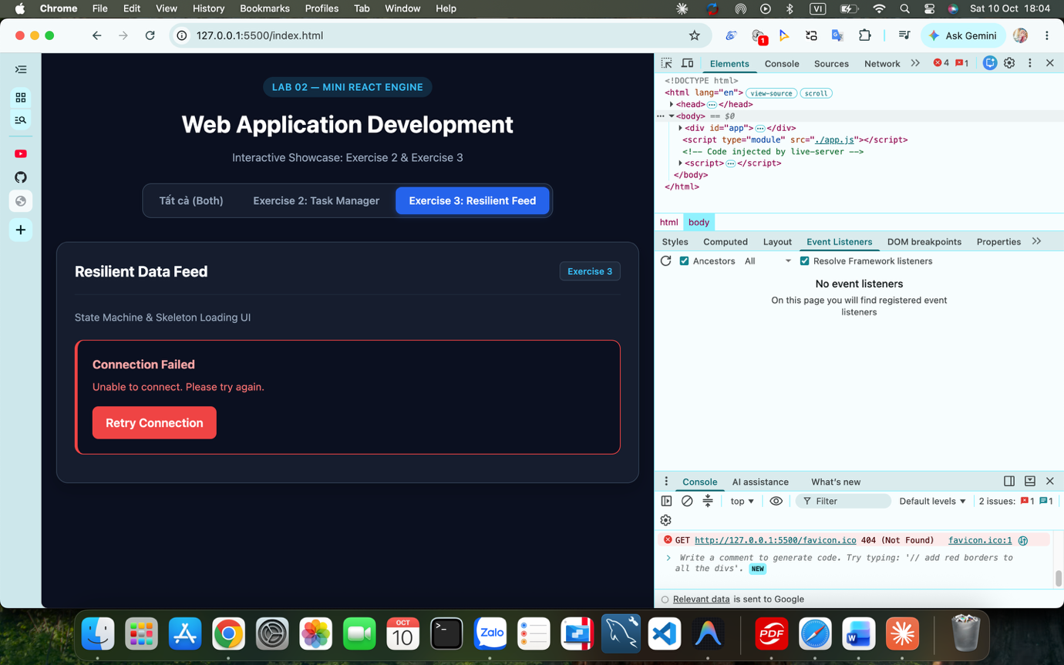
- Error Boundary & Retry: Render human-readable error with 'Retry Connection' button.
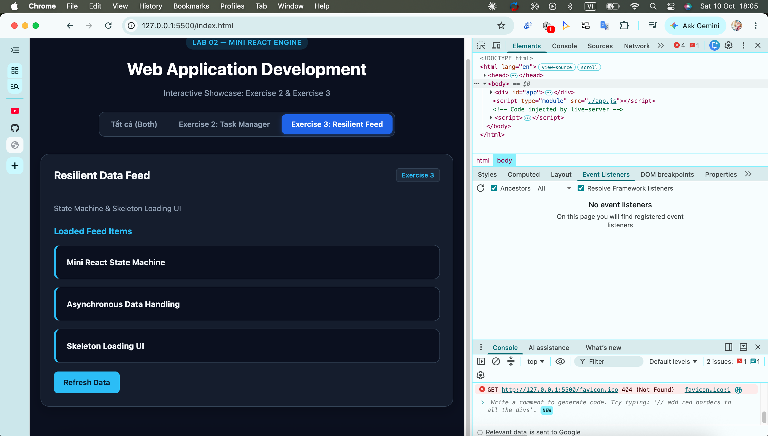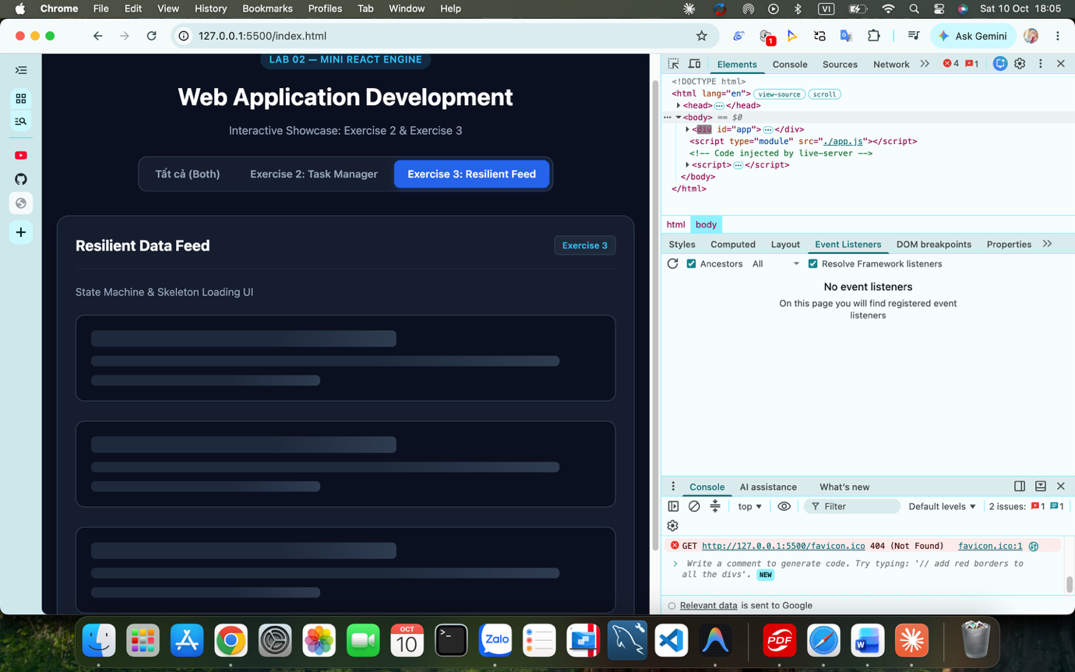
- Git Milestone Commit: 'feat(ui): implement multi-state data component with skeleton feedback'
