Intention Uncertainty (IU) under Collaboration Strategy and Communication Latency
CarDreamer · CARLA 0.9.16 · Town03 right-turn task · zero-shot evaluation of right_turn_hard.ckpt (DreamerV3). Model-free intention-uncertainty metric. Report generated 2026-07-22.

1. Objective
We study how which surrounding vehicles share their driving intention (collaboration strategy) and how stale that shared intention is (communication latency) affect the ego vehicle's intention uncertainty about the surrounding traffic. Intention uncertainty is quantified by a model-free metric, IU (Intention Uncertainty), computed purely from recorded geometry, vehicle kinematics, the shared intention paths, and the CARLA map topology — no additional model is trained. We then check whether IU is consistent with the ego's actual driving performance (collision rate, success rate, speed) measured on the same runs.

2. Experiment setup

2.1 Scenario and policy
- Task: carla_right_turn_hard (Town03), fixed ego right-turn path crossing an oncoming car flow. Full observability (the ego always sees surrounding vehicle positions; only the intention channel is subject to sharing and latency).
- Policy: the released DreamerV3 checkpoint right_turn_hard.ckpt, evaluated zero-shot. The policy is fixed across all conditions; only the intention-sharing configuration changes.
- Simulator: CARLA 0.9.16, synchronous 10 Hz (1 step = 100 ms). Each condition ran for 1000 steps (~5–11 episodes); per-frame geometry was recorded for offline metric computation.

2.2 Collaboration strategies (which vehicles share intention)
Strategy | Rule | Vehicles that broadcast their intention to the ego
all | share all | Every flow vehicle broadcasts its planned path.
nearest-2 | nearest, N=2 | The two flow vehicles nearest the ego.
nearest-1 | nearest, N=1 | The single nearest flow vehicle.
random-1 | random, N=1 | One randomly chosen flow vehicle (choice persists until it despawns).

2.3 Communication latency
The intention channel is delayed by k steps: at time t the ego receives the intention snapshot broadcast at t−k (implemented as a fixed-length snapshot buffer). Vehicle positions stay live (full observability); only the intention/plan content is stale. We sweep k = 0 … 10 steps (0–1000 ms).

2.4 The IU metric
For each frame, IU sums a relevance-weighted residual uncertainty over all relevant surrounding vehicles:
IU(t) = Σi ∈ relevant wi · ui
- Relevance wi — spatio-temporal conflict between vehicle i (constant-velocity prediction over a 6 s horizon) and the ego's planned path; w = max(0, 1 − dmin/dsafe). Only vehicles whose future may conflict with the ego contribute.
- Prior uncertainty Uself (entropy) — the ego's uncertainty about vehicle i's maneuver without communication, computed as the normalized entropy of i's plausible routes enumerated from the CARLA map topology (junction branching → high entropy; a single lane → ~0), gated by junction proximity. This is the per-vehicle ceiling.
- Residual uncertainty ui:
  - not shared: ui = Uself (ego keeps the full prior);
  - shared: ui = Uself · (1 − trust(k)), with a communication-freshness decay trust(k) = exp(−k·Δt/τ), Δt = 0.1 s, τ = 1 s. Fresh (k=0) → u=0 (the maneuver is resolved); very stale (k large) → u→Uself (as useless as no communication).
Design note: an earlier version tied latency to a position-residual γ (distance between the vehicle and the first waypoint of its stale plan). Because that first waypoint is a look-ahead point a few meters ahead, γ carries a k-independent floor that swamps the latency drift, so IU was flat in k (Section 3.2). Replacing it with the time-freshness trust(k) makes latency the direct, monotone driver while leaving Uself (the entropy) unchanged.

3. Results

3.1 IU vs latency (main result)
Simple env, freshness formula, τ=1 s. Values are mean IU over relevant frames, ×10−3 (lower = better understanding).
strategy | k0 | k1 | k2 | k3 | k4 | k5 | k6 | k7 | k8 | k9 | k10 | mean
all | 0.0 | 2.5 | 4.8 | 6.0 | 9.0 | 11.2 | 11.9 | 14.2 | 15.0 | 18.5 | 18.9 | 10.2
nearest-2 | 3.1 | 10.1 | 11.5 | 13.4 | 15.6 | 21.5 | 18.9 | 23.1 | 19.9 | 26.8 | 25.9 | 17.3
nearest-1 | 33.6 | 35.4 | 31.7 | 30.7 | 29.8 | 25.0 | 35.6 | 38.3 | 35.2 | 33.8 | 32.7 | 32.9
random-1 | 35.0 | 38.3 | 31.3 | 37.4 | 35.1 | 38.4 | 38.7 | 33.4 | 35.2 | 37.4 | 36.1 | 36.0
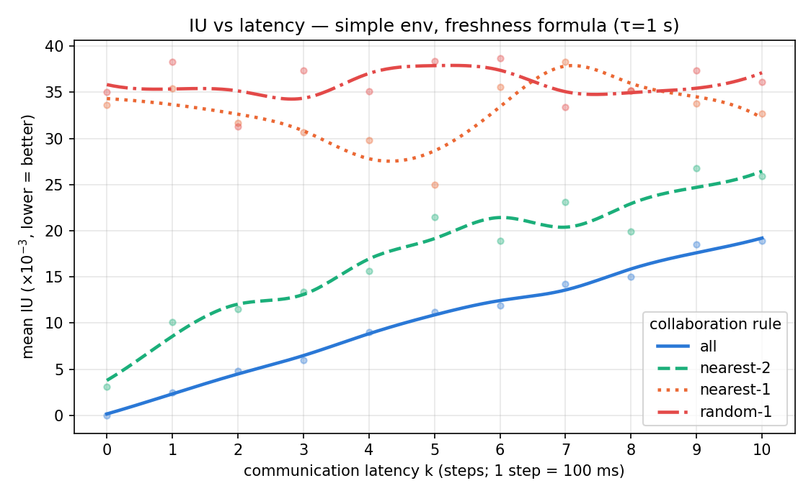
Figure 1. IU vs communication latency (simple env, freshness formula). all and nearest-2 rise monotonically with latency; nearest-1 and random-1 stay flat and high.

3.2 Why the freshness term (formula comparison)
With the old position-residual γ, IU for the all rule is flat at ~5×10−3 across all k (no latency signal). The freshness trust(k) makes the same rule rise monotonically from 0 to ~19×10−3.
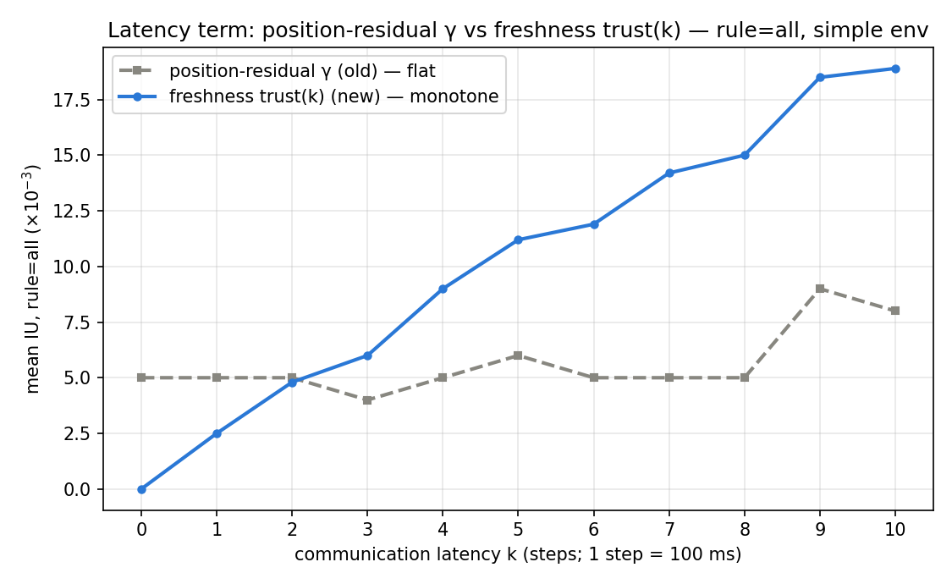
Figure 2. Latency term comparison for rule=all (simple env): position-residual γ (flat, latency-blind) vs freshness trust(k) (monotone).

3.3 Driving performance on the same runs
Aggregated per episode from each condition's eval log (metrics.jsonl): collision rate, success (destination reached) rate, and mean speed. Averages over k=0…10:
strategy | mean IU (×10−3) | collision rate | success rate | mean speed (m/s)
all | 10.2 | 0.00 | 0.93 | 2.97
nearest-2 | 17.3 | 0.06 | 0.86 | 2.91
nearest-1 | 32.9 | 0.23 | 0.68 | 2.28
random-1 | 36.0 | 0.05 | 0.80 | 2.10
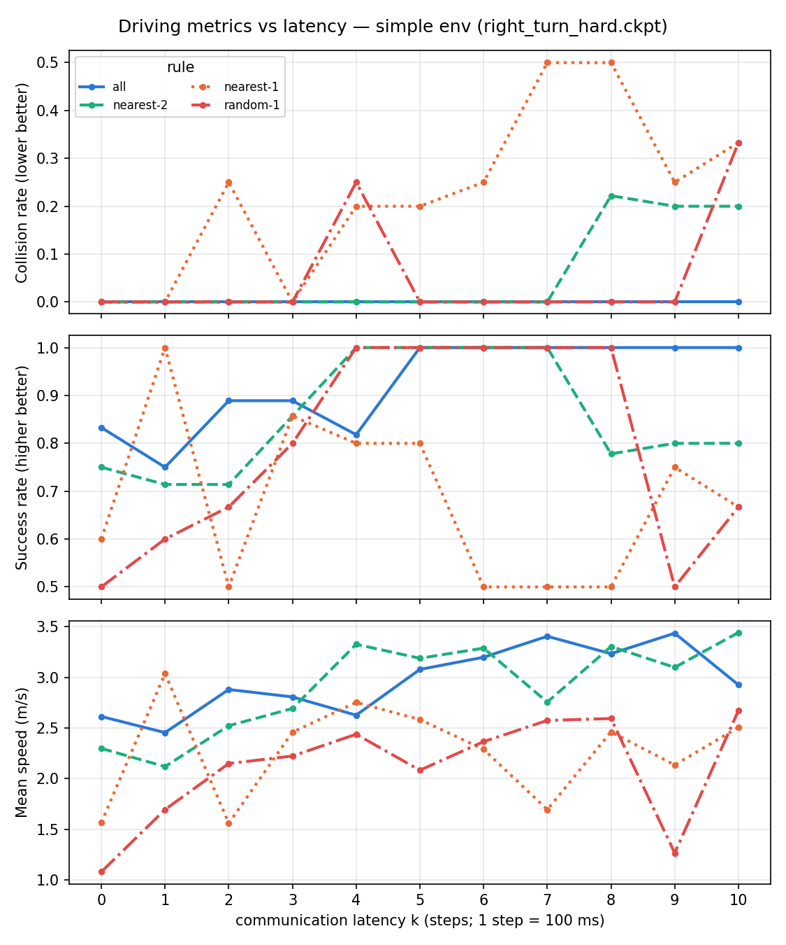
Figure 3. Driving metrics vs latency (simple env). all/nearest-2: near-zero collisions, high success, higher speed. nearest-1: highest collision rate, rising with latency. random-1: low collision but slowest (timid) and noisier.

4. Analysis

4.1 Collaboration strategy sets the level
IU splits into two tiers: all (10.2) < nearest-2 (17.3) « nearest-1 (32.9) < random-1 (36.0) (×10−3). Strategies that cover the key conflict vehicle (all, nearest-2) hold low intention uncertainty; strategies that frequently miss it (nearest-1, random-1) sit near the no-communication prior. The driving metrics agree: all/nearest-2 collide least, succeed most, and drive fastest.

4.2 Latency only hurts strategies that share the key vehicle
Latency degrades only shared intentions, so its effect appears exactly where the key vehicle is actually shared: all and nearest-2 rise monotonically with k (all: 0 → 18.9; nearest-2: 3.1 → 25.9), approaching the unshared prior as the intention goes stale. nearest-1 and random-1 are flat in k because the dominant uncertainty comes from an unshared vehicle, which is latency-independent. In the driving metrics this shows as nearest-2's collisions emerging only at high latency (k≥8) and nearest-1's collision rate trending up with k. The interaction is clean: latency matters only once you share the right vehicle; if you already miss it, staleness is irrelevant.

4.3 IU is consistent with driving outcomes
Across strategies, the model-free IU ordering matches the success-rate and speed ordering, and the strategies with the lowest IU (all, nearest-2) are collision-free or nearly so. This supports IU as a training-free proxy for how well the ego "understands" the scene. (random-1 is an instructive exception: low collision but the lowest speed and mid success — its residual uncertainty makes the policy timid/slow rather than crash-prone, a different failure mode than nearest-1.)

4.4 Two conditions are both required for a clean latency signal
(i) The freshness formula is necessary: with the position-residual γ, even the simple env is flat in k (Section 3.2). (ii) The simple (flow-only) environment is necessary: in a richer scene with ~12 additional, never-shared background vehicles, a latency-independent floor dilutes and buries the signal (recomputing the freshness metric there yields a noisy, non-monotone curve). The simple env, where under the all rule essentially every relevant vehicle is shared, is the discriminative testbed for both IU and driving performance.

4.5 Full-observability caveat
Under full observability the ego always sees vehicle positions, so intention latency can only corrupt the "which maneuver" information, and even a stale plan can be re-anchored to the observed position. This inherently caps how much latency can move an intention-uncertainty metric. The strongest latency effect is expected in an FOV/occlusion setting, where the ego cannot see the vehicle and must rely on the stale plan for position as well as intention.

5. Limitations
- Sample size: ~2–11 episodes per condition, single seed. Collision/success rates are coarse; trends (strategy tiering, nearest-2's high-latency collisions) are reliable, individual cells are not. Multi-seed / more episodes are needed for publication-grade curves.
- Metric assumption: the shared-vehicle residual regrows along the map-branch axis (Uself) as the intention ages; it does not model non-branch deviations (e.g. braking on a straight road) nor the re-anchoring of a stale plan to the observed position. τ = 1 s is a chosen coherence timescale (a τ sweep is a natural sensitivity study).
- Distribution: the policy was trained on flow-only traffic; the richer environment is mildly out-of-distribution.

6. Artifacts and reproduction
All paths are under experiments/epu-collaboration-latency/. Analysis is offline and does not modify car_dreamer source.
- Scripts (scripts/): iu_freshness_table.py (main metric, trust(k)), iu_entropy_table.py (entropy Uself + γ baseline), ecpg_from_geometry.py (relevance/geometry), iu_decompose.py (shared vs unshared decomposition), driving_metrics_vs_latency.py (collision/success/speed), plot_iu_vs_latency.py, figs_for_doc.py.
- Results (results/): simple_freshness/ (main table+csv), simple_gamma_iu_table.csv (γ baseline), rich_freshness/ and entropy_gamma_rich/ (richer-env comparisons), driving_simple.csv, driving_rich.csv.
- Figures (figures/): Figures 1–3 above.
- Recorded geometry (inputs, outside this dir): logdir/ecpg_geom (simple env, 44 conditions), logdir/group_epu_geom (rich env). Metric computation requires a running CARLA/Town03 for the map-topology Uself queries only (no simulation).

