Table of Contents

Communication Latency × Collaborator Selection in Autonomous-Driving Intention Sharing
Branch: coop-intention-latency · Platform: CarDreamer (CARLA 0.9.16 + DreamerV3) · Scenario: carla_right_turn_hard

TL;DR
In the CarDreamer right-turn-through-traffic scenario, a pretrained DreamerV3 policy is evaluated zero-shot across two dimensions of intention sharing: whose intention is shared (collaborator-selection rule) × how stale the intention is (communication latency, 0–1000 ms). 45 configuration cells total. Key findings:
- Redundancy sets the latency-tolerance threshold — the more collaborators share intention, the more the policy tolerates stale information. Sharing all vehicles (all) holds up to ~600 ms; two collaborators (nearest2) hit a knee at ~300–400 ms; a single collaborator has almost no tolerance region.
- Latency causes “misjudge-and-crash,” not “conservative-wait” — unlike no sharing (none, which stalls and times out with near-zero collisions), latency makes the policy act aggressively on stale intentions. Collision rate climbs monotonically with latency (single collaborator: 5% → 42%).
- Locked random tracking beats high-frequency nearest switching — random1 (lock onto one vehicle and track it) dominates nearest1 (re-pick the nearest vehicle every step) at high latency, with less than half the collision rate. Supports the “temporal stability of collaborator selection matters” hypothesis.

1. Background and Motivation
CarDreamer’s original intention sharing draws each background vehicle’s Traffic-Manager planned trajectory (future waypoints) as an orange line in the ego’s bird’s-eye view (BEV); the world model’s CNN ingests this “where others intend to go” information directly as pixels. The original design makes three idealized assumptions:
- Zero latency: at decision time t, the ego receives every other vehicle’s plan as of time t.
- No selection: either share all (all), or coarsely filter by visibility/neighborhood (visible/neighbor).
- Ground-truth: what is shared is the TM’s true internal plan, free of prediction error.
In real V2X communication, an intention signal must be encoded → transmitted → decoded, so it is already several time-steps stale by the time the ego decides; and bandwidth/topology mean the ego can only subscribe to a subset of collaborators. This experiment quantifies the effect of these two realistic constraints (latency × selection) on driving decisions.

2. Experimental Setup

2.1 Scenario and Evaluated Policy
Item | Configuration
Task | carla_right_turn_hard (Town03, right turn across dense oncoming traffic, flow gap 6–8 m)
Evaluated policy | Official pretrained checkpoint right_turn_hard.ckpt (DreamerV3), zero-shot, no fine-tuning
Background-vehicle observation | observability: full (vehicle boxes fully visible, real-time) — the policy stays in-distribution, removing the observation-mode OOD confound
Desired speed | desired_speed = 4 m/s
Why full observability of vehicles: only the intention channel (orange lines) is subjected to latency/selection manipulation, while vehicle positions stay fully visible and real-time. This ensures (a) the policy operates in a familiar observation, making the latency/selection effect a clean single variable; and (b) it avoids the high-collision trigger condition of the CARLA 0.9.16 upstream bug (see §5.3).

2.2 The Two Experimental Dimensions
Dimension A — Collaborator-selection rule (whose intention is shared, env.intention_sharing.rule):
Rule | Meaning
all | All flow vehicles share intention
nearest2 | The 2 vehicles nearest the ego share
nearest1 | The single nearest vehicle shares (target re-selected every step)
random1 | Randomly lock one vehicle and track it until it despawns, then re-pick
none | No vehicle shares (no-sharing lower-bound reference)
Dimension B — Communication latency (how stale the intention is, env.intention_sharing.latency_steps = k): k ∈ {0,1,…,10}, which at 10 Hz corresponds to 0–1000 ms.

2.3 Latency Mechanism Semantics
Each simulation step buffers an intention snapshot in a deque(maxlen=k+1); the head is exactly the snapshot from step t−k:
- Orange-line content = the plan as of step t−k (what the collaborator intended k steps ago);
- Orange-line anchor = the vehicle’s position at step t−k (the stale broadcast carries the stale position);
- Local information stays real-time: vehicle green boxes and the ego’s own blue path are not delayed — only the intention arriving over the communication channel is stale.
- Semantic boundary: what is delayed is the “plan content”; _render_path automatically trims waypoints the vehicle has already driven past, so the drawn line is “the still-untraveled portion of that stale plan.”
k=0 means no latency (the head is the current step). Selection is also delayed with the packet: at step t the ego receives the packet broadcast by the collaborators selected at step t−k.

2.4 Evaluation Protocol
- Each cell runs 20 000 environment steps (~110–290 episodes), policy uses deterministic (zero-entropy) sampling;
- Metrics recorded: success rate (destination-reached rate), collision rate, timeout rate, average speed, average return;
- Single seed; success-rate SEM ≈ ±3–4% (read trends, do not compare point-by-point).

2.5 Matrix Design (45 cells)
- Main matrix: {all, nearest2, nearest1, random1} × k∈{0..10} = 44 cells;
- none reference, 1 cell (no latency dimension).

3. Results

3.1 Success Rate (%)
rule | k0 | k1 | k2 | k3 | k4 | k5 | k6 | k7 | k8 | k9 | k10
all | 99 | 98 | 98 | 99 | 98 | 98 | 98 | 93 | 91 | 90 | 88
nearest2 | 96 | 98 | 98 | 97 | 91 | 88 | 85 | 86 | 81 | 80 | 78
nearest1 | 67 | 85 | 81 | 80 | 76 | 75 | 64 | 63 | 61 | 51 | 44
random1 | 71 | 67 | 66 | 60 | 69 | 68 | 60 | 63 | 53 | 61 | 51
none | 2 (reference)
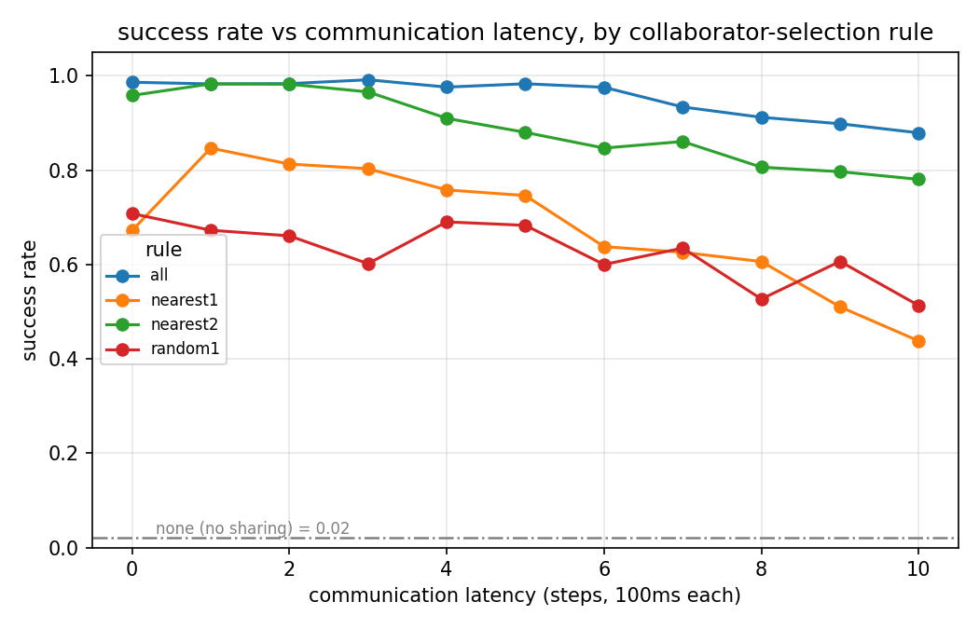
Success rate vs latency

3.2 Collision Rate (%)
rule | k0 | k1 | k2 | k3 | k4 | k5 | k6 | k7 | k8 | k9 | k10
all | 1 | 2 | 1 | 0 | 2 | 1 | 3 | 6 | 8 | 9 | 14
nearest2 | 3 | 1 | 1 | 3 | 10 | 12 | 15 | 15 | 19 | 21 | 22
nearest1 | 5 | 13 | 19 | 19 | 23 | 24 | 34 | 34 | 33 | 39 | 42
random1 | 1 | 4 | 6 | 5 | 7 | 7 | 8 | 9 | 13 | 14 | 18
none | 0 (reference, see §5.2)
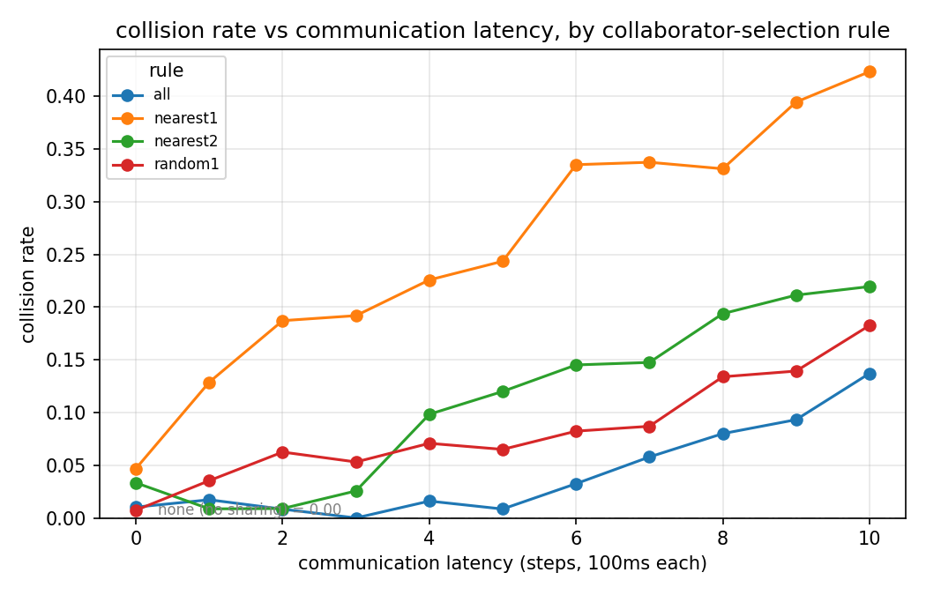
Collision rate vs latency

3.3 Timeout (%)
rule | k0 | k1 | k2 | k3 | k4 | k5 | k6 | k7 | k8 | k9 | k10
all | 0 | 0 | 0 | 0 | 0 | 0 | 0 | 0 | 0 | 0 | 0
nearest2 | 0 | 0 | 0 | 0 | 0 | 0 | 0 | 0 | 0 | 0 | 0
nearest1 | 30 | 1 | 0 | 0 | 1 | 0 | 2 | 2 | 5 | 8 | 12
random1 | 28 | 28 | 27 | 33 | 23 | 24 | 31 | 25 | 33 | 25 | 30
none | 97 (reference)

3.4 Average Speed (m/s, desired_speed=4)
rule | k0 | k1 | k2 | k3 | k4 | k5 | k6 | k7 | k8 | k9 | k10
all | 2.98 | 2.98 | 3.05 | 3.01 | 3.16 | 3.01 | 3.15 | 3.09 | 3.15 | 3.04 | 3.11
nearest2 | 3.07 | 2.97 | 2.88 | 3.03 | 3.10 | 3.11 | 3.12 | 3.07 | 3.16 | 3.06 | 3.03
nearest1 | 1.29 | 2.12 | 2.39 | 2.47 | 2.38 | 2.40 | 2.28 | 2.04 | 2.02 | 1.81 | 1.65
random1 | 1.46 | 1.57 | 1.45 | 1.54 | 1.59 | 1.76 | 1.52 | 1.54 | 1.50 | 1.66 | 1.50
none | 0.50 (reference)
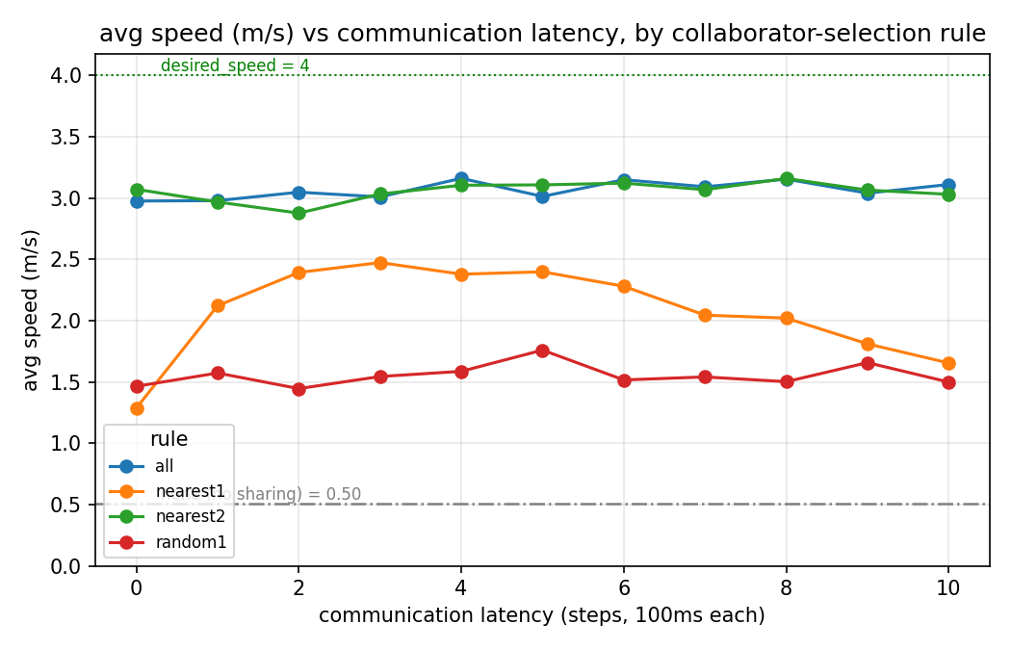
Speed vs latency

3.5 Sample Size (episodes per cell)
rule | k0 | k1 | k2 | k3 | k4 | k5 | k6 | k7 | k8 | k9 | k10
all | 292 | 116 | 120 | 118 | 125 | 118 | 123 | 121 | 125 | 118 | 124
nearest2 | 120 | 116 | 112 | 117 | 122 | 125 | 124 | 122 | 129 | 123 | 123
nearest1 | 128 | 163 | 187 | 198 | 186 | 193 | 185 | 163 | 160 | 147 | 137
random1 | 137 | 113 | 112 | 113 | 113 | 123 | 170 | 115 | 112 | 122 | 115
none | 99

4. Analysis and Findings

Finding 1: Redundancy sets the “latency-tolerance threshold” (strongest result)
Every collaborator scale has a latency knee beyond which performance collapses, and the knee shifts monotonically right with the number of collaborators:
Collaborator scale | Latency knee | Success @ k=10 | Collision @ k=10
all (all) | ~k=6 (600 ms) | 88% | 14%
nearest2 (2) | ~k=3–4 (300–400 ms) | 78% | 22%
nearest1 (1) | almost no tolerance | 44% | 42%
Mechanism: more collaborators means more redundant intention information — when one intention is stale, others still fill in, so the policy’s gap judgment does not fail. This quantitative “redundancy ↔ latency-tolerance” relationship is directly actionable for system design: given a channel latency budget, one can back out the minimum number of collaborators to subscribe to.

Finding 2: Latency causes “misjudge-and-crash,” not “conservative-wait”
Contrast the two failure modes:
- No sharing (none): 97% timeout, ~0% collision, speed only 0.50 m/s — the policy stalls at the intersection, afraid to merge, “safely paralyzed”;
- Delayed sharing (single collaborator): collision rate climbs monotonically with latency (nearest1: 5% → 42%), timeout stays low.
That is: missing information makes the policy conservative (wait); stale information makes it aggressively misjudge (crash). The latter is more dangerous — at k=10 (1 s latency) nearest1 collides at 42%, worse than no sharing at all. A stale intention gives the ego a false-optimistic signal that “traffic has yielded a gap,” so it accelerates into a gap that no longer exists.

Finding 3: Locked random tracking beats high-frequency nearest switching
In the high-latency regime, random1 (lock onto one vehicle and track it) dominates nearest1 (re-pick the nearest vehicle every step):
Metric @ k=10 | nearest1 | random1
Success | 44% | 51%
Collision | 42% | 18%
Speed | 1.65 (volatile) | 1.50 (steady)
Mechanism: nearest1 switches its shared target every step; layered on top of latency, the orange line jumps between vehicles, making the intention signal temporally incoherent and hard for the policy to base a stable judgment on. random1 locks onto one vehicle, so the signal is temporally continuous and latency merely translates the whole trajectory, keeping behavior predictable. This directly supports the hypothesis that the temporal stability of collaborator selection matters as much as instantaneous relevance — greedily picking the “currently most relevant” vehicle every step is not necessarily better than stably tracking a suboptimal target.

Finding 4: Speed draws three clear “information-sufficiency” bands
The speed chart (§3.4) separates three bands more intuitively than success/collision:
- Upper band (~3.0 m/s): all + nearest2 nearly coincide and stay flat — with ≥2 collaborators the policy drives confidently, latency-immune;
- Middle band (1.3–2.5, inverted-U): nearest1’s speed rises then falls. The rising segment (k0→3) “getting faster” is not getting better but getting reckless — it rises in lockstep with collision rate while success rate falls, together forming the full picture of “stale information induces aggressive misjudgment”;
- Lower band (~1.5, steady): random1 slow but steady;
- Floor (0.50): none stalled.
The obvious gap between the upper band and the middle/lower bands is the dividing line of “is the intention information sufficient.”

Synthesis: a behavioral atlas from the four metrics together
Collaborator scale | Speed | Success | Collision | Main failure mode | Behavioral profile
≥2 collaborators | fast (~3.0) | high | low | — | confident, latency-immune (below the knee)
1 collaborator (nearest switching) | medium, reckless w/ latency | mid→low | explodes | collision | stale info → aggressive misjudgment
1 collaborator (random lock) | slow but steady | mid→low | mild | timeout + few collisions | conservative but predictable
No sharing (none) | stalled (0.5) | 2% | ~0 | timeout | safe paralysis, afraid to move

5. Methodological Notes and Limitations

5.1 Statistical power
Single seed, ~110–290 episodes per cell, success-rate SEM ≈ ±3–4%. Small fluctuations between adjacent k values (e.g. nearest1’s 85→81→80) are within noise; read trends, not individual points. Multiple seeds would tighten the error bars and pinpoint the knees.

5.2 Two points requiring careful interpretation
- none’s ~0% collision is misleading: it collides ~0% not because it drives well but because it stalls (97% timeout). So collision rate is not a meaningful “lower bound” for none; its meaningful reference is the 2% floor on success rate.
- Code-path inconsistency in the k=0 column: the k=0 data for all/nearest1/random1/none were run with the earlier v1 code (query at render time), while k≥1 used the v2 code (post-tick cache + comm_packet). Evidence is the abrupt failure-mode shift in nearest1 from k0→k1: timeout 30%→1%, success 67%→85%, collision 5%→13% — this discontinuity is partly a code-path artifact rather than a true latency effect. Recommendation: re-run the 4 seeded k=0 cells with the v2 code (~30 min) to make the column comparable.

5.3 CARLA 0.9.16 upstream-bug workaround
CARLA 0.9.16’s Traffic Manager get_all_actions has a use-after-free in the vehicle-destroy window (confirmed by gdb C++ stack: LocalizationStage::ComputeActionBuffer → SimpleWaypoint::GetRoadOption dereferencing a dangling pointer), which segfaults under “collision churn × full-stack concurrency × high-frequency querying.” The latency mechanism must query the TM once per step and cannot drop it; the fix moves that query into the safe window in WorldManager.step(), after tick() and before on_step() (destroys), and caches it (the 7-line fix in world_manager.py). This is a necessary workaround for the upstream bug, not a removable patch. The CARLA version is a hard constraint and cannot be changed.

6. Reproduction
cd <repo> # coop-intention-latency branch
conda activate cardreamer
export CARLA_ROOT=/home/peh324/carla_simulator # CARLA 0.9.16
# A single cell (example: share only the nearest 1 vehicle, 200 ms latency)
bash eval_dm3.sh 2000 0 ./checkpoints/CarDreamer_checkpoints/right_turn_hard.ckpt \
--task carla_right_turn_hard \
--env.observation.birdeye_wpt.waypoint_obs designated \
--env.intention_sharing.rule nearest --env.intention_sharing.num 1 \
--env.intention_sharing.latency_steps 2 \
--dreamerv3.run.steps 2e4
# Full matrix (45 cells, ~5–6 h, with hang/crash watchdogs)
bash run_latency_matrix.sh
# Analysis and figures
python analyze_coop_matrix.py --outdir logdir/eval/latency
Note: checkpoints/ (HuggingFace weights, hf download ucd-dare/CarDreamer ...) and logdir/ (evaluation data) are not tracked in git.

7. Deliverables
File | Content
experiments/coop-intention-latency/coop-intention-latency.md | This report (Markdown)
experiments/coop-intention-latency/coop-intention-latency.docx | This report (Word)
experiments/coop-intention-latency/coop_matrix_results.csv | Raw summary data for all 45 cells
experiments/coop-intention-latency/figures/success_vs_latency.png | Success-rate vs latency (4 rules + none reference)
experiments/coop-intention-latency/figures/collision_vs_latency.png | Collision-rate vs latency
experiments/coop-intention-latency/figures/speed_vs_latency.png | Speed vs latency (+ desired_speed reference)
Key code: car_dreamer/carla_wpt_fixed_env.py (selection + latency buffer), car_dreamer/toolkit/observer/handlers/renderer/birdeye_renderer.py (intention/collaborator-vehicle rendering), car_dreamer/toolkit/carla_manager/world_manager.py (TM-segfault workaround), run_latency_matrix.sh + analyze_coop_matrix.py (experiment orchestration + analysis).

