**Networking: Labs**

**Week 1: Session 2**

**Tasks:**

1. Get one of the PCs or laptops from the lab and open them up to see what is inside. Try to identify where each of the following is:

***Note:*** *If you can’t access the part, don’t try to take out parts that won’t move, e.g. the heat sink, have a look online to see if you can find out where it is hidden.*

* 1. RAM
  2. CPU
  3. Storage

1. For each of the following computer components, write down their purpose, characteristics, and some brand names of them.
   * Motherboards
   * CPUs
   * Cooling systems
   * ROM and RAM
   * Adapter cards
   * Storage drives
   * Internal cables
2. There are many different types of servers that are used in networking. Have a look online at the different types of servers. Can you list at least 5 different types of servers and provide a brief description of what each server’s job is?
3. Have a look around the classroom at the network of computers that is set up and that you are using. List all of the different types of network hardware that you can see and write down what you think the purpose of each one is.
4. Now that you have learned about different types of network hardware, list out the different types of networking hardware that you think CU Scarborough uses as a whole.
5. Draw a network diagram of what you think CU Scarborough’s network structure looks like. On the next page is an example of a simple network structure that you can use for reference.

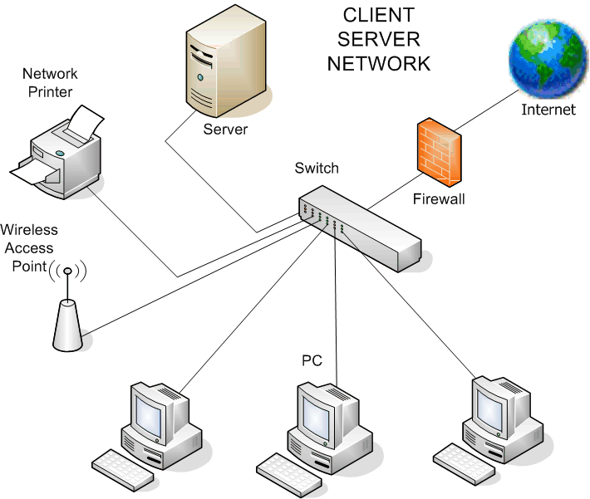

**Final 30 Minutes: Read, Research, Reflect**