Output from fine tuned bert model chosen for parsing

Simple first version of Neural network UI for universal robot

Prototype command being processed, and universal robot change (moves linear in tool space):

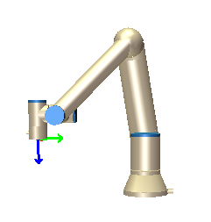

Showing the grammatical finesse of the neural network powered natural language processing. The letter A is not registered as a noun, and can therefore not be seen as a position. The letter B is seen as a noun, which is why it is switched by its mask input which is P2

Move to skill names

Masked positions

Spacy word dependency

Dependency parsing in program form

Result from using python robotics toolbox, translation, transformations and results.

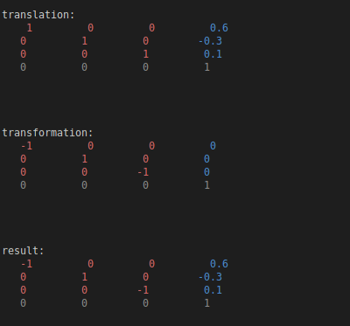

Sentence deconstruction. Detection of intertwined verb sentences and isolated verb sentences:

Input: *pick up object, put down object, go to california*

AI output

Proof that the stanza “en” package uses BERT models

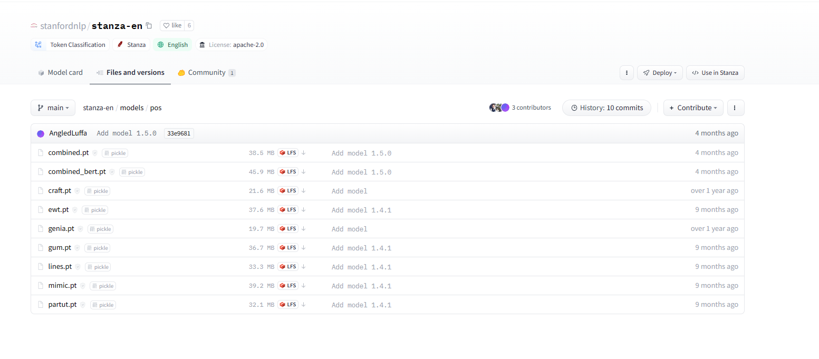

Using chat GPT as the NLP pipeline process from text to simple actions sequence given start impromptu

Will probably not be used in this bachelor, as the GPT as a low action intent accuracy for its produced sequence. It is probably not trained to execute this kind of command very good.

First test with version one pipeline from text to sequence of actions

Input: move frame 2 to frame 3, then move to frame 3

The actual models for the stanza NLP pipeline

NER

Tokenizer

POS

Lemmatization

Argue, that LSTMs are also useful, write a little about that

Create an evaluation test for next week

Martin has some cool Euclidean distance (cosine similarity)

Some things might be skippable in the kinematics. Building full kinematics.

Deparser extremely large

Using verb proceed, which was removed from database. The verb was then caught by the embedded word comparison method

