Output from fine tuned bert model chosen for parsing

Simple first version of Neural network UI for universal robot

Prototype command being processed, and universal robot change (moves linear in tool space):

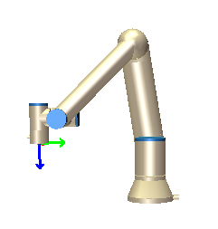

Showing the grammatical finesse of the neural network powered natural language processing. The letter A is not registered as a noun, and can therefore not be seen as a position. The letter B is seen as a noun, which is why it is switched by its mask input which is P2

Move to skill names

Masked positions

Spacy word dependency

Dependency parsing in program form

Output from dependency parsing with standfordNLP

Figure 1 - Also gives grammatical categories

Output with both relations pos taggings and NER

All NLP pipelines used for the projects

What should be seen is that all three nouns have direct dependencies to their respective verbs,

Shoulder -> move

Base -> turn

Tool point -> hold