# Dependency parsing test

This test is made with the purpose of figuring out which of the dependency parsers (and POS tags) are best for the bachelor task made.

For this test a number of predefined general sentences which is believed to be typical for this application is used to measure the quality of the dependency parsing and POS tagging.

The following NLP models which are used are all listed in the document: [Natural Language Processing — Dependency Parsing | by Shivanee Jaiswal | Towards Data Science](https://towardsdatascience.com/natural-language-processing-dependency-parsing-cf094bbbe3f7)

These three models are:

* Spacy model
* Standford_NLPCore model
* Stanza model

The sentences which will be used is:

* Move robot to point a
* Go towards the coffee machine
* Go towards point b but avoid the red box
* Move the shoulder 6 degrees
* Move the joint 3 along the x-axis in accordance with the base frame
* Go to California
* Make me scrambled eggs
* Move forward in the tool point frame 5 centimetres
* Turn the shoulder 180 degrees
* Move 5 centimetres in the direction of the red box
* Move towards the coffee machine but try to avoid the red box
* Stop the robot
* Exit
* Emergency stop
* Lock the robot
* Grab the bin at bin frame
* Put the bin in the dropoff frame

## Spacy results:

### Move robot to point a

Figure 1 - cool graph, but takes long to generate, so wont make more

Point is seen as a verb

### Go towards the coffee machine

### Go towards point b but avoid the red box

### Move the shoulder 6 degrees

### Move the joint 3 along the x-axis in accordance with the base frame

Accordance should be an ADP Adposition but is a noun

Output is too long, so here is a snippet.

## Standford_NLP results:

### Move robot to point a

A is seen as a determinant

### Go towards the coffee machine

### Go towards point b but avoid the red box

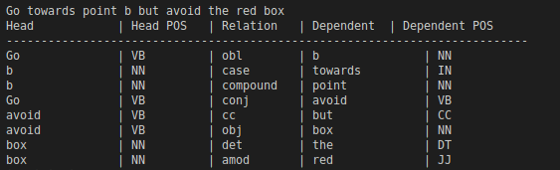

### Move the shoulder 6 degrees

### Move the joint 3 along the x-axis in accordance with the base frame

## Stanza results:

### Move robot to point a

‘a’ is marked as punctuation.

### Go towards the coffee machine

### Go towards point b but avoid the red box

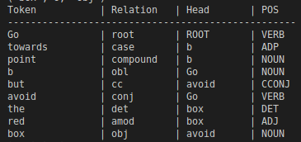

### Move the shoulder 6 degrees

### Move the joint 3 along the x-axis in accordance with the base frame

Accordance should be an ADP Adposition