Capacitive Controlled Wheelchair

Michael Koutsostamatis
UIC Department of Computer Science
Chicago, USA
mkouts2@uic.edu

Abstract—This device is a wheelchair that is controlled through capacitive touch. It enables the control of a wheelchair without the need for limbs in the event of a catastrophic accident. It was worked on and researched by Michael Koutsostamatis and Josh Smejkal during the fall semester of 2018 along with several other students in the BIOE and Computer Science departments.

Introduction
When a patient has lost the use of their legs and requires a wheelchair, almost all of the options feature a joystick that the user can manipulate with their hands to move around with. This can be problematic if the patient has also lost the functionality of their upper body. This can include arms, spine, and even the head. The current process for giving these people mobility is a mix of the use of these joystick wheelchairs [1] or through the use of a Sip-and-puff device that utilizes air pressure generated by the user to give input to the device. These solutions are merely stepping stones however, as the capacitive controlled wheelchair makes it easier to control while requiring less of the body to do it.

Technology

Capacative touch
Our device operates on the principle that the human tongue can interfere with the uniform electrostatic field on an array of “buttons”, or electrically conductive surfaces. We measure the differences in those electrostatic fields, one for each button, and then determine which action to perform based on what button the user has activated. This is a similar technology that smartphone screens employ, just with less sensing area and without employing projected capacitance.

Arduino

The platform we have use in this project was the Arduino Pro Micro 5v board. It supported the use of 4 buttons with a sensing pin for the sensor, Bluetooth serial (TX, RX) and power for the touch sensor as well as BLE communication. It was programmed in C using Arduino studio and much of our circuit design was done on a breadboard.
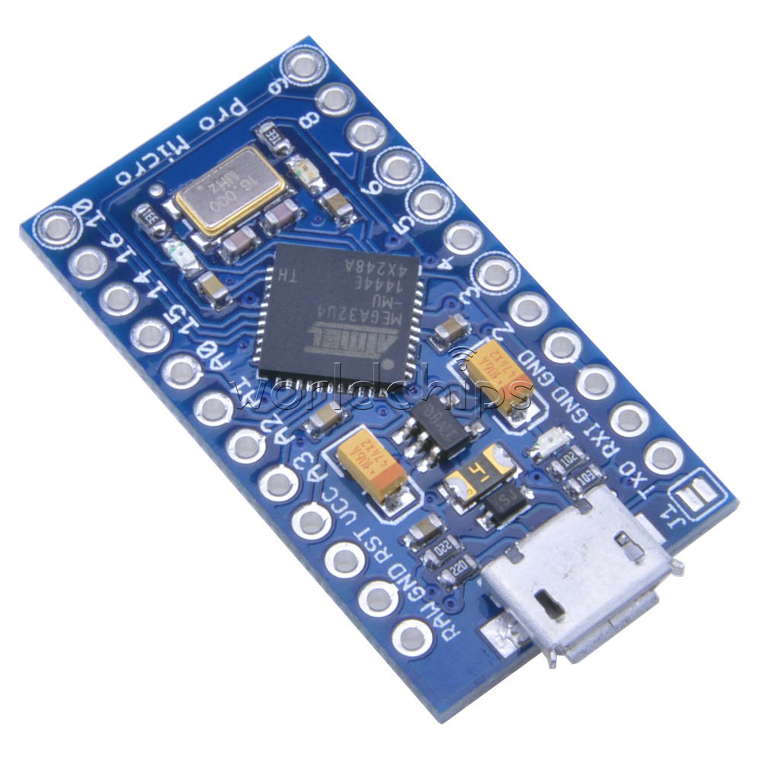
We juggled with the idea of using a custom made chip made by one of the BIOE graduate students using a Nordic Semiconductor BLE module, but communication with our wheelchair was increasingly difficult due to the protocol the communication chips used. The decision to remain on Arduino didn’t come without its own set of issues however. These will be discussed in the issues section.

Bluetooth Low Energy
Bluetooth low energy (BLE) is a low power version of Bluetooth designated in 2011 that would allow devices to use significantly less power than conventional Bluetooth. This advancement in power efficiency allows very small devices to interface with other Bluetooth devices while still having long battery life and taking up much less space.

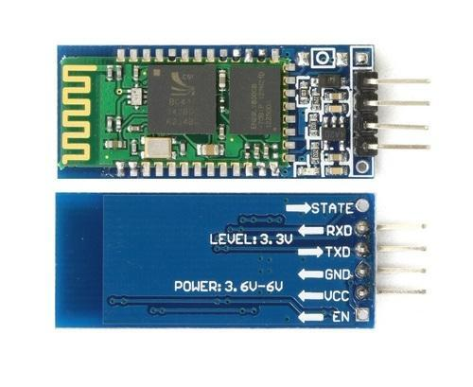
This technology is the backbone of the communication boards we use to allow communication between the sensor and the car. We used the HC-06 Bluetooth breakout board hooked to both the wheelchair and the sensor and set them to auto pair with each other.

Circuit Board Design
We etched a custom flexible circuit board with copper targets that the user can touch with their tongue or finger. It was etched using ferric chloride and masking a PCB with the trace pattern. The board design itself is an early model that another grad student drew up while researching this technology with Nordic Semiconductor boards. We have several choices when it comes to materials we can print on as well. They vary in flexibility and thickness but both accomplish the same task. The “Paper” board material is made of a thin layer of board material with a copper backing. The “Semi-Rigid” material is a thicker and less flexible material that can stand up to lots of abuse. We have been making our most recent models with the semi-rigid material and it has survived multiple pressings with minimal damage.

Software
Software for this project was compiled on a Windows computer running Arduino Studio. It included the code that lived on the remote controlled wheelchair and code for the sensor. The sensor module talks to the wheelchair by sending any command that is detected by the sensor. This command is in the form of a string and has 4 possibilities (one for each of the 4 buttons on the retainer). They can be configured to whatever that programmer sees fit, but for the wheelchair the possible directions are forward (“f”), backwards (“b”), and clockwise/counter-clockwise rotation (“l”, “r”).

Code
There are several aspects of the code worth talking about.
CapacitiveSensor cs_3 = CapacitiveSensor(4,5);
Line 15 of the sensor code initializes button on pin 5 with the sensing pin being 4. Hardware specifics will be covered in the hardware section, but every pin gets its own pin and then all the buttons rely on a separate pin for pulling them up. This means that another button initialized on pin 6 would also have 4 as its sensing pin.
SoftwareSerial BTSerial = SoftwareSerial(15,14);
Line 13 shows that we are using pins 14 and 15 as TX RX temporarily in a “Software Defined Serial” since these pins can technically transmit whatever data we want.
if (total1 > CAP_THRESHOLD) {
BTSerial.write('f');
lastCommand = 'f';
Serial.println("forward");
}
This is the function that senses one of our buttons and outputs a Bluetooth signal. This is done through serial printing the letter indicating the direction that is mapped to the button through the Bluetooth adapter attached to our temporary Bluetooth serial pins. A capacitance value is then printed out to our serial monitor on our PC for tuning purposes.
void _mleft() {
analogWrite(ENA,ABS);
analogWrite(ENB,ABS);
digitalWrite(in1,HIGH);
digitalWrite(in2,LOW);
digitalWrite(in3,HIGH);
digitalWrite(in4,LOW);
Serial.println("go left!");
}
This code lives on the remote controlled wheelchair and defines what the electric motors do when the command to go left is issued. The digitalWrite commands are electrical signals to the motor controller located onboard the wheelchair. They then get redirected to their respective motor and the motor begins moving.
getstr=Serial.read();
if(getstr=='f')
{
_mForward();
}
This code also comes from the wheelchair and is what reads commands from the wheelchair’s Bluetooth serial monitor pins (which are connected to the second HC-06 Bluetooth breakout board) In the event that the data read matches “f” for forward, the function to move forward is called that sets in motion the steps for moving the electric motors.

Calibration
Capacitive sensors can be very temperamental depending on the setup that is being used. For best results, we have found that the sensor array had to be plugged into the USB port of a computer that has a power plug with a three prong connector (ground pin). This gives the sensors a true ground point so that capacitance values were as consistent as possible. Even so, when powering on the device a baseline should be recorded and threshold values set to slightly above the baseline value (10-20%). The need to tune these values is almost constant and has provided much of a headache as we change configurations and sensor pads. More information can be found on this in section VI.

Hardware
Hardware was a huge part of our work and something I can thank many others in the BIOE department for helping us with. Hardware involves everything from molding retainers to testing connections on buttons to designing the wheelchair itself.

Retainer
The retainer was molded using dental foam that we would press into he roof of our mouth and slowly harden over 24 hours. This was then used and reused to press pheated sheets of plastic over with a vacuum mold to make plastic inverted impressions of our teeth. This is something that we can slide onto our teeth. By carefully placing our printed flexibal circuit board on the “top” of the retainer and vacuum molding another plastic sheet over it, we are then able to seal the electronics between a sandwich of thin plastic that offers water proofng and protection from the lements in the users mouth.
From this point, all electronics (including the battery) are sealed and cannot be accessed without destroying the retainer. This poses an engineering issue as if the battery runs out the deconstruction of the retainer would be required. We solved this for our presentation by using USB power and only sealing the etched sensor array in the plastic sandwich.

Capacative Sensor
As mentioned in previous sections, the capacitive sensors are comprised of copper contacts whose capacitances are tuned by software and constant tinkering. Using 10 mega ohm resistors (one for each button), these buttons regulate their capacitance and can change what values the sensors rise to when touched. We initially started off with 100k and 200k resistors but quickly found out that the values at baseline were much too high. This also affected touch behavior as values wouldn’t rise high enough to be consistently detectable with a threshold value. For example, our baseline capacitance would be 2350, and when touched the value would rise to 2500. This is an increase, but not touching the button perfectly would not bring it all the way to 2500. This resulted in inconsistent or “missed touches” occurring when testing with moving the wheelchair. Moving up in resistance solved this as the baseline was lowered while the jump in capacitance when touched went up.
We could increase the resistance even further to 20 or 50 mega ohms, but there is yet another caveat of too much resistance. As it rises, the electric arc that our fingers interrupt when touching rises above the surface of the flexible circuit. This makes “air touching” possible as the button can now detect touches above the sensor. This is a side effect that we want to eliminate as we prefer the tactile feedback of touching a surface with the tongue.
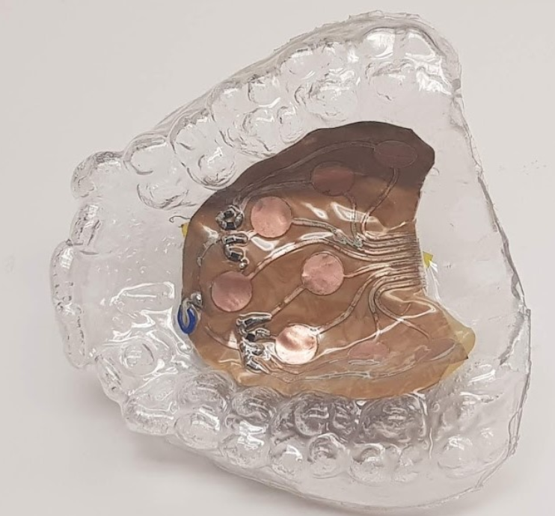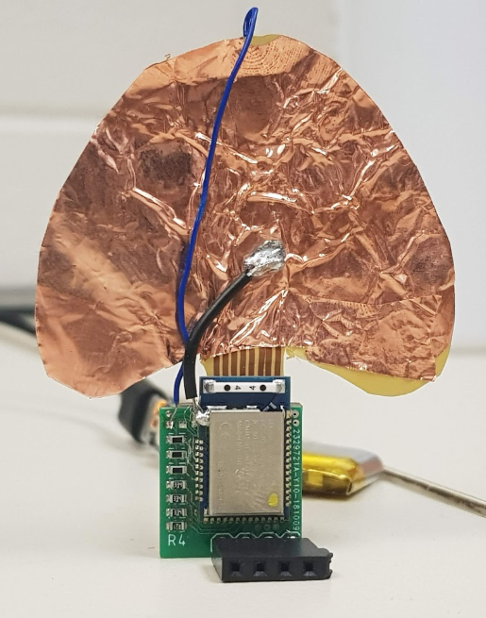

Iterations

We have developed one intermediate working version encased in a disc shaped plastic sandwich. This unit was created for the purpose of testing capacitance levels with different resistors. The bending that occurs when the sensor board is formed around a mouth shaped mold is inconsistent and placement of the board is vital. There was a higher chance of failure and we needed a reliable mule board with maximum probability of survival for our circuit board (since we were going to rip apart the sandwich each time to replace resistors).

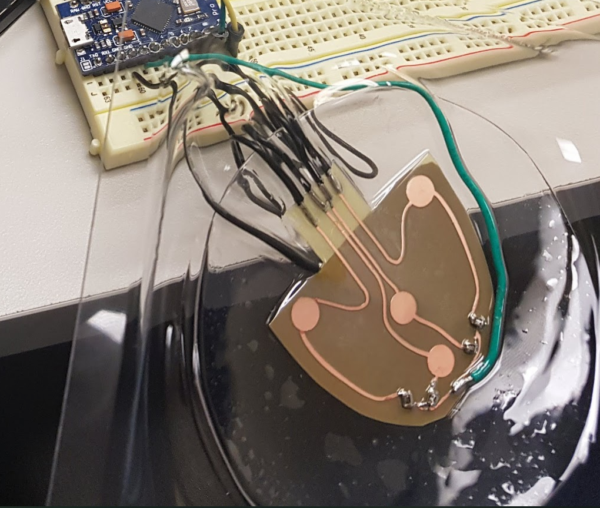

There was always the option of making cuts in the plastic of our test unit to make soldering new resistors easy, but that would affect the capacitive field that was generated in that area. This opened up the possibility of a tongue/finger causing higher detection than normal at that location. Complete rebuilds were required to ensure maximum consistency between builds and capacitance values. Once we were confident with the results on the flat unit we began making in mouth prototypes.

Power
There are two ways to power this device. One is simply through USB power, while the other is through a coin battery case we wired to our breadboard. Two coin batteries are enough to power both the Pro Micro and the Bluetooth breakout board. Grounding becomes something to consider when using battery power however. If the circuit is not grounded the capacitance values may fluctuate or be inconsistent. Attaching a ground wire to a proper ground source can remedy this problem and return some of the consistency in capacitance baseline values.

Additional Hardware
There are a couple of devices we used for debugging and testing purposes that are documented here.

We used a small OLED display to monitor capacitance values when on battery power. It replaced the USB serial connection that we leveraged when we had USB power and allowed us to monitor the rapid fluctuations in baseline capacitance that the sensor experiences in that configuration.

RESULTS
During testing we created several videos and conducted a demo at the LatinX incubator and startup event at the 1871 makerspace in Chicago. These demonstrations of the wheelchair’s functionality proves to us that that capacitive touch is a viable use case for operating a wheelchair and we are confident that this functionality could extend to other fields and application as well.

ISSSUES
With all the successes that came about with this project, there were at least 10x more problems we faced. During out 1871 demo for example, we had discovered that the contact points for the wheels on the wheelchair were too small, meaning that a wheel fell off several times during our demo. This was in addition to come capacitance baseline issues as our setup wasn’t grounded to a plug (our laptop was running on battery power).
We had some challenges progressing when we began applying the plastic sandwich molding method to our sensor. Our resistors weren’t large enough to project a touch field through the plastic layer that was laid on top of the sensor, so this led us to begin trying higher resistor values.

Acknowledgment
Thanks to Hananeh Esmailbeigi and her hard work at the UIC Bioengineering department. Her resources, labs, and facilities helped us develop and plan this project. He contacts also brought us to the LatinX incubator competition in Chicago, IL to present our research as a viable product.

References
- "Medicaid Electric Wheelchair - Medicare Wheelchairs", Karman Healthcare, 2018. [Online]. Available: https://www.karmanhealthcare.com/medicaid-electric-wheelchair/. [Accessed: 07- Dec- 2018].
- "Shop for Portable Motorized Wheelchairs Online | 1800wheelchair.com", 1800wheelchair.com, 2018. [Online]. Available: https://www.1800wheelchair.com/category/335/motorized-wheelchairs/. [Accessed: 07- Dec- 2018].
- “Used Power Wheelchairs | Pre-Owned Electric Wheelchairs |Wide Selection", Marcs Mobility, 2018. [Online]. Available: https://marcsmobility.com/used-power-chairs-options.html. [Accessed: 07- Dec- 2018].
[4]"Bluetooth Low Energy", En.wikipedia.org, 2018. [Online]. Available: https://en.wikipedia.org/wiki/Bluetooth_Low_Energy. [Accessed: 07- Dec- 2018].

