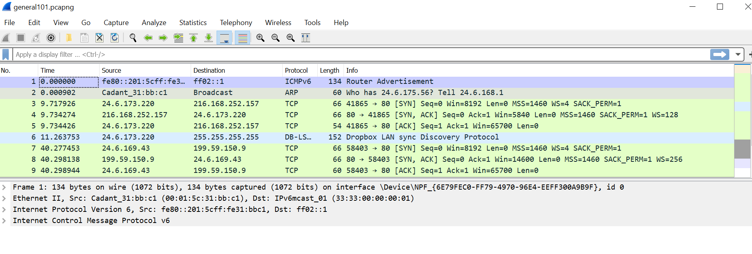LAB 1: Use Packets to build a picture of a network

FRAME 1:



FRAME 2:



FRAME 3:

FRAME 4:



FRAME 5:



FRAME 6:

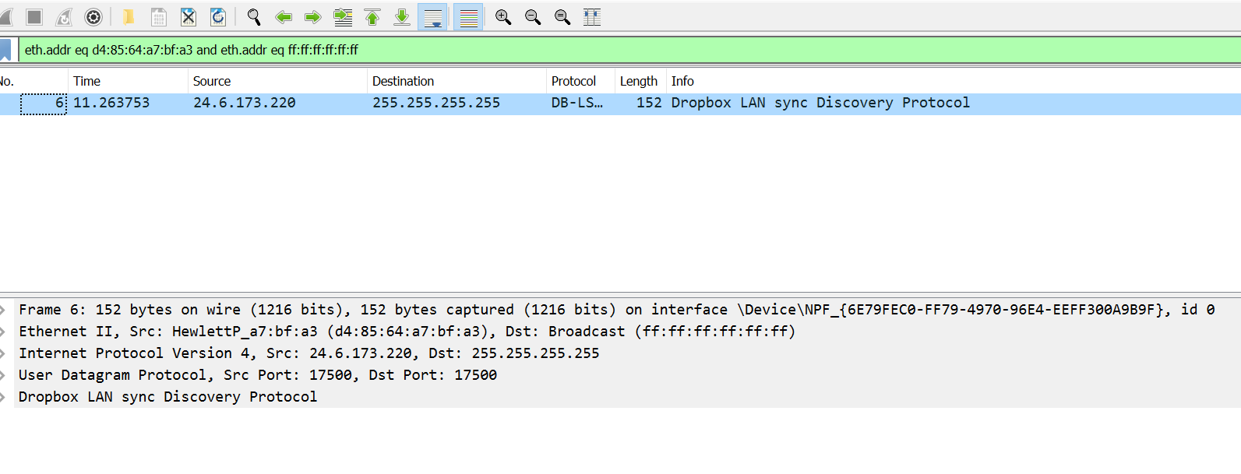

FRAME 7:



FRAME 8:

FRAME 9:

FRAME 10:

FRAME 11: