**Условие**

Задание выполняется как консольное приложение Ruby. Результат следует предоставлять в виде трех отдельных файлов:

* основная программа;
* программа для взаимодействия с пользователем;
* программа для тестирования на основе

MiniTest::Unit::TestCase

**Тексты программ**

**source.rb**

# This module stores client methods

module Source

def self.change_grammar_time(*args)

result = [] # array with the result string sequence

(0..args.size - 1).each do |count|

str = args[count].split(' ')

result_str = ''

str.each do |word|

word.gsub!('ing', 'ed') if word.index('ing') == word.size - 3

result_str += word + ' '

end

result << result_str

end

result

end

def self.calc_func(xxx, yyy)

puts 'Source.calc_func'

xxx = xxx.to_i

yyy = yyy.to_i

(2 * Math.cos(xxx - Math::PI / 6)) / (0.5 + Math.sin(yyy)**2)

end

end

**client.rb**

# frozen_string_literal: true

require './source.rb'

# :reek:ManualDispatch

# :reek:UtilityFunction

def execute(method_name, *args)

Source.public_send(method_name, *args) if Source.respond_to? method_name

end

# :reek:TooManyStatements

def start

puts 'What program do you want to execute?'

p Source.methods - Object.methods

puts "Please, enter a number, corresponding to the func position in the list.

Then enter arguments, if needed (type 'stop' to stop):"

response = gets.chomp.to_i

puts 'enter arguments, if needed'

arguments = gets('stop').chomp('stop')

[response, arguments]

end

start_response = start

response = start_response[0]

arguments = start_response[1]

method_names = (Source.methods - Object.methods)

MIN_POSITION = 1

if response && response >= MIN_POSITION && response <= method_names.size

name = method_names[response.to_i - 1]

formatted_arguments = arguments.split("\n")

case formatted_arguments.size

when 0

execute(name)

when 1

execute(name, formatted_arguments[0])

when 2

execute(name, formatted_arguments[0],

formatted_arguments[1])

when 3

execute(name,

formatted_arguments[0],

formatted_arguments[1],

formatted_arguments[2])

when 4

execute(name, formatted_arguments[0],

formatted_arguments[1],

formatted_arguments[2],

formatted_arguments[3])

else

puts 'Too many arguments'

end

end

**test.rb**

# frozen_string_literal: true

require_relative 'source.rb'

require 'minitest/autorun'

def generate_str_sequence(number_of_times)

random_input = []

random_result = []

number_of_times.times do

random_str = generate_string

random_input << random_str[1]

random_result << random_str[0]

end

[random_input, random_result]

end

def generate_string

random_string = ''

result_string = ''

5.times do

random_word_base = (0...8).map { rand(97..122).chr }.join

random_string += random_word_base

result_string += random_word_base

if rand(0..1) == 1

random_string += 'ing'

result_string += 'ed'

end

random_string += ' '

result_string += ' '

end

[result_string, random_string]

end

# Class for setting any tests on functions

class Tests < MiniTest::Test

def setup; end

def test_calc_func

assert_equal(-1.4084366469497145, Source.calc_func(41, 2))

assert_equal(-0.32940836640837823, Source.calc_func(5, 5))

end

# :reek:FeatureEnvy

def test_change_grammar_time

invoke = generate_str_sequence(3)

input_strings = invoke[0]

assert_equal(invoke[1], Source.change_grammar_time(input_strings[0],

input_strings[1],

input_strings[2]))

end

def teardown; end

end

**Результаты выполнения**

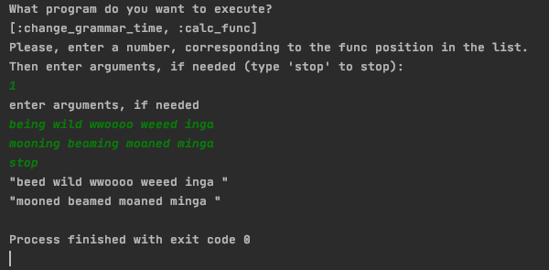

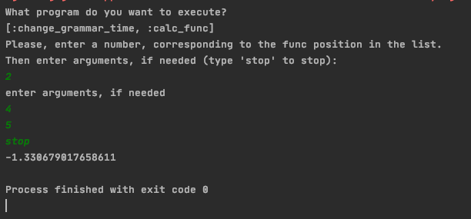

**Результаты проверки анализаторами rubocop и reek**

