Aether Tap Project:

Inexpensive networked microcontrollers for
creating internet enabled devices

Charles V Bock

CST 590, Fall Semester 2010

Professor Richard Whitehouse

Aug 27, 2010
Bock 1
A Brief Note from the Author
During the course of this project I will be entering a lot of new territory, I have never before used a 16 bit uC (Microcontroller), I have never before coded a Microcontroller in C, until now I have only used the 8bit 12 and 16 series microchips and coded them in Assembly or PIC Basic, I have also never used the SPI hardware peripheral which many PIC’s provide. I also have absolutely zero experience with the ENC28J60 module. So this project will without a doubt put me in a position to learn and expand my knowledge of embedded systems.

Bock 2
Summary
Aether Tap is an embedded Ethernet experiment created by myself using Microchip's TCP/IP stack and FAT File system stack. Produced at a nominal single unit cost of approximately $20 and compiled from a list of parts found below in the BOM (Bill of Materials). Aether Tap’s main components include a versatile PIC microcontroller and an ENC28J60 MAC/PHY transceiver which is able to leverage the extensive communication abilities of Ethernet to perform various tasks. Including but not limited to those listed below in the "Project Objectives" Section.

Project Objectives
When beginning a project its prudent to identify what objectives are to be accomplished or what is to be learned in the process. The primary objective of this project is to produce an inexpensive Ethernet enabled controller which can be interacted with via the Internet. The device will be a product of its programming, meaning that depending on what the current task at hand is the device should be able to perform all of the following functions.
- Host web content and display real time data via the web.
- Send emails or alerts when necessary.
- Monitor and interact with external devices, sensors, and appliances.
- Allow control of the above mentioned devices via email, web based interface, or internet connected smartphone (Android, IPhone, etc.)
- Log and respond to network traffic.
- Inject arbitrary packets into the network (security research).

Component Identification
The second step in this project is to identify the main components which are needed to make the above listed goals play out. In this case a Microchip PIC24F series Microcontroller has been chosen as the core CPU of the project, supplemented by a Microchip ENC28J60 Ethernet controller to handle the MAC and Physical layers of the Ethernet interface. These two main components will be joined with a number of lesser important and passive components to assemble the completed project board.

Bock 3
PIC24F Overview
The PIC24F series has many advantages over its 10, 12, 16, and 18 series cousins; First and foremost the 16 bit architecture allows the chip to have a far expanded instruction set which makes it much more viable to program the chip in a higher level language such as C or even BASIC. This project will make use of Microchip’s student version of its C30 Compiler which comes fully loaded with individual header files for each chip in the 24 series and even libraries to help out with the on chip hardware peripherals like USART, I2C, SPI, Etc. The 24 series also has one advantage that most people tend to overlook, its hardware peripheral pins can be remapped to almost any pin on the device, meaning much less time working on routing a PCB. Its also interesting to notice the distinction between the 24F and 24H series controllers, while the 24H controllers can typically run at much higher speeds achieving in the range of 64mips, it typically lacks the expanded peripherals of the 24F series which on average has about double the hardware peripherals of the 24H series but performs at only around 16Mips The exact model used in this project is the PIC24Fj64GA002 with 64K of flash memory, 2 hardware SPI interfaces, and a max speed of 32 MHz (16Mips).

ENC28J60 Overview
The ENC28J60 Ethernet controller handles everything below the network layer of the standard OSI Model. It handles the media access control layer and the physical reception and transmission of packets. The ENC28J60 interfaces to a main controller via SPI and receives and transmits information via an internal 8k buffer operating in a FIFO fashion. The ENC28J60 supports full and half duplex modes as well as unicast, multicast, and broadcast packets. It is also fully compatible with all 10/100/1000 Base-T networks making it a very “plug and play” device as far as embedded Ethernet solutions go. One drawback about this device is that it doesn’t support auto-negotiation which means it’s not safe to use full-duplex mode unless the switch port can be manually changed to full-duplex.

Bock 4
Schematic Design
The Schematic design process is a combination of logical planning and reading a considerable number of product data sheets. During this phase of the project all main and passive components are accounted for and a logical mapping is established. Passive components are selected for by using requirements defined in the main component data sheets. For example the “CPU Core” (PIC24FJ64GA002) marked below requires a core voltage of 2.5 volts which means a filtered power supply “Power Regulation” must be established which provides 3.3 volts to the VCAP pin on the PIC, this is then down converted to 2.5 volts using an internal regulation process. This and other requirements are all outlined in the respective component data sheets. At this stage a number of 0.1uF (0.1 microfarad) capacitors are also added to help decouple the power bus and remove any voltage spikes or noise which may occur.
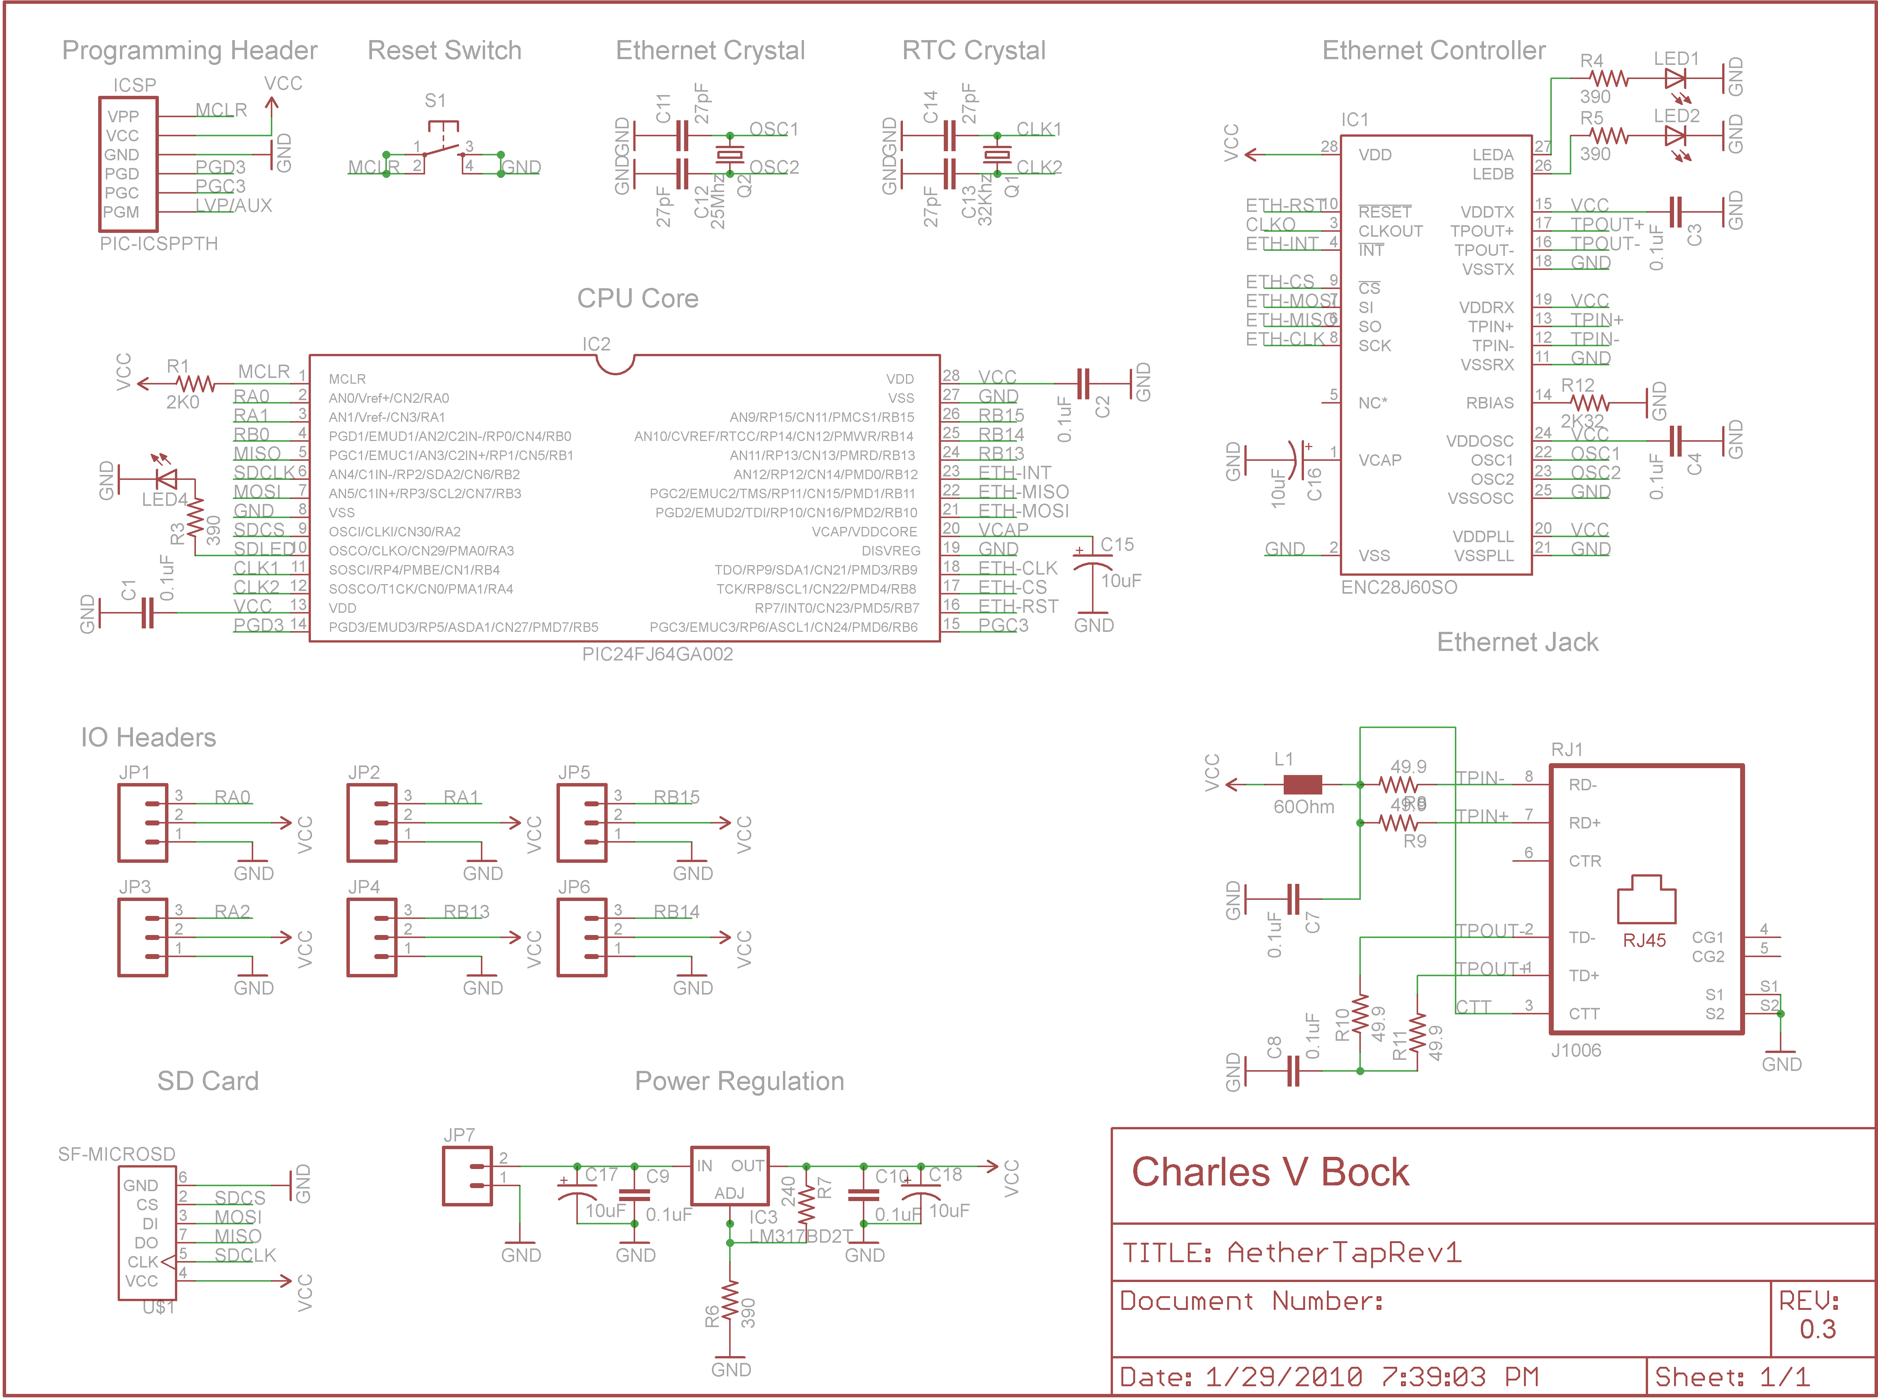
Figure 1. Aether Tap fully revised schematic layout, refer to BOM below for specific part numbers.

Bock 5
PCB Layout
After all logical connections are established the next design step is to place and route the individual components. In modern PCB fabrication facilities this is sometimes done completely by computer algorithms. For this project a significant portion of the placement and routing of components was done by hand to reduce the complexity of the layout and make the resulting board easier to produce. Components are commonly laid out as close to other connected components as possible. This reduces latency introduced by electrons traversing the relatively vast distances between components. After placement, interconnects must be routed between pins and all passive components. This process is not trivial and would require days or weeks of work to complete if done completely by hand. Luckily there are algorithms which are fairly good at this kind of NP problem. Using routing algorithms this kind of work can be reduced to minutes with after-refinements taking only a few hours. Its also interesting to notice that a ground plane is used on the back side of this board as well as alignment markers at each corner which will help with the PCB creation process in the next several stages of design.
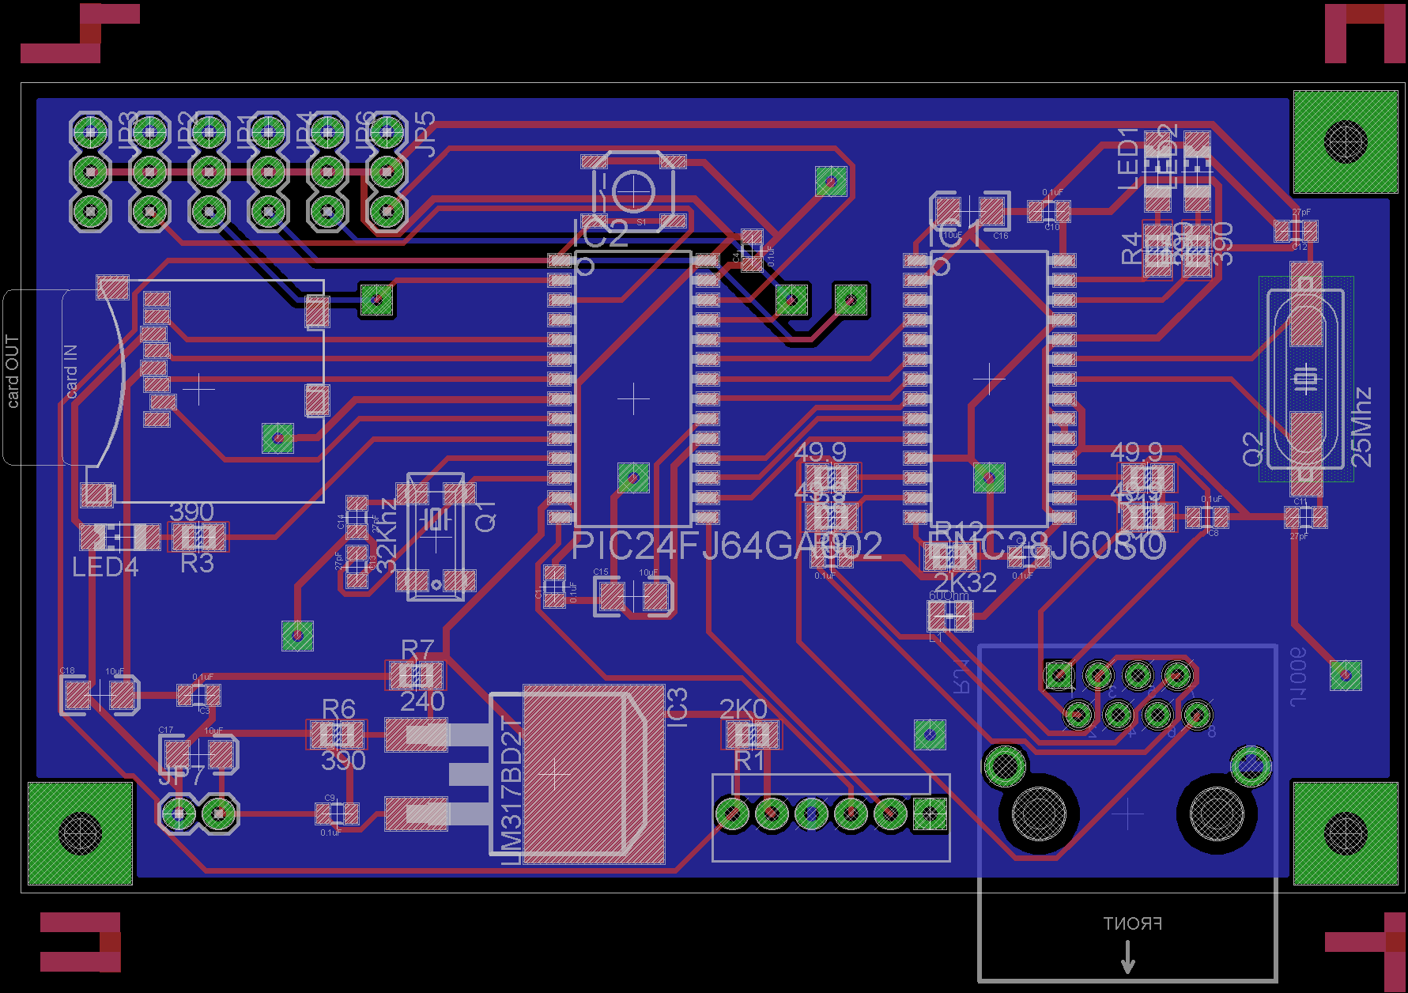
Figure 2. Aether Tap dual side PCB layout with alignment markers.
Bock 6
Toner Transfer PCB Creation
After finalizing the physical layout of the PCB it is time to etch the design into the copper clad substrate seen below in figure 3. To begin this process the etch-resist mask is printed out using a modern laser printer. A laser printer is preferable to an ink based printer because of the use of pulverized plastic which resists being eaten away by the acidic etchant. After the mask is prepared it is applied to the bare copper using significant amounts of heat and pressure. The heat and pressure cause the mask to bind to the copper, which then allows the paper backing to be removed without damaging or skewing the mask. See figure 4 for an example of copper clad with a toner etch-resist applied. Finally after the etch resist is applied the copper substrate is subjected to warm ferric chloride. This causes any unmasked copper to be removed, leaving behind only the initially desired traces. See figure 5 for an example of a fully etched board.
For a much more in depth look at this process see the guide which was created for this project at this web address http://www.phx2600.org/wiki/index.php/Toner_Transfer_PCB_creation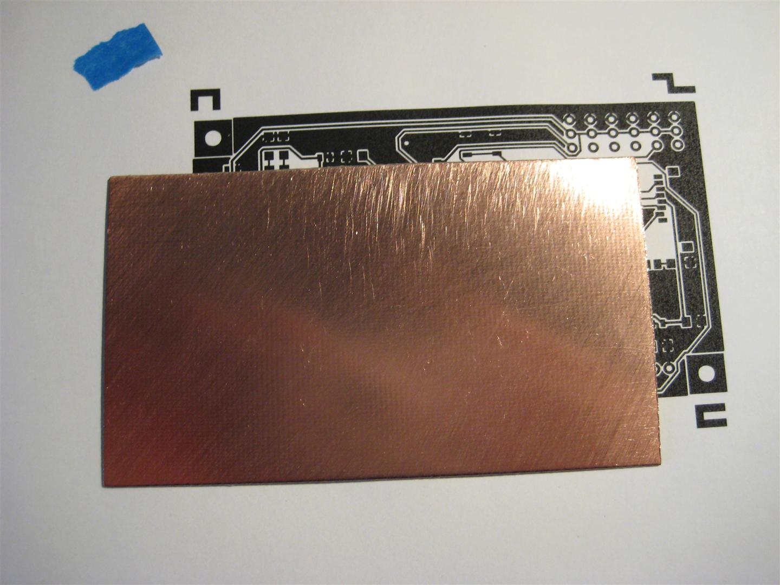
Figure 3. Bare copper clad seen in front of the top side toner mask.
Bock 7
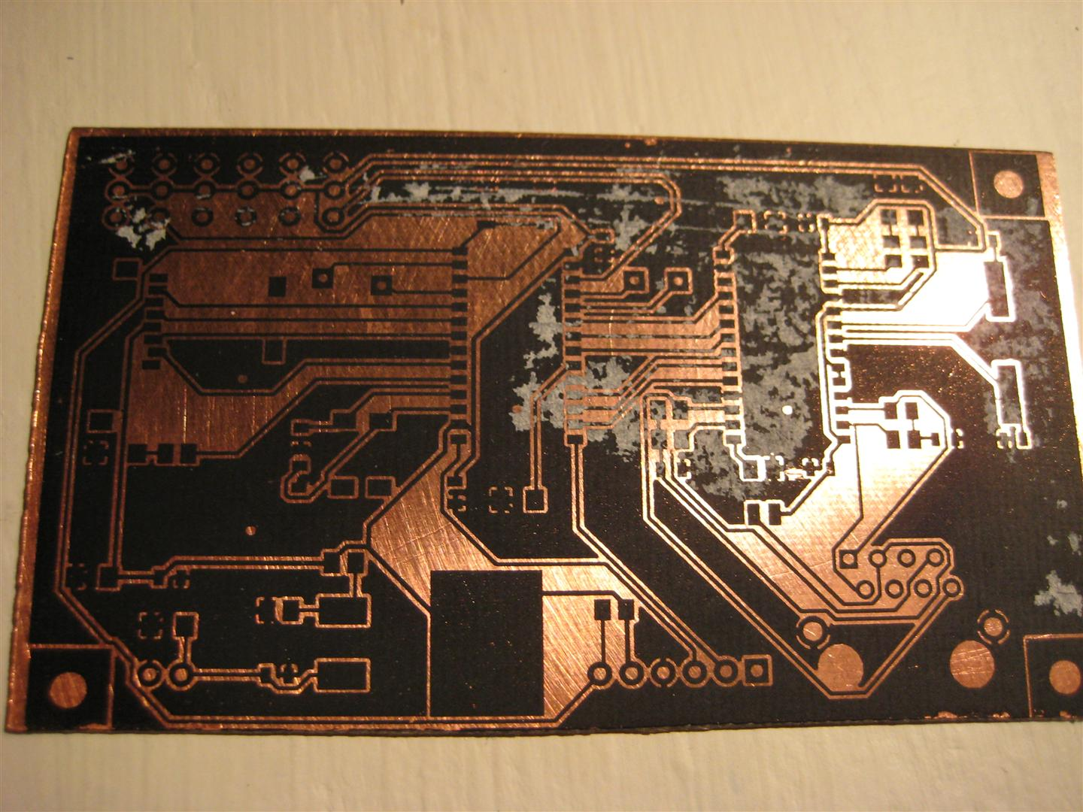
Figure 4. Copper clad after applying the toner mask.
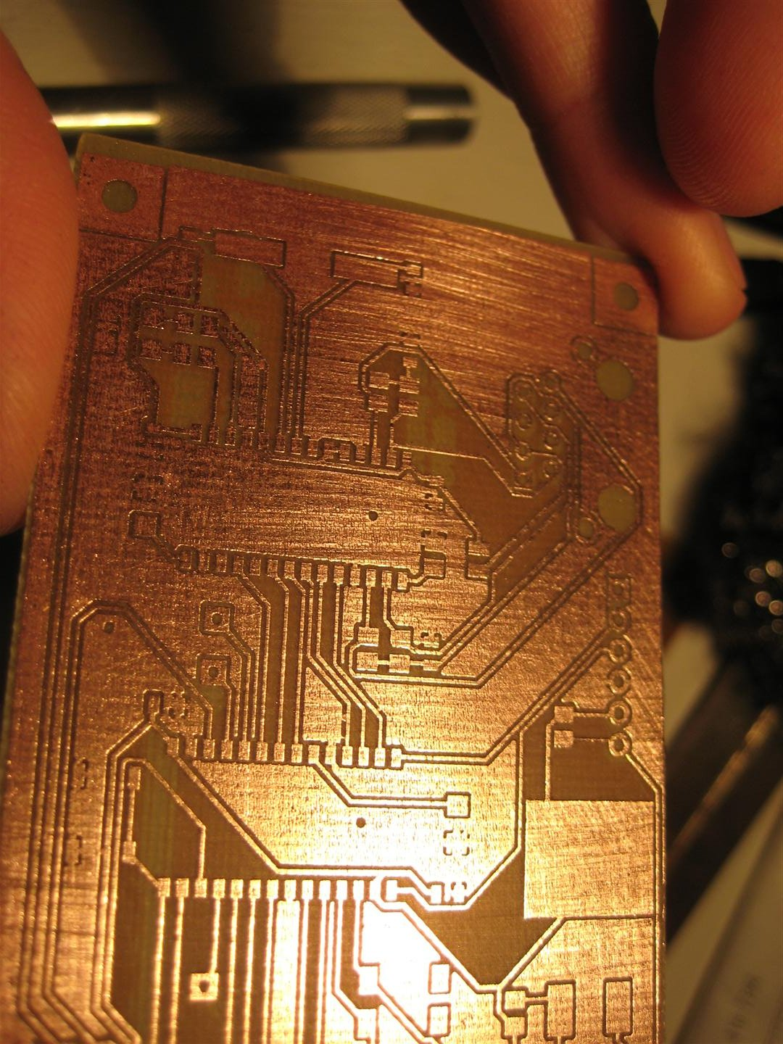
Figure 5. Completed Etched PCB after submersion in the etchant.
Bock 8
Toaster Oven Reflow
Most of the passive components for this project are 0805 surface mount devices measuring 2.0 mm × 1.25 mm. Anyone who has dealt with surface mount devices knows that they can be a real pain to solder, especially if you don’t have a variable temp iron with a small diameter tip, So for this project It was decided to forgo that mess and purchase a slightly used toaster oven from a second hand store, unfortunately it is missing a knob but besides that its in pretty good shape.
The basic process goes something like this:
- Tin all solder pads.
- Apply flux to the tinned pads.
- Stick the components where they go using tweezers / forceps using the flux as a sort of tacky glue.
- Heat the entire board until the solder “re-flows” and binds the components to the board.
- Immediately remove the board from the oven to prevent heat damage.
The key to toaster oven reflow is the temperature; basically you want to get to 180-190 Degrees Celsius without getting any higher than ~210 Degrees Celsius. At 180 Celsius most solder will begin to melt, by 190 it will all have become liquid, By 210 Many components will begin to burn, By 230 the entire board and copper substrate will begin to burn.
In figure 6 below you can see the toaster oven which was used. A multi-meter connected to a thermocouple device for monitoring the temperature was also employed to ensure that the temperature limit wasn’t exceeded.
Programming
Programming is achieved using a PIC-Kit 3 In circuit programmer and debugger with an ICSP (In-Circuit Serial Programming) Port located on the side of the device. See figure 7 below for an image of the programmer connected to the board.
Software
At this point much of the software for this project is undocumented and it will take significant effort to change that.

Bock 9
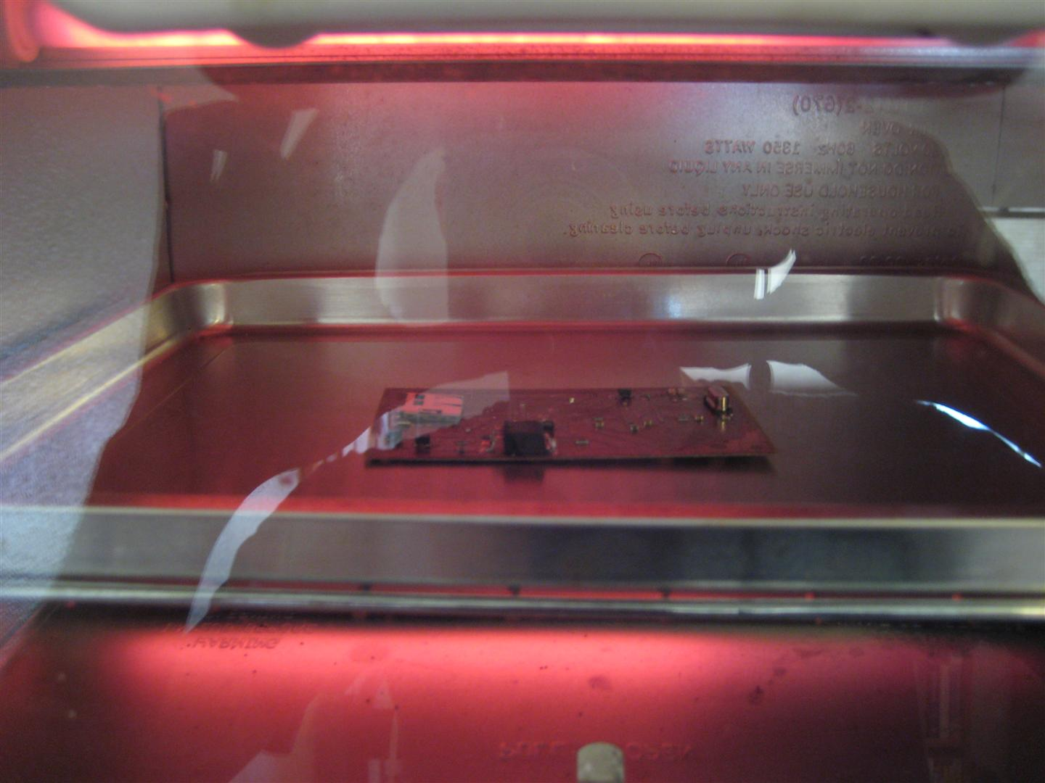
Figure 6. Reflow in progress
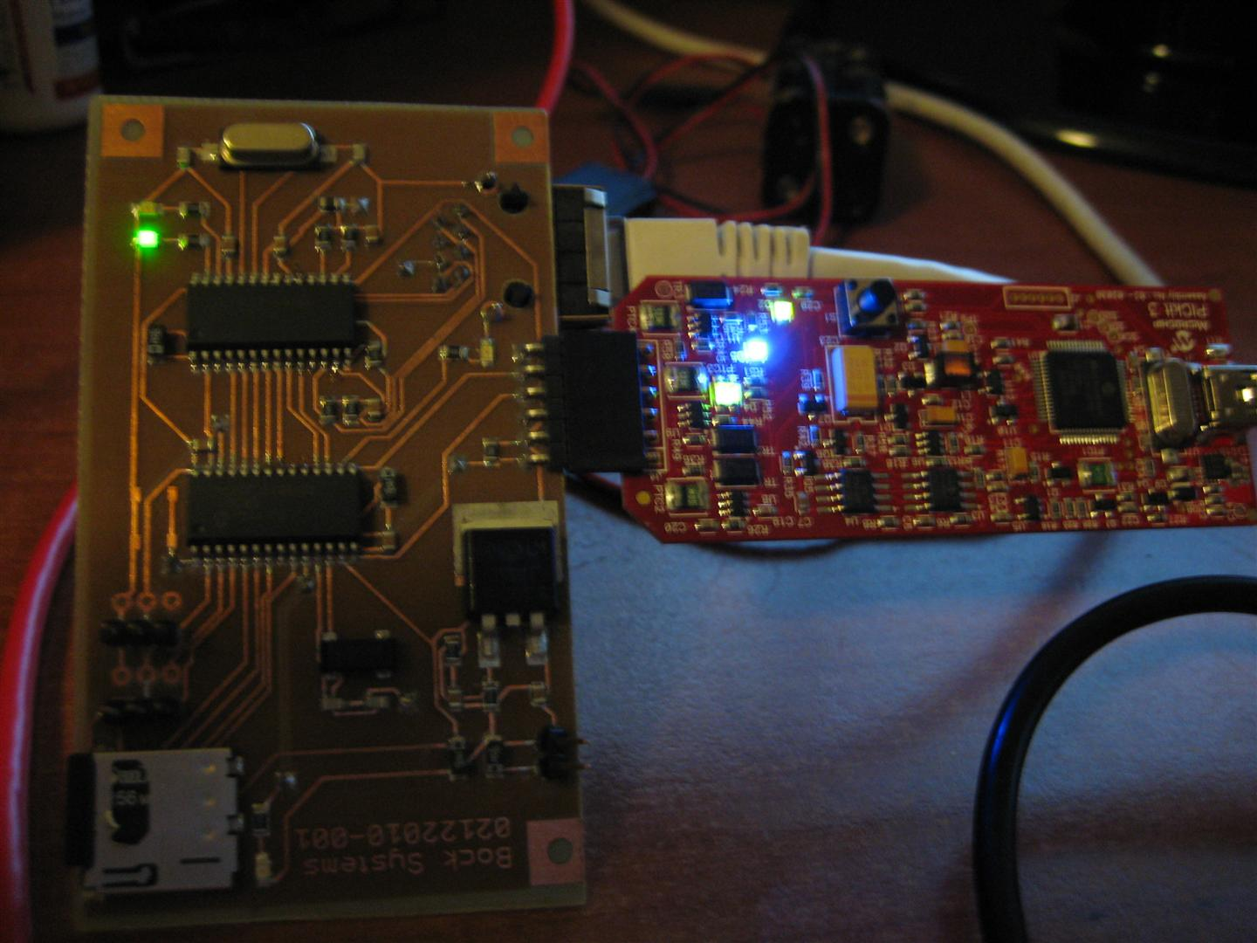
Figure 7. Final prototype attached to PICKIT3 and Ethernet for programming via ICSP Header.
Bock 10
Appendix A: Bill Of Materials
Part | Value | Package | Mouser Part #
C1-10 | 0.1uF | 805 | 80-C0805C104M5R
C11-14 | 27pF | 805 | 140-CC501N270J-RC
C15-18 | 10uF | 1206 | 74-293D106X96R3A2TE3
IC1 | ENC28J60 | SO28W | 579-ENC28J60-I/SO
IC2 | PIC24FJ64GA002 | SO28W | 579-PIC24FJ64GA002SO
IC3 | LM317D2TG | D2PACK | 863-LM317D2TG
ICSP | ICSP Header | 1X6 Pin Header | 538-22-28-8062
JP1-4 | IO Header | 1X3 Pin Header | 517-2314-6111TG
JP5 | Power Header | 1X2 Pin Header | 517-2314-6111TG
L1 | 60Ohm | 805 | 81-BLM21BB600SN1D
LED1-4 | Green | 805 | 645-598-8170-107F
Q1 | 32Khz | MM20SS | 695-CM200C-327KF-U
Q2 | 25Mhz | HC49UP | 815-ABLS-25-B2
R1-2 | 2K0 | 805 | 292-2.0K-RC
R3-7 | 390 | 805 | 71-CRCW0805-390
R8 | 240 | 805 | 71-CRCW0805-240
R9-12 | 49.9 | 805 | 71-CRCW0805-49.9
RJ1 | Ethernet Jack | RJ45 | 673-J1006F21
S1 | Push Button | SMD | On Hand
SD1 | SD Card Slot | MICROSD | 517-2908-05WB-MG

