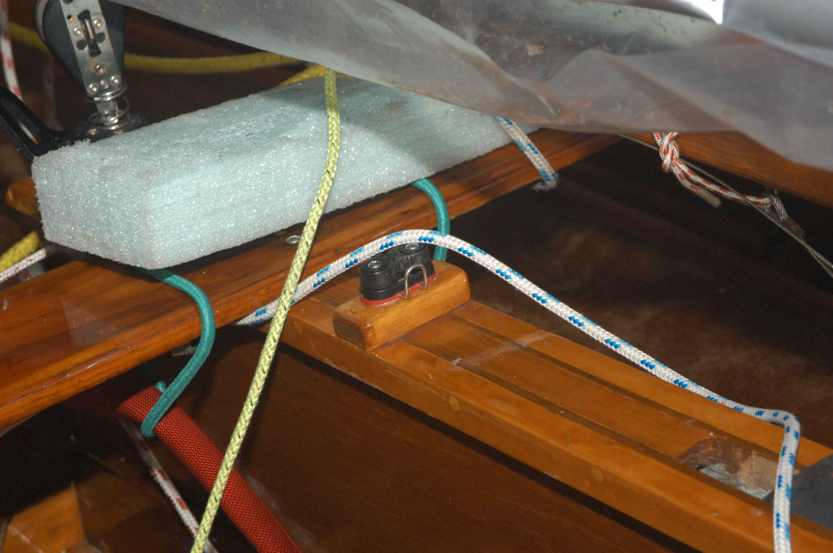
Centerboard cleat . This one is mounted on a wooden block. Note strips added to sides of centerboard trunk to stiffen trunk (and make a wider surface for fastening cleats).

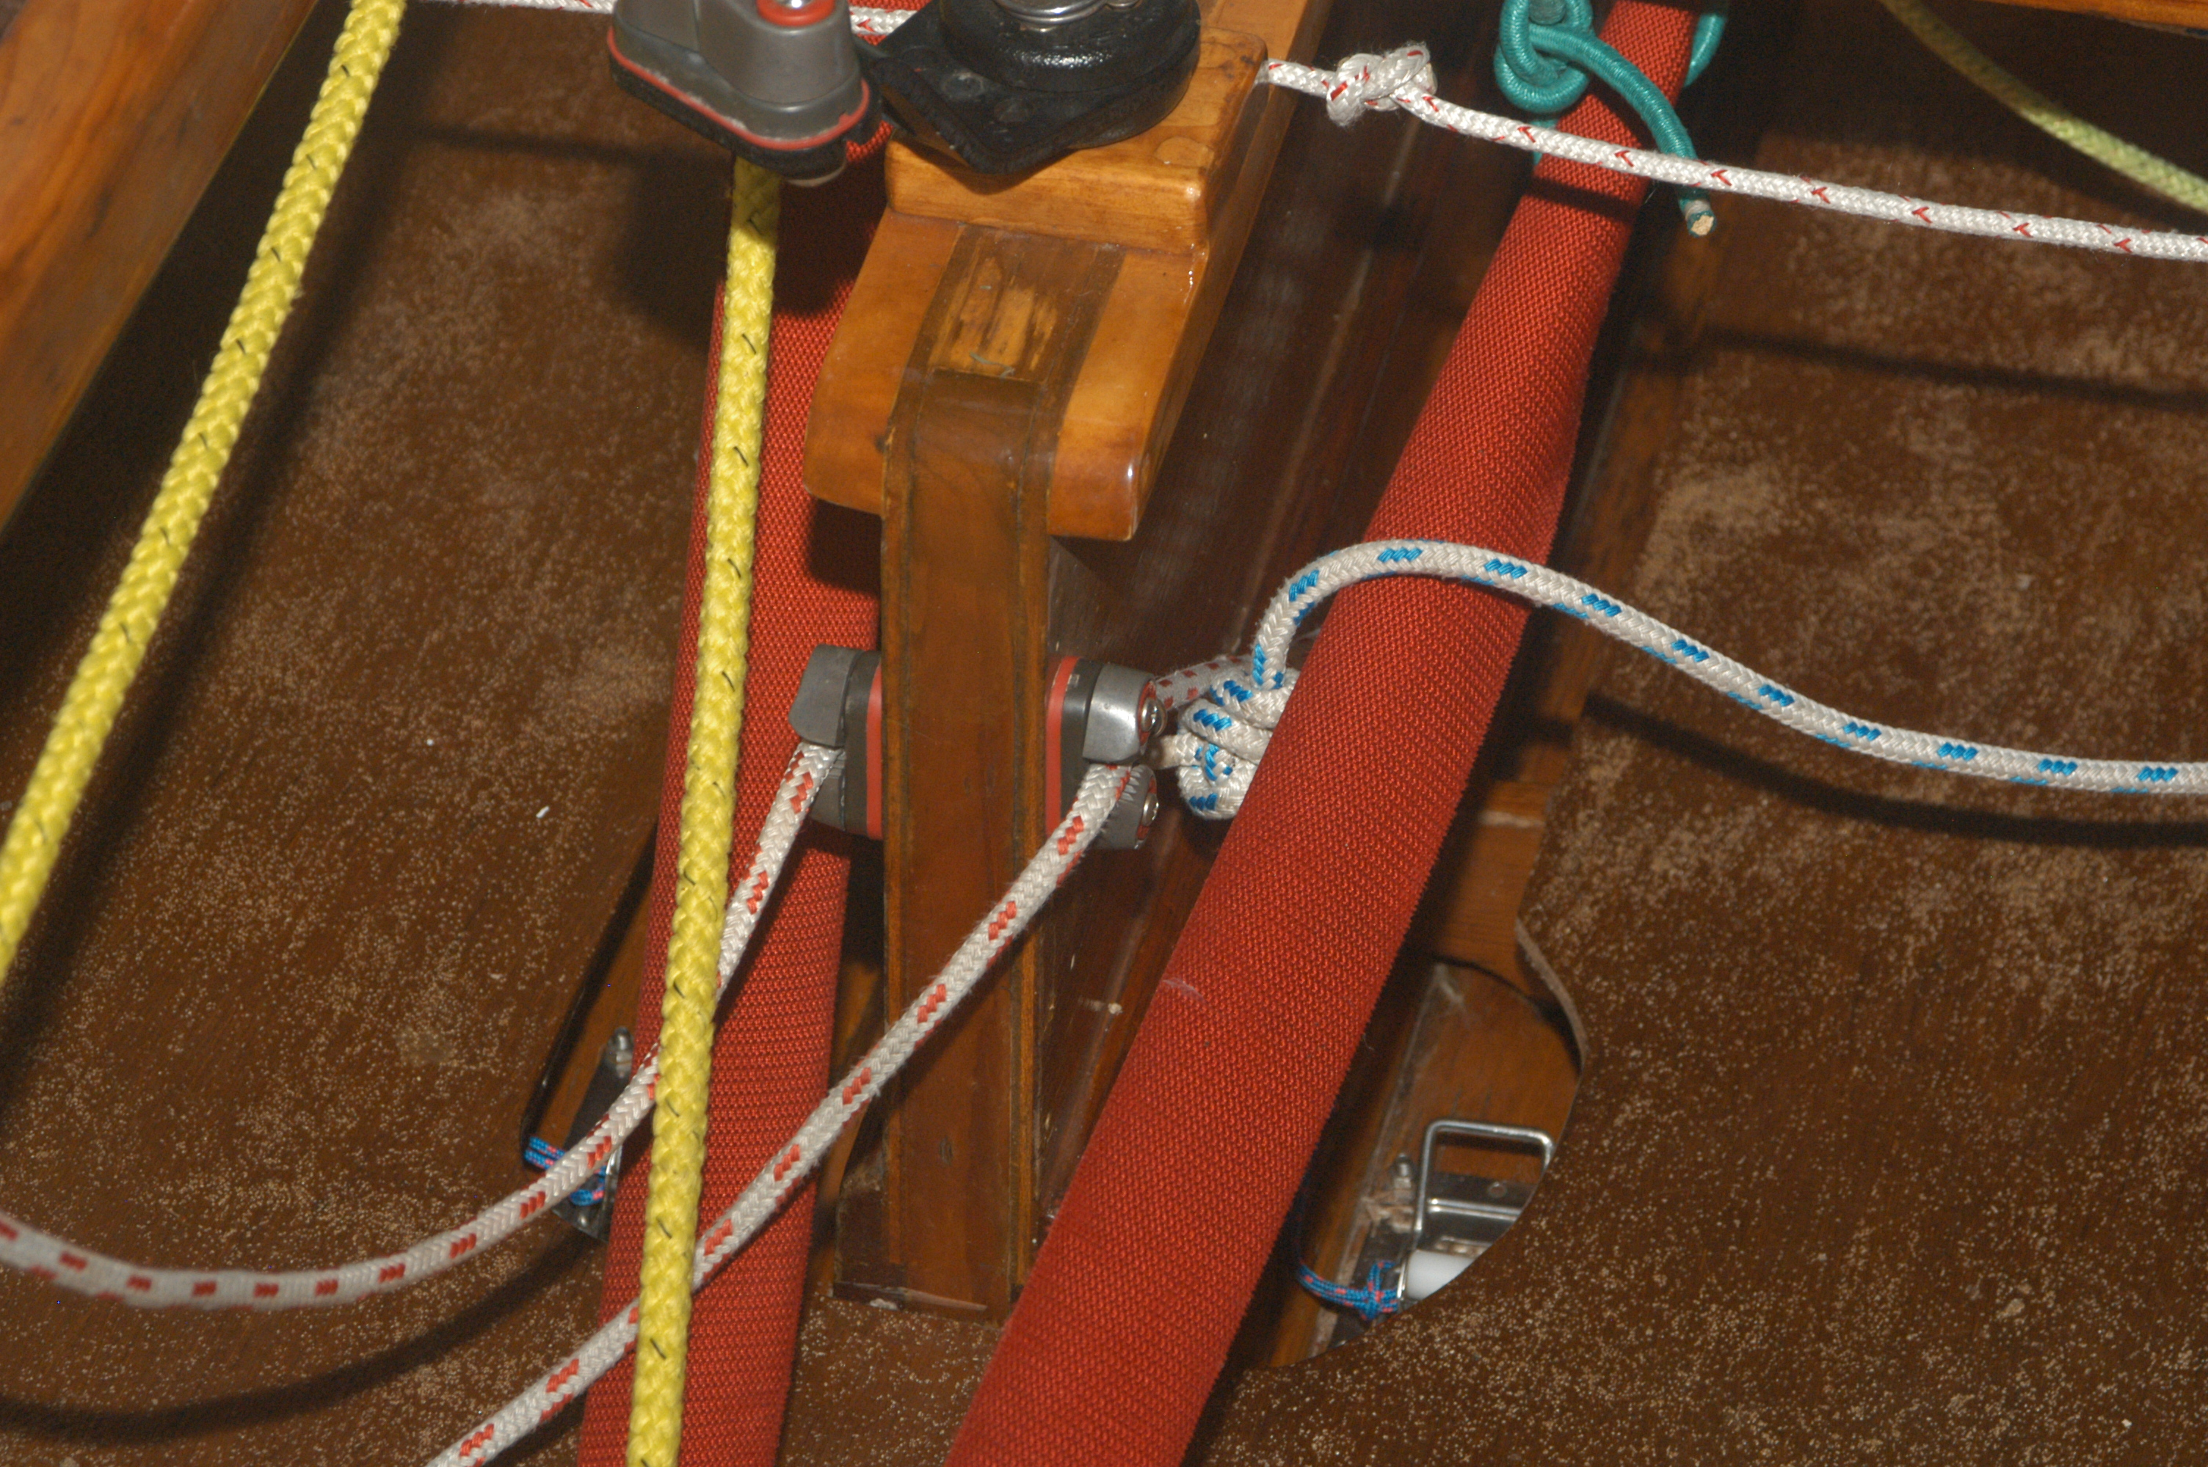

Cleats for Vang and Cunningham (downhaul) mounted at aft end of centerboard trunk
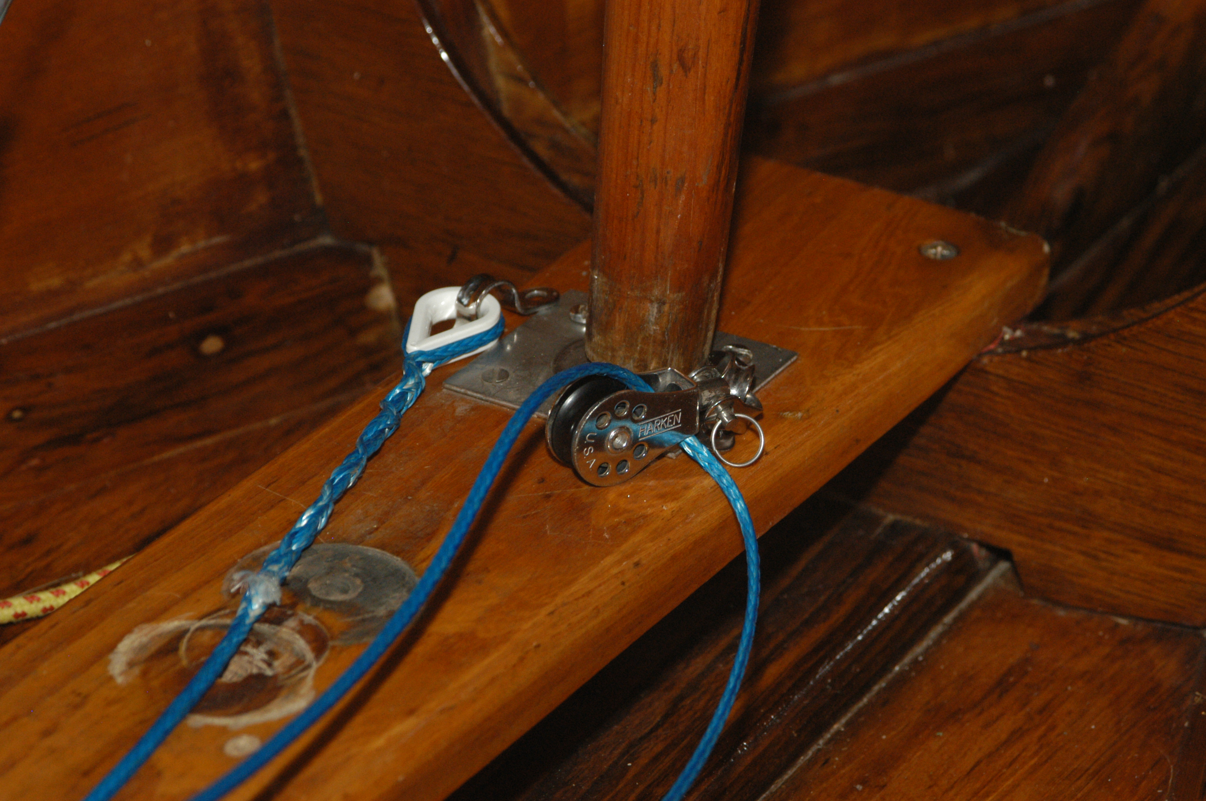

Boom vang. Eye strap on one side (thimble). Swivel block attached to other eye strap. Note, these should be as close to the center of the mast (in the fore and aft direction) as possible. Some people use a tang under the foot of the mast (if the mast has a pin in the base).
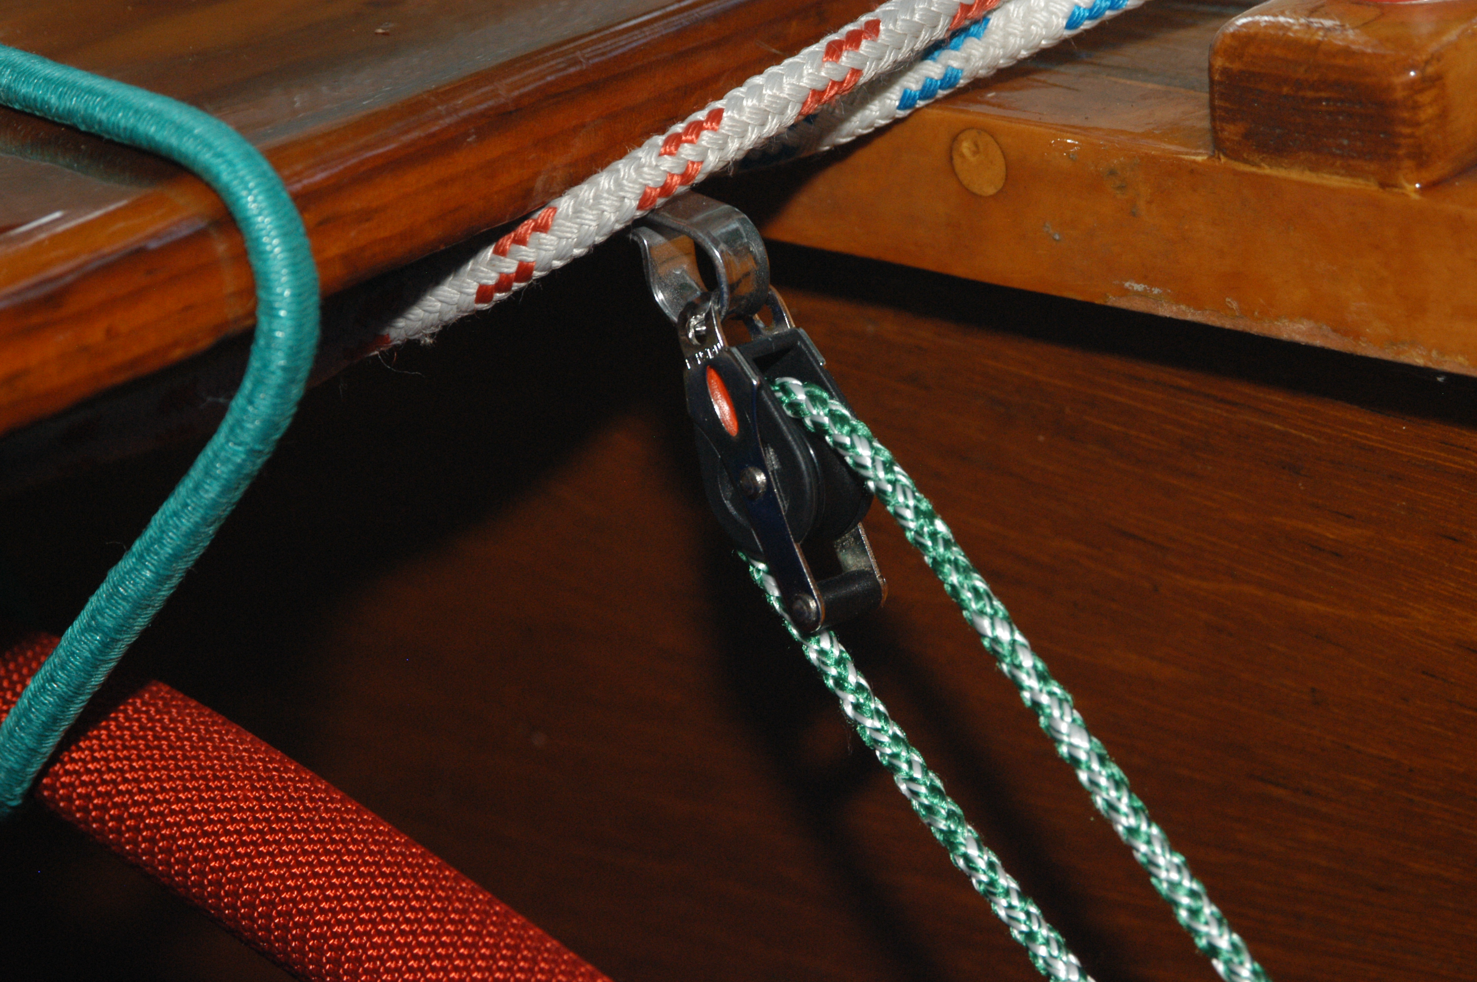

Boom vang – the eye strap is mounted on the underside of the thwart. Cleat for green line will be at the aft end of the centerboard trunk.

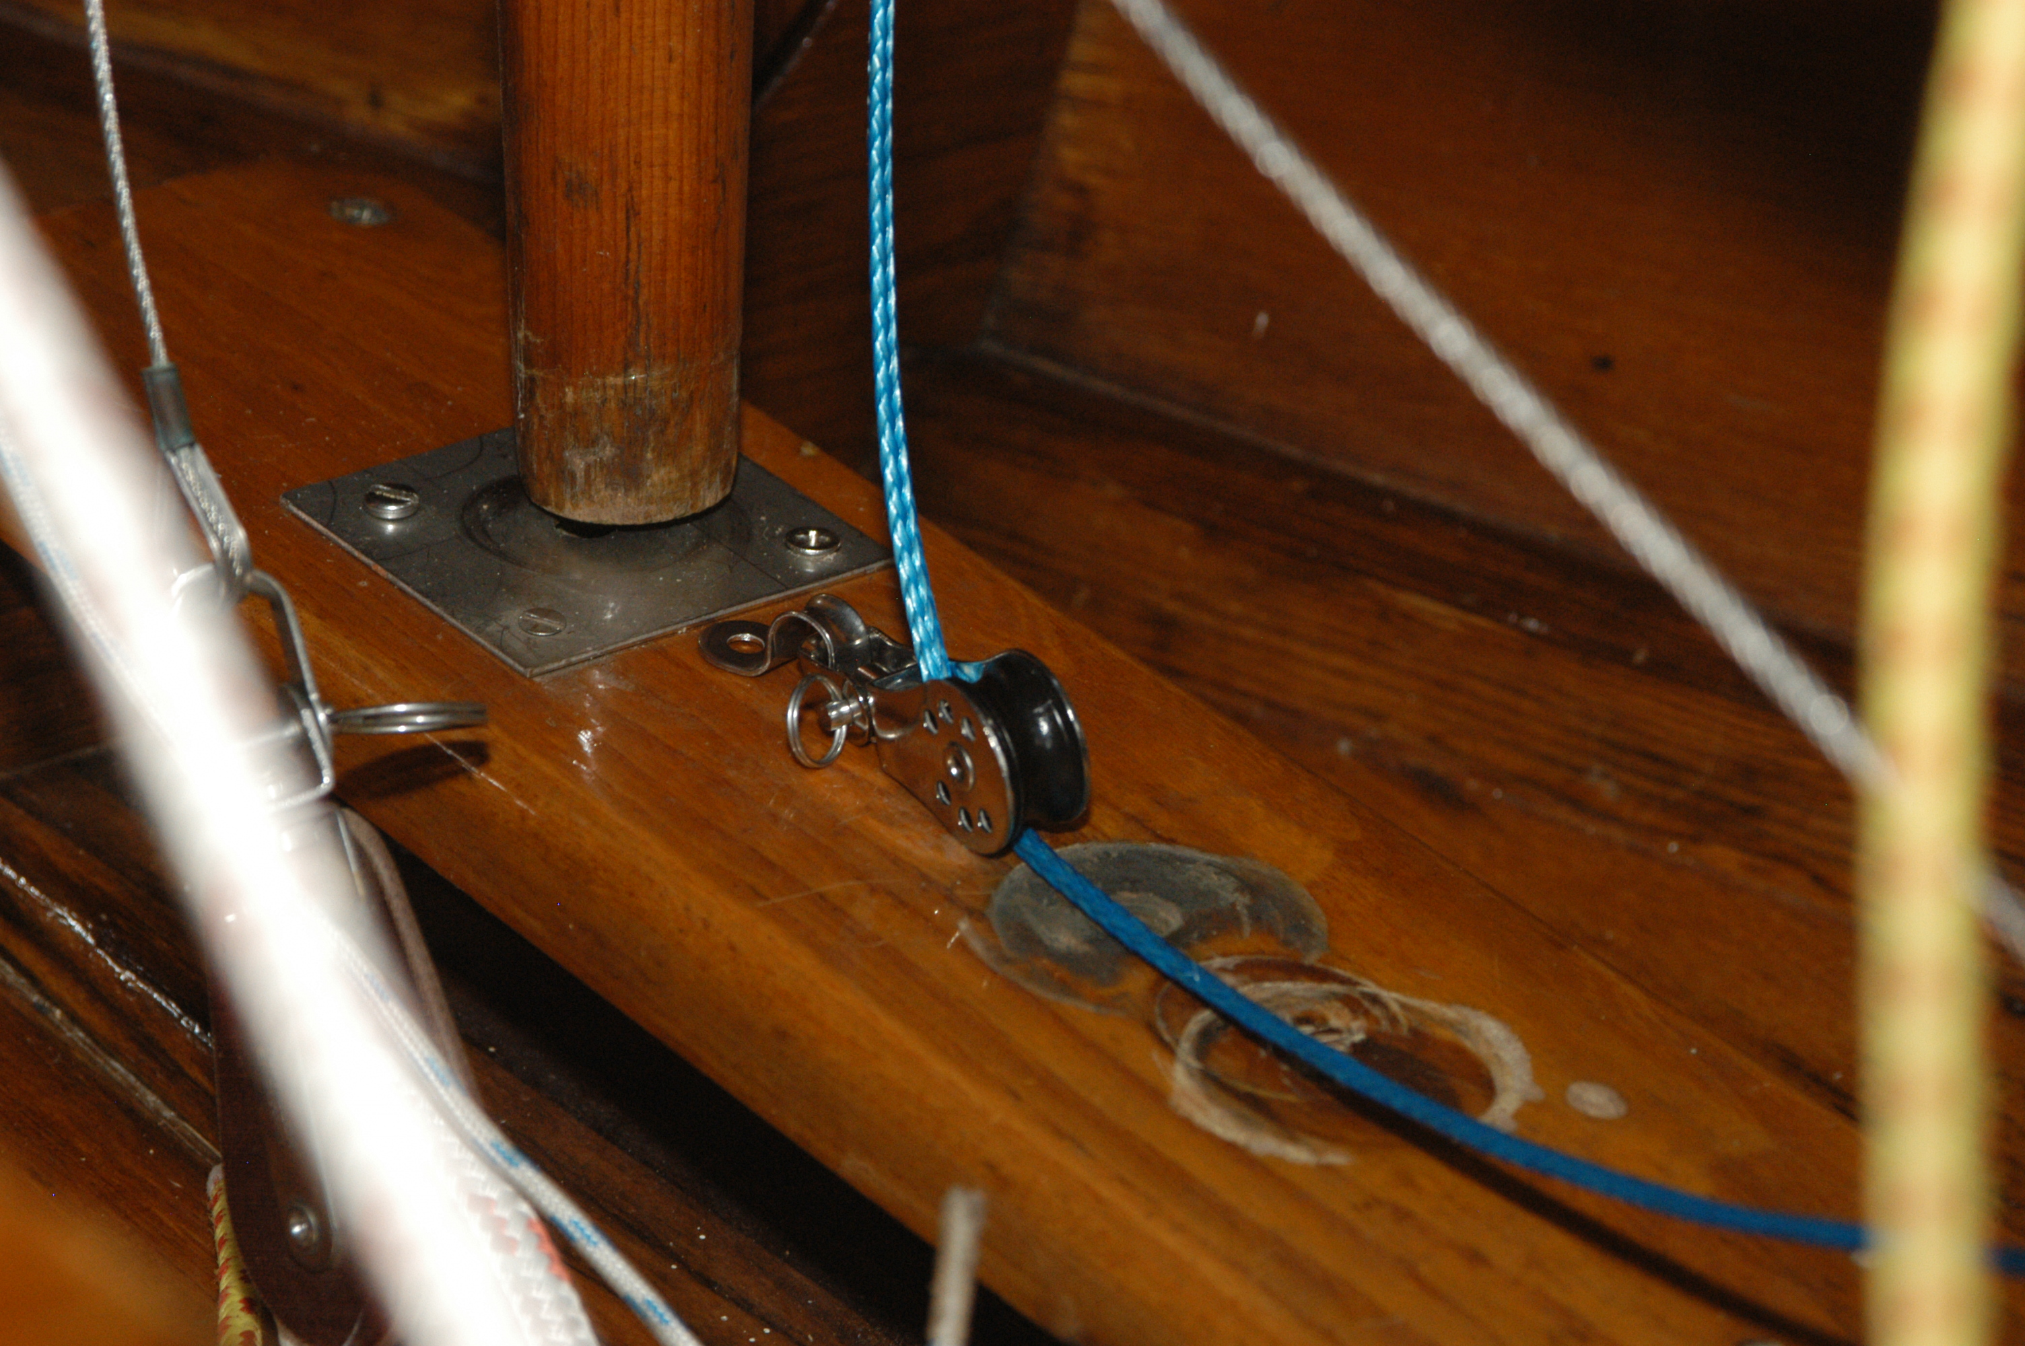

Cunningham. Eyestrap mounted directly behind mast. (Boom vang – not shown here – will be on the sides, foreward of the eyestrap for the Cunningham, but shouldn’t interfere

