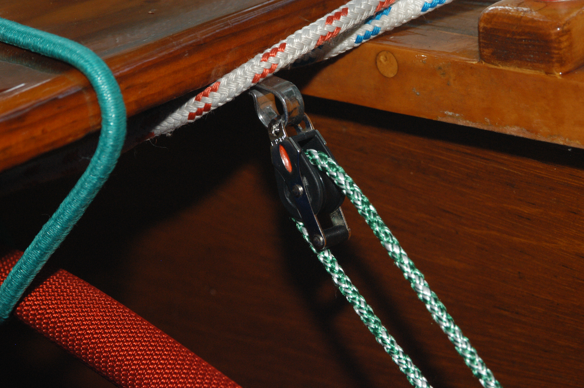

Boom vang – the eye strap is mounted on the underside of the thwart. Cleat for green line will be at the aft end of the centerboard trunk.

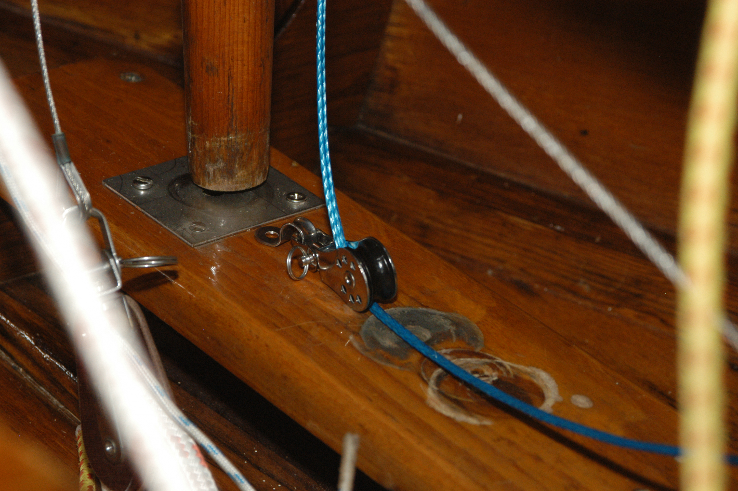

Cunningham. Eyestrap mounted directly behind mast. (Boom vang – not shown here – will be on the sides, foreward of the eyestrap for the Cunningham, but shouldn’t interfere

