Wayne (Sandy) Rapp
June 1, 1945 – September 18, 2024
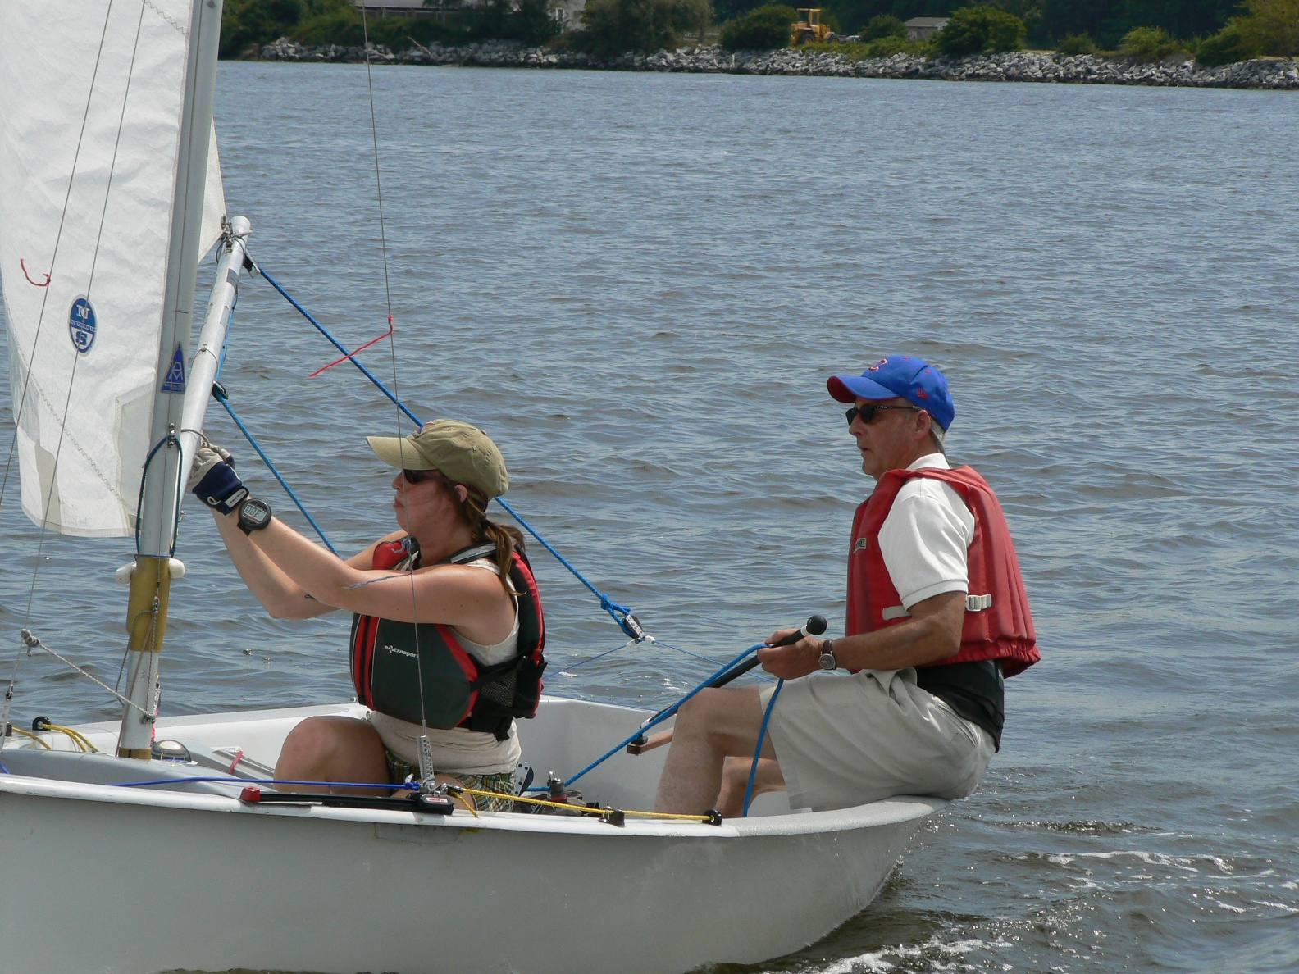
It is with profound sadness that we report the passing of Sandy Rapp. Sandy was Penguin International Champion in 1968, 1993, and 1998. He placed second in 1983, 1989, and 2012, and at other championships was always near the top of the fleet. Sandy was more than a successful sailor, giving back to the Class in numerous ways as well as mentoring sailors, young and old. Born in Evanston, IL, he grew up in Medina, MN and Racine, WI. Professionally, with a Masters in business administration, he started with Quaker Oats but quickly moved to become a small business owner, first running a ski and bicycle shop, and later a number of auto service businesses. Although pictured above sailing at the Internationals at Corsica River with crew Margaret Bodnovich in 2014, he sailed many regattas with his wife Marilyn. He was instrumental in getting the Innovator Penguin launched in the US, helping form the Rockhopper Syndicate which underwrote much of the development cost. He also was active in the Thistle class, placing 4th at the Nationals in 1979 and 1981. He also campaigned in the 470, Vanguard 15, and Sunfish classes.
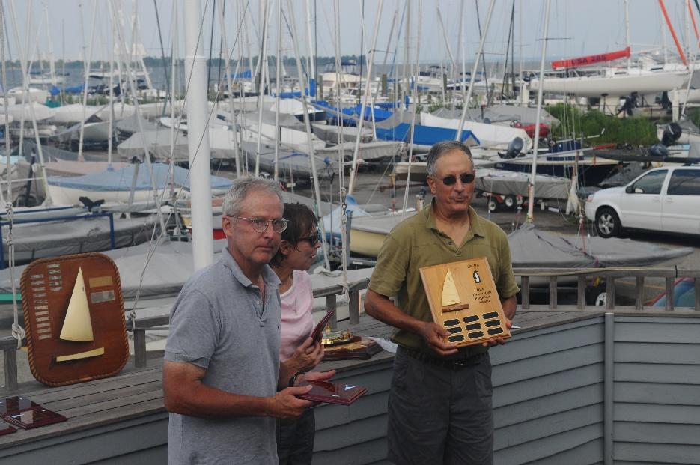
Paul Hull presenting Sandy and Marilyn the Dick Tennerstedt Grandmaster’s trophy at the 2011 Internationals.

