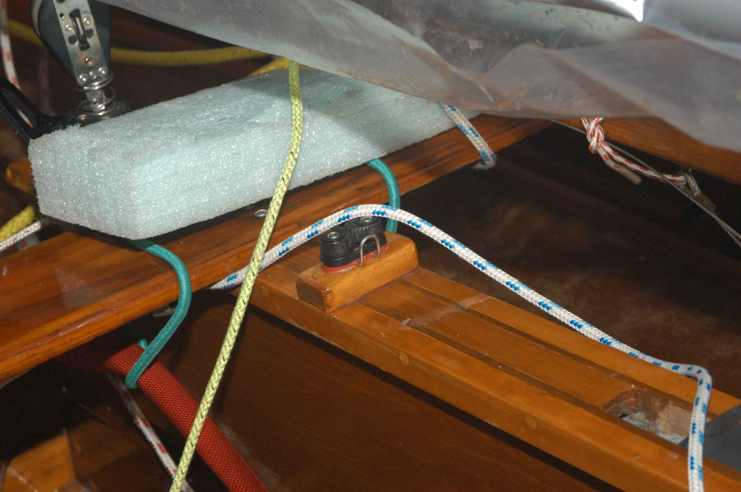
Centerboard cleat . This one is mounted on a wooden block. Note strips added to sides of centerboard trunk to stiffen trunk (and make a wider surface for fastening cleats).

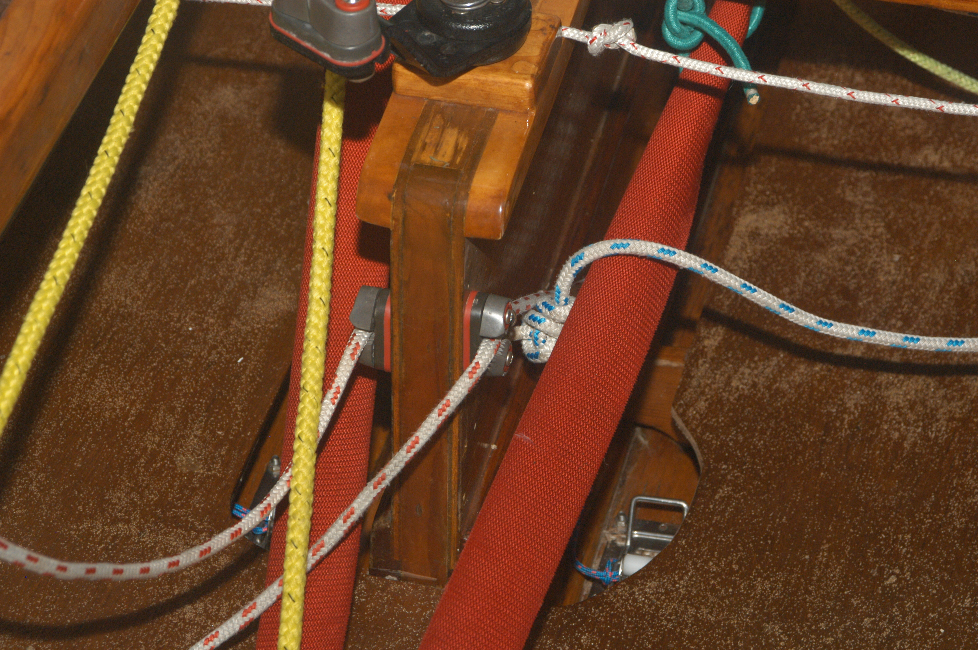

Cleats for Vang and Cunningham (downhaul) mounted at aft end of centerboard trunk
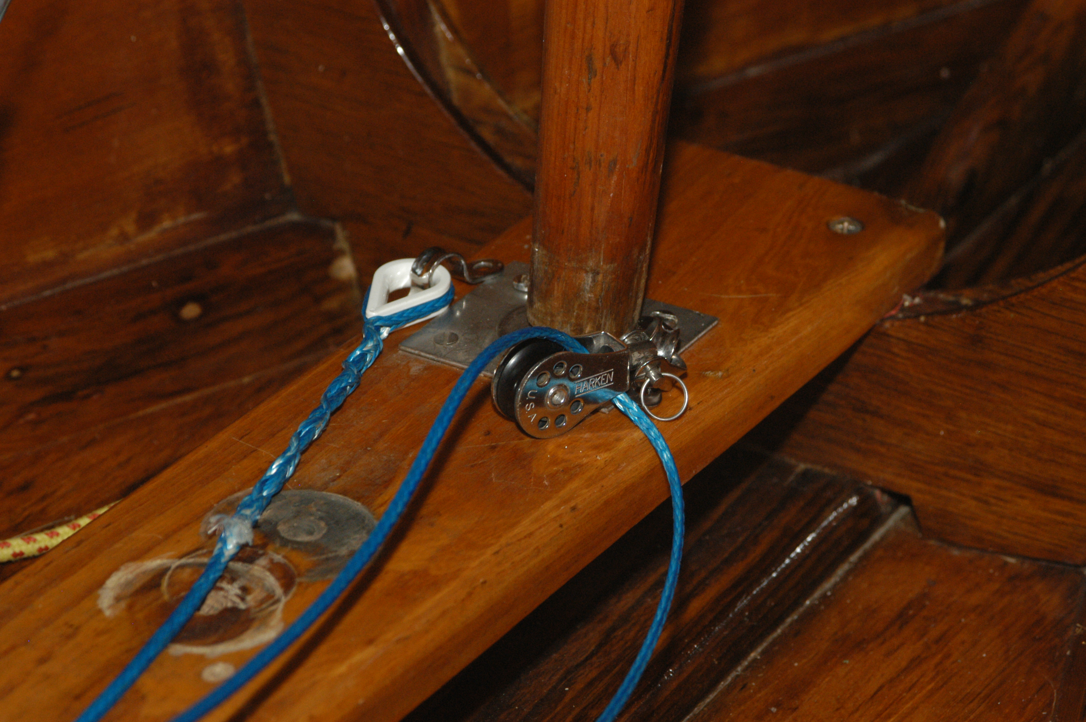

Boom vang. Eye strap on one side (thimble). Swivel block attached to other eye strap. Note, these should be as close to the center of the mast (in the fore and aft direction) as possible. Some people use a tang under the foot of the mast (if the mast has a pin in the base).

