8/20/2023

This documentation entry came way later than the actual project completion, but I wanted to highlight the primary struggle I’ve experienced in developing this mechanic up to this point. There are four major aspects to the Blink mechanic in Arkane’s Dishonored that I want to replicate, which I will list in decreasing difficulty:

* The distance travelled is affected by the direction the player aims the teleport. This means that if the player is looking straight up, the overall distance travelled will not be as high as if the player were looking straight ahead.
* There is an automatic clamber mechanic when the player aims the teleport to a ledge, or slightly below the ledge.
* There is a brief dilation of time starting from the initial triggering of the teleport and ending a couple seconds after the teleport is complete.
* Visual aspects include changing the camera’s perspective, and adding a vfx indicator of where the player will end up.

As of writing this, the first objective has been achieved. Below is an image showing the process of calculating the desired distance determinations I posted to the project’s Discord server.

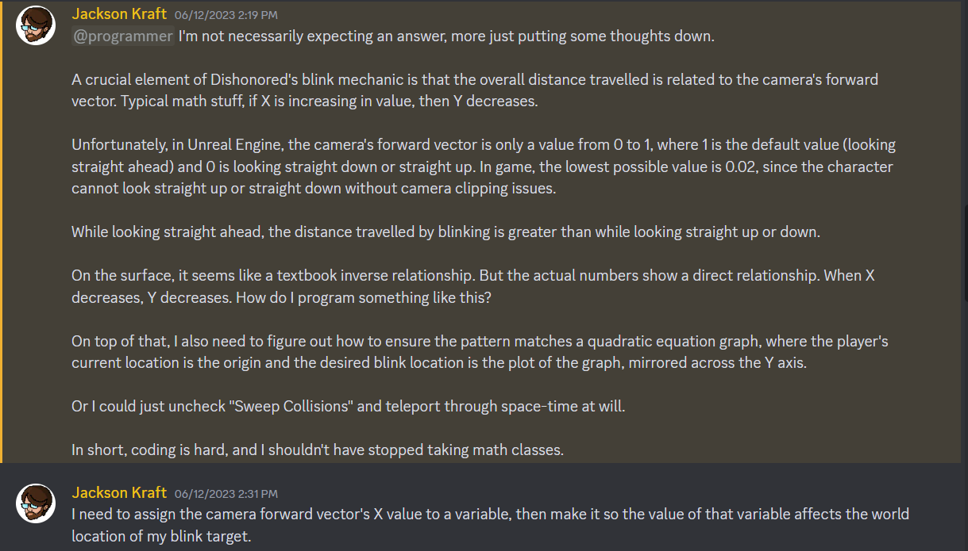

After talking through this process with myself, I figured out that I was emphasizing the wrong variable. I should have been considering the Z axis due to Unreal Engine’s placements of the X, Y, and Z axes. This resulted in a (thankfully) non-quadratic solution to the issue.

8/21/2023

Brief mention: Summer 2023 course load greatly impacted my ability to work on the project in a negative way in the short term. In the long term, however, I feel much more confident in my understanding of programming concepts. Delaying Practicum III completion by a semester also has thrown my initial planning for a loop.

11/30/2023

Did some minor retouching of the mechanics. I learned that the distance calculations weren’t behaving as expected once initial calculations were made. Essentially, if you aimed straight up (the shortest possible distance travelled), that distance would be set to the default distance for every subsequent activation. I implemented an automatic reset to full distance upon reactivation of the ability.

2/24/2024

I replaced the constant Niagara system effect within the FP_Character with the ability for the character to spawn in the effect when the press the key associated with power activation. I’m hoping this leads to a less-intensive and less confusing result. It’s location does need to be constantly updated, which I have not done yet.

3/26/2024

**I wanted to discuss something that I would have done differently while I was thinking about it. The main issue preventing my version of blink from being the same/similar as Dishonored’s blink is the clamber system. My solution is a band-aid that sometimes likes to fall off. Were I to implement the functionality differently, I would have a different event within the player character specifically handling ledge clambering. If the player blinks at an edge, I would have it automatically call this event. While a trigger volume may still be necessary, this solution would be leagues better than artificially increasing the step height of the player.**