**Business Requirements Document**

**“HomeView” - Uniting streaming services on one site**

September 25, 2021

**Unite**

Christian Lam (017662032)

Daniel Monge (018191106)

Eric Truong (018149311) (Team Leader)

Erina Lara (018182630)

Michael Lamera (018487727)

## **Introduction**

#### **1.1 Purpose**

Salesman Software is designed for Windows 7 Operating System and above. The user is expected to be the owner of a small electronics store and requires only a password to access the program. Salesman Software is intended to monitor and aid in various functions regarding invoices, warehouses, inventory, and sales.

**1.2 Document Conventions**

Each requirement statement has its own priority.

#### **1.3 Intended Audience and Reading Suggestions**

This document is intended for developers and the owner of the company. The rest of the document contains specifications on the development of Salesman Software.

Reading Sequence:

Developers: Start at Section 2 and read all sections in order.

User: Start at Section 2 then skip Section 3 and go straight to Section 4.

#### **1.4 Product Scope**

#### Salesman Software is a desktop program intended to be used to manage a company. The main point of this application is to aid in managing products, product inventory, warehouses, invoices, and salespeople of a company.

#### **1.5 References**

[Proposal - Unite - 09/25/21 - v.1.0](https://docs.google.com/document/u/0/d/1kCcbzwiDLFnN1WNk4xtEuz4D2xOi-mMNxiVkZdcn7DU/edit)

## **Overall Description**

#### **2.1 Product Perspective**

#### This application is a new independent product that operates on the Windows Operating System. All of the features will be implemented and developed by Team Java Avengers.

#### **2.2 Product Functions**

#### The major functions of this application includes:

* Restocking products
* Viewing products
* Adding new models and warehouses
* Hiring and dismissing salespeople
* Viewing invoices
* Managing sales and commissions

#### **2.3 Operating Environment**

#### The software requires a computer running Windows 7 Operating System and above with at least 1GB RAM and 100MB of storage. And java runtime environment.

#### **2.4 Design and Implementation Constraints**

#### The design and content must follow professional standards.

#### **2.5 User Documentation**

#### There will be a tutorial presented when the application is first used, and at any point when the user opens the tutorial.

#### **2.6 Assumptions and Dependencies**

#### The Windows Operating system is assumed to be functional and stable.

## **External Interface Requirements**

**3.1 User Interface**

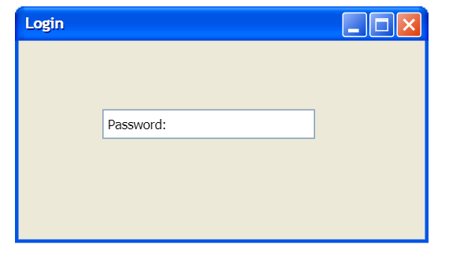 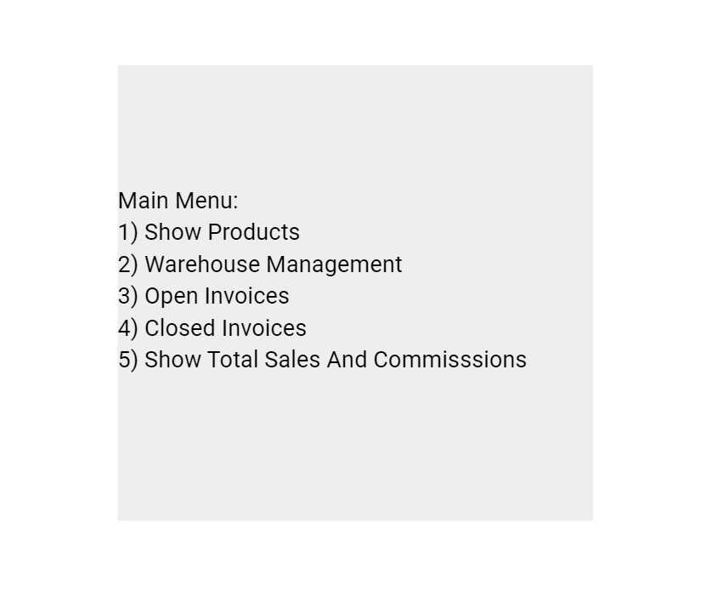

#### **3.2 Hardware Interfaces**

#### Computers that are able to run Java Runtime Environment 12.0+ will be used to execute the Salesman Software Application.

#### **3.3 Software Interfaces**

#### All interfaces used are created with the java programming language. DATABASE will be used to store and retrieve data regarding inventory, sales, salesman, and invoices.

#### **3.4 Communication Interfaces**

#### All data will be formatted then presented to the user via monitor, data is retrieved from the database hosted on the user’s computer.

## **System Features**

* Password Entry
* Main Menu
  + Show Products
    - Add new Model
    - Add more warehouses
    - Add inventory items to a warehouse
  + View Low Inventory
  + View Quantity
  + Show Open Invoices
    - Choose Delivery
    - Choose Pickup
    - Delivery Cost
  + Show Closed Invoices
  + View Total Sales/Commissions
    - Add salesperson
    - Remove salesperson
    - Change commission rates

#### **4.1 Use Case 1**

| Use Case 1 | Start Application |
| --- | --- |
| Actors | User/Owner of company |
| Pre-Conditions | Knowledge of password |
| Flow of Control | * User fills out password field * User clicks submit   + System validates the entered password |
| Post Conditions | System displays menu options  User logs into system |
| Error-Condition | Password is incorrect |
| Non-Functional Requirements | Data should be processed and updated within 5 seconds. |

#### 

#### **4.2 Use Case 2**

| Use Case 2 | Show Products |
| --- | --- |
| Actors | User/Owner of company |
| Pre-Conditions | User must be logged in |
| Flow of Control | * User selects “Show Products”   + System shows products, prices, quantities, sales, costs, and profits of all warehouses * User enters a certain product to display |
| Post Conditions | System displays product |
| Error-Condition | NONE |
| Non-Functional Requirements | Selected display should be processed within 5 seconds |

#### 

#### **4.3 Use Case 3**

| Use Case 3 | Add new warehouse |
| --- | --- |
| Actors | User/Owner of company |
| Pre-Conditions | User must be logged in  User must be in “Warehouse management” |
| Flow of Control | * User selects “Add new warehouse” * User enters name, street address, city, state, zip code, and phone number of warehouse |
| Post Conditions | Warehouse gets added to database  Returns user to “Warehouse management” display |
| Error-Condition | User tries to make a warehouse that already exists at the same address, with the same name, city, state, zip code, and phone number |
| Non-Functional Requirements | Selected display should be processed within 5 seconds |

#### **4.4 Use Case 4**

| Use Case 4 | Show Low Inventory |
| --- | --- |
| Actors | User/Owner of company |
| Pre-Conditions | User must be logged in  User must be in “Show Products” |
| Flow of Control | * User selects “Show Low Inventory” * User selects a certain warehouse to show which product that is 5 or fewer in quantity. |
| Post Conditions | System displays products with 5 or fewer quantity in specified warehouse |
| Error-Condition | NONE |
| Non-Functional Requirements | Selected display should be processed within 5 seconds |

#### **4.5 Use Case 5**

| Use Case 5 | Show Quantities of each warehouse |
| --- | --- |
| Actors | User/Owner of company |
| Pre-Conditions | User must be logged in  User must be in “Warehouse Management” |
| Flow of Control | * User selects “Show Quantities of each Warehouse” * User enters which warehouse to view quantity of hand for each product |
| Post Conditions | System displays selected warehouse and its quantity of hand for each product |
| Error-Condition | NONE |
| Non-Functional Requirements | Selected display should be processed within 5 seconds |

#### **4.6 Use Case 6**

| Use Case 6 | Add new model |
| --- | --- |
| Actors | User/Owner of company |
| Pre-Conditions | User must be logged in  User must be in “Show Products” |
| Flow of Control | * User enters model name |
| Post Conditions | Database updates with new model.  Returns user to the “Show Products” display. |
| Error-Condition | Model already exists in the database |
| Non-Functional Requirements | Information should be processed within 5 seconds |

#### 

#### **4.7 Use Case 7**

| Use Case 7 | Add inventory items to a warehouse |
| --- | --- |
| Actors | User/Owner of company |
| Pre-Conditions | User must be logged in  User must be in “Warehouse management” |
| Flow of Control | * User inputs inventory items to be added to a warehouse * User inputs quantity of items |
| Post Conditions | Database is updated with new items and its quantity to a warehouse  Returns user to “Warehouse Management” display |
| Error-Condition | User inputs negative quantity  User inputs an item that doesn’t exist |
| Non-Functional Requirements | Selected display should be processed within 5 seconds |

#### **4.8 Use Case 8**

| Use Case 8 | Show Open Invoices |
| --- | --- |
| Actors | User/Owner of company |
| Pre-Conditions | User must be logged in |
| Flow of Control | * User selects “Open Invoices” |
| Post Conditions | System shows all unpaid invoices |
| Error-Condition | NONE |
| Non-Functional Requirements | Selected display should be processed within 5 seconds |

#### 

#### **4.9 Use Case 9**

| Use Case 9 | Show closed invoices |
| --- | --- |
| Actors | User/Owner of company |
| Pre-Conditions | User must be logged in |
| Flow of Control | * User selects “Closed Invoices” |
| Post Conditions | System displays all closed invoices |
| Error-Condition | NONE |
| Non-Functional Requirements | Selected display should be processed within 5 seconds |

#### 

#### **4.10 Use Case 10**

| Use Case 10 | Show total sales and commissions |
| --- | --- |
| Actors | User/Owner of company |
| Pre-Conditions | User must be logged in  User must be in main menu |
| Flow of Control | * User selects “Show total sales and commissions” |
| Post Conditions | System displays total amount of sales and total commission earned for each salesperson |
| Error-Condition | NONE |
| Non-Functional Requirements | Selected display should be processed within 5 seconds |

#### 

#### **4.11 Use Case 11**

| Use Case 11 | Change commission rates |
| --- | --- |
| Actors | User/Owner of company |
| Pre-Conditions | User must be logged in  User must be in “Show total sales and commissions” |
| Flow of Control | * User selects “Change commission rates” * User enters the desired commission rate |
| Post Conditions | Commission rate is changed for all salespeople  Returns user to “Show total sales and commissions” display |
| Error-Condition | User enters negative commission rate |
| Non-Functional Requirements | Change should be processed within 5 seconds |

#### 

#### **4.12 Use Case 12**

| Use Case 12 | Add new salesperson |
| --- | --- |
| Actors | User/Owner of company |
| Pre-Conditions | User must be logged in  User must be in “Show total sales and commissions” |
| Flow of Control | * User selects “Add new salesperson” * User enters the new salesperson’s information (i.e. name, email, phone number) |
| Post Conditions | Database is updated with new salesperson  Returns user to “Show total sales and commissions” display |
| Error-Condition | Duplicate salesperson (exactly same information) |
| Non-Functional Requirements | Selected display should be processed within 5 seconds |

#### 

#### **4.13 Use Case 13**

| Use Case 13 | Remove salesperson |
| --- | --- |
| Actors | User/Owner of company |
| Pre-Conditions | User must be logged in  User must be in “Show total sales and commissions” option from main menu |
| Flow of Control | * User selects “Remove salesperson”   + System shows a list of salespeople * User selects a salesperson to be removed |
| Post Conditions | Database removes specified salesperson  Returns user to “Show total sales and commissions” display |
| Error-Condition | NONE |
| Non-Functional Requirements | Selected display should be processed within 5 seconds |

#### **4.14 Use Case 14**

| Use Case 14 | Chooses Pickup |
| --- | --- |
| Actors | User/Owner of company |
| Pre-Conditions | User must be logged in  User must be in “Open invoices” |
| Flow of Control | * User marks open invoice as pickup |
| Post Conditions | Database updates open invoice as pickup  Returns user to “Open Invoices” display |
| Error-Condition | NONE |
| Non-Functional Requirements | Selected display should be processed within 5 seconds |

#### 

#### **4.15 Use Case 15**

| Use Case 15 | Chooses Delivery |
| --- | --- |
| Actors | User/Owner of company |
| Pre-Conditions | User must be logged in  User must be in “Open invoices” |
| Flow of Control | * User marks order as delivery |
| Post Conditions | Database updates invoice to be delivered and adds delivery charges to invoice  Returns user to “Open invoices” display |
| Error-Condition | NONE |
| Non-Functional Requirements | Selected display should be processed within 5 seconds |

#### 

#### **4.16 Use Case 16**

| Use Case 16 | Enter delivery cost |
| --- | --- |
| Actors | User/Owner of company |
| Pre-Conditions | User must be logged in  User must be in “Open invoices” |
| Flow of Control | * User enters the delivery cost of an invoice |
| Post Conditions | Invoice is updated with the delivery cost  Returns user to “Open Invoices” display |
| Error-Condition | User enters a negative amount |
| Non-Functional Requirements | Selected display should be processed within 5 seconds |

## **Nonfunctional Requirements**

All of the instructions and database updates should process within 5 seconds.

## **Other Requirements**

All materials here are copyrighted by Unite and may not be redistributed or resold without permission.