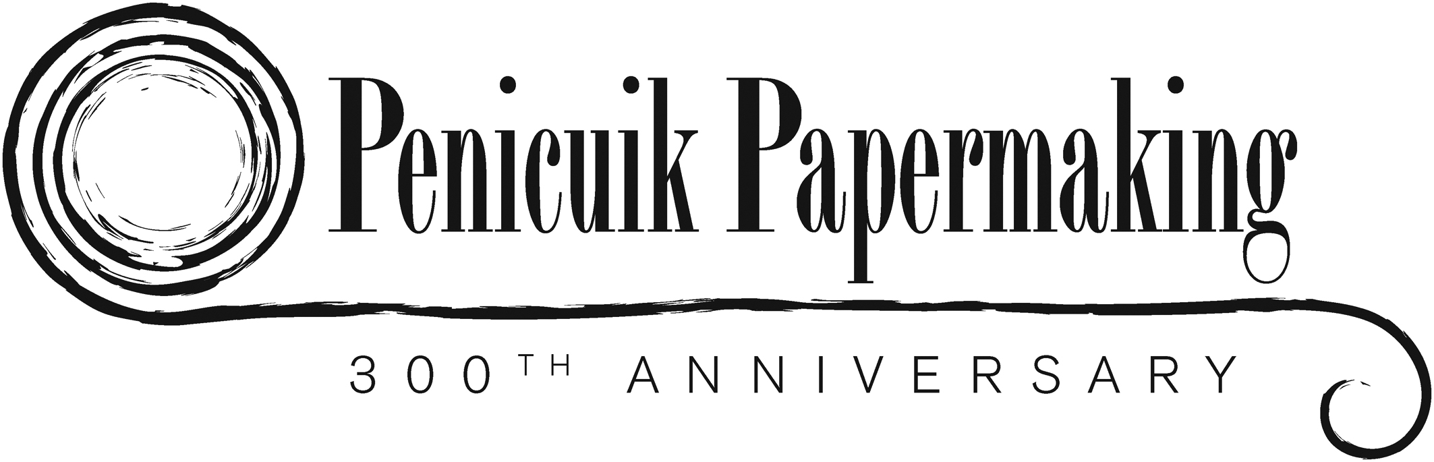

300 years of Papermaking in Penicuik

Welcome to our Exhibition about papermaking, its history and how it affected the town and its people.

The first part of the Exhibition tells about some other “visitors” to the mills in Penicuik.

Write down four facts that you found interesting about this part of the Exhibition.

PAPERMAKING IN PENICUIK

1. List the 4 main raw materials used in papermaking starting with the earliest.
(1)
(2)
(3)
(4)

2. What did they use to power the machinery in early papermaking?

3. What was needed to produce 1 ton of paper and how was the finished product transported?

4. What was the name of the new beating machine and who developed the paper machine and when?

5. What improvements appeared in the 19th century?

6. What problem did esparto grass produce?
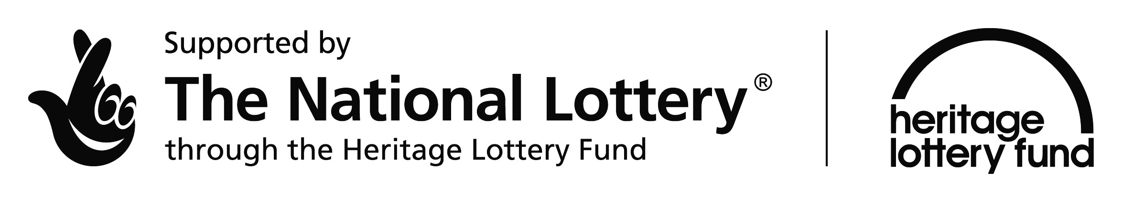

7. List the 7 stages paper went through to supply printers with correct sized paper.
(1) (5)
(2) (6)
(3) (7)
(4)

This involved workers. What happens now?

8. Name the 3 other kinds of industries involved in paper production.

9. Look at the “Fires” board. What happened on Friday 8th April 1938?

What went on during this that would not be allowed today?

10. What kind of paper did Eskmills make in 1832?

11. Name the clever inventions patented by James Brown.

12. What were the 2 sources of water for Dalmore and what were they used for?

13. What kinds of paper did Dalmore make?

14. Why was Auchendinny Mill called the “Brunt Mill”?

15. The mills provided opportunities for sport and recreation. What kinds of activities were available?

16. How old is Penicuik Cricket Club and against which team did they play their first recorded match?

17. What made Valleyfield School different from your school?

18. What happened in 1872?

19. Who was the first Cowan at Valleyfield?

20. How many generations of Cowans were at Valleyfield and who was the last one?

21. How many Laidlaws emigrated and how many of them continued in the paper industry in their new homes?

When you go back to school see if you can make your own Family Tree beginning with yourself. Are there any paper mill workers on it?

22. Why were Friendly Societies important?

23.Look at the Coronation Chair. Find the brass plaque and write down what is written there.

24. What symbols can you see on the chair?

25. Why are the bird and the clasped hands there?

26. When did the Cowan Institute open and what kinds of activities took place there?

27. This advertisement appeared in an Edinburgh newspaper. What does it tell you about Esk Mills?

28. Who had Valleyfield built in 1709?

29. Bank Mill was bought in 1803. What kind of paper did it make?

30. What happened in 1861 which pleased papermakers?

31. What improvements were made at Valleyfield especially in 1898?

