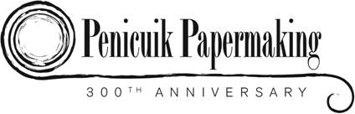

Penicuik and Auchendinny

Local place names: a glossary

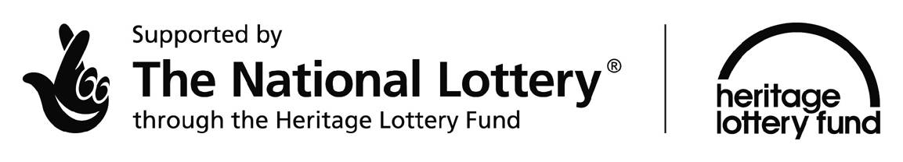

Name | Location
B
Braes, the | Slopes on the right bank of the River North Esk.
Brosie Pond | Another name for the Mill Pond at Dalmore Mill.
C
Carrot Haugh | An area down river from Dalmore Mill know named because of the red sandstone.
Castle Brae | On Pomathorn Road at Uttershill Castle.
Concretes, The | Tenement housing in Bridge Street, between ‘the Nunnery’ and Valleyfield Road, owned by Cowan’s and occupied by mill workers.
Cowan Institute | Now known as ‘The Town Hall’ in High Street, Penicuik. Opened in 1894 ‘the Institute’ as it was known locally was a gift from the Cowan family to the people of Penicuik. It provided facilities such as a library, reading room, billiard room, a hall to accommodate six hundred people and soon became a focal point in the social life of the town. In 1960 the Institute was gifted to the Town Council for their use provided that recreational and hall use was still available to the public in accordance with modern conditions. After refurbishment the Institute re-opened as Penicuik Town Hall and became the meeting place of the Town Council. Today it houses Midlothian Council’s Sport and Leisure division and continues to be used for recreational and community activities.
Cowan’s Pend | The pend to the side of ‘The Old Crown Inn’, High Street, leading to Valleyfield House, residence of the Cowan family. The pend is laid with wooden cobbles so that guests in the Inn would not be disturbed by traffic going through at night.
Craw Wood | Wood at top of The Haugh, Auchendinny.
Crawley Burn | Glencorse Burn which ran through Dalmore Mill.
D
Delve, the; Delft Brae; Delf Brae | Short cut taken by Valleyfield workers, from the back of Cowan’s Pend down to the Mill gate.
Dublin Street | Top of Kirkhill, row of cottages where Esk Mill Reading Rooms were now part of Kirkhill Gardens.
F
Fieldsend | Tenements which lay between the Loan Burn and Carnethy Avenue, now the location of Kirklands and Watson Street. There was a row of shops on John Street known as Pryde's Place and Hamilton Place. A long street, Napier Street, ran parallel to the Loan Burn, it had more shops and housed the Band of Hope. There was also a lodging house.
Ferrier’s Foundry | Formerly the Penicuik Foundry, situated on the site in John Street now occupied by The Royal Bank of Scotland stretching to Dance Pointe Studio (formerly the Salvation Army Hall).
H
Harper’s Brae | Road leading down from Maybank on the B7026 to Esk Bridge.
Haugh, The | Ground behind Dalmore Mill.
I
Institute The | See: Cowan Institute.
Island, The | Now Telford Cottages. Piece of land at the confluence of the North Esk and the Black Burn, off Pomathorn Road and in the shadow of the Telford Bridge. Houses originally owned by Cowans and occupied by workers.
K
Kirkhill School | School originally run by the Miss Browns, of the James Brown and Co, Esk Mill located on the Kirkhill. Since then occupied by Esk Mill Recreation Rooms and YMCA Penicuik and now disused.
M
Mill Brae, Auchendinny | Brae Leading down from Auchendinny to Dalmore Mill.
Miners The | Shottstown Miners Social Club, John Street, Penicuik.
N
Nunnery, The | Name for Park End, a courtyard of houses in Bridge Street, designed by F.T. Pilkington for Cowan’s, used as a hostel for unmarried female workers.
O
Old Manse, Eskbridge | Latterly used as housing for Esk Mill workers.
P
Park End | See The Nunnery
Pentland View | On Kirkhill where St. Mungo’s View is now situated.
Q
Quarry Hole, The | Pond which was adjacent to the Crawley Burn.
R
Rooms The | Esk Mill Recreation Rooms, opened in 1926 in the former Kirkhill School buildings. Facilities included a large bowling green and two tennis courts.
S
Shop Raw, Eskbridge | Row of houses on right hand side of road between Esk Mill and Esk Bridge.
Shottstown | Miners' rows built by the Shotts Iron Company. Stood beside the Miners' Institute on the site of the present shops and Coronation Clock Tower.
Smiddy Brae | Short brae running between Croft Street and Bridge Street.
Southbank House, Eskbridge | House on Harper’s Brae, one time home of the McDougall family of Esk Mill.
Spring Pond | Pond at Dalmore Mill fed by a spring.
T
Tait’s Buildings | In John Street, tenements, built by Tait the builder and joiner on the site of the old Cavalry Barracks. They faced the North Kirk with Tait's yard behind.

Concise Scots Dictionary: a place dug out.

