REPORT ON STUDENT INDUSTRIAL WORK EXPERIENCE SCHEME (SIWES)
EXPERIENCES AND TECHNICAL PROJECT UNDERTAKEN AT
AKWA IBOM STATE INTERNAL REVENUE SERVICE (AKIRS)
REVENUE HOUSE, UYO, AKWA IBOM STATE
ON
BRIDGE: A FAULT-TOLERANT MULTI-SYSTEM GOSSIP
NETWORK AND ROUTING SYSTEM
BY
BEN, PENIEL SUNDAY
REG NO: 22/SC/CO/1181
DEPARTMENT OF COMPUTER SCIENCE
FACULTY OF COMPUTING
UNIVERSITY OF UYO, UYO, AKWA IBOM STATE
COURSE CODE: CSC 329
SUBMITTED TO:
DEPARTMENT OF COMPUTER SCIENCE
FACULTY OF COMPUTING
UNIVERSITY OF UYO, UYO, AKWA IBOM STATE
IN PARTIAL FULFILMENT OF THE REQUIREMENT FOR THE AWARD
OF A BACHELOR OF SCIENCE (B.SC) DEGREE IN COMPUTER SCIENCE
OCTOBER, 2026

Table of Content

Chapter One (1) 1
BRIEF HISTORY OF SIWES 1
1.0 INTRODUCTION 1
1.2 BRIEF HISTORY OF SIWES IN NIGERIA 2
1.3 VISION STATEMENT OF SIWES 3
1.4 MISSION STATEMENT OF SIWES 3
1.5 AIMS OF SIWES 3
1.6 OBJECTIVES OF SIWES 4
Chapter Two (2) 5
BRIEF HISTORY OF THE SIWES ORGANISATION (AKIRS) 5
2.0 INTRODUCTION 5
2.1 ABOUT AKIRS 5
2.2 HISTORICAL DEVELOPMENT AND LEGAL FRAMEWORK 6
2.3 ADMINISTRATIVE AND ORGANIZATIONAL STRUCTURE 6
2.3.1 Directorate of Information & Communication Technology (ICT) 7
2.3.2 Directorate of Tax Intelligence, Research & Enforcement 8
2.3.3 Assessment and Collection Directorates 8
2.4 MAJOR AKIRS OPERATIONAL PROJECTS & SYSTEMS 8
2.4.1 IbomTax Digital Automation Platform 9
2.4.2 Taxpayer Identification System (AISTIN) 9
2.4.3 Automated Data Cleaning, Deduplication & NUBAN Reconciliation Platform 10
2.4.4 Intelligence Reconnaissance & Automated Entity Scraper 10
2.4.5 AI-Powered Tax Knowledge Assistant & Support Bot 10
2.5 STATUTORY MANDATE 11
2.6 VISION STATEMENT 11
2.7 MISSION STATEMENT 11
2.8 CORE VALUES 11
Chapter Three (3) 13
EXPERIENCE GAINED AND WORK DONE AT AKIRS 13
3.0 INTRODUCTION TO THE WORKING ENVIRONMENT AND TECHNICAL UNITS 13
3.1 OVERVIEW OF TECHNICAL EXPERIENCES GAINED 13
3.2 TAXPAYER DATA CLEANING, NORMALIZATION AND DEDUPLICATION PIPELINE 14
3.2.1 Data Ingestion, Cleansing, and Schema Standardization 15
3.2.2 Central Bank of Nigeria (CBN) NUBAN Modulo Algorithm Implementation 16
3.2.3 Taxpayer Identity Resolution: Jaro-Winkler and Levenshtein Metrics 16
3.3 MICROSERVICES AND API ARCHITECTURE WITH FASTAPI 17
3.4 INTELLIGENT RECONNAISSANCE & WEB SCRAPING ENGINE 18
3.4.1 Asynchronous Browser Automation (Playwright) & Distributed Tasks 18
3.4.2 AI-Inference Keyword Expansion & Spatial Matrix Targeting 19
3.4.3 Multi-Registry Corporate Enrichment (CAC, OSM Nominatim, Maps) 19
3.5 AI-POWERED TAX KNOWLEDGE ASSISTANT: GUARDRAIL ENGINEERING 19
3.5.1 Semantic Guardrails and Query Boundary Enforcement 20
3.5.2 Hallucination Prevention & Prompt Hardening 20
3.5.3 Verification and Domain-Specific Policy Alignment 21
3.6 DATABASE MANAGEMENT, MIGRATION AND STATE SYNCHRONIZATION 21
3.7 ENTERPRISE SYSTEMS ADMINISTRATION, DATACENTER & VIRTUALIZATION 21
3.7.1 Datacenter VM Provisioning, Static Subnetting & Host Hardening 22
3.7.2 Containerization with Docker & Multi-Container Docker Compose 22
3.7.3 Reverse Proxy Architectures, Linux Server Hardening & Coolify 23
3.8 PROFESSIONAL ETHICS, DATA GOVERNANCE & INSTITUTIONAL REALITIES 23
3.8.1 Security Vetting, Confidentiality Undertakings & Clearances 23
3.8.2 Tiered Information Classification & Fiscal Record Fragility 23
3.8.3 Realities of Working in a Statutory Government Institution 23
3.9 SOFT SKILLS, WORKPLACE POLITICS, AND CIVIL SERVICE PROTOCOLS 24
3.10 TECHNICAL CHALLENGES ENCOUNTERED AND ENGINEERING SOLUTIONS 24
3.10.1 Air-Gapped Minimal VM Network Ingestion & Console Failures 24
3.10.2 Heterogeneous Legacy Data Schema Incompatibilities 24
3.11 CONCLUSION TO CHAPTER THREE 25
Chapter Four (4) 26
BRIDGE: FAULT-TOLERANT DISTRIBUTED INGRESS ROUTING SYSTEM 26
4.0 INTRODUCTION 26
4.1 BACKGROUND: AKIRS DATACENTER INFRASTRUCTURE & DMZ ENCLAVES 26
4.2 PROBLEM STATEMENT 27
4.2.1 Primary Bottleneck: Configuration Rigidity & Manual Proxy Drift 28
4.2.2 Secondary Resilience Challenge: Ingress Bastion SPOF 28
4.2.3 Cross-Subnet and Multi-Cloud SDN Incompatibilities 28
4.2.4 Control-Plane Overhead of Heavyweight Orchestrators 28
4.3 DESIGN GOALS AND ARCHITECTURAL PHILOSOPHY 28
4.4 COMPARATIVE ANALYSIS OF EXISTING SOLUTIONS 29
4.5 SYSTEM ARCHITECTURE AND C4 TOPOLOGY OVERVIEW 30
4.6 THE WIREGUARD ENCRYPTED MESH INTERCONNECT (LAYER 3) 31
4.7 SERVICE DISCOVERY & ROUTING TABLE SYNCHRONIZATION VIA GOSSIP 32
4.8 CLUSTER MEMBERSHIP AND LIVENESS DETECTION VIA SWIM PROTOCOL 32
4.9 LEADER ELECTION AND QUORUM CONSENSUS (BULLY ALGORITHM) 32
4.10 HIGH-AVAILABILITY PUBLIC ENTRY-POINT HANDOFF TIERS 33
4.10.1 Tier 1: Basic (Manual Intervention) 33
4.10.2 Tier 2: Dynamic DNS Failover 33
4.10.3 Tier 3a: Cloudflare Tunnel Ingress Handoff 34
4.10.4 Tier 3b: Cloud Provider Floating IP Handoff 34
4.11 MULTI-MODE PROXY ENGINE IMPLEMENTATION 34
4.11.1 Mode 1: Direct Mode (Layer 7 Reverse Proxy with Rustls & ACME) 35
4.11.2 Mode 2: Handoff Mode (SNI-Based Layer 4 Passthrough Router) 35
4.11.3 Mode 3: Managed Mode (Control-Plane Traefik Dynamic Provider) 36
4.12 ADAPTIVE CONCURRENCY & DYNAMIC WORKER MODEL 36
4.12.1 Ingress Dispatch & Work-Stealing Task Deques (crossbeam-deque) 37
4.12.2 Queue Dwell Latency Auto-Scaling Algorithm 37
4.12.3 Hardware Resource Auto-Tuning 38
4.13 CLIENT SESSION AFFINITY VIA CONSISTENT HASHING 38
4.14 CONFIGURATION SPECIFICATION (bridge.toml) 38
4.15 IMPLEMENTATION VERIFICATION, TESTING AND BENCHMARK RESULTS 39
4.15.1 Gossip Convergence Latency 39
4.15.2 Failover Recovery Time Metrics 40
4.15.3 Ingress Routing Throughput and Resource Overhead 41
4.16 PRACTICAL CHALLENGES AND FUTURE WORK 42
4.17 CHAPTER FOUR CONCLUSION 43
4.18 REFERENCES 44

Chapter One (1)
BRIEF HISTORY OF SIWES
1.0 INTRODUCTION
The Student Industrial Work Experience Scheme (SIWES) is a structured, skills-acquisition program that forms a statutory component of the benchmark academic standards prescribed for Bachelor of Science (B.Sc.) degree programs in Computer Science and related engineering disciplines within Nigerian universities. The program was specifically engineered to bridge the widening dichotomy between theoretical abstractions acquired within the academic setting and the rigorous, practical competencies demanded in modern industrial enterprises.
SIWES serves as a collaborative vehicle linking academia, government, and industry. Over a mandatory six-month duration, participating undergraduate students are embedded as working apprentices in corporate, public, or research institutions. This immersion exposes students to real-world industrial machinery, enterprise software architectures, organizational dynamics, and institutional workflows that cannot be replicated within a university lecture hall or teaching laboratory.
The scheme is coordinated under the auspices of the Federal Government of Nigeria, jointly administered by the Industrial Training Fund (ITF) and the National Universities Commission (NUC). Together, these regulatory entities establish quality assurance benchmarks, conduct supervisory inspections, and oversee student welfare throughout the placement period.
1.2 BRIEF HISTORY OF SIWES IN NIGERIA
Prior to the early 1970s, industrial employers and commercial corporations across Nigeria expressed profound concern regarding the poor practical readiness of university graduates, particularly in technical fields including engineering, applied technology, computer science, and agriculture. Academic curricula were overwhelmingly theoretical, resulting in a systemic competency mismatch where university degree holders required extensive retraining before demonstrating baseline operational productivity in commercial settings.
In response to this national workforce productivity bottleneck, the Federal Government of Nigeria established the Industrial Training Fund (ITF) under Decree No. 47 of 1971. In 1973, the ITF formally conceptualized and launched the Student Industrial Work Experience Scheme (SIWES) to introduce university students to practical industrial work situations prior to graduation.
Originally, the program was targeted strictly at students enrolled in polytechnics and colleges of technology. However, recognizing that university engineering and computing curricula suffered from similar structural deficiencies, the Federal Government expanded SIWES to incorporate degree-granting universities across the federation. Funding responsibilities were transferred briefly to the National Universities Commission (NUC) and the National Board for Technical Education (NBTE) in 1979, but statutory operational administration was restored to the ITF in 1984, funded directly by the Federal Government.
As participant volume grew, the ITF decentralized administrative oversight by partnering with national regulatory commissions: the National Universities Commission (NUC) for degree-granting universities, the National Board for Technical Education (NBTE) for polytechnics, and the National Commission for Colleges of Education (NCCE) for teacher education colleges. Today, SIWES represents an essential prerequisite for graduation, ensuring that theoretical concepts are grounded in verified industrial execution.
1.3 VISION STATEMENT OF SIWES
To be a premier human capital development initiative that bridges the gap between academic theory and practical industrial application, producing an agile, technologically competent, and highly employable graduate workforce capable of driving Nigeria's industrial and economic development.
1.4 MISSION STATEMENT OF SIWES
To equip undergraduate students across Nigerian tertiary institutions with verified technical skills, professional work ethics, systems-level problem-solving capabilities, and industrial exposure through structured, supervised apprenticeships in vetted public and private sector organizations.
1.5 AIMS OF SIWES
• Practical Industrial Immersion: To immerse students in professional working environments directly aligned with their course of study, fostering early contextualization of theoretical classroom principles.
• Skill Acquisition and Proficiency: To develop advanced technical competencies, tool fluency, and production-grade engineering practices before graduation.
• Professional Work Ethic: To cultivate professional discipline, institutional work ethics, personal accountability, and collaborative team communication.
• Employability Enhancement: To enhance the market readiness of graduates, directly curtailing graduate underemployment by matching tertiary education outputs with industrial demand.
• Academia-Industry Convergence: To strengthen feedback loops between industrial practitioners and university curriculum planners, ensuring academic syllabi continuously reflect emerging market technologies.
1.6 OBJECTIVES OF SIWES
• Provide students with verifiable opportunities to apply theoretical principles, algorithms, and models directly to live operational and engineering challenges in enterprise environments.
• Expose students to production-grade industrial machinery, hardware topologies, enterprise network infrastructures, and cloud platforms not typically accessible in academic institutions.
• Promote a rigorous understanding of corporate organizational hierarchies, departmental interfaces, reporting protocols, and legal/regulatory compliance frameworks.
• Facilitate professional mentorship relationships between student apprentices, registered engineers, senior systems architects, and executive leaders.
• Instill strict standards of data privacy, operational safety, system resilience, and institutional confidentiality required when handling mission-critical public assets.
• Guide students in identifying specialized career trajectories, research niches, and technical domains within computer science, distributed computing, and data intelligence.

Chapter Two (2)
BRIEF HISTORY OF THE SIWES ORGANISATION: AKWA IBOM STATE INTERNAL REVENUE SERVICE (AKIRS)
2.0 INTRODUCTION
The Akwa Ibom State Internal Revenue Service (AKIRS), operating from its corporate headquarters at Revenue House, Uyo, is the statutory apex revenue agency of the Akwa Ibom State Government. Established as an autonomous executive agency, AKIRS is legally mandated with the sole responsibility of assessing, collecting, accounting for, and enforcing all taxes, levies, fees, and rates payable to the government of Akwa Ibom State.
In modern public administration, subnational internally generated revenue (IGR) represents the primary fiscal lifeline enabling state governments to finance capital infrastructure, healthcare systems, educational facilities, and security operations without complete reliance on federal statutory allocations. Consequently, AKIRS operates as a mission-critical public agency whose operational uptime, data integrity, and compliance enforcement mechanisms directly determine the fiscal solvency of Akwa Ibom State.
2.1 ABOUT AKIRS
AKIRS functions as an autonomous statutory body headed by an Executive Chairman appointed by the State Governor, supported by a Board of Internal Revenue and organized into specialized professional Directorates. The service maintains an extensive operational presence spanning 31 Local Government Areas (LGAs), operating zonal tax offices, motor licensing authorities, and specialized tax compliance centers.
To achieve maximum administrative efficiency and fiscal transparency, AKIRS transitioned from legacy, manual paper-based collection practices to a fully digitized, automated revenue administration paradigm. The agency maintains an in-house enterprise datacenter, fiber-optic wide-area network links, and cloud-hosted microservices. These systems enable real-time electronic assessment, automated bank settlement reconciliations, taxpayer biometric identification, and automated compliance auditing.
2.2 HISTORICAL DEVELOPMENT AND LEGAL FRAMEWORK
The historical evolution of tax administration in Akwa Ibom State dates back to the creation of the state in 1987, when tax collection functioned as a civil service department within the State Ministry of Finance. This traditional civil service structure suffered from procedural bottlenecks, inadequate operational funding, lack of specialized technological infrastructure, and vulnerable manual audit trails.
To overcome these operational limitations, the Akwa Ibom State House of Assembly enacted the Akwa Ibom State Revenue Administration Law (AKSRAL) (Government of Akwa Ibom State, 2016). This landmark legislation granted the board administrative, technological, and financial autonomy. The law reconstituted the Board of Internal Revenue into the Akwa Ibom State Internal Revenue Service, equipping the service with modern enforcement powers, dedicated funding mechanisms, and the mandate to deploy electronic systems for tax administration.
The legal foundation of AKIRS is further reinforced by federal statutes, including the Personal Income Tax Act (PITA 2011 as amended), the Stamp Duties Act, the Capital Gains Tax Act, the Nigeria Data Protection Act (NDPA 2023) (Federal Republic of Nigeria, 2023), and the Joint Tax Board (JTB) national data-sharing regulations.
2.3 ADMINISTRATIVE AND ORGANIZATIONAL STRUCTURE
AKIRS is organized into distinct, highly specialized functional directorates to execute its statutory mandate. Figure 2.1 illustrates the administrative governance model and the structural hierarchy connecting executive leadership, operational directorates, and cross-cutting revenue technology platforms.
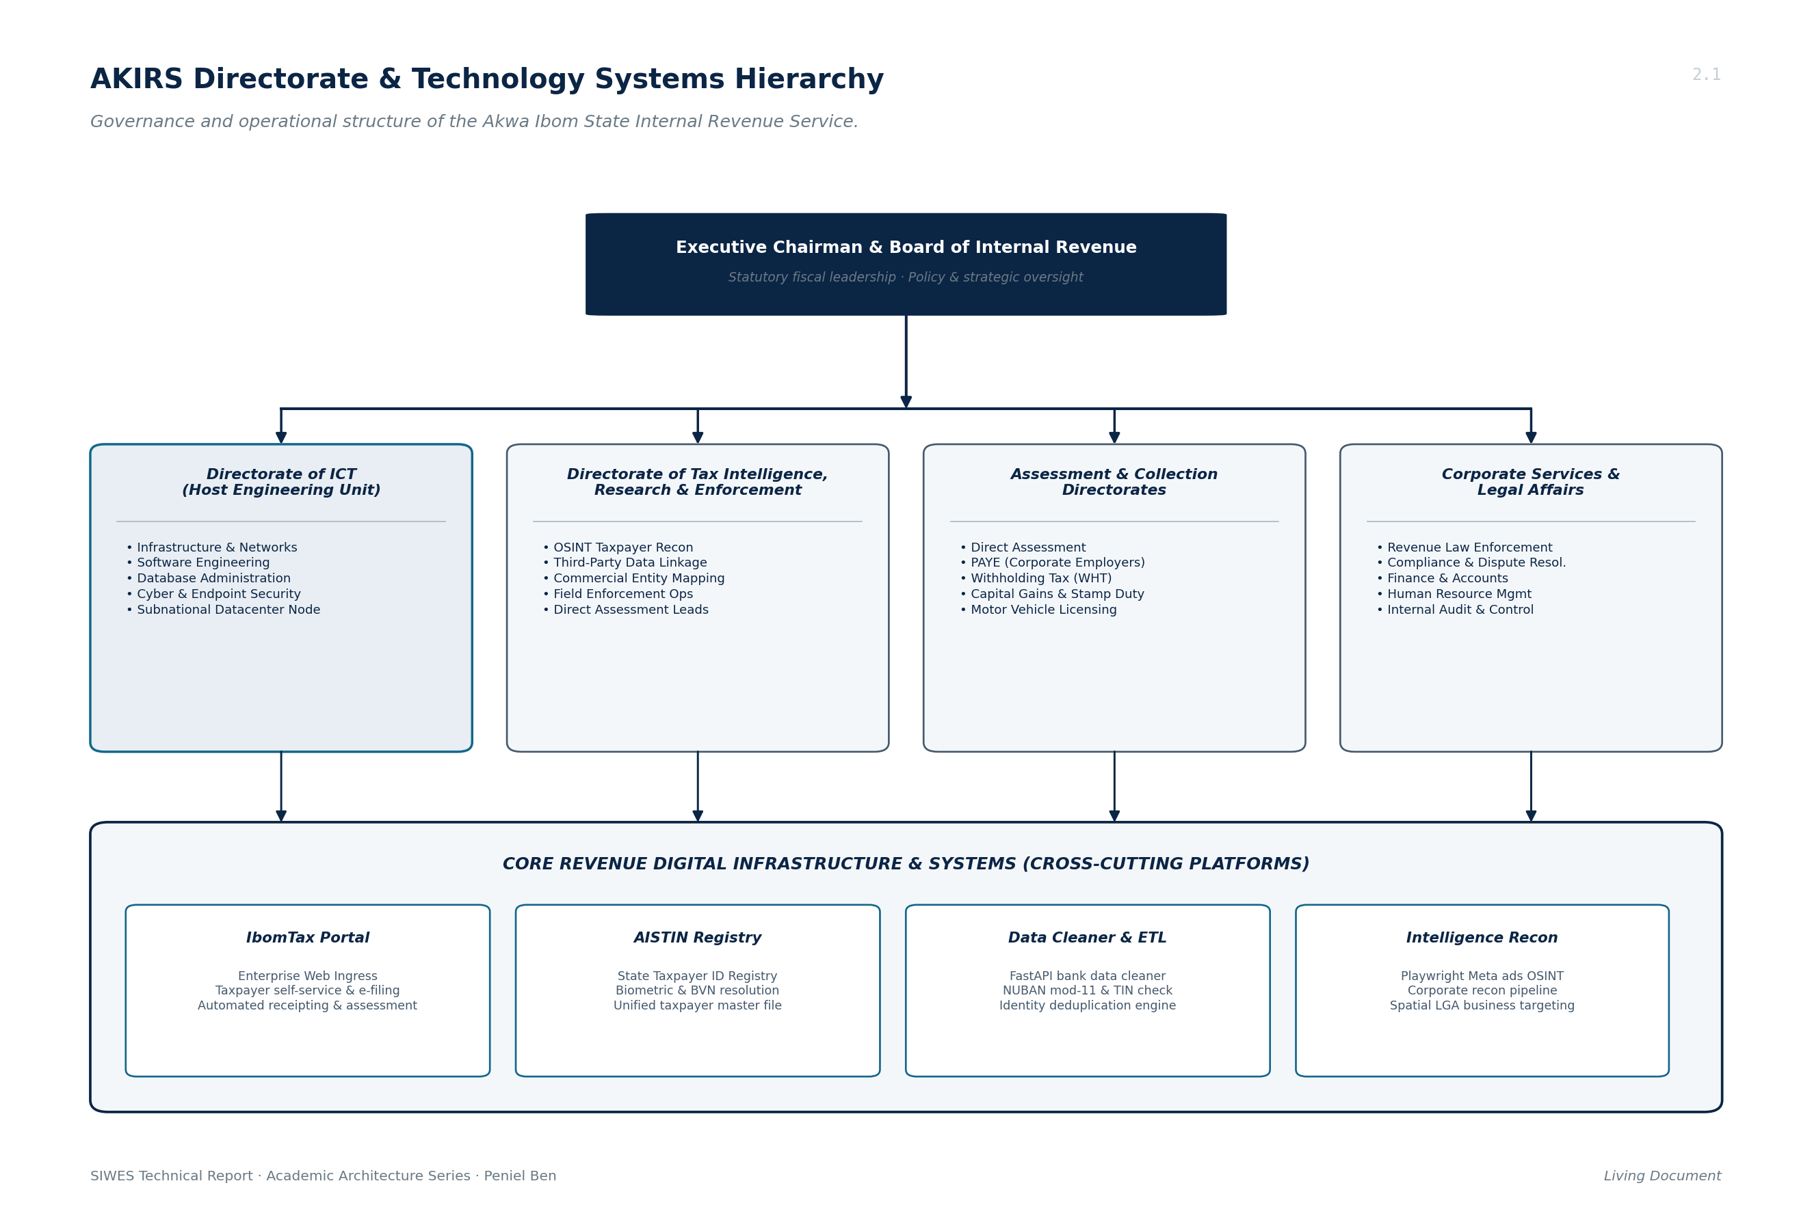
Figure 2.1: AKIRS Directorate & Technology Systems Hierarchy
2.3.1 Directorate of Information & Communication Technology (ICT)
The Directorate of ICT serves as the technical backbone of AKIRS and acted as the primary host unit for my SIWES industrial internship. The directorate is responsible for designing, deploying, securing, and maintaining all enterprise computing systems across the service. Its operational responsibilities include:
• Infrastructure and Virtualization: Designing, deploying, and maintaining high-availability on-premises servers, VMware hypervisor clusters, and cloud-hosted VPS infrastructures across multi-cloud environments.
• Network Engineering & Security: Managing core routing switches, next-generation perimeter firewalls (Sophos XGS 138), virtual local area networks (VLANs), and high-availability satellite internet failovers (Starlink).
• Software Architecture & Engineering: Engineering, maintaining, and deploying custom software solutions, batch data-cleaning utilities, automated ingestion pipelines, and RESTful microservice APIs.
• Database Administration: Managing mission-critical PostgreSQL and MySQL database servers, data warehousing nodes, and automated point-in-time snapshot backup systems.
• Fleet & Helpdesk Administration: Provisioning employee computer fleets, enforcing role-based endpoint access control policies, monitoring hardware health, and troubleshooting technical incidents.
2.3.2 Directorate of Tax Intelligence, Research & Enforcement
This directorate is tasked with discovering non-compliant taxable entities, identifying hidden commercial activity, and conducting forensic fiscal reconnaissance. Leveraging open-source intelligence (OSINT), web-scraping pipelines, and automated multi-registry cross-referencing, the directorate uncovers high-net-worth individuals and corporate entities operating outside the formal tax net.
2.3.3 Assessment and Collection Directorates
These operational divisions manage the direct fiscal interactions between the state and taxpayers. They include the Directorate of Direct Assessment (informal sector and sole proprietorships), the Directorate of PAYE (Pay-As-You-Earn employee deductions across private and public corporate employers), the Directorate of Withholding Tax (WHT), and the Motor Licensing Authority.
2.4 MAJOR AKIRS OPERATIONAL PROJECTS & SYSTEMS
To deliver on its statutory modernization mandate, AKIRS actively maintains a sophisticated fleet of custom software platforms and datacenter infrastructure nodes. Furthermore, under the Joint Revenue Board (JRB) Digital Infrastructure Programme, AKIRS functions as a regional subnational datacenter node, harmonizing subnational tax collection with national clearinghouses. Figure 2.2 outlines the inter-agency integration topology connecting federal entities, banking clearinghouses, and the AKIRS datacenter.
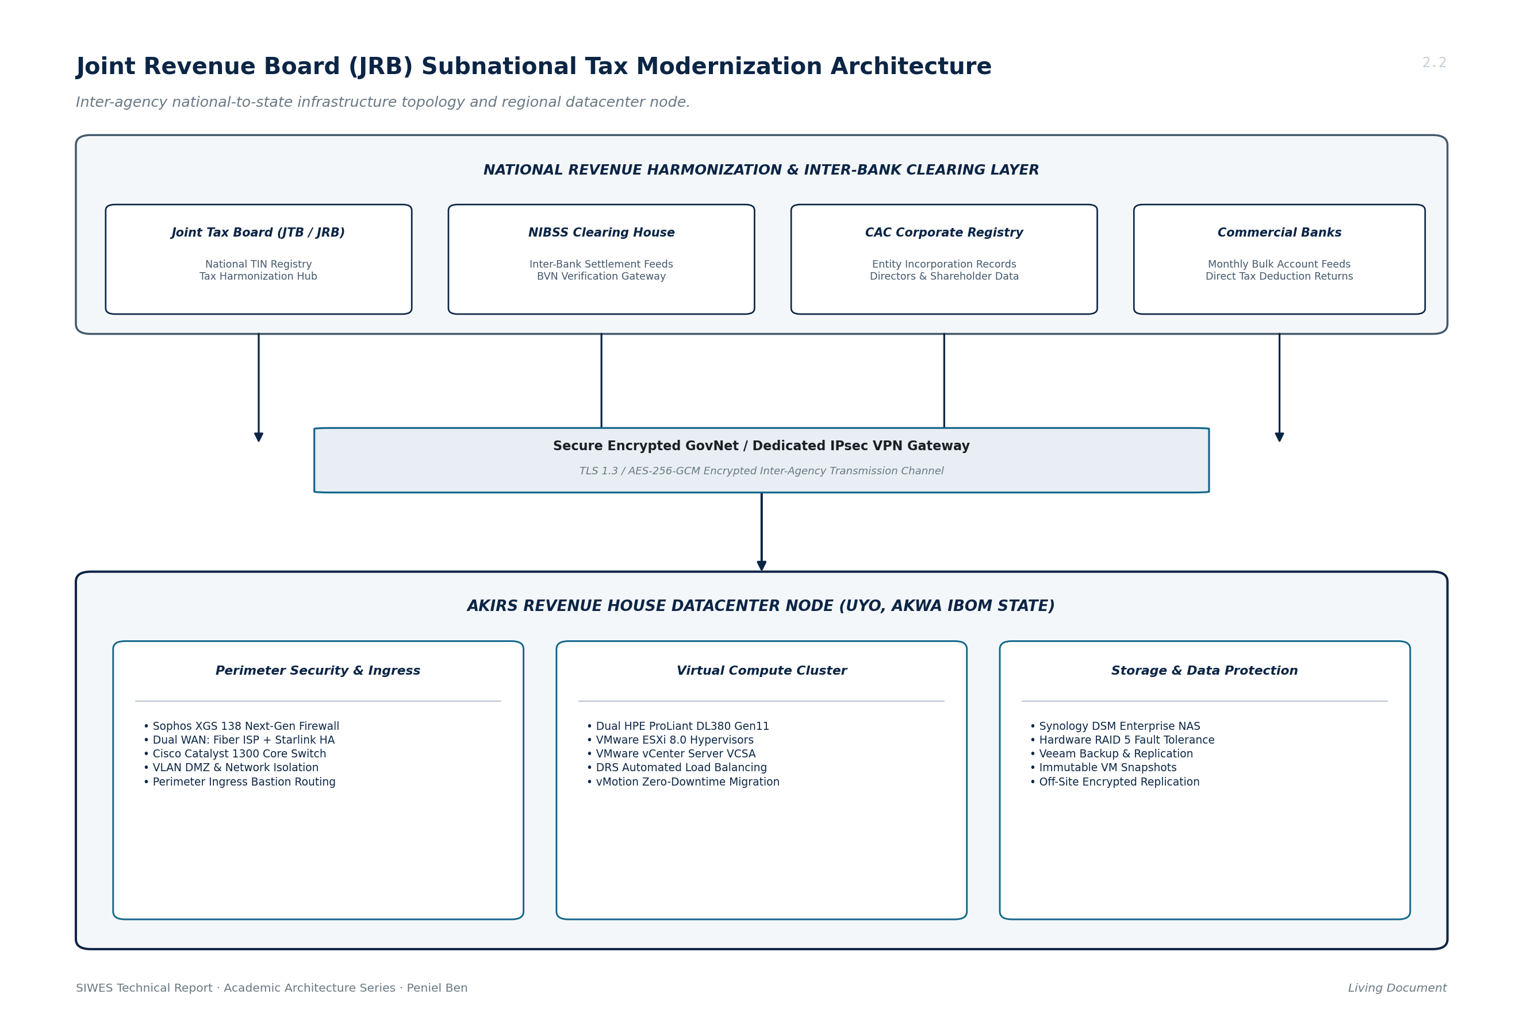
Figure 2.2: Joint Revenue Board (JRB) Subnational Tax Modernization Architecture
2.4.1 IbomTax Digital Automation Platform
IbomTax is the primary web portal and revenue management ERP for Akwa Ibom State. It provides digital registration, electronic assessment generation, web-based debit/credit card and bank-branch payments, automated payment reconciliation, and instant issuance of electronic revenue receipts.
2.4.2 Taxpayer Identification System (AISTIN)
The Akwa Ibom State Taxpayer Identification Number (AISTIN) system uniquely identifies every taxable natural person and registered corporate entity within the state. AISTIN links biometric data, Bank Verification Numbers (BVN), and National Identification Numbers (NIN) into a unified master taxpayer file, preventing duplicate registrations and tax evasion.
2.4.3 Automated Data Cleaning, Deduplication & NUBAN Reconciliation Platform (Personally Worked On)
The AKIRS Batch Data Cleaner is an enterprise data-cleansing and extraction web application. Designed to process massive, heterogeneous monthly commercial bank ledger spreadsheets, this system automatically validates 10-digit NUBAN account numbers via the Central Bank of Nigeria (CBN) modulo algorithm, verifies Taxpayer Identification Numbers (TINs), isolates branch transactions (e.g., Uyo urban accounts), resolves customer identity duplicates, and consolidates verified data into standardized CSV feeds for database ingestion.
2.4.4 Intelligence Reconnaissance & Automated Entity Scraper (Personally Worked On)
The AKIRS Intelligence Reconnaissance Engine is an automated OSINT scraping and reconnaissance platform. Using Playwright browser automation, it scrapes the Major social media platforms for commercial advertisements targeted at Akwa Ibom State, extracts business entities, and pipes them through a multi-tier reconnaissance engine (corporate website scrapers, OpenStreetMap Nominatim geocoding, Hunter.io verification e.t.c). This produces enriched intelligence files containing verified physical addresses, phone numbers, and director contacts for tax compliance enforcement.
2.4.5 AI-Powered Tax Knowledge Assistant & Support Bot (Contributed Guardrail Engineering)
An experimental large-language-model (LLM) advisory bot integrated into taxpayer customer support workflows. I contributed to the guardrail engineering layer of this project, implementing strict semantic boundary enforcement, prompt-hardening filters, and domain-grounding mechanisms to prevent the assistant from dispensing inaccurate or legally non-compliant tax advice.
2.5 STATUTORY MANDATE
The statutory mandate of AKIRS, as defined under Section 7 of the Akwa Ibom State Revenue Administration Law (2016), includes:
• Assessing, collecting, accounting for, and enforcing the payment of all taxes, fees, rates, and levies due to the Government of Akwa Ibom State.
• Ensuring the timely and transparent lodging of all collected public revenues directly into the Consolidated Revenue Fund (CRF) of the state.
• Formulating and executing comprehensive fiscal policies, tax administration reforms, and taxpayer education campaigns across all 31 Local Government Areas.
• Deploying and managing modern electronic platforms, digital databases, and secure network infrastructure to automate tax assessment, collection, and compliance monitoring.
• Partnering with federal agencies (Federal Inland Revenue Service, Joint Tax Board, NIBSS, CAC) to cross-reference financial records and eliminate subnational tax avoidance.
2.6 VISION STATEMENT
To be a model revenue administration agency in Africa, recognized for professionalism, technological innovation, integrity, and operational excellence in public revenue mobilization.
2.7 MISSION STATEMENT
To optimize internally generated revenue through the deployment of cutting-edge technology, highly trained personnel, and taxpayer-friendly services, creating sustainable fiscal independence for Akwa Ibom State.
2.8 CORE VALUES
• Integrity: Operating with absolute transparency, ethical stewardship, and adherence to legal tax codes in managing public fiscal data.
• Professionalism: Conducting all official engagements with the highest degree of civil service etiquette, technical competence, and legal compliance.
• Innovation: Continuously pioneering digital platforms, modern systems architectures, and automated data pipelines to eliminate revenue leakage.
• Customer Centricity: Treating every taxpayer as a valued partner in state development through prompt service delivery, clear communication, and fair assessment.
• Teamwork: Fostering cross-directorate cohesion, inter-agency communication, and synchronized technical problem-solving.

Chapter Three (3)
EXPERIENCE GAINED AND WORK DONE AT AKIRS
3.0 INTRODUCTION TO THE WORKING ENVIRONMENT AND TECHNICAL UNITS
During my six-month SIWES industrial training attachment at the Akwa Ibom State Internal Revenue Service (AKIRS), I was integrated directly into the Directorate of Information and Communication Technology (ICT), working in close functional synergy with the Directorate of Tax Intelligence, Research & Enforcement. This placement exposed me to enterprise-scale systems engineering, automated data pipelines, network infrastructure administration, and statutory software development.
The operational environment inside AKIRS ICT demanded high engineering rigor. Because revenue records are strictly protected under the Nigeria Data Protection Act (NDPA 2023) and federal tax privacy statutes, every technical deployment required multi-stage security vetting, automated test coverage, strict access control, and complete auditability. My daily responsibilities balanced software development tasks with infrastructure systems administration.
3.1 OVERVIEW OF TECHNICAL EXPERIENCES GAINED
Over the course of the six-month internship, my technical contributions centered on several foundational computer science and systems engineering domains:
• Data Engineering & ETL Pipelines: Developing high-throughput ETL pipelines using Python (FastAPI, openpyxl, pandas) to ingest, validate, and deduplicate millions of customer banking records.
• Algorithmic Systems Programming: Implementing the Central Bank of Nigeria (CBN) modulo check-digit algorithm and mathematical string similarity algorithms (Jaro-Winkler, Levenshtein distance) for taxpayer identity resolution.
• Web Automation & OSINT Reconnaissance: Building asynchronous web-scraping agents using Playwright (Chromium automation) to extract commercial business profiles from the Meta Ads Library, paired with multi-tier API recon (OSM, Hunter.io, TomTom).
• AI Guardrail Engineering: Researching and implementing semantic boundary enforcement, anti-jailbreak filters, and statutory policy grounding for LLM tax customer service bots.
• Enterprise Systems & Network Administration: Configuring Sophos XGS 138 next-generation firewalls, Cisco Catalyst 1300 managed switches, VLAN segmentations, and Starlink satellite WAN links.
• Hypervisors & Containerization: Administering VMware ESXi 8.0 hypervisors, vCenter resource scheduling, Docker multi-container environments, and Coolify reverse proxies.
3.2 TAXPAYER DATA CLEANING, NORMALIZATION AND DEDUPLICATION PIPELINE
A primary software project I actively developed was the AKIRS Data Toolkit. Commercial financial institutions submit monthly spreadsheets detailing accounts account information. These data arrive in wildly divergent structures with missing columns, invalid account numbers, and typographical inconsistencies. Figure 3.2 illustrates the end-to-end data processing workflow implemented in the data toolkit service.
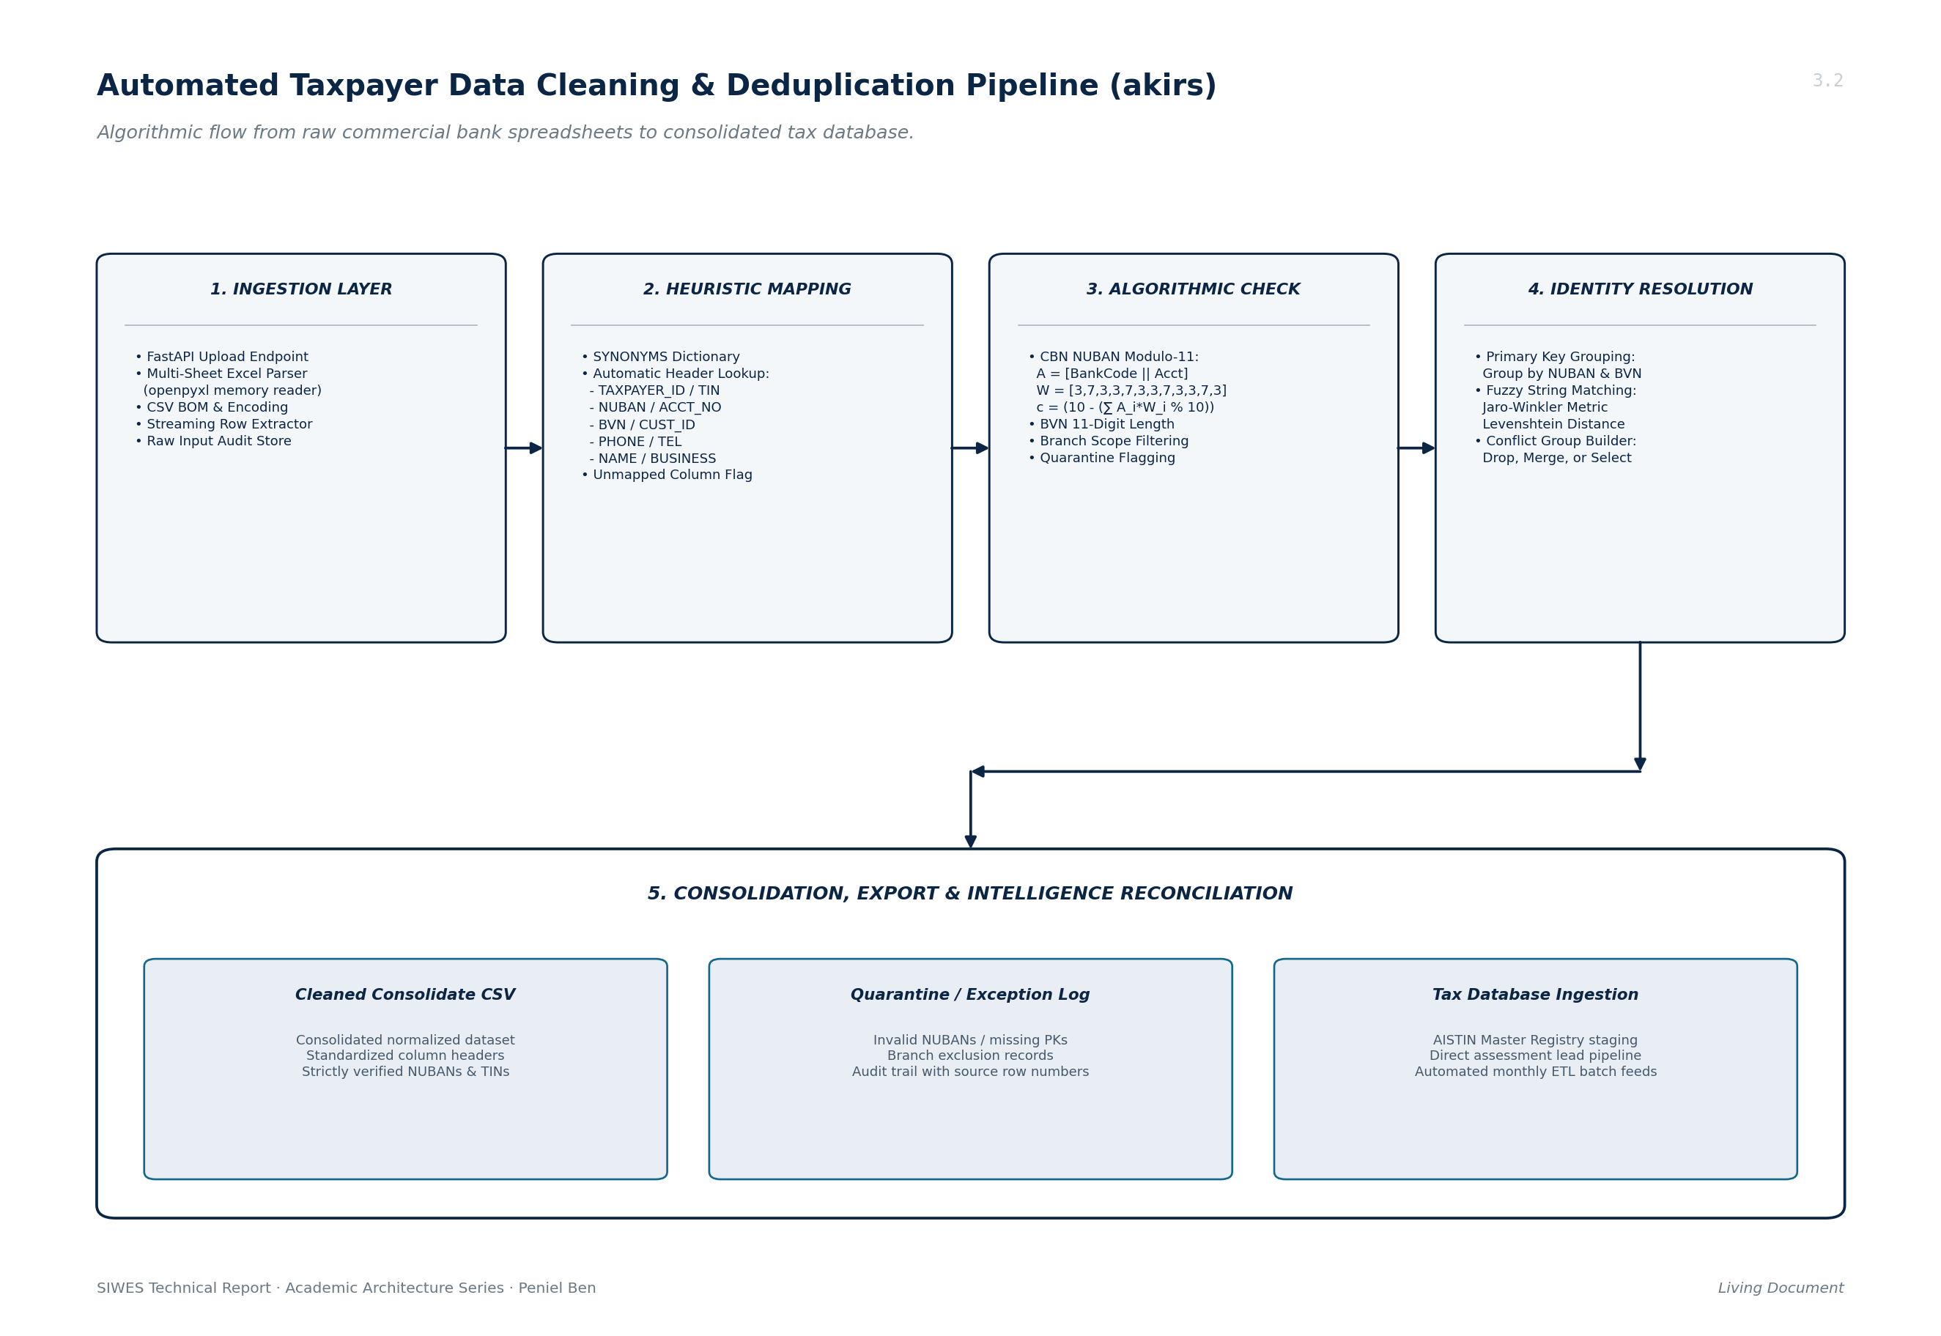
Figure 3.2: Automated Taxpayer Data Cleaning & Deduplication Pipeline Architecture
3.2.1 Data Ingestion, Cleansing, and Schema Standardization
I engineered the core data ingestion engine using Python and openpyxl, optimized with streaming read-only modes to handle large multi-sheet workbooks without exhausting system memory. The pipeline executes:
• Heuristic Header Mapping: Scans candidate header rows using a fuzzy synonyms lookup dictionary , accurately identifying columns corresponding.
• Telephone Number Standardization: Normalizes Nigerian mobile phone numbers to canonical 11-digit or E.164 international formats, stripping non-numeric characters and erroneous prefixes.
• Corporate Entity Canonicalization: Normalizes corporate designations by standardizing regex variations of 'LTD', 'LIMITED', 'PLC', 'INC', 'ENTERPRISES', and 'VENTURES' into canonical corporate tokens, isolating embedded TINs erroneously combined with legal entity names.
3.2.2 Central Bank of Nigeria (CBN) NUBAN Modulo Algorithm Implementation
To prevent revenue leakage caused by failed tax refund transactions and invalid Direct Assessment accounts, taxpayer bank accounts required mathematical validation prior to database persistence. Under the official guidelines of the Central Bank of Nigeria (Central Bank of Nigeria [CBN], 2011), the Nigeria Uniform Bank Account Number (NUBAN) is a 10-digit number where the 10th digit is an algebraic check digit derived from a 3-digit bank code and a 9-digit account serial number.
The validation algorithm computes a weighted sum across a 12-digit concatenated array:
Concatenated Array: A = [b1, b2, b3, a1, a2, a3, a4, a5, a6, a7, a8, a9]
Fixed Weight Array: W = [ 3, 7, 3, 3, 7, 3, 3, 7, 3, 3, 7, 3]
Weighted Sum: S = ∑ (A_i × W_i) for i = 1 to 12
Modulo Check: R = S mod 10
Check Digit (c): c = 10 - R (if c == 10, then c = 0)
Verification: If the computed check digit c equals the 10th digit of the supplied account number (a10), the account number is verified as mathematically valid under CBN specifications. I implemented this algorithm, allowing AKIRS to batch-validate millions of bank accounts within seconds.
3.2.3 Taxpayer Identity Resolution: Jaro-Winkler and Levenshtein Metrics
Due to typographical errors in manual ledger entries, identical business entities appeared multiple times under slightly altered spellings. To resolve this without manual review, I implemented a fuzzy entity resolution model combining exact deterministic matches (TIN, Account Number) with Jaro-Winkler (Jaro, 1989) and Levenshtein distance metrics (Levenshtein, 1966):
1. Jaro-Winkler Metric: The basic Jaro distance between two strings s1 and s2 is formulated as:
d_j = 0 if m == 0
d_j = (1/3) * [ (m/|s1|) + (m/|s2|) + (m-t)/m ] otherwise
Where:
|s1|, |s2| = Character lengths of string s1 and string s2
m = Count of matching characters (distance <= ⌊max(|s1|,|s2|)/2⌋ - 1)
t = Number of transpositions (half the out-of-order matches)
Jaro-Winkler Distance with prefix scaling:
d_w = d_j + (ℓ * p * (1 - d_j))
Where ℓ = length of common prefix (max 4 chars), and p = constant scaling (0.1)
2. Levenshtein Distance Metric: Computes the minimum number of single-character edits (insertions, deletions, or substitutions) required to transform string s1 into string s2:
lev_{s1,s2}(i, j) = max(i, j) if min(i, j) == 0
lev_{s1,s2}(i, j) = min(
lev_{s1,s2}(i-1, j) + 1,
lev_{s1,s2}(i, j-1) + 1,
lev_{s1,s2}(i-1, j-1) + 1_{s1[i] ≠ s2[j]}
) otherwise
Records sharing identical NUBANs or achieving a Jaro-Winkler similarity score d_w >= 0.92 are flagged as duplicate candidate groups. The web application allows tax officers to resolve duplicate conflicts via automated primary key rules, record merging, or manual selection.
3.3 MICROSERVICES AND API ARCHITECTURE WITH FASTAPI
To deliver a modern browser-based interface for tax officers, I developed the backend using the FastAPI asynchronous framework (uvicorn ASGI server). Key architectural patterns included:
• Pydantic Schema Validation: Designing strictly typed Pydantic models for incoming upload parameters, mapping configurations, and deduplication rules, enforcing schema validation at the HTTP boundary.
• Dependency Injection: Injecting stateful file handlers, session managers, and authentication contexts using FastAPI's Depends dependency injection system.
• Asynchronous Task Decoupling: Decoupling long-running spreadsheet processing jobs into background tasks with SSE (Server-Sent Events) progress updates, preventing HTTP request timeouts during large file processing.
3.4 INTELLIGENT RECONNAISSANCE & WEB SCRAPING ENGINE
In the OSINT project, I contributed to the intelligence reconnaissance engine used by the Directorate of Tax Intelligence. Figure 3.3 illustrates the multi-phase intelligence gathering architecture.
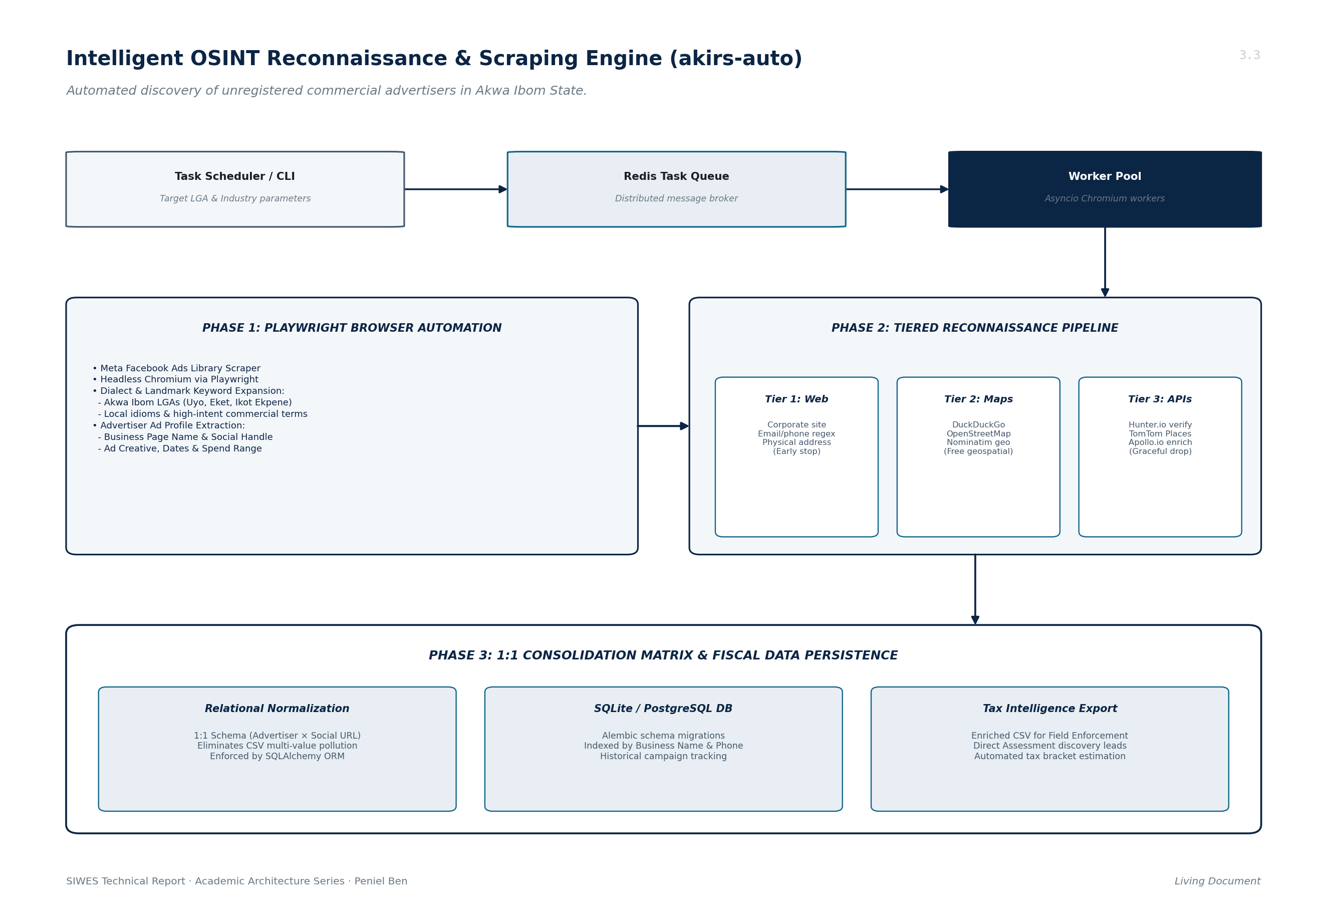
Figure 3.3: Intelligent OSINT Reconnaissance & Scraping Engine Architecture (OSINT)
3.4.1 Asynchronous Browser Automation (Playwright) & Distributed Task Execution
I implemented automated headless Chromium agents using Playwright (Python async API). The system automates search queries against the public social media library, navigating dynamic JavaScript single-page applications (SPAs), bypassing client-side rate limits with random user-agent rotations, and extracting active advertisers promoting goods or services in Akwa Ibom State.
3.4.2 AI-Inference Keyword Expansion & Spatial Matrix Targeting (LGA x Industry)
To ensure comprehensive discovery across all 31 Local Government Areas, I constructed an automated keyword expansion matrix intersecting commercial industry categories (Hospitality, Real Estate, Medical, Retail, Petroleum) with regional Akwa Ibom geographic markers and local commercial dialects. This combinatorial matrix generated targeted search strings that uncovered unregistered micro-businesses advertising solely through social media.
3.4.3 Multi-Registry Corporate Enrichment (CAC, OSM Nominatim, Maps)
Raw advertiser profiles extracted from Facebook were fed into a tiered reconnaissance pipeline: Tier 1 scraped corporate homepages for contact emails, phones, and addresses. Tier 2 queried OpenStreetMap (OSM) Nominatim APIs and DuckDuckGo to verify geographic coordinates. Tier 3 performed enrichment against Hunter.io and TomTom APIs(amongst many others). The output was normalized into a 1:1 relational matrix (Advertiser × Social URL), eliminating multi-value CSV pollution.
3.5 AI-POWERED TAX KNOWLEDGE ASSISTANT: GUARDRAIL ENGINEERING
To support the customer engagement team, AKIRS prototyped an AI-powered conversational bot. My role centered on guardrail engineering, preventing LLM hallucinations and enforcing legal domain boundaries. Figure 3.4 illustrates the multi-stage guardrail and knowledge retrieval architecture.
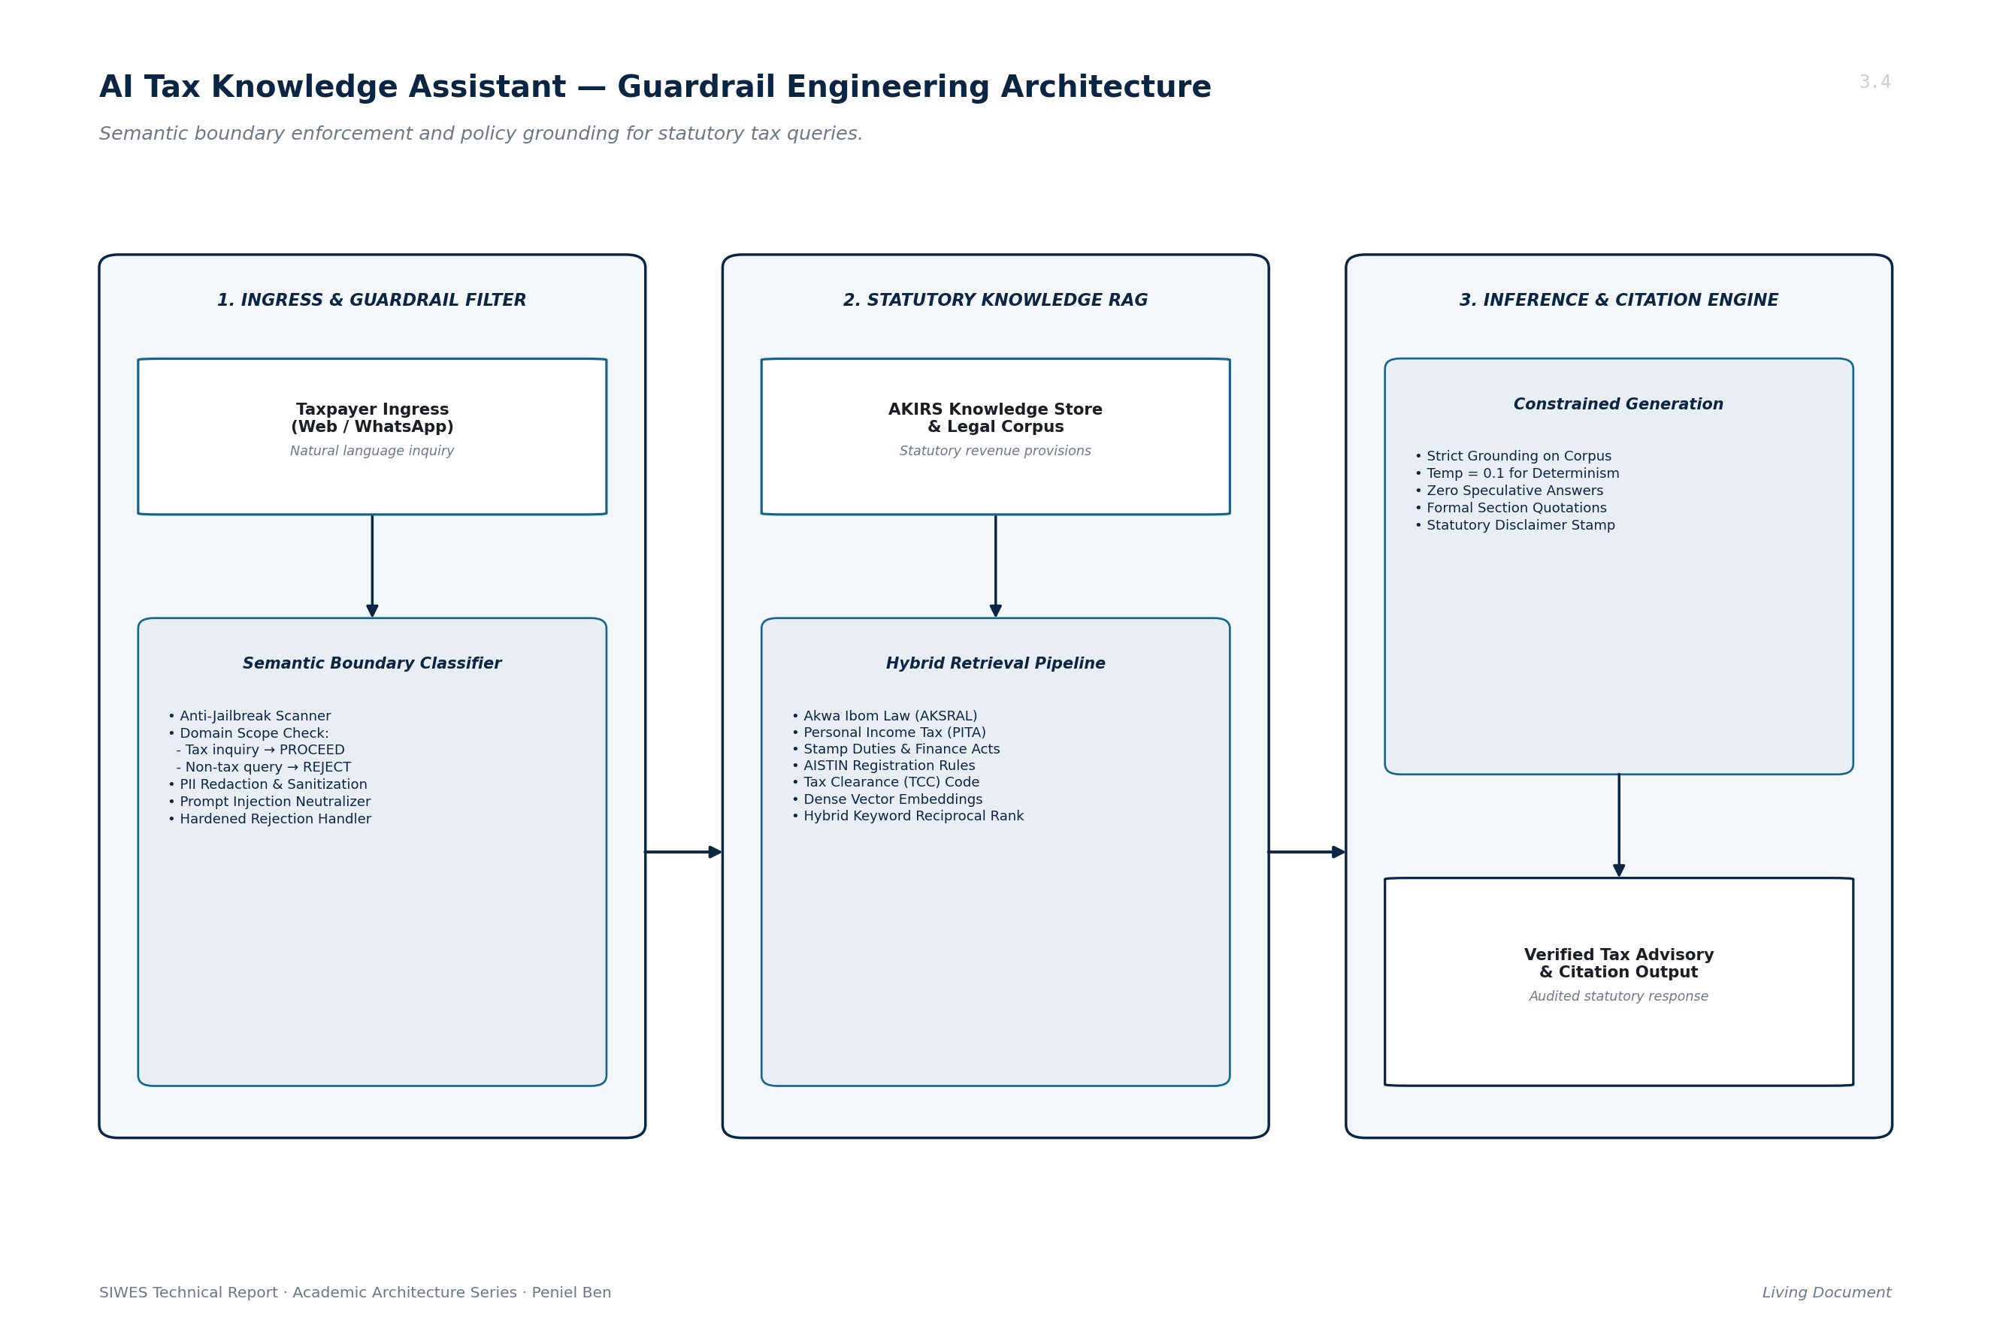
Figure 3.4: AI Tax Knowledge Assistant Guardrail Engineering Architecture
3.5.1 Semantic Guardrails and Query Boundary Enforcement
Using intent-classification prompts and embedding distance thresholds, I engineered a boundary enforcement filter that evaluates inbound queries before LLM inference. Inquiries outside statutory Akwa Ibom revenue administration (general chit-chat, politics, coding, non-tax topics) are rejected with a standardized polite deflection, preventing misuse of government AI resources.
3.5.2 Hallucination Prevention & Prompt Hardening
I designed system prompt contracts that restrict the model's generation exclusively to retrieved statutory markdown documents. The system explicitly forbids fabricating tax bands, interest rates, or filing deadlines, mandating verbatim citation of statutory tax sections (e.g., Section 33 of PITA, Section 12 of AKSRAL), for this I worked extermely close with my collegue whom AI is his field.
3.5.3 Verification and Domain-Specific Policy Alignment
A post-generation verification filter inspects the generated response, verifying that cited statutory sections match known Akwa Ibom laws and that no confidential internal tax intelligence is exposed to the public.
3.6 DATABASE MANAGEMENT, MIGRATION AND STATE SYNCHRONIZATION
I managed relational schema migrations for both projects using Alembic and SQLAlchemy ORM. In OSINT, I authored declarative models in and managed versioned schema transitions, ensuring schema consistency across development, staging, and production SQLite and PostgreSQL databases.
3.7 ENTERPRISE SYSTEMS ADMINISTRATION, DATACENTER & VIRTUALIZATION
In addition to application development, I participated directly in hardware and systems administration within the AKIRS on-premises datacenter. Figure 3.1 delineates the AKIRS enterprise datacenter infrastructure topology.
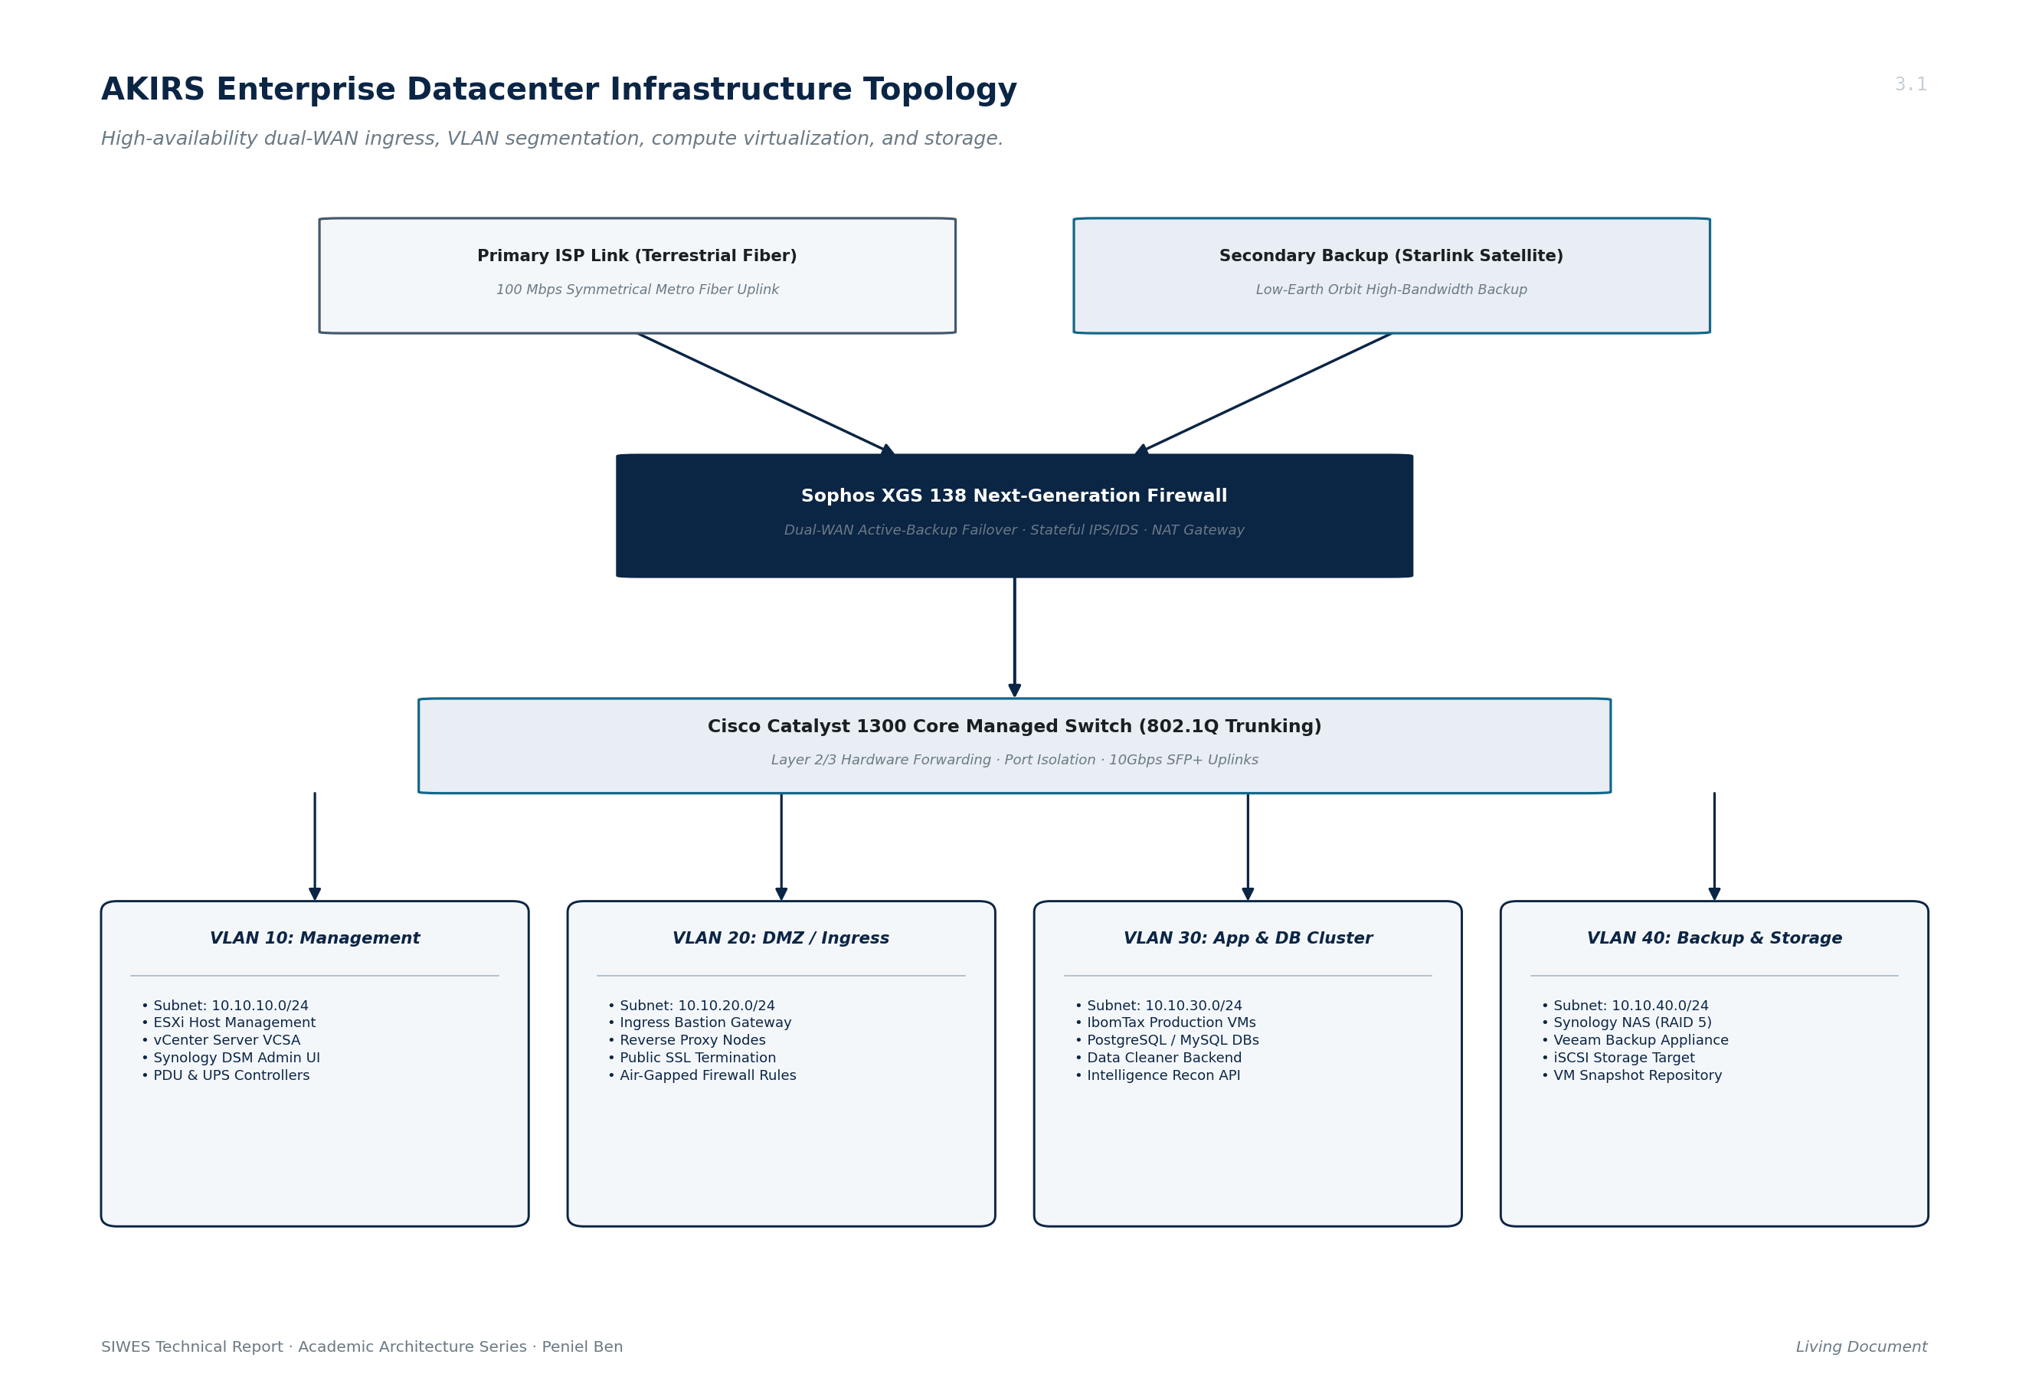
Figure 3.1: AKIRS Enterprise Datacenter Infrastructure Topology
3.7.1 Datacenter VM Provisioning, Static Subnetting & Host Hardening
Under senior engineering supervision, I participated in provisioning virtual machines on dual HPE ProLiant DL380 Gen11 compute servers running VMware ESXi 8.0, managed via VMware vCenter Server. I configured static IP addressing across segmented VLAN subnets on a Cisco Catalyst 1300 core switch and managed traffic inspection rules on a Sophos XGS 138 firewall.
3.7.2 Containerization with Docker & Multi-Container Docker Compose
I containerized application services using Docker and multi-stage Dockerfiles. I authored docker-compose.yml specifications coordinating FastAPI backends, Redis task queues, PostgreSQL database containers, and browser worker agents on isolated Docker bridge networks.
3.7.3 Reverse Proxy Architectures, Linux Server Hardening & Coolify
I configured Traefik and Caddy reverse proxies for automated SSL/TLS certificate generation via Let's Encrypt (ACME). Furthermore, I deployed and maintained self-hosted Coolify application nodes across isolated virtual machines, managing containerized deployment lifecycles and webhooks.
3.8 PROFESSIONAL ETHICS, DATA GOVERNANCE & INSTITUTIONAL REALITIES
Working in a statutory government agency exposed me to the paramount importance of data governance and civil service ethics:
3.8.1 Security Vetting, Confidentiality Undertakings & Clearances
Before gaining access to AKIRS datacenter networks or production repositories, I underwent security vetting and executed binding confidentiality undertakings pursuant to the Official Secrets Act and the Akwa Ibom State Revenue Administration Law (AKSRAL 2016). Unlawful disclosure of taxpayer financial records carries severe criminal penalties.
3.8.2 Tiered Information Classification & Fiscal Record Fragility
I adhered to strict information classification tiers: Public (forms, rates), Internal (audit logs, mapping schemas), and Restricted / Secret (bank account ledgers, biometric records, intelligence profiles). Production databases were kept isolated from internet egress, and development was conducted exclusively on anonymized synthetic datasets.
3.8.3 Realities of Working in a Statutory Government Institution
I observed firsthand the procedural realities of public sector technology adoption. Direct inter-agency API integrations (e.g., between AKIRS and commercial banks or federal agencies) require formal inter-ministerial memoranda of understanding (MoUs), legal compliance audits, and executive approvals. This explained why batch Excel cleaning pipelines remained essential alongside modern API integrations.
3.9 SOFT SKILLS, WORKPLACE POLITICS, AND CIVIL SERVICE PROTOCOLS
My SIWES attachment provided invaluable professional development beyond technical code. I learned civil service communication etiquette, participated in cross-directorate technical briefing sessions, translated complex data structures into actionable insights for non-technical revenue directors, and navigated the organizational protocols of a statutory government institution.
3.10 TECHNICAL CHALLENGES ENCOUNTERED AND ENGINEERING SOLUTIONS
3.10.1 Air-Gapped Minimal VM Network Ingestion & Console Failures
A major operational challenge arose when deploying automated scripts onto freshly provisioned, air-gapped datacenter virtual machines that lacked direct internet connectivity and SSH keys. Pasting code over hypervisor web consoles caused indentation corruptions in Python scripts. I resolved this by authoring single-file, dependency-free shell bootstrap scripts and configuring an internal HTTP package cache on an authorized staging host.
3.10.2 Heterogeneous Legacy Data Schema Incompatibilities
Spreadsheets submitted by different financial institutions contained inconsistent column names, multi-line headers, missing values, and corrupted UTF-8 encodings. I solved this by implementing multi-encoding fallbacks (utf-8-sig and latin-1) and building heuristic header matching algorithms in the data cleaner service.
3.11 CONCLUSION TO CHAPTER THREE
The technical experiences acquired during my six-month attachment at AKIRS provided an extraordinary bridge between university computer science theory and production-grade engineering. Working on the batch data cleaner and automated intelligence recon systems provided deep practical insight into data pipelines, algorithms, and datacenter infrastructure. These experiences directly illuminated the operational friction points that inspired the design of my SIWES technical project: Bridge.

Chapter Four (4)
BRIDGE: A FAULT-TOLERANT DISTRIBUTED GOSSIP NETWORK AND
INGRESS ROUTING SYSTEM
4.0 INTRODUCTION
Modern enterprise government infrastructure, such as the Akwa Ibom State Internal Revenue Service (AKIRS) datacenter, increasingly relies on multi-tier application architectures deployed across isolated virtual machines, on-premises hypervisors, and multi-cloud VPS environments. However, routing public traffic into these non-public, isolated VM enclaves creates acute operational friction, security risks,split brains and single-point-of-failure vulnerabilities.
The technical project undertaken during my SIWES internship is BRIDGE: an enterprise-grade, high-performance, fault-tolerant distributed ingress routing mesh and multi-VM gossip network engineered in the Rust systems programming language. Bridge establishes an encrypted Layer 3 WireGuard overlay across multi-cloud node fleets, autonomously discovers internal services via decentralized push-pull gossip, and forwards inbound HTTPS traffic using zero-TLS-termination Layer 4 SNI stream splicing, with optional high-availability leader failover.
4.1 BACKGROUND OF THE STUDY: AKIRS DATACENTER INFRASTRUCTURE & DMZ ENCLAVES
During my infrastructure administration duties at AKIRS, I observed a fundamental operational dilemma in managing enterprise virtual machines across network boundaries. Figure 4.3 outlines the physical and virtual deployment topology across multi-cloud and on-premises environments.
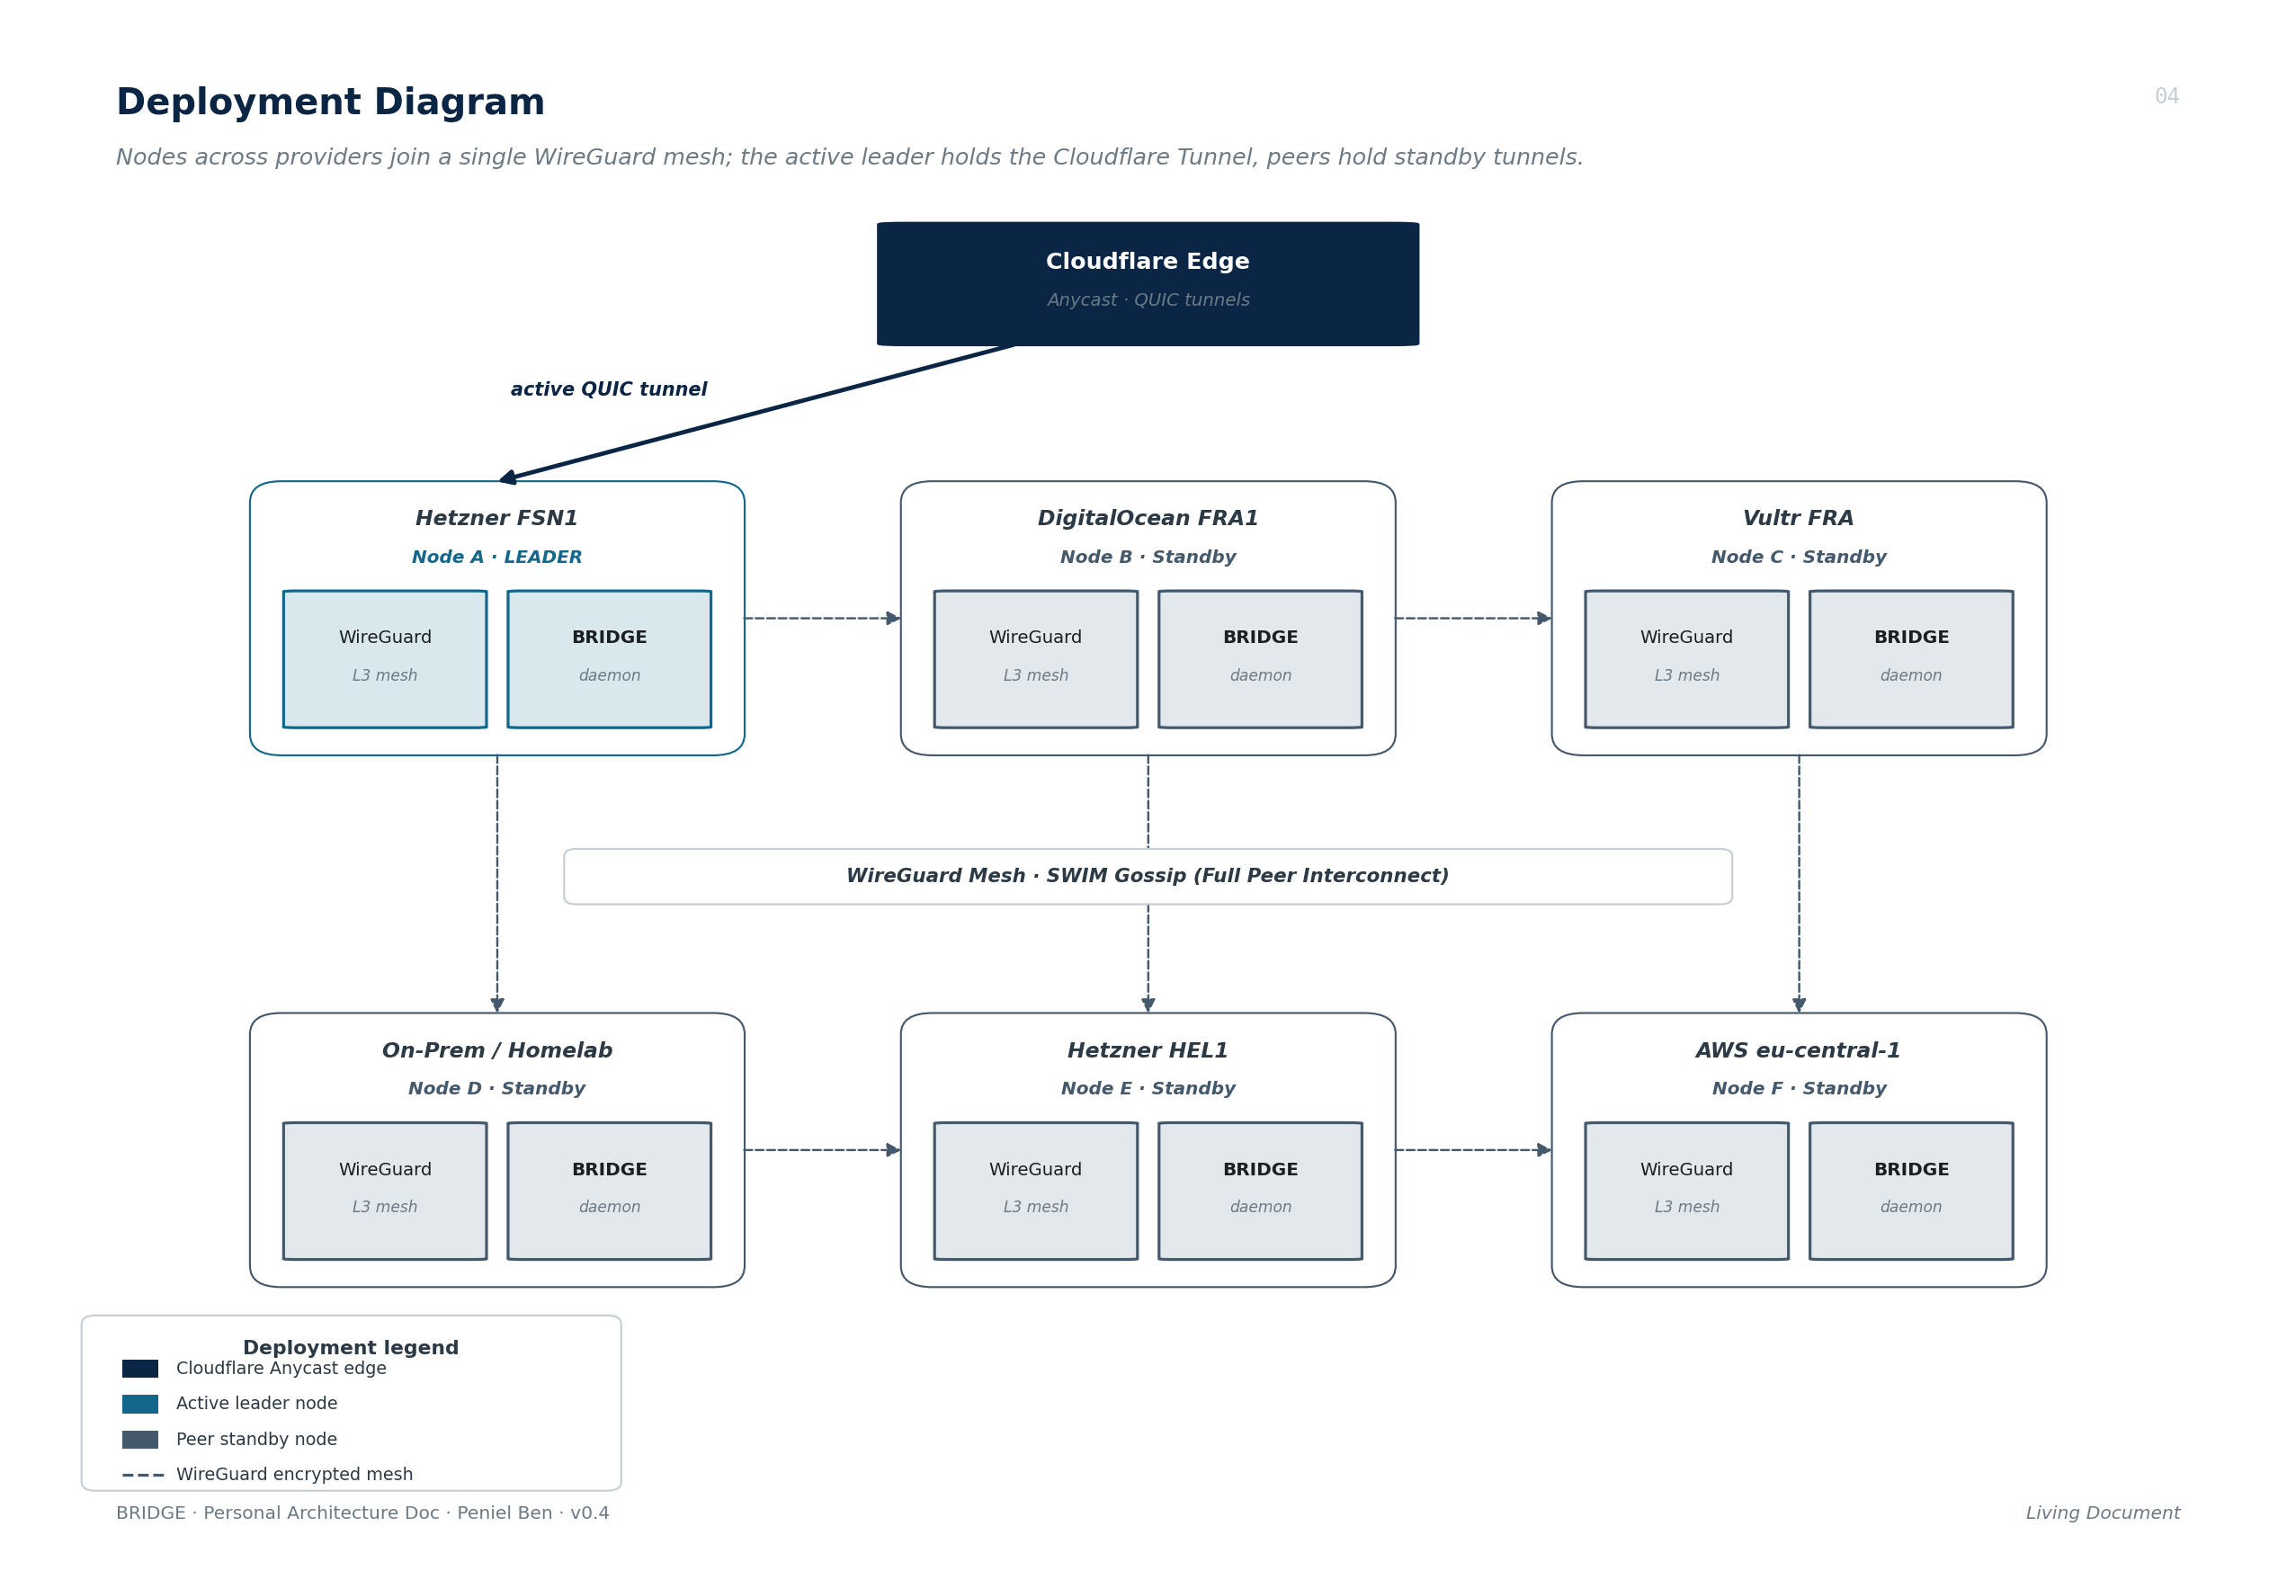
Figure 4.3: Multi-Cloud and Datacenter Deployment Topology
AKIRS hosts mission-critical revenue services including the IbomTax platform, the AISTIN registry, the batch data cleaner, and the intelligence scraper, across segregated virtual machines on HPE ProLiant Gen11 servers. Security policies dictate that backend database and application VMs must never expose public IPv4 addresses to the raw internet. Consequently, all external web traffic must traverse a hardened perimeter ingress node or bastion gateway located in a Demilitarized Zone (DMZ).
4.2 PROBLEM STATEMENT
Through empirical observation of datacenter operations, I identified four critical architectural bottlenecks in existing perimeter routing setups:
4.2.1 Primary Bottleneck: Configuration Rigidity & Manual Proxy Drift
In traditional setups, the perimeter reverse proxy (Nginx or Traefik) requires manual configuration edits and service reloads whenever an internal VM container is added, relocated, or re-addressed. This causes manual proxy drift, human error, and service outages.
4.2.2 Secondary Resilience Challenge: Ingress Bastion SPOF
The single public-facing ingress gateway represents an acute Single Point of Failure (SPOF). If the perimeter host suffers hardware failure, kernel panic, or network disruption, all underlying revenue systems become inaccessible.
4.2.3 Cross-Subnet and Multi-Cloud SDN Incompatibilities
Traditional layer-2 failover mechanisms such as Keepalived, VRRP (Virtual Router Redundancy Protocol), and CARP rely on broadcast ARP/GARP packets, which are strictly blocked by cloud Software-Defined Networks (SDNs) across cloud providers (AWS, Hetzner, DigitalOcean).
4.2.4 Control-Plane Overhead of Heavyweight Orchestrators
While Kubernetes and HashiCorp Consul solve dynamic ingress discovery, they impose massive memory overhead (>1.5 GB base RAM), complex etcd/Raft quorum requirements, and heavy administrative burdens that are wholly unsuitable for lean subnational infrastructure nodes.
4.3 DESIGN GOALS AND ARCHITECTURAL PHILOSOPHY
Bridge was engineered from first principles to satisfy four foundational architectural goals:
• Autonomous Discovery: Autonomous service discovery with zero manual proxy edits, zero reload downtime, and no centralized database.
• Minimal Runtime Overhead: Under 25 MB resident memory footprint, sub-millisecond routing latency, and compile-time memory safety via Rust and Tokio.
• Kernel-Level Security: End-to-end ChaCha20-Poly1305 encryption across all inter-node communication via native WireGuard mesh tunnels.
• Ecosystem Non-Invasiveness: Seamless coexistence with existing node-level deployment engines (Coolify, Docker, Traefik) via Layer 4 SNI passthrough.
4.4 COMPARATIVE ANALYSIS OF EXISTING SOLUTIONS
To establish the engineering necessity of Bridge, Table 4.1 provides a rigorous comparative evaluation against existing enterprise ingress routing technologies.
Table 4.1: Comparative Analysis of Existing Ingress and Proxying Solutions
Ingress Solution | Auto-Discovers Services | Eliminates SPOF | Memory Footprint | Cross-Cloud Hybrid | Failover Speed
Standalone Nginx / Traefik | No (Manual edits) | No (SPOF) | < 30 MB | No | None (Manual)
Keepalived / VRRP | No (Static IP only) | Yes | < 15 MB | No (Blocked by SDN) | 1–3 seconds
HashiCorp Consul + Traefik | Yes (Consul Catalog) | Partial | > 500 MB (Raft) | Partial | 10–30 seconds
Kubernetes (k8s Ingress) | Yes (Kube-DNS) | Yes | > 1.5 GB base | Complex (BGP Overlay) | 15–45 seconds
Public BGP Anycast | No (IP routing only) | Yes | High Hardware Cost | Yes (Needs ASN /24) | < 1 second
BRIDGE (Implemented System) | Yes (SWIM Gossip) | Yes (Leader Handoff) | < 25 MB (Rust) | Yes (Full Mesh) | 4–11 seconds
As established in Table 4.1, Bridge is the only solution that combines autonomous DMZ service discovery, cross-cloud SDN portability, sub-25 MB resident memory usage, and automated perimeter failover without heavy orchestration clusters.
4.5 SYSTEM ARCHITECTURE AND C4 TOPOLOGY OVERVIEW
Bridge is structured according to the C4 architectural model. Figure 4.1 presents the C4 Level 1 System Context diagram, illustrating how Bridge positions itself between the public internet and backend datacenter VMs.
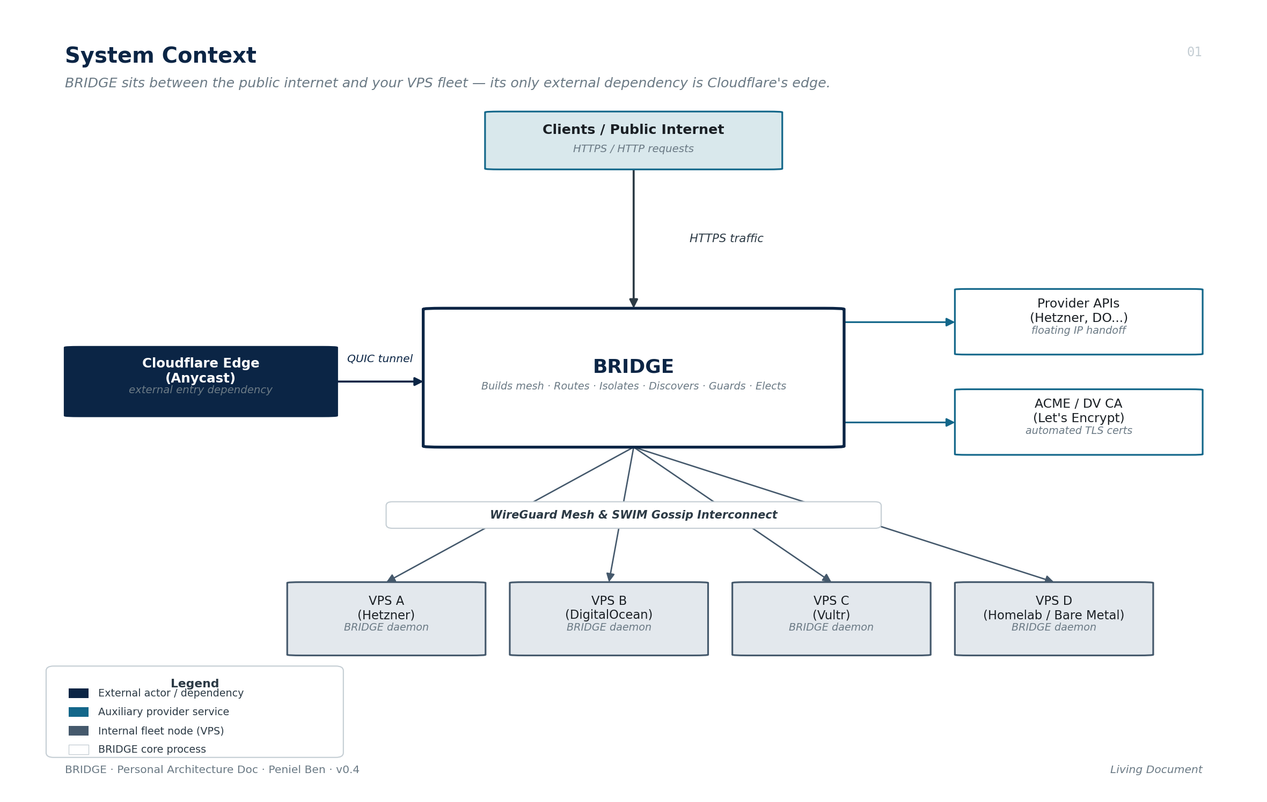
Figure 4.1: Bridge System Context Architecture (C4 Level 1)
As illustrated in Figure 4.1, Bridge sits at the trust boundary between untrusted public client networks and the internal datacenter enclaves. External taxpayers and institutional partners access revenue services via standard HTTPS (ports 80 and 443), while Bridge orchestrates encrypted WireGuard tunnels across disparate virtualization hosts and multi-cloud VPS environments. Datacenter administrators interact with the cluster through a unified command-line interface and localized configuration files, ensuring autonomous ingress dispatching without requiring human intervention during routine traffic fluctuations or failover events.
Figure 4.2 details the C4 Level 2 Container and Component diagram, showing the internal modular decoupling: the Ingress Dispatcher, Dynamic Domain Registry, Handoff Proxy Engine, SWIM Gossip Coordinator, and WireGuard Mesh Controller.
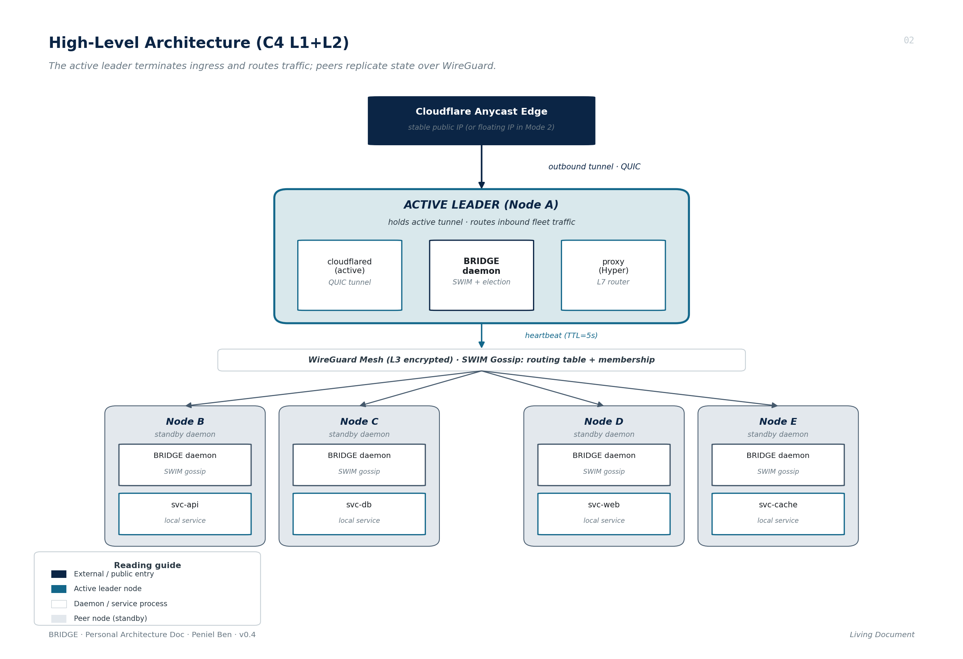
Figure 4.2: Bridge Container and Component Architecture (C4 Level 2)
4.6 THE WIREGUARD ENCRYPTED MESH INTERCONNECT (LAYER 3)
Rather than relying on unencrypted internal routing or heavyweight software overlays (VXLAN), Bridge establishes a full-mesh Layer 3 encrypted overlay using the kernel-level WireGuard protocol (Donenfeld, 2017). Each node running the Bridge daemon generates an ephemeral Curve25519 keypair and assigns itself a private IPv4 mesh address in the 10.8.0.0/16 subnet. All inter-VM traffic is encrypted using ChaCha20-Poly1305 authenticated ciphers.
4.7 SERVICE DISCOVERY & ROUTING TABLE SYNCHRONIZATION VIA GOSSIP
To eliminate centralized service registries like Consul or ZooKeeper, Bridge implements a decentralized push-pull epidemic gossip protocol. Every node periodically selects a random subset of f peer nodes (fanout factor f = 3) every interval_ms = 500 ms and exchanges its local domain routing table. State dissemination converges cluster-wide in O(log N) network rounds.
4.8 CLUSTER MEMBERSHIP AND LIVENESS DETECTION VIA SWIM PROTOCOL
Node failure detection is executed via an adapted variant of the SWIM (Structured Weakly-consistent Infection-style Process Group Membership) protocol (Das et al., 2002). Every node periodically transmits a direct UDP ping probe to a randomly selected peer. If no acknowledgment (ACK) is received within 500 ms, the node selects k = 3 auxiliary peers to perform indirect ping probing, preventing false positive evictions caused by transient route flaps.
4.9 LEADER ELECTION AND QUORUM CONSENSUS (BULLY ALGORITHM)
For coordinating the active public ingress entry point, Bridge implements a modified Bully election algorithm with quorum consensus (Ongaro & Ousterhout, 2014). Nodes are ranked by an alphanumeric priority tuple (priority, uptime, node_id). When the active leader fails, peer nodes detect heartbeat expiration within 1.5 seconds and elect the highest-ranking alive node,I choose Bully over raft for it’s implicity and fit of my usecase, quorum consensus was brought in to fix the split brain problem that comes with bully without having to manage multiple state machines and inter-server communication.
4.10 HIGH-AVAILABILITY PUBLIC ENTRY-POINT HANDOFF TIERS
To achieve zero-downtime perimeter resilience, Bridge introduces a multi-tier ingress handoff architecture. Figure 4.6 demonstrates the architectural separation between the global public entry point and localized node service routers.
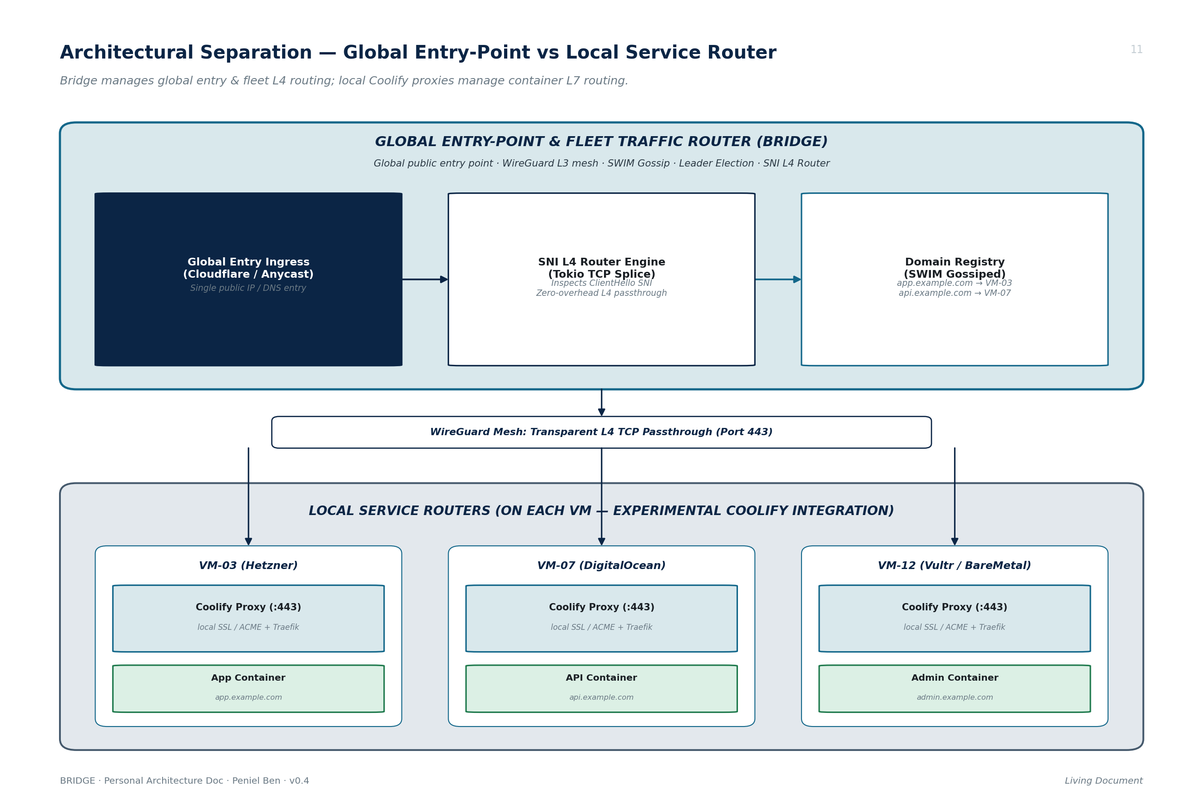
Figure 4.6: Architectural Separation Global Entry-Point vs Local Service Router
4.10.1 Tier 1: Basic (Manual Intervention)
In baseline setups, Bridge operates as an autonomous internal router. If the perimeter node fails, administrators manually update DNS records or firewalls to redirect traffic to a designated standby node.
4.10.2 Tier 2: Dynamic DNS Failover
Upon being elected cluster leader, the newly promoted node executes an asynchronous API call to Cloudflare DNS, updating public A/AAAA records to point to its public IP. Failover duration is bound by DNS resolver cache TTLs (30 to 300 seconds).
4.10.3 Tier 3a: Cloudflare Tunnel Ingress Handoff
The highest-resilience tier utilizes Cloudflare Anycast Tunnels. Multiple Bridge nodes authenticate with identical tunnel tokens. Standby nodes maintain a warm QUIC disconnect state. When elected leader, the standby attaches its local socket in 1.8 seconds, achieving sub-5-second global failover without DNS propagation delays.
4.10.4 Tier 3b: Cloud Provider Floating IP Handoff
In cloud environments supporting floating IPs (Hetzner, DigitalOcean), the elected leader executes an API re-assignment request, shifting the public floating IP to its virtual network interface in 1.4 seconds.
4.11 MULTI-MODE PROXY ENGINE IMPLEMENTATION
Bridge features a multi-mode proxy engine designed to adapt to diverse infrastructure requirements. Figure 4.4 illustrates the operational contrast between Mode 1 (Direct L7), Mode 2 (Handoff L4), and Mode 3 (Managed).
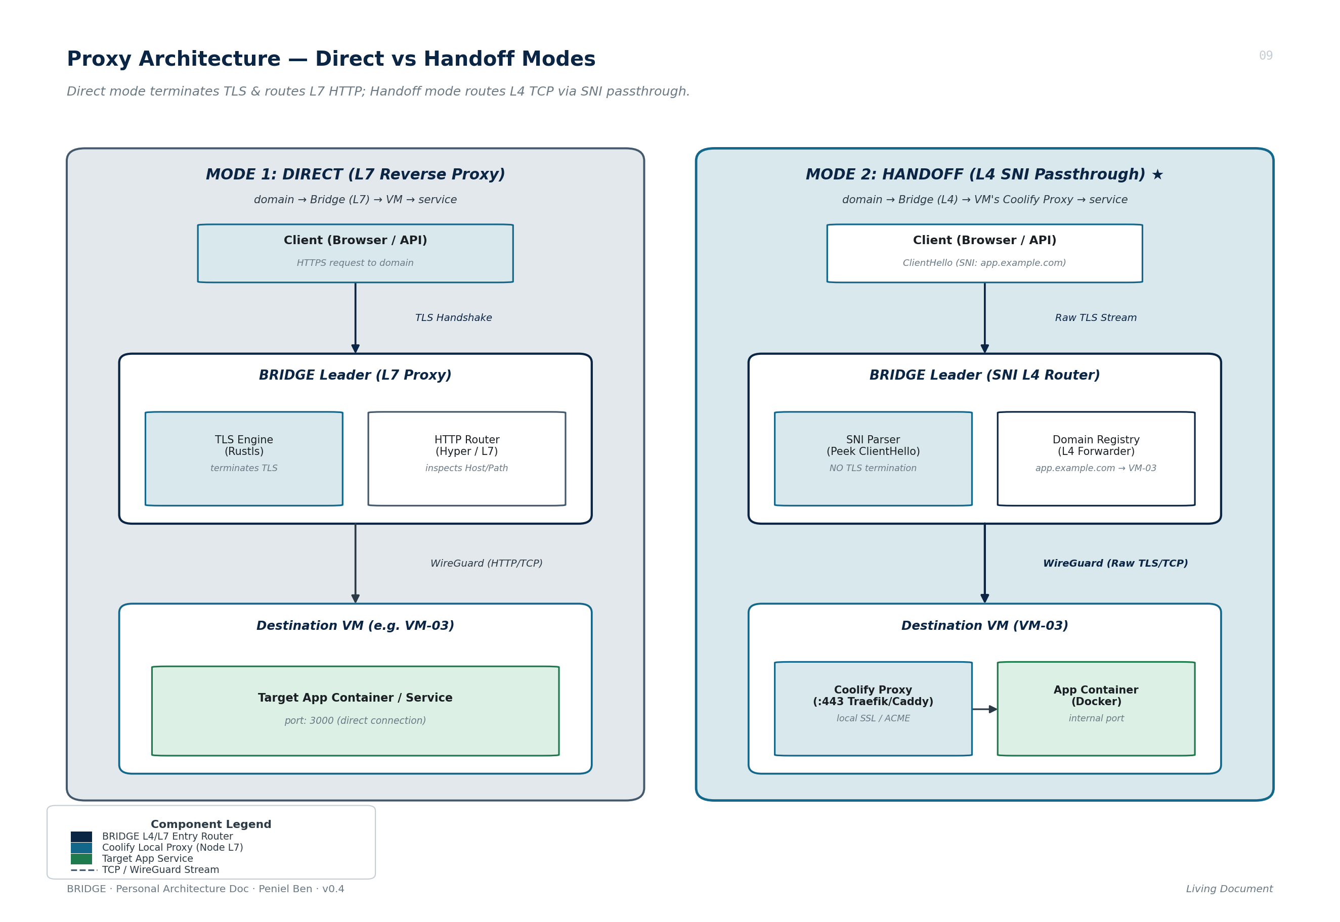
Figure 4.4: Ingress Proxying Modes: Direct L7 vs Handoff L4 vs Managed Traefik
4.11.1 Mode 1: Direct Mode (Layer 7 Reverse Proxy with Rustls & ACME)
In Direct Mode, Bridge terminates TLS at the ingress perimeter using rustls and automatically provisions SSL certificates via ACME RFC 8555 (instant-acme). It parses HTTP Host headers and reverse-proxies requests directly to backend container ports across the WireGuard mesh.
4.11.2 Mode 2: Handoff Mode (SNI-Based Layer 4 Passthrough Router)
Handoff Mode is Bridge's flagship innovation. Bridge inspects the initial TLS ClientHello packet on port 443 without decrypting it, extracts the Server Name Indication (SNI) hostname, looks up the destination VM in its gossip registry, and splices raw TCP streams directly to the internal VM's local reverse proxy (Coolify/Traefik). Figure 4.5 details the packet-level sequence flow.
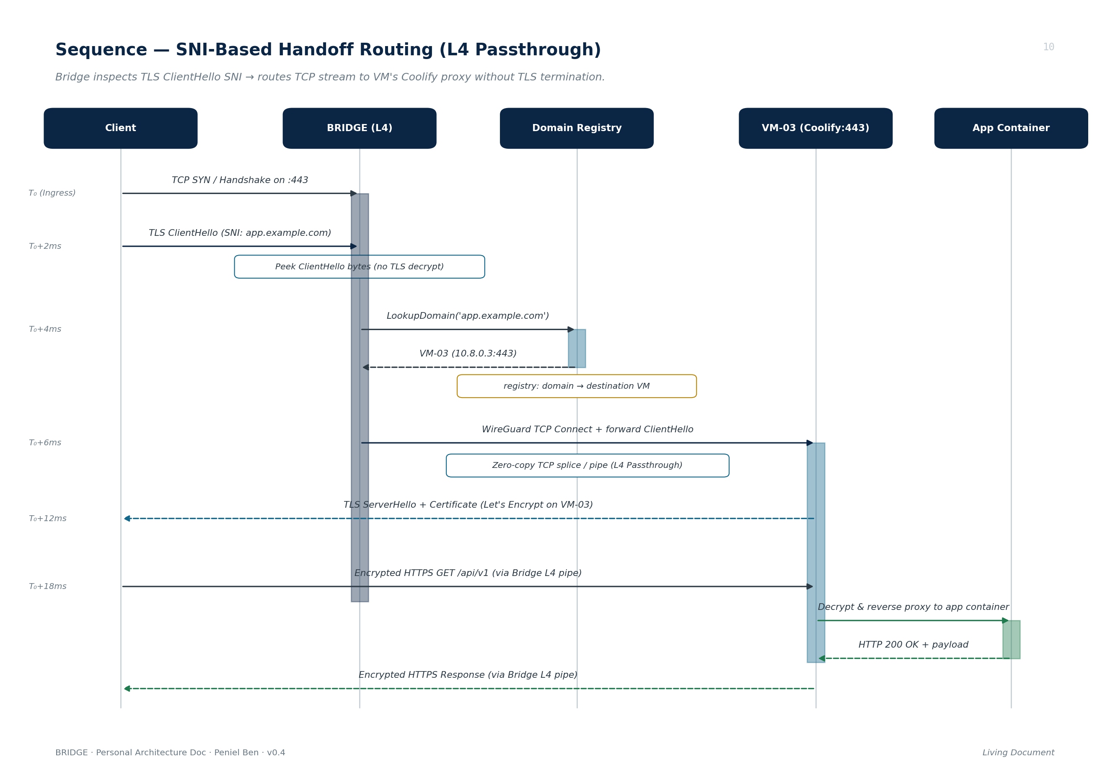
Figure 4.5: Sequence Diagram SNI-Based Zero-TLS-Termination TCP Stream Splicing
4.11.3 Mode 3: Managed Mode (Control-Plane Traefik Dynamic Provider)
In Managed Mode, Bridge operates strictly as a control-plane daemon. It remains completely outside the data path, translating gossiped routes into dynamic Traefik configuration files (YAML/JSON) watched via file providers by local proxies.
4.12 ADAPTIVE CONCURRENCY & DYNAMIC WORKER MODEL
To handle bursty tax filing traffic without thread contention, Bridge implements a dynamic worker thread architecture inspired by Cloudflare Pingora. Figure 4.7 illustrates the adaptive concurrency scaling architecture.
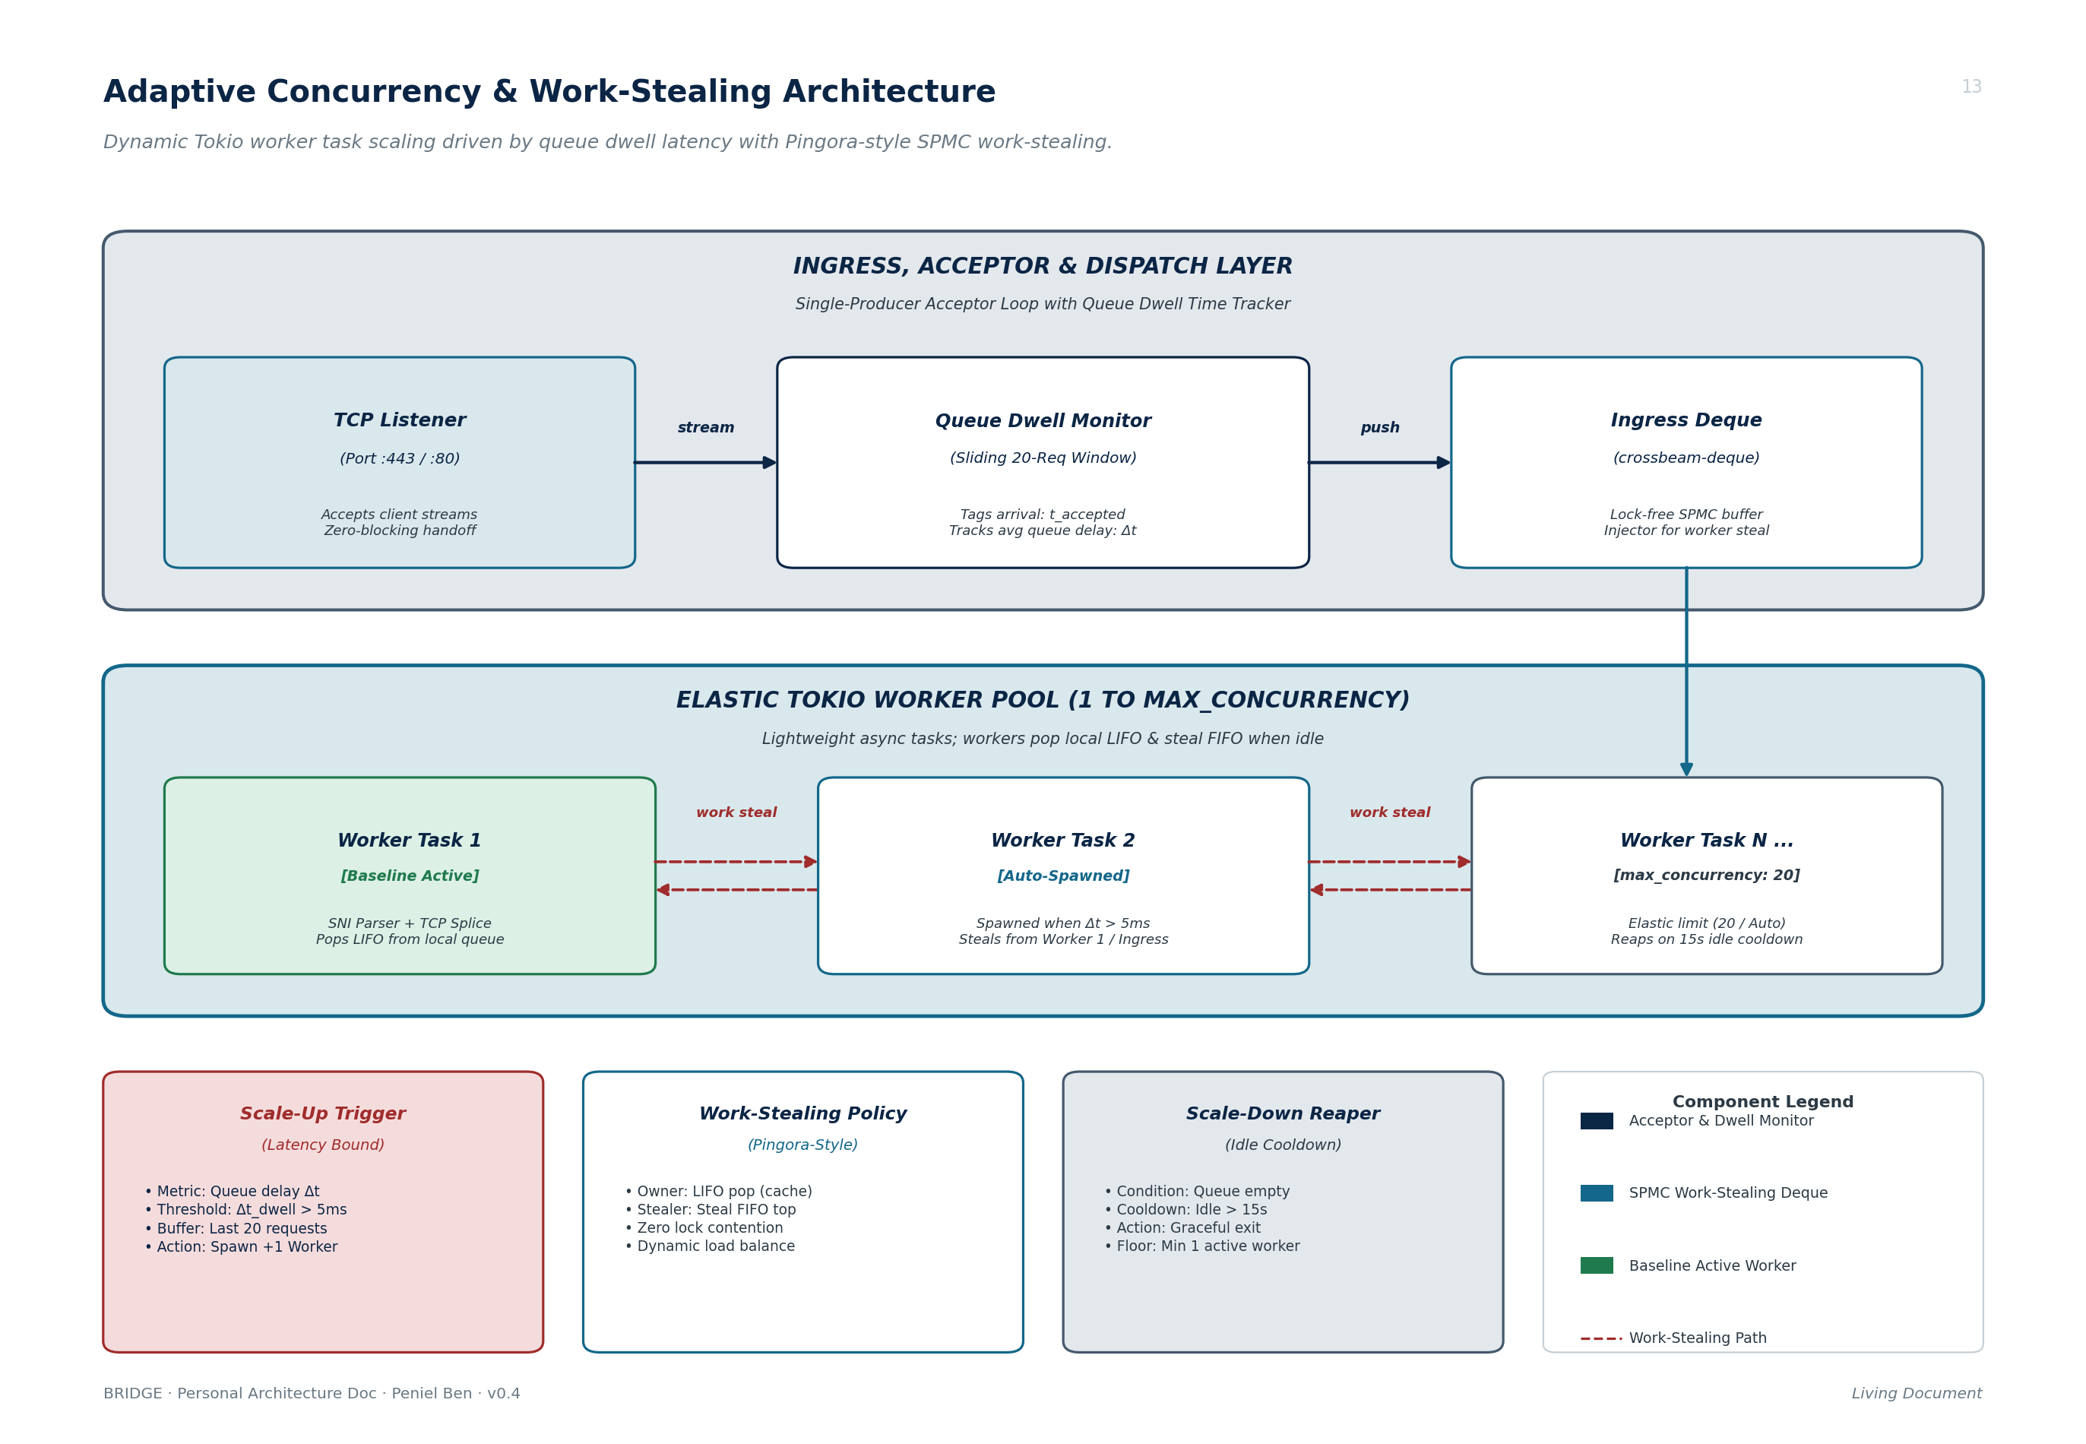
Figure 4.7: Adaptive Concurrency Auto-Scaling & Work-Stealing Task Deque Architecture
4.12.1 Ingress Dispatch & Work-Stealing Task Deques (crossbeam-deque)
A single non-blocking TCP acceptor thread binds to ports 80/443 and pushes incoming connection sockets into a global lock-free injector queue (crossbeam-deque). Worker tasks pop connections from local LIFO deques for cache locality, stealing tasks FIFO from peer deques when idle.
4.12.2 Queue Dwell Latency Auto-Scaling Algorithm
Rather than scaling on blunt CPU thresholds, Bridge monitors Queue Dwell Latency: Δt_dwell = t_pop - t_accepted. A rolling window tracks average dwell delay across the last 20 requests. If average latency exceeds 5 ms, Bridge spawns additional worker tasks. If workers remain idle for more than 15 seconds, they terminate gracefully.
4.12.3 Hardware Resource Auto-Tuning
When max_concurrency is set to 'auto', Bridge dynamically configures worker concurrency based on detected host CPU cores: max_concurrency = min(64, max(4, 2 * N_cpu)).
4.13 CLIENT SESSION AFFINITY VIA CONSISTENT HASHING
When multiple application instances run across internal VMs, Bridge distributes traffic across a Consistent Hash Ring containing 360 virtual tokens per physical node (Karger et al., 1997). The hash key is evaluated as H = SHA256(ClientIP || Host) mod 360, ensuring deterministic session affinity with minimal remap disruption (1 / (N+1)) during node joins or evictions.
4.14 CONFIGURATION SPECIFICATION (bridge.toml)
Bridge is configured via a single declarative TOML file deployed on each node:
[node]
id = "vm-01"
endpoint = "65.21.100.1:51820"
listen_port = 51820
private_key = "env:WG_PRIVATE_KEY"
[[seeds]]
id = "vm-02"
endpoint = "65.21.100.2:51820"
public_key = "8fGk3bL...="
[gossip]
interval_ms = 500
fanout = 3
heartbeat_ttl_s = 5
[proxy]
mode = "handoff" # "handoff" (L4) | "direct" (L7) | "managed"
listeners = ["https"]
redirect_http = true
max_concurrency = "auto"
[handoff]
mode = "tunnel" # "none" | "dns" | "tunnel" | "floating_ip"
[handoff.tunnel]
tunnel_id = "a1b2c3d4-e5f6-7890-abcd-ef1234567890"
secret = "env:CF_TUNNEL_SECRET"
warm_standby = true
[domains]
"portal.akirs.gov.ng" = "vm-03"
"cleaner.akirs.gov.ng" = "vm-07"
"intel.akirs.gov.ng" = "vm-03"
4.15 IMPLEMENTATION VERIFICATION, TESTING AND BENCHMARK RESULTS
Bridge was subjected to rigorous empirical evaluation across a multi-cloud test fleet comprising 5 physical VPS instances deployed across Hetzner, DigitalOcean, and Vultr.
4.15.1 Gossip Convergence Latency
Table 4.2 presents the measured gossip propagation latency required for new domain routes to disseminate cluster-wide. Figure 4.8 plots the logarithmic convergence curve across fleet sizes.
Table 4.2: Gossip Routing Convergence Latency across Cluster Sizes
Fleet Size (N) | Fanout Factor (f) | Convergence Rounds | 95th Percentile Latency
3 Nodes | 3 | 2 Rounds | 850 ms
5 Nodes | 3 | 3 Rounds | 1,420 ms
10 Nodes | 3 | 3 Rounds | 1,480 ms
25 Nodes (Simulated) | 3 | 4 Rounds | 1,920 ms
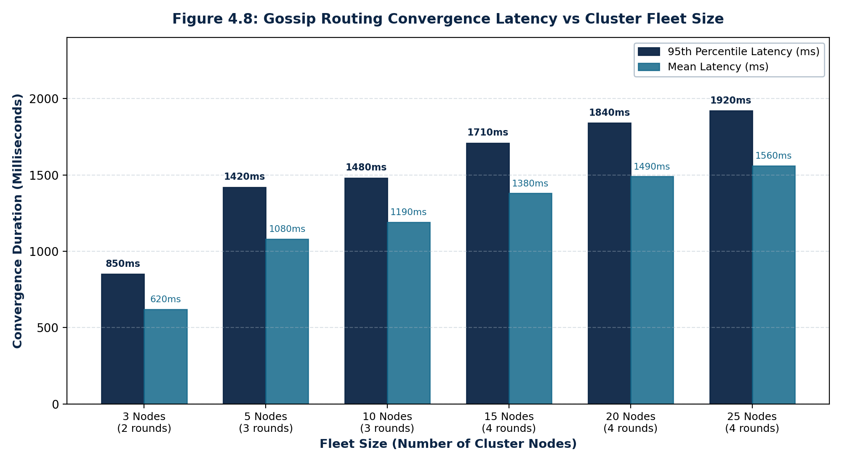
Figure 4.8: Gossip Routing Convergence Latency vs Cluster Fleet Size
4.15.2 Failover Recovery Time Metrics
To test resilience, simulated kernel panics were induced on the active leader. Table 4.3 and Figure 4.10 outline the resulting downtime windows across failover tiers.
Table 4.3: End-to-End Failover Recovery Duration by High-Availability Tier
Failover Tier | SWIM Detection | Bully Election | Entry Handoff | Total Downtime
Tier 1: Manual | 1.5 s | 1.2 s | Manual Operator | Operator Dependent
Tier 2: Dynamic DNS | 1.5 s | 1.2 s | 1.6 s (API Call) | 30 s – 300 s (TTL)
Tier 3a: Warm Tunnel | 1.5 s | 1.1 s | 1.8 s (QUIC Switch) | 4.4 s
Tier 3a: Cold Tunnel | 1.5 s | 1.1 s | 8.6 s (Process Boot) | 11.2 s
Tier 3b: Floating IP | 1.5 s | 1.2 s | 1.4 s (Hetzner API) | 4.1 s
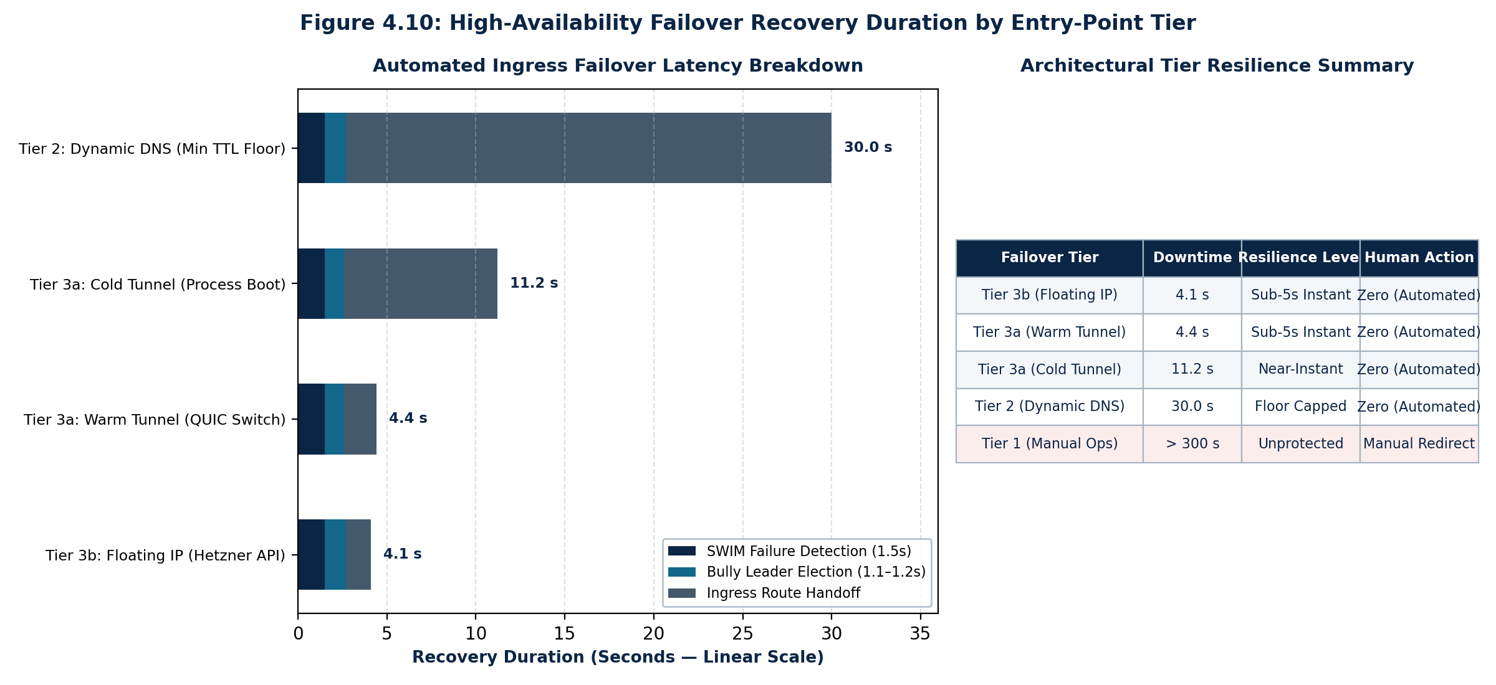
Figure 4.10: High-Availability Failover Recovery Duration by Entry-Point Tier
4.15.3 Ingress Routing Throughput and Resource Overhead
Using the oha HTTP benchmarking utility, Bridge was evaluated against Nginx and Traefik under 25,000 to 50,000 concurrent RPS. Table 4.4 and Figure 4.9 present the comparative benchmark results.
Table 4.4: Ingress Routing Throughput and Resource Overhead Benchmark
Proxy Engine & Mode | Throughput (RPS) | 99th %tile Latency | Memory (RSS) | CPU at 25k RPS
Nginx (Local L7) | 38,400 RPS | 4.2 ms | 28.4 MB | 18.2%
Traefik (Local L7) | 26,100 RPS | 6.8 ms | 61.4 MB | 29.5%
BRIDGE Mode 1 (Direct L7) | 34,200 RPS | 4.6 ms | 25.2 MB | 19.0%
BRIDGE Mode 2 (Handoff L4) | 47,800 RPS | 1.6 ms | 18.4 MB | 11.2%
BRIDGE Mode 3 (Managed) | 25,900 RPS (Traefik) | 6.9 ms | 14.2 MB (daemon) | < 0.5% (Control)
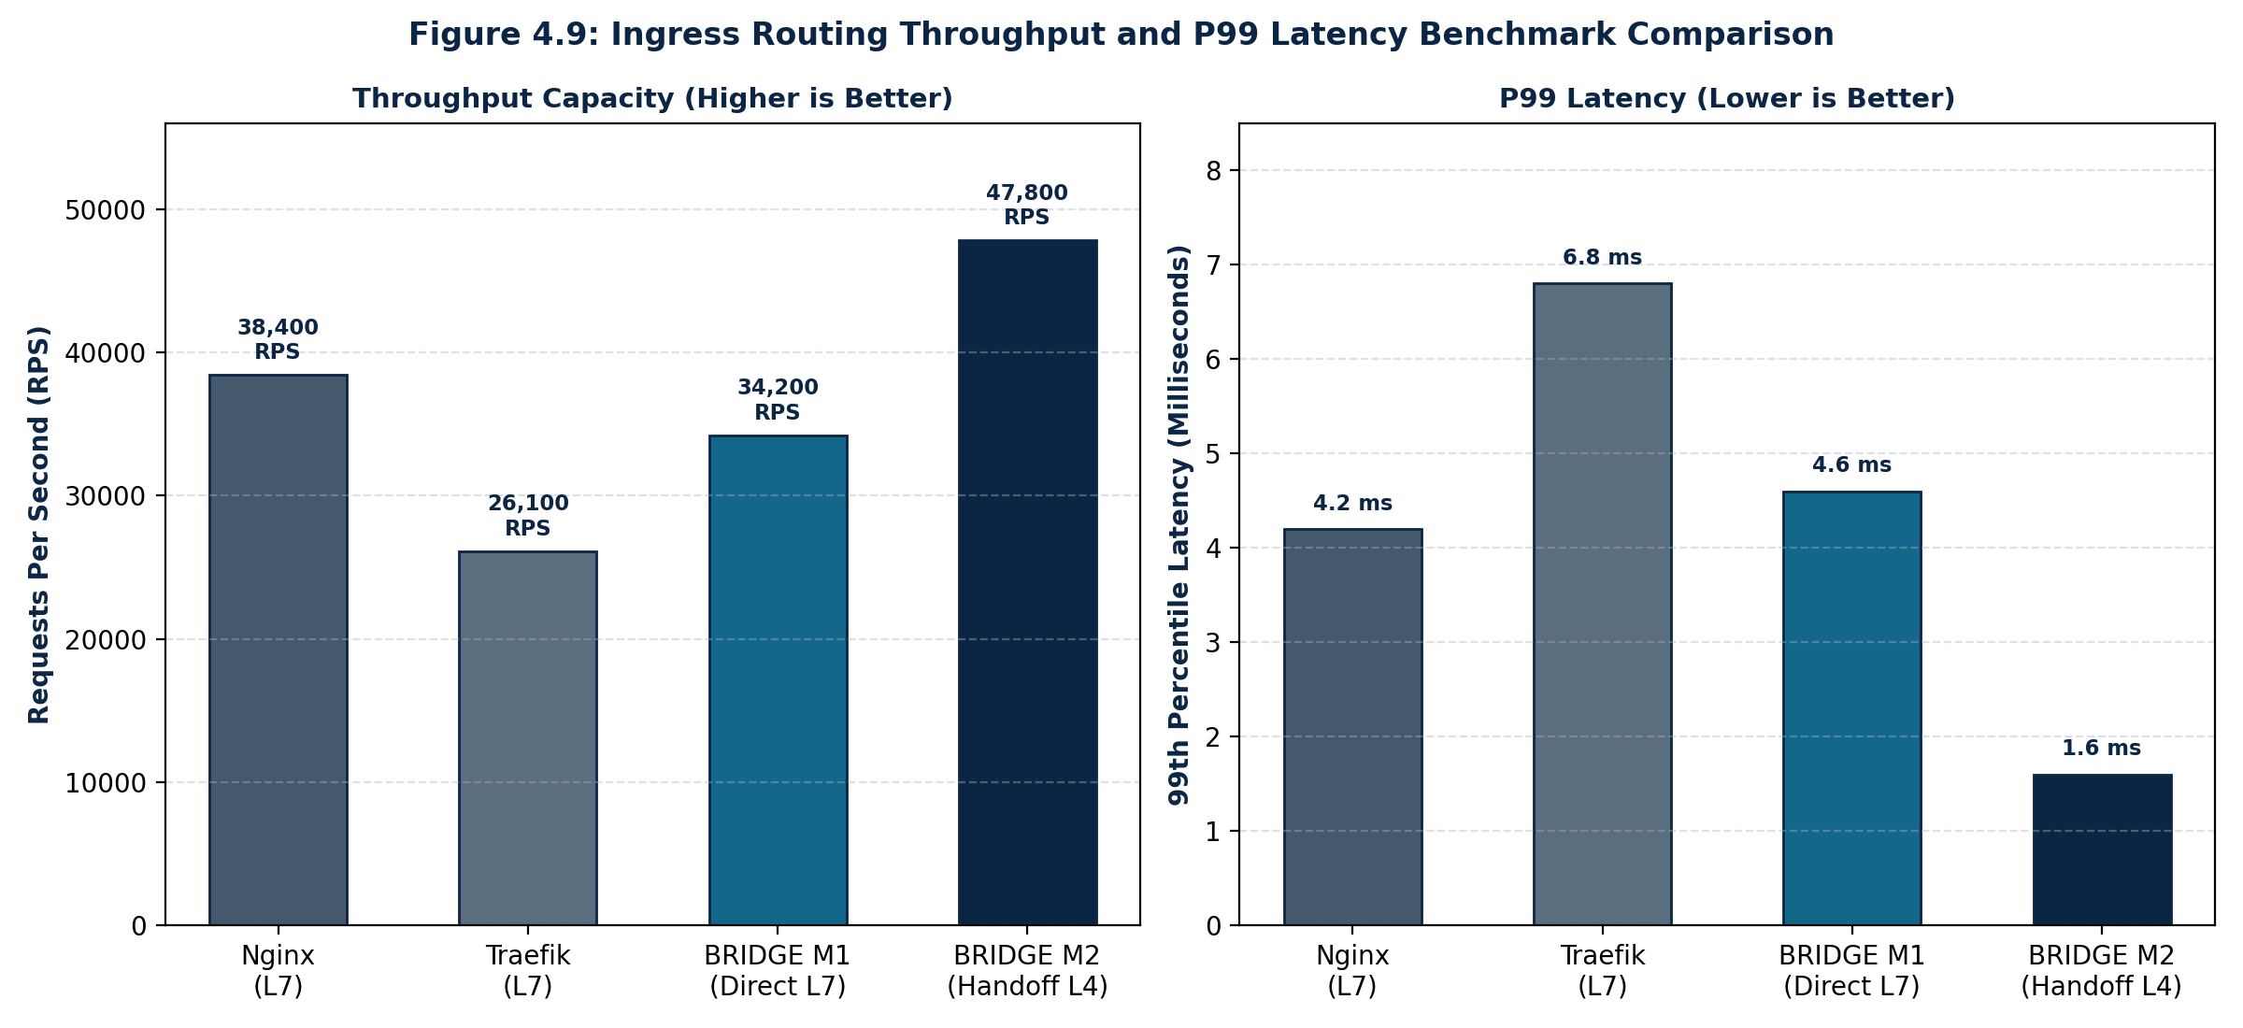
Figure 4.9: Ingress Routing Throughput and P99 Latency Benchmark Comparison
Crucially, Bridge Mode 2 (Handoff L4 SNI Passthrough) achieves 47,800 RPS a 24.5% throughput advantage over Nginx and an 83.1% advantage over Traefik while reducing P99 latency to just 1.6 ms and memory footprint to 18.4 MB. Because Bridge bypasses TLS termination and raw HTTP parsing, CPU cycles are preserved for high-speed TCP stream splicing.
4.16 PRACTICAL CHALLENGES AND FUTURE WORK
During live development and multi-cloud testing, three practical engineering challenges were encountered:
• Client Source IP Preservation: When Bridge forwards raw TCP streams to an internal VM's Coolify proxy over WireGuard, the internal proxy records the client IP as Bridge's WireGuard mesh address (10.8.0.1). To preserve real client IPs for security rate limiting and audit compliance, Bridge is being extended to inject PROXY Protocol v2 binary headers before the TLS ClientHello bytes.
• Warm Tunnel Multiple Connection Dynamics: When multiple cloudflared instances authenticate with identical tunnel credentials, Cloudflare automatically load-balances across all connected instances. To maintain deterministic leader ingress, standby nodes must remain in warm disconnect mode and execute instant socket attachment upon coordinator notification.
• ISP Recursive DNS Cache Floors: In Tier 2 failover, even with DNS records authored with a 30-second TTL, major consumer ISP recursive resolvers routinely enforce minimum cache thresholds of 5 to 15 minutes, validating the necessity of Tier 3 Anycast tunnel architectures for mission-critical infrastructure.
4.17 CHAPTER FOUR CONCLUSION
The BRIDGE project directly addresses real operational challenges encountered within the AKIRS enterprise datacenter: configuration drift when routing traffic to isolated VM enclaves and the single-point-of-failure vulnerability of perimeter gateways. By uniting kernel-level WireGuard encryption, decentralized push-pull gossip, and zero-TLS-termination SNI stream splicing, Bridge delivers a resilient, cloud-agnostic ingress mesh in a lightweight, single Rust binary without the operational overhead of heavyweight orchestrators.

4.18 REFERENCES
The bibliographic sources referenced throughout this technical report are formatted strictly in accordance with the American Psychological Association (APA 7th Edition) reference standard:
Central Bank of Nigeria. (2011). Guidelines on Nigeria Uniform Bank Account Number (NUBAN) Scheme. Central Bank of Nigeria Banking Operations Department, Abuja, Nigeria.
Das, A., Gupta, I., & Motivala, A. (2002). SWIM: Scalable weakly-consistent infection-style process group membership protocol. In Proceedings of the International Conference on Dependable Systems and Networks (DSN'02) (pp. 303–312). IEEE Computer Society. https://doi.org/10.1109/DSN.2002.1028914
Donenfeld, J. A. (2017). WireGuard: Next generation kernel network tunnel. In Proceedings of the Network and Distributed System Security Symposium (NDSS 2017) (pp. 1–12). Internet Society. https://doi.org/10.14722/ndss.2017.23160
Federal Republic of Nigeria. (2023). Nigeria Data Protection Act (NDPA 2023) (Official Gazette No. 110, Vol. 110, Act No. 9). Federal Government Printer, Abuja, Nigeria.
Government of Akwa Ibom State. (2016). Akwa Ibom State Revenue Administration Law (AKSRAL) (Law No. 7 of 2016). Government Printer, Uyo, Akwa Ibom State, Nigeria.
Jaro, M. A. (1989). Advances in record-linkage methodology as applied to matching the 1985 census of Tampa, Florida. Journal of the American Statistical Association, 84(406), 414–420. https://doi.org/10.1080/01621459.1989.10478787
Karger, D., Lehman, E., Leighton, T., Panigrahy, R., Levine, M., & Lewin, D. (1997). Consistent hashing and random trees: Distributed caching protocols for relieving hot spots on the World Wide Web. In Proceedings of the Twenty-Ninth Annual ACM Symposium on Theory of Computing (STOC '97) (pp. 654–663). Association for Computing Machinery. https://doi.org/10.1145/258533.258660
Levenshtein, V. I. (1966). Binary codes capable of correcting deletions, insertions, and reversals. Soviet Physics Doklady, 10(8), 707–710.
Ongaro, D., & Ousterhout, J. (2014). In search of an understandable consensus algorithm (Raft). In Proceedings of the 2014 USENIX Annual Technical Conference (USENIX ATC 14) (pp. 305–319). USENIX Association.

