BUG REPORT

Testing site “store.demoqa.com”

BUG REPORT 1
Design Bugs 2
Product Category invalid data input 2
Missing “Service and support” hyperlink 3
Missing product pictures in “People who bought ...” 4
Functional Bugs 5
Product “Magic Mouse” is on the wrong page 5
Collapse menu Button in Dashboard 6
Pin links out of order 7
Searching of products doesn't works 8
Wrong products when searching “iPod” 9
Zero price “$0.00” 10
Description is not complete 11
Discount with “!” symbol and price in “INR” 12
Searching wrong product 13
All Product Button functionality 14
User-acceptance Bugs 15
Reset forgotten password 15

Design Bugs

Product Category invalid data input
A short Title | Product Category invalid data input
Description | Invalid data input – wrong message
Pre-Conditions | -
Steps to reproduce | - Visit the site store.demoqa.com  - Go on Product Category Page  - Input invalid data ex. “ggg”
Expected result | When the filter is applied and if the input data is invalid, it should display “Not Found” and “Appologies, but the page you requested could not be found. Perhaps searching will help.”
Actual result | We see the massage “Sorry, but nothing matched your search criteria. Please try again with some different keywords.”
A screenshot of the issue | 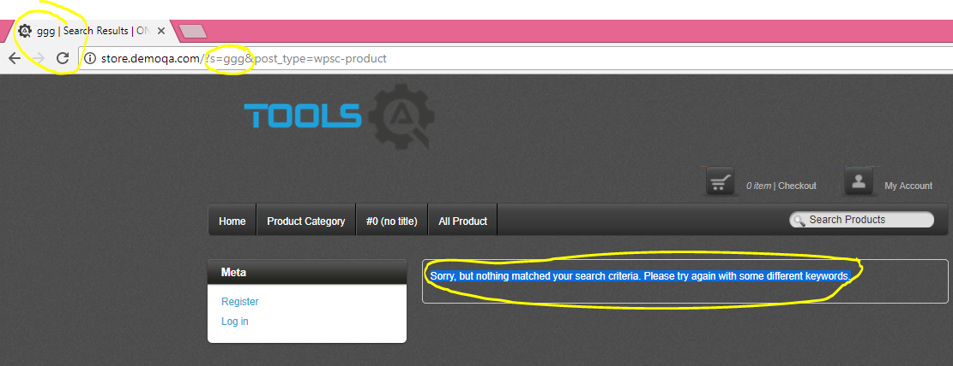

Missing “Service and support” hyperlink
A short Title | Missing “Service and support” hyperlink
Description | Missing “Service and support” hyperlink on the navigation bar
Pre-Conditions | -
Steps to reproduce | 1. Visit the site store.demoqa.com
Expected result | We should see the navigation bar with navigational hyperlinks to the Home, Product category, Services & Support, All Products
Actual result | We see hyperlinks only for Home, Product category and All Products. On the place of the hyperlink for “Services & Support” is written” #0 (no title) “
A screenshot of the issue | 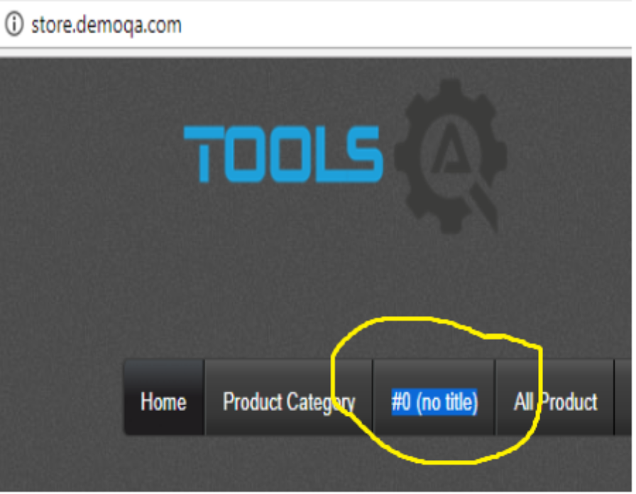

Missing product pictures in “People who bought ...”
A short Title | Missing product pictures in “People who bought ...”
Description | On the product page in “People who bought this item also bought” section the pictures of some products are missing
Pre-Conditions | Open the site store.demoqa.com
Steps to reproduce | - select “product category” page  - select poduct “Magic Mouse”
Expected result | In the the “People who bought this item also bought” section we should see other products with their pictures
Actual result | Some of the products don't have pictures but only product name and price
A screenshot of the issue | 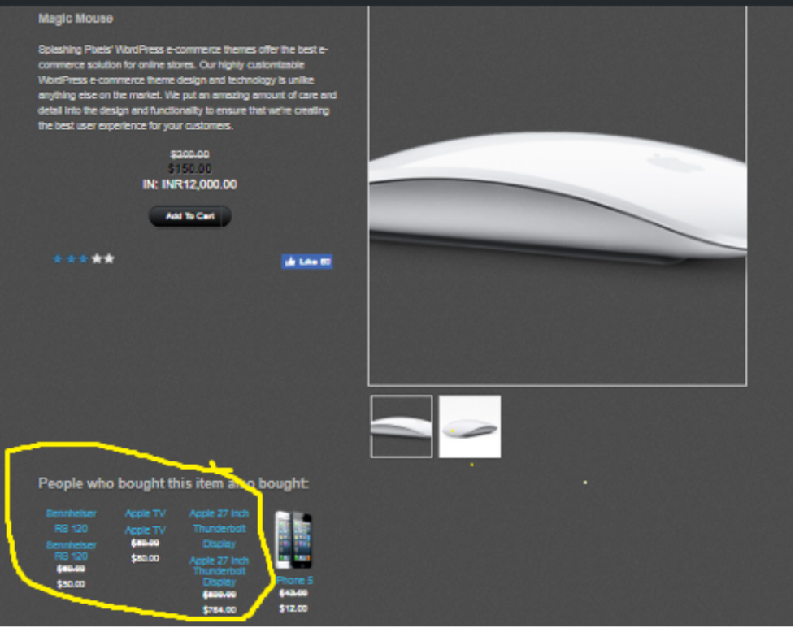

Functional Bugs

Product “Magic Mouse” is on the wrong page
A short Title | Product “Magic Mouse” is on the wrong page
Description | In simple view
Pre-Conditions | Open the site store.demoqa.com
Steps to reproduce | 1. select “Product category” page  2. select “iPads” (or “iPhones” or “iPods” or “Macbooks”)
Expected result | We should see only the products from “iPad” category
Actual result | The first product that we see is “Magic Mouse” and after that the other products from the category.
A screenshot of the issue | 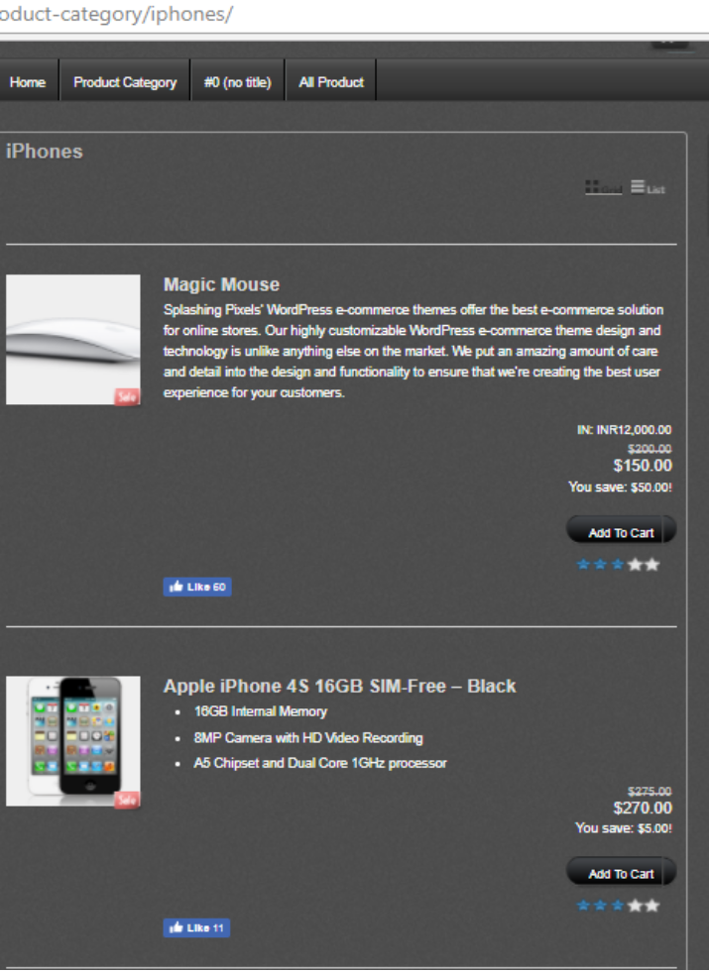

Collapse menu Button in Dashboard
A short Title | Collapse menu Button doesn't work
Description | Collapse menu Button do nothing
Pre-Conditions | User must be logged in
Steps to reproduce | - click on the “ONLINE STORE” button in the left upper corner  - select “Dashboard”  - click “Collapse menu”
Expected result | Do something.
Actual result | There is no functionality.
A screenshot of the issue | 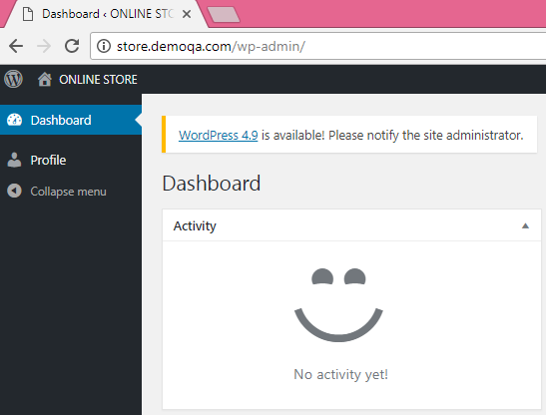

Pin links out of order
A short Title | Pin link out of order
Description | Pin links in the left corner doen't work
Pre-Conditions | Open the site store.demoqa.com
Steps to reproduce | 1. click on the pin links “Follow our Pins” or “Checkout our Google plus profile”
Expected result | The site should navigate to the link.
Actual result | There is no functionality.
A screenshot of the issue | 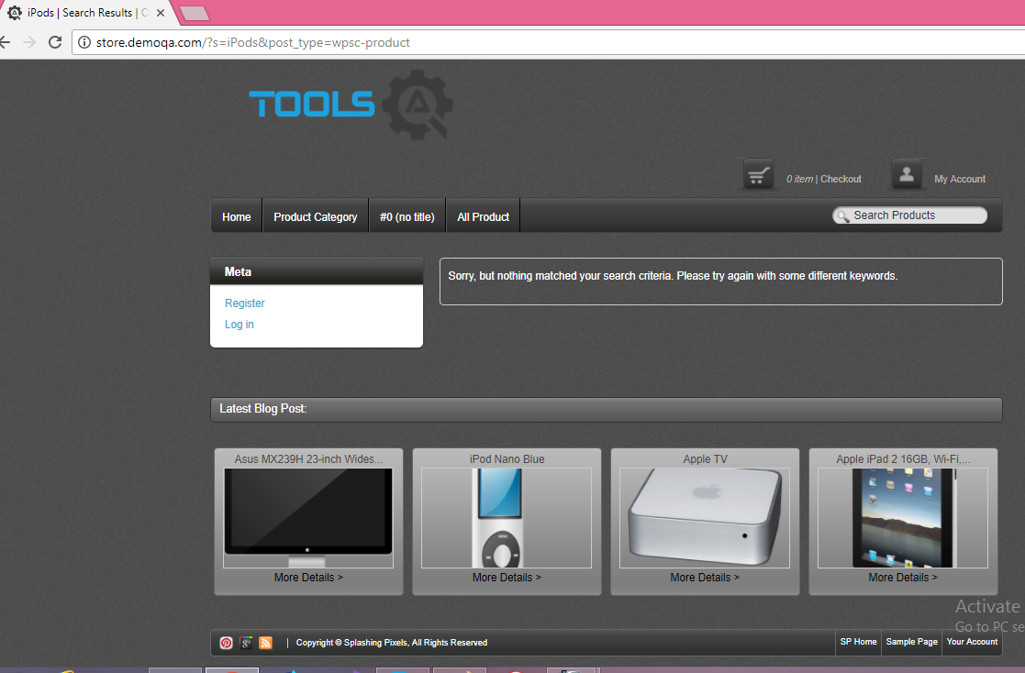

Searching of products doesn't works
A short Title | Searching of products doesn't works
Description | When searching “iPods” or “iMacs”products it shows a message “Sorry, but nothing matched your search criteria. Please try again with some different keywords”
Pre-Conditions | Open the site store.demoqa.com
Steps to reproduce | 1. click in “Search product” field  2. enter “iPods” /as the Product category name/  3. click Enter
Expected result | We should see products from “iPods” category.
Actual result | It doesn't show any iPods. It shows a message “Sorry, but nothing matched your search criteria. Please try again with some different keywords”.
A screenshot of the issue | 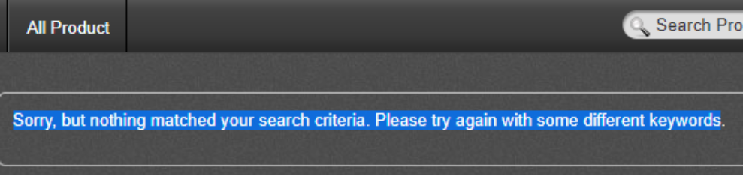

Wrong products when searching “iPod”
A short Title | Wrong products when searching “iPod”
Description | Showing wrong products when searching “iPod”
Pre-Conditions | Open the site store.demoqa.com
Steps to reproduce | 1. click in “Search product” field  2. enter “iPod”  3. click Enter
Expected result | We should see products from “iPods” category.
Actual result | We see some iPods, one Aplle Ipad and “Apple TV”
A screenshot of the issue | 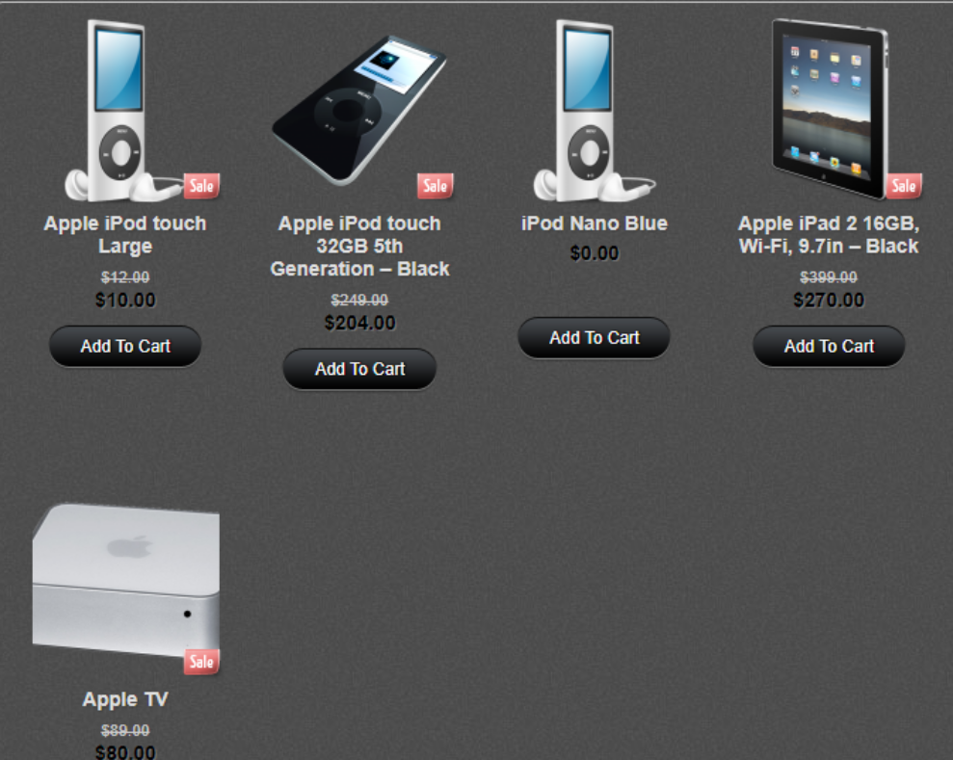

Zero price “$0.00”
A short Title | Zero price “$0.00”
Description | In simple view mode the price is zero
Pre-Conditions | Open the site store.demoqa.com
Steps to reproduce | 1. select “product category” page  2. slide down to “iPod Nano Blue”
Expected result | We should see the price of the product
Actual result | We see zero price (“$0.00”)
A screenshot of the issue | 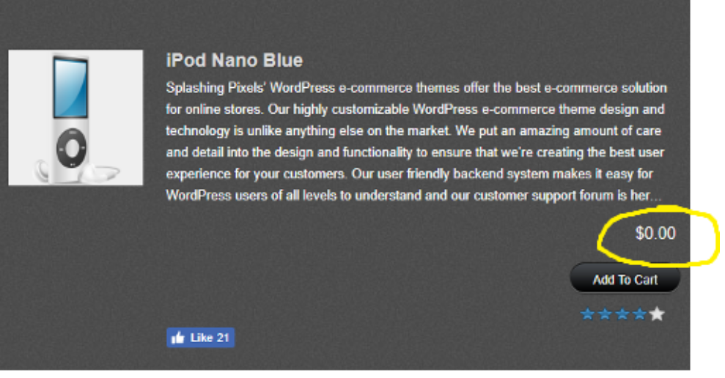

Description is not complete
A short Title | Descrition is not complete
Description | Description is not complete
Pre-Conditions | Open the site store.demoqa.com
Steps to reproduce | - select “Home” button
Expected result | We could see the product description at all.
Actual result | The product description is not completed. It has “....”
A screenshot of the issue | 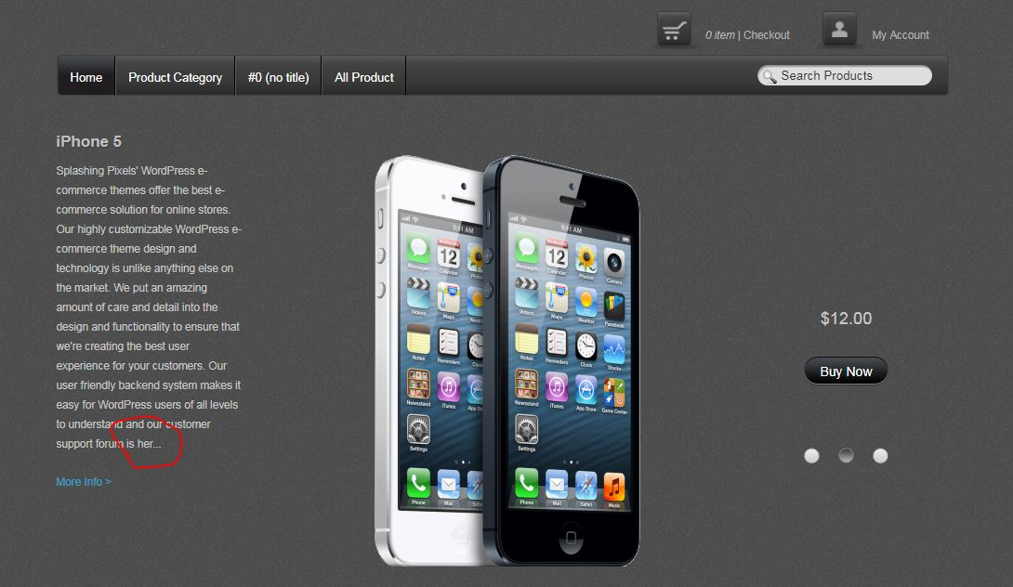

Discount with “!” symbol and price in “INR”
A short Title | Discount with “!” symbol and price in “INR”
Description | In simple view we see price in “INR” and discount with “!” symbol
Pre-Conditions | Open the site store.demoqa.com
Steps to reproduce | 1. select “product category” page  2. select “IMacs”
Expected result | We should see the price of the product in USD and discount in USD too.
Actual result | We see price in “INR 12 000.00” and the discount have “!” symbol
A screenshot of the issue | 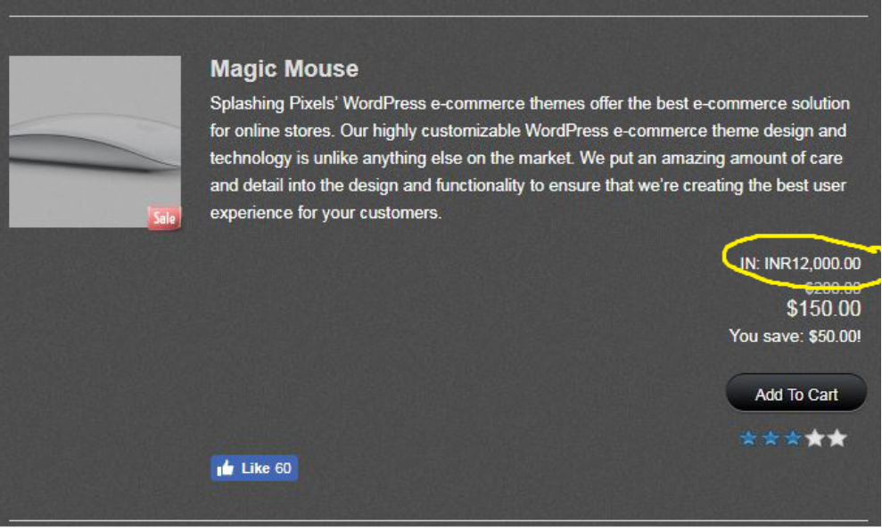

Searching wrong product
A short Title | Searching invalid product “car”
Description | When we search “car” products it shows different products like iPads, iPod, mouse and other
Pre-Conditions | Open the site store.demoqa.com
Steps to reproduce | 1. click in “Search product” field  2. enter “car”  3. click Enter
Expected result | We should see a message “Sorry, but nothing matched your search criteria. Please try again with some different keywords”.
Actual result | It shows product for the entered criteria “car”.
A screenshot of the issue | 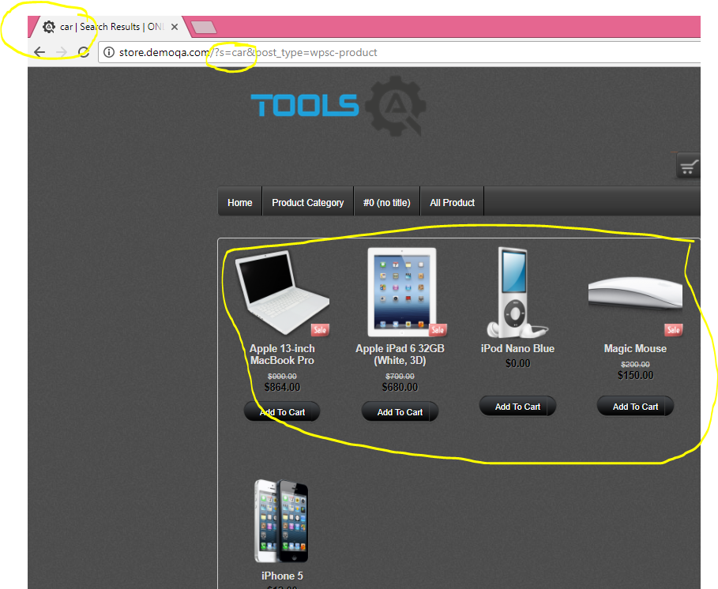

All Product Button functionality
A short Title | All Product Button functionality
Description | In simple view
Pre-Conditions | Open the site store.demoqa.com
Steps to reproduce | - select “All Product”
Expected result | We should see all products on the site.
Actual result | We see some products, not all of them.  All Product Button and Product Category Button have the same functionality.
A screenshot of the issue | 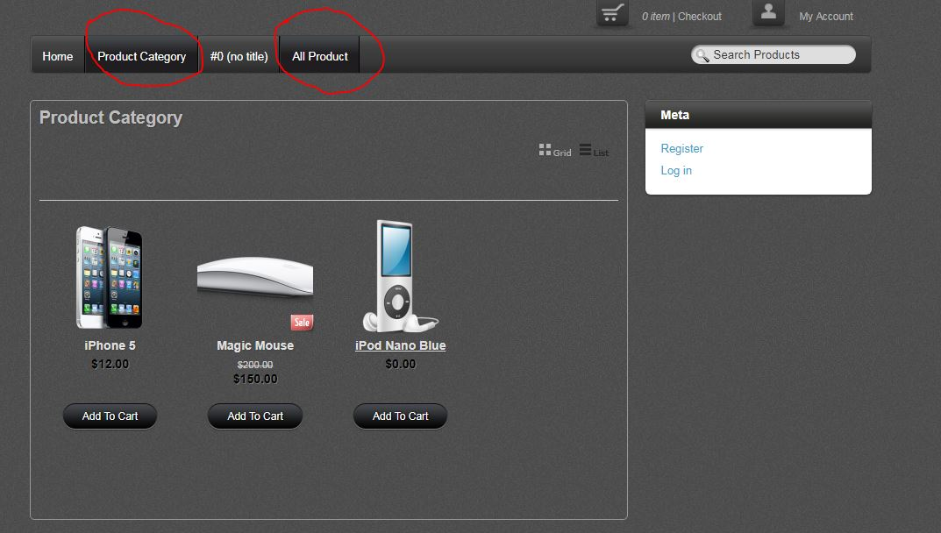

User-acceptance Bugs

Reset forgotten password
A short Title | Reset forgotten password
Description | Reset forgotten password is difficult
Pre-Conditions | Open the site store.demoqa.com
Steps to reproduce | - click on “My account”  - select “Log in”  - select “Lost your password?”  - enter the personal email with which we are registered  - go to personal email and open the message
Expected result | We should see the link which leads to a reset password page.
Actual result | We see a form to get new password and it is a permenent cycle with no result for changing the password.  We have to copy only the link between the < link > but it is not written.
A screenshot of the issue | 