Functional and Security Bugs

1.When click iMacs -  in the picture is Magic Mouse List 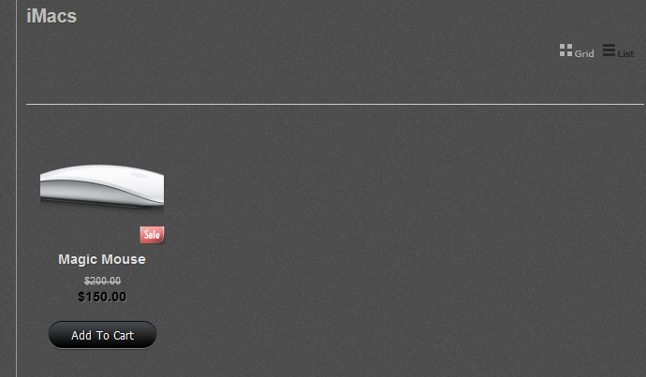 and Magic Mouse Grid
The text is wrong and IN INR 12000
2. When click iPad  first is Mouse in List
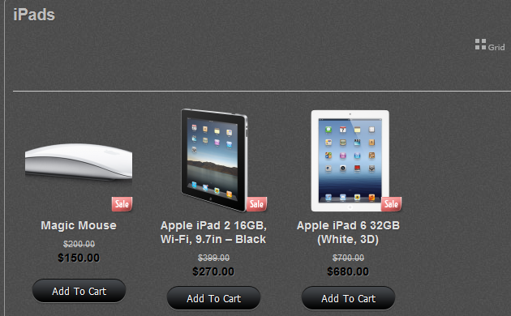 first is Mouse in Grid
3. When click iPhones  first is Mouse in List

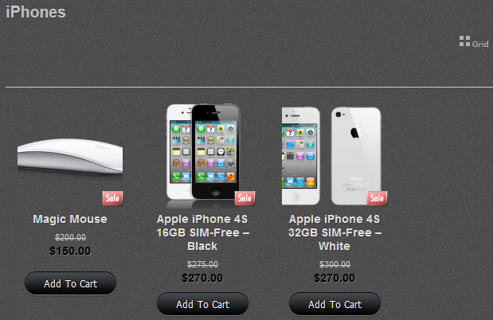 first is Mouse in Grid
4. When click iPods  first is Mouse in List
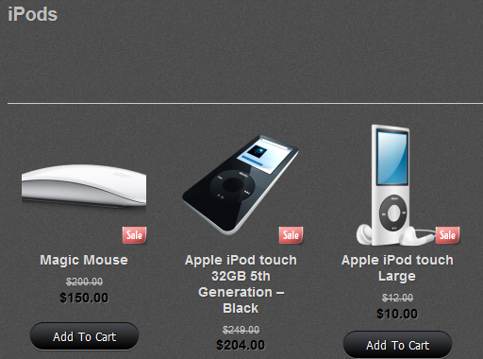 first is Mouse in Grid
5. When click MacBooks  first is Mouse in List

 first is Mouse in Grid
6.When you write in Search products – IPod the answer is 3 IPods and IPad and TV – wrong!
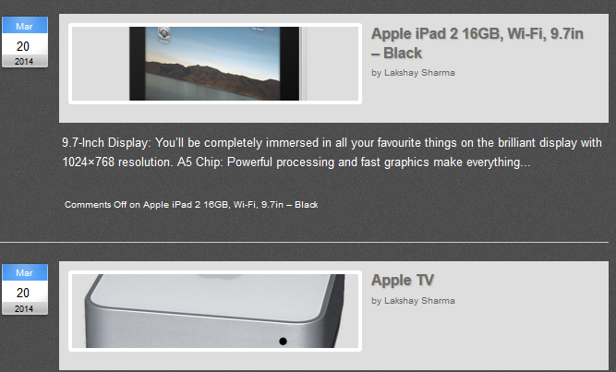

7. In Apple TV the price is $80 and discount is $80 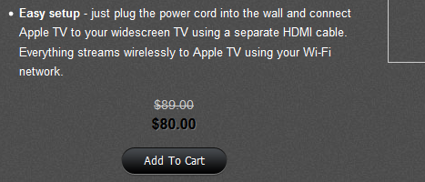
8.People also bought 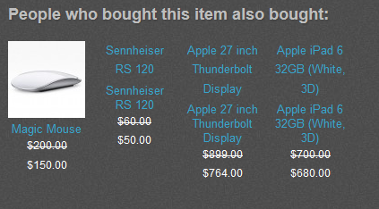 1picture and 3 items without pictures
Next time 2 pictures 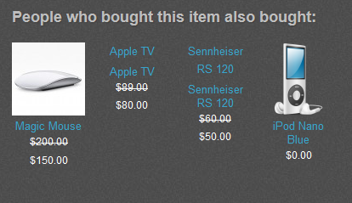
9. Follow the pins 
10. Google + 
11. Get Fed on the Feeds 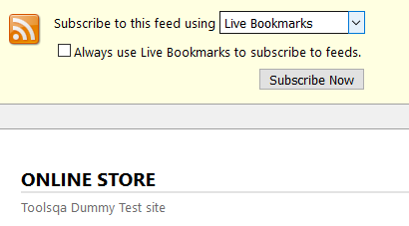 Down without any functionality
12.IPod Nano Blue  the price is $0.00
13.When click All Products 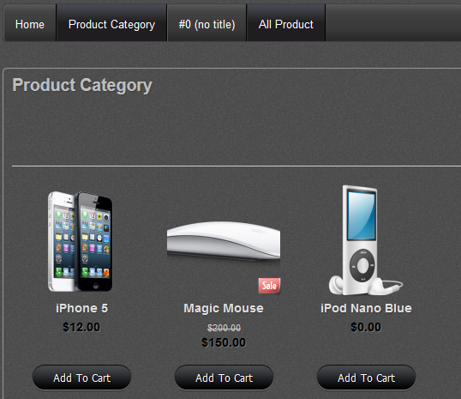 the name is Product Category and only 3 products
14. Your Account Page 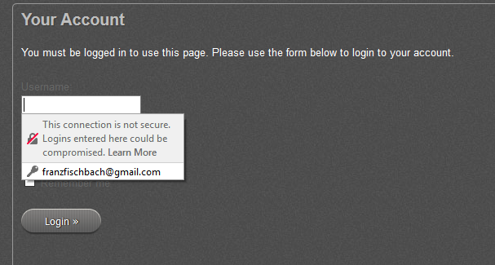User name is inside – Security Bug
15. And Password is also inside – Security Bug
16. When you search IPad – 2 IPads and 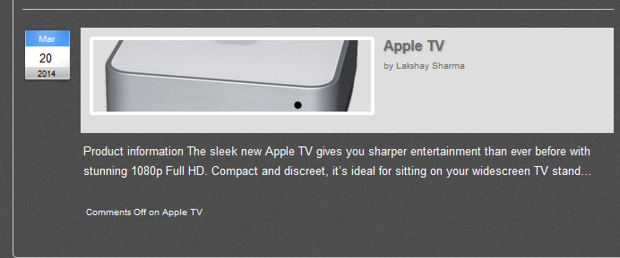
17. When you click Site Admin 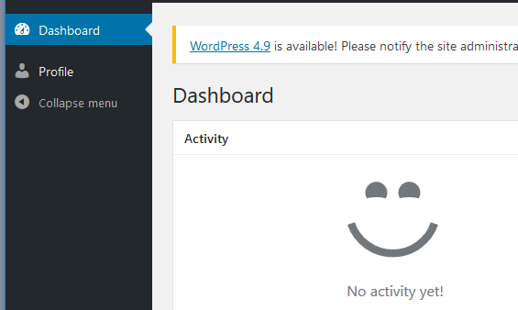
and no click on Collapse menu

