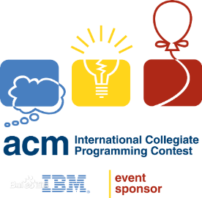

NWAFU ICPC TEAM

Code Library

by iterator

努力变得不水，保持良好心态